Optimizin*g* EDM Process Parameters Using RSM Method Linked with Grey Relational Analysis and Artificial Neural Networks

***\*R. Rajesh1 M. Dev Anand2 and K.S.Jai Aultrin3***

*1Associate Professor and Head, 2Professor and Dean,*

*Department of Mechanical Engineering,*

*3Associate Professor, Department of Marine Engineering,*

*Noorul Islam Centre for Higher Education,*

*Kumaracoil – 629 180,Kanyakumari District, Tamilnadu, India*

***\****Email: rajesh2009@niuniv.com

**ABSTRACT**

Electro discharge machining is as of late perceived as one of the adaptable assembling innovations to ensure less surface roughness and high rate of material removal all through machining of aluminum composite materials. This work portrays a preliminary examination of a full factorial plan completed on aluminum composite material with EDM process by separating the machining boundaries like Pinnacle current, Heartbeat On Time , Heartbeat Off Time, Discharge Voltage, Hole Width and Oil Strain. To assess the ideal cutting circumstances the machined opening amount boundaries analyzed include Surface Roughness (SR) and Material Removal Rate (MRR). System utilized is the multi objective optimization utilizing Demonstrating and reasonable reenactment strategy to assess the ideal cutting circumstances for creating deformity free machining. Aluminum composite material machinability boundaries were upgraded; utilizing ANN strategies trial information is gathered and tried. Executing Dark Engendering Calculation utilizing info and instrument type, the Multi-Layer Perceptron model has been made. Surface Roughness and Material Removal Rate are yield boundaries of the machined parts on culmination of the exploratory test and ANN are associated with approving the outcomes developed and furthermore to decide the presentation of the framework under different circumstances inside the working reach.

**Keywords:** Electro Discharge Machine, Response Surface Methodology, Gray Relational Analysis, Artificial Neural Network

1. **INTRODUCTION**

Electro Discharge Machining (EDM) is a famous electrical sort unpredictable machining process for the most part utilized in unambiguous machining process for complicated molded work pieces. It is a thermal erosion process where an electrically created flash disintegrates electrically conductive material. The electrode (instrument) and work piece ought to be electrically conductive. The flash emerges in a hole loaded up with dielectric solution between the device and work piece. The metal removal process by means of electrical and thermal energy has no mechanical contact with the work piece. It's an exceptional component of utilizing thermal energy to electrically machine the conductive parts in spite of their hardness; its special benefit is in the production of above said present day industry. EDM doesn't connect between the electrode and the work piece, taking out mechanical burdens, jabber and vibration issues during machining. Today, an electrode really small engaged with making opening into bended surfaces as steep points without drill. The flash is generated by the hole between the work piece and an instrument. Better Surface Roughness (SR) can be gotten utilizing smaller holes. Composites are materials containing in any event or multiple constituents bonded together along the connection point in the composite, where each impel from a separate fixing material which pre-exists the composite. Metal Framework Composites (MMCs) are materials in which one component is a metal or alloy shaping no less than one entering organization. Typical MMCs consolidate an intense metallic lattice that is contiguous with a hard fired support. Most common grid materials are aluminum, magnesium and titanium while the most famous fortifications are Silicon Carbide (SiC), Titanium Carbide (TiC), Titanium Boride (TiB2), Boron Carbide (BiC) and Alumina (Al2O3). The thickness of a lot of the MMC's is roughly 33% of steel, following in high unambiguous strength and solidness. In machining of such materials conventional assembling processes are being supplanted by further developed procedures that utilization different fashion of energy to dispose of the material on the grounds that these development materials are confounded to machine by conventional machining cycle and achieving great surface finish and close tolerance is hard. With the progression of automation innovation, makers are more captivated in handling and miniaturization of components made by these exorbitant and hard materials.

Plausibility of evaluating a global ideal solution and its precision relies upon the kind of optimization displaying strategies utilized in communicating the goal functions and limitation regarding the decision factors. Accurate and solid models of the cycle can make up for ineptitude to understand and sufficiently depict the interaction component totally. Thus the formulation of optimization model is the main undertaking in optimization. It includes conveying optimization issue as a mathematical model in a standard configuration which could be straightforwardly tackled by RSM. Optimization of EDM, kind of goal function and constraints, number of targets and reach out of the significance or need to be given to true depends on the result boundary SR and info boundaries like Peak Current (Ip), Pulse On Time (Ton), Pulse Off Time (Toff), Discharge Voltage, Hole Width and Oil Tension, machining of Al/10% SiCp was performed and noticeable exhibitions are weighed against.

1. **LITERATURE SURVEY**

Different researchers have performed process parameter optimization of different types of EDM from time to time using different optimization models and solution techniques. The reviews of such past studies have prominent decision variables, objective functions, constraints, variable bounds, remarks and their limitation. The results were recapitulated as follows: (Kuldeep Ojha et al., 2010) informs research on EDM relating to improvement in MRR along with some insight into mechanism of material removal. (Later Sen and Shan, 2007, Gao et al, 2008 and Rao et al., 2009) followed the similar methodology for the modeling and optimization of EDM process for different work-tool material pairs. The (Tolga Bozdana et al., 2010) reports that experimental investigation of EDM drilling of Ø2mm holes on Inconel718 using brass electrode. The effect of process parameters on process outputs was reported based on minimum number of experiments. The mathematical modeling of process has been performed using Response Surface Methodology (RSM). The results show that the developed model can attain reliable prediction of experimental results within acceptable accuracy. (Musraat Ali et al., 2009). Differential Evolution (DE) is an influential yet simple Evolutionary Algorithm (EA) for optimization of real valued, multimodal functions. (B.H. Yan, et al., 1999) reviews the characteristics of micro hole and minimal tool electrode wear rate to obtain a high precision micro-hole in the carbide, the effects of changing the polarity, the tool electrode shape and the rotational speed of the tool electrode are premeditated. (S. S. Mahapatra, et al., 2006) proposed to study factors like discharge current, pulse duration, pulse frequency, wire speed, wire tension and dielectric flow rate and few preferred interactions both for for maximizations of MRR and minimization of SR in WEDM process using Taguchi method. (Qing GAO et al., 2008) depicts Artificial Neural Network (ANN) and Genetic Algorithm (GA) are exclusively used to create the parameter optimization model. An ANN model which adapts L-M algorithm has been set up to depict the relationship between MRR and input parameters, and GA is used to optimize parameters, so that optimization results are attained. The model is exhibited to be efficient, and MRR is progressed using optimized machining parameters. (M. R. Shabgard, et al., 2009), endeavor has been made to develop mathematical models for relating the MRR, TWR (Tool Wear Rate) and SR to machining parameters. Furthermore, a study was performed to analyze the effects of machining parameters in respect of listed technological characteristics. (Sushant Dhar a, et al., 2007) describes aluminium matrix composites are hard to machine due to the presence of hard and brittle ceramic reinforcements. EDM is a significant process for machining such materials. The work estimates the effect of current (c), pulse-on time (p) and air gap voltage (v) on MRR, TWR, and Radial over Cut (ROC) on EDM of Al–4Cu–6Si alloy–10%weight SiCp composites. The optimum conditions for maximum MRR with reduced TWR and ROC can also be achieved through linear programming. The MRR, TWR and ROC increase considerably in a nonlinear fashion with enhanced current. (I. Puertas. et al., 2003), this work is concentrated on features related to surface quality and dimensional precision, which are one of the most predominant parameters form the point of view of selecting not only the optimum conditions of processes but also the economical aspects. (A. Thillaivanan, et al., 2010) suggested practical method of optimizing cutting parameters for EDM under the minimum total machining time supported by Taguchi Method and ANN is presented. This methodology is not only economical and time saving but also efficient and accurate in examining the machining parameters. It is found that current has a noteworthy control on the total machining time. As a result, the performance attributes like total machining time can be improved through this approach. (Sameh S. H, 2009), shows the improvement of a wide-ranging mathematical model for correlating the interactive and higher order manipulation of various EDM parameters through RSM, utilizing relevant experimental data as acquired through conducting tests. The mathematical models have been developed on the basis of RSM, employing the data from practical observable conditions of the EDM of work pieces. Exploration was performed for analysis of the control conditions required for the control of the MRR, electrode Wear Ratio (EWR), gap size and SR. (Seung-Han Yanga et al., 2009), recommends an optimization methodology for the selection of best process parameters EDM. Regular cutting experiments are performed on die-sinking machine under different conditions of process parameters. This system model is utilized to simultaneously maximize the MRR as well as minimize the SR using SA scheme. (Ramezan Ali Mahdavi Nejad, 2011), proposed the work which aims the optimization of SR and MRR of EDM of SiC parameters simultaneously. As the output parameters are contradictory in nature, so there exists no single combination of machining parameters, making available with the best machining performance. ANN with back propagation algorithm is used to reproduce the process. A multi-objective optimization method, non dominating sorting genetic algorithm-II is used to optimize the process. Effects of three important input parameters of process viz., discharge current, pulse on time (Ton), pulse off time (Toff) on EDM of SiC are believed. Experiments have been performed over a collection of considered input parameters for training and verification of the model. (G. Krishna Mohana Rao et al., 2010), work is intended at optimizing the hardness of surface formed in die dipping EDM by considering the simultaneous effect of various input parameters. The experiments are performed on Ti6Al4V, HE15, 15CDV6 and M-250 by varying the peak current and voltage and the corresponding values of hardness were measured. (Majumder, et al., 2012) propose investigation of the process parameters of EDM has optimized for minimum EWR. The machining parameters used in this study are spark-current, pulse-on duration and pulse-off duration.The relation between electrode wear rate and machining parameters has been developed by using RSM. The main reason of this work is to demonstrate the input process distinctiveness of EDM and has influenced by the process parameters. These works demonstrate a study of the intervening variable in EDM of material (Al alloy with HE9 and LM25 Al/15%SIC). The MRR and SR were studied. Six parameters were modified during the experiments. The result illustrate that current was the main parameter affecting the MRR. Different investigators were presents the classification of the various research areas in EDM and possible future research directions as shown in Figure 1.The retro analysis of literature exposed and brought out into view that no works were performed in EDM of Al/10% SiCp and with more than three parameters.(Wang et al 2016) implemented a pulse counting method to analyze the alternating current run during discharge to see the effect of reverse current. The reverse current flow helps to polish the edges and to form the crater. Bypassing the reverse current by connecting the diode between the spark tracks of the discharging circuit enhances the tool wear with respect to the work piece removal.



**Figure 1: Classification of Major EDM Research Areas**

1. **EXPERIMENTAL DETAILS**

Innumerous analyses were achieved to look at the performance and study the impacts of various machining boundaries of EDM process on MMC in the construction of rectangular block of test pieces. These examinations have been accepted to investigate the impacts of Peak Current (Ip), Discharge Voltage (V), Spark Gap, Pulse on Time (Ton), Pulse Off Time (Toff) and Oil Pressure (Poil) on SR and these boundaries are considered as plan variable in this optimization process. The formulation of an optimization issue begins with sorting the hidden plan variables, which are principally different during the optimization process. The constraints represent some deliberate relationship among the plan variables and other plan filling specific actual phenomenon and certain asset are more noteworthy than or equivalent to, an asset value. In this work, oversize and the EDM opening are estimated as constraints.

* 1. **Work Material**

The work material Al-10% SiCp (MMC) was made utilizing mix projecting strategy, properly assessed and liked for rectangular piece (120mm x 120mm x 8mm) dimensions. The material is picked with its huge arising scope of utilizations in the space of assembling devices in shape businesses and also utilized successfully in aeronautical and vehicle ventures as a result of their high solidarity to weight ratio, mechanical and physical properties decided against with solid material. Table-1 shows the physical and mechanical properties of Al-10% SiCp MMC material. Table-2 shows the chemical creation of Al-10% SiCp MMC material.

**Table 1: Physical and mechanical properties of Al-10% SiCp MMC**

|  |  |  |  |  |  |
| --- | --- | --- | --- | --- | --- |
| Material | Density  (gms/cm3) | Tensile Strength  (N/mm2) | Hardness  (BHN) | Modulus of Elasticity  (x103N/mm2) | % Elongation |
| Al-SiC10p | 2.68 | 275 | 110 | 90 | 1.2 – 1.8 |

**Table 2:** **Chemical composition of Al-10% SiCp MMC**

|  |  |
| --- | --- |
| **Work Material** | **LM 25 Al-SiC10p** |
| Mg (%) | 0.45 |
| Si(%) | 7.5 |
| Cu(%) | 0.2 |
| Mn (%) | 0.1 |
| Fe (%) | 0.2 |
| Zn (%) | 0.1 |
| Ti (%) | 0.2 |
| SiC (%) | 10 |
| Reinforcement | 10% SiCp Particles (by Volume) |
| Particle Size (µm) | 20 |

* 1. **Tool Material**

A cylindrical unadulterated copper with a diameter of 10mm was used as a tool cathode and it is utilized to puncture the work piece to 1mm profundity according to ISO specification cutting and tool holder M16 type were utilized for the manufacturing trials under various setting condition.

1. **FABRICATION OF COMPOSITE**

The casting process with its initial stage is to put 90% aluminium LM25 metal into the vertical muffle furnace and set a temperature of 900ºC from initial stage. After reaching the 900ºC temperature the solid metal was melted and then 10% of powdered SiCp is supplemented to it for removing slag formed in furnace. Then the molten metal is poured into the die. The die used for casting is rectangular die. Then the die is divided and finished Aluminium LM25 10% SiC composite material is taken. The desired end product composition is Mg .45%, Si 7.5%, Cu -.2, Mn.1, Fe .2, Zn .1, Ti .2,SiC 10%.

* 1. **Sintering**

Figure 2 shows the stir casting furnace and die their specifications are given below. Figure 3 shows the fabricated aluminum composite material.

|  |  |
| --- | --- |
| Furnace Type | : Stir Casting Furnace |
| Load Voltage | : 100 Volt |
| Load Current | : 7 to 8 Amps |
| Melting Temp:  Lm25 Al-alloy | : 900˚C |
| SiC | : 1400 ˚C |
| Degassing Tablet | : To remove moisture and gases |
| Soaking Time | : 3 Hours |
| Stir Rate | : 300 rpm |

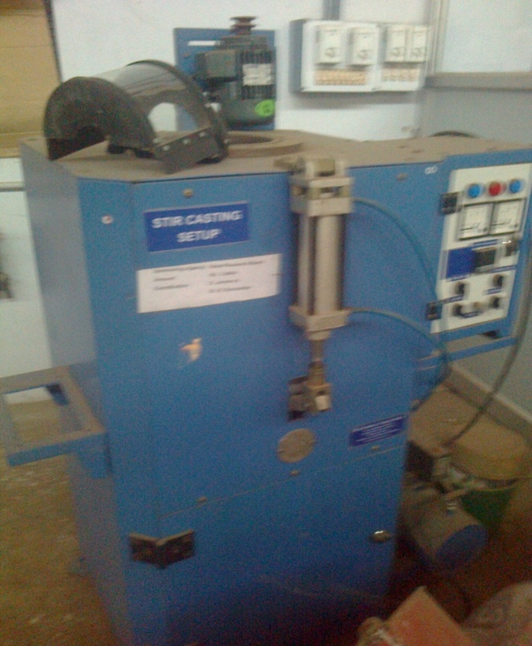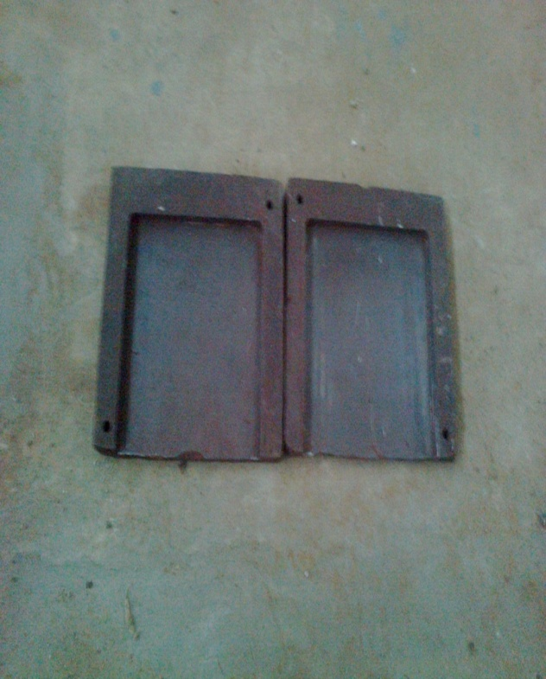  
**Figure: 2: Stir Casting Furnace and Die**

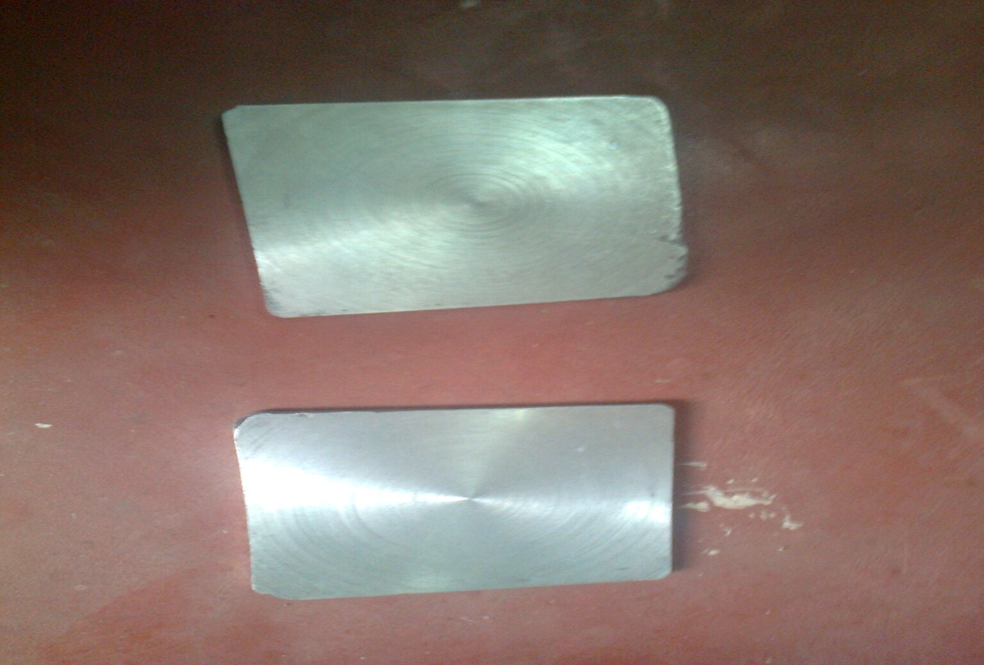

**Figure 3: Al-10%SiCp Composite Material**

* 1. **EDM MACHINE**

With Electronica 5030 Die Sinking EDM machine experiments were conducted as shown in Figure 4. The dielectric fluid and electrode flushing method was utilized. The design of experimental conditions for EDM is depicted in Table 3.

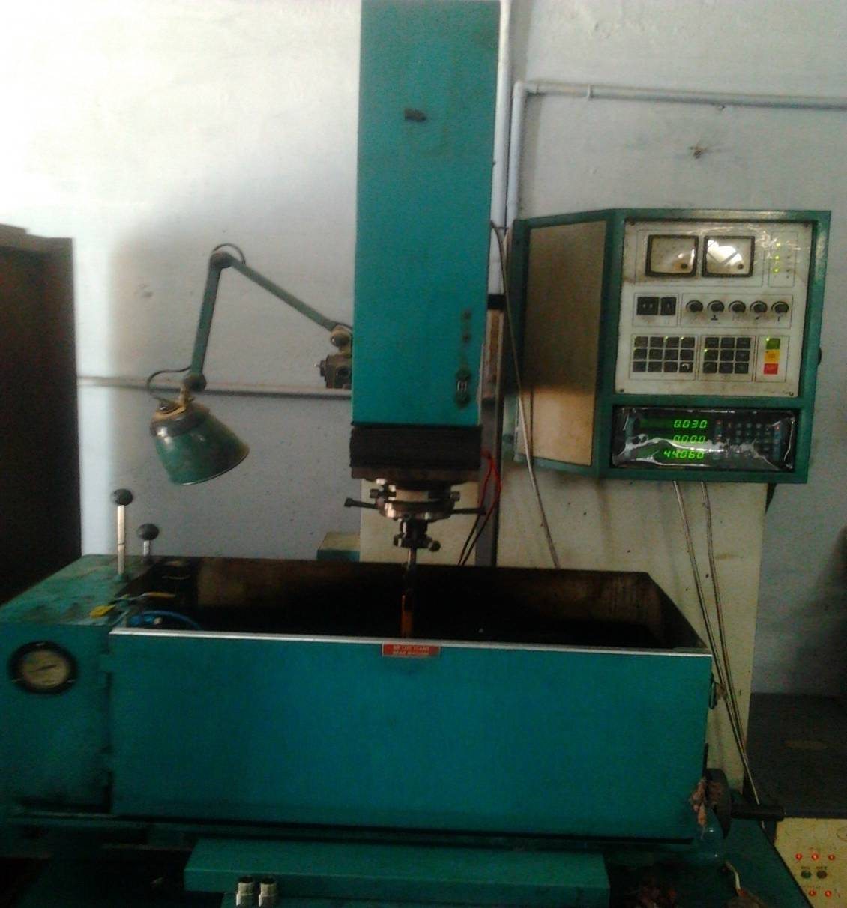

**Figure 4: Electronica 5030 Die Sinking EDM Machine**

**Table 3:** **EDM Machining Conditions**

|  |  |
| --- | --- |
| **Conditions** | **Descriptions** |
| Machine | Electronica 5030 die sinking EDM machine |
| Test Specimen | Composite Material (Mg .45%, Si 7.5%, Cu -.2, Mn.1, Fe .2, Zn .1, Ti .2, SiC 10%) |
| Tool | Copper Electrode of Diameter 10mm |
| Tool Polarity | Positive |
| Dielectric Fluid | EDM Oil (DEF-92) |
| Flushing Type | External |
| Depth of Cut (mm) | 1 |
| Electrode Polarity | Positive |
| Dielectric Flushing | Injection Flushing |
| Weight Measuring Instrument | Digital Balance (FX-3000) |
| SR Measuring Instrument | Portable SR Tester SJ201 |
| **Technical Data** | **Co-Ordinate Table** |
| Supply Voltage : 415V, 3Ph.,50Hz | Mounting Surface (l*b) : 500*300mm |
| Taps : 380V, 415V, 440V | Maximum Workpiece Height : 175mm |
| Power Factor : 0.8 Approx | Maximum Workpiece Weight : 175kg |
| Height : 2075mm | Longitudinal Travel (X-axis) : 280mm |
| Width : 1230mm  Depth : 1035mm | Transverse Travel (Y-axis) : 200mm |
| Net Weight : 800Kg (Approx.) | L.C of Hand Wheel Graduations with Vernier Scale : 0.005mm |
| Width of Work Tank – Internal : 725mm |
| Depth of Work Tank – Internal : 415mm |
| Height of Work Tank : 315mm |
| **Working Parameters** | |
| Machining Current Max.: 35 Amps | Pulse Current : 2Amps |
| Open Gap O/V : 140 ± 5% | Current Range Selection : 10 Selection |
|  | 1 = 1Amp  2 = 2Amps   * 1. = 4Amps |
| Pulse Current : 2 Selection | Pulse On Duration : 2 to 1000μs |
| 1 = 1Amp  1 = 1 Amp |  |
| Weight : 250 Kg. (Approx.) |  |

1. **EXPERIMENTAL PROCEDURE**

The machining system is acted in ELECTRONICA EMS5030 as shown in Figure 5; the work piece is mounted on the V-block which is situated on the machine with attractive table. The apparatus holder holds the device and dial measure has been utilized to test its arrangement. 54 runs were chosen involving various parameter mixes in view of Analysis of Variance.

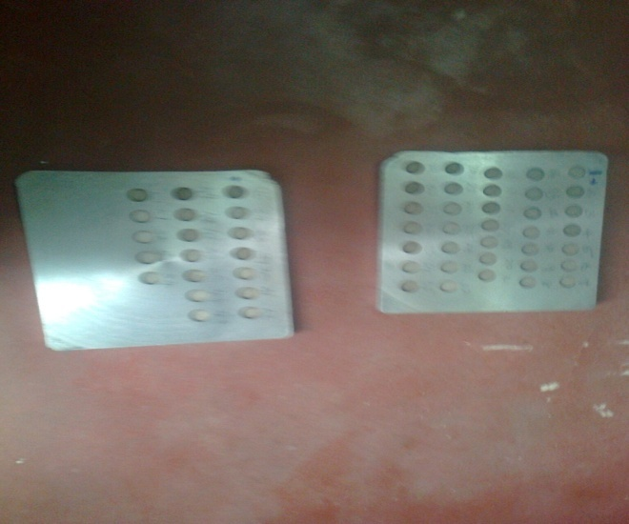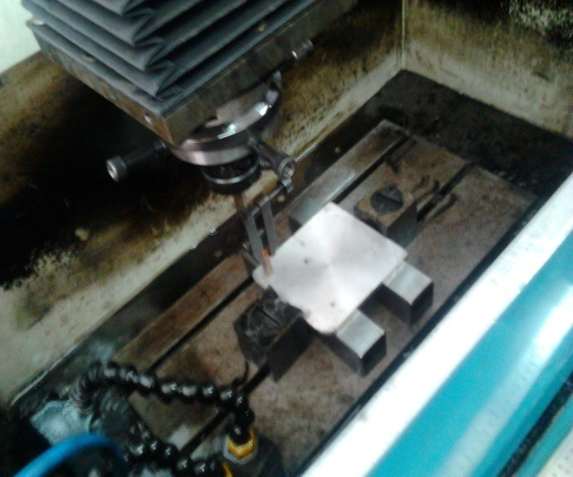

**Figure 5: Electronica 5030 Die Sinking EDM Machining Process Underway**

1. **MEASUREMENT PROCEDURE**

Portable Roughness Tester SJ201 has been used to quantify roughness which is displayed in Figure 6. It is a portable, independent instrument for the estimation of surface texture. The parameters are performed on premise of chip. LCD screen shows the estimation and divert the result by means of an optical printer or one more PC for assistant assessment. Non-battery-powered soluble battery supplies power. It is likewise outfitted with a Jewel pointer having a tip span 5μm. From outrageous outer position the estimating stroke begins generally.

During the remainder of the estimation the pickup gets back to the position ready for the following estimation. The assortment of removed length decides the traverse length. Constantly of course, the traverse length is multiple times the cut-off length however the amplification element can be adjusted. The profile meter is set to a cut-off length of 0.8mm, channel 2CR and traverse speed 1mm/sec and 4mm traverse length. Roughness measurements, in the traverse bearing, on the work pieces have been repeating multiple times and normal of four measurements of SR parameter values bas been recorded.

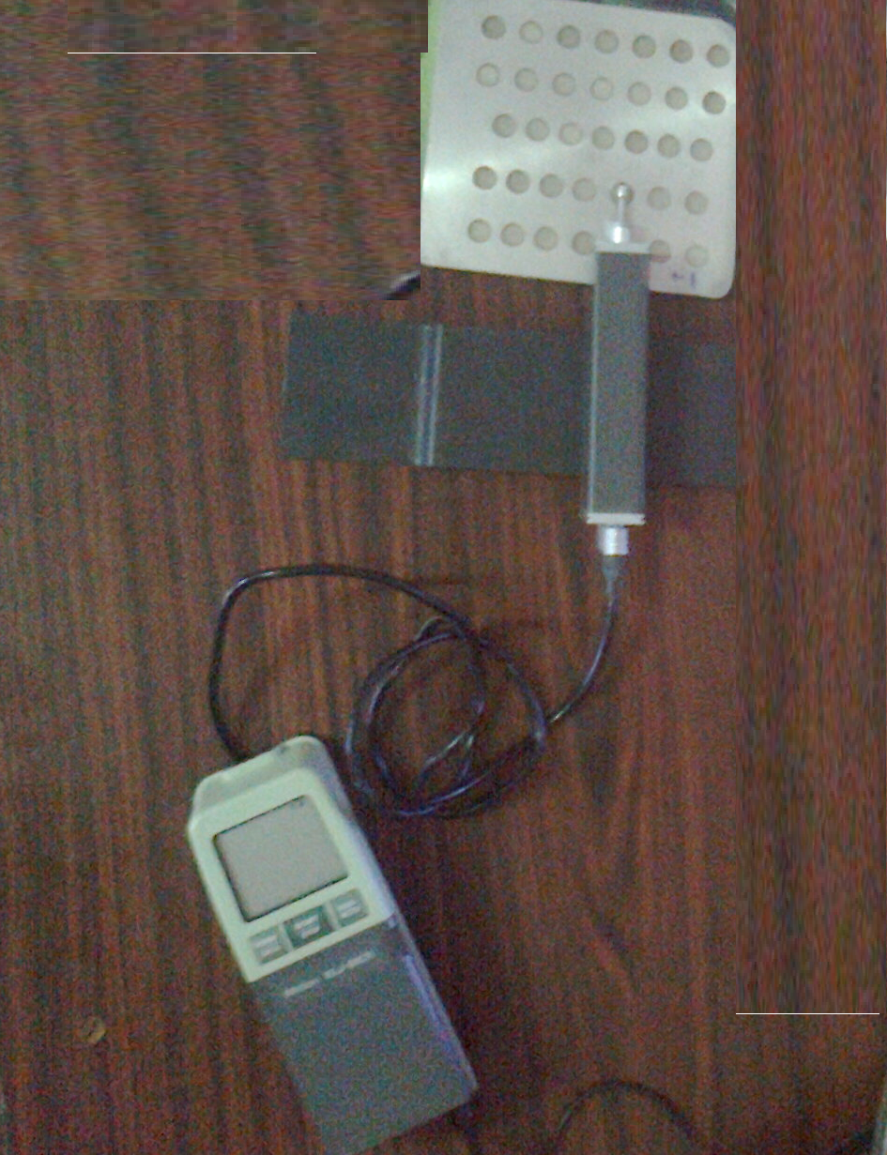

**Figure 6: Experimental Setup for Measuring Roughness**

1. **EXPERIMENTAL SET-UP**

Under different machining conditions the tests were directed utilizing Electronica 5030 Die Sinking EDM machine, which is 3HP/2.2KW power. By setting the machine and state of the outer layer of work piece the info boundary was gotten. With typical above depicted methodology the tests were performed. On determining levels for each process boundary as given in the Table 4, the boundary levels were liked within the stretches proposed by machining apparatus producer and examination of the current review. From the 54 tests two three levels with six process parameters associated with machining operation.SR tester SJ201 is used resulting to each test, to gauge the work piece to decide the SR. The perceptions are portrayed in the Table 5 for helper examination and studies. In light of the states of plan grid, the machining activities were performed aimlessly to make error free measurement.

**Table 4: Different Variables Used in the Experiment and Their Levels**

|  |  |  |  |  |
| --- | --- | --- | --- | --- |
| **Variable** | **Coding** | **Level** | | |
| **1** | **2** | **3** |
| Discharge Voltage (V) in V | A | 60 | 65 | 70 |
| Discharge Current in A | B | 5 | 10 | 15 |
| Pulse on time (Ton)in s | C | 15 | 30 | 45 |
| Pulse off Time (Toff) in s | D | 5 | 7 | 9 |
| Spark gap (G) in mm | E | 0.1 | 0.2 | 0.3 |
| Oil Pressure in kg/cm2 | F | 1 | 1.5 | 3 |

In the next step, the planning to accomplish the experiments by means of RSM using a Box Behnken approach with six variables. Total numbers of experiments conducted with the combination of machining parameter and the corresponding recorderd SR are presented in Table 5.

**Table 5: Planning Matrix of the Experiments with the Optimal Model Data**

|  |  |  |  |  |  |  |
| --- | --- | --- | --- | --- | --- | --- |
| **Sl. No.** | **A**  **Voltage**  **(V)** | **B**  **Current**  **(A)** | **C**  **Pulse on Time**  **(sec)** | **D**  **Pulse off Time**  **(sec)** | **E**  **Gap Width (mm)** | **F**  **Oil Pressure**  **(Kg/cm²)** |
| **1.** | 65 | 5 | 15 | 7 | 0.3 | 1.5 |
| **2.** | 75 | 10 | 45 | 7 | 0.2 | 2.0 |
| **3.** | 75 | 10 | 30 | 9 | 0.1 | 1.5 |
| **4.** | 65 | 15 | 45 | 7 | 0.3 | 1.5 |
| **5.** | 75 | 15 | 30 | 5 | 0.2 | 1.5 |
| **6.** | 75 | 5 | 30 | 5 | 0.2 | 1.5 |
| **7.** | 65 | 10 | 15 | 9 | 0.2 | 1.0 |
| **8.** | 75 | 15 | 30 | 9 | 0.2 | 1.5 |
| **9.** | 75 | 10 | 45 | 7 | 0.2 | 1.0 |
| **10.** | 65 | 5 | 45 | 7 | 0.3 | 1.5 |
| **11.** | 60 | 10 | 30 | 9 | 0.1 | 1.5 |
| **12.** | 60 | 5 | 30 | 5 | 0.2 | 1.5 |
| **13.** | 60 | 10 | 30 | 5 | 0.3 | 1.5 |
| **14.** | 60 | 10 | 30 | 9 | 0.3 | 1.5 |
| **15.** | 65 | 5 | 30 | 7 | 0.1 | 1.0 |
| **16.** | 65 | 10 | 30 | 7 | 0.2 | 1.5 |
| **17.** | 60 | 10 | 45 | 7 | 0.2 | 2.0 |
| **18.** | 65 | 5 | 30 | 7 | 0.3 | 2.0 |
| **19.** | 65 | 10 | 15 | 5 | 0.2 | 2.0 |
| **20.** | 60 | 5 | 30 | 9 | 0.2 | 1.5 |
| **21.** | 75 | 10 | 30 | 5 | 0.1 | 1.5 |
| **22.** | 65 | 15 | 15 | 7 | 0.1 | 1.5 |
| **23.** | 75 | 5 | 30 | 9 | 0.2 | 1.5 |
| **24.** | 75 | 10 | 30 | 5 | 0.3 | 1.5 |
| **25.** | 75 | 10 | 15 | 7 | 0.2 | 2.0 |
| **26.** | 65 | 10 | 15 | 9 | 0.2 | 2.0 |
| **27.** | 65 | 5 | 30 | 7 | 0.1 | 2.0 |
| **28.** | 65 | 10 | 45 | 5 | 0.2 | 2.0 |
| **29.** | 65 | 5 | 30 | 7 | 0.3 | 1.0 |
| **30.** | 65 | 15 | 30 | 7 | 0.1 | 1.0 |
| **31.** | 65 | 15 | 30 | 7 | 0.3 | 2.0 |
| **32.** | 65 | 10 | 30 | 7 | 0.2 | 1.5 |
| **33.** | 65 | 10 | 45 | 9 | 0.2 | 1.0 |
| **34.** | 60 | 10 | 15 | 7 | 0.2 | 1.0 |
| **35.** | 65 | 10 | 45 | 9 | 0.2 | 2.0 |
| **36.** | 65 | 10 | 45 | 5 | 0.2 | 1.0 |
| **37.** | 65 | 5 | 15 | 7 | 0.1 | 1.5 |
| **38.** | 75 | 10 | 15 | 7 | 0.2 | 1.0 |
| **39.** | 65 | 15 | 30 | 7 | 0.1 | 2.0 |
| **40.** | 65 | 15 | 15 | 7 | 0.3 | 1.5 |
| **41.** | 65 | 10 | 30 | 7 | 0.2 | 1.5 |
| **42.** | 75 | 10 | 30 | 9 | 0.3 | 1.5 |
| **43.** | 65 | 10 | 30 | 7 | 0.2 | 1.5 |
| **44.** | 65 | 10 | 30 | 7 | 0.2 | 1.5 |
| **45.** | 65 | 15 | 45 | 7 | 0.1 | 1.5 |
| **46.** | 60 | 15 | 30 | 5 | 0.2 | 1.5 |
| **47.** | 60 | 10 | 45 | 7 | 0.2 | 1.0 |
| **48.** | 65 | 15 | 30 | 7 | 0.3 | 1.0 |
| **49.** | 60 | 15 | 30 | 9 | 0.2 | 1.5 |
| **50.** | 65 | 10 | 30 | 7 | 0.2 | 1.5 |
| **51.** | 65 | 10 | 15 | 5 | 0.2 | 1.0 |
| **52.** | 60 | 10 | 15 | 7 | 0.2 | 2.0 |
| **53.** | 65 | 5 | 45 | 7 | 0.1 | 1.5 |
| **54.** | 60 | 10 | 30 | 5 | 0.1 | 1.5 |

**Table 6: Process Variables and Their Corresponding Responses**

|  |  |  |  |  |  |  |  |  |
| --- | --- | --- | --- | --- | --- | --- | --- | --- |
| **Sl. No.** | **A**  **Voltage (V)** | **B**  **Current (A)** | **C**  **Pulse ON (sec)** | **D**  **Pulse OFF**  **(sec)** | **E**  **Gap**  **(mm)** | **F**  **Oil Pressure (Kg/cm²)** | **G**  **MRR (Mg/sec)** | **H**  **SR (µm)** |
| **1.** | 65 | 5 | 15 | 7 | 0.3 | 1.5 | 1.435 | 3.01 |
| **2.** | 75 | 10 | 45 | 7 | 0.2 | 2.0 | 5.800 | 6.09 |
| **3.** | 75 | 10 | 30 | 9 | 0.1 | 1.5 | 4.952 | 5.82 |
| **4.** | 65 | 15 | 45 | 7 | 0.3 | 1.5 | 8.823 | 6.86 |
| **5.** | 75 | 15 | 30 | 5 | 0.2 | 1.5 | 7.880 | 5.88 |
| **6.** | 75 | 5 | 30 | 5 | 0.2 | 1.5 | 2.083 | 4.43 |
| **7.** | 65 | 10 | 15 | 9 | 0.2 | 1.0 | 3.355 | 4.32 |
| **8.** | 75 | 15 | 30 | 9 | 0.2 | 1.5 | 7.960 | 5.22 |
| **9.** | 75 | 10 | 45 | 7 | 0.2 | 1.0 | 6.444 | 6.27 |
| **10.** | 65 | 5 | 45 | 7 | 0.3 | 1.5 | 2.653 | 6.16 |
| **11.** | 60 | 10 | 30 | 9 | 0.1 | 1.5 | 5.205 | 6.20 |
| **12.** | 60 | 5 | 30 | 5 | 0.2 | 1.5 | 1.990 | 4.41 |
| **13.** | 60 | 10 | 30 | 5 | 0.3 | 1.5 | 4.613 | 5.77 |
| **14.** | 60 | 10 | 30 | 9 | 0.3 | 1.5 | 4.511 | 6.41 |
| **15.** | 65 | 5 | 30 | 7 | 0.1 | 1.0 | 2.182 | 5.69 |
| **16.** | 65 | 10 | 30 | 7 | 0.2 | 1.5 | 4.951 | 5.39 |
| **17.** | 60 | 10 | 45 | 7 | 0.2 | 2.0 | 6.059 | 6.36 |
| **18.** | 65 | 5 | 30 | 7 | 0.3 | 2.0 | 2.136 | 4.35 |
| **19.** | 65 | 10 | 15 | 5 | 0.2 | 2.0 | 3.383 | 4.86 |
| **20.** | 60 | 5 | 30 | 9 | 0.2 | 1.5 | 2.206 | 4.91 |
| **21.** | 75 | 10 | 30 | 5 | 0.1 | 1.5 | 5.272 | 5.79 |
| **22.** | 65 | 15 | 15 | 7 | 0.1 | 1.5 | 5.342 | 3.12 |
| **23.** | 75 | 5 | 30 | 9 | 0.2 | 1.5 | 2.280 | 4.87 |
| **24.** | 75 | 10 | 30 | 5 | 0.3 | 1.5 | 4.951 | 6.17 |
| **25.** | 75 | 10 | 15 | 7 | 0.2 | 2.0 | 3.500 | 5.18 |
| **26.** | 65 | 10 | 15 | 9 | 0.2 | 2.0 | 3.248 | 5.14 |
| **27.** | 65 | 5 | 30 | 7 | 0.1 | 2.0 | 1.411 | 5.09 |
| **28.** | 65 | 10 | 45 | 5 | 0.2 | 2.0 | 5.544 | 7.44 |
| **29.** | 65 | 5 | 30 | 7 | 0.3 | 1.0 | 1.906 | 4.30 |
| **30.** | 65 | 15 | 30 | 7 | 0.1 | 1.0 | 7.381 | 6.39 |
| **31.** | 65 | 15 | 30 | 7 | 0.3 | 2.0 | 7.518 | 6.33 |
| **32.** | 65 | 10 | 30 | 7 | 0.2 | 1.5 | 5.272 | 5.10 |
| **33.** | 65 | 10 | 45 | 9 | 0.2 | 1.0 | 6.643 | 5.60 |
| **34.** | 60 | 10 | 15 | 7 | 0.2 | 1.0 | 3.383 | 3.74 |
| **35.** | 65 | 10 | 45 | 9 | 0.2 | 2.0 | 6.343 | 5.60 |
| **36.** | 65 | 10 | 45 | 5 | 0.2 | 1.0 | 6.766 | 8.19 |
| **37.** | 65 | 5 | 15 | 7 | 0.1 | 1.5 | 1.684 | 4.20 |
| **38.** | 75 | 10 | 15 | 7 | 0.2 | 1.0 | 2.859 | 5.31 |
| **39.** | 65 | 15 | 30 | 7 | 0.1 | 2.0 | 6.655 | 8.12 |
| **40.** | 65 | 15 | 15 | 7 | 0.3 | 1.5 | 3.866 | 4.01 |
| **41.** | 65 | 10 | 30 | 7 | 0.2 | 1.5 | 4.613 | 6.82 |
| **42.** | 75 | 10 | 30 | 9 | 0.3 | 1.5 | 4.142 | 7.08 |
| **43.** | 65 | 10 | 30 | 7 | 0.2 | 1.5 | 4.511 | 6.49 |
| **44.** | 65 | 10 | 30 | 7 | 0.2 | 1.5 | 4.720 | 6.51 |
| **45.** | 65 | 15 | 45 | 7 | 0.1 | 1.5 | 9.441 | 7.77 |
| **46.** | 60 | 15 | 30 | 5 | 0.2 | 1.5 | 6.766 | 7.70 |
| **47.** | 60 | 10 | 45 | 7 | 0.2 | 1.0 | 5.486 | 7.98 |
| **48.** | 65 | 15 | 30 | 7 | 0.3 | 1.0 | 5.205 | 8.02 |
| **49.** | 60 | 15 | 30 | 9 | 0.2 | 1.5 | 6.444 | 7.31 |
| **50.** | 65 | 10 | 30 | 7 | 0.2 | 1.5 | 3.941 | 5.01 |
| **51.** | 65 | 10 | 15 | 5 | 0.2 | 1.0 | 2.743 | 4.91 |
| **52.** | 60 | 10 | 15 | 7 | 0.2 | 2.0 | 2.985 | 4.97 |
| **53.** | 65 | 5 | 45 | 7 | 0.1 | 1.5 | 2.040 | 5.28 |
| **54.** | 60 | 10 | 30 | 5 | 0.1 | 1.5 | 4.776 | 6.54 |

* 1. **Equation for MRR**

MRR = 1.6059+0.0852A-0.2872B-0.0740C-0.1632D-4.1745E-0.9694F - 0.0008A2-0.0071B2-0.00C2+0.05D2-7.6986E2-0.4526F2+0.0084AB+0.0006AC-0.0056AD -0.0663AE-0.0045AF+0.0125BC-0.0082BD-0.5275BE+0.1064BF +0.0008CD +0.1433CE -0.0197CF -0.6375DE + 0.0219DF+10.1EF

* 1. **Equation for SR**

SR = 4.4805-0.1893A+1.2479B+0.6101C-0.4769D-41.5598E-3.2685F + 0.0021A2-0.0163B2-0.0023C2+0.0165D2+22.4167E2 + 1.3300F2 - 0.0116AB - 0.0043AC +0.0060AD+0.4410AE-0.0007AF+0.0038BC-0.0249BD + 0.1575BE+0.0295BF-0.0172CD+0.1058CE-0.0368CF+1.1625DE + 0.2025DF-6.9250EF

A - Working Voltage

B - Working Current

C - Pulse ON Time

D - Pulse OFF Time

E - Spark Gap

F - Oil Pressure

These relations are gotten by utilizing Minitab software. Every one of the exploratory qualities and the anticipated info values are taken for the examination for tracking down streamlined inputs. The above said condition are utilized to examined all the information's in MINITAB software and the streamlined qualities for surface roughness and material removal rates are in the table.

**Table 7: Result Obtained in Response Surface Methodology**

|  |  |  |  |  |  |  |
| --- | --- | --- | --- | --- | --- | --- |
| **Sl. No.** | **MRR (Mg/sec)** | **SR (µm)** | **Predicted MRR (Mg/sec)** | **Error MRR (Mg/sec)** | **Predicted SR (µm)** | **Error SR (µm)** |
| **1.** | 1.435 | 3.01 | 1.344776 | -0.09022 | 3.087113 | 0.077113 |
| **2.** | 5.8 | 6.09 | 6.061756 | 0.261756 | 5.813608 | -0.27639 |
| **3.** | 4.952 | 5.82 | 5.251514 | 0.299514 | 5.541237 | -0.27876 |
| **4.** | 8.823 | 6.86 | 8.973476 | 0.150476 | 7.680313 | 0.820313 |
| **5.** | 7.88 | 5.88 | 7.859906 | -0.02009 | 6.124508 | 0.244508 |
| **6.** | 2.083 | 4.43 | 1.970906 | -0.11209 | 4.953008 | 0.523008 |
| **7.** | 3.355 | 4.32 | 3.160856 | -0.19414 | 4.599508 | 0.279508 |
| **8.** | 7.96 | 5.22 | 7.552506 | -0.40749 | 5.527908 | 0.307908 |
| **9.** | 6.444 | 6.27 | 6.375656 | -0.06834 | 6.473108 | 0.203108 |
| **10.** | 2.653 | 6.16 | 2.740976 | 0.087976 | 5.119313 | -1.04069 |
| **11.** | 5.205 | 6.2 | 5.020214 | -0.18479 | 6.347487 | 0.147487 |
| **12.** | 1.99 | 4.41 | 2.133056 | 0.143056 | 4.587758 | 0.177758 |
| **13.** | 4.613 | 5.77 | 4.523526 | -0.08947 | 6.079263 | 0.309263 |
| **14.** | 4.511 | 6.41 | 4.461126 | -0.04987 | 6.085663 | -0.32434 |
| **15.** | 2.182 | 5.69 | 2.530314 | 0.348314 | 5.174287 | -0.51571 |
| **16.** | 4.951 | 5.39 | 4.661306 | -0.28969 | 5.942458 | 0.552458 |
| **17.** | 6.059 | 6.36 | 5.660656 | -0.39834 | 7.111108 | 0.751108 |
| **18.** | 2.136 | 4.35 | 2.182026 | 0.046026 | 4.482963 | 0.132963 |
| **19.** | 3.383 | 4.86 | 3.450356 | 0.067356 | 4.357608 | -0.50239 |
| **20.** | 2.206 | 4.91 | 2.489656 | 0.283656 | 4.627158 | -0.28284 |
| **21.** | 5.272 | 5.79 | 5.139914 | -0.13209 | 6.104837 | 0.314837 |
| **22.** | 5.342 | 4.12 | 5.155064 | -0.18694 | 4.953837 | 0.833837 |
| **23.** | 2.28 | 4.87 | 1.991506 | -0.28849 | 5.352408 | 0.482408 |
| **24.** | 4.951 | 6.17 | 4.891926 | -0.05907 | 6.236013 | 0.066013 |
| **25.** | 3.5 | 5.18 | 3.335956 | -0.16404 | 5.370808 | 0.190808 |
| **26.** | 3.248 | 5.14 | 3.526756 | 0.278756 | 5.456008 | 0.316008 |
| **27.** | 1.411 | 5.09 | 1.014914 | -0.39609 | 5.618787 | 0.528787 |
| **28.** | 5.544 | 7.44 | 5.948156 | 0.404156 | 7.122408 | -0.31759 |
| **29.** | 1.906 | 4.3 | 1.677426 | -0.22857 | 5.423463 | 1.123463 |
| **30.** | 7.381 | 6.39 | 7.410814 | 0.029814 | 6.702787 | 0.312787 |
| **31.** | 7.518 | 6.33 | 7.071526 | -0.44647 | 6.621463 | 0.291463 |
| **32.** | 5.272 | 5.1 | 4.661306 | -0.61069 | 5.942458 | 0.842458 |
| **33.** | 6.643 | 5.6 | 6.345656 | -0.29734 | 6.404308 | 0.804308 |
| **34.** | 3.383 | 3.74 | 2.860256 | -0.52274 | 4.278308 | 0.538308 |
| **35.** | 6.343 | 5.6 | 6.120556 | -0.22244 | 6.156808 | 0.556808 |
| **36.** | 6.766 | 8.19 | 6.260856 | -0.50514 | 8.179908 | -0.01009 |
| **37.** | 1.684 | 4.2 | 1.617564 | -0.06644 | 3.847837 | -0.35216 |
| **38.** | 2.859 | 5.31 | 3.058856 | 0.199856 | 4.926308 | -0.38369 |
| **39.** | 6.655 | 8.12 | 6.959414 | 0.304414 | 7.442287 | -0.67771 |
| **40.** | 3.866 | 4.01 | 3.827276 | -0.03872 | 4.508113 | 0.498113 |
| **41.** | 4.613 | 6.82 | 4.661306 | 0.048306 | 5.942458 | -0.87754 |
| **42.** | 4.142 | 7.08 | 4.493526 | 0.351526 | 6.602413 | -0.47759 |
| **43.** | 4.511 | 6.49 | 4.661306 | 0.150306 | 5.942458 | -0.54754 |
| **44.** | 4.72 | 6.51 | 4.661306 | -0.05869 | 5.942458 | -0.56754 |
| **45.** | 9.441 | 7.77 | 9.441464 | 0.000464 | 7.491237 | -0.27876 |
| **46.** | 6.766 | 7.7 | 6.762056 | -0.00394 | 7.499258 | -0.20074 |
| **47.** | 5.486 | 7.98 | 5.907056 | 0.421056 | 7.760108 | -0.21989 |
| **48.** | 5.205 | 8.02 | 5.502926 | 0.297926 | 7.266963 | -0.75304 |
| **49.** | 6.444 | 7.31 | 6.790656 | 0.346656 | 6.542658 | -0.76734 |
| **50.** | 3.941 | 5.01 | 4.661306 | 0.720306 | 5.942458 | 0.932458 |
| **51.** | 2.743 | 4.91 | 3.172056 | 0.429056 | 4.311108 | -0.59889 |
| **52.** | 2.985 | 4.97 | 3.204856 | 0.219856 | 4.733308 | -0.23669 |
| **53.** | 2.04 | 5.28 | 2.153964 | 0.113964 | 5.245237 | -0.03476 |
| **54.** | 4.776 | 6.54 | 4.572614 | -0.20339 | 7.271087 | 0.731087 |

1. **GREY RELATIONAL ANALYSIS**
   1. **INTRODUCTION TO GRA**

To examine the suitable choice of machining parameters for Electrical Discharge Machining (EDM) process, Gray Relational Analysis (GRA) are applied. Arrangement of a framework given by Gray theory is that the model is uncertain or the information is incomplete. Plus, it shows a proficient answer for the uncertainty, multi-input and discrete data issue. According to the Taguchi quality plan idea, a L32 mixed-orthogonal-array table was liked for the investigations. With both GRA and statistical strategy, it is seen that the table-feed rate has a noticeable impact on the machining speed, while the gap width and heartbeat on time impacts the SR. Moreover, by setting the maximum machining speed and minimum SR, optimal machining parameters (or a desired SR) can be acquired.

In the past area the relationship between various factors referenced is unclear. Those are called "gray", inferring poor, inadequate and uncertain information. Without large data sets their analysis by standard statistical technique may not be acceptable or reliable. In this work, to renovate the multi-reaction optimization model into a solitary reaction gray relational grade, GRA has been used. Grades are utilized to concentrate about multi-reaction characteristics, as an alternative of utilizing experimental values straightforwardly in numerous relapse model and GA.

* 1. **STEPS IN GRA**

The below mentioned steps to be followed while applying grey relational analysis to find the Grey relational coefficients and the grey relational grade:

1. Normalizing the experimental results of MRR and surface roughness to avoid the effect of adopting different units to reduce the variability.

Zij= $\frac{yij-min⁡(yij, i=1,2,……..n)}{ \max\left(yij, i=1,2…….n\right)-min⁡(yij, i=1,2…….n)}$**(1)**

Zij= $\frac{\max\left(yij, i=1,2……n\right)-yij}{\max\left(yij, i=1,2…….n\right)-min⁡(yij, i=1,2…….n)}$**(2)**

1. Performing the grey relational generating and calculating the grey coefficient for the normalized values yield.

γ(y0(k),yi(k))= $\frac{∆min+ξ∆max}{∆oj\left(k\right)+ξ∆max}$**(3)**

Where,

* j=1, 2...n; k=1, 2...m, n is the number of experimental data items and m is the number of responses.
* y0(k) is the reference sequence (yo(k)=1, k=1, 2...m); yj(k) is the specific comparison sequence.
* Δoj=║yo(k)-yj(k)║= The absolute value of the difference between y0(k) and yj(k).
* Δmin=minmin║yo(k)-yj(k)║ is the smallest value of yj(k).
* Δmax=maxmax║yo(k)-yj(k)║is the largest value of yj(k).
* ζ is the distinguishing coefficient which is defined in the range 0 ≤ ζ≤ 1 (the value may adjusted based on the practical needs of the system).

1. Calculating the grey relational grade by averaging thegrey relational coefficient yields:

γj= $\frac{1}{k}$ ∑ γij **(4)**

Where γj is the grey relational grade for the jth experiment and k is the number of Performance characteristics. To normalize the experimental value, Equation (1) is used, when the target of the original value is with the characteristic of ‘higher the better’. Here MRR is standardized using the above equation. When the ‘lower the better’ is a characteristic of the original sequence, then the original sequence is normalized using Eqn. (2), i.e., surface roughness is normalized using this equation. Using Eqn. (3), we calculate the grey relational coefficient for MRR and SR as Shown in Table 2. Also the grey relational grade is computed as per Eqn. (4)

**Table 8:** **Grey Relational Grade**

|  |  |  |  |  |  |
| --- | --- | --- | --- | --- | --- |
| **Sl. No.** | **Normalized**  **Values for**  **MRR** | **Normalized**  **Values for**  **SR** | **GRC Values for**  **MRR** | **GRC**  **Values for SR** | **Grade** |
| **1.** | 0 | 1 | 0.333 | 0.4169 | 0.6665 |
| **2.** | 0.5452 | 0.405 | 0.523 | 0.4393 | 0.4699 |
| **3.** | 0.4394 | 0.457 | 0.4714 | 0.3641 | 0.4553 |
| **4.** | 0.923 | 0.257 | 0.8665 | 0.4344 | 0.6153 |
| **5.** | 0.805 | 0.446 | 0.7194 | 0.6100 | 0.5769 |
| **6.** | 0.08 | 0.728 | 0.3521 | 0.6234 | 0.4810 |
| **7.** | 0.239 | 0.747 | 0.3965 | 0.4991 | 0.5099 |
| **8.** | 0.815 | 0.573 | 0.7299 | 0.4035 | 0.6145 |
| **9.** | 0.625 | 0.371 | 0.5714 | 0.4117 | 0.4874 |
| **10.** | 0.152 | 0.392 | 0.3709 | 0.4085 | 0.3973 |
| **11.** | 0.470 | 0.384 | 0.4854 | 0.6109 | 0.4469 |
| **12.** | 0.069 | 0.729 | 0.3494 | 0.4439 | 0.4801 |
| **13.** | 0.396 | 0.461 | 0.4528 | 0.3891 | 0.4483 |
| **14.** | 0.384 | 0.332 | 0.4480 | 0.4514 | 0.4185 |
| **15.** | 0.093 | 0.483 | 0.3553 | 0.4805 | 0.4033 |
| **16.** | 0.439 | 0.540 | 0.4712 | 0.4838 | 0.4758 |
| **17.** | 0.652 | 0.546 | 0.5896 | 0.6216 | 0.4367 |
| **18.** | 0.087 | 0.741 | 0.3538 | 0.5438 | 0.4477 |
| **19.** | 0.243 | 0.643 | 0.3977 | 0.4939 | 0.4707 |
| **20.** | 0.096 | 0.564 | 0.3561 | 0.4221 | 0.4250 |
| **21.** | 0.479 | 0.463 | 0.4897 | 0.6654 | 0.4659 |
| **22.** | 0.488 | 0.786 | 0.4940 | 0.5424 | 0.5797 |
| **23.** | 0.105 | 0.641 | 0.3584 | 0.4105 | 0.5404 |
| **24.** | 0.439 | 0.389 | 0.4712 | 0.5038 | 0.4408 |
| **25.** | 0.257 | 0.581 | 0.4022 | 0.5087 | 0.4530 |
| **26.** | 0.226 | 0.589 | 0.3924 | 0.5142 | 0.4505 |
| **27.** | 0.089 | 0.598 | 0.3543 | 0.3323 | 0.4343 |
| **28.** | 0.4173 | 0.145 | 0.4618 | 0.6308 | 0.3970 |
| **29.** | 0.058 | 0.751 | 0.3467 | 0.3945 | 0.4887 |
| **30.** | 0.7426 | 0.347 | 0.6601 | 0.3989 | 0.5273 |
| **31.** | 0.759 | 0.359 | 0.6747 | 0.5129 | 0.5365 |
| **32.** | 0.479 | 0.596 | 0.4897 | 0.4597 | 0.5013 |
| **33.** | 0.65 | 0.5 | 0.5882 | 0.7511 | 0.5239 |
| **34.** | 0.243 | 0.859 | 0.3977 | 0.5497 | 0.5744 |
| **35.** | 0.613 | 0.5 | 0.5636 | 0.2985 | 0.5116 |
| **36.** | 0.665 | 0 | 0.5988 | 0.6491 | 0.4486 |
| **37.** | 0.311 | 0.77 | 0.3403 | 0.4894 | 0.4947 |
| **38.** | 0.177 | 0.556 | 0.3779 | 0.3012 | 0.4346 |
| **39.** | 0.652 | 0.013 | 0.5896 | 0.6879 | 0.4454 |
| **40.** | 0.303 | 0.807 | 0.4177 | 0.3663 | 0.5528 |
| **41.** | 0.396 | 0.264 | 0.4528 | 0.3512 | 0.4095 |
| **42.** | 0.3381 | 0.214 | 0.4303 | 0.6332 | 0.3857 |
| **43.** | 0.3842 | 0.328 | 0.4481 | 0.3863 | 0.5406 |
| **44.** | 0.4103 | 0.324 | 0.4588 | 0.3165 | 0.4225 |
| **45.** | 1 | 0.081 | 1 | 0.3196 | 0.6582 |
| **46.** | 0.665 | 0.094 | 0.5988 | 0.3071 | 0.4592 |
| **47.** | 0.505 | 0.040 | 0.5025 | 0.3056 | 0.4048 |
| **48.** | 0.470 | 0.033 | 0.4854 | 0.3338 | 0.3955 |
| **49.** | 0.625 | 0.151 | 0.5714 | 0.5243 | 0.4526 |
| **50.** | 0.313 | 0.614 | 0.4212 | 0.5369 | 0.4727 |
| **51.** | 0.163 | 0.633 | 0.3739 | 0.5245 | 0.4554 |
| **52.** | 0.193 | 0.622 | 0.3825 | 0.4928 | 0.4560 |
| **53.** | 0.075 | 0.562 | 0.3508 | 0.3842 | 0.4212 |
| **54.** | 0.4173 | 0.318 | 0.4618 | 0.3841 | 0.4230 |

1. **ARTIFICIAL NEURAL NETWORKS ARCHITECTURE**

For the most part ANN comprises of various layers: the layer where the info designs are applied is known as the info layer, the layer where the result is gotten is the result layer, and the layers between the info and result layers are the secret layers are displayed in Figure 7. One or more secret layers are available, which are so named on the grounds that their results are not straightforwardly detectable. At the point when the size of the info layer is huge, the expansion of stowed away layers makes conceivable the network to remove higher-order insights which are dominatingly important. Fully or partially interconnected Neurons layers are continuing and ensuing layer of neurons with every interconnection having a related association strength (or weight). In a forward course, the information signal engenders through the network, on a layer-by-layer premise which are regularly alluded to as Multilayer Perceptrons (MLP). Numerous distributions examine the turn of events and theory of ANN.

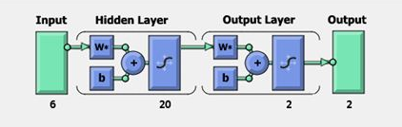

**Figure 7: General configuration of Artificial Neural Network**

To iteratively minimize the following cost function, the back-propagation training algorithm is commonly used, with respect to the interconnection weights and neurons thresholds:

$$E=\frac{1}{2}\sum_{1}^{P}{\sum_{i=0}^{N}{\left(d_{i}-o_{i}\right){}^{2}}} (5)$$

Where P is the number of training input/output patterns and N is the number of output nodes. di and Oi are the target and actual responses for output node i respectively. Iteratively, the interconnection weights between the jth node and the ith node are updated as:

$$W_{ij}\left(t+1\right)= {αw}_{ji}\left(t\right)+x_{i}f^{'}\left({net}_{j}^{k}\right)\sum_{i=1}^{N}{(d_{i}}-O_{i})f^{'}({net}_{i}^{0})w_{ij} (6)$$

where a is a momentum constant, g the learning rate, xi the input pattern at the iterative sample t, net0N the input to node N at the output layer and netkj is the input to a node j in the kth layer. The learning rate establishes error sensitivity to weight change, which will be used for the weight correction. The convergence speed and the stability of weights during learning get affected. Depending on the characteristics of the error surface, the ‘‘best’’ value of the learning rate exists. A smaller rate is desirable for rapidly changing surfaces, while, a larger value of the learning rate will speed up convergence for smooth surfaces. The invariable momentum (usually between 0.1 and 1) smoothes weight updating and avoids oscillations in the system and makes the system escape local minima in the training process by supporting the system less sensitive to local changes. Similar to the learning rate, the momentum constant ‘‘best’’ value is also weird to specific error surface contours.

The training process is concluded either when the Mean-Square-Error (MSE), Root-Mean-Square-Error (RMSE), or Normalized-Mean-Square-Error (NMSE), between the experiential data and the ANN outcomes for all elements in the training set has reached a pre-specified threshold or after the pre-specified number of learning epochs completion.

Input requirements and modeling and generalization abilities are different even though all neural network models share common operational features. Consequently, every paradigm possesses pros and cons based on the particular application and in selecting the apt network class with suitable parameters is imperative to make certain a successful application.

* 1. **Back-Propagation Network Algorithm**

The algorithm for the back-propagation network program is depicted below with the support of flow diagram as shown in Figure 8.



**Figure 8: Back-Propagation Network Program**

**Step 1:** Confirm the number of hidden layers.

**Step 2:** Confirm the neurons number for the input layer and the output layer. For the input layer, the neurons number equalizes the number of input variables and for the output layer it equalizes the number of outputs required. Set few neurons number for the hidden layer.

**Step 3:** Get the training input pattern.

**Step 4:** Assign small weight values for the neurons interconnected between the input, hidden and output layers.

**Step 5:** Calculate the output values for all the neurons in hidden and output layers using the following formula.

${out}_{i}=f(\sum_{wij}{{Out}_{j}}+ θ_{1}$**(7)**

Where outputi is the output of the ith neuron in the layer under consideration; outputj is the output of the jth neuron in the preceding layer. f is the sigmoid function can be expressed as:

Where q is termed as temperature.

**Step 6:** Determine the output at the output layer and compare it with the desired output values.

$f\left({net}_{1}\right)= \frac{1}{1+e^{-net i/q}}$**(8)**

Determine the error of the output neurons,

Error = desired output - actual output **(9)**

Similarly, determine the root mean square error value of the output neurons.

**Step 7:** Determine the error existing at the neurons of the hidden layer and back-propagate those errors to the weight values connected in between the neurons of the hidden layer and input layer. Similarly, back propagate the errors available at the output neurons to the weight values connected in between the neurons of the hidden layer and output layer using the following formula.

$$E_{p}= \frac{1}{2}\sum{{(t_{pj}- O_{pj})}^{2}} (10)$$

Where Ep is the error for the pth presentation vector, tpj is the desired value for the jth output neuron and Opj is the desired output of the jth output neuron.

$$\left(11\right)$$

for output neurons,

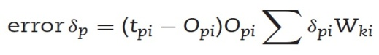 **(12)**

for hidden neurons Weight adjustment is made as follows:

Eqn 8.jpg **(13)**

Where η is the learning rate parameter and α is momentum factor.

**Step 8:** Go to **Step 3** and do the calculations up to **Step 7** at the end of cycle determine the root-mean-square error value, mean percentage of error and worst percentage of error over the complete patterns. To reach to **Step 9** check for reasonable error, if so, go to Step 9 otherwise go to **Step 3** and repeat the same from **Step 3** to **Step 7**.

**Step 9:** Stop the iteration and note the final weight values of the hidden layer neurons and also to the output layer neurons.

**Step 10:** Testing neural network model with the trained weight values, determine the output for the testing pattern and check whether the deviation from desired value is reasonably less or not. If not, try the back propagation with revised network by modifying the number of neurons, varying learning rate parameters, momentum value and temperature values as well. Table 9 shows the typical observation of network performance while testing the pattern.

**Table 9:** **Results Obtained in Artificial Neural Network**

|  |  |  |  |  |
| --- | --- | --- | --- | --- |
| **Sl. No.** | **MRR**  **(Mg/sec)** | **SR**  **(µm)** | **Predicted MRR**  **(Mg/sec)** | **Predicted SR**  **(µm)** |
| **1.** | 1.435 | 3.01 | 1.435 | 3.01 |
| **2.** | 5.8 | 6.09 | 5.8 | 6.09 |
| **3.** | 4.952 | 5.82 | 4.957 | 5.82 |
| **4.** | 8.823 | 6.86 | 8.823 | 6.85 |
| **5.** | 7.88 | 5.88 | 7.88 | 5.88 |
| **6.** | 2.083 | 4.43 | 2.085 | 4.43 |
| **7.** | 3.355 | 4.32 | 3.355 | 4.32 |
| **8.** | 7.96 | 5.22 | 7.96 | 5.22 |
| **9.** | 6.444 | 6.27 | 6.444 | 6.25 |
| **10.** | 2.653 | 6.16 | 2.653 | 6.16 |
| **11.** | 5.205 | 6.2 | 5.205 | 6.2 |
| **12.** | 1.99 | 4.41 | 1.99 | 4.41 |
| **13.** | 4.613 | 5.77 | 4.613 | 5.77 |
| **14.** | 4.511 | 6.41 | 4.511 | 6.41 |
| **15.** | 2.182 | 5.69 | 2.182 | 5.68 |
| **16.** | 4.951 | 5.39 | 4.954 | 5.39 |
| **17.** | 6.059 | 6.36 | 6.059 | 6.34 |
| **18.** | 2.136 | 4.35 | 2.136 | 4.35 |
| **19.** | 3.383 | 4.86 | 3.383 | 4.86 |
| **20.** | 2.206 | 4.91 | 2.205 | 4.93 |
| **21.** | 5.272 | 5.79 | 5.272 | 5.79 |
| **22.** | 5.342 | 4.12 | 5.342 | 4.12 |
| **23.** | 2.28 | 4.87 | 2.28 | 4.86 |
| **24.** | 4.951 | 6.17 | 4.951 | 6.17 |
| **25.** | 3.5 | 5.18 | 3.5 | 5.18 |
| **26.** | 3.248 | 5.14 | 3.245 | 5.15 |
| **27.** | 1.411 | 5.09 | 1.411 | 5.09 |
| **28.** | 5.544 | 7.44 | 5.545 | 7.45 |
| **29.** | 1.906 | 4.3 | 1.908 | 4.3 |
| **30.** | 7.381 | 6.39 | 7.384 | 6.36 |
| **31.** | 7.518 | 6.33 | 7.518 | 6.33 |
| **32.** | 5.272 | 5.1 | 5.272 | 5.1 |
| **33.** | 6.643 | 5.6 | 6.643 | 5.6 |
| **34.** | 3.383 | 3.74 | 3.383 | 3.75 |
| **35.** | 6.343 | 5.6 | 6.343 | 5.6 |
| **36.** | 6.766 | 8.19 | 6.766 | 8.19 |
| **37.** | 1.684 | 4.2 | 1.687 | 4.2 |
| **38.** | 2.859 | 5.31 | 2.859 | 5.31 |
| **39.** | 6.655 | 8.12 | 6.655 | 8.12 |
| **40.** | 3.866 | 4.01 | 3.866 | 4.01 |
| **41.** | 4.613 | 6.82 | 4.613 | 6.82 |
| **42.** | 4.142 | 7.08 | 4.144 | 7.07 |
| **43.** | 4.511 | 6.49 | 4.511 | 6.49 |
| **44.** | 4.72 | 6.51 | 4.72 | 6.51 |
| **45.** | 9.441 | 7.77 | 9.441 | 7.77 |
| **46.** | 6.766 | 7.7 | 6.766 | 7.7 |
| **47.** | 5.486 | 7.98 | 5.488 | 7.99 |
| **48.** | 5.205 | 8.02 | 5.205 | 8.02 |
| **49.** | 6.444 | 7.31 | 6.444 | 7.31 |
| **50.** | 3.941 | 5.01 | 3.941 | 5.01 |
| **51.** | 2.743 | 4.91 | 2.743 | 4.91 |
| **52.** | 2.985 | 4.97 | 2.985 | 4.97 |
| **53.** | 2.04 | 5.28 | 2.04 | 5.28 |
| **54.** | 4.776 | 6.54 | 4.776 | 6.54 |

1. **RESULT AND DISCUSSION FOR MRR AND SR**

The symmetrical exhibit was arranged by utilizing Focal Composite Design of 54 runs. The Focal Composite Design, Response Surface Methodology, Contour plots and Optimization plots are framed by utilizing MINITAB Software. Figure 9 addresses MRR as an element of heartbeat off time and heartbeat on time, though the Voltage, current, hole width and Poil stays steady in its more significant level. It is seen as the most elevated MRR values happened at the higher heartbeat on time and lower beat off time. Figure 10 shows MRR as an element of heartbeat on time and voltage, though the current, hole width, Poil and beat off time stay consistent in its more elevated level. It shows that the most elevated MRR values happened at the higher heartbeat on time and lower voltage. Figure 11 addresses SR as a component of current and hole width, while the voltage, beat on time, beat off time and oil pressure stays steady in its more significant level. It shows that the most noteworthy SR values happened at the greatest current and lower hole width.

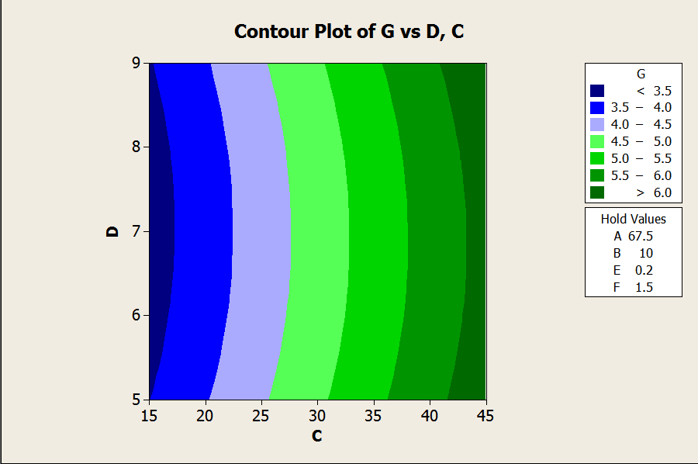

**Figure 9: MRR as a Function of Pulse OFF Time and Pulse ON Time**

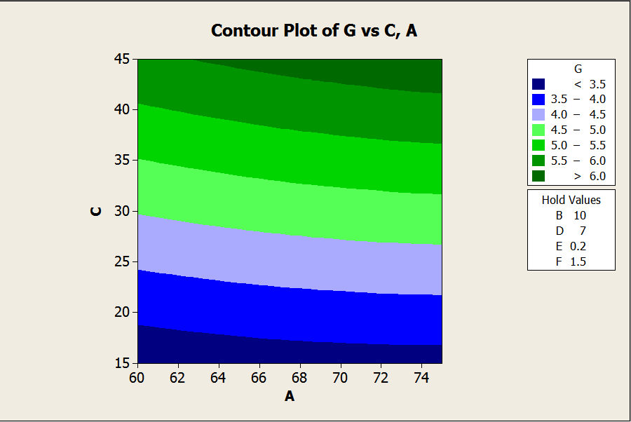

**Figure 10: MRR as a Function of Pulse OFF Time and Voltage**



**Figure 11: SR as a Function of Current and Gap Width**

Figure 12 represents SR as a function of voltage and pulse off time, whereas the current, pulse off, voltage, gap width and Poil remains constant in its higher level. It is observed that the highest SR values occurred at the minimum voltage and minimum gap width value. Figure 13 represents SR as a function of pulse on time and pulse off time, whereas the voltage, gap width, current and Poil remains constant in its higher level. It’s observed that the highest SR values occurred at the higher pulse off time and lower pulse on time.



**Figure 12: SR as a Function of Voltage and Pulse OFF Time**



**Figure: 13 SR as a Function of Pulse ON Time and Pulse OFF Time**

The bar outline for MRR and SR are displayed in Figure 14 and 15 alongside the different boundaries utilizing RSM and ANN. The ANN is prepared with different quantities of hubs in the secret layer. 10 secret layers are acquired from the specific hubs. The thought process in involving two secret layer and 10 hubs in this arrangement is because of diminished blunder. The Typical blunder for the performance of ANN during testing of all the preparation and it is 1.47% to test design. ANN is a fitting apparatus, utilized in ascertaining the material removal rate and surface roughness in machining process. ANN model has been tried utilizing the preparation information and bar outlines were not set in stone and tried values. The outcomes illustrate that ANN model has been effectively applied to the machining boundaries of LM25 Aluminum composites. It is seen from Figure 14 (Validation of ANN and RSM model for SR) Figure 15 (Validation of ANN and RSM model for MRR) that anticipated in view of ANN model is extremely near the trial perception. The validation for the MRR SR values utilizing ANN has been recorded in Table 4. The level of blunder between the trial and anticipated values is tracked down that base of 0.30 and limit of 3.22. This mistake is a sensible one and shows that the ANN model anticipated palatable for MRR and SR.

**Figure 14: Variation of MRR and MRR Output of Training Data Set w.r.t RSM**

**Figure 15:** **Variation of SR and SR Output of Training Data Set w.r.t RSM**

1. **CONCLUSION**

In this work, the information parameters are Discharge Current, Discharge Voltage, Pulse ON time, Pulse OFF Time, gap width, Oil Pressure and Metal Removal Rate, Surface Roughness are the output machining parameters. Different degrees of information conditions are consequential of Surface Design of Experiments. The experiments are performed on Electrical Discharge Machining machine. Utilizing the exploratory outcomes, two models viz., the Response Surface Methodology and Artificial Neural Networks are made and determined. The last conclusions in view of these two prediction models, the ANN back propagation strategy with a sort of observational model gives great outcome when contrasted and RSM model and the upgraded boundary for this composition are given in table 10.

|  |  |  |  |  |  |  |  |
| --- | --- | --- | --- | --- | --- | --- | --- |
| **A**  **Voltage (V)** | **B**  **Current (A)** | **C**  **Pulse ON (sec)** | **D**  **Pulse OFF**  **(sec)** | **E**  **Gap**  **(mm)** | **F**  **Oil Pressure (Kg/cm²)** | **G**  **MRR (Mg/sec)** | **H**  **SR (µm)** |
| 65 | 15 | 15 | 7 | 0.1 | 1.5 | 5.342 | 3.12 |

**REFERENCES**

Kuldeep Ojha, R. K. Garg, Singh.K. K. (2010). MRR Improvement in Sinking Electrical Discharge Machining, *A Review Journal of Minerals and Materials Characterization and Engineering,* 9, (8), 709-739.

Sen. M, Shan. H. S. (2007).Electro Jet Drilling Using Hybrid NNGA Approach, *International Journal Robot and Computer Integrated Manufacturing,* 23, 17–24.

Gao. Q, Zhang. Q. H, Su. S. P, Zhang. J. H. (2008). Parameter Optimization Model In Electrical Discharge Machining Process, *Journal of Zhejiang University Science,* A9, (1), 104–108.

Rao. G. K. M, Janardhana. G. R, Rao. D. H, Rao. M. S. (2009). Development of Hybrid Model and Optimization of Surface Roughness in Electric Discharge Machining Using Artificial Neural Networks and Genetic Algorithm, *Journal of Material Processing Technology,*.209, 1512–1520.

Tolga Bozdana. A, Oguzhan Yilmaz, Ali Okka. M, Huseyin Filiz. I.(2010). Mathematical Modelling of EDM Hole Drilling Using Response Surface Methodology, *Department of Mechanical Engineering, The University of Gaziantep,* 27310, Gaziantep, Turkey 90 – 94.

Musrrat Ali, Millie Pant, and Singh. V. P. (2009). An Improved Differential Evolution Algorithm for Real Parameter Optimization Problems, *International Journal of Recent Trends in Engineering,* 1, (5).

Yan. B. H, Huang. F. Y, Chow. H. M, Tsai. J. Y. (1999). Micro-Hole Machining of Carbide by Electric Discharge Machining, *Journal Materials Processing Technology,* 87, 139–145.

Mahapatra.S and Amar Patnaik. (2006). Parametric Optimization of Wire Electrical Discharge Machining Process using Taguchi Method, [*Journal of the Brazilian Society of Mechanical Sciences and Engineering*](http://www.scielo.br/scielo.php?script=sci_serial&pid=1678-5878&lng=en&nrm=iso)*,* 28(4) 422-429.

Qing Gao, Qin-He Zhang, Shu-peng SU, Jian-hua Zhang.(2008). Parameter Optimization Model in Electrical Discharge Machining Process, *Journal of Zhejiang University Science* A, 9(1), 104-108*.*

Shabgard M. R, Shotorbani. R. M, (2009).Mathematical Modeling of Machining Parameters in Electrical Discharge Machining of FW4 Welded Steel, *World Academy of Science, Engineering and Technology,* 52.

Sushant Dhar, Rajesh Purohit, Nishant Saini, Akhil Sharma, Hemath Kumarb. G*.* (2007).Mathematical Modeling of Electric Discharge Machining of Cast Al–4Cu–6Si alloy–10 wt.% SiCp Composites, *Journal of Materials Processing Technology,* 194, 24–29.

Puertas. I, LuisA. C. J. (2003).Study on the Machining Parameters Optimization of EDM, *Journal of Materials Processing Technology,* 143–144, 521–526.

Thillaivanan. A, Asokan. P, Srinivasan. K. N and Saravanan. R. (2010). Optimization of Operating Parameters for EDM Process Based on the Taguchi Method and Artificial Neural Network, *International Journal of Engineering Science and Technology,* 2, (12), 6880-6888.

Sameh S. Habib. (2009). Study of the Parameters in EDM Through Response Surface Methodology Approach, Applied Mathematical Modeling, 33, 4397–4407.

Seung-Han Yanga, Srinivas .J, Sekar Mohana, Dong-Mok Leea, Sree Balaji B. (2009). Optimization of Electric Discharge Machining Using Simulated Annealing, *Journal of Materials Processing Technology,* 209, 4471–4475.

Ramezan Ali MahdaviNejad. (2011). Modeling and Optimization of EDM of SiC Parameters, Using Neural Network and Non-dominating Sorting Genetic Algorithm (NSGA II), *Materials Sciences and Applications,* 2, 669-675.

Krishna Mohana Rao. Gand Hanumantha Rao. D. (2010).Hybrid Modeling and Optimization of Hardness of Surface Produced by Electric Discharge Machining Using Artificial Neural Networks and Genetic Algorithm, *Journal Engineering and Applied Sciences,* 5, (5), 1819-6608.

[Majumder, Arindam.](mailto:arindam2012@gmail.com) (2012). Parametric Optimization of Electric Discharge Machining by GA-Based Response Surface Methodology, *Journal for Manufacturing Science and Production,* 12, (12), 25–30.

Jun Wang, Fei Yang, Jun Qian, Dominiek Reynaerts. (2016). Study of alternating current flow in micro-EDM through real time pulse counting, Journal of Materials Processing Technology (231) 179–188.