An Evaluation of Thin Layer Chromatography as a Biotechnology Tool for the Isolation of Bioactive Compounds from Medicinal Plants: A Brief Review
Ria Bhar¹*, Amit Gamit²

¹Department of Biotechnology, School of Life Science and Biotechnology, Adamas University, Kolkata, India.
²ICAR-IVRI, ERS, Kolkata-700037

*Corresponding Author: RiaBhar
Address for Correspondence:
E-mail addresses: bhar.riya89@gmail.com (R.Bhar)

Abstract:
The goal of this work was to give a general overview of the fundamental ideas behind Thin Layer Chromatography (TLC) and its significance for phytochemistry research in particular. For many years, general chemistry laboratories have frequently employed thin layer chromatography to separate chemical and biological components because it is straightforward, affordable, and user-friendly. The analyte spots on the TLC plate are typically observed using chemical and optical techniques. It has numerous uses in locating contaminants in a chemical. The evaluation of TLC and its application for qualitative and quantitative determination of bioactive components from therapeutic plants is highlighted by St.
Keywords: Thin Layer Chromatography, TLC Principle, TLC Benefits, and TLC Uses.
Introduction:
Thin layer chromatography is a method employed for the separation of non-volatile mixtures. The procedure is carried out on a substrate, which can be a glass, plastic, or aluminum foil surface, coated with a thin layer of an adsorbent material. Typically, the adsorbent substance used includes silica gel, cellulose, or aluminum oxides.
Each component appears as a group of vertically divided spots once the separation is complete. Each position's retention factor (Rf) is displayed as follows:
Rf is equal to the sum of the sample and solvent travel distances.
Temperature, adsorbent, amount of substance spotted, and solvent system all affect the retardation factor. One of the chromatographic methods that is the quickest, least expensive, most straightforward, most simple is TLC.
Particularly in the domains of phytochemistry and biotechnology, thin layer chromatography (TLC) is a vital method for tracking the development of organic chemical reactions and determining the purity of organic materials. TLC, like other chromatographic methods, segregates intricate mixtures of organic compounds by leveraging the varying affinities of the analytes for both the mobile and stationary phases. To prepare a TLC plate, a slender layer of a solid adsorbent material is applied to a substrate, typically composed of glass, metal, or plastic A tiny amount of the sample for analysis is placed close to the plate's lower edge. After that, the TLC plate is placed very carefully within a developing chamber, with only the very bottom of the plate submerged in a shallow reservoir filled with the solvent, also referred to as the eluent. Using capillary action, the eluent progressively rises to the TLC plate to act as the mobile phase. This ascent of the eluent allows for the separation and visualization of the components within the sample mixture on the TLC plate. The stationary phase, consisting of the adsorbent material, interacts differently with the analytes, leading to their separation based on their affinities for the mobile and stationary phases. To find the best solvent, or combination of solvents, known as a "solvent system," for the development of a TLC plate or chromatography column containing an unknown mixture, the polarity of the solvent must be modified. Every component in the combination will move more freely as the solvent system's polarity rises (conversely, decreasing polarity leads to decreased mobility). The effectiveness of a solvent system is gauged by the degree of separation it achieves.
It is common practice to extrapolate TLC elution patterns from column chromatography elution patterns. TLC serves as a rapid method for selecting the most suitable solvent system for subsequent column chromatography. In this context, an ideal chromatographic process is one that effectively separates the target component from its nearest neighbor by a minimum of a 0.20 difference in TLC Rf values. This ensures that the desired component within the mixture is shifted to a TLC Rf range of 0.25 to 0.35.
Thin layer chromatography is employed to assess a mixture, allowing for the identification of the optimal solvent or solvents for subsequent flash chromatography. Furthermore, TLC finds utility in monitoring the advancement of a chemical reaction, discerning the constituents present in a product, and ascertaining the purity of a substance. Competition for binding sites on the stationary phase between the solute and the mobile phase is what drives compound separation.
For instance, in a normal phase reaction employing silica gel as the stationary phase, it is considered polar. When two molecules with differing polarity interact with silica, the more polar molecule exhibits a stronger ability to displace the mobile phase from the binding sites. Consequently, the less polar compound tends to migrate toward the upper regions of the TLC plate.
In situations where a more polar solvent or a solvent mixture is introduced as the mobile phase, all compounds present on the TLC plate will ascend higher on the plate. This is attributed to the increased effectiveness of the solvent in displacing solutes from the binding sites on silica. Importantly, altering the polarity of the mobile phase typically does not lead to a reversal in the migration order of compounds on the TLC plate, ensuring the predictability of the separation process (1, 2, 4, 6, 7).

Principle of TLC:
Thin-layer chromatography (TLC), like other chromatographic techniques, hinges on the fundamental principle of separation. The process of separation relies on the varying affinities of chemicals for the two distinct phases involved. The mobile phase, which contains the chemicals, flows across the surface of the stationary phase.
Compounds that exhibit a stronger attraction to the stationary phase undergo a slower migration, while those with weaker interactions move more rapidly. Consequently, the mixture is effectively fractionated. Upon the completion of the separation procedure, the individual components of the mixture become visible as distinct spots on the plates at their respective positions.
In order to discern the nature and characteristics of these separated components, appropriate detection methods are employed (16).
Calculation of the Rf Value:
The way a compound reacts in TLC is what distinguishes it. It is represented as a decimal fraction by the symbol R. The R is obtained by dividing the displacement of the chemical from its starting location by the displacement of the solvent (the solvent front). The adsorbent's nature: different adsorbents provide different R values for the same solvent. It is possible to reproduce just an adsorbent with consistent particle size and binder. Before using, plates should be kept in desiccators over silica gel. Samples should be applied right away to prevent the plate from collecting water vapor from the air. It is better to use plates that have been stored at room temperature instead of activating them because of the challenges involved in the activation operations. Usually, measurements are obtained from the plate to help identify the substances that are present. The travel distances of the various places and the solvent are also included in these figures. The plate is taken out of the beaker and the location of the material's solvent identification is noted when the solvent front reaches the top of the plate. An actual sample of the compound, or standard, is spotted and run on a TLC plate next to (or on top of) the chemical in question if the identity of the molecule is suspected but not yet confirmed. Two compounds are most likely the same chemical if their Rf values are the same, however this isn't always the case. If their Rf values differ, it is obvious that they are distinct substances. The fact that this identification check needs to be done on a single plate is crucial to emphasize because it is hard to precisely replicate all the factors that affect Rf from trial to experiment. (5,7,8,14,15).
View in chromatography: Chromatogram:
The various dye mixture components ravel at different rates as the solvent progressively flows up the plate, dividing the mixture into different colored patches.
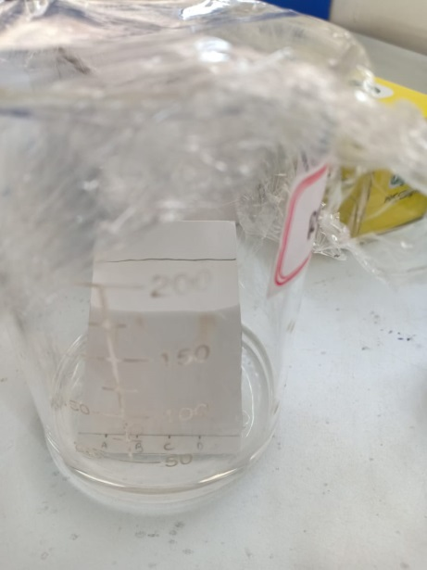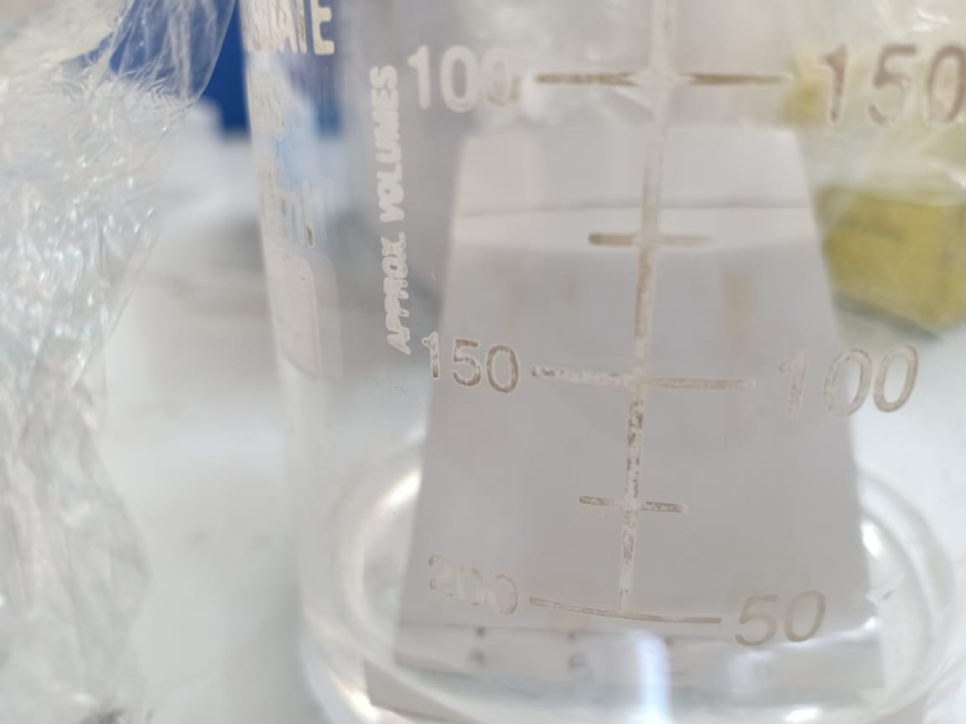
Figure 1: Chromatogram Figure 2: Developing Tank Figure 3: Spots as compounds
Before it gets a chance to vanish, it is marked with another line. These dimensions are measured as:
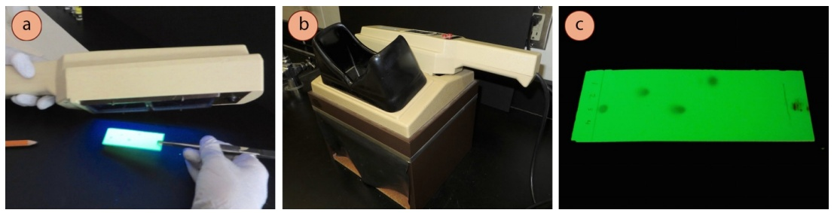
Figure 4: a) Tilting a UV lamp to visualize a TLC plate, b) Box to protect eyes from UV damage, c) Appearance under UV (Lisa Nichols, Butte College 2023).
Next, each dye's Rf value is calculated using the formula:
Rf = sample travel distance / solvent travel distance
For example, if the solvent moved 5.0 cm and the red component moved 1.7 cm from the baseline, the red dye's Rf value would be 1.7 cm.
If we were to replicate this experiment with the identical setup, the Rf values for each color would remain the same. For example, the red dye's Rf value is always 0.34. This assertion is no longer true if anything changes (such the solvent's exact chemical makeup or temperature). This is important to remember if we want to use this method to identify a particular dye. Later on this page, we'll examine thin layer chromatography for analysis.
From one experiment to the next, the Rf for a given molecule will only stay constant provided the following chromatographic requirements are met. -
- Solvent system
- Absorbent
- Adsorbent thickness
- Amount of material spotted.
Generally, relative Rf values are utilized because it is hard to maintain these variables between experiments. "Relative Rf" describes values that are presented in relation to a standard or compares several substances that are tested simultaneously on the same plate along with their corresponding Rf values. Compound Rf extends a compound's TLC plate travel distance. When two different compounds are compared and run under the same chromatographic conditions, the chemical with the higher Rf is less polar because it interacts with the polar adsorbent on the TLC plate less strongly. On the other hand, you could anticipate that a compound with low polarity will have a higher Rf value than a polar compound run on the same plate if you knew the structures of the compounds in the combination. The Rf can offer more details regarding a chemical's identity. An actual sample of the compound, or standard, is spotted and run on a TLC plate next to (or on top of) the chemical in question if its identity is suspected but not yet confirmed. It is most frequently (but not always) the case that two compounds are the same chemical if their Rf values are the same. It is evident that they are different substances if their Rf values are different. It should be emphasized that because it is difficult to perfectly duplicate all the variables that affect Rf from trial to experiment, this identification check needs to be done on a single plate (5, 7, 8, 14, 15).
Preparation of Plate:
To improve reproducibility, commercially available TLC plates frequently include preset particle size ranges. They are created by combining an inert binder like calcium sulphate (gypsum), a little amount of water, and an adsorbent like silica gel. This slurry is applied to a nonreactive carrier sheet, which is commonly constructed of plastic, glass, or thick aluminum foil. The finished plate is dried and activated in an oven for 30 minutes at 110 °C. For analytical purposes, the adsorbent layer is typically between 0.1 and 0.25 mm thick, while for preparative TLC, it is between 0.5 and 2.0 mm thick (6,10,11).
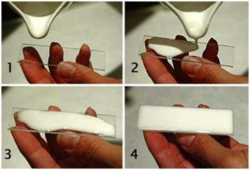
Figure 5: Steps of Preparative TLC (S. Kumar, 2012).

Spotting the plate:
Utilizing capillary forces, the liquid ascends to the surface when the narrow end of the spotter is immersed in a diluted solution. Gently touch the plate at the designated starting line. After the solvent has undergone evaporation, proceed to spot it in the same position. This approach ensures the creation of a precise and compact spot. It is advisable to exercise caution in spotting excessive material, as it can significantly compromise the quality of separation, leading to undesirable tailing effects.
To maintain proper separation, it is essential to ensure an adequate distance between the individual dots, both from each other and from the plate's boundaries. Whenever feasible, label the compound or mixture on the plate, including the raw components and any potential intermediates in the process (1, 12, 13).
Location of the place’s spots:
There are several ways to locate the positions of different solutes that have been separated using TLC. When viewed against a stationary phase, colored compounds are immediately apparent, but colorless substances cannot be seen without the aid of a spraying agent that creates colored regions in the area they occupy. The following can be utilized to spray the invisible places in TLC specifically:
1. Corrosive substances, which are entirely inorganic in nature, can also be sprayed on the undetectable patches.
2. In the process, a concentrated sulfuric acid solution containing potassium dichromate is employed. During this procedure, a wide range of organic chemicals, particularly those found in substances like sugars, undergo a reduction reaction, converting potassium dichromate (yellow) into chromic sulfate (green).
3.Warming fuming sulfuric acid causes sulfur trioxide to be formed, which chars organic compounds and turns them into dark blotches.
4. Potassium permanganate solute ion.
5. Iodine vapors.
The following reagents are also commonly used: 0.2N aqueous ammonium sulfide, 0.1% alcoholic quercetin, 0.2% methanolic 1-(2-pyridylazo)- 2- napthol, 1% methanolicoxine, and 0.5% aqueous sodium rhodizonate. Saturated hydrogen sulfide solution. Under UV light, the solutes on the TLC plate will be visible if the adsorbent contains a fluorescing material (1,14, 18).
Development solvents:
The right solvent to employ depends on the kind of substance and adsorbent used on the plate. It is important to select a development solvent that won't react chemically with the components of the mixture being studied. Avoid using solvents that are either detrimental to the environment (such as dichloromethane) or carcinogenic (such as benzene). There are two types of solvent systems: polar and non-polar. Non-polar solvents are widely used because highly polar solvents cause any part of the solvent mixture to adsorb. Among the often-used developing solvents are petroleum ether, carbon tetrachloride, pyridine, glycol, glycerol, diethyl ether, formamide, methanol, ethanol, acetone, and n-propanol (1,4,10).
Mobile Phase:
The mobile phase in silica gel chromatography might be an organic liquid or a mixture of organic solvents. The analyte migrates through the stationary phase's particles as the mobile phase passes over the silica gel's surface. Analyte molecules flow freely with the solvent when they are not attached to the surface of the silica gel. Consequently, the retention factor of an analyte quantifies the time it remains attached to the silica gel's surface relative to the time it spends in solution. The analyte's ability to adhere to the silica gel surface in the presence of a specific solvent or solvent mixture results from two competitive interactions.
First, the analyte and polar groups in the solvent compete with one another for binding sites on the surface of the silica gel. There will be fewer binding sites accessible for the analyte on the stationary phase if a highly polar solvent is utilized because of its strong interaction with the surface of the silica gel. The analyte will therefore swiftly pass through the stationary phase.
Similarly, polar groups in the solvent may strongly interact with the polar functional groups of the analyte, preventing it from binding to the surface of the silica gel. As a result, the analyte rapidly exits the stationary phase. The polarity of a chromatography solvent can be estimated by evaluating its dielectric constant and dipole moment. When these two values are higher, the solvent is more polar. Additionally, the solvent's capacity to form hydrogen bonds must be considered. For instance, methanol, known for being an excellent hydrogen bond donor, significantly limits the ability of all but the most polar analytes to adhere to the silica gel's surface.
Developing a Plate:
You can prepare a TLC plate in a jar with a tight lid or a beaker. Pour the solvent (mobile phase) halfway into the container. The sample is added to a small area of solution on a plate that is one centimeter from the bottom. After being dipped in an appropriate solvent, like hexane or ethyl acetate, the plate is placed in a sealed container. The solvent travels up the plate due to capillary action, coming into touch with the sample mixture and dissolving it before moving up the plate again.
Due to differences in their solubility in the solvent and attraction to the stationary phase, the various compounds in the sample combination travel through space at different rates. Changes to the solvent or possibly a combination of solvents can affect the components' separation (as indicated by the Rf value). The solvent level needs to be below the TLC's starting line in order to stop the spots from evaporating. After that, a solvent is poured over the lower border of the plate. Due to their varying degrees of solubility in the rising solvent and interaction with the matrix (stationary phase), the components of the samples move at different speeds as the solvent (eluent) ascends the matrix via capillary. Because non-polar solvents dissolve quickly and do not interact with the polar stationary phase, non-polar compounds tend to rise to the top of the plate. Allow the solvent to rise on the plate to a height of about 1 cm. As soon as the plate is removed, make a note on the solvent front. Make sure that no solvent overflows the edge of the plate. Let the solvent evaporate entirely (1, 8).
Visualization:
Once the plate has been pushed for 15 to 45 minutes and is within 1 cm of the top end of the adsorbent, it should be removed from the developing chamber, the location of the solvent front marked, and the solvent allowed to evaporate.
If the sample's bits are colored, it is possible to see each one clearly. If not, they can occasionally be seen by subjecting the plate to ultraviolet light or by briefly placing it in a closed container that contains a lot of iodine vapor. Spraying the plate with a reagent that will react with one or more components of the sample can occasionally make the spots visible (1,10).
Analysis:
The components are identified by comparing their travel distances to those of the approved reference materials. The components are identifiable as single dots. Calculate the separation between the solvent front and the beginning line. Next, find the distance between the starting line and the spot's center. Take the solvent's travel distance and subtract it from the total travel distance of all the sites. The Rf-value is the name given to the resulting ratio. The molecules being separated could be colorless, in which case there would be multiple ways to view the dots. To make spots visible under a blacklight, the adsorbent is commonly coated with a small amount of a fluorescent material, usually manganese-activated zinc silicate (UV254). The result is a faint green glow in the adsorbent layer that is diminished by analyte spots. On the other hand, specific colorants are available that can be sprayed or dipped into the TLC plate. Vapors of iodine are a colorless reagent. The Rf value, or retention factor, of each visible spot is obtained by multiplying the distance traveled by the product by the total distances travelled by the solvent (the solvent front). These figures are not physical constants; rather, they vary according to the kind of TLC plate and solvent used (1, 5, 8).
Identifying chemicals with thin-layer chromatography:
Assume you wanted to determine the specific amino acids present in an amino acid mixture. We'll assume you're aware that the mixture can only comprise five of the most common amino acids for the sake of simplicity. On the bottom of the thin layer plate, a tiny drop of the mixture is applied, followed by tiny dots of the identified amino acids. The plate is then submerged in the proper solvent and given time to develop normally. The known amino acids are identified in the diagram by the numbers 1 through 5 and the mixture is denoted by the letter M. When the solvent front has nearly reached the top of the plate, it is illustrated in the left-hand diagram. The spots are still unnoticeable. The second image represents how it might look after being sprayed with ninhydrin. There is no need to quantify the Rf values because it is straightforward to compare the spots in the mixture with those of known amino acids based on their positions and colors. The amino acids 1, 4, and 5 are represented in this image. What if the combination contains amino acids that were not in the baseline? There would be places in the combination that did not match the known amino acid sites. To draw a comparison, you would need to repeat the test with different amino acids (1,12, 16).
The compound's and the adsorbent's interactions:
An organic molecules dipole-dipole, ion-dipole, hydrogen bonding, dipole-induced dipole, and van der Waals forces determine how tightly it binds to an adsorbent. The adsorbent and the components that need to be separated in silica gel mostly interact on a dipole-dipole basis. Due to their strong interaction with the polar SiOH groups on the surface of these adsorbents, highly polar molecules prefer to adhere or adsorb onto the small particles of the adsorbent, while weakly polar molecules are held less strongly. Weakly polar molecules often bond to the adsorbent more quickly than polar ones. The compounds elute in the above-mentioned order (1, 10).
Application:
Thin layer chromatography has proven to be an effective method in several significant medicinal applications (1).
Amino Acid:
TLC of amino acids is more challenging than that of inks due to their colorlessness. As a result, the dots are hidden from view once the plate has dried and fully formed. Use the ninhydrin visualization method or the black-light visualization methodology to see the spots. Proteins, peptides, and amino acids, for instance: A mixture of 34 amino acids, proteins, and peptides have been successfully separated and isolated from urine using silica gel plates. All of these compounds had positive ninhydrin tests. There were two types of solutions employed initially: phenol-water and chloroform-methanol-20% ammonium hydroxide.
Pharmaceuticals and drugs:
The production of synthetic medications uses TLC for process control, active component and auxiliary compound identification, purity testing, and concentration determination in medications and drug formulations. A number of pharmacopoeias have authorized the TLC technique for detecting contaminants in medications and chemicals such as antibiotics. Using two solvents, iso-propanol-methanol (3:7) and acetone-methanol (1:1), penicillins were isolated on silica gel "G". A 0.1% iodine solution containing 3.5% sodium azide was sprayed onto the dry plates in order to use the iodine-azide reaction as the detecting agent.
Separation of multicomponent pharmaceutical formulations:
Additionally, it is utilized to separate pharmaceutical compositions with many components.

Qualitative analysis of alkaloids:
It is employed at the control stage of both plant-based medicines and pharmaceutical formulations for the qualitative study of alkaloids. Alkaloids have been isolated and identified using TLC in toxicology; the 30–60-minute runs offer a significant benefit over the 12–24-hour time frame needed for paper chromatography. Using silica gel, aluminum oxide, and silicic acid, TLC was used to identify purine alkaloids. Spraying a 25% HCL-96% ethanol solution and then an alcoholic iodine-potassium iodine solution will allow you to see the dots.
Clinical chemistry and Biochemistry:
This tool is very helpful in identifying metabolic diseases in children, such as phenylketonuria, cystinuria, and maple syrup disease, as well as in the detection of active substances and their metabolites in biological samples. It serves as a valuable tool in the analysis of various urinary components, encompassing steroids, amino acids, porphyrins, and bile acids that originate from lipid metabolism. In order to detect and resolve small metabolites fully free of other components, urinary analysis by TLC works best when combined with other chromatographic procedures.
Cosmetology:
When identifying dye raw materials, finished goods, preservatives, surfactants, fatty acids, and scent ingredients.
Food Analysis:
To find out if drinking water contains pesticides and fungicides, if fruits, vegetables, salads, and meat contain residues, if soft drinks contain vitamins, if additives that Germany has banned are present (like sandalwood extract in fish and meat products), and if limit values are being followed (like polycyclic compounds in drinking water and aflatoxins in milk and milk products).
Analysis of Heavy Petroleum Product:
Petroleum products are among the most complex materials, but they are hardly ever studied using thin-layer chromatography (TLC), a technique that is widely used in the examination of complex mixtures. There is no such information in the literature, particularly with regard to heavy petroleum products. At the same time, this approach has advantages over column chromatography that are well known, including simplicity, affordability, and efficiency. TLC was used (in the preparative version) to rapidly assess the group composition of heavy petroleum products (residues, asphalts, and pitches) in conjunction with spectroscopic analyses of the chemical composition of the generated fractions.
Separation of aromatic amines:
By employing cat ionic and non-ionic surfactant-mediated systems as mobile phases in thin-layer chromatography, aromatic amines have been separated on silica gel layers. It was investigated how the concentration of surfactant affected the mobility of amines below and above their critical micellar concentration. Furthermore, the influence of both organic and inorganic additives, such as alcohols, urea, NaCl, and NaBr, on the mobility and efficiency of amine separation in micellar solutions is assessed.
Applications related to Organic Chemistry:
- A lot of other separation processes have utilized it to check them. TLC has also been utilized successfully in a number of purification procedures, including the analysis of distillation fractions and the monitoring of the molecular distillation process for purification.
ii) Because TLC can be used to a broad range of chemical compounds and separates quickly, it has been utilized as an analytical method in organic chemistry. The main use of this technique is to separate and isolate individual components of mixtures. However, it has also been applied in organic chemistry to characterize and isolate a wide range of compounds, such as acids, alcohols, glycols, amides, alkaloids, vitamins, amino acids, antibiotics, food ingredients, and food products, as well as to determine sample purity, identify organic compounds, and research various organic reactions. The reaction's completion is ascertained by TLC examination of the reaction mixture. Other separation and purification techniques, like as distillation and molecular distillation, are also tested using this methodology. Because high sensitivity makes it possible to detect contaminants in purportedly pure samples, TLC's great sensitivity is utilized to ensure sample purity (3,17).

Conclusion:
Thin layer chromatography is a straightforward, affordable, and user-friendly phytochemical and biochemical technology with a wide range of uses, including the creation of novel medications and a variety of formulations from medicinal plants. Additional thorough documentation is required for the sustained development of research and teaching.

Acknowledgments: This work was supported by a grant of the Adamas university seed grand letter no. AU/R&D/SEED/28/03-2020-21.

Reference:

- A. Archana, Bele and Anubha Khale, An overview on thin layer chromatography, IJPSR, 2(2), 2011, 256-267.

- A. Mohammad, S.A. Bhawani and S. Sharma, Analysis of herbal products by thin-layer chromatography: a review, International Journal of Pharma and Biosciences, 1(2), 2010, 1-50.

- A.H. Beckett, J.B. Stenlake, Practical pharmaceutical chemistry, thin layer chromatography, CBS publishers, 4th edition, 2005, 115-128.

4. A.V. Kasture, K.R. M ahadik, S.G.W adodkar, H.N. More, A textbook of pharmaceutical analysis, instrumental methods, NiraliPrakashan, 9th edition, 2, 2005, 18-30.

- B. Fried, J. Sharma, Thin-layer chromatography, fourth edition, revised and expanded, Marcel Dekker inc., New York - Basel, 1999, 499.

- B.K. Sharma, Instrumental methods of chemical analysis, Goel publishing house, Meerut, 5th edition, 2007, 241-264.

- D.A.Skoog, F.J.Holler and T.A. Nieman, “ Principles of instrumental analysis, Saunders college publishing, 5th edition, 2006: 761-766.

- E. Dreassi, G. Ceramelli, P. Corti, Thin-layer chromatography in pharmaceutical analysis. In practical thin-layer chromatography—a multidisciplinary approach. Fried b., Sharma J. (eds.) Crc press, Boca Raton, fl, 1996, p. 231.

- G. Szepesi, M. Gazdag, St eroids. In handbook of thin layer chromatography, Sharma G, Fried B (eds.) M arcel Dekker, New York, 1991, 907.

- G. Szepesi, M. Gazdag, St eroids. In handbook of thin layer chromatography, Sharma G, Fried B (eds.) Marcel Dekker, New York, 1996, 971.

- G. Just us, Kirchner, Thin-layer chromatographic quantitative analysis, Journal of Chromatography a-1, 82(1), 1973, 101- 115.

- G.R. Chatwal, S.K Anand, Instrumental methods of chemical analysis, Himalaya publishing house, 5th edition, 2008, 2.599-2.616.

- H.T. Quach, R.L. Steeper, G. W. Griffin, Separate ion of plant pigments by thin layer chromatography. Journal of Chemical Education. 81, 2004, 385-7.

- M Ali and V. Agrawal, Thin-layer chromatography of aromatic amines, Separation Science and Technology, 37, 2002, 363 - 377.

- R.M. Scot t, Clinical analysis by thin-layer chromatography techniques. Ann Arbor science publishers, Ann Arbor, mi. 1969.

- S. Singhal, N. Singhal, S. Agarwal, Pharmaceutical analysis-II, Thin Layer Chromatography, Pragati Prakashan, first edition, 2009, 98-111.

17. Vidyasagar, Instrumental methods of drug analysis, Pharma M ed Press, first edition 2009,263.

