Utilizing Ozone in the Food Processing Sector: Unveiling its Various Applications
Anushree R. K¹, Dr. Ankita Dobhal², Soumya Sucharita Sahoo³ , Veena U K⁴, Dr. R. B. Kshirsagar ⁵ and Dr. B.S. Agarkar
¹ Ph. D. Research Scholar, Department of Food Science and Nutrition, VNMKV, Parbhani, India.
²Assistant Professor, Department of Food Science and Technology, Graphic Era(Deemed to be university)Dehradun, Uttarakhand, India
³M.Sc. Student, Department of Food Science and Nutrition, VNMKV, Parbhani, India
⁴M.Sc. Food Science and Nutrition, GKVK Bengaluru, Karnataka, India
⁵Professor and Head, Department of Food Engineering and Dean, College of Food Technology, VNMKV, Parbhani, India.
⁶Associate Professor and Head, Department of Food Plant Operation, VNMKV, Parbhani, India
.
*Corresponding author: veenauk115@gmail.com
Abstract
Food producers are very concerned about extending the shelf life of their products, and the industry needs "greener" alternatives to the current technology. Food preservation using ozone may be appropriate in this situation. Ozone, which has qualities like fast disintegration and few aftereffects during food preservation, is an appealing alternative preservative that the food industry requires. Only elemental fluorine has more oxidising strength than ozone, the strongest chemical currently used to disinfect water. Ozone is utilised in the food sector for a number of purposes, including the cleaning of water and equipment surfaces. A number of studies have concentrated on the use of ozone to inactivate germs on fresh produce, such as fruits, vegetables, meat, poultry, fish, and eggs, as well as dry goods, such as grains, pulses, and spices. The use of ozone to various food items at the industry level, which has an impact on the quality and safety of food products, is covered in detail in this book chapter.
Key Words: Ozone, Food Industry, Microorganisms, Quality and Food safety
Introduction
The food processing industry is putting in more effort than ever to improve global standards for food safety and quality. Recent large increases in food-borne illness outbreaks have caused grave public health concerns. (Stephan et al., 2015). As a result, the safety of microorganisms in food is a concern for both the food business and consumers. In order to reduce unwelcome microbial and fungal contamination and deterioration as well as to maintain the product's sensory and nutritional quality, appropriate technologies must be employed throughout the production and distribution chain (De Souza et al., 2018). Numerous food preservation techniques, such as chilling, water activity reduction, freezing, pasteurisation, sterilise, acidification, drying, dehydration, antimicrobials, and fermentation, have been researched to address food safety concerns. The look, colour, texture, scent, and nutrition of some uses of these technologies, however, are negatively impacted. Furthermore, there are important problems that have not yet been adequately resolved, such as food contamination and microbiological decomposition. Because they taste better, have fewer additives, and have a longer shelf life, consumers now favour organic foods. In this case, ozone-based food preservation technology benefits both farmers and consumers. (Mohammadi et al., 2017).
Food can be chemically decontaminated by using ozone treatment, which entails exposing contaminated foodstuffs (including fruits, vegetables, beverages, spices, herbs, meat, and fish) to ozone in aqueous and/or gaseous phases. Microorganisms are inactivated during ozonation in the gaseous phase at a constant pressure, set flow rate, and predetermined ozone concentration, depending on the level of contamination. Ozone is preferred to traditional decontaminating agents like chlorine because of its strong oxidative properties. It has a wide variety of antibacterial effects because it is about 50% stronger than chlorine. It has been demonstrated that both Gram-positive and Gram-negative microorganisms, as well as bacterial spores, are sensitive to ozone's bactericidal effects (Guzel-Seydim et al., 2004a; Kunicka – Styczyńska and Śmigielski, 2011). As a result, ozone treatment improves the microbiological safety of food products while also prolonging their shelf life without dramatically changing their nutrient, chemical, or physical properties.
Ozone has been used for many years as a potent antibiotic to disinfect water for a variety of uses, including drinking (bottled water), swimming (pools), spas, marine aquaria, preventing fouling of cooling towers, as well as treating municipal water and sewage. It can also be utilised in the food and beverage sectors, as well as in the production of meat, vegetables, fruits, fish, and herbs and spices (Gonçalves, 2016; Guzel-Seydim et al., 2004a; Peleg, 1976; Strittmatter et al., 1996; Tapp and Rice, 2012). However, ozone toxicity is the most important criteria for its acceptability in a variety of food branches (Pryor et al., 1995). Additionally, it's crucial to monitor both the ozone dose and the people who may have been exposed to ozone at work. This study intends to gather data that will help in pinpointing the major achievements by ozone applications in the food processing industries.
A Brief History of Regulatory Approval of Ozone Technology
Prior to the middle of 1997, the United States hardly ever employed ozone for food processing or treatment. The root of the problem was entirely regulatory and unrelated to ozone technology. The use of ozone is governed by the Federal Food, Drug, and Cosmetic Act (FDCA), which was put into effect by the FDA in the late 1950s. Any substance that comes into touch with food is considered a "food additive" under the act, and its use requires FDA approval. All food items are subject to FDA regulation, with the exception of meat, poultry, and egg products. These latter three food groups are under USDA regulation. But the FDA won't let its regulated commodities use a food additive unless the agency has already given its approval.
The FDA's approval of employing ozone in contact with food has required a lot of time and work. Early in the 1980s, the International Bottled Water Association (IBWA) requested from the FDA that under certain conditions, the use of ozone to disinfect bottled water be deemed generally recognised as safe (GRAS). The restrictions stipulated that the treated water had to already meet EPA (U.S. Environmental Protection Agency) requirements for potable water, with a maximum ozone dosage of 0.4 mg/L over a four-minute contact period. IBWA's request to use ozone in bottled water was approved by the FDA, and in 1982 a formal FDA regulation confirming GRAS Status for ozone use was published in the Code of Federal Regulations (CFR) (U.S. FDA, 1982). Later, the FDA approved the use of ozone as a sanitising agent for bottled water treatment lines under a similar GRAS petition.
Unfortunately, the 1982 GRAS certification for using ozone to sterilise bottled water also stipulated that "all other food additive applications for ozone must be the subject of appropriate Food Additive Petitions (FAP)" 2001 (USDA FSIS) According to this assertion, FAPs must be submitted in order to get FDA approval for any additional ozone uses that include direct contact with food. The FDA received several petitions for food additive clearance for the use of ozone treatments in contact with various foods, particularly chicken, in the years that followed. However, each of these petitions was withdrawn (without prejudice) for a variety of reasons. According to a panel of knowledgeable food scientists assembled by the Electric Power Research Institute (EPRI) in Palo Alto, California, in June 1997, ozone is safe when used as a food disinfectant or sanitizer and further, the available information supports a GRAS classification of ozone as a disinfectant or sanitizer for foods when used at levels and by methods of application consistent with good manufacturing practises. Although the FDA's lack of specific regulatory approval for ozone published in the Federal Register continued to concern many food processors and slowed ozone's acceptance in the food industry, EPRI's GRAS affirmation gave food processors a clear green light to test and use ozone for a variety of food processing applications (EPRI,1987).
The FDA acknowledged all of these facts, in addition to the fact that the majority of ozone applications in food treatment utilise ozone's antibacterial properties. As a result, the FDA suggested to the EPRI in mid-1999 that a single FAP could be reviewed quickly and, if approved, would get around the requirement of the 1982 GRAS regulation regarding "other food uses for ozone." This FAP would give the FDA specific data showing the antimicrobial properties of ozone in a number of food processing applications. The EPRI supported this strategy and, with assistance from other interested organisations involved in the food processing industry, produced and formally submitted a FAP to the FDA in August 2000. On June 26, 2001, the Federal Register revealed the FDA's clearance of this FAP. Later that year, with no labelling issues for treated commodities, the USDA/FSIS approved the use of ozone on meat and poultry products, including the treatment of ready-to-eat meat and poultry products just prior to packaging (EPRI., 2000).
Properties and Characteristics of Ozone
Ozone was discovered and given its name by Schoenbein in 1840, but it took a long time for its uses in food preservation to become apparent. Tri-atomic oxygen, or ozone (O3), is created when a molecular oxygen molecule is combined with an oxygen free radical. The three oxygen atoms that make up the ozone molecule are arranged in an obtuse angle, with a central oxygen atom bound to two oxygen atoms that are spaced equally apart; the included angle is approximately 116° 492 and the bond length is 1.278. Ozone has a critical pressure of 54.6 ATM, a critical temperature of 12.1 °C, a critical boiling point of 111.9 0.3 °C, and a critical melting point of 192.5 0.4 °C (Manley and Niegowski, 1967). Ozone is a gas that exists at both room and refrigerator temperatures and is only marginally soluble in water. Ozone is a gas that is unstable at room temperature. Ozone breaks down quickly, but its half-life in gas is longer than it is in aqueous solution (Rice, 1986). Ozone is highly unstable in water, where it decomposes quickly, but somewhat stable in air. It must constantly be generated because it cannot be preserved. Food products that have been disinfected with ozone are free of disinfection residue because ozone only produces oxygen when it breaks down. It is detectable between 0.01 and 0.05 ppm (Miller et al., 1978). It has a strong, distinctive smell that has been compared to "fresh air after a thunderstorm". Ozone is a blue gas at room temperature when it is made from dried air, but it is colourless when it is produced from highly pure oxygen.
Ozone stability typically depends on the quality of the water. While ozone breaks down relatively slowly in clean solutions, it does so far more quickly in contaminated ones. after distilled or tap water at 20°C, around 50% of the ozone is destroyed after 20 minutes, while only 10% of the ozone is destroyed in 85 minutes in double-distilled water at the same temperature, according to Hill and Rice (1982). Ozone is 13 times more soluble in water than oxygen is between 0 and 30 °C, and as the temperature drops, it gets more soluble (Rice, 1986). Ozone deterioration is accelerated by warmer water temperatures. Ozone is a dangerous gas, and the amount and length of exposure determine how poisonous it is (Pascual et al., 2007). At short-term exposure rates of 0.1-1.0 ppm, symptoms such headaches, nosebleeds, eye irritation, dry throat, and respiratory irritation might occur. Asthma-like symptoms, exhaustion, and appetite loss are some of the more severe symptoms that are brought on by higher exposure levels (1-100 ppm).
How Ozone Works
Ozone operates through ozonolysis, a form of direct or indirect oxidation, and catalysis. The following three main action routes take place: (Brooks and Pierce, 1990; Seafish, 1997; Campos et al., 2006):
• Examples of first order, high redox potential reactions include the direct oxidation of ozone by an oxygen atom.
• Indirect oxidation processes occur when the ozone molecule breaks down into free radicals (OR), which work fast to oxidise both organic and inorganic substances.
• Ozone can also function by ozonolysis, which fixes the entire molecule on double-linked atoms and creates two simple molecules with distinct properties.
Ozone Treatment Equipment for the Food Processing Industry
Ozone treatment in the food processing industry may employ aqueous and/or gaseous forms of ozone. A gas (air or pure oxygen), an ozone generator, an electric power source, a contactor (if the ozone is in the water phase), a reactor, a surplus gas removal unit, and an ozone analyzer are the sole fundamental parts of an ozone treatment system in use. In corona discharge type generators, dry air or pure oxygen is typically used as an oxygen supply for conversion into ozone.
To optimise the efficiency of ozone therapy and reduce the formation of nitrogen oxides, which speed up electrode corrosion, if air is used, it must be dried to -65°C. Zeolite towers, which serve as molecular screens, are frequently used to create pure oxygen by inhibiting the creation of nitrogen compounds in the air. The air should also be cooled since ozone quickly breaks down into oxygen at temperatures above 30 °C. Ozone therapy equipment traditionally operates at low frequencies (50 to 60 Hz) and high voltages (> 20,000 V), although contemporary technologies need higher frequencies (1000 to 2000 Hz) and lower voltages (10,000 V) to function. In ozone-based water treatment systems, contactors are utilised to transfer generated ozone to the water for disinfection. There are two main contactors: those with a turbine-agitated reactor and those with bubble diffuser chambers, depending on the purpose of ozone therapy. It was demonstrated that a multicolumn contactor with a bubble diffuser was an effective transfer (Bablon et al., 1991). Additionally, to ensure mixing and optimise contact, contact chambers, turbine diffusers, and static agitators can help accelerate gaseous ozone. Excess ozone should be eliminated during ozone therapy due to safety concerns. It can be diluted with air in smaller treatment facilities; in larger ones, it can be eliminated through catalytic breakdown or absorption in wet granular activated carbon (Bablon et al., 1991).
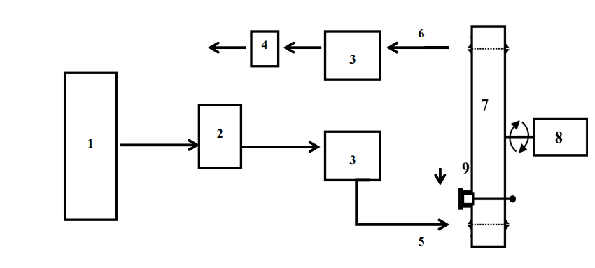
In order to treat ozone-contaminated plant material, Brodowska et al. (2014) proposed a straightforward method for ozone treatment in a gaseous medium for laboratory applications (Figure 1). The apparatus permits continuous ozone treatment of a polluted sample using an ozone/oxygen mixture in a reactor (a cylindrical glass and steel cylinder). A rotating and jolting mechanism that is directly connected to the reactor is also a part of the control system for the device, which speeds up the movement of plant material inside the chamber. Ozone concentrations at the intake and exit can be determined by ozone analysers. Comparable components make up the ozone treatment system in the water phase, on the other hand (Figure 2), but the pH of the sample solution in the reactor needs to be continuously adjusted (Brodowska et al., 2014, 2015; Naito and Sawairi, 2000).

Fig. 1. Ozone treatment system for gaseous phase used for laboratory purposes (1-oxygen bottle, 2-ozone generator, 3-ozone analyzer, 4-surplus gas elimination unit, 5-inlet of ozone, 6-outlet of ozone, 7-reactor, 8-control system with jolting and rotating mechanism, 9-supply and disposal of plant material treated with ozone) (adapted from Brodowska et al., 2015).
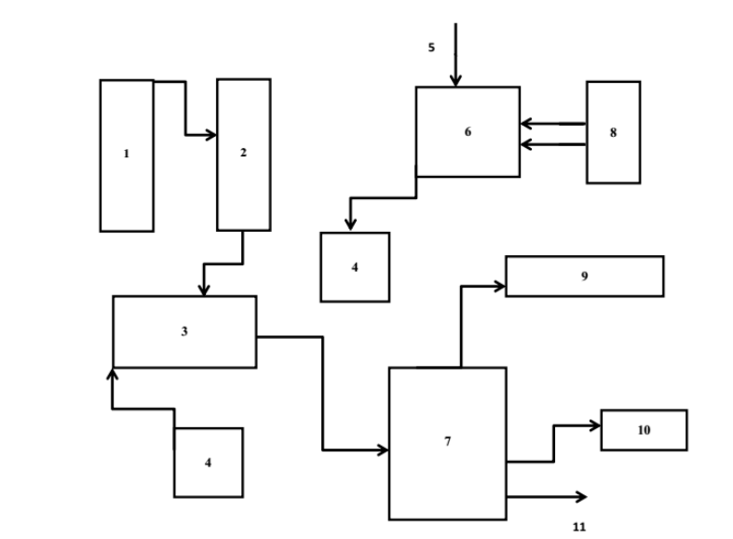
Fig. 2. Ozone treatment system for aqueous phase (1-oxygen cylinder, 2-ozone generator, 3- ozone dissolutor, 4-pump, 5-water, 6-water vessel, 7-dissolution vessel, 8-chiller, 9-ozone decomposition catalyst, 10-ozone monitor, 11-ozone-containing water) (based on Naito and Sawari, 2000).
Advantages of Ozone Treatment
- Nonoxidative biocins (chlorine) have a greater antibacterial effect in terms of concentration and time.
- Less contact time is required for disinfection when compared to other methods.
- No lingering problem because it is entirely utilised and diminished.
- Effective for bactericidal use at low ppm (less than 4 ppm) and non-toxic at low ppm.
- Unlike other sanitation techniques, there is no need to store dangerous materials.
- Lower operational costs, with just the price of replacing oxygen cylinders and potential power supply issues.
- The requirement for input energy is reduced because there is no need for heat and no heat creation during treatment (applicable to foods that are sensitive to heat).
- • It lowers the cost of storing petrol and transporting cleaning agents.
- Environmentally sustainable and commercially viable technology.( Prabha et al.,2015)
Limitations of Ozone Treatment
- When inhaled, ozone is harmful and can induce throat and sinus difficulties, as well as asthma.
- Because ozone is a highly unstable gas, a controlled release on demand must be constructed.
- Recontamination issues in clean process pipes since ozone decomposes completely in a short period of time.
- Corrosive at high ppm (more than 4 ppm), ozone should be used with caution and released into a treatment chamber.
- It necessitates regular leak detection in indoor applications.
- Higher initial investment in generation equipment is necessary because it is unstable and unsuitable for storage.
- Ozone decomposes quickly and is susceptible to oxidation with organic matter, therefore it can be used primarily as a surface treatment ( Prabha et al.,2015).
Applications of ozone in the food business to limit the growth of microorganisms and lengthen the shelf life of foods
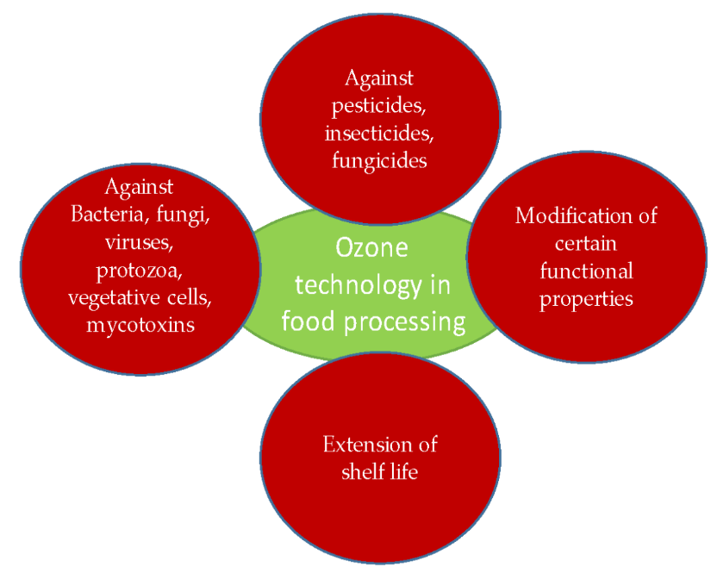

Figure 3: Ozone technology application in food processing (source: Chiozzi et al., 2022)

Ozone in Fluid Food Processing
Ozone was utilised to achieve the requisite 5-log reductions in spoilage and potentially pathogenic species most frequently found in fruit and vegetable juices, according to microbiological investigations done to date. The application of ozone at levels that effectively disinfect may have an impact on the sensory qualities of food. Ozone isn't always healthy, and it occasionally increases the likelihood that food may oxidatively degrade. Unwanted organic and inorganic compounds (including iron, manganese, nitrite, cyanide, and hydrogen sulphide) readily oxidise when ozone is applied (Rakness, 2005).
According to Dock (1999), apple cider's qualitative qualities were unaffected by the ozone treatment. According to Bravo et al. (2007), after being exposed to ozone (7g/h) for 24 hours, the majority of the polyphenols in green table olive solutions were quickly destroyed. A further 72 hours of ozone bubbling was needed to reduce the remaining tyrosol concentration in the solution.
Ozone in Meat Processing
Reagan et al. (1996) investigated cutting and washing techniques for beef carcasses to improve the microbiological quality of meat. Other intervention therapies included knife trimming, water washing, and rinsing with ozone (0.3-2.3 ppm) or hydrogen peroxide (5%). Hydrogen peroxide reduced aerobic plate counts by 1.14 CFU/cm2, whereas ozone treatment reduced carcass surface contamination by 1.30 CFU/cm2. In their study on beef carcasses, Greer and Jones (1989) evaluated the effects of gaseous ozone therapy on the bacterial spoilage profiles, meat quality, and carcass shrinkage. They discovered that when psychrotrophic bacteria were exposed to an ozone atmosphere, their growth was slowed on carcass surfaces.
Before cooking, ozone has also been employed as a pre-treatment to see if it has any synergistic effects on reducing bacteria. To find out how ozone treatment on beef surfaces affected strains of Clostridium perfringens that produce enterotoxins, Novak and Yuan (2004a) cooked the treated meat at 45–75 °C. The authors noted that C. perfringens was reduced by 1-2 log CFU/g following aqueous ozone treatment and 45–75 °C heating. The same treatments also resulted in a fall in spore count, but the size of the decrease was rather small, indicating that the spores were far more resilient to ozone and thermal treatments. The researchers came to the conclusion that heat treatment followed by ozone treatment allowed reductions to occur at cooking temperatures where they would not normally occur.
Ozone in Grain Processing
After harvest, pest (insects and microorganisms like mould, fungi, and bacteria) development in stored grains must be controlled because it currently reduces grain yield by 3–10% in developed nations and can reach 50% in some (Jian et al., 2013; Fleurat-Lessard, 2004; Magan and Aldred, 2007). Tribolium, Sithophilus, and moths, among other insects, cause considerable harm to storage grains and have the potential to develop resistance to conventional insecticides. Ozone, which can be utilised in fumigation, is an intriguing substitute for pesticides that are used to prevent the growth of insects.
The effectiveness of ozone fumigation against adult insects like the red flour beetle (Tribolium castaneum), maize weevil (Sithophilus zeamais), and Indian meal moth larvae (Plodia interpunctella) was examined by Kells et al. (2001) in a corn grain mass. Insects were housed in cages with maize kernels and positioned just below the surface of a grain column. After the columns were treated with or without ozone (50 ppm for 3 days or 25 ppm for 5 days), the number of dead insects was counted. There was a significant increase in insect mortality (92-100% vs to 3-10%) when insect species in grain samples were exposed to 50 ppm for three days. The smaller dose was still extremely effective but caused reduced insect death (between 77 and 99.9%, depending on the type of bug). Under the same conditions, Mason et al. (2006) obtained comparable results with insects that were placed deeper in maize grain samples (0.6 m below the grain surface) and in the plenum of silos. Ozone can also be thought of as assisting in lowering mycotoxin production during grain storage due to its capacity to inactivate fungi.
Ozone in Fruits and Vegetables Processing
The extension of fruits and vegetables' shelf lives after harvest is another use for ozone technology. Additionally, the majority of the research indicates that the primary objective of employing ozone was the elimination or decrease of Botrytis cinerea, often known as a grey mould, from vulnerable fruits and vegetables such blackberries, strawberries, grapes, peaches, plums, carrots, tomatoes, etc. (Barth et al., 1995; Hildebrand et al., 2008). In a 1995 study, Barth et al. treated blackberries with ozone (0.1 and 0.3 ppm) to prevent the growth of fungus. 20% of the berries displayed substantial mould B degradation after a 12-day storage period. cinerea. In addition to preventing the growth of fungi, anthocyanins, colour, and peroxidase (POD) activity were all assessed. Throughout the course of a 12-day ozone storage period, the anthocyanin concentration stayed steady. No substantial changes in defects or damage to the blackberry surface occurred during ozone storage. Berry surface colour was kept at a high level of hue angle values after being exposed to 0.1, 0.3, and 0.3 ppm of ozone and being held for 5 or 12 days, respectively. The shelf life and quality of ozone-enriched blackberries were extended (Barth et al., 1995). With the same objective in mind, Perez et al. (1999) assessed the impact of ozone therapy on strawberries. Contrary to what Barth et al. (1995) discovered, ozone had no impact on B. cinerea. In addition, after three days of storage, the vitamin C content of strawberries exposed to ozone decreased threefold. Furthermore, a 40% reduction in volatile ester content showed that ozone had a negative effect on strawberry fragrance (Perez et al., 1999). But strawberries stored and handled with 0.3 and 0.7 L/L of gaseous ozone were unaffected—the ascorbic acid concentration remained unchanged, according to Kute et al. (1995). Additionally, throughout the treatment, the total soluble solid content grew for a week and eventually surpassed levels found in untreated strawberries (Kute et al., 1995).
Ozone in Beverage Processing
Juice quality control is a second area where ozone technology is used. Typically, ozone is added to the juice in bubble columns or stirred-tank reactors as a gas. Ozone treatment can reduce spoilage and possibly dangerous species in fruit and vegetable juices by 5 log numbers, according to numerous microbiological studies (Tiwari and Muthukumarappan, 2012).
Ozone in Dairy Processing
Dairy products are treated using ozone technology to increase their quality and prevent microbial contamination. An innovative technique for processing raw milk with low doses of ozone was developed and patented by Sander in 1985. Raw milk has previously been heated, which could have a negative effect on its sensory and nutritional qualities. The approach proposed by Sander (1985) addressed these issues while limiting quality decline. When ozone concentrations of 5-35 mg/L were applied to skim milk for 5–25 minutes, Rojek et al. (1995) discovered a significant reduction (99%) in the psychrotrophic count. Similar to this, Listeria monocytogenes was rendered inactive by ozone in raw and branded milk (Sheelamary and Muthukumar, 2011).
Ozone in Spices Processing
Zhao and Cranston (1995) looked into how ozone affected the volatile components of spices (whole and ground black pepper). They discovered similar results to Perez et al. (1999), who demonstrated a significant microbial reduction at higher ozone concentrations. The quality of the aroma of the spices is also influenced by their form (whole, ground), as demonstrated by Zhao and Cranston in 1995. Additionally, treating whole or ground black pepper with ozone in the gaseous phase (6.7 mg/L) for ten minutes at a flow rate of six litres per minute reduced the microbial population by three to four log units and three to six log units, respectively. Although ozone had little to no impact on whole black peppercorns, numerous volatile components did oxidise in crushed black pepper that had been exposed to the gas (Zhao and Cranston, 1995). It might be because volatile chemicals are more vulnerable to ozone oxidation since they are more accessible in ground plant materials than in unground plant materials.
Conclusion
The food industry continues its quest for more effective methods to ensure the safety of food products for consumers. The data presented in this review uniformly indicate that ozone treatment holds promise as a viable option for food preservation. While there have been isolated negative accounts regarding ozone's impact on various food types, its application as a sterilizing agent, particularly for stored food items, remains undeniable. The merits of employing ozone within the food sector, such as maintaining the original product quality and prolonging shelf life, provide compelling evidence for this assertion. Furthermore, the technology offers an added advantage by curbing undesirable odor emissions through ozone's effects. It is prudent, however, to acknowledge that despite ozone's swift structural decomposition, which precludes residue formation, certain precautions are necessary to address potential human exposure.
References
- Bablon G., Bellamy W.D., Bourbigot M.-M., Daniel F.B., Dore M., Erb F., Gordon G., Langlais B., Laplanche A., Legube B., Martin G., Masschelein W.J., Pacey G., Reckhow D.A., Ventresque C. (1991). Fundamental aspects. In: Langlais G., Reckhow D.A., Brink D.R., editors. Ozone in water treatment: Application and engineering. Chelsea, Mich., USA: Lewis Publishers, Inc. pp. 11-132.
- Barth M.M., Zhou C., Mercier J., Payne F.A. (1995). Ozone storage effects on anthocyanin content and fungal growth in blackberries. J Food Sci. 60(6): 1286–1288.
- Bravo, K. S., López, F. A., García, P. G., Quintana, M. D., & Fernández, A. G. (2007). Treatment of green table olive solutions with ozone. Effect on their polyphenol content and on Lactobacillus pentosus and Saccharomyces cerevisiae growth. International journal of food microbiology, 114(1), 60-68.
- Brodowska A.J., Śmigielski K., Nowak A., Brodowska K., Catthoor R., Czyżowska A. (2014). The impact of ozone treatment on changes in biologically active substances of cardamom seeds. J Food Sci. 79(9): C1649-1655
- Brooks, G. M. and Pierce, S. W. (1990), Ozone applications for commercial catfish processing. Paper presented at 15th Annual Tropical and Subtropical Fisheries Technological Conference of the Americas, December 2-5, Orlando, Florida. Available at
- Campos, C. A. et al. (2006), Evaluation of an ozone– slurry ice combined refrigeration system for the storage of farmed turbot (Psetta maxima). Food Chemistry, 97, 223–230.
- Chiozzi, V., Agriopoulou, S., & Varzakas, T. (2022). Advances, applications, and comparison of thermal (pasteurization, sterilization, and aseptic packaging) against non-thermal (ultrasounds, UV radiation, ozonation, high hydrostatic pressure) technologies in food processing. Applied Sciences, 12(4), 2202.
- De Souza, L.P., Lê Faroni, Rita D.’Antonino, F.F Heleno, P.R Cecon, T.D.C Gonçalves, G.J Da Silva, and L.H.F Prates. (2018). “Effects of Ozone Treatment on Post Harvest Carrot Quality.” LWT - Food Science and Technology doi: 10.1016/ j.lwt.2017.11.057.
- Dock L.L. (1999). Development of thermal and non-thermal preservation methods for producing microbially safe apple cider. PhD thesis, Purdue University, West Lafayette
- EPRI.(2000).“Ozone as an Antimicrobial Agent for the Treatment, Storage and Processing of Foods in Gas and Aqueous Phases.” Food Additive Petition filed with FDA.
- EPRI.( 1997). Technical Report-108026, Vols. 1, 2, 3: Evaluation of the history and safety of ozone in processing food for human consumption. EPRI. Palo Alto, CA.. www.epri.com
- Fleurat-Lessard, F. (2017). Integrated management of the risks of stored grain spoilage by seedborne fungi and contamination by storage mould mycotoxins–An update. Journal of Stored Products Research, 71, 22-40.
- Gonçalves A.A. (2016). Ozone as a safe and environmentally friendly tool for the seafood industry. J Aquat Food Product Technol. 25(2): 210-229.
- Greer, G.G. and Jones, S.D.M. (1989). Effects of ozone on beef carcass shrinkage, muscle quality and bacterial spoilage, Can Inst Food Sci Technol J, 22: 156–60.
- Guzel-Seydim Z.B., Greene A.K., Seydim A.C. (2004). Use of ozone in the food industry. LWT - Food Sci Technol. 37: 453–460.
- Hildebrand P.D., Forney C.F., Song J., Fan L., McRae K.B. (2008). Effect of a continuous low ozone exposure (50 nL L−1 ) on decay and quality of stored carrots. Postharvest Biol Technol. 49(3): 397–402.
- Jian, F., Jayas, D. S., & White, N. D. (2013). Can ozone be a new control strategy for pests of stored grain?. Agricultural Research, 2, 1-8.
- Kells, S. A., Mason, L. J., Maier, D. E., & Woloshuk, C. P. (2001). Efficacy and fumigation characteristics of ozone in stored maize. Journal of stored products research, 37(4), 371-382.
- Kunicka - Styczyńska A., Śmigielski K. (2011). Bezpieczeństwo mikrobiologiczne surowców ziołowych. Przemysł spożywczy. 6: 50-53.
- Kute K.M., Zhou C., Barth M.M. (1995). The effect of ozone exposure on total ascorbic acid activity and soluble solids contents in strawberry tissue. Proc IFT Ann Meet. pp. 82.
- Magan, N., & Aldred, D. (2007). Post-harvest control strategies: Minimizing mycotoxins in the food chain. International journal of food microbiology, 119(1-2), 131-139.
- Manley, T. C., and S. J. Niegowski. (1967). “Ozone.” Encyclopedia of Chemical Technology 14:410–32.
- Mason, L. J., Woloshuk, C. P., Mendoza, F., Maier, D. E., & Kells, S. A. (2006). Ozone: A new control strategy for stored grain. In Proceedings of the 9th International Working Conference on Stored Product Protection (pp. 15-18).
- Miller, G. W. (1978). An assessment of ozone and chlorine dioxide technologies for treatment of municipal water supplies (Vol. 1). Environmental Protection Agency, Office of Research and Development, Municipal Environmental Research Laboratory.
- Mohammadi, H., S.M. Mazloomi, M.H. Eskandari, M. Aminlari, and M. Niakousari. (2017). “The Effect of Ozone on Aflatoxin M1, Oxidative Stability, Carotenoid Content and the Microbial Count of Milk.” Ozone: Science & Engineering 39: 447–53. doi: 10.1080/ 01919512.2017.1329647
- Naito S., Sawairi A. (2000). Ozone inactivation of lactic acid bacteria. Biocontrol Sci. 5(2): 107– 110.
- Novak, J. S., & Yuan, J. T. (2004). Increased inactivation of ozone-treated Clostridium perfringens vegetative cells and spores on fabricated beef surfaces using mild heat. Journal of food protection, 67(2), 342-346.
- Pascual, A., Llorca, I., & Canut, A. (2007). Use of ozone in food industries for reducing the environmental impact of cleaning and disinfection activities. Trends in food science & technology, 18, S29-S35.
- Peleg M. (1976). Review paper: The chemistry of ozone in the treatment of water. Water Res. 10: 361–365
- Perez A.G., Sanz C., Rios J.J., Olias R., Olias J.M. (1999). Effects of ozone treatment on postharvest strawberry quality. J Agri Food Chem. 47: 1652–1656.
- Perez A.G., Sanz C., Rios J.J., Olias R., Olias J.M. (1999). Effects of ozone treatment on postharvest strawberry quality. J Agri Food Chem. 47: 1652–1656
- Prabha, V. I. T. H. U., Barma, R. D., Singh, R. A. N. J. I. T., & Madan, A. (2015). Ozone technology in food processing: A review.
- Pryor W.A., Squadrito G.L., Friedman M. (1995). A new mechanism for the toxicity of ozone. Toxicol Lett. 82/83: 287-293
- Rakness K.L. (2005). Ozone in drinking water treatment: process design, operation, and optimization. First edition. Denver, CO, USA: American Water Works Association
- Reagan, J. O., Acuff, G. R., Buege, D. R., Buyck, M. J., Dickson, J. S., Kastner, C. L., ... & Sofos, J. N. (1996). Trimming and washing of beef carcasses as a method of improving the microbiological quality of meat. Journal of food protection, 59(7), 751-756.
- Rice, R.G.(1986). Application of ozone in water and waste water treatment. In: Rice, R.G., Browning, M.J. (Eds.), Analytical Aspects of Ozone Treatment of Water and WasteWater. Syracuse, The institute, New York, pp. 726.
- Rojek U., Hill A.R., Griffiths M. (1995). Preservation of milk by hyperbaric ozone processing. J Dairy Sci. 78(suppl. 1), 125.
- Sander M. (1985). Process for the gentle ozone treatment of liquids, such as fruit juices, milk, liquid milk products, wine, oils, liquid medicaments, blood and/or similar products. Patent No. DE 3325568A1
- Seafish (1997), Use of Ozone in the Fish Industry. Seafish Fish Technology Department, Sea Fish Industry Authority, St. Andrew’s Dock, East Yorkshire Available at
- Sheelamary M., Muthukumar M. (2011). Effectiveness of ozone in inactivating Listeria monocytogenes from milk samples. WJYR. 1: 40–44
- Stephan, R., D. Althaus, S. Kiefer, A. Lehner, C. Hatz, C. Schmutz, M. Jost, N. Gerber, A. Baumgartner, H. Hächler, et al. (2015). “Foodborne Transmission of Listeria Monocytogenes via Ready-To-Eat Salad: A Nationwide Outbreak in Switzerland, 2013–2014.” Food Control 57: 14–17. doi: 10.1016/j.foodcont.2015.03.034
- Strittmatter R.J., Yang B., Johnson D.A. (1996). Ozone application for cooling tower water. ASHRAE J. 38: 27–34.
- Tapp C., Rice R.G. (2012). Generation and control of ozone. In: O’Donnell C., Tiwari B.K., Cullen P.J., Rice R.G., editors. Ozone in food processing. First edition. Chichester: Blackwell Publishing Ltd. pp. 33-46
- Tiwari B.K., Muthukumarappan K., O’Donnell C.P., Cullen P.J. (2008). Kinetics of freshly squeezed orange juice quality changes during ozone processing. J Agric Food Chem. 56(15): 6416–6422.
- U.S. FDA.( 1982). GRAS status of ozone. Federal Register 47(215):50209-50210.
- USDA FSIS.( 2001). Letter from Robert C. Post (FSIS, Washington, DC) to Mark D. Dopp (American Meat Institute, Arlington, VA).
- Zhao J., Cranston P.M. (1995). Microbial decontamination of black pepper by ozone and the effect of the treatment on volatile oil constituents of the spice. J Sci Food Agri. 68: 11–18.

