Exploring Destination Resilience in Sustainable Tourism: A Bibliometric Analysis
¹Dr. Aparna Merin Mathew
Assistant Professor, Department of Commerce, All Saints’ College, Trivandrum, Ph 9495023932, Email: aparnamathew25@gmail.com

Abstract
Tourism is the key revenue generating sector and the central driver of post COVID recovery of the economy, community enterprises, job opportunities, cultural exchanges, infrastructure development. In the post pandemic era tourism industry is reviving. Similarly, many researchers have tried to determine the effects of sustainable tourism development on economic growth of country. This study will be provided new insights in the sustainable tourism area by analyzing published articles, conference papers, and book chapters from Web of Science database. The results revealed, academic interest in this area has skyrocketed from 2020 to 2022. This paper shed light on articles on sustainable tourism in order to identify top themes, determine the current status of research in sustainable tourism, and indicate how influential works have shaped it. Using bibliometrics analysis, this study examined 951 papers published in Web of Science (WoS) database between 1990 to 2022. Academic interest in this area shows a positive trend as the annual scientific productivity shows a gradual increase over these years.
Keywords: Sustainable tourism, Bibliometric analysis, WoS

1.Introduction
Due to the impact of the COVID-19 pandemic on the tourism industry, 2020 and 2021 are showing a negative growth rate in the arrival of foreign tourists. The domestic tourist arrivals registered a negative growth of 72.86 per cent which recovered up to 51.09 per cent increase in 2021. Earnings from the industry in 2020 and 2021 decreased by (-)74.81 per cent and (-)72.70 per cent, respectively, compared to 2019. These declines in earnings indicate a slow post-COVID recovery in the tourism industry (Economic review, 2022). Tourism is the key activity and the central driver of post COVID recovery of the economy, community enterprises, job opportunities, cultural exchanges, infrastructure development. It will build linkages and interconnections with other sectors and departments like agriculture, fishing, transport, education and infrastructure.
Over the years, it was realized that tourism must be environmentally sustainable along with being economically and socially beneficial (Garg, P., & Pandey, A., 2021). The World Tourism Organization defines sustainable tourism as tourism that takes full account of its current and future economic, social and environmental impacts, addressing the needs of visitors, the industry, the environment and host communities. The principles of sustainable tourism address the environmental, economic, and socio-cultural aspects of tourism development. To ensure long-term sustainability, a suitable balance must be established between these three dimensions. Its significance stems from its goal of conserving resources while also expanding and preserving local cultures and traditions. In simple terms, sustainable tourism is responsible tourism intended to generate employment and income, thereby reducing any deeper impact on the environment and local culture (Venugopalan, T., & Kumar, D., 2017). The principles of sustainable tourism lay especial emphasis on the participation of local communities at tourism destinations. In this case, the active participation of local residents is a critical success factor in maintaining momentum. Local communities should ideally benefit directly from tourism development, as evidenced by the expansion of local business opportunities. Training and education programmes play an important support role here as they help to improve cultural heritage and the management of natural resources Kaul, H., & Gupta, S. (2009). The purpose of sustainable tourism is to promote the social and economic benefit to society without hampering the local community culture and environmental quality (Yadav, N., Sahu, N. C., Sahoo, D., & Yadav, D. K., 2018). One method of achieving sustainable tourism in developing countries such as India has been identified as effective community engagement. (Kokkranikal, J., & Morrison, A , 2002).
In recent years, various reviews of the literature on sustainable tourism development and economic growth have been done. Hussain, K., Ali, F., Ragavan, N. A., & Manhas, P. S. (2015) developed a model named “the prism of sustainability”, and it is a holistic model formulated around four interrelated dimensions: (1) environmental sustainability; (2) economic sustainability; (3) socio-cultural sustainability; and (4) institutional sustainability which could leads to satisfaction with tourism. Each study has provided information about the field under consideration, but additional analysis of this literature using rigorous bibliometric tools may provide additional information that has not previously been fully understood or evaluated. As a result, bibliometric tools can be a powerful tool for identifying established and emerging current areas, as well as identifying research groups and researchers to demonstrate how various areas of thought may have emerged based on institutional and author characteristics. Identifying the most influential researchers within a group opens the door to identifying additional emerging fields of study by identifying more recent topics covered by these researchers. The current study, therefore, presents a comprehensive evaluation of the influence of sustainable tourism development on economic growth, starting with a group of more than 17,000 published articles and filtering this group to find specialized works on the proposed topic. These findings provide additional information about current research interests and potential future research directions.
2. Methodology
2.1. Method
To evaluate and identify publishing trends and patterns in sustainable tourism literature, the bibliometric analysis method was used. Bibliometrics is a quantitative/statistical method for analysing research article, conference paper, and other scholarly document publishing trends. It can be used to assess a discipline's progress, publishing trends, and patterns, and one of its most significant strengths is its ability to evaluate published research without directly contacting the authors (Saleem et al., 2021).
2.2. Database Selection
WOS was chosen for this study because it is widely regarded as the most trustworthy, powerful, and dependable database in the world.
2.3. Search Query
The following search query was made in the topic field of the WOS database. Keywords includes “Sustainable Tourism”.
2.4. Inclusion/Exclusion Criteria
The time frame for the publication search in WOS was from 1990 till 2022. All articles, review articles, proceedings, books chapters, and book review from business and management area was filtered and included.
2.5. Data Analysis
After data was retrieved from WOS database. Data analysis was performed using various tools and software including R studio, MS Excel, and Biblioshiny were used.
3.Result and Discussion
3.1 Summary of Analysis
Table 1 presents the results of a bibliometric analysis of 951 sustainable tourism-related documents published between 1990 and 2022. The summary findings from the analysis are presented in Table 1 Documents published in the WOS database during this time period received an average of 28.77 citations per year. The higher average number of citations per document indicates a rapid increase in the number of scholarly papers in the field of sustainable tourism. The findings also revealed that 2181 distinct authors contributed to the field of sustainable tourism during this time period. Furthermore, single-author documents accounted for 221 of the total. The number of co-authors per document is 2.72. This indicates that a significant amount of research studies in the development of sustainable tourism are conducted in collaboration with other authors. However, a substantial number of single-author articles are also published.

Table 1
Summary Statistics
Timespan | 1990:2022
Sources (Journals, Books, etc) | 137
Documents | 951
Annual Growth Rate % | 15.86
Document Average Age | 7.61
Average citations per doc | 28.77
References | 1
DOCUMENT CONTENTS
Keywords Plus (ID) | 1229
Author's Keywords (DE) | 2389
AUTHORS
Authors | 2181
Authors of single-authored docs | 221
AUTHORS COLLABORATION
Single-authored docs | 267
Co-Authors per Doc | 2.72
International co-authorships % | 25.97
DOCUMENT TYPES
Article | 761
article; proceedings paper | 12
biographical-item | 1
book review | 85
Correction | 1
editorial material | 53
Letter | 3
meeting abstract | 2
Review | 33

3.2 Performance Analysis
The key trend in the annual scientific production in the field of sustainable tourism from 1990 onwards shows a positive upward growth trend. Tourism is a constantly growing and economically important sector on a global and local level. Post pandemic period reported a high number of contributions in the field of sustainable tourism. In the year 2020, 100 studies were made in the field of sustainable tourism which increased to 125 in 2021 and 111 in 2022. Figure 1 shows the annual scientific production in the field of sustainable tourism.
Figure 1
Annual Scientific Production in Sustainable tourism
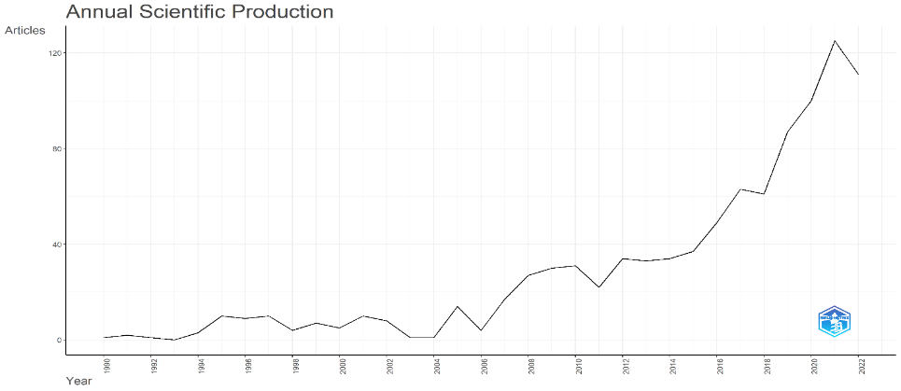

3.3 Analyzing the Contribution of Journals
In order to point out the most contributing journals, most relevant sources category has been taken it is found from Figure 2 that the journal Sustainability had the highest contribution in this domain. This journal solely published 219 research papers within the specified period. Journal of Sustainable tourism with 148 documents, Tourism management with 73, and annals of tourism Research with 53 documents are the main journals in the field of sustainable tourism.

Figure 2
Most Relevant Sources
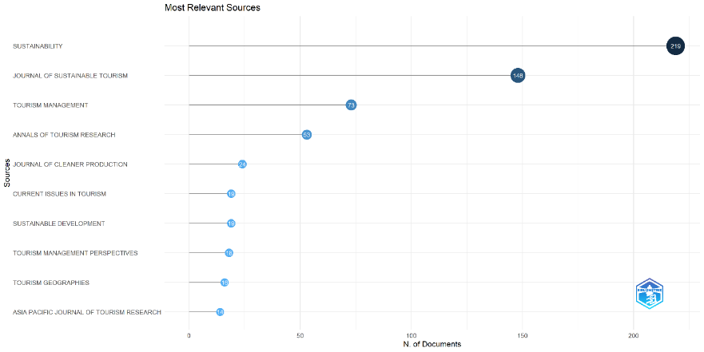

3.4 Most relevant Authors
The most relevant authors in the filed of sustainable tourism are depicted in Figure 3. Bramwell B is the top most among the ten authors with 17 publications, Lane B with 13 publications followed by Blancas F J and Lozano - Oyola M with 9 publications each.
Figure 3
Most Relevant Authors
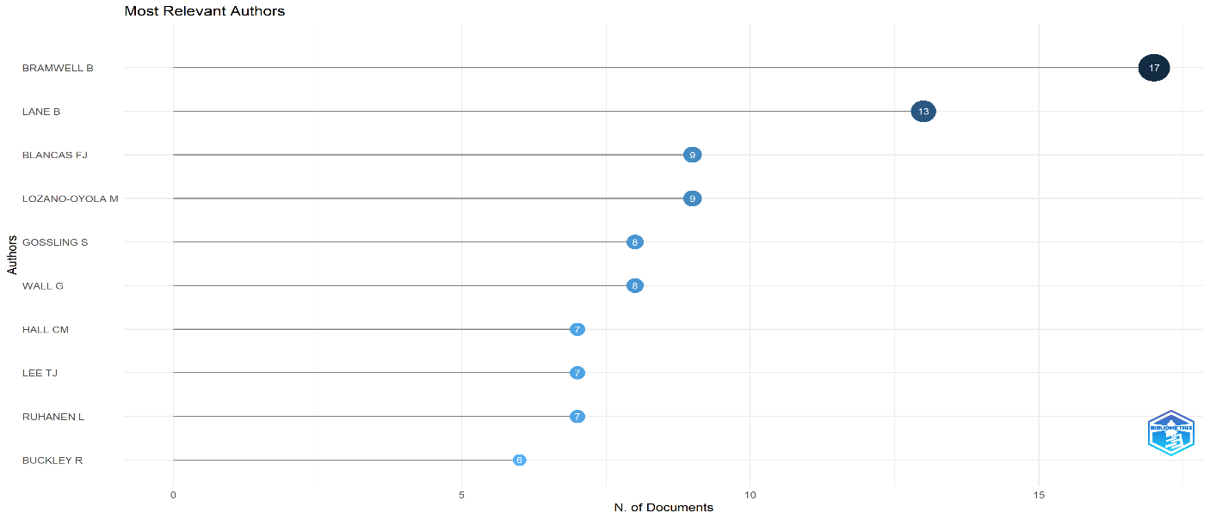

3.4 Contribution by Countries
Among different countries contribution in scholarly works on sustainable tourism (Figure 4), the bibliometric analysis found that the China had contributed the most (269 papers) followed by Spain 277 papers, and Australia 164 papers. In case of India only 18 papers were published in field of Sustainable Tourism. Hence, there is a scope for future research in the field of sustainable tourism.
Figure 4
Countries Scientific Production
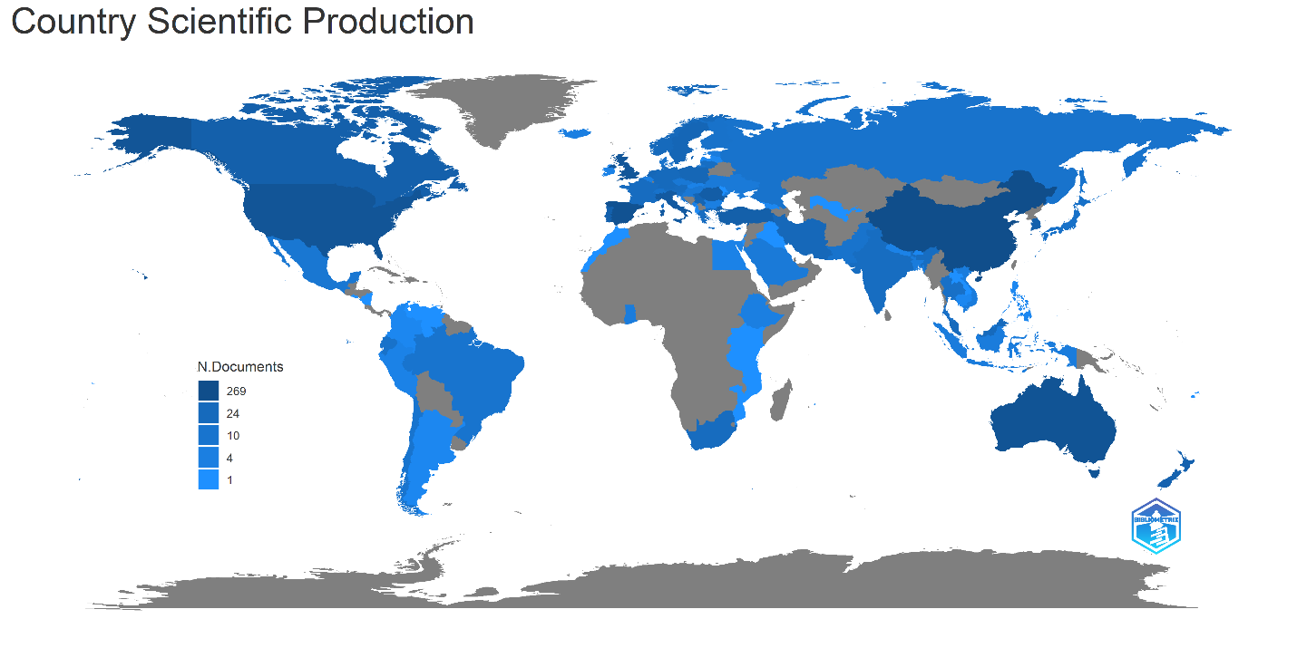

3.5 Bradford’s Law
Figure 5 shows Bradford's law of scattering, which is a description of how articles in a discipline are dispersed over the universe of journals. It reveals that most articles are on Sustainability journal followed by Journal of sustainable tourism.
Figure 5
Braford’s Law
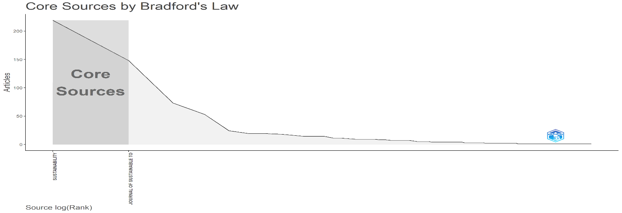

3.6 Word cloud
Word cloud shows the frequency of words used in studies related to sustainable tourism. Figure 6 shows that Management, Eco tourism, destinations, climate change, conservation and community are the frequently used key words in most of the studies.
Figure 6
Word cloud
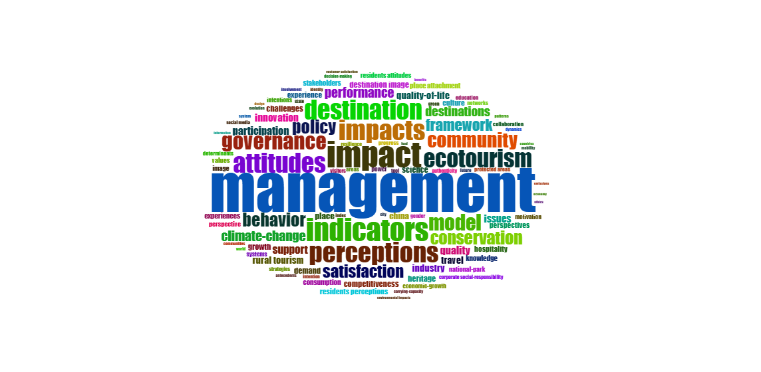
4.Conclusion
The sole purpose of this study was to provide a comprehensive review of the research published on sustainable tourism. Bibliometric analysis has been done on the topic sustainable tourism with keywords “Sustainable tourism” for a period from 1990 to 2022. Researchers working in the sustainable tourism field can use this study to develop strategies centered on the topics that are emerging (as evidenced by the data visualization in this study). Furthermore, they are capable of identifying the most influential papers, authors, and journals in this field of research. To summarize, this study has contributed significantly to the growing body of knowledge on sustainable tourism research. The study had provided new insights in the sustainable tourism research area by analyzing 951 published articles, conference papers, and book chapters from web of science database. According to the findings, academic interest in this area has skyrocketed from 2020 to 2022.
Reference
Economic review. (2022). State Planning Board, Thiruvananthapuram, Kerala, India.

Garg, P., & Pandey, A. (2021). Towards sustainable tourism: an empirical investigation. Foresight, 23(2), 188-200.

Hussain, K., Ali, F., Ragavan, N. A., & Manhas, P. S. (2015). Sustainable tourism and resulting resident satisfaction at Jammu and Kashmir, India. Worldwide Hospitality and Tourism Themes.

Kaul, H., & Gupta, S. (2009). Sustainable tourism in India. Worldwide Hospitality and Tourism Themes, 1(1), 12-18.

Kokkranikal, J., & Morrison, A. (2002). Entrepreneurship and sustainable tourism: The houseboats of Kerala. Tourism and Hospitality Research, 4(1), 7-20.

Saleem, F., Khattak, A., & Rehman, S. U. (2021). Bibliometric Analysis of Green Marketing Research from 1977 to 2020. MDPI, 9(1). https://doi.org/10.3390/publications9010001

Venugopalan, T., & Kumar, D. (2017). Sustainable development through sustainable tourism in India-A case study of Kerala tourism. Asian Journal of Research in Business Economics and Management, 7(12), 10-27.

Yadav, N., Sahu, N. C., Sahoo, D., & Yadav, D. K. (2018). Analysis of barriers to sustainable tourism management in a protected area: A case from India. Benchmarking: An International Journal, 25(6), 1956-1976.

