**A Review Paper on Self-Driving Car Using Machine Learning and Artificial Intelligence**

**ABSTRACT**

A self-driving car is one that can sense its environment and move autonomously through traffic and other obstacles with little to no human intervention. This is the most recent emerging technology in the car sector, and TESLA has produced it successfully despite years of discussion and development. These vehicles have just started to appear in global markets as both private and public transportation (taxis etc.). With this product development, numerous businesses are involved, including Waymo, UBER, Nissan, and Nvidia. With this kind of vehicle, the efficiency, security, and safety of all automobile transportation are boosted, and human errors can be eliminated while driving is performed at its highest level. This project's goal is to hasten the process.

Keywords: Machine Learning, Artificial Intelligence, Human Input, Self Driving Car.

**I. Introduction**

This paper is about creating an autonomous vehicle from scratch, specifically a self-driving radio control car. The project's objective is to create a model that can drive autonomously on a track while displaying the ability to carry out actions like lane changes. From the initial RC car model and embedded hardware platform to the end-to-end machine learning pipeline required for automated data collecting, labeling, and model training, and the project will go through every step of creating such a vehicle [1]. The main driving force behind the topic choice is the rapidly advancing state of applied artificial intelligence (AI) and the anticipated significance of autonomous vehicles on humanity's future, from independent mobility for non-drivers and low-income people to decreased pollution, reduced traffic, and increased road safety. However, it is anticipated that some of the most difficult human-planned efforts, like space exploration, would rely on autonomous vehicles. The development of such an autonomous car was made possible without the use of expensive laboratories or lengthy research because to the rapid growth of AI and deep learning (DL) techniques and frameworks. Many private businesses and academic organisations are now working on autonomous vehicles and its integration into current rules, laws, and regulations [2].

The benefits and quality-of-life enhancements that autonomous vehicles bring include safer and less crowded roads, decreased parking, and fewer automobiles per capita, as well as up to several thousand dollars saved year in travel time, fuel economy, parking benefits, and crash costs. Given the above and the well-known emergence of artificial intelligence, it is clear that the field of autonomous vehicles is only getting started and will have a significant long-term impact on society in terms of both the financial and ethical ramifications. If the discipline is to advance through expanded discussion on crucial issues and avoid stagnating in a winter of autonomous vehicles, it should be made more widely available to researchers and students, which is one of the reasons behind the topic of this paper [3].

II. Approaches In Machine Learning



A. Supervised learning: utilizes an algorithm that requires external help. Training and testing datasets are created using the input database that is provided. The training database is used to predict or categories the output variable. In order to produce results in estimating, algorithms attempt to learn particular shapes when training the database and then apply these learnt patterns to the testing database [4].

B. An approach for machine learning called unsupervised learning picks up on some properties of the input data. After offering a new database, it uses previously learnt features to identify the data class. It is mostly preferred for both clustering and feature reduction [4].

C Reinforcement learning: Action-based decision concept learning is known as reinforcement learning. In this learning, decisions are followed by actions to increase the value of the outcomes at the intended outcome or favorable situation. The learner, however, lacks any prior knowledge of the data. It learns to select the appropriate course of action after being presented with the situation. The learner's choice, or the action taken, has an impact on the circumstance now and in the future. Only two conditions are used in reinforcement learning: delayed outcome and trial-and-error searching [5].

III. Machine Learning Algorithms Used By Self-Driving Cars

a. SIFT (scale-invariant feature transform) for feature extraction

SIFT algorithms analyze images and find things. The three points of a triangular symbol, for instance, are entered as features. With those points, an automobile can then quickly detect the sign [6].

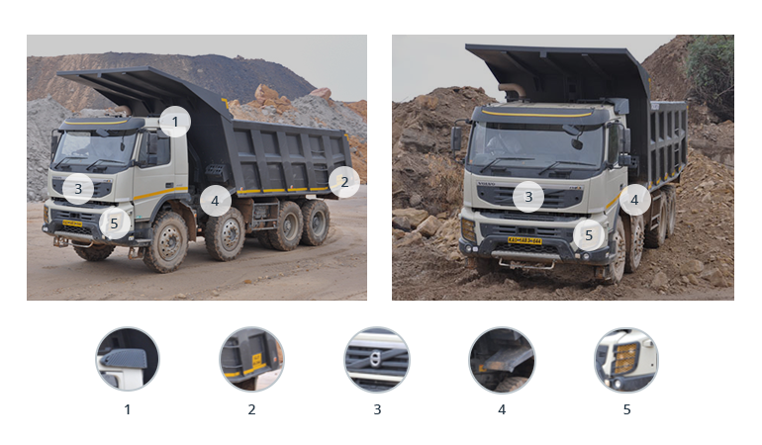

b. AdaBoost for data classification

To improve vehicle performance and learning, this programme gathers and categorizes data. To create a single high-performing classifier for better decision-making, it aggregates several low-performing classifiers [6].

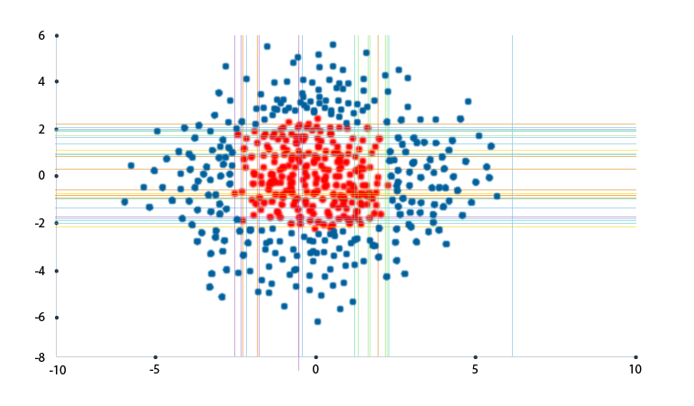

c. TextonBoost for object recognition

Similar to AdaBoost, the TextonBoost method enhances learning using textons by using data from shape, context, and appearance (micro-structures in images). It compiles visual data with recurring elements [7].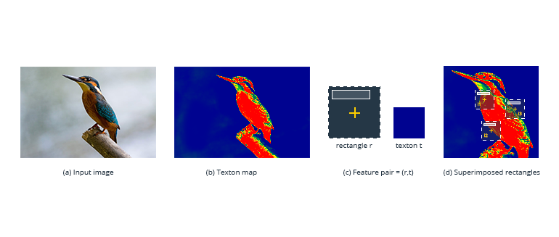

d. Histogram of oriented gradients (HOG)

HOG makes it easier to analyze a cell—the location of an object—to determine how it shifts or moves. [7]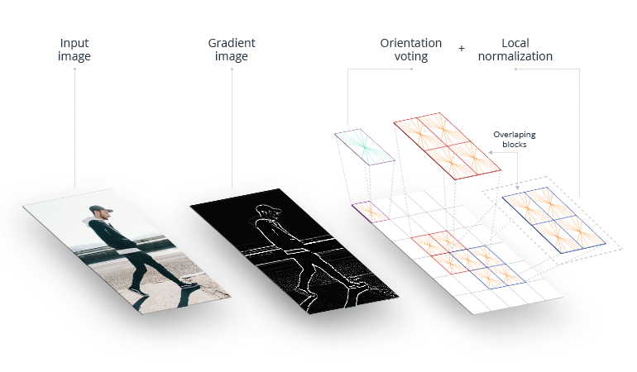

e. YOLO (You Only Look Once)

Objects including people, plants, and automobiles are detected and grouped by this algorithm. To make objects easier for the automobile to recognize, it gives distinct traits to each class of object that it groups. For classifying and identifying items, YOLO works well [8].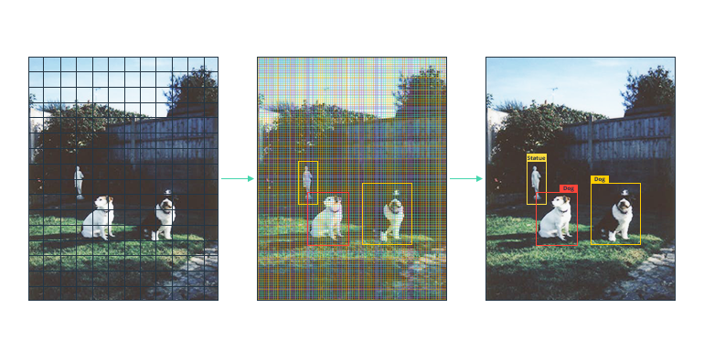f. Wrap-up

Self-driving cars are made possible by machine learning algorithms. They enable an automobile to get information from cameras and other sensors about its surroundings, understand it, and choose what actions to perform. Even automobiles can learn to accomplish these jobs as well as (or even better than) people thanks to machine learning [8].

IV. LITERATURE SURVEY

A. using a driving simulator to learn, George Hotz, Eder Santana, and the University of Florida.

The artificial intelligence method used by Comma.ai for self-driving cars is based on an agent that learns to copy driver behaviors and predicts man oeuvres by simulating upcoming road situations. This essay serves as an example of one of our study methods for driving simulation. the one where we practice simulating. Here, we examine variation auto encoders for embedding road frames using generative adversarial networks with classical and learning cost functions.[9]

B. Learning from Start to Finish for Self-Driving Vehicles, Davide Del Testa, NVIDIA Collaborations, and Mariusz Bojarski. They developed a convolution neural network (CNN) to convert front-facing camera data directly from raw pixels to steering commands. This end-to-end strategy turned out to be unexpectedly effective. The machine learns to drive in traffic on local roads with or without lane markings, on motorways, and with the least amount of training data from people. Also, it works in places with poor visibility, such parking lots and gravel roads. [9]

C. Self-Driving Vehicles' 3D Vision Perception Using a Multi-Camera System, Lionel Heng, Christian Häne, and the University of Trier in Germany. Because to their affordability, compact size, ability to operate in a variety of weather conditions, and ability to offer appearance information about the environment, cameras are an essential exteroceptive sensor for self-driving cars. They can be employed for a variety of tasks, including obstacle detection and visual navigation. A surround multi-camera system can be used to capture the whole 360-degree field of view surrounding the car .We use fisheye cameras to reduce the number of cameras required for surround perception. As a result, common vision pipelines exist for 3D mapping, visual localization, obstacle detection, etc [10].

V. CONCLUSION

This project focuses on bringing Improvements in road safety and commuting and drastically reducing accidents and human errors through continuous learning by the system because self-driving cars are the primary advancement in the automatable sector in the future. This initiative will revolutionize transportation for those with disabilities and the blind. Can drive on their own. Mobile applications can be created using our product as the foundation, allowing users to call a vehicle via an app and manufacture a fully autonomous vehicle after the law has been passed (totally autonomous vehicles are currently illegal, but they will soon become the norm for transportation).

VI.FUTURE SCOPE

Future self-driving cars have a lot of potential many automakers are rapidly developing their autonomous models, making them more accurate and secure. Accuracy is increased by using many cameras and sensors. Designing a system where each automobile is connected to nearby cars can prevent future delays.

VII .REFERENCES

[1].Raivo Sell, Anton Rassõlkin, Mairo Leier, Juhan-Peep Ernits, “Self-driving car ISEAUTO for research and education”in 19th international conference on Research and Education in Mechatronics (REM), IEEE, 2018, pp: 111-116.

[2] T. Banerjee, S. Bose, A. Chakraborty, T. Samadder, Bhaskar Kumar, T.K. Rana, “Self Driving Cars: A Peep into the Future”, IEEE, 2017, pp: 33-38.

[3] Qudsia Memon, Muzamil Ahmed and ShahzebAli, “Self Driving and Driver Relaxing Vehicle”, in IEEE 2016, pp: 170-174.

[4] U. o. M. Centre for Sustainable Systems, "Autonomous Vehicles Factsheets," 2018.

[5] 3D Visual Perception for Self-Driving Cars using a Multi-Camera System, Christian Häne, Lionel Heng, University of Trier, Germany.

[6] Artificial Intelligence: A Modern Approach Stuart J. Russel and Peter Norvig.

[7] A dynamic k-means based clustering algrothim using fuzzy logic for CH selection and data transmission based on machine learning https://doi.org/10.1007/500500-023-07964-w 14 march 2023.

[8]”.DDos attack detection using cross domain challenges and research “, IJEAT vol9.issue 1pp.2373-2382, Oct 2019, scopus indexed.

[9] Student Performance Prediction using Machine Learning by Havan Agrawal , Harshil Mavani . International Journal of Engineering Research & Technology (IJERT) ISSN: 2278-0181 IJERTV4IS030127 www.ijert.org l. 4 Issue 03, March-2015 .

[10] M. Chen, W. Saad, C. Yin, and M. Debbah, “Echo state networks for proactive caching in cloud-based radio access networks with mobile users,” IEEE Transactions on Wireless Communications, vol. 16, no. 6, pp. 3520–3535, 2017.