Novel Relative Studies: Synthesis, Characterization of Copolymer Composites and Their Antimicrobial Study

Wasudeo B. Gurnule  Department of Chemistry  Kamla Nehru Mahavidyalaya  Nagpur-440024, Maharashtra, India  *Corresponding Author Email:wbgurnule@gmail.com | Yashpal Rathod  Department of Chemistry  C. J. Patel College  Tirora-441911, Maharashtra, India | Anup Parmar  Department of Chemistry  C. J. Patel College  Tirora-441911, Maharashtra, India

ABSTRACT
The antimicrobial study of copolymer/activated charcoal composites underwent a unique comparative analysis. 8-hydroxyquinoline5-sulphonic acid, guanidine and formaldehyde were utilized to create the copolymer resin, and activated charcoal was used to create the new composite. The properties and structure of the copolymer and the copolymer/activated charcoal composite were assessed using a variety of characterisation methods, such as FTIR, NMR (1H), elemental analysis, and SEM. The differences in the antibacterial activity of copolymer/activated charcoal composites could be attributed to the material's nature, metal ions, high porosity, large surface area, and particle size. Additionally, the copolymer's and its composite's antibacterial outcomes were contrasted.
Keywords- copolymer; composite; antimicrobial studies; polycondensation; elemental analysis, disc diffusion

I. INTRODUCTION

Advanced composites known as polymeric nanocomposites are made of a polymeric matrix and nanoparticles that have been coated with polymers, allowing for the formation of a core-shell structure. Nanoparticles can be placed in a polymer matrix in the optimal morphologies due to the particular shape, chemical makeup and structure of polymers. Due to wide range of infections and diseases, the existence of dangerous microbes in the human healthiness became a major worry; rapid antibiotic resistance exacerbates the problem [1]. Contamination, persistence, adhesion, and colonization of surfaces by microorganisms have proven harmful to human health and society, microorganisms is a big issue today.
Biofilms are microbial assemblages that cling tenaciously to a substrate and reason for 80% of contaminations that increase patient stench and increase therapeutic costs. Vancomycin-safe enterococci and methicillin-safe Staphylococcus aureus (MRSA) may persist for a day on constituents utilized in healthcare organisations, according to Neely and Maley, and certain organisms can survive for over 90 days [2]. Materials with antibacterial action are being researched for biomedical application to reduce infections acquired in medical clinics as a way to combat these problems [3] [4].
Disinfectants, for example, hydrogen peroxide, hypochlorite, and so forth have a brief span of activity and ecological harmfulness issues [5]. Antimicrobial materials are equipped for restraining or killing the microorganisms on their surface or inside their environmental elements [6]. However, they have substantial clinically shortfalls such as inadequate antimicrobial effectiveness, microbial resistance concerns, the inability to work in a dynamic environment. To address the needs of biomedicine effective and durable antibacterial and biofilm-prevention constituents are essential. In order to achieve advantageous biological and physicochemical qualities, novel macromolecules with antibacterial activity as well as structural alterations of polymers are being produced [7]. Biofilms are a bacterial safeguard system that shield microscopic organisms from being washed away and make microorganisms less helpless or incapable towards poisons. Biomedical gadgets are normally utilized in emergency clinics as a feature of clinical practice. They can be a wellspring of microbial contaminations through contact with body liquids and tissues and because of openings in defensive hindrances, like the skin, leading to nosocomial or hospital-acquired infections. In the United States over 200 000–400 000, intravascular devices used each year. As a result, infection control becomes critical in order to lessen patient grief and related high medical expenses [8]. As a result, there is greater need to investigate long-term, broad-spectrum and extra effectual antimicrobial drugs, as a result of ongoing global emergent infections agents [9].
In the biomedical industry, antimicrobial polymers are widely used, especially when they come into contact with the human body. For safe use inside the body, they must meet requirements and have specific features. First and foremost, they ought to be biocompatible, inert to the body with great dependability and protection from organic liquids. In addition, as recently referenced, higher substance of microorganisms in biofilms can bring about genuine diseases and medical problems. Thusly, choosing fitting polymers against organisms is fundamental for biomedical uses [10]. Microbes can quickly develop resistance conventional antimicrobials, resulting in environmental contamination and human toxicity as a result biocidal diffusion [11] - [12]. Antibacterial polymeric materials can solve these issues by enhancing antibacterial activity and lowering residual toxicity [13].The most used material for covering nanoparticles is polymers. In most cases, organic polymer based nanocomposites have number of advantages such as good process ability, long-term stability, and catalytic, outstanding optical, electrical and magnetic capabilities. For that reason, the resultant nanocomposites could have a wide range of applications in fields such as aerospace, automotive, optoelectronics and many more. By thermal or chemical reduction of silver ions to silver nanoparticles, Bryaskova et al. prepared Ag/polyvinylpyrrolidone nanocomposites. The antimicrobial properties of the nanocomposites were investigated using a variety of fungal and bacterial strains. The findings discovered that the tested strains had a strong antimicrobial property [14]. Sheikh and colleagues synthesized methacrylate copolymers and their composites with nano‑CdS and studied thermal behaviour and antimicrobial properties from the results it has been observed that the copolymers and their composites showed excellent antimicrobial properties [15].
A synthetic approach has been developed for the new solution terpolymer derived from styrene, methyl styrene and polyaniline, as well as organo clay nanocomposites. A solution intercalation approach was used to create nanocomposites of the terpolymer with modified montmorillonite.
Additionally, Bionanocomposites that can prevent or regulate microbial colonization by adding nanoparticles with proven antibacterial activity to the polymer matrix or boosting the antibacterial characteristics already present in the matrix are urgently needed. The syn has been related to a considerable boost in the polymer matrix's capacity to kill bacteria in the second scenario [16] - [17]. In turn, this broadens the potential applications of the bionanocomposites in biomedical applications and medical devices like endotracheal tubes and vascular and urinary catheters. The polymer can also improve antibacterial performance in addition to serving as a support matrix for the nanoparticles [18] [19].
In numerous investigations, metal nanoparticles have been employed as an antibacterial agent. The metal utilized, particle mass, superficial area and structure are just a few of the factors affecting these materials' inherent biological properties. Any of these factors alone or in combination can slow the development of antibiotic resistance [20]. For possible usage in the production of dental tools, the antibacterial efficacy of PBAT-containing nanocomposites with varied Cu-NP concentrations must be evaluated. Authors have conducted a thorough comparative research of the thermomechanical and antibacterial characteristics of materials based on PBAT. Cu nanoparticles were used in PBAT nanocomposites at three different concentrations. Similar to this, Cu|Cu2O-NPs were used as the load to create nanocomposites [21].

II. EXPERIMENTAL

MATERIALS

Guanidine, formaldehyde, and 8-hydroxyquinoline-5-sulphonic acid were used exactly as supplied from Merck, India. The Merck-purchased additional chemicals and solvents were employed directly after delivery without further purification.

SYNTHESIS OF COPOLYMER AND COMPOSITE

Following a process based on prior literature [22], the 8-hydroxyquinoline-5-sulphonic acid (0.4 mol), guanidine (0.1 mol), and formaldehyde (0.5 mol) copolymer resin was created utilising the polycondensation technique on DMF medium for 6 h at 124 2°C in an oil bath.9 Scheme 1.1 depicts the copolymer synthesis mechanism. A composite made of a new copolymer and activated charcoal was created in a 1:2 ratio. The activated charcoal was added after the copolymer had been dissolved in 25 ml of DMF, and the mixture was then ultrasonically processed for 3 hours with continuous stirring for 24 hours. Last but not least, the dark colored composite was dried in an air oven at 70°C for 24 hrs.

Figure 1: Synthesis of 8-HQ5-SAGF-IV Copolymer

III. RESULTS AND DISCUSSION

Elemental analysis
Elemental analysis is a test that determines the amount of an element in a compound (usually expressed as a weight percent). 8-HQ5-SAGF-IV copolymers and their composites with nano carbon were micro analysed for carbon, hydrogen, nitrogen, and sulphur content. The estimated values and the results that were actually observed agree fairly well as shown in table 1.

Table 1: Elemental Analysis and Empirical Formula of 8-HQ5-SAGF copolymers.

Copolymer | % of C observed (Cal.) | % of H observed (Cal.) | % of N observed (Cal. | % of S observed (Cal. | Empirical formula of repeated unit | Empirical formula Weight
8-HQ-5SAGF-IV | 46.96  (47.68) | 3.11  (3.68) | 9.16  (9.27) | 12.00  (12.10) | C₄₂H₃₉N₇O₁₈S₄ | 1057.12

Molecular weight determination

The (8-HQ5-SAGF-IV) copolymer's average molecular weight was determined using gel permeation chromatography. The following table 2 displays the molecular weights of the copolymer (8-HQ5-SAGF-IV) in terms of weight average (${\overline{M}}_{w}$) and number average (${\overline{M}}_{n}$).

Table 2: Determination of Number Average, Weight Average and Size Average Molecular Weight by GPC of (8-HQ5-SAGF-III) Copolymer.

Copolymer  sample | weight average molecular weight (${\overline{M}}_{w}$) | number average (${\overline{M}}_{n}$) molecular weight | size average (${\overline{M}}_{z}$) molecular weight | The polydispersity index (${\overline{M}}_{w}$/${\overline{M}}_{n}$) | The polydispersity index (${\overline{M}}_{z}$/${\overline{M}}_{w}$)
(8-HQ5-SAGF)-IV | 10698 | 10663 | 10725 | 1.0032 | 1.0025

The copolymer (8-HQ5-SAGF-IV) was found to have a polydispersity index(${\overline{M}}_{w}$/${\overline{M}}_{n}$) of 1.0032. Additionally, it was discovered that the copolymer (8-HQ5-SAGF-IV) has a polydispersity index (${\overline{M}}_{z}$/${\overline{M}}_{w}$) of 1.0025.
The copolymer's polydispersity index (${\overline{M}}_{w}$/${\overline{M}}_{n}$) and (${\overline{M}}_{z}$/${\overline{M}}_{w}$) values amply demonstrate the copolymer's narrow molecular weight dispersion.

FTIR

The FTIR spectra for copolymers is shown in Fig. 2. The stretching frequency of the phenolic hydroxy (-OH)group is responsible for an expanding band in the copolymer spectra that is observable at a wavelength of 3537 cm-1 and is indicative of intermolecular hydrogen bonding [23]. The peak at 3102–3080 cm⁻¹ may reflect stretching vibrations of the -NH linkage (imide), while the sharp band at 820 cm⁻¹ designates the bending vibrations of the -NH (imide) group [24]. The distribution of a solid peak at 2801 cm-1 may have resulted from aromatic -CH stretching. The quinoline ring stretching frequency of -C=C may be the cause of the band that appears between 1600 and 1400 cm⁻¹. Methylene bridges can be detected in the polymeric chain between 1421 and 1503 cm⁻¹. At 821, 1050, 1144, and 1200 cm-1, the quinoline ring's tetra substitution moiety 1, 4, 6, and 8 are discernible.

The FTIR spectra of the synthesized 8-HQ5-SAGF-IV-C composites are shown in (Fig. 2). The -OH group is proven to have appeared from the copolymer by the strong band assigned at 3405 cm-1, respectively [25]. The band at 1461 & 1553 cm⁻¹, respectively, can be attributable to the presence of -NH bending vibrations. Additionally, from copolymer caused the aromatic ring to stretch, which caused the band to form at 3080 & 2850 cm⁻¹, respectively. The band may have been caused by the C-N stretching vibration shifting from the copolymer at 1498 and 1461 cm⁻¹, respectively. This clearly implies the creation of composites, and the presence of distinct absorption bands in the composites confirms the presence of an interface between the copolymer and the charcoal and chitosan. Considering the aforementioned evidence, copolymer and carbon (activated charcoal) are firmly established in the formation of composites.

Figure 2: FTIR Spectra of 8-HQ 5-SAGF Copolymer and its composites
¹H NMR Spectra

The spectra of the 8-HQ 5-SAGF-IV copolymer's ¹H NMR investigation, which was conducted in DMSO d₆, is shown in Fig. 3. The protons in the quinoline ring are assigned to the multiple signal in the region of 8.16 (δ) ppm [26]. The phenolic hydroxyl group is accredited to a clear and consistent signal at 9.1 (δ) ppm. -NH bridging might be allotted to a signal acquired at d 4.9 ppm, and the -C=NH proton may be assigned at d 7.0 ppm (imine). The -SO3Hgroup was given the sharp singlet at 9.8 (δ) ppm.

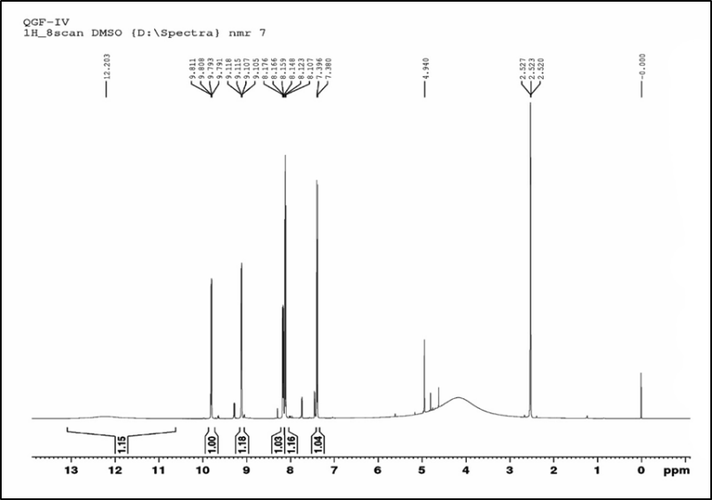

Figure 3: ¹H NMR Spectra of 8-HQ 5-SAGF Copolymer

Surface analysis

SEM were utilized to examine the superficial characteristics of the copolymer and its composite. SEM images of the copolymer and its composite are presented in Figure 4. The composite and its copolymer, as seen in the image, have bigger pore architectures that can act as a more effective site for increased heavy metal ion adsorption. The copolymer's structure in Figure 4 includes a significant amount of surface void space, which suggests that metals can easily be adsorbed there. The large dimple and the reinforcing particles were combined to create the copolymer structure. High porosity and permeability can be found in the copolymer's surface microstructure [26]. A SEM image of the copolymer composite is shown in Figure 3.16. The pores in the composite are diverse. The copolymer and carbon have been bonded, as shown by the micrograph, which also displays a new active site adhesive in a sputter cluster on the surface. The composite's surface area grows more than the copolymer's does.

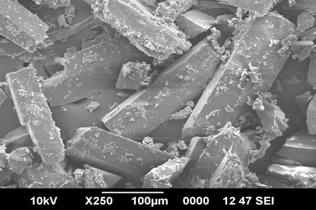  8-HQ5-SAGF-IV | 8-HQ5-SAGF-IV-C
Fig. 4 SEM images of 8-HQ 5-SAGF Copolymer and its composites

Antimicrobial studies

Protocol for antibacterial activity
A biological assay evaluates the inhibition of microorganism growth by comparing the concentration of the sample under investigation with a recognised concentration of a reference antibiotic. Utilising in vitro disc diffusion, the antibacterial analysis was performed. In this study, the effects of several human pathogenic bacteria, including fungi (Candida albicans and Aspergillus niger) and Gram-positive (Staphylococcus aureus) and Gram-negative (Escherichia coli), on copolymers and their composites were investigated. The nutrient agar medium was boiled and sterilised by an autoclave at 7 kg pressure (121 °C) for 15 minutes to assess the antibacterial activity. 20mL of media was added to the disinfected petri plates, which were then left at room temperature for a short while to allow the media to harden. After that, it was manually injected with bacteria using sterile swabs and incubated for 12 hours.
The chemicals were added to the test solution after being dissolved in DMSO. A micropipette containing the media was filled, and it was then incubated for 48 hours at 35 °C. Similar steps were taken for the antifungal analysis, using potato dextrose as a control.
As the test fluid diffuses over time, it affects how well inoculation bacteria like Candida albicans, Staphylococcus aureus, and Escherichia coli thrive. The activity that formed on the plate was calculated from the millimetre diameter of the inhibited zone. For bacteria, ciprofloxacin was the gold standard, whereas nystatin was utilized for fungus.
For antimicrobial study, the findings of the microbiological screening of the 8-HQ 5-SAGF-IV copolymer and their composites are shown in Table 3. The 8-HQ 5-SAGF copolymer outperformed the industry standard in regard to its performance against the E. coli bacterium. The gram-negative rod-shaped bacterium E. coli causes infections in the urinary tracts of people. Infections caused by the gram-negative, non-motile Klebsiella bacteria include pneumonia, septicemia, and disorders of the soft tissues. The results indicated effective action against Klebsiella. Gram-positive, spherical S. aureus bacteria cause dangerous conditions like pneumonia, osteomyelitis, endocarditis, and harmful shock disorder. The results of the experiment revealed that the resins had a moderate amount of activity against S. aureus species. The 8-HQ 5-SAGF-IV copolymer and its composites antibacterial activity was displayed in Fig. 5.
Using Ciprofloxacin as a reference antibiotic, the antibacterial activity of the 8-HQ 5-SAGF-IV copolymer and its composites was assessed using the disc diffusion method. The synthesized compounds were tested against the bacteria Escherichia coli, Klebseilla species, Candida albicans, Candida tropicalis, and A. niger. The test's findings, which are shown in table 3, suggested that the metal composites and copolymer are effective against specific species. The 8-HQ 5-SAGF-IV copolymer and its composites antibacterial activity was displayed in Fig. 5.
The copolymer and its composites were assessed for antibacterial activity alongside E. coli, Klebsiella, K. pneumoniae as well as A. niger which causes aspergillosis and the growth of which is, to some extent, restricted by the composites, in order to study antimicrobial characteristics. Diseases can be brought on by the Candida albicans, which can enter the intestinal walls. The results show that the addition of 8-HQ 5-SAGF composites inhibits the development of Candida albicans, and the results are shown as zone inhibition values in Table 3. The copolymer and composites exhibit acceptable activity against S. aureus, and E. coli, K. pneumoniae. In contrast to Klebsiella and E. coli, the copolymer 8-HQ 5-SAGF exhibits an inhibitory zone of 18, 20 mm.
The 8-HQ 5-SAGF-IV composite showed the greatest antibacterial activity (20 mm) against K. pneumonia Klebsiella. The composites exhibit superior activity compared to the copolymer; this may be due to the composites interactions with the copolymer's donor atoms and the delocalization of the π-electron throughout the complete quinoline ring. As a result, composites' lipophilic characteristics increase. The presence of -OH and the aromatic ring in composites improves their antibacterial properties [27].

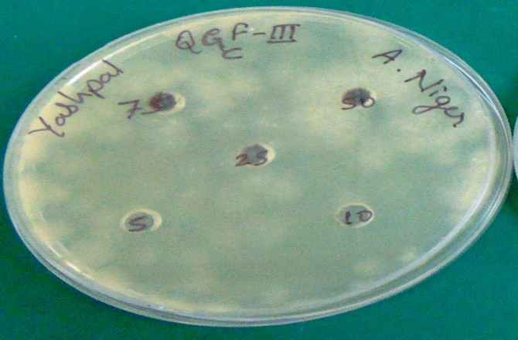  a) A. niger | 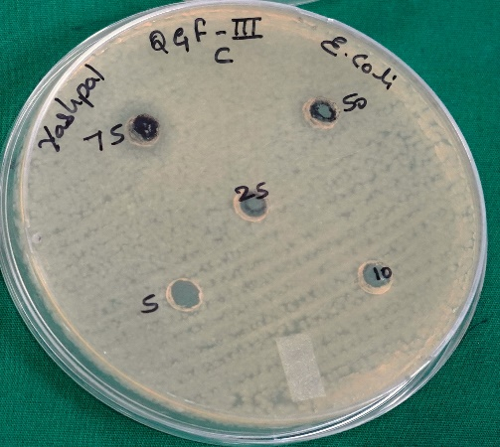  b) E. coli
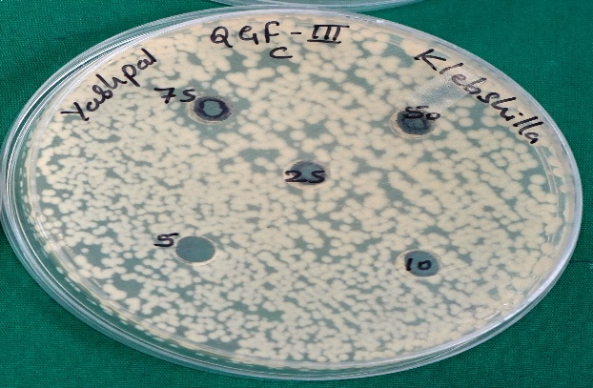  c) Klebsiella species | 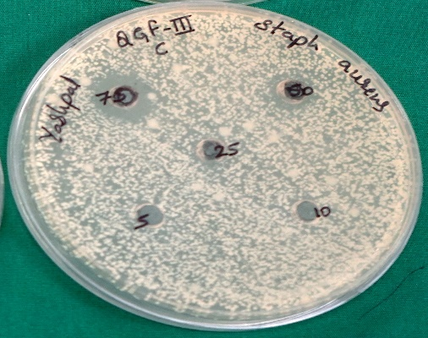  d) S. aureus
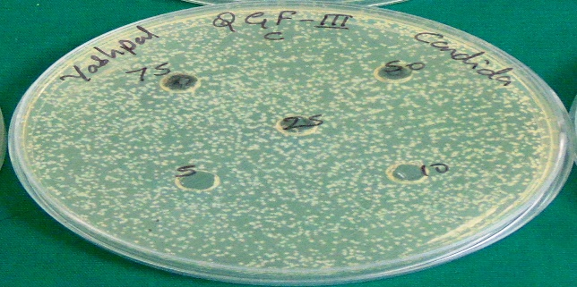  e) C. tropicals | 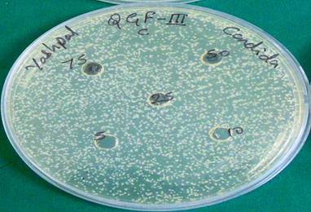  f) C. albicans
Fig. 5 Antibacterial Activity of 8-HQ 5-SAGF-IV copolymer (a) A. niger (b) E. coli (c) Klebsiella species (d) S. aureus (e) C. tropicals (f) C. Albicans

Table 3. Antimicrobial activity of 8-HQ 5-SAGF copolymer
Copolymer |  | Inhibition Zone (mm)
 | E. coli | Klebeseilla sp. | S.aureus | A.niger | C. albicans | C. tropicals
8-HQ 5-SAGF-IV | 18 | 20 | 18 | 19 | 24 | 22
8-HQ 5-SAGF-IV-C | 25 | 23 | 22 | 23 | 20 | 26
Standard | 26 | 32 | 34 | 38 | 30 | 26
Control | - | - |  | - | - | -
Standard=Ciprofloxacin Control= DMSO

IV CONCLUSION

The novel composite was made using guanidine, formaldehyde, and 8-hydroxyquinoline-5-sulphonic acid. The structure and properties of the copolymer and copolymer/carbon composite were examined using a variety of characterization techniques, including elemental analysis, FTIR, UV-Visible, NMR (¹H), and SEM. The copolymers and composites were also examined using an antimicrobial analytical method. The antimicrobial analysis has been studied using the disc diffusion method. When it comes to specific bacteria like Staphylococcus aureus, Escherichia coli, and fungus like Aspergillus niger and Candida albicans, the copolymer and its composites have antibacterial activity. SEM was used to determine the surface morphology of the copolymer and its composites. The composites have greater efficacy against Aspergillus niger, Staphylococcus aureus, and other bacterial species including Escherichia coli.

REFERENCES

[1] | N. Beyth,Y. Houri-Haddad, A. Domb,W. Khan and R. Hazan, "Alternative antimicrobial approach: nano-antimicrobial materials," Evid Based Complement Alternat Med., p. 246012, 2015.
[2] | A. N. Neely and M. P. Maley, "Survival of enterococci and staphylococci on hospital fabrics and plastic," J Clin. Microbiol., vol. 38, pp. 724-726, 2007.
[3] | A. Jones, A. Mandal and S. Sharma, "Protein-based bioplastics and their antibacterial potential," J Appl PolymSci, vol. 132, p. 41931, 2015.
[4] | F. Siedenbiedel and J. C. Tiller, "Antimicrobial polymers in solution and on surfaces: overview and functional principles," Polym, vol. 4, pp. 46-71, 2012.
[5] | A. Jain,L.S. Duvvuri ,S. Farah,N. Beyth, A. J. Domb and W. Khan, Adv. Healthcare Mater, vol. 3, pp. 1969-1985, 2014.
[6] | E. R. Kenawy, S.D. Worley and R. Broughton, "The chemistry and applications of antimicrobial polymers: a state-of-the-art review," Biomacro., vol. 8, p. 1359 –1384, 2007.
[7] | A. Jones, J. Pant, E. Lee, M. J. Goudie, A. Gruzd, J. Mansfield, A. Mandal A., Sharma S. and H. Handa, "Nitric oxide-releasing antibacterial albumin plastic for biomedical applications," J Biomed Mater Res Part A, vol. 106, pp. 1535-1542, 2018.
[8] | Y. Xue,H. Xiao and Y. Zhang, "Antimicrobial Polymeric Materials with Quaternary Ammonium and Phosphonium Salts," Int J MolSci, vol. 16, pp. 3626-3655, 2015.
[9] | A. D. Fuchs and J. C. Tiller , "Contact-Active Antimicrobial Coatings Derived from Aqueous Suspensions," Angew Chem. Int Ed, vol. 45, pp. 6759-6762, 2006.
[10] | J. M. Thomassin , S. Lenoir, J. Riga, R. Jerome and C. Detrembleur, " Grafting of poly[2-(tert-butylamino)ethyl methacrylate] onto polypropylene by reactive blending and antibacterial activity of the copolymer.," Biomacromolecules, vol. 8, pp. 1171-1177, 2007.
[11] | M. F. Ilker, K. Nusslein, G. N. Tew and E. B.Coughlin, "Tuning the Hemolytic and Antibacterial Activities of Amphiphilic Polynorbornene Derivatives,," J Am Chem Soc, vol. 126, pp. 15870-15875, 2004.
[12] | C. Dong,Y. Ye,L. Qian, G. Zhao,B. He, and H. Xiao , "Antibacterial modification of cellulose fibers by grafting β-cyclodextrin and inclusion with ciprofloxacin," Cellulose, vol. 21, pp. 1921-1932, 2014.
[13] | I. Y. Jeon, J. B. Baek, "Nanocomposites Derived from Polymers and Inorganic Nanoparticles," Mater.,, vol. 3, pp. 3654-3674, 2010.
[14] | R. Bryaskova,D. Pencheva,S. Nikolov,T. Kantardjiev, "Synthesis and comparative study on the antimicrobial activity of hybrid materials based on silver nanoparticles (AgNps) stabilized by polyvinylpyrrolidone (PVP)," J Chem Biol, vol. 4, pp. 185-191, 2011.
[15] | M. I. Shekh, D. M. Patel, N. N. Patel,U. S. Patel,K. P. Patel,R. M. Patel, "Methacrylate copolymers and their composites with nano-CdS: synthesis, characterization, thermal behavior and antimicrobial properties," Inter J of Ind Chem, vol. 9, pp. 153-166, 2018.
[16] | E. Kenawy, S. D. Worley, and R. Broughton, "The Chemistry and Applications of Antimicrobial Polymers: A State-of-the-Art Review, J Appl Polym Sci 89 (2003) 895.," Biomacromolecules, vol. 8, no. 5, pp. 1359-1384, 2003.
[17] | P. Hemalatha, M. K. Veeraiah, S. Prasannakumar, K. V. Anasuya, "Synthesis, characterisation and antibacterial activity of copolymer (N-vinylpyrrolidone-maleic anhydride) with Ndiethylethanolamine," Int. Res. Engg. Tech., vol. 3, no. 3, pp. 56-64, 2014.
[18] | M. P. Muller, C. MacDougall and M. Lim, "Antimicrobial surfaces to prevent healthcare-associated infections: a systematic review," J Hosp. Inf., vol. 92, no. 1, pp. 7-13, 2016.
[19] | S. Alfei, G. Piatti , D. Caviglia and A. M. Schito, "Synthesis, Characterization and Bactericidal Activity of a 4-Ammoniumbuthylstyrene-Based Random Copolymer," Polym, vol. 13, no. 7, p. 1140, 2021.
[20] | M. R. Berber , "Current Advances of Polymer Composites for Water Treatment and Desalination," Hindawi J of Chem, pp. 1-19, 2020.
[21] | A. F. Jaramillo, S. A. Riquelme, G. Sánchez-Sanhueza, C. Medina, F. Solís-Pomar, D. Rojas, C. Montalba, M. F. Melendrez and E. Pérez-Tijerina, "Comparative Study of the Antimicrobial Effect of Nanocomposites and Composite Based on Poly(butylene adipate-co-terephthalate) Using Cu and Cu/Cu2O Nanoparticles and CuSO4," Nanoscale Res Lett., vol. 14, p. 158, 2019.
[22] | W. B. Gurnule and Y. U. Rathod, "Synthesis, Characterization and Thermal Behaviour Studies of Terpolymer Resin Derived from 8-Hydroxyquinoline-5-Sulphonic Acid and Anthranilic Acid," Curr. Appl. Polym.Sci. , vol. 4, pp. 47-54, 2021.
[23] | Y. U. Rathod, S. B. Zanje and W. B. Gurnule, "Hydroxyquinoline copolymers synthesis, characterization and thermal degradation studies," J Phy Conf Series, vol. 1913, p. 012061, 2021.
[24] | W. B. Gurnule, K. Vajpai and A. D. Belsare, "Selective removal of toxic metal ions from waste water using polymeric resin and its composite," Materials Today: Proceeding, vol. 36, pp. 642-648, 2021.
[25] | Y. U. Rathod, V. U. Pandit, D. S. Bhagat and W. B. Gurnule, "Synthesis of copolymer and its composites with carbon and their photoluminescence studies," Materials Today: Proceedings, vol. 53, pp. 123-129, 2022.
[26] | M. A R. Ahamed, R. S. Azarudeen, D. Jeyakumar and A. R Burkanudeen, "Terpolymer chelates: synthesis, characterization and biological applications," Int. J. Polym. Mater, vol. 60, no. 2, pp. 124-143, 2010.
[27] | S. W. D. a. W. B. G. Y. U. Rathod, "Synthesis, Characterization and Antimicrobial Studies of a Copolymer and Its Composite," Int. J. Adv. Res. in Sci. Commn. and Tech., vol. 12, no. 4, pp. 444-449, 2021.
[28] | R. S. Azarudeen, M. A. R. Ahamed, R. Subha and A. R. Burkanudeen, "Heavy and toxic metal ion removal by a novel polymeric ion-exchanger: synthesis, characterization, kinetics and equilibrium studies," J. Chem. Tech. and Biotech., vol. 90 , no. 12, pp. 2170-2179, 2015.

