Biofuels & Biotech Advancements

Sidharth Ramanand
Scientist, Enzyme Application Research
Hørkær 21C, 1.2, Herlev 2730
Denmark
sidharth.17@gmail.com

ABSTRACT
Biofuels hold promise as sustainable alternatives to fossil fuels. Biotechnology is revolutionizing biofuel research by enhancing production efficiency, feedstock availability, and environmental sustainability. As technology continues to evolve, biofuels may play a crucial role in mitigating climate change and transitioning towards a greener energy future.

Keywords- biofuels, carbon footprint, environmental impacts, life cycle assessment, transport, sustainability
- Introduction to Biofuels
In the quest for sustainable energy sources, biofuels have emerged as a promising alternative to fossil fuels. Biofuels are derived from renewable organic materials such as plants, algae, and agricultural waste. They offer the potential to reduce greenhouse gas emissions, decrease dependence on fossil fuels, and promote energy security. This chapter delves into the basics of biofuels, their production processes, and the role of biotechnology in advancing biofuel technologies.
Biofuels are renewable energy sources derived from organic materials, primarily plants and plant-derived materials. They serve as alternatives to fossil fuels, aiming to reduce greenhouse gas emissions and dependence on non-renewable resources. Biofuels are generally categorized into two main types: first-generation and second-generation, with third and fourth generation biofuels also being recognized. (Fig.1)
First-generation biofuels are produced from food crops like corn, sugarcane, and vegetable oils. They have faced criticism for competing with food production and leading to deforestation. Second-generation biofuels, on the other hand, are made from non-food feedstocks such as agricultural waste, algae, and dedicated energy crops. They are more sustainable as they don't directly compete with food production.
The greenhouse emission potential of biofuel varies considerably, from levels comparable to fossil fuels in some situations to negative emissions in others. The Intergovernmental Panel on Climate Change (IPCC) determines bioenergy as a renewable energy form.
- Biotechnology in Biofuel Research
Biotechnology plays a crucial role in advancing biofuel research by optimizing the production process, enhancing fuel yields, and developing more efficient feedstocks. Key biotechnological approaches include:
Microbial Fermentation: Microorganisms like bacteria and yeast can convert sugars and cellulose from plant materials into biofuels like ethanol and butanol. Genetic engineering is used to create strains with enhanced fermentation capabilities.
Enzymatic Hydrolysis: Enzymes are used to break down complex plant materials into simpler sugars, which can then be fermented into biofuels. Researchers are focused on improving enzyme efficiency and stability.
Algae Cultivation: Algae can produce lipids that can be converted into biodiesel. Biotechnological advancements aim to increase lipid production and streamline extraction processes.
Genetic Modification of Crops: Scientists are engineering energy crops with higher energy yields, faster growth rates, and resistance to environmental stresses.
Synthetic Biology: This emerging field involves designing and constructing biological systems for specific functions. Synthetic biology is being explored to create microorganisms that produce biofuels more efficiently.
- Types of Biofuels
Biofuels are generally of two categories: gaseous biofuel and liquid biofuel. Biogas and syngas are two types of gaseous biofuels. Biogas is methane generated in the process of anaerobic digestion of organic matter by anaerobes. With the removal of impurities from biogas, biomethane is produced. Syngas is a mix of carbon monoxide, hydrogen, and other hydrocarbons, which is produced by the partial combustion of biomass. Partial combustion is fuel-burning with insufficient oxygen to convert the biomass entirely to carbon dioxide and water. Syngas can be utilized to make methanol, Dimethyl ether (DME, [10]), and hydrogen.
The most common types of liquid biofuels are bioethanol and biodiesel. Bioethanol is a type of alcohol produced by fermentation, often from carbohydrates made in sugar or starchy crops like corn, sugarcane, or sweet sorghum. Cellulosic biomass obtained from non-food sources, including trees and grasses, is also being developed as a raw material for ethanol production. The pure form of ethanol (E100) can be used as a fuel for vehicles, but it is usually applied as an additive to gasoline to increase octane and enhance vehicle emissions.
Biodiesel, as the most common biofuel in Europe, is generated from oils or fats using transesterification. The pure form (B100) can be employed as a fuel for vehicles but is commonly used as a diesel additive to reduce particulate matter, carbon monoxide, and hydrocarbons in diesel vehicles.
- Advantages of Biofuels
Efficiency- Biofuel is produced from renewable resources and is relatively less-flammable than fossil diesel. It has significantly better lubricating properties and emits less harmful carbon compared to standard diesel.
Cost- Presently, the price of biofuels in the market is the same as gasoline. However, in terms of overall cost, the benefits of using biofuels is much higher. They are cleaner fuels, meaning that they produce fewer emissions during burning. As the demand for biofuels increases, it is also possible that they will become cheaper in the future.
According to the report of the RFA (Renewable Fuels Association) in February 2019, ethanol is the highest-octane and the least expensive motor fuel on earth. Aiming for a cost reduced biofuel availability enables high-value products from biomass or waste resources, as well as the reduction in the cost of bioenergy production.
Durability- Biofuels are compatible with current engine designs and work very well in most conditions. When biodiesel is utilized as a combustible fuel, engine durability increases. The engine requires no conversion and allows it to run for longer periods with less maintenance and reduces overall pollution check costs. Engines designed to operate on biofuels produce lower emissions than other diesel engines.
Renewable- Gasoline is refined from crude oil, a non-renewable resource. Biofuels are made from various sources, including manure, crop waste, algae, other byproducts, and plants grown specifically for fuel.
Most fossil fuels will expire one day. Because most sources such as manure, corn, soybeans, switchgrass, and waste from crops and plants are renewable and do not run out any time soon, the use of biofuels in nature is efficient.
Reduction in Greenhouse Gas Emissions- Studies show that biofuels decrease greenhouse gases by up to 65 percent. When fossil fuels burn, they produce large amounts of greenhouse gases in the atmosphere, such as carbon dioxide. The greenhouse gases bring about global warming by trapping sunlight. Furthermore, the burning of coal and oil raises the temperature and warms the planet.
Economic Security- Being forced to import oil creates problems for any country’s economy. A country can diminish its dependence on fossil fuels if it employs biofuels. Biofuel production boosts the demand for suitable biofuel products and strengthens the agriculture industry. Fueling homes, businesses, and vehicles with biofuels is less expensive compared to fossil fuels. With the growth of the biofuel industry, more jobs will be created, which will help keep the economy secure. As crude oil prices rise, we need several alternative energy solutions to reduce dependence on fossil fuels.
Reduced pollution- Because biofuels can be produced from renewable resources, they bring less pollution to the planet. Apart from this they emit less carbon dioxide and other emissions when burned compared to standard diesel. Its use also leads to a significant reduction of particulate matter emissions, the term used to explain solid particles and liquid droplets in the air.
Although the creation of biofuels produces carbon dioxide as a byproduct, it is often used to grow plants that are converted into fuel. This makes it something close to a self-sustaining system. In addition, biofuels are biodegradable, which reduces the risk of contamination of underground water during transportation, storage, or use.
- Disadvantages of Biofuels
Technical Challenges- A few technical challenges exist in implementing biofuels. The simplest drawback is that it will work differently in engines developed for petroleum-based fuel. For example, the density of corn-based ethanol is higher than gasoline; fuel injectors must be larger in an ethanol-only engine to suit the fuel flow of a comparable gasoline engine. Corrosion of metal and rubber fittings, new injectors, gaskets and fuel-line requirements and adjustments to ignition timing are also a few other technical challenges.
Also, the higher gel point of many biodiesel-producing oils than petroleum makes it difficult, if not impossible, to start a biodiesel engine in cold weather. The problem is worse for pure vegetable oil as a fuel, in so-called grease cars. Users will usually have to install heating units to protect the fuel tank and lines free from gelled fuel or dual-fuel mechanisms flushing the engine with petroleum diesel during start-up and shut-down. Several manufacturers sell biodiesel and grease car conversion components, and some others find methods to overcome the gelling problem. But the conversions impose additional time and money on the biofuel users.
Genetic Engineering of Biofuel Crops- Farmers of corn, cotton, and soybeans, all possible sources of biofuel, are increasingly planting genetically modified types of those plants. This is not the selective breeding they have followed for years; genetically modified crops are developed in the laboratory to tolerate herbicides better, fight off pests, and have higher yields. Enough research and regulatory requirements must be met before genetically modified crops for biofuels are planted and grown in large scale.
Monoculture- Monoculture refers to the production of one concentrated crop rather than the rotating of different crops through a farmer’s field over time. Although this is an economically attractive measure, the greater economic profitability for the farmer can have serious environmental disadvantages. Thousands of hectares of unbroken acres of one crop are an irresistible destination for plant pests exploding uncontrollably in this tempting environment.
Long-time monoculture farms also employs much more fertilizer than sustainable peers, and this increases water pollution. The unique nature of a monoculture crop raises the risk of a complete loss for the farmer; if a severe strain of corn blight hits an ethanol-producing corn farm, there will be significant damage.
Variation in Biofuel Quality- Many biofuel crops are applied to produce biodiesel. The oil in their grains is pressed out, filtered, and reformed to fuel by a chemical process. But while different crops can be converted to biodiesel through the same process, the resulting fuel can be very different in its ability to produce energy.
Firstly, the output varies due to different climatic and local conditions. Second, the oil produced by these plants is not identical. This difference affects the viability of the oil as fuel. When choosing unsaturated oil as a biofuel source sounds reasonable, there is another problem that appears with numerous unsaturated oils having undesirable burn properties and leaving gummy residues in the engine.
Fuel Use- Some scientists argue that producing enough biodiesel or ethanol to replace one gallon of petroleum fuel needs energy equal to several gallons value of petroleum fuel. Extensive production of biofuel is a negative-sum game. While technology eventually will limit these ratios, the ratio of energy input to the output of modern biofuel production is an important disadvantage to its widespread use.
Water Use- The water demands of some biofuel crops can put unsustainable pressure on local water resources. Genetically engineered less-thirsty crops are the need of the hour.
Food Security- Biofuel production utilizing food crops such as corn can drastically change the world’s access to cheap food. It could be a threat to food security or access to adequate nutritious food for the population.

One way to deal with this lies in simple diplomacy: The globalization of world commerce means that today it is easier than ever to transfer food supplies from one point of the world to another in response to increased need. However, ease of access to food imports and export depends on a wide variety of political and social factors.
VI. Examples and Graphs
Figure 1: Different generations of Biofuels [9]
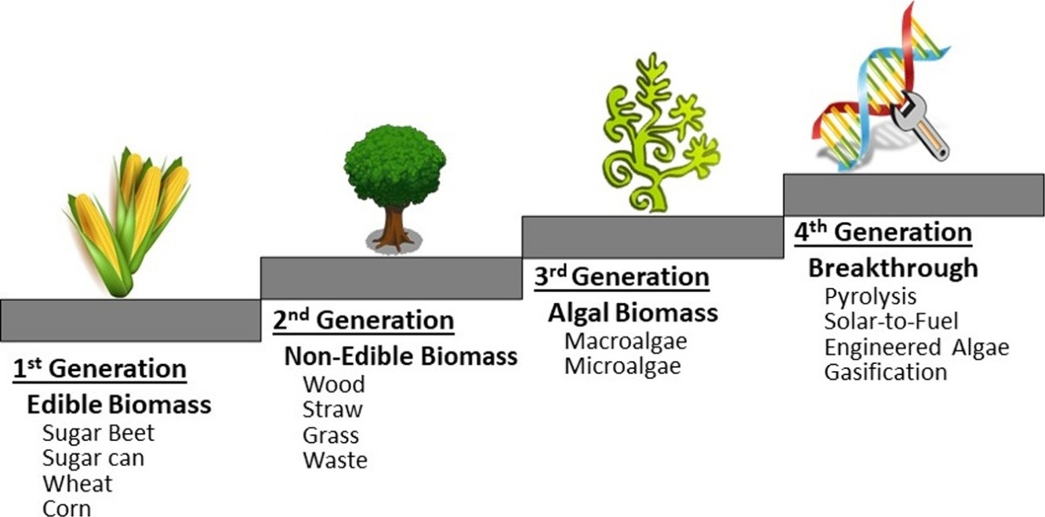
Figure 2: Biodiesel cycle [11]
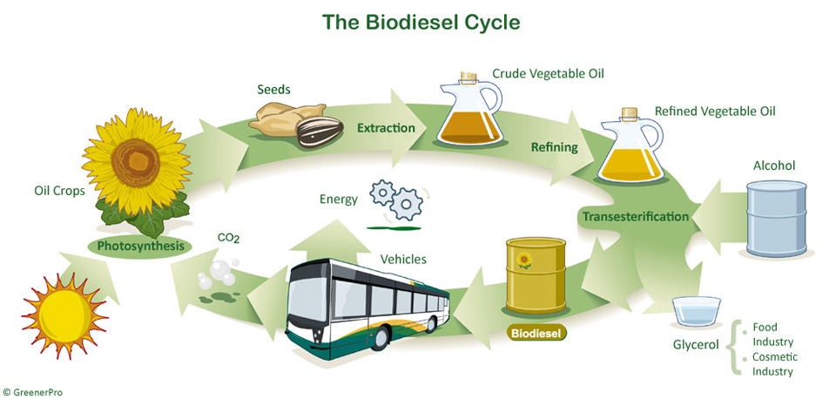
Figure 3: Biofuel production by country/region and fuel type, 2016-2022 [12]
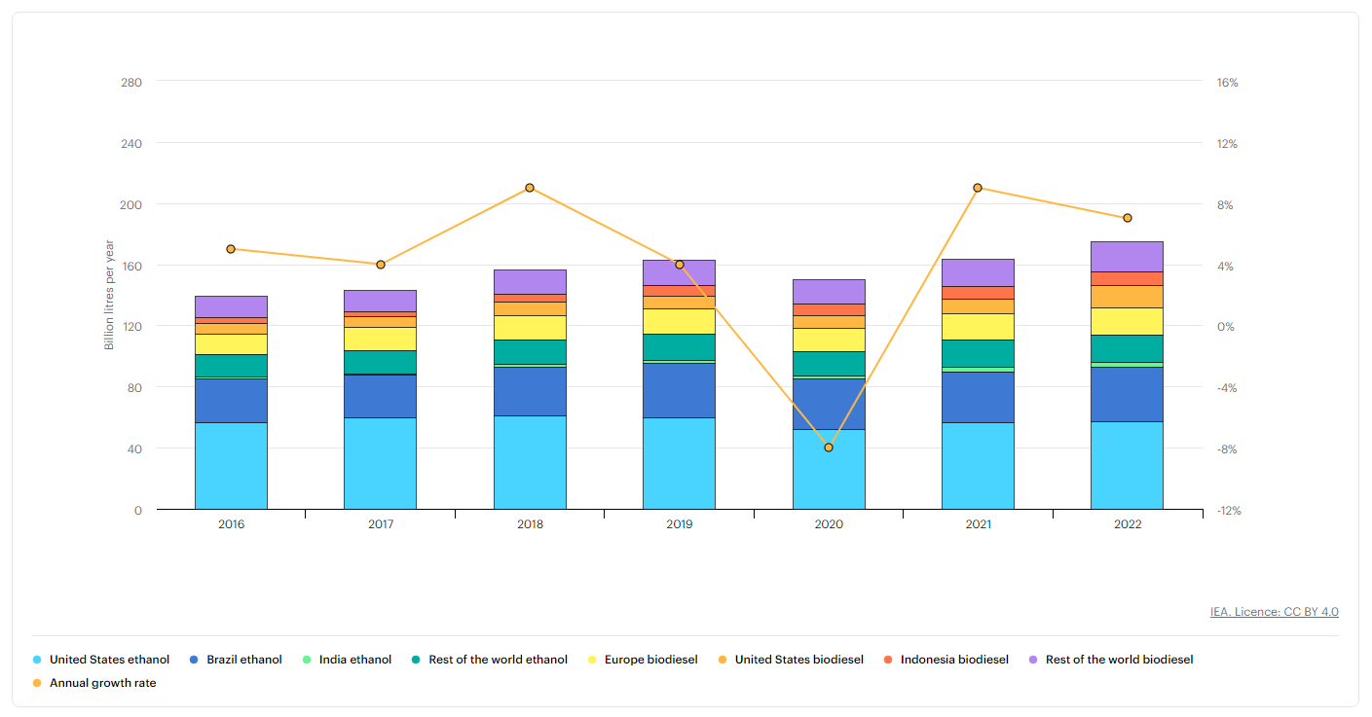
REFERENCES

[1] Smith, S. (2019). "Biofuels: A New Paradigm for the Development of Sustainable Energy Sources." Environmental Science & Technology, 53(21), 12415-12418.
[2] Lynd, L. R., et al. (2017). "Microbial Biomass Conversion Technologies: A Comprehensive Introduction." Biotechnology and Bioengineering, 115(3), 691-705.
[3] Chisti, Y. (2007). "Biodiesel from microalgae." Biotechnology Advances, 25(3), 294-306.
[4] Ragauskas, A. J., et al. (2014). "Lignin Valorization: Improving Lignin Processing in the Biorefinery." Science, 344(6185), 1246843.
[5] Himmel, M. E., Ding, S. Y., Johnson, D. K., Adney, W. S., Nimlos, M. R., Brady, J. W., & Foust, T. D. (2007). Biomass recalcitrance: engineering plants and enzymes for biofuels production. Science, 315(5813), 804-807.
[6] Peralta-Yahya, P. P., Ouellet, M., Chan, R., Mukhopadhyay, A., Keasling, J. D., & Lee, T. S. (2011). Identification and microbial production of a terpene-based advanced biofuel. Nature Communications, 2, 483.
[7] Mata, T. M., Martins, A. A., & Caetano, N. S. (2010). Microalgae for biodiesel production and other applications: a review. Renewable and Sustainable Energy Reviews, 14(1), 217-232.
[8] Blanchard, F., Rivoire, A., & Blin, O. (2010). Biotechnological processes for biodiesel production using alternative feedstocks. Biofuels, 1(6), 835-856.
[9] www.sciencedirect.com
[10] Dimethyl ether- Wikipedia
[11] www.gstarbio.com
[12] https://www.iea.org/data-and-statistics/charts/biofuel-production-by-country-region-and-fuel-type-2016-2022

