Pyrazole & It’s Derivatives

Swapnil Dahat

Department of Chemistry

Nagpur University

Nagpur, India

swapnildahatresearcher@gmail.com

Dr. Ajmal Bhat

Department of Chemistry Nagpur University

Nagpur, India

bhatajmal@gmail.com

Tahir Nasir Shiekh

Department of Chemistry Nagpur University

Nagpur, India

Shiekhtahir878@gmail.com

ABSTRACT

Pyrazoles are five-membered heterocyclic compounds and have played an important portion in the development of theory in heterocyclic chemistry. These compounds broadly found as the main structure in a great variety of compounds that have an essential pharmaceutical and agrochemical activities in addition to biological activity like antifungal, antitumor, antiviral, antibacterial, anti-tubercular and antiphrastic. The pyrazole moiety has significant role in some drugs construction such as some pyrazole-3-carbox- amide moiety has anti-CB1 cannabinoid ability and some aryl pyrazole derivatives have anti-HIV-1 activity. The structures of the new pyrazoles were confirmed by spectral studies and elemental analysis. Results of the antimicrobial activity reveal that some of the compounds particularly with substituents act as potential antimicrobial agents against different fungal and bacterial organisms.

Keywords — Antibacterial, Antifungal, Cycloaddition, Dipolar, Inhibition.

# INTRODUCTION

Pyrazoles are chemical compounds that contain a five membered heterocyclic with two nitrogen atoms and three head-to-head carbons. Pyrazole derivatives, some members of the pyrazoles class, have presented excellent pharmacological effectiveness and biological antimicrobial(1) , anti-inflammatory(2), antihistaminic(3), antiviral(4), anticonvulsant(5)and fungicidal activities(6,7).In 1883 Knorr(8,9) leading synthesized compounds containing this system via the reaction of ethyl acetoacetate with phenyl hydrazine, which produced 1-phenyl-3-methyl-5-pyrazolone. Knorr(10)introduced the name pyrazole for these compounds to indicate that the centre was derived from pyrrole through the replacement of a carbon by nitrogen. They prepared various members of this part and systematically tested their properties (11,12).Pyrazoles are aromatic molecules because of their planar conjugated ring configurations with six delocalized π-electrons(13). For that reason, many essential properties of these molecules were studied by comparing with the properties of benzene derivatives(14). Five membered nitrogen heterocycles, particularly pyrazoles and their derivatives are regarded as important molecules in organic synthesis; they serve as building blocks for the construction of biologically potent molecules.

A series of structurally related 1H-pyrazolyl derivatives synthesized compounds were tested for their anti-inflammatory and antimicrobial activities. The enormous pharmacological applications associated with pyrazoles prompted us to work in this area. In continuation of our work on pyrazoles and in search of new potential antifungal and antibacterial agents, we herein report the synthesis of a series of new novel pyrazoles and in vitro evaluation of their antibacterial and antifungal activities against different organisms.

**Reactions of Derivatives of Pyrazole**

Pyrazoles and their new derivatives have been prepared by 2'-cinnamoyl- oxyacetophenones from obtainable 2-hydroxyacetophenone. Antibacterial activities and antifungal were also performed as in-vitro antimicrobial screening against fungal strains and bacterial strain respectively.



Bavatenko et al. described replaced pyrazoles (**9a-d**) by cyclizing aryl hydrazones (**8a-d**) in Vilsmeier conditions.



Borrell et al. synthesized pyrazole library via using Merrifield resin as a solid-phase support to a hydroxyacetophenone (**18**), Vilsmeier-Haackformylation on methyl group and cyclization with replaced hydrazine to afford 4-hydroxybenzoyl-1-substituted pyrazoles (**20a-e**).



Shamsuzzaman et al. described that the treatment of 5*α*-cholestan-6-one tosylhydrazones (**50a-c**) with Vilsmeier reagent obtain 5ʹ-formyl-5*α*-cholestan [6,7-*c*] pyrazole compounds (**51a-c**) in 60-65% yields.



Ayaz M Dar and Shamsuzzaman(20) reported the quick and suitable synthesis of novel 5α-cholestano [6,7-c]-5’-methyl-1’-carbothioic acid amide pyrazoles (**65d-f**) based on the reaction of 5α-cholestan-6-one thiosemicarbazones (**64a-c**) with improved Vilsmeier-Haack reagent (H3C-CO-NH2/POCl3).



**Synthesis of Sodium Citerate**

|  |  |
| --- | --- |
| |  | | --- | | The synthesis of sildenafil citrate was first reported in the *Bioorganic & Medicinal Chemistry Letters*, Vol 6, pp. 1819, 1824, 1996. The reaction scheme is reproduced below. Sildenafil was reported in this journal as "a potent and selective inhibitor of type 5 PDE with utility for the treatment of male erectile dysfunction". | |

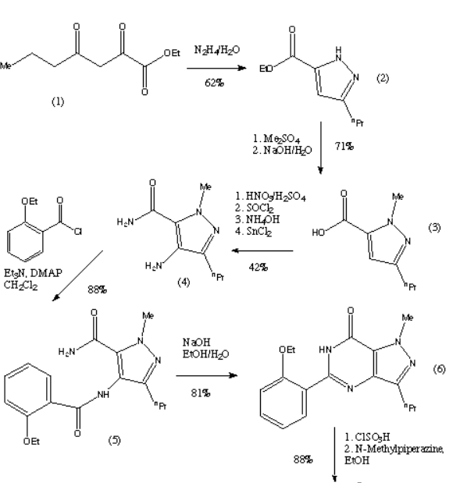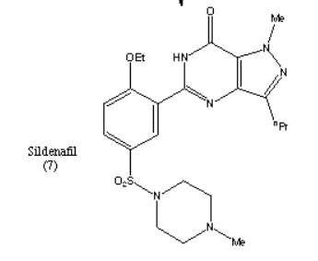

|  |  |  |
| --- | --- | --- |
| |  | | --- | | The first step of the synthesis is the reaction of a diketoester (1) and hydrazine to give the pyrazole ring. The regioselective N-methylation of the pyrazole and hydrolysis gives a carboxylic acid (3). Compound (3) is then reacted with HNO3 and H2SO4 to give a nitrated product. This is then followed by a carboxamide formation and the reduction of the nitro group. The compound (4) is then acylated under basic conditions and this produces the pyrazolopyrimidinone (6). (6) is then chlorosulphonylated selectively on the 5'-position of the phenyl ring. This can then couple with an amine to give sildenafil (7). The yield of each step is given on the reaction scheme. | | This is the original synthesis which was reported in the literature when the molecule was first synthesised. A variant of the synthesis was published but the changes it involved only consisted in the change of a few reactants, and no major changes were reported. This synthesis appeared in the January 1999 issue of *Chemistry in Britain*. This journal only reported the original discovery synthesis and said that the synthesis used commercially had not been published. | |

**Future research on pyrazole and it's derivatives**

**Some potential areas of future research include**:

Medicinal Chemistry: Further investigation into the pharmacological properties of pyrazole derivatives could lead to the discovery of new drug candidates for various diseases. Researchers may focus on optimizing the structures of these compounds to improve their efficacy, reduce side effects, and enhance their target selectivity.

Drug Resistance: Studying the potential of pyrazole derivatives in combating drug resistance, especially in the field of antimicrobial agents and anticancer drugs, could be a promising area of research.

Agrochemicals: Researchers might explore novel pyrazole derivatives for crop protection and pest control, with an emphasis on developing environmentally friendly and sustainable solutions for agriculture.

Materials Science: The use of pyrazole derivatives as building blocks for innovative materials with specific properties could be an exciting avenue for future research in the field of materials science and nanotechnology.

Computational Approaches: Advances in computational chemistry and molecular modeling techniques will play a vital role in accelerating the discovery and design of new pyrazole derivatives with desired properties.

Bioconjugation and Drug Delivery: Exploring the potential of pyrazole derivatives for bioconjugation and targeted drug delivery strategies could be an important area of research to improve drug delivery efficiency and reduce off-target effects.

Mechanism of Action: In-depth studies to elucidate the mechanisms of action of pyrazole derivatives at the molecular level could provide valuable insights for drug design and development.

It's essential to keep in mind that the above-mentioned areas of future research are speculative and may not fully encompass all potential directions. As research and scientific advancements progress, new avenues for the exploration of pyrazole and its derivatives may emerge, leading to exciting discoveries and practical applications in various industries.

**State of the art:**

Pyrazole and its derivatives continue to be of great interest in medicinal chemistry, agrochemicals, materials science, and other areas due to their diverse biological activities and potential applications.

In medicinal chemistry, researchers are exploring the therapeutic potential of pyrazole derivatives as they exhibit a wide range of biological activities, including anti-inflammatory, antiviral, anticancer, and antifungal properties. Scientists are continually designing and synthesizing new pyrazole derivatives to enhance their potency, selectivity, and safety as potential drug candidates.

In the agrochemical industry, pyrazole derivatives are studied for their insecticidal, fungicidal, and herbicidal activities. These compounds play a crucial role in crop protection and pest management, contributing to sustainable agriculture practices.

In materials science, pyrazole derivatives are being investigated for their potential use in organic electronics, optoelectronics, and as building blocks for the design of novel materials with specific properties.

It's important to note that research in chemistry and its applications is an ever-evolving field.

**Summary:**

Pyrazole and its derivatives are a class of organic compounds with diverse applications in pharmaceuticals, agrochemicals, and other industries. They possess a five-membered ring containing two nitrogen atoms at positions 1 and 2. These derivatives are known for their biological activities, which have made them valuable in drug development and crop protection.

A pyrazole derivative is a chemical compound that contains a pyrazole ring in its structure. Pyrazole is a five-membered aromatic ring composed of three carbon atoms and two nitrogen atoms in a specific arrangement. Pyrazole derivatives have various applications in medicinal chemistry, particularly as pharmaceutical agents due to their diverse biological activities. They are known for their potential in anti-inflammatory, antiviral, antitumor, and other therapeutic activities. Specific pyrazole derivatives may have unique properties and functions depending on the substituents attached to the pyrazole core. These compounds continue to be of interest in drug discovery and development.

**Acknowledment**

We are very thankful to our guide Prof. Rajendra Dongre for their guidance to us in writing this chapter.

We are also very thankful to Department of Chemistry RTM Nagpur University Campus.

**References**

[1] Du, K., Mei, Y. J., Cao, X. T., Zhang, P. F., & Zheng, H. (2013). The synthesis of pyrazole derivatives based on glucose. *International Journal of Chemical Engineering and Applications*, *4*(4), 238-240.

[2] Pimerova, E. V., & Voronina, E. V. (2001). Antimicrobial activity of pyrazoles and pyridazines obtained by interaction of 4-aryl-3-arylhydrazono-2, 4-dioxobutanoic acids and their esters with hydrazines. *Pharm. Chem. J*, *35*(11), 602-604.

[3] A. K. Tewari , A. Mishra, *Monatsh. Chem*., 1999 ,vol. 130 , pp. 1167-1174 .

[4] Michon, V., du Penhoat, C.H., Tombret, F., Gillardin, J.M., Lepage, F. and Berthon, L. Preparation, structural analysis and anticonvulsant activity of 3-and 5-aminopyrazole N-benzoyl derivatives. *European journal of medicinal chemistry* **30** (2) (1995)147-155.

[5] Janus, S.L., Magdif, AZ Erik, BP and Claus, N. Synthesis of triazenopyrazole derivatives as potential inhibitors of HIV-1*, Monatsh fur Chem* **130** (1999) 1167-1171.

[6] Bouabdallah, I., M’Barek, L.A., Zyad, A., Ramdani, A., Zidane, I. and Melhaoui, A. Anticancer effect of three pyrazole derivatives. *Natural product research* **20** (11) (2006) 1024-1030.

[7] Park, H.J., Lee, K., Park, S.J., Ahn, B., Lee, J.C., Cho, H. and Lee, K.I. Identification of antitumor activity of pyrazole oxime ethers. *Bioorganic & medicinal chemistry letters* **15** (13) (2005) 3307-3312.

[8] Chu, C.K. and Cutler, S.J. Chemistry and antiviral activities of acyclonucleosides. *Journal of heterocyclic chemistry* **23** (2) (1986) 289-319.

[9] Knorr, L. Einwirkung von acetessigester auf phenylhydrazin. *Berichte der deutschen chemischen Gesellschaft* **16** (2) (1883) 2597-2599.

[10] Dar, A.M., Shamsuzzaman. A Concise Review on the Synthesis of Pyrazole Heterocyclic. *J. Nucl. Med. Radiat. Ther* **6 (5)** (2015) 1-5.

[11] Dar, A.M. Shamsuzzaman, *EurChem Bull*, 2014, 3, 1104-1106.

[12] Krygowski, T.M., Anulewicz, R., Cyrański, M.K., Puchala, A. and Rasala, D. Separation of the energetic and geometric contribution to the aromaticity. Part IX. Aromaticity of pyrazoles in dependence on the kind of substitution. *Tetrahedron* **54** (40) (1998) 12295-12300.

[13] Premkumar, T. and Govindarajan, S. Antimicrobial study of pyrazine, pyrazole and imidazole carboxylic acids and their hydrazinium salts. *World Journal of Microbiology and Biotechnology* **21** (4) (2005) 479-480.

[14] Joule, J. A.; Mills, K., *Heterocyclic Chemistry*; 5*th* Ed.; John Wiley&Sons: United Kingtom, 2010.