A Statistical Study on Sivan Temple in Ettayapuram Village
Sasikumar. R, Kanimozhi. A and Gohula Viji. K
Department of Statistics, Manonmaniam Sundaranar University, Tirunelveli, Tamilnadu, India.
sasikumarmsu@gmail.com, akanimozhi944@gmail.com and gohulavg@gmail.com
Abstract
A Statistical Analysis Shiva Temple at Ettayapuram is the work obtained in this study. Our culture has played an important role in ancient times, but in the modern era culture and Worship of God are less. For this, a survey was conducted among the people of Ettayapuram people to see how many people know about the Ettayapuram Shiva temple and who have more faith in God. According to Hindu mythology, there are three main deities in Hinduism, consisting of the god Brahma, the deity Vishnu, and the god Shiva is the destroyer of the world, but he has many other complex roles and has different attributes as well.
Keywords: Sivan temple, Ettayapuram and Eetteeswarar temple
1.0 Introduction
Shiva is one of Hinduism principal deities, and there are many temples dedicated to him throughout the country. In the south Indian state of Tamil Nadu, there are 2500 shiva temples of significance. Several type of temples can be found in Tamil Nadu, a state in South India. Ettayapuram shiva temple is famous among them.

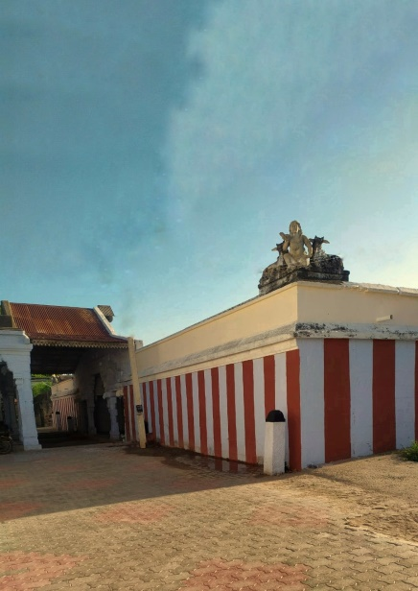
Figure 1 Shivan Temple
“Veera Rama Kumara Ettappa Nayakar” is one of the ettappa Kings. In January 742 they built the Shiva alayam and do Shiva Pirathistaiyag in Ettiyapuram. There was a one anthanar in kaashi his name is Vishwanathar, who lost his eyesight by birth while he was praying, he hear a sound come from that place. Like of you might was in southern part of Tamil Nadu you might get your eyesight. Ramanatha Swamy and his wife went to Rameshwaram, while he was praying he got his one eye sight power. Suddenly another sound came from the place and says that “go to Ettiyapuram” because of ettapa Kings you got your eyesight. They both went to Ettaiyapuram and saw Veera Rama Kumara Nayakar and he says I don’t have any super natural power to get your eye power and then he went back to Shiva alayam, he takes the holy water and spread his face suddenly he got another eye sight. From, this incident lord Shiva had another name like “Kankodutha Shiva Peruman”.
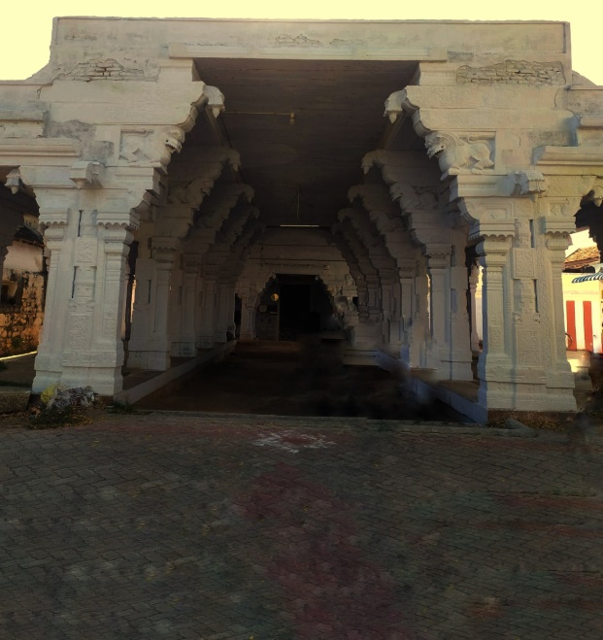
Figure 2 Temple entrance
In November, full moon day all Shiva temple has “Maha Annaabisegam” this abisegam was conducted by two brothers’. They were taking care of all the temple works. There were two famous things in Ettayapuram, one was the famous poet Bharathiyar and the another one is Shiva temple. Bharathiyar didn’t go to school properly. He mostly spent his time in Shiva temple. Due to poverty Bharathi’s mother didn’t feed him. Whenever he was in hungry Shiva’s wife name called Paravathy gave milk form the lotus, to feed hungry Bharathiyar. This is the reason Bharathi for proper education and knowledge and he became famous poet. And he also wrote a poem about the Lord Shiva and is entitled as “Elasai Oru Pa”.
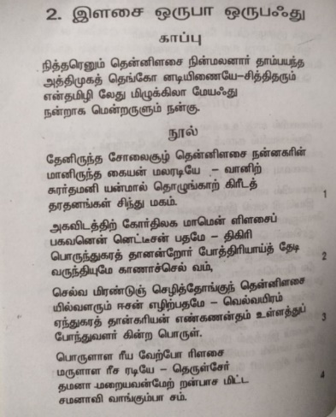
Figure 3: Bharathiyar Book
2.0 Review of Literature
- The Paliyars and Shiva Temples of the Caturagiri Hills, Virudunagar District, Tamil Nadu, South India and the Caturagiri Vazhinadaiccindu.
- A Historical study on Shiva temple of Bhumara, Rajana Singh, International Journal of Histroy 2021; 3(1): 10-12.
- Santhanam, K., Ramadoss, R. (2022). Restortation of an ancient temple at Parvathamalai in Tamil Nadu to preserve cultural heritage. The European Physical Journal Plus, 137(5), 549.
- A Review study on Architecture of Hindu temple, Uday Patil, Bharati Vidyapeeth Deemed University, International Journal for Research and development in techonology, Volume-8, Issue-4, (Oct-17).
3.0 Methodology
As for the research methodology, the data collection was carried out using a sampling method. The data was collected from Primary sources from Primary sources through interviews, surveys, experiments, etc., primary data is collected directly from the main sources by researchers. There are two types of surveys namely, Online and Offline. For this survey, an Offline survey us conducted. In this statistical analysis we use frequency distribution and Chi square.
3.1 Data Collection Method
In this study out of 500 samples 80 random samples were taken using Simple Random Sampling. These samples were collected through a small interview method in offline mode. The variables which have been used in this analysis were Age, Gender, Visited Years, Education Qualification, Maha Annabisegam, Month of Maha Anabisegam, Attend all the Pooja, God Believe and Delightful archana leaf, attending the pooja. Timings were only a difficult one in this collection of data.
3.2 Sources of Data
3.2.1 Primary data
Primary data are the data which are collected through survey. In order to collect data for the study, the researcher conducted survey among the respondents of Ettayapuram people about Shiva temple.
4.0 Objectives
- To find out how many people are known about the Shiva temple in Ettayapuram village
- To find if they have faith in the god.
- To find out if they know the meaning of pooja and workship.
5.0 Statistical Tools for Analysis
5.1 Frequency
Bar chart are often referred to as column charts or bar charts, where the bars are arranged in rows or columns based on the values they represent. A vertical bar chart is often called a column chart.
5.2 Chi-square Test
A chi-Square test is an important test that statisticians use for comparing variances to theoretical variances in sampling analysis. It is symbolized by χ² and it is pronounced by Ki-Square test. It is one of several tests of significance developed by statisticians. As a result, Chi-Square tests can be used in wide variety of problems. Chi-Square test can be used to perform a number of different types of test including i) checking the goodness of fit. ii) undertaking test for significant associations. iii) a test of homogeneity or the significance of population variance can be performed.

6.0 Statistical Analysis
6.1 Age
Table 1: Frequency for Age distribution
Age | [16,26] | [26,36] | [36,46] | [46,56] | [56,66] | [66,76] | [76,86]
Frequency | 25 | 14 | 16 | 12 | 4 | 8 | 1

From the table 1 we observed that out of 80 people (25) are the age groups between 16-26 are the majority ratio as per statistical report.
6.2 Gender
Table 2: Gender distribution
Gender | Male | Female
Numerical Code | 1 | 2
Frequency | 39 | 41

From the table 2 we observed that out of 80 people 51.25% (41) are female and (39) are male where female are the majority ratio that went for temple as per statistical report.
6.3 Visited Years
Table 3: Frequency Visited years distribution
Visit Years | 0-5 Years | 6-10 Years | 10-20 Years | About 20Years
Numerical Code | 1 | 2 | 3 | 4
Frequency | 26 | 21 | 14 | 19

From the table 3 we observed that out of 80 people 32.5% (26) have been visited the temple up to 0-5 years which are the majority ratio as per statistical report.
6.4 Maha Annabisegam, Month of Maha Annabisegam And Bharathiyar Poem
Table 4: Frequency for Maha Annabisegam, Month of Maha Annabisegam and Barathiyar Book
 |  | Numerical  Code | Frequency
Maha  Annaabisegam | Yes | 1 | 71
 | No | 0 | 9
Month of  Maha  Annaabisegam | Aip pasi | 1 | 14
 | Karthigai | 2 | 53
 | Margali | 3 | 8
 | Thai | 4 | 5
Bharathiyar  Poem | Elasai Oru Pa | 1 | 44
 | PanchaliSapatham | 2 | 22
 | Vedhantha Padal | 3 | 12
 | Tharasu | 4 | 2

From the table 4 we observed that many of people who lived in Ettayapuram are knew about Maha Annaabisegam. They are also known about which month does the Maha Annaabisegam will be held on. And majority of the people were know about the poem “Elasai our pa” which was written by the great poet Bharathiyar.
6.5 Attemd all the Pooj
Table 5: Frequency for Attend all the pooja,
 |  | Numerical  Code | Frequency
Attend  all the Pooja | Yes | 1 | 30
 | No | 2 | 50
Yes | Devotion | 1 | 11
 | Peace of Mind | 2 | 11
 | Hope | 3 | 6
 | Entertainment | 4 | 3
No | No Hope | 1 | 2
 | Timing | 2 | 16
 | Work Issue | 3 | 19
 | No | 4 | 12

From the table 5 we observed that among 80 people maximum of people were not attending the pooja regularly. Majority of the people in Ettayapuram were go the temple and attend the pooja for peace of Mind and Devotion. Some of the people have not attended the pooja regularly because of Work issue. They are very much regret for not attending the pooja
6.6 Known Pooja
Table 6: Known Pooja
Known Pooja | Yes | No
Numerical Code | 1 | 0
Frequency | 36 | 44

From the table 6 we observed that out of 80 people (44) are not known the right meaning and reason for the pooja which was held in the ettyapuram Shiva temple.
6.7 God Believe
Table 7: God Believe
God Believe | Yes | No
Numerical Code | 1 | 0
Frequency | 76 | 4

From the table 7 we have seen that most of the people are believer in God.
6.8 Chi-Square Test
Chi – Square test is used to find the association between two variables. We use Age, Gender, Visited Years, Education Qualification, Maha Annabisegam, Month of Maha Anabisegam, Attend all the Pooja, God Believe and Delightful archana leaf are taken as the variables of this test.
Table 8 for Chi – Square Test
P Value
Age | 0.2198
Visited Years
Gender | 0.362
Visited Years
Education Qualification | 0.08319
Maha Annabisegam
Education Qualification | 0.1304
Month of Maha Annabisegam
Attend all the Pooja | 1.154e⁻¹⁵
Yes
Attend all the Pooja | 1.304e⁻¹⁵
No
Gender | 0.32812
God Believe
Education Qualification | 0.0294
God Believe
Age | 0.4326
One who meditates of Shiva
Age | 0.9981
Delightful archana leaf

6.8.1 Interpretation
- From the above table 8 the P value 0.2198 > α = 0.05 it is not significance. So, we concluded that there is no association between Age and Visited years.
- The P value 0.362 > α = 0.05 it is not significance. So, we inferred that there is no association between Gender and Visited years.
- The P value 0.08319 > α = 0.05 which not significant. So, we conclude that there is no association between the Education Qualification and Maha Annabisegam.
- The P value 0.1304 > α =0.05 which not significant. So, we conclude that there is no association between the Education Qualification and Month of Maha Annabisegam.
- The P value is 1.154e⁻¹⁵ < α = 0.05 which is significant. So, we gather that there is an association between Attend all the Pooja and Yes.
- The P value is 1.304e⁻¹⁵ < α = 0.05 which is significant. So we gather that there is an association between Attend all the pooja and No.
- The P value is 0.2812 > α = 0.05 which is not significance. So, we conclude that there is no association between the Gender and God believe.
- The P value is 0.436 > α = 0.05 which is not significance. So, we conclude that there is no association between the Age group and one who meditates on Shiva.
- The P value is 0.0294 < α = 0.05 which is significance. So, we concluded that there is an association between the Education Qualification and God believe.
- The P value is 0.9981 > α =0.05 which is significance. So, we inferred that there is no association between the Age group and Delightful Archana Leaf.
7.0 Conclusion
The data which has collected for this study consisted of 80 observations. In this analysis there is no gender bias, everyone is treated equally and distributed equally. Both Male and Female can visit the temple without any hesitation. More than 70% of the people in Ettayapuram know about this temple. It was crowded with all kinds of people including literate, illiterate, etc were came to this temple. Due to work issue and delay timing most of the people are not come to this temple. They feel much regretted about this. People went to the temple with full faith, they had faith in God. They do not know the exact reason for the poojas which was held in Ettayapuram Shiva temple.

8.0 Suggestions
- Television advertisement and other advertisement will help to promote temple publicity.
- Information about all types of poojas displayed on the temple notice board in Tamil language.
- Awareness is often created among the people of Ettayapuram about the merits of the Shiva temple.
9.0 Referenece
- Andy field (2005) Discovering Statistics Using SPSS(Second Edition), Sage
Publications, New Delhi.
- Bhumara (Bhumara) Shiva temple viewed from south, Gupta Dynasty, India, Ca. 5th 6th century ADC Krishna Gaiola, University of Washingon, 1975.
- C R Kothari – Gaurav Garg, Research Methodology, Fourth Edition, 2019.
- Gupta S.P (2008) Statistical Methods, Sultan Chand & amp; Sons Educational publishers, New Delhi.
- https://statistics.laerd.com/spss-tutorials/chi-square-test-for-association-using-spss-statistics.php
- https://timesofindia.indiatimes.com/travel/things-to-do/all-about-12-jyotirlinga-temples-in-india/articleshow/68248943.cms

