Properties of Self Compacting Light Weight Aggregate Concrete
K.S.Elango ¹, S.Yuvaraj ², R.Saravanakumar ³, D.Vivek ⁴, V.Kavinkumar ⁵, P.Prasanthni ⁶
^{1,2,3,4,5}Department of Civil Engineering, KPR Institute of Engineering and Technology, Coimbatore, Tamilnadu, India
⁶Department of Civil Engineering, K.S.R College of Engineering, Tiruchengode, Namakkal, India
Corresponding author E-mail: kselango04@gmail.com, Mobile: +91 9942920668
- Introduction
Self Compacting Concrete (SCC) has been quite well-liked in recent decades due to its intrinsic qualities. SCC plays a significant role when concrete compaction is problematic owing to placement conditions or congested reinforcing since it compacts on its own. A concrete that has an ability to flow of its own weight and because of gravity is termed as self compacting concrete. SCC exhibits enormous advantages such as reduced labor cost, enhanced durability, minimal void content and permeability etc. Many researchers have been in practice by using alternate construction materials in SCC that improves the performance of SCC concrete. Upon various materials, nowadays utilization of light weight aggregates in SCC shows remarkable performance in workability and strength properties of SCC. Light weight products such as blocks, panels are being made using light weight concrete. Studies proved that shape and texture of light weight aggregate has direct influence in strength and workability properties of SCC. As per construction industry needs compressive strength of LWA should be 3000 – 5000 psi. Light Weight Aggregate has cubical, rounded, angular or any other shape. The shape of the aggregate has direct influence in workability. It was also observed that, water demand, air content, moisture content and mix proportion plays major role in deciding density of light weight concrete. The water absorption capacity of light weight concrete is less that maintains the low density and also it has high degree of saturation. Moreover, light weight concrete also possesses better resistance against fire environment. Concrete made with light weight concrete is being used for architectural purpose, light weight blocks, panels, heat insulation purpose panels etc. Light weight solid blocks can be used in framed structure as partition walls that also reduce dead weight of the structure. According to the sources light weight aggregate is classified in to different types (Figure.1)
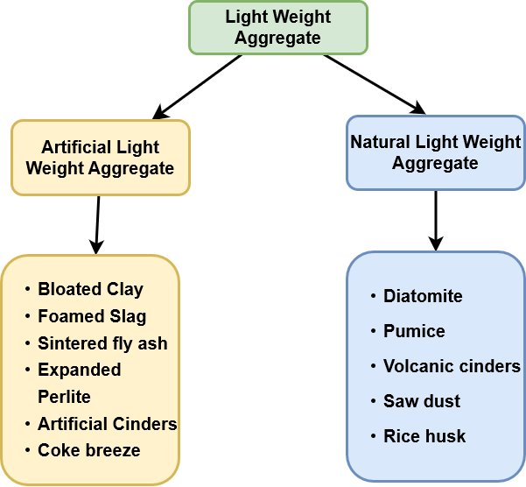
Figure.1 Types of Light Weight Aggregate
  - Merits of Light Weight Aggregate
Light weight panels can be easily transported from one place to another place. Construction technology using light weight concrete exhibits significant reduction in self weight of the structure that indirectly reduces the cost of the structure of about 30 to 40 percent. It was also observed that LWA shows better freezing and thawing resistance when compared with conventional concrete due to its pores that protects cement paste by air entrainment.
  - Demerits of Light Weight Aggregate
High porosity nature in light weight concrete increases the depth of carbonation, so that corrosion rate is twice than conventional concrete. It is suggested to take utmost care to reinforcement to avoid corrosion. The reinforcement can be easily protected by providing sufficient cover to that.
- Self Compacting Concrete – An Introduction
Self Compacting Concrete (SCC) has the ability of flowing inside the form work. It also does not require vibration, manual compaction and without any external compaction it places in every corner of formwork by its own self weight. The application of SCC in construction gives better finishes, durability, easy construction, better time consumption, less vibration, noise etc. Moreover, SCC is being used in congested reinforcement areas. A perfect SCC should satisfy three workability properties such as filling ability, passing ability and segregation resistance. Addition of fly ash in self compacting concrete as filler material showed remarkable performance [1]. Recycled coarse aggregates can be effectively used in self compacting concrete as a partial replacement for fine and coarse aggregates [2]. Incorporation of nano silica in self concrete as a partial replacement for Portland cement exhibits better durability properties. It was also observed that, replacement percentage of nano silica beyond 6% possesses decrease in compressive strength properties [3]. When compared with Silica Fume (SF) based self compacting concrete, GGBS based self compacting concrete shows better performance against fresh and hardened properties [4]. Incorporation of foundry sand shows significant improvement in fresh and hardened properties. It also improves durability properties [5]. Effective reduction in super-plasticizer can be achieved by using fly ash as cementitious material in self compacting concrete [6]. Fiber addition in self compacting concrete exhibits slight reduction in workability properties. In addition, 0.75 to 1% addition of steel fibers showed remarkable hardened properties [7].
- Materials and Methodology
3.1 Materials
OPC of grade 53 with a specific gravity of 3.01, a fineness of 98%, and a consistency of 28% was used. It was discovered that the primary and ending setting took 32 and 600 minutes, respectively. As a partial alternative for coarse aggregates with size 12.5-16 mm, crushed granite metal (Coarse Aggregate - CA) with specific gravity 2.73 and M-Diatomite aggregate (DA) size (10 mm - 15 mm) was employed. Aggregates with a particle size range of at least 4.75 mm. This sample of diatomite aggregate was obtained from Saho Minerals Pvt. Ltd. in Mumbai, India, and was subjected to the tests below to characterize it. It has a 1.32 bulk density, a 2.63 specific gravity, and a 5.34 fineness modulus. To make the material more workable, super plasticizer (Auramix 400) was utilised. The dose applied was 0.7% per m3.A fine aggregate (FA) sand with a specific gravity of 2.61 was employed. The thermal power station in Mettur, Tamil Nadu, India, produced fly ash of class (F). It had a 2.27 specific gravity, a pale grey hue, and 3.14% moisture content.

3.2 Mix Design
SCC of grade M25 was used as per EFNARC guidelines. Mix containing 0% diatomite aggregate is considered as control mix and the mix results of the same is kept as bench mark for comparing the results of other mixes. With different percentages of aggregates four mixes were made. Mix was decided as per replacement percentage of diatomite aggregate with natural coarse aggregate. By concrete volume, 5%, 10%, 15%, and 20% of the coarse aggregate utilized was used to partially replace the diatomite aggregate. 50% of the dry rodded unit weight is made up of coarse aggregate, while 45% of the mortar volume is made up of fine aggregate. The amount of super plasticizer utilized as 0.7% of cementitious material makes up the remaining 55% of the paste's total volume (cement, fly ash, and water). The water from the KPRIET College laboratory was added and stirred for seven minutes. The mix proportion for each mix is displayed in Table 1. The figure mentioned in each mix is the percentage of diatomite aggregate partially replaced with coarse aggregate. Mix M-DA stands for mix made using diatomite aggregate.
Table.1 Mix Proportions of Self Compacting Light Weight Aggregate Concrete
Mix ID | Cement (kg/m³) | Fly Ash  (kg/m³) | Fine Aggregate  (kg/m³) | Coarse Aggregate  (kg/m³) | Diatomite Aggregate |  | Water |  | Super Plasticizer
 |  |  |  |  | % | kg/m³ | % | kg/m³ | % | kg/m³
CC | 439.5 | 134.4 | 819.6 | 774.2 | 0 | 0 | 0.85 | 177.7 | 0.7 | 4.02
MA-DA5 | 439.5 | 134.4 | 819.6 | 735.5 | 5 | 38.7 | 0.85 | 177.7 | 0.7 | 4.02
MA-DA10 | 439.5 | 134.4 | 819.6 | 696.8 | 10 | 77.4 | 0.85 | 177.7 | 0.7 | 4.02
MA-DA15 | 439.5 | 134.4 | 819.6 | 658.2 | 15 | 116 | 0.85 | 177.7 | 0.7 | 4.02
MA-DA20 | 439.5 | 134.4 | 819.6 | 619.2 | 20 | 155 | 0.85 | 177.7 | 0.7 | 4.02

- Results and Discussions
  - Mechanical Strength Properties
Table 2 shows the mechanical strength properties of self compacting light weight aggregate concrete. Test results were determined at the age of 7 days and 28 days and the results are represented in the Table.

Table.2 Mechanical Properties of Self Compacting Light Weight Aggregate Concrete
Mix ID | Compressive Strength (MPa) |  | Split Tensile Strength (MPa) |  | Flexural Strength  (MPa)
 | 7 days | 28 days | 7 days | 28 days | 7 days | 28 days
CC | 19.50 | 32.50 | 2.93 | 3.75 | 3.65 | 4.25
MA-DA5 | 16.20 | 29.50 | 2.40 | 3.25 | 3.47 | 4.02
MA-DA10 | 15.35 | 25.85 | 2.10 | 3.02 | 3.02 | 3.58
MA-DA15 | 14.25 | 22.50 | 1.98 | 2.93 | 2.98 | 3.44
MA-DA20 | 13.50 | 21.50 | 1.68 | 2.83 | 2.68 | 3.15

Test results proved that, in self compacting concrete mix when natural coarse aggregate was replaced by diatomite light weight aggregate by 5%, 10%, 15% and 20%, compressive strength is reduced by 11.11%, 23%, 24.5% and 26%. Due to the less density property noticed in light weight aggregate (diatomite), compressive strength was reduced in the mix. The same trend of results is observed in split tensile strength and flexural strength properties. Test results are graphically represented in Figure 2-4 [8-9].
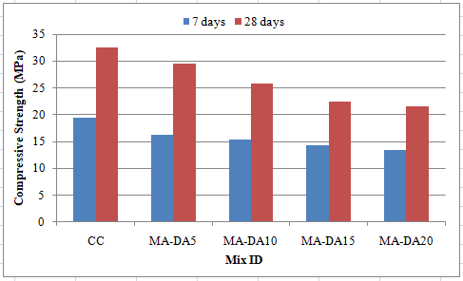
Figure.2 Compressive strength of various mixes
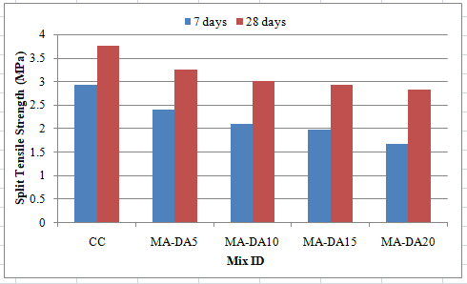
Figure.3 Split tensile strength of various mixes
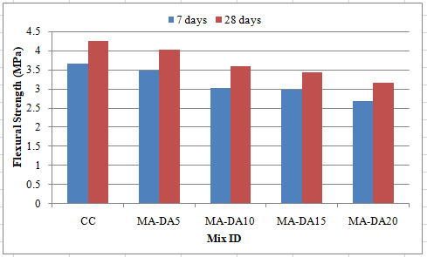
Figure.4 Flexural strength of various mixes
- References
- Shriram H. Mahure, Dr. V. M. Mohitkar, Dr.K.Ravi, “Effect of fly ash on fresh and hardened properties of self compacting concrete” International Journal of Engineering sciences & Research Technology, Feb 2014, pp944-948.
- Sherif A. Khafaga, ”Production of High strength self compacting concrete using recycled concrete as fine and/or coarse aggregate”, World applied sciences Journal 29 (4): pp 465-474, 2014
- M.Iyappan and Dr.A.Jagannathan, “High strength self compacting concrete with nano silica”, International Journal of Emerging Trends in Engineering and Development, 2014, Issue 4, Vol 5, pp 163-168
- B.H.V.Pai, M.Nandy, A.Krishnamoorthy, P.K.Sarkar and C.Pramukh Ganapathy, “Experimental Study on self compacting concrete containing Industrial by-products”, European scientific Journal, April 2014, Vol.10, pp 292-300.
- Rafat Siddique, Ravinder kaur Sandhu, “Properties of self compacting concrete incorporating waste foundry sand”, Leonardo journal of sciences, Issue 23, July-Dec 2013, pp105-124.
- Prajapati Krishnapal, Yadav.R.K and Chandak Rajeev, “Strength Characteristics of self compacting concrete containing fly ash”, Research Journal of Engineering sciences, June (2013),Vol. 2(6), pp 1-5.
- Abbas Al-Ameeri, “The effect of steel fiber on some mechanical properties of self compacting concrete”, American Journal of civil engineering, 2013, Issue 3, pp 102-110.
- Elango,K.S, J. Sanfeer, R. Gopi, A.Shalini, R.Saravanakumar, L.Prabhu, “Properties of light weight concrete – A state of the art review”, Materials Today: Proceedings, March 2021, vol. 46, Part 9, pg.4059-4062,
- Elango,K.S, D.Vivek, S.Anandaraj, R.Saravanakumar, J.Sanfeer, S.Saravanaganesh, “Experimental study on self compacting concrete using light weight aggregate”, Materials Today: Proceedings, 2021, vol.60, pg. 1362 – 1366.

