Hot Compression Behavior of AA 6061-2 Wt.% Al₂O₃ Nanocomposite

¹Dr. D. Jeyasimman*
Department of Mechanical Engineering,
Periiyar Maniammai Institute of Science & Technology, Thanjavur, Tamil Nadu, India.
Jeyasimman76@gmail.com ; jeyasimmand@pmu.edu

²Shrawan Kumar Saran, ³Dr.R.Narayanasamy
Department of Production Engineering,
National Institute of Technology,
Tiruchirappalli. Tamil Nadu, India.

ABSTRACT

This study uses a constitutive model and process mapping to examine the behaviour of heat deformation in Alumina nanoparticles reinforced with Al 6061 alloy. AA 6061-2 wt.% Al2O3 nanocomposites produced using a 30-hour mechanical alloying process. At three different temperatures such as 250, 350, and 450 ̊C hot compression tests were conducted with strain rates of 0.01 s-1, 0.1 s-1, and 1 s-1. Investigations were conducted on the workability zone for various combinations of temperature and strain rates. Dynamic recrystallization (DRX) and dynamic recovery (DRY) formation was verified.

Keywords— Hot compression test; Instabilty regions: Processing map; Constitutive modeling

INTRODUCTION

Aluminium alloy-based composites (AMCs) are often favoured over their monolithic counterparts due to their low density, broad alloying range, heat treatment capacity, and reactivity to both primary and secondary processing. Many researchers are interested in matrix strengthening using nano-sized ceramic reinforcement because it has ductility, temperature and fatigue resistance. Metal matrix composites (MMCs) and alloys made of aluminium that are traditionally produced (i.e., using ingot metallurgy) have been thoroughly assessed in the past. However, little research has been done on how powder metallurgy processing factors affect the behavior of alloys and composites during heat deformation. The workability of composites made using powder metallurgy (P/M) is difficult to assess.
A thorough analysis of the alloy's hot deformation behavior is crucial for designing the thermomechanical processing parameters, which have a direct impact on the product’s microstructural and mechanical qualities. Properties of a material, such as ductility, strain hardening, strength, dynamic recovery, and recrystallization, are significantly influenced by the processing parameters. Therefore, it is crucial to understand how the deformation behaviour and processing parameters interact when metals or alloys are deformed at high temperatures. In order to optimise the processing parameters and better understand the deformation mechanism, the deformation behaviour is often characterised using a number of modelling tools, such as flow stress-strain curves, kinetic analysis, constitutive models, and processing maps.
In bulk metal forming processes including extrusion, rolling, and forging at high temperatures, hot deformation behavior refers to how much a material may deform plastically without flow localization or fracture. The inclusion of hard ceramic nanoparticles in the soft ductile Al matrix affects its hot working characteristics; as a result, various hot working parameters should be investigated and compared to conventional Al composites. During hot deformation under compression state, the ductile matrix transmits the applied load to the hard reinforcing particles. As a result, the soft ductile matrix undergoes plastic flow whereas the rigid particles do not deform. When the accumulated tension reaches a critical level, depending on how the processing is progressing, the interface may separate or the particles may break.
In general, the mechanical behaviour of materials under hot deformation conditions may be evaluated using appropriate constitutive equations that correlate flow stress, strain rate, and temperature. The information needed to extract the constitutive equations is frequently provided by the uniaxial hot compression testing. The Arrhenius equation provides the best explanation of the relationship between strain rate, flow stress, and temperature. The hyperbolic type function more accurately approximates the Zener-Holloman parameter and stress.
Understanding material behaviour and metallurgical evolution during deformation is essential for identifying "safe" and "unsafe" areas. Through the use of numerous methods and strategies, the dissipation efficiency and instability properties that provide the basis for building processing maps have been created over time. Both the phenomenological instability model and the continuum-based Dynamic Materials Model (DMM) have been successfully utilised to produce processing maps for determining safe working distances during hot deformation.

EXPERIMENTAL WORK

To make the necessary nanocomposites, Alfa Aesar, USA, provided pure elemental powders of Si, Fe, Cu, Cr, Mn, Mg, Zn, Ti, and Al with an average particle size of 40 m. The gamma phase nano-size alumina (Al2O3) powder was supplied by Alfa Aesar, USA, and had a purity of 99.5% with an average particle size of 40–50 nm. Al 6061 alloy has the following chemical formula: 0.6 Si, 0.7 Fe, 1.0 Mg, 0.15 Mn, 0.195 Cr, 0.25 Zn, and a balance of 15 Ti and Al.
30 hours of milling duration, stainless steel vials and bowls, and toluene as the process control agent are the ball milling specifications. The ratio of balls to powder was 10. Using a double-action compaction die in a hydraulic press, cylindrical compacts measuring 10 mm in diameter and 13.5 mm in height were manually crushed at a compaction pressure of 500 MPa in order to evaluate the hot deformation properties. The green cylindrical compacts were sintered for two hours at 600 C in a nitrogen-rich reducing environment.
Testing for uniaxial hot compression was carried out using a FIE Servo hydraulic machine. The extruded samples were used to create cylindrical compression specimens with dimensions of 10 mm in diameter and 13.5 mm in height, with the compression axis parallel to the extrusion direction. Graphite was added to the top and bottom surfaces of each sample before heating in order to improve lubrication. The hot compression testing was conducted at three distinct temperatures—250, 350, and 450 ̊C and 3 strain rates—0.01, 0.1, and 1 s-1.

RESULT AND ANALYSIS

At various combinations of temperature and strain rate, the hot compression test provides the values for force and displacement. Previous researchers were utilized the following relations and formulae for calculating true stress, true strain, flow stress, strain rate, previous researchers for hot deformation behavior analysis utilized activation energy.

$σ=\frac{P\left(1-e\right)}{a}$ …………………………….. (1)
$ε=ln⁡(1-$e) ……………………………… (2)
$\overset{̊}{ɛ}=A\{{sinh⁡(ασ)\}}^{n }×e^{-Q/RT}$ ……………………………… (3)
$\overset{̊}{ɛ}=A1{(σ)}^{n1}$ ……………………………………………….. (4)
$\overset{̊}{ɛ}=A2(e^{βσ}$) …………………………………………… (5)
$\ln{ɛ̊}=\ln{A1}+n\ln{σ}$ ………………………………………. (6)
$\ln{\overset{̊}{ɛ}}=\ln{A2 }+βσ$ ………………………………………… (7)
$α=β/n1$ …………………………………………….. (8)
$Z=\overset{̊}{ɛ} e^{Q/RT}$ ………………………………………………… (9)
$Z=A(sinh{{ασ)}^{n}}$………………………………………….. (10)
$Q=-R ×[\frac{d\left(\ln{\overset{̊}{ɛ}}\right)}{d\{\ln{sinh⁡(ασ)\}}}]×[\frac{d\left\{\ln{sinh⁡(ασ)}\right\}}{d\left(\frac{1}{T}\right)}]$………………… (11)
$σ=\frac{1}{n}[\sinh^{-1}({{\frac{\overset{̊}{ɛ}e^{Q/RT}}{A})}^{1/n}]}$…………………………………… (12)

Where, $ɛ̊$ is the strain rate, R is the universal gas constant (8.314 J/mole K), T is the absolute temperature (K), Q is the activation energy for hot deformation (kJ/mole), σ is the flow stress (MPa) for a given strain, A ($s^{-1}$), α (${MPa}^{-1}$), and n are the material constants. Where, A1 and A2 are the material constants independent of the flow stress and deformation temperature. The value of n1 and can be obtained from the slope of the lines in the ln(ɛ̊) versus ln(σ) and ln(ɛ̊ ) versus σ plots, respectively.
True stress and True strain were drawn for three temperatures such as 250, 350 and 450 ̊C as shown in Fig. 1. From the figure 1, up to stain rate 0.1s⁻¹ stress values increased and then stress maintained constant.

Fig.1 True stress curves for various strain rates and temperatures
Fig.2 shows the effect of temperatures on stress-strain curves for constant strain rate 0.01s⁻¹. For the low temperature, stress value is more and decreases for the temperature increases.

.
Fig.2 True stress –True strain curve at strain rate 0.01

PROCESSING MAP

In a hot deformation analysis, work hardening, dynamic recovery (DRV), and dynamic recrystallization (DRX) are the three main phenomena. DRX can remove some crystal flaws. For strains 0.3, 0.4, and 0.5, processing maps were created, and instability zones are displayed in Fig. 3.

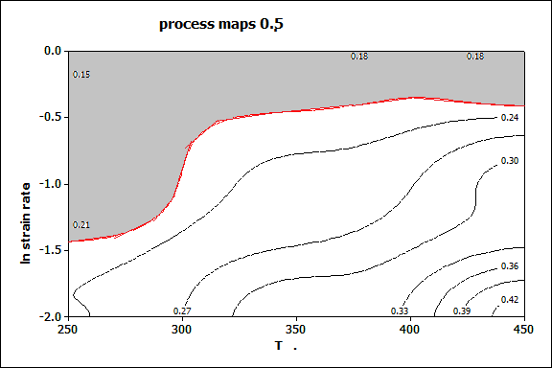
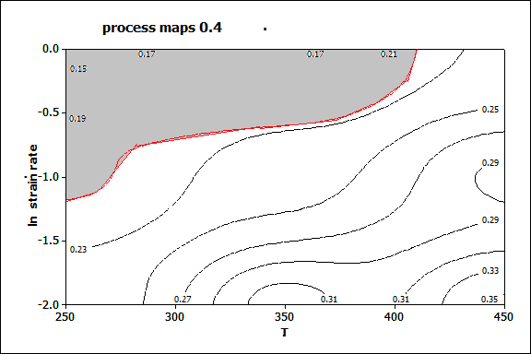
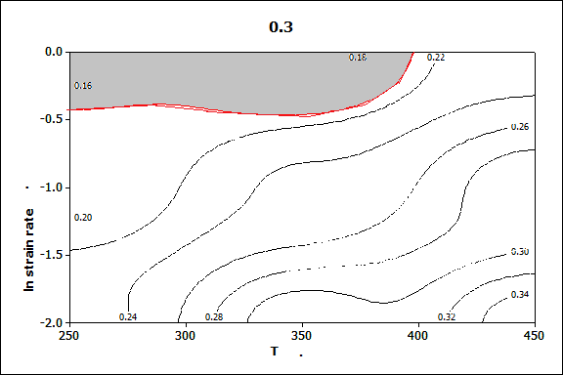

Fig. 3. Instability regions on processing maps for different Strains

CONCLUSION

- Al 6061-2 wt.% Al₂O₃ nanocomposites was successfully fabricated by 30 h of mechanical alloying and followed by conventional sintering at 600 ̊C.
- Hot compression test was conducted for the prepared nanocomposites and stress and strain curves were drawn.
- Processing maps were drawn for the different strains such as 0.3, 0.4 and 0.5.
- Instability regions and workability zones for safe region and unsafe regions were identified.

REFERENCES

- An He, Ganlin Xie, Hailong Zhang, Xitao Wang “A comparative study on Johnson–Cook, modified Johnson–Cook and Arrhenius-type constitutive models to predict the high temperature flow stress in 20CrMo alloy steel”. Materials and Design 2013, 52, 677–685
- Aneta Łukaszek-Sołek, Janusz Krawczyk. “The analysis of the hot deformation behavior of the Ti–3Al–8V–6Cr–4Zr–4Mo alloy, using processing maps, a map of microstructure and of hardness”. Materials and Design 2015, 65 165–173
- D.Jeyasimman, K.Sivaprasad, S.Sivasankaran, R.Ponalagusamy, R.Narayanasamy and Vijay Kumar Iyer “Microstructural observation, consolidation and mechanical behavior of AA 6061 nanocomposites reinforced by gamma-Al₂O₃ nanoparticles”. Advanced Powder Technology, 2014, 26, 139-148.
- Hafeez Ahamed, V. Senthilkumar. “Hot deformation behavior of mechanically alloyed Al6063/0.75Al2O3/0.75Y2O3 nano-composite—A study using constitutive modeling and processing map”. Materials Science and Engineering A 2012, 539, 349–359
- D.Jeyasimman, V.Senthilkumar, R.Narayanasamy. “Hot Deformation Response of Al 6061-MWCNTs Alloy Composites” International Journal of Innovative Technology and Exploring Engineering, 2019, 8 (12), 27-32.
- J. Luo, M.Q. Li, D.W. Ma. “The deformation behavior and processing maps in the isothermal compression of 7A09 aluminum alloy”. Materials Science and Engineering A 2012, 532 , 548– 557
- L. Shi, H. Yang, L.G. Guo, J. Zhang,. “Constitutive modeling of deformation in high temperature of a forging 6005A aluminum alloy”. Materials and Design 2014, 54 576–581
- M. Rajamuthamilselvan∗, S. Ramanathan. “Hot deformation behaviour of 7075 alloy”. Journal of Alloys and Compounds 2011, 509 .948–952
- M.R. Rokni, A. Zarei-Hanzaki, Ali A. Roostaei, A. Abolhasani. “Constitutive base analysis of a 7075 aluminum alloy during hot compression testing”. Materials and Design 2011, 32, 4955–4960
- N. Srinivasan, Y.V.R.K. Prasad, P. Rama Rao. “Hot deformation behavior of Mg–3Al alloy—A study using processing map” Materials Science and Engineering A 2008, 476, 146–156
- O. Sivakesavama, Y.V.R.K. Prasad. “Hot deformation behavior of as-cast Mg–2Zn–1Mn alloy in compression: a study with processing map”. Materials Science and Engineering A 2003, 362, 118–124
- Peng Zhang, Chao Hua, Chao-gang Ding, Qiang Zhu, He-yong Qin. “Plastic deformation behavior and processing maps of a Ni-based superalloy” Materials and Design 2015, 65 575–584
- R.S. Sundar , D.H. Sastry, Y.V.R.K. Prasad. “Hot workability of as-cast Fe3Al_/2.5%Cr intermetallic alloy”. Materials Science and Engineering A 2013, 347 86-92
- V. Senthilkumar, A. Balaji, R. Narayanasamy. “Analysis of hot deformation behavior of Al 5083–TiC nano composite using constitutive and dynamic material models”. Materials and Design 2012, 37 102–110

