Evidence-based practice in nursing profession
Abstract
Evidence based medicine (EBM) is very much recognized and practiced since past 10 years. EBM is a multi-integrative approach involving opinions from patients, their family and caregivers. Nurses can improve their knowledge and clinical experience from available resources and implement them as and when required. Evidence-based practice (EBP) mainly focuses on the patient which is the heart of nursing care. EBP influences the proficiency skills and work responsibilities of nurses so it should be integrated into routine health care practices. There may be necessary healthcare environment for organizations in evidence-based practice supporting it. EBP has its own limitations and benefits. Regarding the implementation of EBP guidelines majority of healthcare practitioners and organizations are still lacking behind for the sake of providing best health care. These identified barriers can be overcome by facilitating the implementation of evidence-based practice among healthcare professionals with the help of Nursing administrators and educators. Training and education must be provided to them to enhance knowledge, skills and awareness to utilize EBP. Provision of adequate resources, time management and guidance can help in facilitation of EBP for better health care.
Keywords: Evidence based medicine, nurses, evidence-based practice, healthcare, patient care

Introduction

Evidence based medicine (EBM) is very much recognized and practiced since past 10 years. EBM is basically solution for patients encountered with clinical problems in a systematic way. It is a multi-integrative approach involving opinions from patients, their family, caregivers and most importantly the clinical experience of professionals with good quality research approach. Evidence-based practice (EBP) is utilized in an organization or a healthcare facility for solving a problem and clinical decision making. It incorporates results and scientific evidences from various studies. It is essential in providing holistic and best quality health care in the field of nursing rather than traditional methods.
Nurses have massive role in the delivery and promotion of quality health care services. Nurses can improve their knowledge and clinical experience from available resources and implement them as and when required. Evidence-based practice mainly focuses on the patient which is the heart of nursing care. EBP influences the proficiency skills and work responsibilities of nurses so it should be integrated into routine health care practices.

There may be necessary healthcare environment for organizations in evidence-based practice (EBP) supporting it. Newly generated knowledge should be a part of routine practice to be evidence-based. In US, there is the supportive healthcare environment for healthcare practitioners adding to health care efficiency. Improvement in health care practice and outcomes is the essential requirement of EBP. Many patient care organizations have created strategic initiatives for EBP.

Regarding the implementation of EBP guidelines majority of healthcare practitioners and organizations are still lacking behind for the sake of providing best health care.

Why is Evidence-Based Practice essential in nursing profession?
- It closes the gap between theories to practical and patient is provided with most advanced health care service and benefits
- Patient expectations and health care benefits in the form of outcomes enforce the platform of evidence-based practice
- EBP assist the organizations to fulfill their healthcare achievements of quality patient care, community care, diminished disease load and increased well-being of hospital staff
- Examples of EBP in nursing care are management of angina pain and measurement of blood pressure (B.P) in children.
How to use EBP: models of EBP:
For the purpose of EBP implementation several models have been made by the nursing staff and other health service providers. These models are the organizing guides to integrate the already accessible research for patient care with available best practices. Training courses for EBP have been provided by the National Library of Medicine designed using pubmed.

THE FIVE STEP EBM MODEL :-
By following five essential steps the nursing staff & healthcare professionals can do evidence-based practice
1. First step involves asking question to the patient and integration of PICO (P= identification of patient, I=interventions, C=comparisons and D= outcomes)
2. Finding for best evidence to answer the question by performing a literature search
3. Evidence appraisal for usefulness and validity clinically
4. Clinical application of the evidence considering the needs of patient
5. Evaluation of efficiency and effectiveness of the process
Johns Hopkins Evidence-Based Practice (JHEBP) model (Figure.1)
One of the best examples is above model (Figure 1). This model is accompanied by user-friendly tools. Here nurses can access all the JHEBP tools. Inquiry toolkit is the way to access these tools which contains all the ten JHEBP tools, organizing them in 4 main categories like 1. EBP tools, 2. Quality improvement tool 3. Research tools and 4. Dissemination tools with their applications.
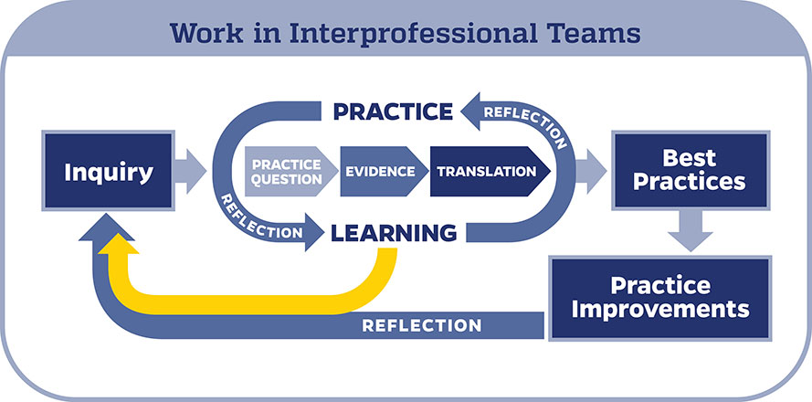
Figure: 1 Johns Hopkins Evidence-Based Practice (JHEBP) model
Some types of tools under EBP tools category are shown in Figure 2. JHEBP Dissemination Tool is used to prepare and share the outcomes of EBP project with the community i.e. for publication after the completion of the project.
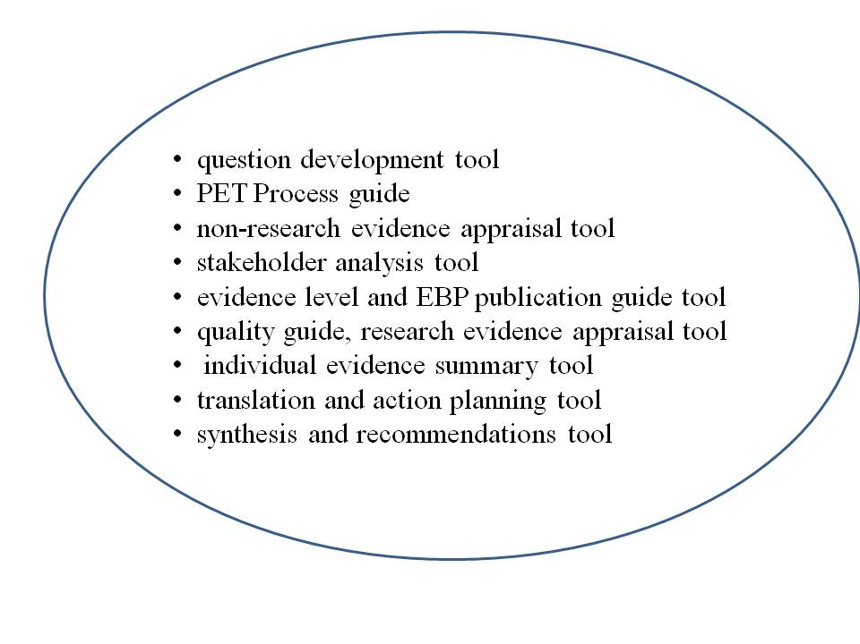
Figure: 2 Evidence Based practice tools
These tools are accessible to other institutions in collaboration with Institute for Johns Hopkins Nursing (IJHN). Here nurses can access online course entitled as JHH Nursing course which is free of cost. The course involves JHEBP (Johns Hopkins Evidence-Based Practice) from beginning to the end with learner instructions to use these tools. 5 steps of EBM are shown in Figure 3.

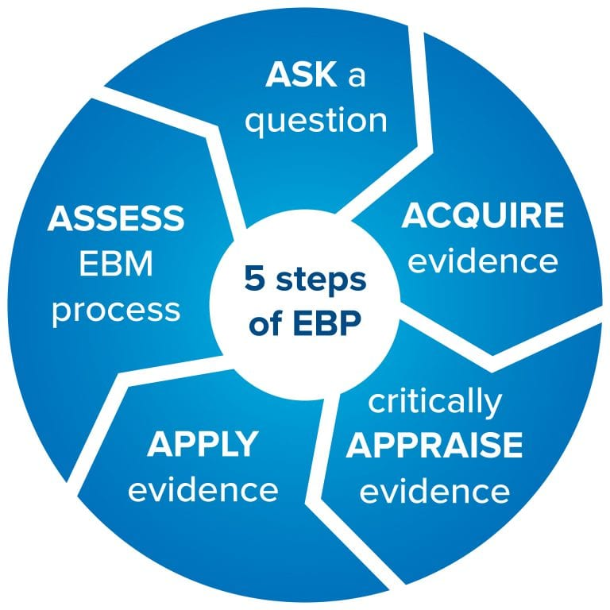
Figure 3: Five steps of EBM (Strauss, S. E. Evidence-Based Medicine: How to Practice and Teach EBM. New York: Churchill Livingstone, 2005)

The healthcare professionals need to be competent in application of new knowledge & skills into clinical practice and in demarcated decision-making approach between individual patient or patient groups (Figure 4).
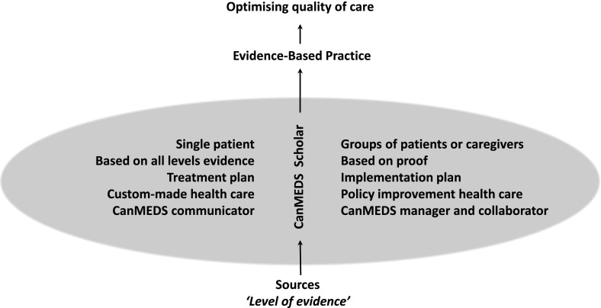

Figure 4: Differences in evidence-based practice for one patient and patient groups in a schematic way

Advantages of EBP:-
- foster shared decision-making about the patient's care
- better outcomes
- higher satisfaction
- clinical care with continuous quality improvement
- better patient outcomes and nursing experience
- reduces the health care costs by preventing complications
Knowledgeable healthcare professionals take decisions on the basis of accessible evidence, not conclusive and up to date information only. As for the practitioners, their professional judgment and expertise to determine whether the evidence is applicable, is required. Sound motivation should be there for nurses to follow EBP guidelines. As the trend has been shifted from classic practices, nurses being new and experienced face few limitations to adjust in EBP environment.
Barriers /Limitations in implementation of EBP in the nursing profession:
These may be organizational barriers or individual in healthcare professionals as mentioned below:
- Non-availability of best evidence
- Lack of resources& limited support
- Current management environment changes
- Lack of new knowledge, skills and awareness in seeking and appraising evidence, nurses’
- Lack of personal attitude professional experience and characteristics
- language barrier
- Time constraints
- Hiring of young and inexpensive practitioners and equiping them with an evidence-based protocol in some organizations to cut off the treatment costs.
(https://cebma.org/faq/limitations-evidence-based-practice/)
Conclusion: These identified barriers can be overcome by facilitating the implementation of evidence-based practice among healthcare professionals with the help of Nursing administrators and educators. Training and education must be provided to nurses to enhance their knowledge, skills and awareness on how to utilize EBP. Provision of adequate resources, time management and guidance can help in facilitation of EBP for better health care.
REFERENCES:-
- Evidence-Based Practice: Context, Concerns, and Challenges. In: Dang D, Dearholt SL, Bissett K, Ascenzi J, Whalen M. eds. Johns Hopkins Evidence-Based Practice for Nurses and Healthcare Professionals Model and Guidelines, 4e. McGraw Hill; 2022. https://apn.mhmedical.com/content.aspx?bookid=3144&sectionid=264685308.
- https://study.com/academy/lesson/critical-care-nursing-scenarios-case-studies.html
- Strauss, S. E. Evidence-Based Medicine: How to Practice and Teach EBM. New York: Churchill Livingstone, 2005.
- Akobeng AK. Principles of evidence based medicine. Archives of Disease in Childhood 2005; 90:837-840.
- https://cebma.org/faq/limitations-evidence-based-practice
- Banakar M, Alatawi M, Aljuhani E, Alsufiany F, Aleid K, et al. (2019) Barriers of Implementing Evidence-Based Practice in Nursing Profession: A Literature Review. J Nurs Care 8: 496.
- Gupta S, Bansal RN. Analyzability of newly developed/commercially promoted drugs among young medical and dental doctors. Perspect Clin Res. 2021;12(1):27-32. doi:10.4103/picr.PICR_56_19

