Biotechnology & Biodiversity conservation
Dr Malika Pal
Principal Mittal institute of Education
Bhopal

Biodiversity

Species diversity, interspecies diversity, and ecosystem diversity are all components of biodiversity, which encompasses the range of variation present in all forms of life on Earth. It is believed that there are currently around 8.7 million known species in the globe.[1].Agriculture, pharmaceuticals, and other forms of technological advancement rely heavily on biodiversity[2]. The country's plant life is home to 47513 species despite just covering 2.4% of the landmass (Singh & Dash, 2014).[3]. The provision of food, shelter, and clothing by biodiversity makes it the bedrock of life on Earth and is essential to the health of the environment. In addition to oxygen, it gives us steady weather, recreation, fibres, dyes, resins, medications, and fibres. Including the cold and high Himalayan regions to the sea costs; the wet north-eastern green forests to the dry north-western arid desert; and a variety of forests, wetlands, islands, and oceans, India is one of the world's mega-diversity nations [4]. Rare and endangered plant species need research on genetic diversity in their natural habitat more than ever. It will aid in the creation of management plans for keeping their genetic variety intact and making sure they survive into the future.
Subspecies, races, ecotypes, and population size all contribute to a region's genetic diversity. Plant species in the wild require genetic variety to ensure their short- and long-term survival. (5) Since the extinction rate of wild species is rising as a direct and indirect result of human activities and environmental conditions, it is crucial that these species be conserved in order to maintain their genetic variety. Rare and endangered plant species must have their genetic make-up examined in order to ensure their survival.
Large-scale efforts to protect endangered species should prioritise the most valuable populations. The measures taken call for an in-depth familiarity with the biology and ecology of species, as well as the levels and distributions of their respective genetic diversity. Many initiatives have been launched in recent years to protect the planet's flora and fauna. "The use of biotechnological methods for in situ and ex situ conservation is central to many of these initiatives.
Identification of Genetic diversity.
In studies using molecular markers to select populations for conservation, allelic richness is a simple measure of genetic variety [6]. Many priority, rare, and endangered species lack data on the extent and distribution of genetic variation. A lack of this information makes it harder to create efficient conservation plans and choose the best populations to manage in order to preserve and grow populations and genetic diversity (7).It is possible to assess a population's genetic diversity by using genetic markers. Methods, instruments, and software package-
- Micro Satellite Markers
Genomic repetitive areas consist of interspersed repeats (or relics of transposable elements), microsatellites (1–10 nucleotides), and minisatellites (>10 nucleotides), all of which fall under the umbrella term ''tandem repeats'' (TRs). Both prokaryotes and eukaryotes include these types of polymorphisms, known as Simple Sequence Repeats (SSR), Short Tandem Repeats (STR), and Simple Sequence Length Polymorphisms (SSLP). They can be found in both coding and non-coding regions of nuclear and organellar DNA, as well as in eukaryotic euchromatin (8).
- Single Nucleotide Polymorphisms
High-density single-nucleotide polymorphisms (SNPs) are the most common and robust form of genetic variants, making them ideal markers for assessing a population's genetic makeup and guiding breeding programme decisions and the identification of new genes linked to economically significant traits (9).
- Inter-Simple Sequence Repeat
Due to their high polymorphism, ISSR markers have found widespread application in the fields of genetics, phylogenetics, gene tagging, genome mapping, and evolutionary biology. DNA fingerprinting makes use of the sequences amplified by ISSR-PCR. Since an ISSR might be either a conserved or non-conserved area, this method is best suited for phylogeographical investigations or, at most, species delimitation (10)
- Expressed Sequence tag-
An expressed sequence tag (EST) is a small fragment of a cDNA sequence used in genetics. ESTs helped with both gene identification and sequencing since they could be utilised to locate transcripts of interest.
- RELP
Restriction Variation in fragment length. It is a frequent method for examining the subtle but significant changes in a DNA strand's sequence. It relies on the ability of restriction endonucleases to cleave DNA only at predetermined locations, known as restriction sites. Electrophoretic separation of digested DNA yields a unique RFLP pattern, characterised by cleavage fragments of varying lengths that are indicative of a particular DNA sequence. RFLP pattern can be used to differentiate between individuals, species, or creatures. Numerous applications exist for RFLP, including genotyping, DNA fingerprinting, gene mapping, and the detection of genetic diseases (11). The construction of polygenetic trees is aided by genetic mapping of species.
- AFLP –
In genetics, DNA fingerprinting, and the field of genetic engineering, the technique of amplified fragment length polymorphism (also known as AFLP) is invaluable. In AFLP, genomic DNA is digested with restriction enzymes, and then adaptors are ligated to the sticky ends of the restriction fragments.
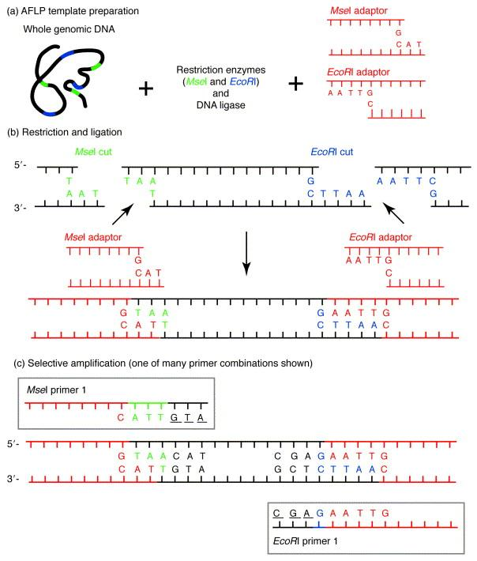
Fig 1. Schematic representation of the AFLP analysis principle. Advantages: i) high genomic abundance and considerable reproducibility in nature ii) no sequence data for primer construction are required iii) high number of polymorphic bands will be formed by single reaction Disadvantages: i) Dominant in nature ii) Technically demanding . Kumar, Anand. (2018). Fundamentals of Plant Breeding.

RAPD-

Random DNA fragments from polymerase chain reaction amplification of unrelated portions of genomic DNA using a single primer of arbitrary nucleotide sequence are called amplified polymorphic DNA markers. Whether or whether a given segment of DNA is amplified by a pair of identical 10-mer primers depends solely on whether or not those primers are in a place that is complementary to that position in the target DNA sequence. If the primers are annealed too far apart or if the 3' ends of the primers are not facing each other, for instance, no fragment will be formed. Because of this, the pattern of amplified DNA segments on the gel will change if a mutation has occurred in the template DNA at the spot that was previously complementary to the primer (12).

DNA bar-coding-

Because it does not necessitate expert taxonomic expertise or knowledge of the entire genome, it is a valuable tool for recognising modern plant species and plant components. It is independent of an organism's anatomy or its internal physiology. The large quantity of taxonomically identifiable DNA barcodes supplied to NCBI GenBank and Barcode of Life Datasystems makes this a reality. Barcode of Life Datasystems has developed a taxonomy identification tool that may be used to determine the identity of previously discovered species based on their DNA sequences. This DNA-based inspection method may also be used to assign a taxonomic group to the query specimen, which can help define the species boundary and facilitate the construction of phylogenetic trees, as well as aid in the utilisation and conservation of plant species through a better comprehension of evolution and ecology (13).

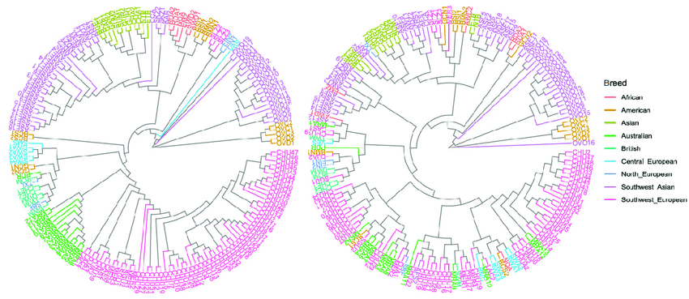

Figure 2Phylogenetic trees constructed from the observed genetic variation in the examined genome and in the candidate gene areas. Maximum composite likelihood was used to construct phylogenetic trees from the variation in a subset of all SNPs found in the genome (on the left) and SNPs found in the genomic areas of milk candidate genes (on the right). Using the neighbor-joining approach, phylogenetic trees were constructed to depict the relationship between all samples included in this study (wild and domestic sheep). The breeds are shown in various colours to indicate the regions to which they are native. In addition, a mean distance of 0.16 (0.02-0.43) was found between the 16,960 SNP variants in the candidate genes, as calculated by a pairwise distance matrix.Similar to how the average divergence index among wild breeds was significantly higher than that obtained among domestic breeds (0.13) in the candidate locations, the same was true for the domestic breeds. High bootstrap values were also found in the branches that distinguish between wild and domestic sheep and between breed groups in the phylogenetic tree constructed from the candidate gene variations. However, there was a significant drop in bootstrap values in the branches that divide the various types of domesticated animals (Figure S2). (Marina, Héctor, Beatriz Gutierrez-Gil, Cristina Esteban-Blanco, Aroa Suarez-Vega, Rocio Pelayo, and Juan-Jose Arranz. (2020). Potential Causal Mutations Influencing Milk Composition Traits Analysed by Analysing Whole Genome Resequencing Datasets from a Global Sample of Sheep Breeds. 10.1542/10.3390/ani10091542) Animals

Conservation of Genetic diversity
In-situ conservation
The term ''germplasm conservation'' is used to describe the practise of protecting genetic material within ecosystems and natural habitats, as well as preserving and restoring populations of wild organisms. When talking about tamed or cultured species, this term refers to keeping them in their original environments. This is typically done in wilderness areas with the goal of preserving wild cousins, and in agricultural settings or private gardens with the aim of preserving domesticated species.

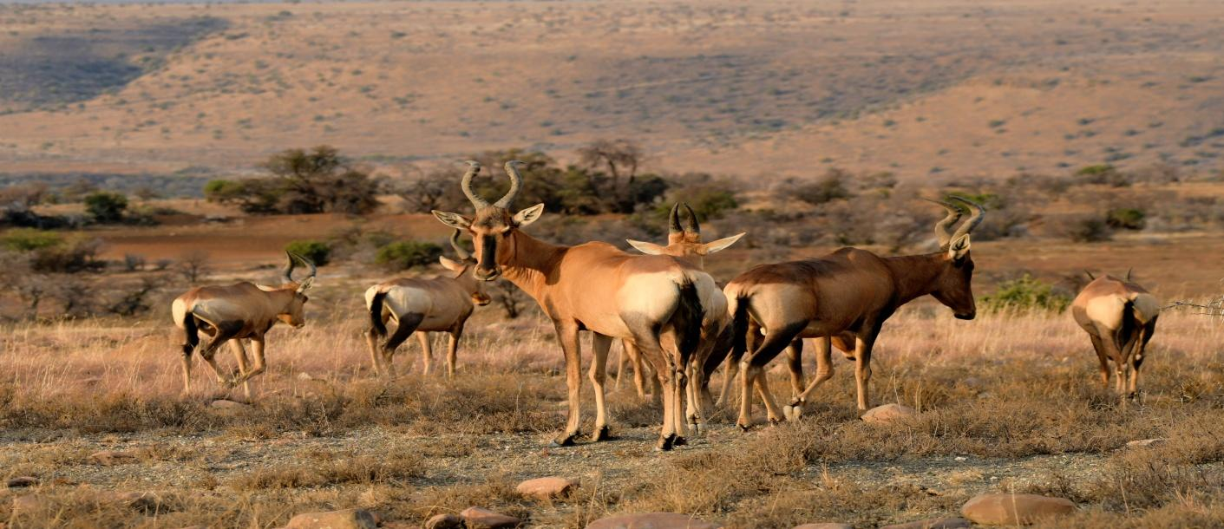
Conserving the entire ecosystem is done by creating biosphere reserves, national parks, wildlife sanctuaries etc.

Ex situ conservation
There are two primary routes that contribute to this form of conservation. One form of conservation is known as germ plasm conservation, and it consists of the storage of eggs, sperm, tissue samples, seeds, or plant material under artificial conditions to guarantee its longevity, viability, and availability in the event of a potential extinction due to overexploitation in natural conditions(14). Seed and propagule cold storage, in vitro (tissue culture or cryopreservation), and pollen and DNA preservation are all included. Storage for long-term security, known as base collections, and storage for immediate use, known as active collections, are both recognised with ex situ conservation. These shops provide a wide range of storage options and distribution structures.

- Micro- propagation PTC
Micro-propagation of plants is a biotechnique used to preserve plant species and even the stubborn seeds of economically significant crops. Explants may be grown from a variety of sources, including apical meristems (meristem culture), lateral buds (bud culture), leaves, cambia, ovaries, pollen, anthers, embryos, and so on. Reintroducing newly grown plantlings into their native environment is an effective strategy for in situ conservation of plant species with unique phenotypic characteristics. Numerous plant species useful in agriculture and forestry can be grown in a short amount of time and on a small footprint using this method. Minimising the amount of sub-cultivations and axillary bud or shoot tip cultures will ensure that the regenerated plantlets have minimal somatic changes, which is important from a conservation standpoint. Because of the successive stimulus they experience in in vitro culture, cells develop normally and create numerous plantlets. For micro-propagation to be successful, the explants used must be carefully chosen, since this will determine whether or not calluses will form throughout the development of the plantlets. Callus formation is associated with somaclonal variation and should be avoided at all costs.

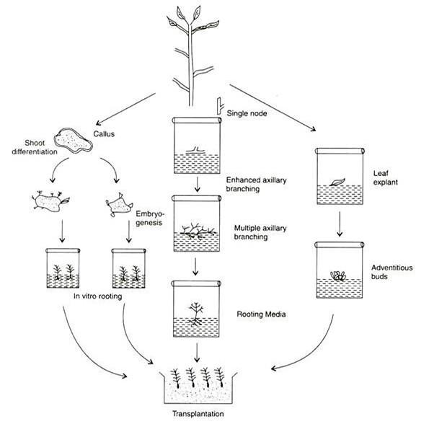

Fig.3 Diagrammatic representation of micro-propagation technique.
- Protoplast culture
Protoplasts are bare plant cells or cells that have not yet developed a cell wall. The plasmalemma is the membrane that surrounds the rest of the cellular contents and components. Because the protoplasts readily fuse, it is utilised to create transgenic plants in tissue culture laboratories. To enhance fusion, substances like polyethylene glycol (PEG) are added after cell walls of the relevant tissue samples have been enzymatically degraded. Once the cells have fused, they will form cell walls and be ready to be plated, at which point, in the presence of appropriate artificial media and environmental conditions, they will regenerate into a brand new transgenic plant. When the given plant sample has an impenetrable cell wall due to age, conservators sometimes resort to this more advanced and challenging procedure. To promote development and multiplication, the wall is chemically digested before being placed in growth media.
- Cryopreservation for Germplasm conservation –
Plant and animal tissue and seeds can be preserved through cryo-preservation by being frozen in a liquid nitrogen bath.Clonally propagated plant species that produce resistant seeds that cannot be readily conserved by seed preservation may benefit greatly from this practise. In addition, it has found widespread application in the preservation of sperm and egg samples from delicate organisms. Cryopreservation techniques like vitrification, encapsulation-dehydration, and encapsulation-vitrification are being applied on a wide range of plant species. Dehydration, which can occur during rapid cooling in liquid nitrogen (15,16), is important before cryopreservation of tissue material to prevent the cells from deadly intracellular freezing. Cryopreservation success is also dependent on the cooling pace, as slow cooling might lead to intracellular freezing. Dehydration is thought to be the cause of the formation of free radicals that can cause genetic changes in cryopreserved material (17,18). Molecular marker research (19) confirms that genetic stability is preserved after cryopreservation. Cryopreserved tissue may also be seen as more secure for international trade in germplasm.
- Seed Banking
The process of preserving seeds by keeping them in a dry, cool place. Taxa with orthodox seeds that can withstand desiccation are ideal candidates for this method. Storage options for seeds range from simple, hermetic containers to elaborate, climate-controlled vaults. It is not common practise for seed banks to store taxa for long periods of time if their seeds are very obstinate and cannot withstand desiccation.
- Gene banks-
Places where sperm, eggs, or embryos are frozen and then later thawed out to be used. The ''frozen zoo" at the San Diego Zoological Society, for instance, houses specimens of over 355 different species of mammals, reptiles, and birds that have been preserved by cryopreservation procedures.(Liquid Nitrogen, -196°C) (20.
- De-extinction-
Many species have disappeared because of a decline in genetic diversity. The process can be slowed by relocating or introducing organisms of the same kind from other places. However, in more dire circumstances, genetic intervention is required to help an organism adapt to a new environment brought on by climate change or to recover from an illness. In vitro fertilisation and the use of surrogate mothers (females of the nearest non-vulnerable species) are examples of cutting-edge reproductive technology. Przewalski's horse, American passenger pigeons, Heath hens, black-footed ferrets, Tasmanian tigers, peregrine falcons, Mallorcan midwife toads, sea otters, Fen orchids, blue whales, island night lizards, rodrigues fruit bats, pygmy Rwandan water lilies, and short-nose sturgeons were all saved from extinction.
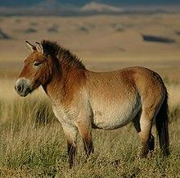
Photo of reintroduced Przewalski's horse taken at the ''Seer'' release site, managed by the Association pour le cheval de Przewalski:TAKH, in the Khar Us Nuur National Park Buffer Zone
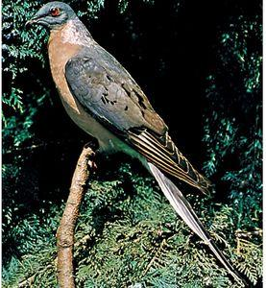 Passenger Pigeons of America https://cdn.britannica.com/98/3398-120-CD959728/Passenger-pigeon.jpg
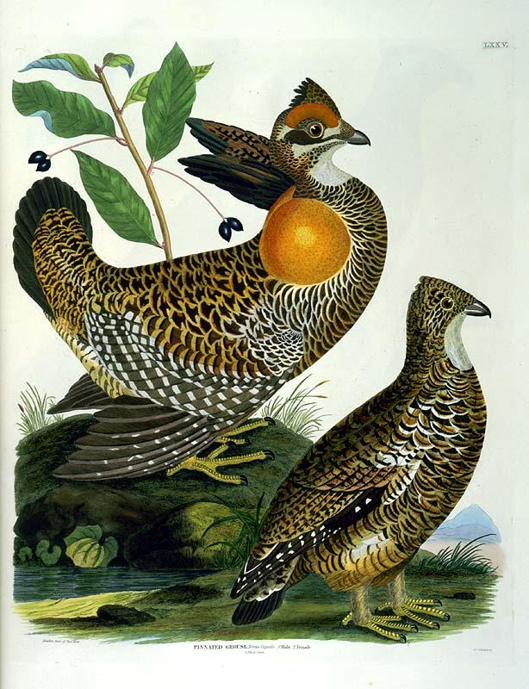
Heath Hen, male & female https://upload.wikimedia.org/wikipedia/commons/f/f9/Heath_Hens.jpg
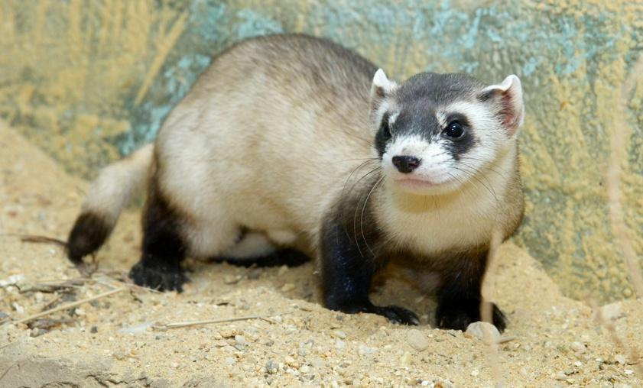

Black-footed ferret | Smithsonian's National Zoo. Creator: Clyde Nishimura | Credit: Smithsonian's National Zoo Copyright: Smithsonian Institution,

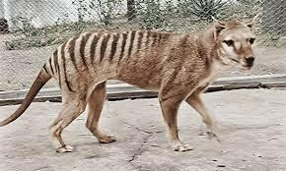
Tasmanian Tiger. : Courtsy : https://www.theguardian.com/australia-news/2023/mar/27/tasmanian-tiger

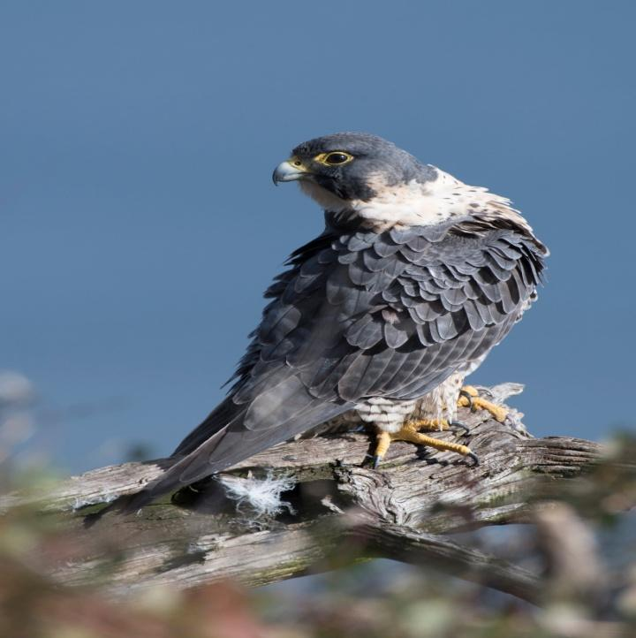
Peregrine falcon, Photo: Mathew Malwitz/Audubon Photography Awards https://www.audubon.org/field-guide/bird/peregrine-falcon
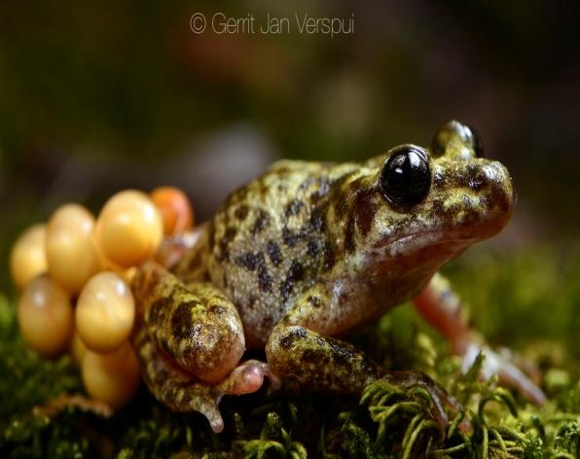

Mallorcan Midwife Toad (Alytes muletensis) · iNaturalist Canada

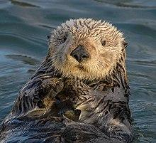
Sea otter https://en.wikipedia.org/wiki/Sea_otter#/media/File:Sea_Otter_(Enhydra_lutris)_(25169790524)_crop.jpg

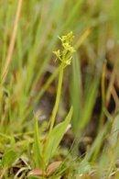

Fen Orchids : Courtsy : Elaine's Wild Orchid Photographs. https://www.first-nature.com/books/eh1.php
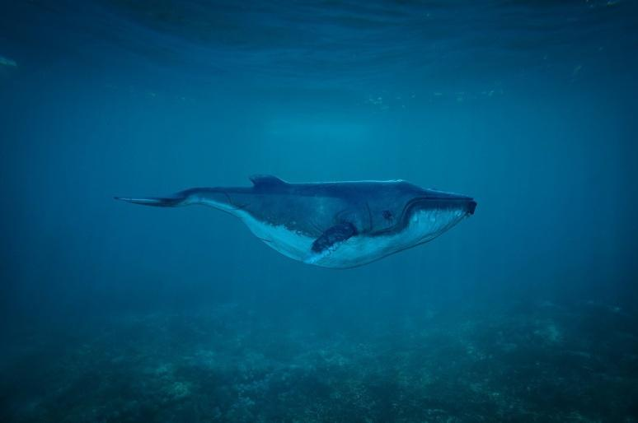
Blue whale
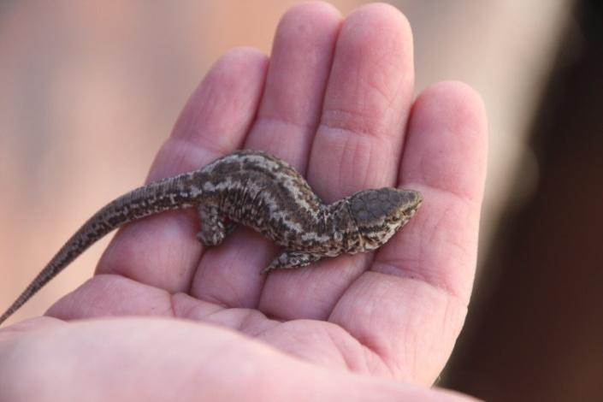
Island night lizard Courtsy : https://cirweb.org/island-night-lizard
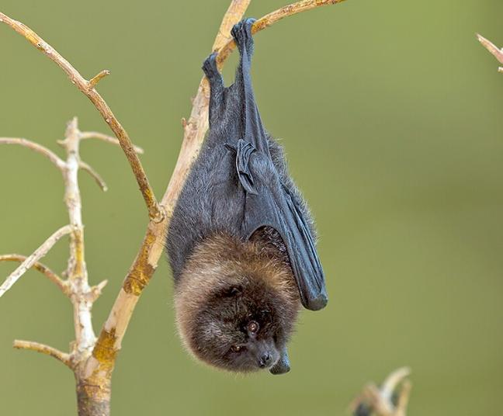
Rodrigues fruit bats Courtsy : https://sdzwildlifeexplorers.org/animals/rodrigues-fruit-bat
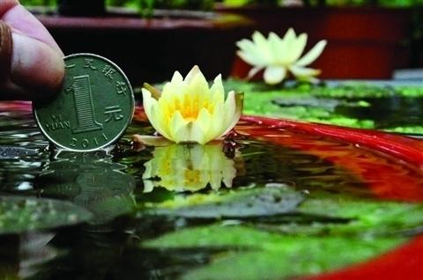
Pygmy Rwandan water lily. Courtsy : https://www.containerwatergardens.net/dwarf-water-lilies/
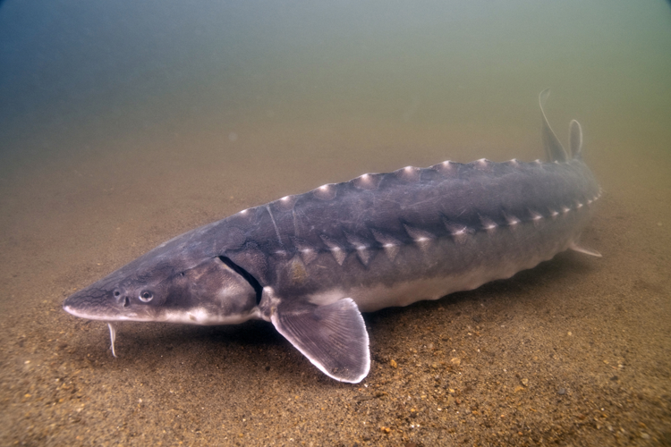
Shortnose sturgeon in the Connecticut River, (NATIONAL OCEANIC AND ATMOSPHERIC ADMINISTRATION | U.S. DEPARTMENT OF COMMERCE CT. Copyright: Robert S. Michelson/Photography by Michelson, Inc.)
References-
- Mora, C, D.P. Tittensor, S. Adl, A.G.B. Simpson and B. Worm. 2011. How many species are there on earth and in the ocean? PLoSBiol9(8): 1-8.
- Hall OP and Ferero OS (2013) Biological Diversity in the patent system. PLoS ONE 8(11); e78737.doi:10.1371/journal.pone.0078737.
- Singh, P. & Dash, S.S.2014. Plant discoveries 2013 – New Genera, Species and new records. Botanical survey of India, Kolkata.
- Singha, R.K., M. Dube, R.D. Tripathi, A. Kumar, P. Tripathi and S .Dwivedi. 2010. India a megadiversity nation. International Society of environmental Botanists,Environews. 16(4). Oct
- Schonewald-Cox et al., 1983; Lande, (1988).
- Genetic Diversity and Population Structure of the Rare and Endangered Plant Species Pulsatilla patens (L.) Mill in East Central Europe.Monika Szczecińska,1,* Gabor Sramko,2,3 Katarzyna Wołosz,1 and Jakub Sawicki1,4.Published online 2016 Mar 22. doi: 10.1371/journal.pone.0151730.PMCID: PMC4803199.PMID: 27003296
- Target SSR-Seq: A Novel SSR Genotyping Technology Associate With Perfect SSRs in Genetic Analysis of Cucumber Varieties.Jingjing Yang12†,Jian Zhang12†,Ruixi Han3†, Feng Zhang1,2 , Aijun . Front. Plant Sci., 24 April 2019.Sec. Plant Breeding.Volume 10 - 2019 | https://doi.org/10.3389/fpls.2019.00531
- Microsatellite markers: what they mean and why they are so useful. Maria Lucia Carneiro Vieira, 1 Luciane Santini, 1 Augusto Lima Diniz, 1 and Carla de Freitas Munhoz 1.Published online 2016 Aug 4. doi: 10.1590/1678-4685-GMB-2016-0027Genet Mol Biol. 2016 Jul-Sep; 39(3): 312–328.PMCID: PMC5004837.PMID: 27561112
- Single nucleotide polymorphism (SNP) markers for genetic diversity and population structure study in Ethiopian barley (Hordeum vulgare L.) germplasm Mihret Yirgu , Mulugeta Kebede, Tileye Feyissa, Berhane Lakew, Aemiro Bezabih Woldeyohannes & Mulusew Fikere BMC Genomic Data 24, Article number: 7 (2023) 2087 Accesses
- Molecular markers: tool for genetic analysis.Avinash Marwal, Rajarshi Kumar Gaur, in Animal Biotechnology (Second Edition), 2020.
- Restriction Fragment Length Polymorphism.B. Mittal, ... S. Tulsyan, in Brenner's Encyclopedia of Genetics (Second Edition), 2013
- Advanced Topics in Forensic DNA Typing: Methodology.Chapter 16 - Non-human DNA,Author links open overlay panelJohn M. Butler.2012, Pages 473-495.
- Kress W. J. (2017). Plant DNA barcodes: applications today and in the future. J. Syst. Evol. 55 291–307. 10.1111/jse.12254
- Hodkinson T.R., Waldren S., Jan P., Kelleher C.T., Salamin K., Salamin N. DNA banking for plant breeding, biotechnology and biodiversity evaluation. J. Plant Res. 2007;120:17–29.
- Popova E., Kim H.H., Paek K.Y. Cryopreservation of coriander (Coriandrum sativum L.) somatic embryos using sucrose preculture and air desiccation. Hortic. Sci. 2010;124:522–528.
- Chen X.L., Li J.H., Xin X., Zhang Z.E., Xin P.P., Lu X.X. Cryopreservation of in vitro-grown apical meristems of Lilium by droplet-vitrification. South Afri. J. Bot. 2011;77:397–403.
- Sanchez C., Martinez M.T., Vidal N., San-Jose M.C., Valladares S., Vieitez A.M. Preservation of Quercus robur germplasm by cryostorage of embryogenic cultures derived from mature trees and RAPD analysis of genetic stability. Cryo. Lett. 2008;29:493–504.
- Martin C., Cervera M.T., Gonzalez-Benito M.E. Genetic stability analysis of Chrysanthemum (Chrysanthemum x morifolium Ramat) after different stages of an encapsulation–dehydration cryopreservation Protocol. J. Plant Physiol. 2011;168:158–166.
- Liu Y.G., Liu L.X., Wang L., Gao A.Y. Determination of genetic stability in surviving apple shoots following cryopreservation by vitrification. CryoLetters. 2008;29:7–14.
- Magdalena Pecul (December 1997). ''ZAMROŻONE ZOO''. ''Wiedza i Życie''. Retrieved 2010-04-26.
- Ten animals we have saved from extinction | Natural History Museum (nhm.ac.uk)
- 25 Animals That Scientists Want to Bring Back From Extinction : ScienceAlert

