A MATHEMATICAL STUDY OF MASS AND HEAT TRANSFER OF A MHD FLUID FLOW WITH BUOYANCY EFFECT

T. Nithya

Department of Mathematics, V. H. N. Senthikumara Nadar College, Virudhunagar, India

Email: [*nithya.t@vhnsnc.edu.in](mailto:*nithya.t@vhnsnc.edu.in)

**Abstract:** This paper studies the flow and heat transfer of a magnetohydrodynanic fluid flow together with buoyancy effect of a viscous fluid over a porous sheet. The non-linear differential equations governing the model are solved analytically using Modified Homotopy analysis method. The effect of the velocity profile and the temperature profile thus obtained on varying the parameters such as suction parameter, magnetic parameter, Prandtl number, Eckert number and buoyancy parameter are discussed graphically.

**Keywords:** Magnetohydrodynamic , Buoyancy effect, Suction Parameter, Non-linear differential equations, Modified Homotopy Analysis method.

**1. Introduction**

The study of MHD flow is relevant to a wide range of industrial applications. Important applications include nuclear reactor cooling, liquid metal fluid cooling, power generation systems, and aerodynamic dynamics. The issues of heat transfer and mass transfer through inclined stretching sheets with Hall current, and heat generation, have been the focus of considerable research in the past few decades. MHD flow is relevant to many engineering challenges, including wire drawing, the production of glass-based materials, paper, and metal spinning. [2] investigated Boundary-layer behavior on compact solid surfaces of a boundary layer axisymmetric flow. The effects of viscous dissipation and the work done by deformations on the MHD flow and heat transfer of a viscous fluid over a stretching sheet was done by [3]. The series solution for Unstable magnetohydrodynamic flows of non-newtonian fluids caused by an impulsive stretching plate was obtained by [4]. [5] studied the impact of thermal radiation on the boundary layer flow due to an exponentially stretching sheet. Heat transfer in a viscous fluid over a stretching sheet with viscous dis-sipation and internal heat generation was made by [6] and [7]. [8] - [10] analyzed the mixed boundary layer in the stagnation point flow towards the stretching vertical sheet. The viscous fluid flow over a nonlinearly stretching sheet were handled by [11]-[14]. The radiation effect of a electrically and magnetically conducting fluid on passing through various surface was illustrated in detail by [15]-[20]. The buoyancy effect of mhd flow was studied by [21] . The convective heat and mass transfer of MHD fluid plays a vital role in scientific industries whish was illustrated by [22]-[25].

[1] Numerically solves the problem of constant laminar 2-D boundary layer minimum density of material (MHD) flow and transfer of heat over an insubstantial viscous liquid with buoyancy forcing and viscous dispersion over a vertical non-linear stretching sheet (partial slip). In the present study, the non-linear differential equation governing the problem derived by [1] was solved analytically using Modified Homotopy analysis method. The semi analytical expression for velocity profile and temperature profile were obtained and the effect on varying the governing parameters are discussed graphically.

**2. Mathematical formulation of the problem**

The investigation focuses on the two-dimensional, nonlinear, steady, MHD laminar boundary layer flow of a viscous, incompressible, and electrically conducting fluid with heat transfer over a porous vertical stretching sheet embedded in the presence of a transverse magnetic field that includes viscous and Joules dissipation. Parallel to the y-axis, a B strength transverse magnetic field is applied uniformly. Consider a stretching sheet that, similar to a polymer extrusion process, emerges from a slit at and is then stretched. Let's assume that boundary layer approximations apply and that the speed at a spot on the plate is proportional to the power of its distance from the slit. The following equations are written with the assumption that the electric field created by the polarization of charges, the external electric field, and the induced magnetic field are all very small.

Consider a nonlinear stretched vertical sheet that is submerged in an incompressible electrically conducting viscous fluid with a temperature of  and a continuous, two-dimensional free convection flow. The surface temperature and the stretching velocity  are determined by the constants a and b, where . The assumption is that the sheet will change nonlinearly as the distance x from the leading edge increases, i.e.,  and . The boundary layer equations that govern momentum, energy with buoyancy, viscous dissipation, and partial slip under these circumstances are:

 (1)

 (2)

 (3)

with boundary conditions:

 (4)

where,

are velocity component in x and y directions respectively, the dynamical viscosity, density,  thermal diffusivity,  Thermal expansion coefficient, temperature, temperature of the fluid outside the boundary layer, gravitational acceleration.

Introduce dimensionless quantities as given:

 (5)

The governing non-linear dimensionless equations are obtained as:

 (6)

 (7)

along with the boundary conditions

 (8)

**3. Semi-Analytic solution by Modified Homotopy Analysis Method [26]-[35]**

Consider a differential equation  (9)

where N is a non-linear operator, 𝜂 denotes independent variable and is an approximate analytical solution of (11) which is ban unknown function. Let denote an initial approximation of , is known as auxiliary function and L denotes an auxiliary linear

operator,  is a non-zero embedding parameter lies between -1 and 1. Then the homotopy is given by:

 (10)

where  is an embedding parameter.

By means of analyzing the boundary conditions of the non-linear differential problem, we can know an appropriate base functions to represent the solution, even without solving the given non-linear problem.

In view of the boundary conditions (8), the initial solution can be guessed to be:

 (11)

 (12)

And the linear operators  are defined as:

 (13)

 (14)

Applying Modifed Homotopy Analysis method,



 (15) where,  (16)  (17)



 (18)

**4. Results and Discussion**

The velocity and temperature profiles have been discussed by giving numerical values in order to get physical knowledge. Analytical expressions were obtained and their effects on flow and heat transfer characteristics were observed for various values of the suction parameter *fw*, magnetic parameter *M*, power law stretching parameter *m*, Prandtl number *Pr*, Eckert number *Ec*, buoyancy parameter, and slip parameter graphically.

Figure 1 shows the effects of the magnetic parameter *M* on the longitudinal velocity profile. As can be observed, raising *M* causes the boundary layer's velocity distribution to decrease, which thins the layer's thickness and causes the velocity gradient at the surface to increase in absolute terms. The suction parameter's impact *fw (fw < 0)*, over Figure 2 displays the non-dimensional longitudinal velocity profiles. It can be shown that the suction parameter has a decelerating influence on longitudinal velocity. Effects of the injection parameter *fw (fw > 0)*, Figure 2 depicts the dimensionless longitudinal velocity profile, and it is clear that the longitudinal velocity rises with injection. Figure 3 depicts the impact of suction and injection on a dimensionless temperature profile. It can be seen that, for suction, a decrease in temperature in the thermal boundary layer causes a reduction in thermal boundary layer thickness, whereas for injection, the opposite trend is observed. Furthermore, it is evident that suction *(fw <0)* reduces the thickness of the thermal boundary layer and improves the heat transfer coefficient significantly more than injection *(fw > 0)*. As a result, suction can be employed to chill the surface considerably more quickly than injection.

It can be seen in Figures 4 and 5 that the longitudinal velocity profile and temperature profile behave differently depending on the value of the power law stretching parameter m. The decrease in the longitudinal velocity profile is more pronounced for small values of m, whereas the temperature profile increases as the stretching parameter m increases. It has been found that the thermal boundary layer is significantly impacted by changes in the sheet temperature. When sheet temperature varies in the direction of greatest stretching rate, the effect is more pronounced. The temperature distribution shown in Figure 6 reduces as Prandtl number Pr increases, which is consistent with the observation that the thickness of the thermal boundary layer decreases as Prandtl number increases. As the Prandtl number grows, so does the rate of heat transmission. As Pr rises, the boundary layer edge is reached more quickly.

Figure 7 displays the dimensionless velocity profile for various slip parameter values . It is obvious that has a significant impact on the solutions. In reality, as slip parameter values  increases, the velocity profile also increases.

Figure 8 illustrates the effects of the buoyancy parameter  on dimensionless longitudinal velocity visually. It is discovered that the effects of the buoyancy force are stronger for a fluid with a small Pr. Smaller Pr fluids are therefore more sensitive to the effects of buoyancy force.

Figure 9 depicts the effect of the Eckert number Ec on dimensionless temperature profiles. The heat energy is stored in the liquid as a result of frictional heating, as shown in Figure 9, hence an increase in the Eckert number Ec raises the temperature.

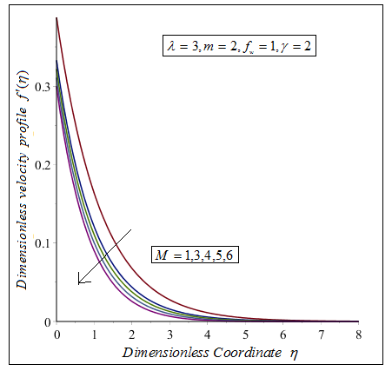

Figure:1. Dimensionless coordinate 𝜂 versus Dimensionless velocity profile . The curve is plotted using (15) for fixed with varying 

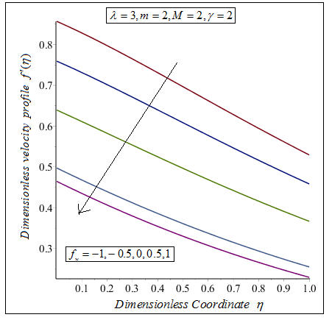

Figure:2. Dimensionless coordinate 𝜂 versus Dimensionless velocity profile . The curve is plotted using (15) for fixed with varying 

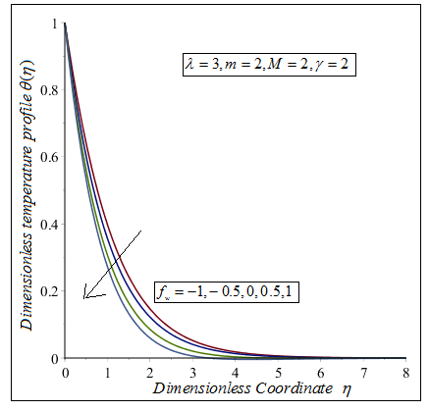

Figure:3. Dimensionless coordinate 𝜂 versus Dimensionless temperature profile . The curve is plotted using (18) for fixed with varying 

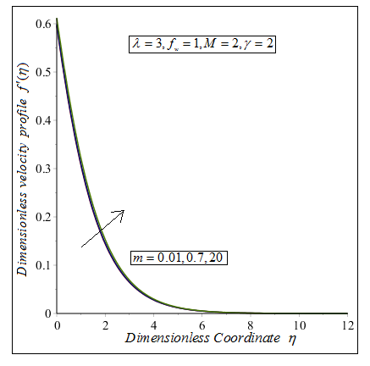

Figure:4. Dimensionless coordinate 𝜂 versus Dimensionless velocity profile . The curve is plotted using (15) for fixed with varying 

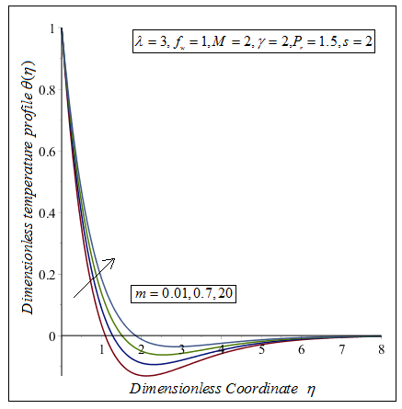

Figure:5. Dimensionless coordinate 𝜂 versus Dimensionless temperature profile . The curve is plotted using (18) for fixed with varying 

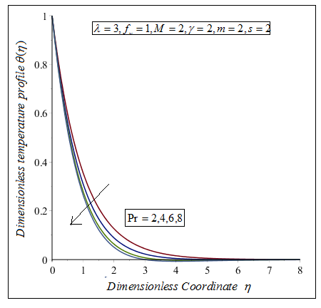

Figure:6. Dimensionless coordinate 𝜂 versus Dimensionless temperature profile . The curve is plotted using (18) for fixed with varying 

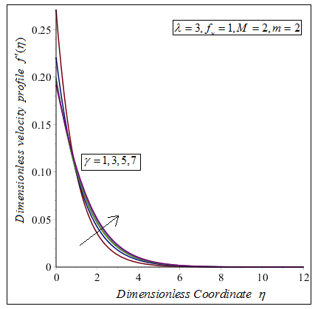

Figure:7. Dimensionless coordinate 𝜂 versus Dimensionless velocity profile . The curve is plotted using (15) for fixed with varying 

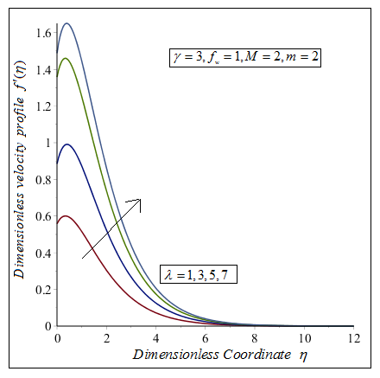

Figure:8. Dimensionless coordinate 𝜂 versus Dimensionless velocity profile . The curve is plotted using (15) for fixed with varying 

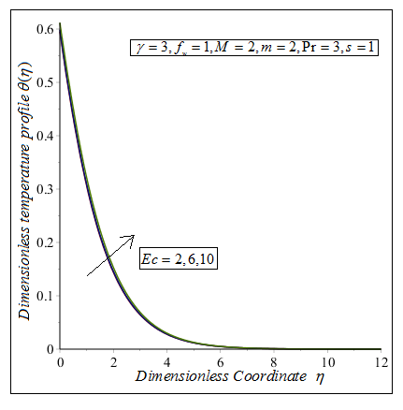

Figure:9. Dimensionless coordinate 𝜂 versus Dimensionless temperature profile . The curve is plotted using (18) for fixed with varying 

**5. Conclusion**

In this paper, Modified Homotopy analysis method is adapted to solve analytically the non-linear differential equations governing the model involving the heat transfer of the MHD fluid flow with buoyancy effect and viscous dissipation past over an inclined stretching porous sheet. The influence of the governing parameters on the derived expressions for velocity and temperature profile are discussed graphically.

**References:**

1. M. Subhas Abel, Kulkarni Anant Kumar, R. Ravikumara, “MHD Flow, and Heat Transfer with Effects of Buoyancy, Viscous and Joules Dissipation over a Nonlinear Vertical Stretching Porous Sheet with Partial Sli**”,** *Engineering*, 3, pp.285-291, 2011.
2. B. C. Sakiadis, “Boundary-Layer Behavior on Conti- nuous Solid Surfaces: I Boundary Layer Equations for Two Dimensional and Axisymmetric Flow,” *AIChE Journal*, Vol. 7, No. 1, 1961, pp. 26-28.
3. R. Cortell, “Effects of Viscous Dissipation and Work Done by Deformation on the MHD Flow and Heat Transfer of a Viscoelastic Fluid over a Stretching Sheet,” *Physics Let- ters A*, Vol. 357, No. 4-5, 2006, pp. 298-305.
4. H. Xu and S. J. Liao, “Series Solutions of Unsteady Magnetohydrodynamics Flows of Non-Newtonian Fluids Caused by an Impulsively Stretching Plate,” *Journal of Non- Newtonian Fluid Mechanics*, Vol. 159, 2005, pp. 46-55.
5. M. Sajid and T. Hayat, “Influence of Thermal Radiation on the Boundary Layer Flow due to an Exponentially Stretching Sheet,” *International Communications in Heat and Mass Transfer*, Vol. 35, No. 3, 2008, pp. 347-356.
6. K. Vajravelu and A. Hadjinicolaou, “Heat Transfer in a Viscous Fluid over a Stretching Sheet with Viscous Dis- sipation and Internal Heat Generation,” *International Communications in Heat and Mass Transfer*, Vol. 20, No. 3, 1993, pp. 417-430.
7. T. C. Chaim, “Magnetohydrodynamic Heat Transfer over a Non-Isothermal Stretching Sheet,” *Acta Mechanica*, Vol. 122, No. 1-4, 1977, pp. 169-179.
8. M. S. Abel, E. Sanjayanand and M. M. Nandeppanavar, “Viscoelastic MHD Flow and Heat Transfer over a Stre- tching Sheet with Viscous and Ohmic Dissipations,” *Com- munications in Nonlinear Science and Numerical Simula- tion*, Vol. 13, No. 9, 2008, pp. 1808-1821.
9. Pantokratoras, “Study of MHD Boundary Layer Flow over a Heated Stretching Sheet with Variable Viscosity: A Numerical Reinvestigation,” *International Journal of Heat and Mass Transfer*, Vol. 51, No. 1-2, 2008, pp. 104-110.
10. Ishak, R. Nazar and I. Pop, “Mixed Convection Boundary Layer in the Stagnation Point Flow towards Stretching Vertical Sheet,” *Meccanica*, Vol. 41, No. 5, 2006, pp. 509-518.
11. M. A. Hossain and H. S. Takhar, “Radiation Effect on Mixed Convection along a Vertical Plate with Uniform Surface Temperature,” *Heat Mass Transfer*, Vol. 31, No. 4, 1996, pp. 243-248.
12. K. Vajravelu, “Fluid Flow over a Nonlinearly Stretching Sheet,” *Applied Mathematics and Computation*, Vol. 181,No. 1, 2006, pp. 609-618.
13. R. Cortell, “MHD Flow and Heat Transfer of an Electri- cally Conducting Fluid of Second Grade in a Porous Medium over a Stretching Sheet Subject with Chemically Reactive species, *Chemical Engineering and Processing*, Vol. 46, No. 8, 2007, pp. 721-728.
14. R. Cortell, “Viscous Flow and Heat Transfer over a Non- Linearly Stretching Sheet,” *Applied Mathematics and Com- putation*, Vol. 184, No. 2, 2007, pp. 864-873.
15. Raptis and C. Perdikis, “Viscous Flow over a Non- Linearly Stretching Sheet in the Presence of a Chemical Reaction and Magnetic Field,” *International Journal of Non-Linear Mechanics*, Vol. 41, No. 4, 2006, pp. 527- 529.
16. Z. Abbas and T. Hayat, “Radiation Effects on MHD Flow in a Porous Space,” *International Journal of Heat and Mass Transfer*, Vol. 51, No. 5-6, 2008, pp. 1024-1033.
17. R. Cortell, “Effects of Viscous Dissipation and Radiation on the Thermal Boundary Layer over a Non-Linearly Stretching Sheet,” *Physics Letters A*, Vol. 372, No. 5, 2008, pp. 631-336.
18. M. Romig, “The Influence of Electric and Magnetic Field on Heat Transfer to Electrically Conducting Fluids,” *Ad- vances in Heat Transfer*, Vol. 1, 1964, pp. 267-354.
19. E. M. A. Elbashbeshy, “Heat Transfer over a Stretching Surface with Variable Surface Heat Flux,” *Journal of Physics D*: *Applied Physics*, Vol. 31, No. 16, 1998, pp. 1951-1955.
20. K. Vajravelu and A. Hadjinicolaou, “Convective Heat Transfer in an Electrically Conducting Fluid at a Stret- ching Surface with Uniform Free Stream,” *International Journal of Engineering Science*, Vol. 35, No. 12-13, 1997, pp. 1237-1244.
21. J. P. Grandet, T. Alboussiere and R. Moreau, “Buoyancy Driven Convection in a Rectangular Enclosure with a Transverse Magnetic Field,” *International Journal of Hea tand Mass Transfer*, Vol. 35, No. 4, 1992, pp. 741-748.
22. H. S. Takhar and P. C. Ram, “Magnetohydrodynamic Free Convection Flow of Water at 4 Degree Centigrade, through a Porous Medium,” *International Communica- tions in Heat and Mass Transfer*, Vol. 21, No. 3, 1994, pp. 371-376.
23. H. M. Duwairi and R. A. Damseh, “Magnetohydrody- namic Natural Convection Heat Transfer from Radiate Vertical Porous Surfaces,” *Heat Mass Transfer*, Vol. 40, No. 10, 2004, pp. 787-792.
24. L. C. Burmeister, “Convective Heat Transfer,” Wiley, New York, 1983.
25. W. M. Kays and M. E. Crawford, “Convective Heat and Mass Transfer,” 2nd Edition, McGraw-Hill, New York, 1987.
26. S. J. Liao, An approximate solution technique which does not depend upon small parameters: A special example, International Journal of Non-Linear Mech, Vol. 30, pp. 371-380, (1995)
27. S. J. Liao, On the Homotopy analysis method for non-linear problems, Appl. Math. Computations*.* Vol.147, pp. 499-513, (2004).
28. S. J. Liao, An optimal Homotopy-analysis approach for strongly non-linear differential equations, Communications in Non-linear Science and Numerical Simulation, Vol. 15, pp. 2003-2016, (2010).
29. S. J. Liao, An explicit totally analytic approximation of basis viscous flow problems, Int. Nonlinear Mach; Vol. 34, pp. 759–78, (1999).
30. S. J. Liao, On the analytic solution of magneto hydrodynamic flows non- newtonian fluids over a stretching sheet, J Fluid Mach, Vol. 488, pp. 189–212, (2003).
31. S. J. Liao, A new branch of boundary layer flows over a permeable stretching plate, Int. J Nonlinear Mech*,* Oscillatory flow and heat transfer in a Horizontal Composite Porous Medium Channel, Vol. 42, pp. 19–30, (2007).
32. Subha, V.Ananthaswamy and L.Rajendran , Analytical solution of a boundary value problem for the electro hydrodynamic flow equation, International Journal of Automation and Control Engineering*,* Vol. 3,No. 2, pp. 48-56, (2014).
33. K. Saravanakumar, V.Ananthaswamy, Subha M., and Rajendran L., Analytical Solution of nonlinear boundary value problem for in efficiency of convective straight Fins with temperature-dependent thermal conductivity, ISRN Thermodynamics, Article I282481, pp. 1-18, 32013.
34. V. Ananthaswamy, T. Nithya, and V.K.Santhi, Approximate analytical expressions of a boundary layer flow of viscous fluid using the modified Homotopy analysis method, Journal of Information and Computational Science, Vol.9, Issue.8, pp.534-541, (2019).
35. V. Ananthaswamy, T. Nithya, and V.K.Santhi, A Mathematical study on MHD plane Poiseuille flow in a porous channel with non-uniform plate temperature, Journal of Applied Science and Computations, Vol. 6, Issue. 3, pp. 1178-1194, (2019)

**Appendix: A Solution of the differential equation using modified HAM:**

The non-linear differential equations are:

 (A1)

 (A2)

along with the boundary conditions

 (A3)

Construct Homotopy as :

 (A4)

 (A5)

The analytical solution of (A1) , (A2) with boundary conditions (A3) are given as:

 (A6)

 (A7)

Substituting (A6), (A7) in the equations (A4) , (A5) and comparing the coefficients of the powers of p and q we get

 (A8)

 (A9)  (A10)

 (A11)

Lettingand 

 (A12)

 (A13)

Solving the equations (A8) to (A11), and substituting the values in ( A12) and ( A13) we obtain the result in the text (15 ) to (18).

**Appendix B: Nomenclature**

|  |  |
| --- | --- |
| **Symbol** | **Meaning** |
|  | Dimensionless velocity profile |
| g | acceleration due to gravity |
|  | nonlinear stretching parameter |
|  | Kinematic viscosity |
|  | Dimensionless coordinate |
|  | Thermal diffusivity |
|  | Thermal expansion coefficient |
|  | Dimensionless temperature |
|  | Density |
|  | Fluid electrical conductivity |
|  | Dimensionless temperature |
|  | Velocity component in x-direction |
|  | Velocity component in y-direction |
|  | Temperature |
|  | Prandtl number |
|  | Temperature at the plate |
|  | Temperature of the fluid outside the boundary |
|  | Dimensionless suction / injection parameter |
| Ec | Eckert number |