COMPARATIVE ANALYSIS OF BIOACTIVE COMPOUNDS IN DRY BLACK AND GREEN GRAPES Vitis vinifera (L.) by GC-MS

S. Vasantha, S. Subramaniyan, S. V. Bakiya Lakshmi
Assistant Professor, Department of Botany, A.V. V. M Sri Pushpam College (Autonomous) Poondi, Thanjavur
Assistant Professor, Department of Zoology,
Assistant Professor, Department of Biotechnology, Bon Secours College for Women, Thanjavur
Affiliated with Bharathidasan University, Tiruchirappalli

Corresponding : subravasanth76@gmail.com, subramanian2376@gmail.com, bakiyalakshmi.sv@gmail.com

Abstract

The study indented to examine the therapeutic potentials of V. vinifera through GC/MS characterization. The ethanolic extracts of Black and Green dry grapes were undergone the qualitative analysis. The results of qualitative phytochemical analysis of black and green grapes extracts showed the presence of alkaloids, flavonoids, glycosides, saponins, tannins, carbohydrates, phytosterol, and triterpenoids, whereas flavonoids were absent in green grapes. The black dry grape possessed Antioxidant, hypocholesterolemic, Antiandrogenic, hemolytic, Alpha reductase inhibitor, Anti-inflammatory, Antimicrobial, and Anticancer compounds. The black grapes having a special steroid compound namely Pregn-5-en-20-one, 3,16- bis[(trimethylsilyl)oxy]-, (3beta,16alpha) possessed Uterine endothelium activity. Similarly, the green dry grape showed fifteen bioactive compounds that possessed Anti-inflammatory, Antimicrobial, anti-cancer, Hepatoprotective and Diuretic, Anti leukemia activity, Anti cataract hypolipidemic properties, and anti larvicidal activity. In addition, male sex hormone compounds, namely Testosterone and Androst-4-en-3-one, 17-hydroxy-, (17.beta.)-. The study shows that both green and black grapes possessed different bioactive especially omega fatty acids found in green grapes. These findings are important and illuminate the role of dry grapes as a future supplement that can prevent adverse effects. In this study, it was suggested that the intake of functional food is useful in the prevention of various diseases.

Keywords: V. vinifera, GCMS, Bioactive compounds, Antioxidant, Anticancer

Introduction
Grapes, a natural product, organically a berry fruit, of the deciduous woody vines of the blooming plant family (Vitis). Vitis Vinifera is an individual from the Vitaceae family, local to southern Europe and Western Asia and developed around the world. Grapes are viewed as rich wellsprings of polyphenolic mixes, such as catechin, epicatechin, gallic acid, procyanidins and Anthocyanin. The total phenolic compounds present in red grapes seed is 62%. Grape seed has a high convergence of Vitamin E, linoleic acid, flavonoids and phenolic procyanidins. The seed extract from grape seeds that are separated, dried and cleaned to create polyphenolic mixes rich possessed antioxidants and oligomeric proanthocyanidins which had antidiabetic cardioprotective, hepatoprotective, anti-carcinogenic, anti-microbial, Vaso-relaxation, Protection against membrane oxidation, inhibit platelet aggregation, anti-viral activity, and metal chelating properties anti-cancer agent, antimicrobial and mitigating properties. It is mostly used for industrial purposes while oral grape seed extract is used in capsules or tablets. The grape seeds are used in herbal medicines, whilst the fruit is consumed as a dietary supplement (Mohanad Jawad Kadhim et al.,2017).
Vitis Vinifera is used in conditions like hemorrhages, iron deficiency, skin problems, syphilis, asthma, jaundice, bronchitis, calming etc. V.vinifera seed contains lipid, protein, carbohydrates and 5-8% polyphenols. The grape seed extract (GSE) has been reported to possess a broad pharmacological and therapeutic effects spectrum. such as antioxidative, anti-inflammatory, and antimicrobial activities, as well as having cardioprotective, hepatoprotective, and neuroprotective effects. The seeds of the grape are used in herbal medicine and as a dietary supplement (Chedea et al., 2010). Hence, the study was to investigated bioactive compounds analysis of Dry black and Green grapes Vitis vinifera (L.).
2. MATERIALS AND METHODS
2.1 COLLECTION OF SAMPLE
The dry black and green grapes (Vitis vinifera) were purchased from PPDS at Thanjavur. The samples were shade dried for 15 days and ground into fine powder. The powder material was stored in air-tight polythene bags until use.
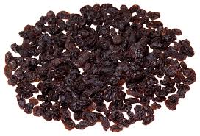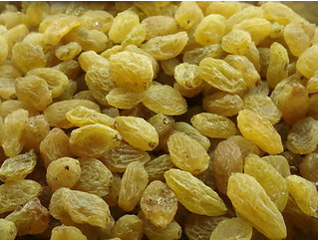
Dry Black Grape Dry Green Grapes

2.2 Preparation of extract
10 g of grape powder were taken separately and boiled in 200mL of distilled water and then heated at 60-70°C to get a concentrated solution. The extracts were filtered using a muslin cloth and then by Whatman no 1 filter paper. The extract was then concentrated using a rotary vacuum evaporator; residues were collected, dried, and used for the experiment. The extracts of samples were subjected to a qualitative test for the identification of various plant constituents by the Harborne method (1973).

ANALYSIS OF BIOACTIVE COMPOUNDS BY GC-MS
The GC-MS analysis of the sample was performed using a Shimadzu GCMS-QP2010 gas chromatography-mass spectrometer interfaced with a Turbo Mass quadrupole mass spectrometer, fitted with an Rtx-5 fused silica capillary column (30 X0.25 mm, with 1 Cm film thickness). The oven temperature was programmed from 100⁰C to 320⁰ C at 100⁰C/min and held for 10 min. Helium was used as carrier gas at a flow of 1.0 mL/min. The injector temperature was 250 ⁰C, injection size 1 µL neat, with a split ratio of 1:10. The interface and MS ion source were maintained at 320⁰C and 200⁰C respectively and the mass spectra were taken at 70eV with a mass scan range of 40-700 amu (atomic mass unit). Data handling was done using GCMS solution software.
Identification of Compounds Interpretation of mass spectrum of GC-MS was conducted using the mass spectral database of National Institute of Standard and Technology (NIST) having more than 62,000 patterns. The spectrum of the unknown component was compared with the spectrum of the known components stored in the NIST library. The name, molecular weight and structure of the components of the test materials were ascertained.
3. RESULT AND DISCUSSION
3.1 Qualitative analysis
The result of qualitative phytochemical analysis of the selected fruit extracts revealed the presence of alkaloids, flavonoids, glycosides, carbohydrates, saponins, tannins, phytosterol and triterpenoids in black grapes; whereas flavonoids were absent in green grapes. The present study for phytochemical analysis qualitatively was analyzed in dry black and green grapes (Vitis vinifera) (Table 1 and Fig. 1).
Table 1. Qualitative analysis of phytochemicals in Dry Black and Green Grapes
(Vitis vinifera)
S.No. | PHYTOCHEMICAL | BLACK | GREEN
1 | Alkaloids | + | +
2 | Flavonoids | + | -
3 | Glycosides | + | +
4 | Carbohydrates | + | +
5 | Saponins | + | +
6 | Tannins | + | +
7 | Phytosterol | + | +
8 | Triterpenoids | + | +

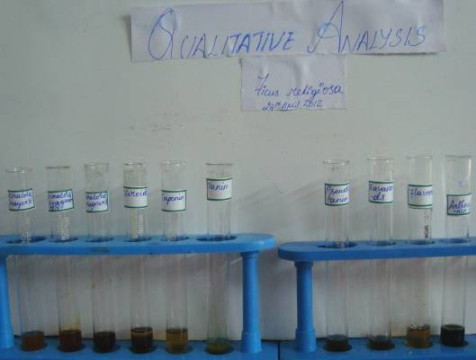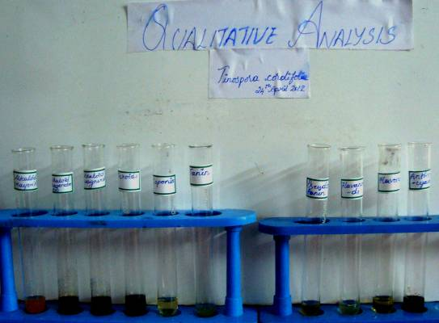
Fig. 1: Qualitative analysis of phytochemicals in Dry Black and Green Grapes (Vitis vinifera)
3.2 GC-MS analysis of Black and Green grapes (Vitis vinifera)
Various bioactive compounds, in the dry black and green Viti’s vinifera extracts, were identified through GC-MS analysis. The identification of some of the important phytoconstituents was based on the peak area, retention time, and molecular weight and their pharmacological activity were major pharmaceutically important compounds from the GC fractions of selected samples. Various compounds present in aqueous extracts of grape peel and seed were listed with their pharmacological activity (Table 2 and 3) and Fig 2 and 3 represent the chromatogram of aqueous extracts of selected Vitis vinifera.

The Diterpenoids compound namely 2-Pentadecanone, 6,10,14-trimethyl was present in black grapes. In addition to that 11-Octadecenoic acid, methyl ester, 9,12-Octadecadienoic acid (Z,Z)-, methyl ester, Hexadecanoic acid, methyl ester and Tridecanoic acid, 12-methyl-, methyl ester was present which showed Antioxidant, hypocholesterolemic, Antiandrogenic, hemolytic, Alpha reductase inhibitor, Anti-inflammatory, Antimicrobial and Anticancer activity. The green grapes having a special steroid compound namely Pregn-5-en-20-one, 3,16- bis[(trimethylsilyl)oxy]-, (3beta,16alpha) possessed Uterine endothelium activity.(Table 2 and Fig. 2).

Similarly, the green dry grape showed fifteen bioactive compounds namely Gamma.-Sitosterol, 9,19-Cyclolanost-24-en-3-ol, Lanosterol, Lup-20(29)-en-3-one, Ferrocene, [(hexadecyloxy)carbonyl, 9,19-Cycloergost-24(28)-en-3-ol and Friedelan-3-one have Anti-inflammatory, Anti microbial, Anti cancer, Hepato protective and Diuretic, Anti leukemia activity, Anti cataract activity, hypolipidemic property and anti larvicidal activity. In addition , male sex hormone compounds were also present, namely Testosterone and Androst-4-en-3-one, 17-hydroxy-, (17.beta.)-. The study shows the both green and black grapes possessed different bioactive especially omega fatty acids were found in green grapes, male sex stimulating hormones were present in green grapes, where as the black grape possessed uterine strengthen compound.( Table 3 and Fig. 3).
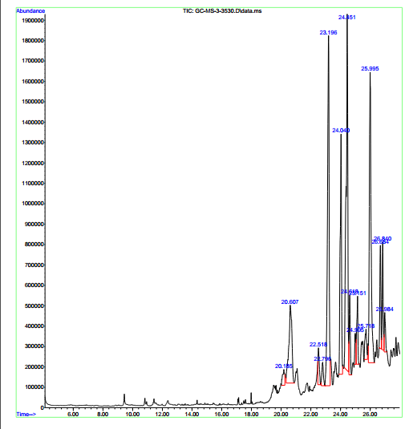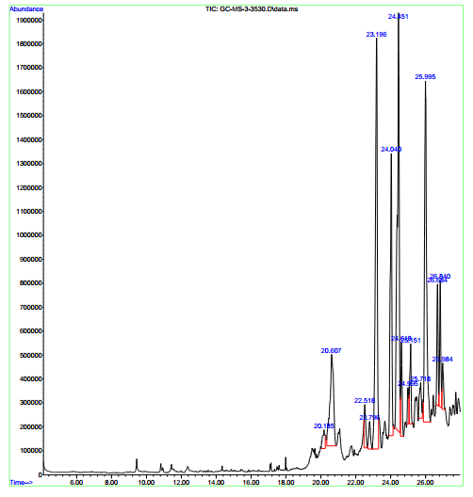
Fig 2 & 3: Analysis of Bioactive compounds in dry black and green grapes by GC-MS
Table 2. Compounds identified in Black Grapes
Name of the compound | Mol. formula | PA % | Compound Nature | Structure | Biological Activity
Glycerin | C₃H₈O₃ | 2.17 | simple polyol compound | 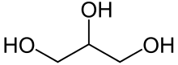 | Sweetener in the food industry and humectants in pharmaceutical formulations
Tridecanoic acid, 12-methyl-, methyl ester | C₁₅H₃₀O₂ | 2.03 | Fatty acid methyl ester. | 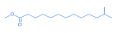 | Antifungal and antibacterial activities.
Phenol, 3-isopropoxy-5-methyl- | C₁₀H₁₄O₂ | 2.70 | Phenol | 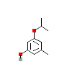 | No activity reported
2-Pentadecanone, 6,10,14-trimethyl | C₁₈H₃₆O₂ | 3.23 | Diterpenoids | 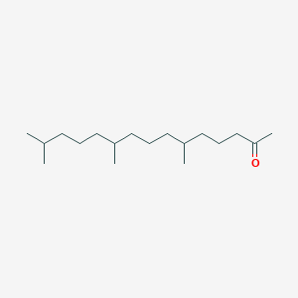 | Antimicrobial
Hexadecanoic acid, methyl ester | C₁₇H₃₄O₂ | 10.47 | Palmittic acid | 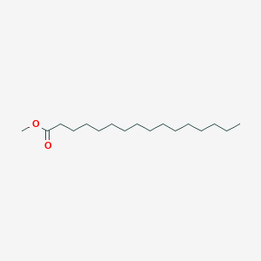 | Antioxidant, hypocholesterolemic, Antiandrogenic, hemolytic, Alpha reductase inhibitor
9,12-Octadecadienoic acid (Z, Z)-, methyl ester | C₁₉H₃₄O₂ | 11.22 | omega 6 unsaturated fatty acid | 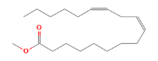 | Anticancer
11-Octadecenoic acid, methyl ester | C₁₉H₃₆O₂ | 9.39 | Oleic acid | 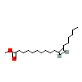 | Hypercholesterolemic, Dermatitigenic, Anti-inflammatory
Phytol | C₂₂H₄₂O₂ | 34.58 | acyclic diterpene | 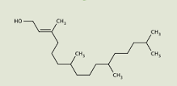 | Flavour and fragrance
l-Leucine, N-(trifluoroacetyl)-, tetradecyl ester | C₆H₁₃NO₂ | 3.66 | Aminoacid | 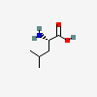 | preventing muscle loss
Benzoic acid, 2-(1-isopropyl)- | C₇H₆O₂ | 1.90 | Aromatic compound | 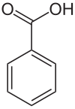 | Antimicrobial activity
2'-Methoxy-2,4-dinitrodiphenylamin | C₁₃H₁₁N₃O₅ | 3.21 |  | 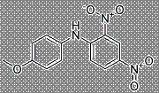 | No activity reported
Pregn-5-en-20-one, 3,16- bis[(trimethylsilyl)oxy]-, (3beta,16alpha) | C₂₇H₄₈O₃Si₂ | 9.45 | Steroid | 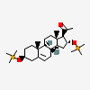 | Uterine endothelium activity
5-Methyl-2-trimethylsilyloxy-acetophenone | C₁₂H₁₈O₂Si | 1.77 | Essential oil | 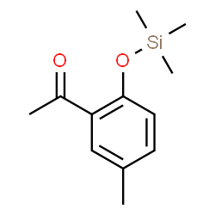 | Antioxidant and antimicrobial

Table 3: Compounds identified in Green Grapes
Name of the compound | Mol. formula | PA % | Compound Nature | Structure | Biological Activity
Gamma.-Sitosterol | C₂₉H₅₀O | 1.10 | Phyto sterol | 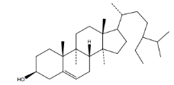 | hypolipidemic property
9,19-Cyclolanost-24-en-3-ol | C32H52O | 8.52 | Triterpenoid | 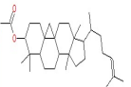 | Anti-mosquito and larvicidal
alpha.-Amyrin | C₃₀H₅₀O | 1.58 | Pentacyclic triterpene | 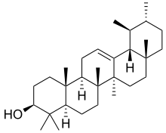 | Antimicrobial and anti-inflammatory activity
Lanosterol | C₃₀H₅₀O | 1.26 | Plant sterol | 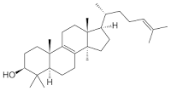 | prevent cataracts
Lup-20(29)-en-3-one | C₃₀H₄₈O | 20.31 | Triterpenoid | 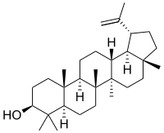 | Anti leukemia activity
9,19-Cyclolanost-23-ene-3,25-diol, | C₃₀H₅₀O | 21.09 | triterpenoid of the sterol class | 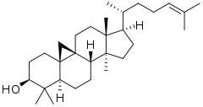 | Antibacterial activity
Phenol, 4-(2-thienylmethyl)- | C₁₅H₁₂OS₂ | 2.95 | Phenol | 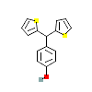 | No activity reported
Testosterone | C₁₉H₂₈O₂ | 1.17 | Steriod | 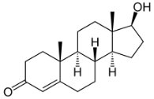 | Sex hormone
Phenol, 4,4'-methylenebis[2,6-bis 1,1-dimethyl ethyl)- | C₂₉H₄₄O₂ | 2.54 | Phenol | 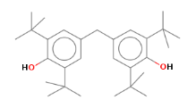 | No activity reported
Ferrocene, [(hexadecyloxy)carbonyl | C₁₀H₁₀Fe | 1.82 | Organometallic compound with iron | 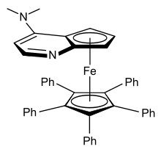 | Anticancer
9,19-Cycloergost-24(28)-en-3-ol, | C₃₂H₅₂O₂ | 17.62 | Plant sterol | 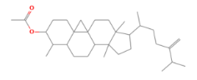 | Anti-inflammatory, Antimicrobial, Anti-cancer, Hepatoprotective, and Diuretic
Friedelan-3-one | C₃₀H₅₀O | 3.67 | Triterpenoid | 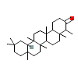 | Antimicrobial
Androst-4-en-3-one, 17-hydroxy-, (17.beta.)- | C₁₉H₂₈O₂ | 3.54 | Steroid | 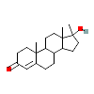 | Regulation of spermatogenesis
Histidine, N-trifluoroacetic-4-iod o-, methyl ester | C₇H₁₁N₃O₂ | 1.48 | Amino acid | 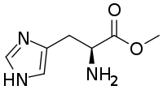 | No activity reported

Conclusion

The results of qualitative phytochemical analysis of black grape extract showed the presence of alkaloids, flavonoids, glycosides, saponins, tannins, carbohydrates, phytosterol and triterpenoids, where as flavonoids was absent in green grapes. The black grapes having a special steroid compound namely Pregn-5-en-20-one, 3,16- bis[(trimethylsilyl)oxy]-, (3beta,16alpha) possessed Uterine endothelium activity. Similarly the green dry grape showed fifteen bioactive compounds. In addition, male sex hormone compounds were also present, namely Testosterone and Androst-4-en-3-one, 17-hydroxy-, (17.beta.)-. Further studies are needed to isolate pure active principle of the extract as well as to elucidate their exact mechanism of action in various diseases using network pharmacology to develop the Nutraceutics for sustainable health.

REFERENCE
Amerine, M.A. and Joslyn, M.A., Table wines. 2nd edition. Berkeley and Los Angeles: University of California press pp. 997, (1967).
Bupesh, G., T.S. vijayakumar, S. Manivannan, M. Beerammal, E. Manikadan, P. Shanthi and A.A. Vijaya, 2016. Identification of secondary metabolites, antimicrobial and antioxidant activity of grape fruit ( Vitis vinifera ) skin extract. Diabetes Obesity Int. J., Vol. 1, No. 1.
Burin, V.M., N.E. Ferreira-Lima, C.P. Panceri and M.T. Bordignon-Luiz, 2014. Bioactive compounds and antioxidant activity of Vitis vinifera and Vitis labrusca grapes: Evaluation of different extraction methods. Microchem. J., 114: 155-163.
Chedea,V.S., Braicu,C. and Socaciu,C., Antioxidant/prooxidant activity of polyphenolic grape seed extract. Food Chem., 121: 132-139, (2010).
Chedea,V.S., C. Braicu and Socaciu, C. 2010. Antioxidant/prooxidant activity of polyphenolic grape seed extract. Food. Chem.121: 132-139.
Dulundu,E., Ozel,Y. and Topaloglu,U., Grape seed extract reduces oxidative stress and fibrosis in experimental biliary obstruction. J. Gastroenterol Hepatol., 22: 885-892, (2007).
Harborne, J. B. (1973). Phytochemical methods: A guide to modern techniques of plant analysis. Chapman and Hall Ltd, London.; Pp. 279.
Kadhim, M.J., A.B. Al-Rubaye and I.H. Hameed, 2017. Determination of bioactive compounds of methanolic extract of Vitis vinifera using GC-MS. Int. J. Toxicol. Pharmacol. Res., 9: 113-126.
Maier,T., Schieber,A., Kammerer,D. and Carle,R., Residues of grape (Vitis vinifera L.) seed oil production as a valuable source of phenolic antioxidants. Food Chemistry, 112: 551-559, (2009).
Mohanad Jawad Kadhim, Abeer Fauzi Al-Rubaye. Determination of Bioactive Compounds of Methanolic Extract of Vitis Vinifera Using GC-MS. International Journal of Toxicological and Pharmacological Research. 2017; 9(2): 113 – 126.
Shenoy,S.F., Keen,C.L.,Kalgaonkar,S. and Polagruto,J.A., Effects of grape seed extract consumption on platelet function in postmenopausal women. Thromb. Res., 121: 431-432, (2007).
Yilmaz Y, Toledo R.T. Health aspects of functional grape seed constituents. Trends Food Sci Tech. 2004; 15: 422 – 433.

