Process of Developing in Organic Light Emitting Diode (OLEDs)
Sunil kumar Yadav¹, Hari Om Sharan², C.S.Raghuvanshi^{3,}
¹Professor, Rama University, Uttar Pradesh, Kanpur, India
Sunilex2015@gmail.com
² Professor, Rama University, Uttar Pradesh, Kanpur, India
drsharan.hariom@gmail.com
³Professor, Rama University, Uttar Pradesh, Kanpur, India
drcsraghuvanshi@gmail.com
Summary
The following subsection analyzes the process by which OLED electrical devices can be put together. OLEDs are often fabricated by either a dry or wet methodology. Vacuum evaporation is often used as a dry procedure in the majority of cases. In this study, three distinct methodologies for using vacuum evaporation are examined. There are methods for applying coatings without generating intricate patterns, as well as techniques for achieving precise designs in wet procedures. In addition to the methods used for the deposition of each organic substance, the utilization of RGB emerging technologies also has significant importance. The RGB patterning technologies include many methods such as vacuum casting using tiny metal plates, wet processing techniques including inkjet printing, nozzle printing, relief printing, and a laser modelling methodology.
Keywords:
Method, wet Method, vacuum Method, masking Technique, patterning, the coating process, laser, ink-jet, nozzle printing, relief printing, etc.
2.1 Vacuum Evaporation Process
The predominant methodology used for the generation of OLED devices is based on the use of a technique known as vacuum evaporation. Figure 2.1 is a diagram demonstrating the performance of this strategy. During this procedure, the organic substances contained inside crucibles undergo a transformation into gaseous form with the application of heat at reduced pressures, typically ranging from 105 to 107 torr. The materials within the gas phase fall onto substrates due to the significant temperature difference between the substrate and the crucible. This deposition process facilitates the transformation of the materials from the gas phase to the phase of solidification.
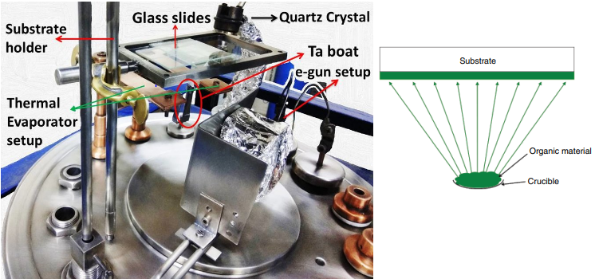
Figure 2.1: A schematic representation of the way vacuum evaporation works
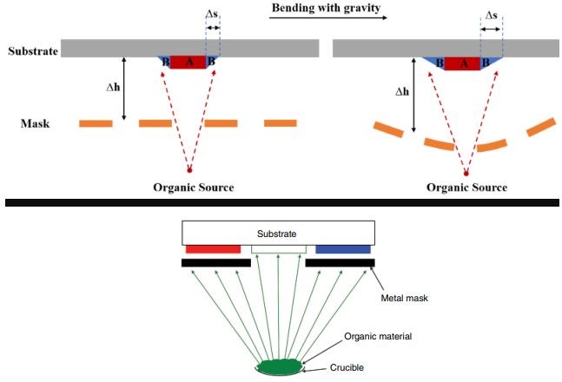
Figure 2.2 the schematic view of mask deposition
2.1.1 Mask Deposition
Shadows mask patterning methods are often used to create sub-pixel emission patterns for the realization of full color [1]. Fig. 2.2 illustrates the schematic representation of the mask deposition process. Although shadow mask deposition is a simple technology in theory, it is not that simple in practice, especially for large displays and displays with high resolutions due to mask distortion or the high danger of faults and fig. 2.2(a).
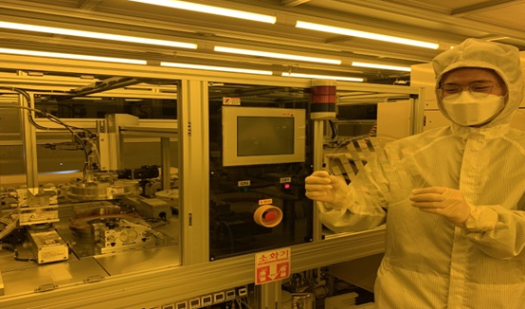
Figure 2.2(a) the view of mask deposition
6.1.2 Three Types of Evaporation Method
To facilitate comprehension of the evaporation approach, it is necessary to first elucidate the structure of the Organic Light-Emitting Diode (OLED). The typical structure of luminescent materials on ITO glass consists of an outer layer of ITO transparent electrode, which is tens of nanometers thick and has a firm framework. The electrode is constructed out of metal as well as serves as both the anode and the cathode in the electrode device. When a certain voltage is applied, electrons and holes are injected from the cathode and anode, respectively, into the electric and electron and hole transport layer. These electrons and holes then migrate through the holes and electron transport layer to reach the light-emitting layer, leading to the release of light by the assembled material. On one aspect of the Indium Tin Oxide (ITO) material, the luminous light is apparent, while the metallic electrode sheet concurrently functions as a reflective coating. Several different kinds of evaporation technologies—
Point source,
Linear source
Planar source evaporation
Planar source evaporation are known based on the interaction between the evaporation source and the substrate. Fig. 2.3
Illustrates various strategies. The focal the source technique, which is often used in research and development as well as in the production of substrates of small and medium sizes, is considered to be the most straightforward approach. This approach involves the placement of an evaporation material inside a point-type crucible source, while a substrate is positioned at a predetermined distance from the source. In order to achieve consistent thickness uniformity of deposited organic layers, it is common practice to use substrate rotation.
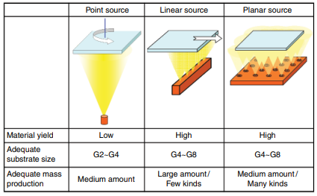
Figure 2.3: Three ways evaporates.
Also, the distance among the target (source) and the substrate (T/S distance) is very wide. This is done so that the thickness of the organic layers formed is regular and so that the radiating rays have less of an effect on the substrate. Most of the time, the gap is a few tens of cm. Because the T/S lengths are so big, most of the materials that evaporate aren't found on the ground but on the walls of the vacuum room.
Point source evaporation normally gives less than 10% of the original material back. If this method is used on large materials, the implements used for drying would have to be very big. Point source evaporation can only be used on small and medium-sized surfaces because of this.G4 (730x920mm) seem to be the largest size of material that can be used. On the other hand, the linear source method can be used with big surfaces. In this method, an evaporation source in the shape of a line is used, and the base moves. The T/S distance can be less than the distance from a single point source. So, it is possible to get a big output of materials. Planar source evaporation is another way. In this method, the source of evaporation is flat and the ground does not move. As in the linear source method, the T/S distance can be cut down. Hitachi Zosen Corporation's Fujimoto et al. made tools for planar source evaporation, as shown in Fig. 2.4 [2].
The investigators conducted a simulation to estimate the quantity of substances that would be extracted by the flat sources. This simulation assumed a T/S separation of 200mm and a thickness homogeneity of less than 3%. The results of the simulation are shown in Figure 2.5. When the dimensions of the foundation are relatively smaller, such as in G2 or G3, the projected material yield ranges from 20% to 30%. When the size of the substrate ranges from G6 to G8, the resulting material production exceeds 60% to 70%. Indeed, a system has been developed for G6 material using a flat source evaporation mechanism.
2.1.3 Ultra‐High Vacuum
It has been stated that the pressure and amount of water left over in vacuum deposition have a big effect on how efficiently OLEDs work.
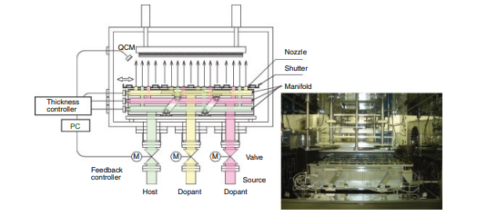
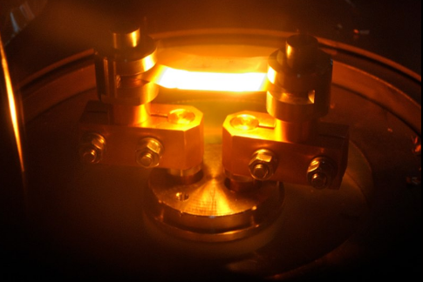
Figure 2.4: An example of evaporation from a planer source 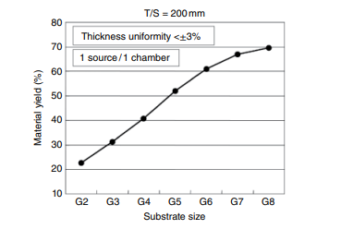
Figure 2.5: Material yield in planar source evaporation it was successfully reproduced
Ikeda, together with other researchers from the Japan Advanced Institute of Science and Technology (JAIST), PRESTO, and Kitano Seiki, conducted a study to investigate the impact of pressure variations in the vacuum chamber on the operational efficiency of OLEDs [3]. The vacuum pressure typically falls within the range of 105 to 107 torr in the majority of OLED substance depositions in court However, a deposition chamber was constructed with a pressure range spanning from 107 to 109 torr. OLED devices were fabricated under three distinct vacuum conditions, using the following arrangement: glass/ITO (150 nm)/Cu Pc (10 nm)/NPD (50 nm)/Alq3 (65 nm)/LiF (5 nm)/Al (80 nm). Table 2.1 demonstrates the correlation between the vacuum pressure and the residual gas quantity subsequent to the deposition process. According to the provided information, water was identified as the primary gas used in the production of device A, while both water and nitrogen were identified as the primary gases employed in the fabrication of device B. Device C, on the other hand, mostly relied on nitrogen as the device's primary gasoline.
Table 2.1: The way vacuum pressure affects the remaining gas components seen during the creation and duration that they endure
Device | Pressure (torr) |  | Ion current (A) |  |  |  | Half lifetime
 | Base | Process | H2 O+  (m/z = 18) | N2 + or CO+  (m/z = 28) | O2 +  (m/z = 32) | CO2 +  (m/z = 44) | LT50 [*]  Hourse
A | 4.9.0 × 10−⁷ | 3.1 × 10−⁷ | 3.76 × 10−⁸ | 2.1 × 10−⁹ | 4.0 × 10−¹⁰ | 5.5 × 10−¹⁰ | 1.2
B | 3.9 × 10−⁸ | 4.5 × 10−⁸ | 2.6 × 10−⁹ | 1.6 × 10−⁹ | 3.3 × 10−¹⁰ | 4.1 × 10−¹⁰ | 24.2
C | 1.9 × 10−⁹ | 1.5 × 10−⁸ | 5.8 × 10−¹ | 1.0 × 10−⁹ | 6.9 × 10−¹¹ | 6.9 × 10−¹⁰ | 31.0
Instrument C is a technological apparatus. Table 1 presents the half-life (LT50) values under a constant direct current of 250mA/cm2, corresponding to an initial luminance (L0) of about 10,000 cd/m2. The research findings indicate that the quantity of residual water significantly impacts individuals' lifespan. During the subsequent discourse on their research article, the authors said that the incidence of water molecules impacting the substrate in device A exceeded the number of Alq3 molecules by a factor of more than 10. The researchers arrived to the determination that the extended lifespan of the gadget may be attributed to the presence of water inside the Alq3 layer. Yamamoto et al. (Universal Display Corporation, USA) and other researchers conducted an investigation on the impact of ultra-high vacuum circumstances on the longevity of phosphorescent OLED devices [4]. In an experimental setting characterized by ultra-high vacuum (UHV) conditions of 6.5x10-7 Pa, another phosphorescent OLED devices exhibits a decrease in brightness of just 6% after a 5-hour operating period at an intensity of 1880cd/m2. In contrast, the identical phosphorescent OLED equipment experiences a greater decline in brightness, amounting to 11%, after a 5-hour performance at an intensity of 1774cd/m2. According to the sources, it was reported that the estimated water content in the EML (Electrochemical Luminescence) of the devices was roughly 9x109 molecules/cm2 for the Ultra-High Vacuum (UHV) technology and approximately 3x1012 molecules/cm2 for the High Vacuum (HV) technology. These values correspond to water concentrations of 10-4 mol% and 0.05 mol% for the UHV and HV equipment, correspondingly. The significance of water admixture in contributing to pollution is evident. According to their statement, it has been shown that the typical electric field strength of an OLED, which is around 106V/cm, has sufficient magnitude to induce the electrolytic reduction of water during the operational phase. This process results in the generation of hydroxide ions (OH-) and hydrogen ions (H+) inside the device. It is believed that the introduction of minute quantities of ionic substances in the form of electrochemically reduced water to the EML initiates the commencement of breakdown mechanisms. The researchers also examined the impact of water on the green phosphorescent organic light-emitting diode (OLED). Water was introduced at certain locations in green PHOLEDs with the following structure: ITO / HATCN / α-NPD / CBP : Ir(ppy)3 / BAlq / LiF / Al. This was done in order to investigate the primary reason of device failure. The analysis of the six instances revealed a high degree of sensitivity of the NPD/EML interaction to water. subsequently is believed that highly reactive ions, such as OH and H+, present in the recombination zone at the interface between α-NPD and EML, have the potential to interact with the EML materials and function as inhibitors. This interaction may lead to a reduction in the operational lifespan of the system.
2.2 Wet Processes
The last section discusses about all the wet processes used for creating OLED equipment, such as ink-jet printing, nozzle printing, relief printing, and spraying. Figure 6.6 is a summary of several wet processes, which can mostly be put into two groups: processes for covering without fine patterns and processes for making fine patterns. The act of coating
 |  | Rotating | Spin coating
 | Without fine patterns |  | Slit-nozzle
 |  | No rotation
 |  |  | Spray
Wet process
 |  |  | Ink-jet printing
 |  | No printing plate
 |  |  | Nozzle printing
 | With fine patterns
 |  |  | Relief printing
 |  | With printing plate
 |  |  | Gravure printing

Figure 2.6 Classification of wet processes for OLED fabrications
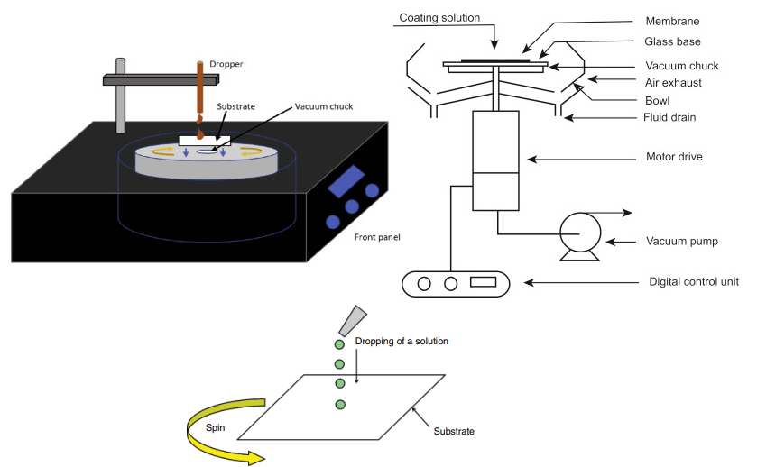
Figure 2.7: A diagram showing the manner in which spin-coating works
Organic coatings that cover virtually the whole instrument area typically arise without fine patterns. So, these covering methods can be used to make white OLEDs for OLED lighting, OLED displays with color filters, and common organic layers that don't give off light, like HIL or HTL, in OLED displays. On the other hand, fine coloring is needed for biological layers that are next to each other and emit RGB light. In these situations, you need to use fine shaping methods. Spin-coating is a common method for covering without fine patterning.
The application of these kinds of ways for film production is well recognized and extensively employed due to its ability to generate consistent layers. According seen in Figure 2.7, the spin-coating technique entails the deposition of solute-laden liquids across a substrate, followed by the rapid rotation of the substrate that elevated velocities, typically ranging from 1000 to 3000 revolutions per minute (rpm). The spin-coating technique is quite advantageous, particularly for experimental purposes; but, its suitability for large-scale manufacturing is limited due to its inherent inefficiency resulting in significant material wastage. The slit-nozzle coating technique is a widely used method for coating that does not rely on the utilization of intricate patterns. Initially, its primary purpose was the fabrication of LCDs of substantial dimensions; nevertheless, it has also found use in the realm of OLED wet techniques.
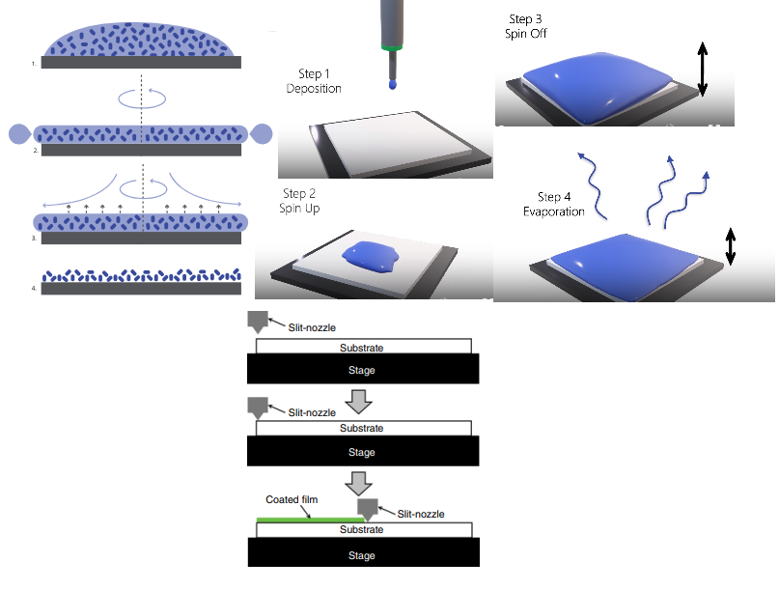
Figure 2.8: A diagram showing the manner in which slit-coating works
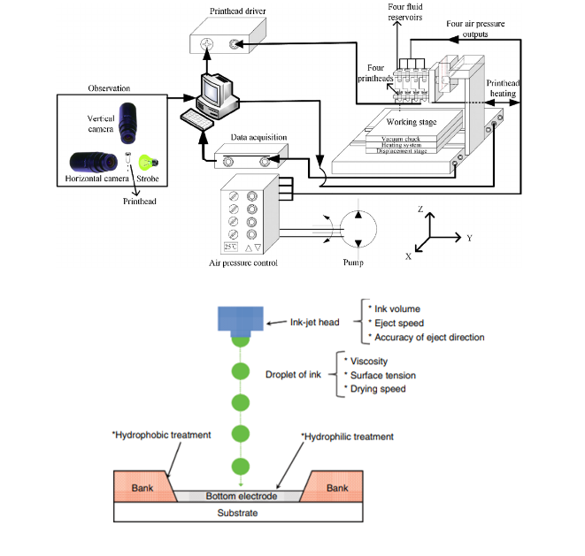
Figure 2.8: A diagram showing the manner in which slit-coating works
Figure 2.8 is a diagram of how slit-coating works. A solution comes out of the slit-nozzle at a fixed volume and speed. Not only are these finishing methods useful for research, but they can also be used to make things without fine design. So, they can be used to make OLED lights. On the other hand, you need fine patterning methods to get RGB subpixels lined up next to each other. The ink-jet method is one of the most widespread forms of technology. Figure 6.9 shows the basic method of the ink-jet process, as well as some of the qualities that it needs.
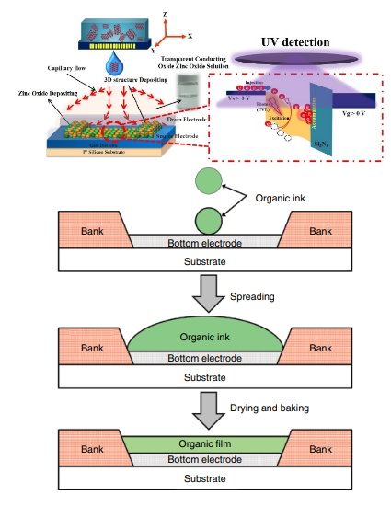
Figure 2.10: A schematic representation demonstrating how a film is made during ink-jet printing
The Piezo-based multi-ink-jet device utilizes piezoelectric technology to dispense minute droplets of ink with precision, targeting particular locations for instance individual sub-pixels of OLED panels. The primary determinant of drop size, whether it ranges from a few Pico-liters or many tens of Pico-liters, is the circumference of the ink-jet tip. Given that the distance between the inkjet nozzle and the printing surface often exceeds the dimensions of a sub-pixel, the precise orientation of ink ejection becomes significant importance. The ink-jet tip requires a consistent ejection speed and precise volume control, since these factors influence the variation in film thickness and the frequency at which the operation may be repeated. The schematic shown in Figure 6.10 illustrates the sequential steps involved in the ink-jet printing process for film production. The solution is spread out over the ground in order to achieve a desirable release, since it is preferable for the viscosity of the solution to be low. In order to maintain the accuracy of the response at the sub-pixel level, it is often necessary to use a bank structure. Moreover, the surface characteristics of both the base and the bank play a crucial role in facilitating the effective dispersion of the solution. Typically, the surface treatment process consists of two plasma phases.The surface undergoes hydrophilic plasma treatment, whereas the bank undergoes hydrophobic plasma treatment. Achieving a base surface that exhibits wetting behavior and a non-wetting bank, together with a uniformly flat layer inside the pixel, requires meticulous tweaking. The manufacturing process of ink significantly influences its jetting performance, including accuracy, flatness of the dried film, and other related factors. Upon the completion of the drying process, ink often results in the formation of discoloration referred to as "coffee stains" on the surface of the film. One potential method for removing a coffee stain involves using a blend of liquids characterized by disparate boiling temperatures. Uniform films may be achieved by optimizing the composition of the solvent, as well as the surface conditions of both the base and the depositor, in order to get a near-perfect match.
Table 2.2 illustrates numerous prototype ink-jet printed AMOLED displays.
 | Size  (diagonal) | Pixel Number | Resolution | Driving | Year | Ref.
Seiko Epson | 2.5 | 200x150 | 100ppi | LTPS-TFT | 2001 | [5]
Seiko Epson | 2.1 |  | 130ppi | LTPS-TFT | 2002 | [6]
TMD | 17 | 1280x768 | 88ppi | LTPS-TFT | 2002 | [7]
Philips | 2.6 | 220x176 | 107ppi | LTPS-TFT | 2004 | [8]
Philips | 13 | 576x324 | 154ppi | LTPS-TFT | 2004 | [9]
Casio | 2.1 | 160x128 | 101ppi | a-si-TFT | 2004 | [10]
Samsung | 7.0 | 480x320 | 82ppi | a-si-TFT | 2005 | [11]
Sharp | 3.6 | 640x360 | 202ppi | CG-Silicon-TFT | 2006 | [12]
AU Optronics | 65 | 1920x1080 | 34ppi | a-ITGO-TFT | 2014 | [13]

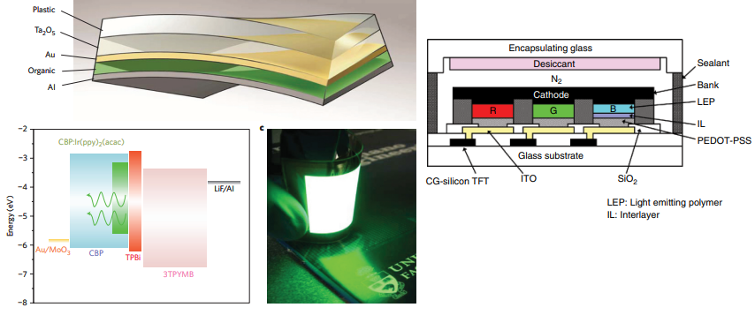
Figure 2.11 the device structure of a 3.6. Full‐color polymer OLED with 202ppi

Ink jet printing was recently used for the fabrication of certain types of active-matrix organic light-emitting diode (AM-OLED) displays, as shown in Table 2.2.
According to Gohda et al. (2006) from Sharp the Corporation, ink-jet printing was identified as having the highest level of accuracy. A polymer-based organic light-emitting diode (OLED) of 3.6 inches in size has been developed, exhibiting full color capabilities and a pixel density of 202 pixels per inch (ppi). Figure 2.11 illustrates the assembly process of the gadget. The researchers used a backplane consisting of continuous grain silicon (CG-silicon) [14], which was integrated with active matrix circuitry. CG-silicon refers to a variant of low temperature poly-silicon (LTPS) that has been subjected to modifications. The researchers used a dual-layer approach including a PEDOT: PSS layer and a releasing polymer layer for the red and green pixels. In contrast, the blue pixel is constructed using a tri-layered structure and a binding agent in order to enhance its longevity. Bank forms are produced using a photosensitive organic film. The arrangement of pixels is seen in Figure 2.12. At a pixel density of 202 pixels per inch (ppi), the average distance between adjacent pixels is about 42 meters. In this study, a 7pl ink-jet head was used for the purpose of printing the three distinct biological layers of PEDOT, namely the PSS layer, the interlayer, and the releasing polymer layer. The approximate dimensions of a drip are estimated to be 23.7 meters, therefore requiring a precision level of around 5.4 meters for its placement.
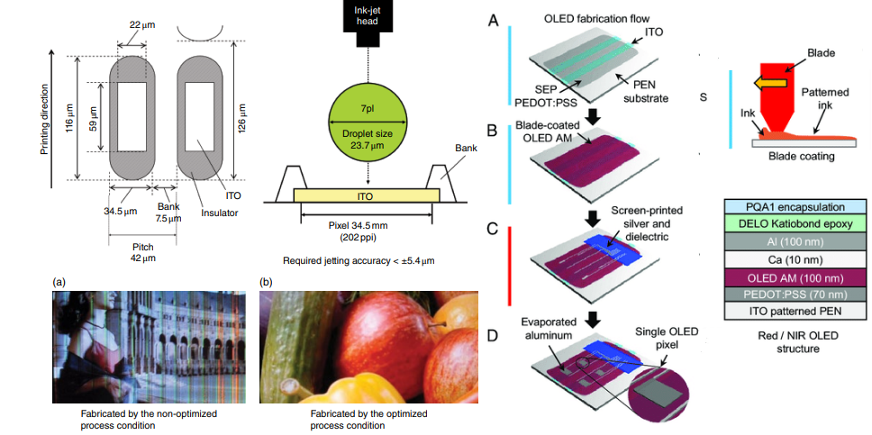
Figure 2.13 has become a picture of a 3.6 active-matrix full-color polymer OLED with 202ppi [12]. (a) Made in a way that isn't the best. b) Made in the best way possible
As was earlier stated, achieving high-resolution designing, such as 202 pixels per inch (ppi), necessitates the use of very precise patterning technology. As seen in Figure 2.13(a), the visual fidelity of the displayed image is compromised when the process characteristics are not adequately tuned. Due to the inherent issues associated with ink-jet printing, a substantial number of errors are encountered. The optimization of process parameters for hydrophilic treatment with respect to the ITO surface, hydrophobic pretreatment on the bank surface, bank material, ink-jet machine, ink mixture, and other relevant factors is necessary. The display image seen in Figure 2.13(b) was generated subsequent to the optimization of various parameters. In their study, Chen et al. (2013) from AU Optronics Technology in Taiwan presented findings on the fabrication of a 65-inch AM-OLED display using ink-jet printing technology. This OLED panel is the largest size achieved using this particular manufacturing method.
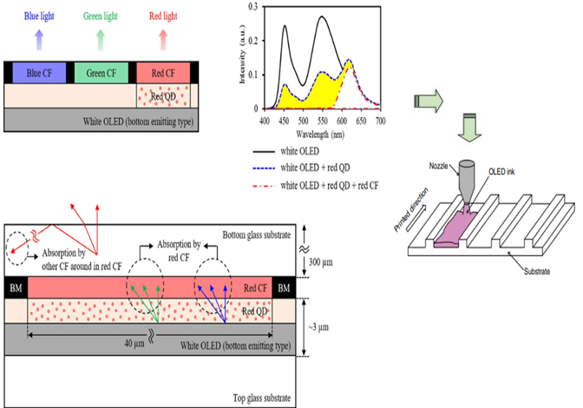
Figure 2.14: An illustration of how jet printing works
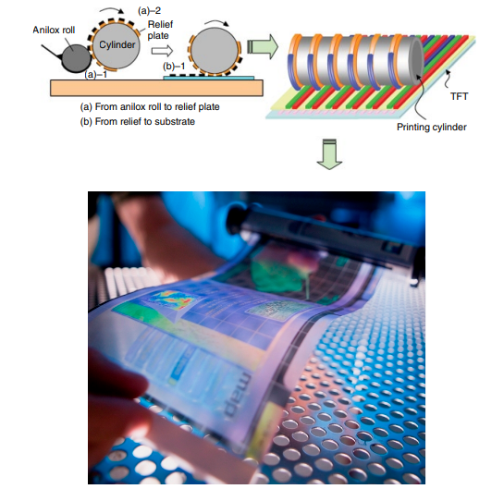
Figure 2.15: A schematic representation of how relief printing operates
There are other accounts of the production of organic light-emitting diodes (OLEDs) using several wet methodologies. DuPont Displays discussed the collaborative efforts between itself and Dainippon Screen Manufacturing Co., Ltd. (Japan) in the development of continuous nozzle printing technology [15, 16]. Figure 2.14 is a schematic representation of the operational principles of tool manufacturing. Continuous-nozzle lithography involves the ejection of a continuous stream of liquid via a designated aperture, which subsequently impacts the target substance.
The printing method involves the controlled movement of a liquid jet throughout a substrate, aligning with pre-established wet and dry regions.The researchers presented a 4.4-inch AMOLED display produced using jet printing technology [16]. Takeshita and Onohara, researchers from Toppan Printing Co. Ltd. in Japan, discussed the use of relief printing in their study [17, 18]. As seen in Figure 2.15, the approach used in this technique has resemblance to the process of direct printing with a relief plate. Convex shapes are used to create the necessary forms on the relief plate. During the first stage, ink is transferred from the ink pan onto the anilox roll, subsequently reaching the intended design on the flat sections of the relief plate. During the subsequent phase, the ink residing on the elevated regions of the relief plate is transferred onto the substrate material. The quantity of ink retained on the anilox roll governs the thickness of the printed film. Additionally, it has been said that the characteristics of the ink during the process of transferring onto the medium have an impact on the regularity and circularity of the resulting printed film. A full-color polymer organic light-emitting diode (OLED) was fabricated, including a screen size of 5 inches. The feasibility of cost-effective OLED manufacture may potentially be realized via the use of roll-to-roll printing techniques characterized by a high throughput. Various methods of printing have been investigated. Kopola and his research team at VTT in Finland used the gravure printing technique for the fabrication of OLED devices [19]. Hast et al. (20) conducted a study at the VTT Technical Research Centre in Finland where they fabricated OLEDs by the use of roll-to-roll gravure printing.
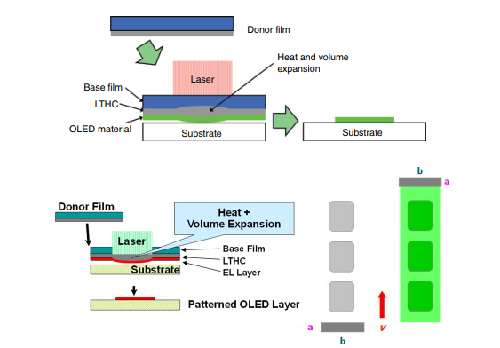

Figure 2.16 is an illustration of how LITI (laser-induced thermal imaging) acts.

Takakuwa, in collaboration with researchers from the Japan Chemical Innovation Institute (JCII) and other institutions, conducted an investigation on the use of micro-contact imprinting using a poly-(dimethylsiloxane) (PDMS) rubber impression fabricated using the nanoimprint technique [21]. The dimensions of each pixel in the design is 400x2000 meters. Hsieh et al. from National Taiwan University in Taiwan developed a novel pattern-coating process known as the air-bubble coating method for OLED devices [22]. According to Panasonic, a 55-inch, 4K2K OLED screen was manufactured using an all-printing technique [23]. The researchers used an indium gallium zinc oxide (IGZO) backplane in conjunction with an organic light-emitting diode (OLED) device structure, which facilitated top-emitting light emission. The specifications include several aspects of the display, such as its pixel count of 3850x2160, maximum brightness of 500cd/m2, contrast ratio of 1,000,000:1, color gamut of NTSC 110%, grey level depth of 10 bits, as well as other pertinent statistics.
2.3 Laser Processes
The concept and execution of using a laser for the purpose of generating patterns was initially conceptualized and subsequently advanced. This section discusses two methods for creating patterns using lasers: Samsung including 3M's laser-induced thermal photography technology, and Sony's laser-induced pattern-wise sublimation (LIPS) technology. The concept was conceived and documented by Lee et al. from Samsung SDI Co. Ltd (South Korea) and 3M Display Materials Technology Centre (USA) [24]. Figure 2.16 (Reference 25) presents a schematic representation of the Laser-Induced Transient Imaging (LITI) technique, illustrating its operational principles.
The Lateral Interference Lithography (LITI) technique involves the use of a source film, a laser exposure device, and a medium. The donor film is a transparent film that has a layer capable of converting light energy into thermal energy, often referred to as light-to-heat conversion (LTHC). The outermost layer of the building envelope, known as the Low Thermal Heat Capacity (LTHC) layer, functions by absorbing incident light and converting it into thermal energy. According to Lee et al. (year), the LTHC layer has the potential to include colors that possess strong absorption properties within the infrared (IR) region of the electromagnetic spectrum. This can be achieved by using pigments such as carbon black and graphite. A biological substance is placed onto the donor film.
Subsequently, the donor film is brought into intimate proximity with a substrate, and the laser apparatus illuminates it. Within the region illuminated by the laser, the layer of Laser-Induced Thermal Imaging (LTHC) undergoes expansion, thereby facilitating the transfer of organic material from the donor film to the substrate.
Lasers provide notable advantages, including their exceptional precision and versatility in generating images of varying forms and dimensions. According to Lee et al. (24), the mean accuracy of the spot is reported to be below 2.5 meters. In a study conducted by Yoo et al. (year), researchers at Samsung SDI Co., Ltd. developed a 2.6-inch full-color VGA AM-OLED display with a pixel density of 302 pixels per inch (ppi). This achievement was accomplished by the use of the LITI method, using a top producing structure [25]. A voltage-compensating pixel circuit was implemented by using a Low-Temperature Polycrystalline Silicon (LTPS) backplane, consisting of six Thin-Film Transistors (TFTs) and one capacitor per pixel.
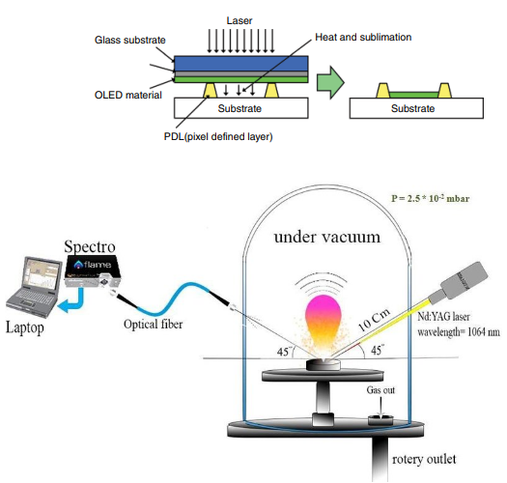
Figure 2.17 is a diagram of how the LIPS (laser-induced pattern-wise sublimation) method functions.
Whereas Hirano et al. from Sony Corporation (Japan) proposed the concept of laser-induced pattern-wise sublimation (LIPS) and documented their findings [26]. Figure 2.17 depicts a schematic representation of the operational mechanism of LIPS. Organic components are synthesized on the glass substrate in addition to the molybdenum absorbing layer. Conversely, it is essential to include a designated pixel specified layer (PDL) into the OLED substrate. The OLED substrate with the glass donor are placed inside a vacuum enclosure, maintaining a certain distance separating them. The objects in question are not exposed to atmospheric conditions. Once the substrate has been mechanically aligned with the laser head, the laser beam proceeds to scan and apply thermal energy to the glass donor at the designated location. The 800 nm diode laser was used as the radiation source. The laser beam's width is adjusted to correspond with the width of the picture being replicated. In order to achieve precise material transfer, a dynamic laser beam is used to transport OLED materials from glass sources to a designated substrate. Donor eyeglasses have the potential for reuse. According to the source, the variation in pattern width is limited to a maximum of 2 meters. A full-color active-matrix organic light-emitting diode (AM-OLED) display with a size of 27.3 inches was developed using the LIPS (low-temperature polysilicon) technological advances.
2.3.1 Laser Induced Thermal Imaging [LITI]
The company 3M has been engaged in research and development of Laser Induced Thermal Imaging (LITI) for a duration of twelve years. It is an electronically patterning methodology characterized by excellent resolution as well as a diverse range of potential applications. These include the patterning for electronic color proofs, plates as well, and film; LCD color filters, black matrix, alongside spacers; anodes for field emission displays (FED), contrast enhancement filters, and nanoemitters; fabrication of organic field effect transistors (OFET); as well as OLED emitters, color filters, and other components. Since the year 2000, a collaborative effort has been undertaken by 3M and Samsung SDI to engage in the development of a methodology for the production of Active-Matrix Organic Light-Emitting Diodes (AMOLEDs). According to the study conducted by Wolk et al. (2004),
The LITI technique employs a donor film that has been previously coated, a laser exposure system of considerable dimensions, and a receiver, such as an AMOLED backplane (see to Figure 2). In the context of OLEDs, a fixed assembly of functional layers is fabricated and maintained as a cohesive unit. A thin layer with a thickness ranging from 20 to 200 nm, capable of producing red, green, or blue light, is applied onto the stock roll by either solvent coating or vapor deposition techniques just before to the patterning process. Subsequently, the coloration of each hue is achieved by a sequential process including the alignment of the receptor, similar to an AMOLED backplane, with the laser exposure system. This is followed by the application of a donor film onto the properly oriented receptor. Following the alignment process, the laser system is used to visually display the stratified configuration. The donor releases the exposed portions, which subsequently adhere to the receptor. The number of iterations in the manufacturing process of OLEDs varies depending on the specific fabrication method used. Alignment occurs just once. According to the study conducted by Wolk et al. in 2004,
After the synthesis of an OLED material from a donor, the donor is subsequently discarded. Despite the fact that the copied region constitutes less than one-third of the overall area of the substrate, a donor film with a high resolution design is now present on the exposed portion. The exposed source cannot be reused due to the film's inherent incapacity to maintain a consistent size and its physical alterations that occur throughout the exposure process. According to the study conducted by Wolk et al. in 2004,
The LITI Process developed by 3M is a suitable option for the fabrication of high-precision flat panel displays that need exceptional clarity, precise alignment, and large-scale imaging capabilities. The LITI technique offers several advantages in situations when the division of tasks between completing and patterning effectively resolves a fundamental issue. The use of Laser-Induced Thermal Imaging (LITI) has been seen in the patterning of organic electronic materials for Organic Light-Emitting Diodes (OLEDs) and organic transistors. Additionally, LITI has been employed in the patterning of stacked OLED stacks, polarizers, and nano-emitters. Additionally, it has the potential to be used in the patterning of enzymes and other nanomaterials. According to the study conducted by Wolk et al. in 2004,
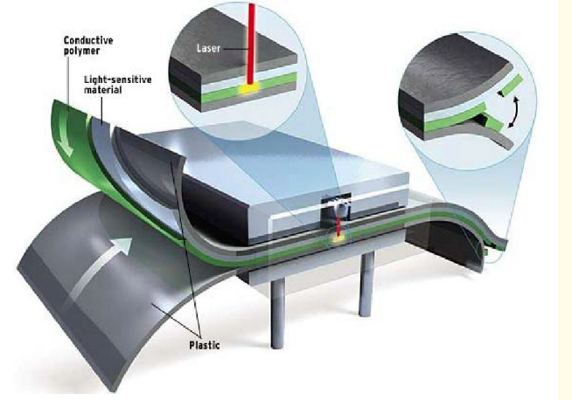

Figure 2.3.1 Laser Induced Thermal Imaging (LITI) process schematics.
Reference
[1] H. Kubota, S. Miyaguchi, S. Ishizuka, T. Wakimoto, J. Funaki, Y. Fukuda, T. Watanabe, H. Ochi, T. Sakamoto, T. Miyake, M. Tsuchida, I. Ohshita, T. Tohma, Journal of Luminescence, 87, 56–60 (2000).
[2] E. Fujimoto, H. Daiku, K. Kamikawa, E. Fujimoto, Y. Matsumoto, SID 10 Digest, 46.3 (p. 695) (2010). [3] T. Ikeda, H. Murata, Y. Kinoshita, J. Shike, Y. Ikeda, M. Kitano, Chem. Phys. Lett., 426, 111–114 (2006)
[4] H. Yamamoto, M. S. Weaver, H. Murata, C. Adachi, J. J. Brown, SID 2014 Digest, 52.3 (p. 758) (2014). [5] S. K. Heeks J. H. Burroughes, C. Town, S. Cina, N. Baynes, N. Athanassopoulou, J. C. Carter, SID 01 Digest, 31.2 (2001).
[6] T. Funamoto, Y. Matsueda, O. Yokoyama, A. Tsuda, H. Takeshita, S. Miyashita, SID 02 Digest, 27.5L (p. 899) (2002). [7] M. Kobayashi, J. Hanari, M. Shibusawa, K. Sunohara, N. Ibaraki, Proc. IDW’02, AMD3‐1 (p. 231) (2002).
[8] M. Fleuster, M. Klein, P. v. Roosmalen, A. d. Wit, H. Schwab, SID 04 Digest, 44.2 (p. 1276) (2004).
[9] N. C. van der Vaart, H. Lifka, F. P. M. Budzelaar, J. E. J. M. Rubingh, J. J. L. Hoppenbrouwers, J. F. Dijksman, R. G. F. A. Verbeek, R. van Woudenberg, F. J. Vossen, M. G. H. Hiddink, J. J. W. M. Rosink, T. N. M. Bernards, A. Giraldo, N. D. Young, D. A. Fish, M. J. Childs, W. A. Steer, D. Lee, D. S. George, SID 04 Digest, 44.4 (2004).
[10] T. Shirasaki, T. Ozaki, K. Sato, M. Kumagai, M. Takei, T. Toyama, S. Shimoda, T. Tano, SID 04 Digest, 57.4L (p. 1516) (2004).
[11] D. Lee, J.‐K. Chung, J.‐S. Rhee, J.‐P. Wang, S.‐M. Hong, B.‐R.Choi, S.‐W.Cha, N.‐D.Kim, K. Chung, H. Gregory, P. Lyon, C. Creighton, J. Carter, M. Hatcher, O. Bassett, M. Richardson, P. Jerram, SID 05 Digest, P‐66 (p. 527) (2005). [12] T. Gohda, Y. Kobayashi, K. Okano, S. Inoue, K. Okamoto, S. Hashimoto, E. Yamamoto, H. Morita, S. Mitsui, M. Koden, SID 06 Digest, 58.3 (2006); M. Koden, Y. Hatanaka, Y. Fujita, Y. Kobayashi, E. Yamamoto, K. Ishida, S. Mitsui, 3rd Japanese OLED Forum, S7‐1 (2006).
[13] P.‐Y. Chen, C.‐L. Chen, C.‐C. Chen, L. Tsai, H.‐C. Ting, L.‐F. Lin, C.‐C. Chen, C.‐Y. Chen, L.‐H. Chang, T.‐H. Shih, Y.‐H. Chen, J.‐C. Huang, M.‐Y. Lai, C.‐M. Hsu, Y. Lin, SID 2014 Digest, 30.1 (p. 396) (2014).
[14] H. Sakamoto, N. Makita, M. Hijikigawa, M. Osame, Y. Tanada, S. Yamazaki, SID 00 Digest, 53.1 (p. 1190) (2000). [15] W. F. Feehery, SID 07 Digest, 69.1 (p. 1834) (2007).
[16] R. Chesterfield, A. Johnson, C. Lang, M. Stainer, J. Ziebarth, Information Display, 1/11, p. 24 (2011).
[17] K. Takeshita, H. Kawakami, T. Shimizu, E. Kitazume, K. Oota, T. Taguchi, I. Takashima, Proc. IDW/D’05, OLED2‐2 (p. 597) (2005).
[18] J. Onohara, K. Mizuno, Y. Kubo and E. Kitazume, SID 2011 Digest, 62.2 (2011).
[19] P. Kopola, M. Tuomikoski, R. Suhonen, A. Maaninen, Thin Solid Films, 517, 5757–5762 (2009).
[20] J. Hast, M. Tuomikoski, R. Suhonen, K.‐L. Väisänen, M. Välimäki, T. Maaninen, P. Apilo, A. Alastalo, A. Maaninen, SID 2013 Digest, 18.1 (p. 192) (2013).
[21] A. Takakuwa, M. Misaki, Y. Yoshida, K. Yase, Thin Solid Films, 518, 555–558 (2009).
[22] Y.‐W. Hsieh, P.‐T. Pan, A.‐B. Wang, L. Tsai, C.‐L. Chen, P.‐Y. Chen, W.‐J. Cheng, SID 2014 Digest, 30.4 (p. 407) (2014).
[23] H. Hayashi, Y. Nakazaki, T. Izumi, A. Sasaki, T. Nakamura, E. Takeda, T. Saito, M. Goto, H. Takezawa, SID 2014 Digest, 58.3 (p. 853) (2014).
[24] S. T. Lee, J. Y. Lee, M. H. Kim, M. C. Suh, T. M. Kang, Y. J. Choi, J. Y. Park, J. H. Kwon, H. K. Chung, J. Baetzold, E. Bellmann, V. Savvate’ev, M. Wolk, S. Webster, SID 02 Digest, 21.3 (p. 784) (2002).
[25] K.‐J. Yoo, S.‐H. Lee, A.‐S. Lee, C.‐Y. Im, T.‐M. Kang, W.‐J. Lee, S.‐T. Lee, H.‐D. Kim, H.‐K. Chung, SID 05 Digest, 38.2 (p. 1344) (2005); S. T. Lee, M. C. Suh, T. M. Kang, Y. G. Kwon, J. H. Lee, H. D. Kim and H. K. Chung, SID 07 Digest, 53.1(p. 1158) (2007).
[26] H. Hirano, K. Matsuo, K. Kohinata, K. Hanawa, T. Matsumi, E. Matsuda, R. Matsuura, T. Ishibashi, A. Yoshida and T. Sasaoka, SID 2007 Digest, 53.2 (p. 1592) (2007)

