Impact of Climate Change on Agriculture

C. Sai Durga, Vaani Sri. S, M. Maheswaran, K. Kokila
PG Scholars, Department of Agronomy, Faculty of Agriculture, Annamalai University, Annamalai Nagar-608 002, Tamil Nadu.

Abstract

Climate of a place determines the type of crops grown in a particular place. Climate is generally defined as “Weather condition prevailing over a large area for a very long time”. Climate has a significant impact on agriculture productivity, type of crops grown, availability of water, crop growing period, precipitation pattern and many more. Hence, it can be drawn and said that, there is a parallel relationship between climate and agriculture and the slightest of the change in the climate can cause a huge impact on agriculture and its production. Agriculture production is highly vulnerable to climate change. Climate change is caused by various factors, some being natural while the others being anthropogenic. The obviously observed changes in climate are increased temperatures (Global warming in other words), increased concentration in green house gases in the atmosphere especially CO₂, unpredictable monsoon, warming of oceans and many more. Of the above mentioned effects of climate change have a direct and great impact on agriculture and its production.

Keywords: Temperature, Climate, Agriculture, Green house gases

Effect of climate change

The climate change effects the agriculture sector in both direct and indirect ways. The direct ways being very common and destructible in nature and brings about a huge difference in the yield and productivity aspects. The direct and indirect effects of climate change on agriculture is mentioned in the flow chart below:

Fig 1: The below figure gives us the idea of effects of climate change on agriculture. The effect can be
classified into Direct and Indirect changes based on the way of impact on agriculture and its production.

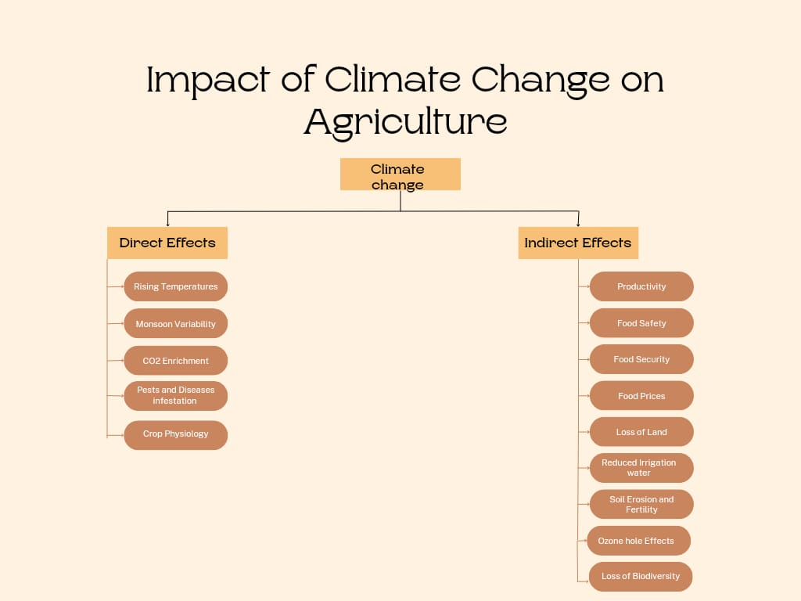
Fig: 1

Direct effects:

- Temperature:
Temperature is one of the most determining factors of the crop choice and its growth and development. The increased temperature effects can be observed in plants right from the seedling to harvesting phase. In many cases the increase in temperatures causes the failure of seed germination. In the vegetative phase, scorching of plants occur in various parts namely leaves, stem causing them to burn and turn yellow. Eventually this leads to defoliation of the plants. It causes stigma and pollen grains to shrivel during maturity phase. The plant experiencing high temperatures at harvesting phase is observed to develop chaffed or unfilled grains. The unusual heating also effects the physiology and timing of blooming in the crops. This effect is majorly observed in wheat crop which requires a low temperature and the rising temperature does not allow the crop to flower.
Heat waves caused due to soaring temperatures leads to shedding of flowers and fruit drop at early stages. Trapping of temperature in a particular area in the form of lid or cap is called heat domes. These causes stunted growth in plants and increases the plant mortality.
Increase in temperatures causes weakening of the pressure belts leading to weakening of the winds and effects water vapour carrying capacity and variation in the amount of rainfall receives is observed. They also cause invisible drought, wherein the amount of moisture present is not sufficient to meet the evapotranspiration needs of the plant.
Increase in temperatures in the Arabian sea region is the main reason for frequent cyclones in the west coast of India which would otherwise experience very less frequency of cyclones. The recent cyclone in the Arabian sea Biparjoy(2023) caused massive floods in the west coast boundary causing immense damage to the agriculture fields.

- Monsoon variabilities:

Indian agriculture is highly rainfall dependent. Any abberations in the rainfall takes a huge toll on the rainfed farms. Unfortunately, climatic change has a primary impact on monsoon. Increase or decrease in the amount of rainfall received by the regions determines the flood or drought like conditions respectively. Drought leads to drying up of the surface and wilting of the plants. And if prolonged leads to crop mortality. Whereas floods leading to water stagnation and chokes the roots with water. As discussed earlier, the temperature changes in the atmosphere along the pressure belts leads to weakening of the existing pressure gradient thus weakening the winds and the monsoon.

The regularly occurring natural phenomenon El Nino, causes unusual heating in the west coast of Peruvian region, reasons for which are still unknown, leads to weakening of the sub tropical high pressure belts and thus reducing the speed of the trade winds. This causes reduced water vapour content carried by the winds and India and Australia experiences drought during south west monsoon and floods are experienced by western coast of South America On the other hand, the retrieving north east monsoon picks up speed and causes floods in the south eastern coast of India. This was the reason behind 2015 floods in Chennai.

The monsoon vagaries like early withdrawal, early onset, prolonged dry spells causes hindrances to the crop effecting crop growth period. Dry spell during the maturity period has the greatest effect on the yield obtained. This forces the farmers to adapt drought resistance crops reducing the choice of crops. Rainfall during pollination wash out the pollen grains causing disrupting and withering of the male flower.

Acid rain (water vapour with NO_{X} and SO_{X}) caused rupturing of leaves especially the leady vegetables like spinach and reduces the quality and sometimes make it unfit for consumption.

- CO₂ enrichment:

The Earth’s atmosphere witnessed a considerate hike in the CO₂ levels from 315ppm in 1959 to 385ppm in 2009(Keeling et all, 2009). Although increase in carbondioxide levels is on the positive side for the plants by increasing the rate of photosynthesis but at the same time reduces the nutrition quality of the fruits and vegetables i.e, reduction in the levels of protein as well as minerals (for example zinc and iron) are expected in certain crops. Declines in magnesium, calcium, potassium, iron, zinc and other minerals in crops can worsen the quality of human nutrition.
This also sometimes causes potential shift in the plant weed communities. It alters the physiology of the plant through disruption in the photosynthesis process where C₄ plants have an added advantage over the C₃ plants.

- Increased Pests and Disease infestation:

The climate change is found to have triggered new pests and diseases in the crop fields. The warming of temperatures has provided congenial conditions for certain pests, on the other hand untimely rainfall has caused pest and disease infestation during the maturity phase of the crop leading to heavy damage. Temperatures becoming warmer along with rainfall invites locust swarms. It has also provided conditions favourable for spreading of pests from one region to the other. The spread of fall army worm in the African regions is believed to be due to climate change.

Elevation in levels of CO₂ is observed to favour the insect infestation. It is also believed that warmer temperature reduces the effectiveness of the pesticides. The coupling of both the reasons have synergic effect on the damage caused by insects to the crops.

- Crop physiology:

The change in the climate forces the crop to bring about adaptations in themselves. Escalating temperatures does not allow those flowers to bloom which require less temperature. It also causes closing of stomata and influencing physiological aspects of the crops.

Indirect Effects:

Where the direct effects deals with the crop related aspects, the indirect effect deals with practical and real time problems caused due to climate change. Though classified as indirect effect, they play an equally significant role in posing threat to the agricultural equilibrium and disturbs the productivity of agricultural sector if not the agriculture field directly. The damage caused to the crop in the field has direct and negative effect on productivity of the area. This proves that the effect of climate on the crops in the agriculture field will no doubt de-escalates the production and productivity of the land.

The irreversible effect in the field have deteriorating effect on the quality of the produce. The biotic and abiotic factors mentioned in the direct causes, the temperatures, the acid rains, pests and disease attack and carbondioxide independently or coupled or sometimes combined altogether have adverse effect on quality of the produce in terms of physical and nutritional aspects. Malnutrition already being burdensome, reduction of nutritional status in crops will only exaggerate the problem even more.

The reduction in the productivity and loss of land due to various factors of climate change will pose a threat to worlds food security. It also increases the cost of production making food more expensive than it already was, due to the hike in the amount and price of inputs required to be able to achieve higher yields. All these summed up together leads to increased food prices. If observed carefully, it seems more like a chain reaction than individual set of problems, where one problem leading other then another.

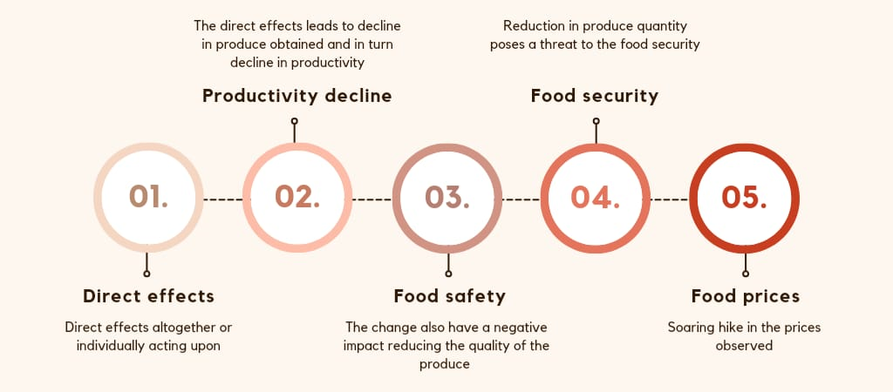
Figure: 2
The above figure shows about the chain reaction of one event leads to another showing its aggregate and final impact.

The effect of climate change is more evident in sub polar or polar regions than any other places on earth. The rapid heating of the polar regions is causing melting of ice caps and glaciers at a surprisingly faster rate. Svalbard alone is heated by 4.9ºC and due to radiative forcing has led to melting of ice at a soaring rate. This leads to rise in the sea levels. This causes inundation of the coastal areas and later submergence of the coastal lands and losing the coastal agriculture lands to the wrath of the sea. Sometimes the inundated water retrieve back and leaves the coastal agricultural areas with deposits of salt making it highly unsuitable for cultivation. This also leads to loss of land. In frequent cases the intrusion of sea water into the ground water takes place which when applied in agricultural lands does more harm than good.

The soil is also the victim of the climate change. There are observed changes in its properties, components and fertility. The monsoonal aberrations also causes displacement of soil particles from one place and depositing it in place far away from the original site. This phenomenon is termed as Soil Erosion. This leads to carrying away of the top most fertile soil layer where most of the nutrients reside, bring a change in the fertility status of the very soil. In some cases, the monsoonal aberration causes leaching of the nutrients to the lower layers of the soil making it acidic and further reduces the choice of crops. The soil fauna, vulnerable to heat dies leaving the soil nothing less than dead soil. This in turn leads to application of more fertilizers to suffice the crop demand as the microbes that are assigned to help soil to convert unavailable nutrients to the available form are already dead

The effect of O₃ is experienced by crops as well. It has been observed that O₃ causes a variety of responses on crops including visible injury, reductions in Rubisco activity, chlorophyll content and photosynthesis and alterations in stomatal conductance, alterations to carbon allocation including decreased root:shoot ratios and reductions in biomass and yield quantity and quality.

Loss of Biodiversity is also prevalent. The changes brought makes some species of the crops or wild varieties go extinct. The temperatures also bring about spontaneous mutations and certain section of gene pool is found to be lost.

Way Forward:

Climate change effects are very challenging to tackle. Actions and mitigation measures must be taken at both agriculture level and community as a whole to contain the catastrophe. Precautions at community level must be taken to reduce further deterioration of the climate and reduce its effects. On the agriculture part, measures must be taken to reduce the impact caused by climate change on the crops and maintain the same level of productivity that the sector produces without the effects of climate change.

At community level:

- At community level, the first and most important step to reduce the temperature of the atmosphere is to stop deforestation and plant as many trees as possible. Planting more number of trees has the ability to reduce the temperature to a certain extent. Afforestation must be encouraged and practised.
- The carbon emmiting machinery and automobiles must be kept in check and reduced to the maximum extent possible. The Bharath Stage norms(BS) must be implemented strictly and update based on the need of the situation accordingly. Green house gases emission must be kept under control. The system of allotting ranks to the nations in reduction of carbon emission should be encouraged and continued to encourage and provide motivation to the nations.
- Use of renewable energy to be encourage rather than consumption of non renwable resources.
- Marine health must be maintained to reduce alterations in their composition like avoiding dumps, release of industrial effluents into water bodies, excessive fishing etc.

At Agriculture level:
Agriculture is probably the only sector which not only get effected due to climate change but also contributes to climate change. The emissions from agriculture like CO₂(Carbondioxide), CH₄(methane) which are known as Green house gases) play a pivotal role in increasing the earth’s temperature. Hence, here a 2 way action must be approached which not only reduce emissions but also to protect from the effects. The following approaches could help solve the mitigating such effects.

- Usage of climate resilient crops which produce same or sometimes more yield even during the stress period. Introduction of salinity, pest, disease and drought resistant crops would do the job.
- Proper farm planning and management must be followed. The areas prone to floods should maintain a proper drainage. The areas that have shown pattern of frequent heat waves can be protected by planting trees in the border to provide some relief.
- Constructing farm ponds for rain water harvesting or collecting run off water
- Mulching and addition of organic matter not only maintains the soil fertility but also provides protection for soil from erosion and microorganisms from killing. It should be made sure that only well decomposed organic matter must be used to prevent further addition of methane into the atmosphere and worsen the condition than doing any better.
- Keeping the use of agriculture chemicals in check would also help. The alternatives for the emission causing chemicals must be used. Judicious application is appreciated. Indiscriminate application would only lead to accelerating the problem.
- Precision agriculture can be encouraged to identify the point source of the problem and react accordingly.
- Sustainable practices must be followed in agriculture. Integrated Pest management practices must be followed to reduce the pest infestation.
- Early warning systems must be strengthened to announce any calamity prior and reduce the postharvest losses especially that frequently occur. It is always witnessed where farmers leave the produce for drying and is washed out completely and the produce goes into drain.

REFERENCES

- https://www.unep.org/explore-topics/climate-action/what-we-do/mitigation

- https://climate.nasa.gov/solutions/adaptation-mitigation/

- https://www.ncbi.nlm.nih.gov/pmc/articles/PMC8958839/

- https://royalsocietypublishing.org/doi/10.1098/rsta.2019.0327

- https://en.wikipedia.org/wiki/Climate_change

- https://en.wikipedia.org/wiki/Effects_of_climate_change_on_agriculture

- Aggarwal PK (2008) Global climate change and Indian agriculture: impacts, adaptation and mitigation. Indian Journal of Agricultural Sciences, 78(11), 911.

- Fan Zhai and Juzhong Zhuang (2012) Agricultural impact of climate change: A general equilibrium analysis with special references to southeast Asia. doi:10.4135/9788132114000.n3

- Fauchereau N, Trzaska M, Rouault M and Richard Y (2003) Rainfall variability and changes in Southern Africa during the 20th century in the global warming context. Natural Hazards 29, 139–154.

- G. Malla (2008) Climate Change and Its Impact on Nepalese agriculture The Journal of Agriculture and Environment. Vol.: 9.

- Gautam H R (2009) Preserving the future. In; Joy of Life The Mighty Aqua. Bennett, Coleman & Co. Ltd., The Times of India, Chandigarh.

- Imhen (2010) Climate change and its impact in Vietnam. Science and Technics Publishing House, HaNoi.

