Protocol Standardization for generating invitro Punica granatum improved callus cells through advanced tissue culture techniques.
Dr. Manasa P.
Abstract
In recent years, plant cell culture based nutritional supplements and cosmetics are extensively gaining potential in nutraceuticals and cosmetology as they are pesticide free sources of plant extracts. Exposing plant tissue to any stress, induces formation of unorganized cell mass called callus. Remarkable advances and new technologies in tissue culture did not limit its extent to pluripotent cells but also improved callus cells which are raised from meristematic cells available from shoot tips, cambial cells and root tips. Significant increase of production of secondary metabolite is obtained through plant improved callus cells. Punica granatum being one such fruit with high natural phytochemical content and threefold more antioxidants than green tea. Present health and cosmetic market discovered this nutrient dense fruit to cure many challenging diseases due to its high concentration of polyphenols and anti-aging property. This report has standardized the protocol for pomegranate improved callus cell generation for efficient scale up of phytochemical extraction from improved callus cell. The node explant of pomegranate was optimum for callus induction. Murashige and Skoog medium supplemented with 3% sucrose + 1 mg 2,4 D was the most favorable medium for callus formation with the highest induction rate (96 %), the best callus growth and the lowest contamination observed with sterilization treatment at 5 min with mercuric chloride. Optimum growth index was observed 6 th day of the cultivation cycle. This study provided an efficient way to develop pomegranate improved callus cells and improve the production of valuable phytochemical, on scale-up in P. granatum improved callus cell suspension culture using elicitors.
Keywords: Improved callus cell, Callus, Cell suspension culture, Polyphenols, Punica granatum

Introduction
The healing power of pomegranate are known to people for centuries. The pomegranate fruit is appreciated for its health promoting effects such as triggering healthy cell communication, reduce stress, heal diseases, increase hemoglobin, fight against free radicals (1). Pomegranate is a deciduous fruit originated from Middle East and was distributed across to East Asia (2). Plant cultures that are derived from non-improved callus plant tissues from an explant are having limitations in subculture often leading to mutations. Whereas, plant improved callus cells that are immortal were derived from definite improved callus cells exhibit anti-aging property, possess superior genes to transfer, produce high concentration of phytochemicals and with no limits in passages (3). Pomegranate being known for its antimicrobial and anticancer properties (4). Pomegranate also contains higher quantities of hydrolysable tannins and condensed tannins. It is also reported to contain other phytochemicals such as anthocyanins contributing to 30% of phenolics (5). It is discovered that pomegranate contains substantial number of phytonutrients benefiting human health (6).
Nevertheless, success rate is very low involving plant cell culture besides having advantages to produce valuable phytochemicals through controlled manufacture via standardized batches (7). This study is the first to report standardization for generating invitro Punica granatum improved callus cells through advanced tissue culture techniques. The organogenic events occur by dedifferentiation and cellular redifferentiation, depending on the resumption of the improved callus activity in the mature differentiated cells or in disorganized callus tissue. The in vitro organogenesis process is complex, with the involvement of multiple external and internal factors, being influenced by the genotype, the explant type, the makeup of the culture medium and by the cultivation environment. Considering the influence of the explant, the use of those that contain a higher proportion of improved callus tissue is recommended, or those that present higher capacity to express totipotency (George 2008). Also, Elicitation is an efficient process for improving the phytochemical production in improved callus cells. Elicitors stimulate any type of plant defense, promoting to protect the cell against biotic and abiotic stress (8). Salicylic acid (SA) and jasmonic acid (JA) is widely studied in plant improved callus cells as potential elicitors. SA is involved in regulating plant responses to heavy-metal-induced toxicity by enhancing antioxidant defense (9). SA interacts with the reactive oxygen species (ROS) signaling pathway. ROS and nitric oxide (NO) have also been shown to regulate SA biosynthesis. Salicylic acid (SA), a small molecule with a vital role in plant defense regulatory improved callus, is known to induce improved calluses acquired resistance (SAR) to many pathogens (10). During the plant-pathogen interaction, a rapid SA accumulation in the infection site triggers a hypersensitive response. The signal then spreads to other parts of the plant to induce a wide range of defense responses.
JAs, particularly methyl jasmonate (MeJa), have been reported to play an important role in signal transduction processes that regulate defense genes in plants [11]. When exogenously applied to plant cell cultures of a variety of species, MeJa (100–200 μM) positively stimulates the workflow of secondary biosynthetic pathways, leading to an increased production of diverse PSM, including terpenoids, flavonoids, alkaloids and phenylpropanoids. An effective application of MeJa requires empirical studies to find the optimum dose and time of supplementation.
Among the Punica species, generation of improved callus cells has been not described so far and there is no information available with respect to P. granatum. Realizing the importance of P. granatum and its extract in medicine and cosmetology, we attempted to apply this strategy to establish callus and improved callus cell suspension cultures of P. granatum acting as a source for the production of valuable phytochemicals. In the present paper, the initiation of callus and cell suspension culture of Punica granatum and their characteristics are described. This provides a tool for investigation on phytochemical biosynthesis pathway and scale- up in the future.
Materials and Methods
Plant Material
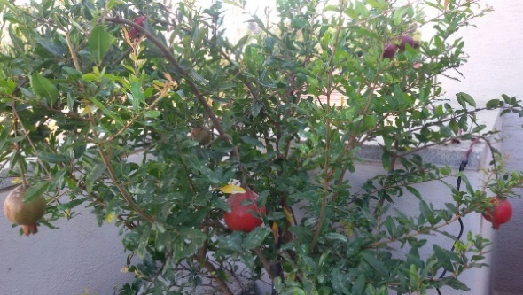
Actively growing of Punica Granatum called Bhagwa was obtained from IIHR, Bangalore. The donor plants were maintained under protected condition (Fig.1) and were treated with 0.2% antifungal and antibacterial spray once in 15 days. Then the plant was used as mother source for obtaining explant.

Fig.1. Punica granatum mother plant

Culture Medium
The initial media used as induction medium contains MS medium (Murashige and Skoog, 1962) supplemented with 3% sucrose, 2,4-D-1mg/l to induce good callus proliferation and PVP (Polyvinyl pyrollidone)-300mg/l solidified with 5.6gm litre of agar. Addition of PVP avoids the browning of medium due to accumulation of phenolic compounds. Suspension cell culture medium to transfer induced callus contains MS medium without gelling agent.
Selection and Processing of explants
Nodal segment of the terminal bud of pomegranate improved callus was employed as explant. The explant was subjected to aseptic condition by treating with 0.1% of antifungal and antibacterial agents for 10 minutes. Followed by washing with Tween 20 for 15 minutes and later surface sterilization by 70% ethanol for 30 sec and Mercuric chloride for 3 to 4 minutes based on the size of explant.
The sterilized explant was subjected to excise prior transferring to medium so as to separate cambium tissue from other cells to enhance callus induction. Cambial tissue getting seperaed from the xylem and phloem tissue is clearly observed in Figure. 2 c.
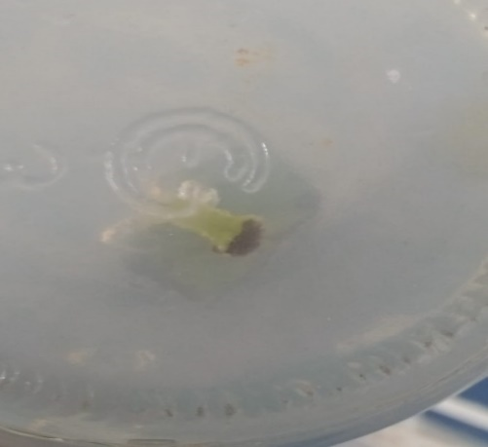

Fig 2.a Fig 2.b

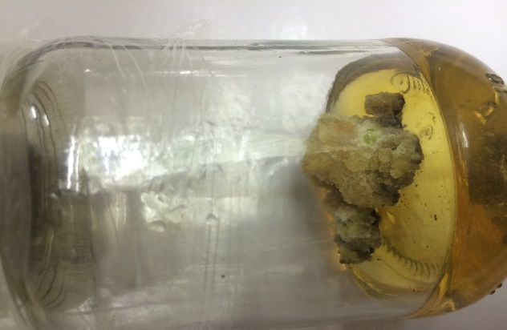
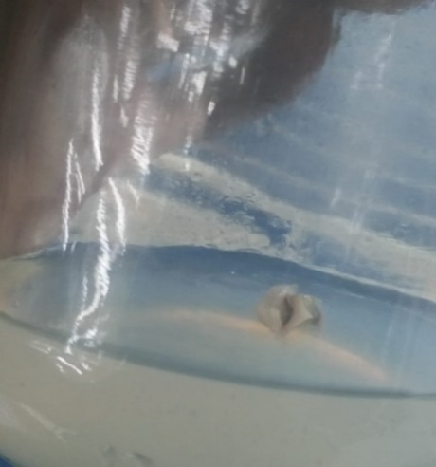
Fig 2.c Fig 2.d
Fig 2. Stages of Callus initiation. 2a-Selection of nodal segments, 2b- Explant processed in medium, 2c- Cambial tissue getting separated from other cells and 2d- callus ready to go into suspension cell medium
Culture Conditions
The pH of the medium was adjusted to 5.8 and was sterilized in autoclave for 20 minutes at 121ºC. After sterilization, the media was poured in jam tissue bottles under laminar flow hood. Inoculated cultures were incubated in a culture room in continuous darkness with temperature of 24 ºC and relative humidity of 70%. The initial media were cultured at 28ºC under 5000 lux light intensity for 28 days.
Subculturing
Induced callus at 1-2 gm/100 ml of liquid media was weighed. This was then inoculated into liquid callus multiplication media comprising MS- Salts with 1mg/ L 2,4-D, 3% sucrose as carbon source, 100mg/L inositol, 200mg/L PVP, 5mg/L citric acid, pH 5.8. The cells were cultured at 120-140 RPM in shaker at a temperature of 24±2 °C without light for 28 days. Subcultures are realized by renewing medium every 28 days once after cell decantation. The well-established suspension cultures with no cellular clumps were passage into fresh medium and incubated under constant agitation for maintaining viable cells in a free form in every passage.
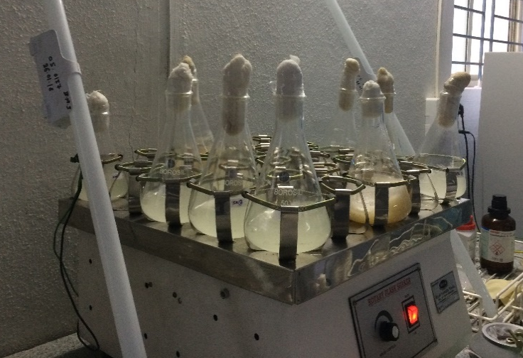
Fig 3. Pomegranate Cell suspensions in shaker
Determination of Growth and Viable cells
The culture finally taken in conical flask and placed in the shaker was monitored every 24 hours for the growth and viability of the culture. The growth was determined using the various methods mentioned below. Once it enters into the stationary phase, it was incubated in the presence of light to enhance the production of the secondary metabolite. The growth index is relative estimation which was done using the fresh and dry cell weight (11). This is important in determining the theoretical maximum cell concentration in high density culture of plant cell suspensions. 10 ml of the culture was centrifuged at 5000 rpm for 10 mins and filtered using a 45µm filter paper. This was weighed to get the fresh cell weight. This was then dried overnight at 37⁰C in a hot air oven and then weighed to give the dry cell weight. The Growth Index (GI) was determined according to the formula given below (11.b):
$GI=\frac{Wf-Wi}{Wi}$ ………………………………………………… (1)
Where,
GI is growth index

W_{i} is the initial cell mass.
Both W_{f} and W_{i} are taken either as fresh or dry weight

Measure of Conductivity
The Cell culture conductivity was measured using a conductivity meter as described by Loyola-Vargas et al, 2006 (12). This is used for measuring growth kinetics of plant cell lines as it is very economical, convenient, reliable and accurate. It often is used for the purpose of bioprocess engineering applications of plant cell cultures. It does not adversely affect the plant cells.
Measure of Growth Curve (Calorimeter and UV-Vis Spectrophotometer)
The growth curve was constructed on the basis of the cell density measured as optical density by the UV-Vis spectrophotometer (13). The initial stages of the viability check were done in a wide range of wavelengths and was optimized at 630 nm. The plant improved callus cell density was thus noted at 630nm by UV-Vis spectrophotometer.

Viability and selection of the Improved callus Cells
The viability of the improved callus cells checked using Evan’s Blue Staining to attain the accurate growth of the suspended improved callus cells. The cells were visualized using phase contrast microscope (14). The Suspension culture is in the viable state till it has 95% viable cells and also the plant cells with vacuoles. Below that percentage the cells enter into the death phase. The percentage of viability was calculated using the below formula:

$\% Viability=[1-(No. of Blue Cells÷Total No. of Cells)×100]$……………. (2)
Elicitors in suspension cells
Elicitors are used along with subculture medium to induce accumulation of higher amount of phytochemicals. Jasmonic acid- 200 µg/ l and Salicylic acid -20 mg / l is used along with basal medium as previously reported to be effective (15). After 28 days of incubation, it is analysed.
Harvesting
Callus were harvested by centrifugation of the suspension cultures at 5000 RPM for 10 min. The supernatant was discarded. The cell pellets were measured for measuring growth index for comparison of phenolic acid concentrations in both control improved callus cells as well as elicitor induced improved callus cell pellets.
Estimation of phenolic contents
Total phenolic content of Aloe vera extract was analyzed by using the Folin Ciocalteu calorimetric method [16]. About 1 ml of extract was mixed with 5 ml of Folin-Ciocalteu reagent and 4 ml of sodium carbonate (5%) were added. After that, the mixture was shaken vigorously and incubated at 50ºC for 30 min. The absorbance of the standard gallic acid solution (1 mg/ml) was measured using 1 ml of 50, 100, 150, 200, 250, 300, 350, 400, and 450 µg/ml gallic acid solutions. The mixture was kept it in dark for 90 min, after which the absorbance read at 765nm. Total phenolic content value was obtained and expressed as mg gallic acid equivalent (GAE) per gram of extract using the formula,
C=C₁ x V/M--------------------------------------------------------------------------------(3)

Where,
C - Total phenolic content in mg/g in Gallic acid equivalent (GAE),
C₁- Concentration of Gallic acid established from the calibration curve in mg/ml,
V- Volume of extract in ml, and
M- The weight of plant extract in g.

Statistical Analysis
Experimental results were expressed as mean, standard deviation (SD) of the means of samples. All the collected data were analyzed were performed in duplicate, with the three independent replicates and expressed with standard errors using Microsoft excel.
Elicitors in improved callus cell production

Results and Discussion
Table 1: Callus induction percentage in relation to explant treatment time.
Medium constituents | Sterilization Agents | Concentrations (%) | Time (Minutes) | Total Contamination | Callus induction percentage
MS medium + 2,4 D- 1 mg /l+ | Hgcl₂ (Mercuric chloride) | 0.1% | 3 | 62% | 98%
 |  |  | 4 | 30% | 94%
 |  |  | 5 | 2% | 95%

The callus proliferation started from the cut surface of the explant and finally covered the whole explant as described by Hoque A et al., 2006. In the initial stages, the calli was colourless to yellowish and over the period, it turned into light green. After two weeks of incubation, it turned to dark green. Dark green calli were observed in basal medium MS+ sucrose 3%+ 2,4-D-1 mg⁻¹l+ PVP-300 mg ⁻1l. Calli with hyper hydric exudates induced necrosis soon after started to turn brown. The growth of some calli showed high lignification, including of their hard texture, whereas others were embryogenic and separated easily into small fragments. Success rate on explant treatment is shown in Table 1. Pomegranate callus growth curve was sigmoid type and four growth phases can be distinguished in different days (15, 25, 35, 45 and 55 days) In the lag phase (15-25 days), callus initiation and proliferation were observed by profound cell division as also described by previous studies (18). At 25-35 days (exponential phase), biomass of the callus natured was significantly increased. The high level of callus biomass in the stationary phase (45 days) of the callus growth curve suggests the cellular membrane stabilization. It has been previously reported that the stationary phase callus evidently demonstrated an increase in the accumulation of gagaminine in the callus of Cynanchum wilfordii (19). At the decline phase (55 days) the callus biomass was drastically reduced as compared to other phases. Explant treated for 5 minutes in surface sterilant gave maximum success rate and less contamination. This response increased to 83.33 % when 2,4-D (2 mg/L) was used in combination with BA at 0.75 mg/L or with IBA at 0.25 mg/L as reported by Savita et al., 2011 (20). The callus induced were green and fragile, and suitable for subculture.

Table 2: Estimation of growth index, conductivity and viability of improved callus cells with respect to days after subculture
S.No | Time (Days) | Growth Index | Conductivity | UV-Vis Spectroscopy | Viability
 |  | (no unit) | (mS/cm) | (600nm) | (%)
1 | 0 | 0 | 4.08±0.02 | 0 | 92.14±0.04
2 | 1 | 0.028±0.004 | 3.83±0.03 | 0.091±0.007 | 93.72±0.05
3 | 2 | 0.084±0.023 | 3.84±0.05 | 0.459±0.013 | 94.97±0.01
4 | 3 | 0.088±0.024 | 3.58±0.01 | 0.845±0.021 | 95.32±0.15
5 | 4 | 0.774±0.086 | 3.20±0.02 | 1.640±0.014 | 96.78±0.04
6 | 5 | 0.948±0.024 | 2.97±0.01 | 1.621±0.020 | 97.92±0.06
7 | 6 | 0.863±0.078 | 2.72±0.01 | 1.654±0.009 | 98.99±0.04
8 | 7 | 0.669±0.075 | 2.69±0.02 | 1.647±0.011 | 99.47±0.03
9 | 8 | 0.629±0.018 | 2.38±0.01 | 1.662±0.007 | 98.72±0.02
10 | 9 | 0.644±0.034 | 2.21±0.02 | 2.349±0.005 | 97.40±0.09
11 | 10 | 0.844±0.057 | 2.14±0.02 | 2.534±0.010 | 94.54±0.10
12 | 11 | 0.612±0.041 | 2.34±0.03 | 2.864±0.834 | 96.47±0.03
13 | 12 | 0.744±0.041 | 2.11±0.03 | 3.012±0.005 | 97.33±0.05
14 | 13 | 0.680±0.097 | 2.56±0.04 | 3.249±0.834 | 96.23±0.04
15 | 14 | 0.612±0.034 | 2.62±0.06 | 3.746±0.832 | 98.43±0.02
16 | 15 | 0.600±0.043 | 2.78±0.01 | 3.993±0.034 | 97.77±0.07
17 | 16 | 0.480±0.021 | 3.04±0.03 | 4.274±0.002 | 96.21±0.09
18 | 17 | 0.507±0.054 | 3.17±0.02 | 4.431±0.832 | 97.83±0.06
19 | 18 | 0.495±0.092 | 3.01±0.02 | 4.624±0.021 | 98.73±0.07
20 | 19 | 0.470±0.036 | 3.22±0.04 | 4.743±0.469 | 97.62±0.06
21 | 20 | 0.410±0.065 | 3.05±0.05 | 4.925±0.487 | 96.32±0.21
22 | 21 | 0.367±0.054 | 3.19±0.03 | 5.120±0.049 | 95.49±0.16
23 | 22 | 0.378±0.092 | 3.24±0.09 | 5.359±0.972 | 95.89±0.03
24 | 23 | 0.348±0.036 | 3.25±0.06 | 5.534±0.486 | 96.93±0.05
25 | 24 | 0.306±0.065 | 3.06±0.03 | 5.439±0.756 | 95.02±0.25
26 | 25 | 0.237±0.041 | 3.19±0.04 | 5.692±0.040 | 96.48±0.17
27 | 26 | 0.278±0.054 | 3.23±0.05 | 5.934±0.488 | 95.75±0.03
28 | 27 | 0.254±0.092 | 3.58±0.03 | 6.046±0.546 | 94.91±0.04
29 | 28 | 0.267±0.064 | 3.47±0.03 | 6.172±0.856 | 93.64±0.03
30 | 29 | 0.241±0.041 | 3.69±0.07 | 6.210±0.573 | 91.38±0.04
31 | 30 | 0.222±0.045 | 3.58±0.04 | 6.184±0.814 | 83.99±0.07
32 | 31 | 0.187±0.018 | 3.79±0.04 | 6.298±0.783 | 76.83±0.09
33 | 32 | 0.210±0.034 | 3.76±0.05 | 6.234±0.435 | 71.33±0.07
34 | 33 | 0.197±0.057 | 3.81±0.04 | 6.338±0.567 | 67.54±0.08
35 | 34 | 0.201±0.004 | 3.69±0.07 | 6.438±0.543 | 67.34±0.05
36 | 35 | 0.191±0.057 | 3.74±0.09 | 6.359±0.326 | 67.29±0.06
37 | 36 | 0.218±0.082 | 3.86±0.08 | 6.254±0.356 | 65.83±0.02
38 | 37 | 0.207±0.074 | 3.90±0.10 | 6.435±0.364 | 64.32±0.01
39 | 38 | 0.195±0.064 | 3.87±0.02 | 6.234±0.872 | 63.75±0.05
40 | 39 | 0.187±0.075 | 3.92±0.01 | 6.432±0.573 | 60.19±0.07
41 | 40 | 0.285±0.067 | 3.95±0.03 | 6.298±0.457 | 57.72±0.05
42 | 41 | 0.283±0.025 | 3.71±0.07 | 6.473±0.922 | 50.32±0.08
43 | 42 | 0.286±0.034 | 3.74±0.05 | 6.542±0.487 | 47.17±0.06
44 | 43 | 0.290±0.034 | 3.58±0.06 | 6.234±0.457 | 46.38±0.08
45 | 44 | 0.271±0.057 | 3.72±0.03 | 6.487±0.547 | 45.19±0.12

The thumb rule for the exploitation of plant cells on an industrial scale for phytochemicals is the stability of their growth in bioreactor (22). We therefore monitored the growth curve, conductivity, stability of these cells to analyse the day of lag phase for subculturing. Based on the growth curve, the need for subculturing to new fresh media was between days 24 and 28 days of incubation, the end of exponential growth phase. At this stage, the viability of cells started to decline less than 95% which is not good for steady yield of phytochemicals.
We found it better to subculture cells at the end of exponential growth phase. After linear growth stage, the medium became low in nutrients and toxic substances were produced by the cells (Bhojwani and Razdan 1983. Furthermore, the cell viability as shown in table 2 was around 95 % throughout the 28 days of culture. When cell viability remained around 50 %, it is considered that the suspension culture establishment has failed (Qui et al. 2009). For maintenance of the fine suspension culture, it is necessary to subculture them because the cultures tend to form cell clusters of a few cells to aggregate. These results confirm that the P. granatum cell suspension culture has been successfully established.
Table 3: Analysis of total phenolic contents in improved callus cells.
Conc. Of phenolic content in | Total Phenols µg/GAE
µg/ml | Control | SA cells | JA cells
Blank | 0 | 0 | 0
50 | 6.83 | 11.05 | 10.96
100 | 9.23 | 15.37 | 13.28
150 | 11.42 | 19.45 | 16.72
200 | 14.74 | 24.91 | 22.13
250 | 19.64 | 29.53 | 21.62

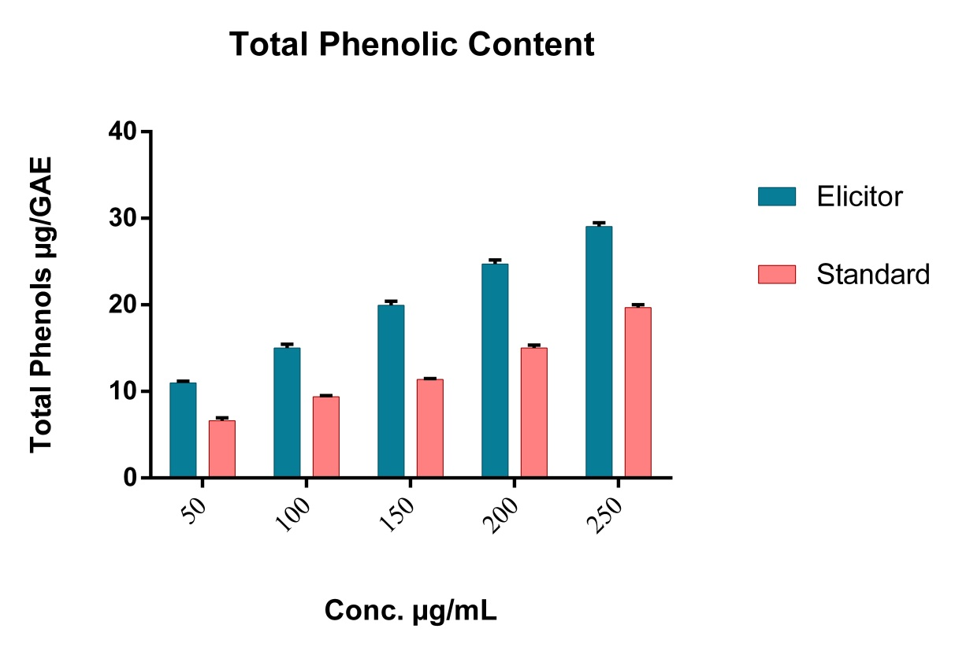
Graph1: Comparison of Phenolic content in standard as well as elicitor SA induced improved callus cells.

The growth index and the phenolic acids concentrations of the suspension cell cultures of P. granatum after treatment with elicitors (SA and JA) in Table 3. Elicitor SA has produced higher quantity of phenolic content and it is depicted in graph1. Our cultures showed the variation between 11.05 and 29.53μg/g cells fresh weight in phenolic content within the growth cycle in elicitors induced suspension cells. It is essential to produce as much metabolically active biomass per unit volume by cell suspension culture as possible in order to achieve the higher possible production of bioactive compounds.

Conclusion
The cell culture growth trend was similar in almost all cases with a steady increasing in biomass from day zero until day 28. Meanwhile, the phenolic content in P. granatum suspension cells treated with Salicylic acid was increasing with the concentration used in the medium throughout the experimental period. On the other hand, the total phenolic acid content increased sharply from day zero until day 28 in all treated in vitro cultures. Therefore, 28 days was optimum for phenolic acid synthesis for P. granatum suspension cells treated with elicitors. The growth of the suspension culture was optimized. The data obtained from the study suggests further studies on response for various elictors and concentrations to enhance the yield. These results points that for successful scale-up of plant cell suspensions, the present protocol clearly demonstrates the feasibility of using cell suspension culture improved callus for the production of phytochemicals in a very short period of time.
References:
1. Bioactive components of pomegranate fruit and their transformation by fermentation processes Małgorzata Gumienna1 · Artur Szwengiel1 · Barbara Górna1 Pomegranate (Punica granatum L.) M.OMURAl
2. M. Pavlović and K. Radotić, Animal and Plant Improved callus Cells, DOI 10.1007/978-3-319-47763-3_26
3. Silva, S., Costa, E. M., Calhau, C., Morais, R. M., & Pintado, M. E. (2017). Anthocyanin extraction from plant tissues: a review. Critical Reviews in Food Science and Nutrition, 57(14), 3072–3083.
4. Elham Azarpazhooh1 & Parvin Sharayei1 & Shahin Zomorodi2 & Hosahalli S. Ramaswamy. Received: 11 March 2018 /Accepted: 8 October 2018.
5. J.-M. Mérillon, K. G. Ramawat (eds.), Bioactive Molecules in Food, Reference Series inPhytochemistry
6. Regine Eibl1 & Philipp Meier1 & Irène Stutz 1 & David Schildberger2 & Tilo Hühn2 & Dieter Eibl1 Received: 12 June 2018 / Revised: 27 July 2018 /Accepted: 28 July 2018 /Published online: 11 August 2018
7.Cusido, R.M.; Palazon, J.; Bonfill, M.; Navia-Osorio, A.; Morales, C.; Piñol, M.T. Improved paclitaxel and baccatin III production in suspension cultures of Taxus media. Biotechnol. Prog. 2002, 18, 418–423. [Google Scholar] [CrossRef] [PubMed]
8. Zhou ZS, Guo K, Elbaz AA, Yang ZM (2009) Salicylic acid alleviates mercury toxicity by preventing oxidative stress in roots of Medicago sativa. Environ Exp Bot 65:27–34
9. Wang, Y.D.; Wu, J.C.; Yuan, Y.J. Salicylic acid-induced taxol production and isopentenyl pyrophosphate biosynthesis in suspension cultures of Taxus chinensis var. mairei. Cell Biol. Int. 2007, 31, 1179–1183. [Google Scholar] [CrossRef] [PubMed]
10. Loyola-Vargas and V á zquez-Flota (2006) plant cell culture protocols (book) pg 51-58
11.Kittipongpatana.N, Hock, R.S. Porter, J. R. Production of solasodine by hairy root callus and cell suspension cultures of Solanum aviculare forst. Plant Cell Tiss. Organ Cult. 52:133-143; 1998.
12. Wasternack, C.; Hause, B. Jasmonates: Biosynthesis, perception, signal transduction and action in plant stress response, growth and development. An update to the 2007 review in Annals of Botany. Ann. Bot. 2013, 111, 1021–1058. [Google Scholar] [CrossRef] [PubMed]
13. Al-Khayri, Jameel. (2012). Determination of the date palm cell suspension growth curve, optimum plating efficiency, and influence of liquid medium on somatic embryogenesis. Emirates Journal of Food and Agriculture. 24. 444-455.
14. Khanpour-Ardestani N, Sharifi M, Behmanesh M. Establishment of callus and cell suspension culture of Scrophularia striata Boiss.: an in vitro approach for acteoside production. Cytotechnology. 2015;67(3):475–485. doi:10.1007/s10616-014-9705-4
15. Farmer, E.E.; Ryan, C.A. Interplant communication: Airborne methyl jasmonate induces synthesis of proteinase inhibitors in plant leaves. Proc. Natl. Acad. Sci. USA 1990, 87, 7713–7716. [Google Scholar] [CrossRef] [PubMed]
16. Wintola OA, Afolayan AJ. Phytochemical constituents and antioxidant activities of the whole leaf extract of Aloe ferox Mill. Pharmacogn Mag 2011; 7:325-33.
17. Hoque A, Nahar A, Razvy MA, et al. Micropropagation of water chestnut (Trapa sp.) through local varieties of Rajshahi Division. Asian J Plant Sci. 2006;5(3):409–413. [Crossref] [Google Scholar]
18. LETICIA C.A., PAIVA P.D.O., PAIVA R., GARCIANO H.P., 2010. Growth curve and biochemical analyses of callus of IPE-BRANCO (Tabebuia roseo alba (Ridl.) Sand. Naturalia 33, 45-56.
19. SHIN G., CHIL M., LEE D., 2003. Comparative study of the effects of various culture conditions on cell growth and gagaminine synthesis in suspension culture of Cynanchum wilfordii. Biol Pharm Bull 26, 1321-1325.
20. Savita, Singh, B., Virk, G. S., & Nagpal, A. K. (2011). An efficient plant regeneration protocol from callus cultures of Citrus jambhiri Lush. Physiology and molecular biology of plants : an international journal of functional plant biology, 17(2), 161–169. doi:10.1007/s12298-011-0055-9
21. Lee, Eun-Kyong & Jin, Young-Woo & Park, Joong & Yoo, Young & Hong, Sun & Amir, Rabia & Zejun, Yan & Kwon, Eunjung & Elfick, Alistair & Tomlinson, Simon & Halbritter, Florian & Waibel, Thomas & Yun, Byung-Wook & Loake, Gary. (2010). Cultured cambial improved callus cells as a source of plant natural products. Nature biotechnology. 28. 1213-7. 10.1038/nbt.1693.
22. Roberts, S.C. Production and engineering of terpenoids in plant cell culture. Nat. Chem. Biol. 3, 387–395 (2007).
24. Yang, S.-J., Fang, J.-M. & Cheng, Y.-S. Lignans, flavonoids and phenolic derivatives from Taxus mairei. J. Chinese Chem. Soc. 46, 811–818 (1999).
25. Bhojwani SS, Razdan MK. Plant tissue culture: theory and practice. Amsterdam: Elsevier; 1983. [Google Scholar]
26. Qui JA, Castro-Concha LA, García-Sosa K, Peña-Rodríuez LM, Miranda-Ham ML. Differential effects of phytotoxic metabolites from Alternaria tageticaon Tagetes erecta cell cultures. J Gen Plant Pathol. 2009;75:331–339. doi: 10.1007/s10327-009-0184-y. [CrossRef] [Google Scholar]

