"Synthesis and Characterization of Metal Oxide Nanoparticles: Approaches and Techniques"

Vishal S. Kamble¹  Department of Chemistry, Changu Kana Thakur Arts, Commerce and Science College New Panvel (Autonomous) Maharashtra India 410206.  vishalchemistry1@gmail.com | Jitendra M. Pawara^{2*}  Department of Chemistry, Changu Kana Thakur Arts, Commerce and Science College New Panvel (Autonomous) Maharashtra India 410206.  jmpawara@gmail.com
Satyajit S. Kamble³  Department of Physics, Changu Kana Thakur Arts, Commerce and Science College New Panvel (Autonomous) Maharashtra India 410206.  satyajitkamble2@gmail.com | Sagar L. Khairnar⁴  Department of Mathematics, Changu Kana Thakur Arts, Commerce and Science College New Panvel (Autonomous) Maharashtra India 410206.  sagarkhairnar1604@gmail.com
Digambar K. Patil⁵
Department of Chemistry, Changu Kana Thakur Arts, Commerce and Science College New Panvel (Autonomous) Maharashtra India 410206.
dkmrudula980@gmail.com

ABSTRACT
The abstract provides a succinct summary of a wide array of techniques used in the synthesis of metal oxide nanoparticles. It places particular emphasis on two primary approaches: "top-down" and "bottom-up" methods. These techniques encompass a diverse range of environments, including gases, liquids, solids, supercritical fluids, and vacuum conditions. In the "top-down" approach, the focus lies on breaking down bulk materials into nanoparticles. On the other hand, the "bottom-up" approach involves the assembly of atoms or molecules into nanoparticles, often with the assistance of stabilizers. Within this context, the abstract explores commonly employed methods such as chemical vapor deposition, sol-gel, and co-precipitation. Each of these methods is analyzed with its respective advantages and disadvantages in mind. To gain a deeper understanding of the structural and optical properties of these nanoparticles, various characterization techniques are discussed, including X-ray diffraction (XRD), field-emission scanning electron microscopy (FESEM), high-resolution transmission electron microscopy (HRTEM), Fourier-transform infrared spectroscopy (FTIR), UV-visible spectroscopy (UV-VISIBLE), energy-dispersive X-ray spectroscopy (EDAX), and X-ray photoelectron spectroscopy (XPS). In summation, this abstract offers a concise yet comprehensive overview of the preparation and characterization methods employed in the realm of metal oxide nanoparticles.

Keywords- Nanoparticle synthesis, Metal oxide nanoparticles, Top-down approach, Bottom-up approach, Characterization techniques, XRD, FESEM, HRTEM, FTIR, UV-VISIBLE, EDAX, XPS

INTRODUCTION

In today's era, a multitude of physical, chemical, and biological techniques have emerged and been documented for the synthesis of pure and mixed metal oxide nanoparticles. Figure 1 illustrates the categorization of nanoparticle synthesis techniques into two primary categories: "top-down" and "bottom-up" approaches. These methodologies are employed across various environments, including gases, liquids, solids, supercritical fluids, and vacuum conditions. The "top-down" approach involves the creation of nanoparticles by progressively breaking down bulk materials into smaller subdivisions. Although this method is relatively more expensive and technically intricate due to challenges in controlling particle size and structure, it remains relevant for synthesizing nanomaterials for structural, magnetic, and catalytic applications. Common techniques employed in the top-down approach include ball milling, electron beam lithography, photolithography, ion and plasma etching, and anodization [1]. In contrast, the "bottom-up" approach involves the synthesis of nanoparticles by connecting atoms, molecules, or clusters in the presence of a shielding agent or stabilizer, which prevents nanoparticle agglomeration through steric or electrostatic repulsion among particles. The majority of researchers prefer the bottom-up approach for nanoparticle synthesis. Prominent examples of this approach include sol-gel processes, chemical vapor deposition, self-assembly of monomeric or polymeric molecules, co-precipitation, laser pyrolysis, bio-assisted synthesis, plasma or flame spraying synthesis [2]. Following the successful synthesis of nanomaterials, the primary objective is to characterize them thoroughly. Comprehensive characterization of nanomaterials is essential for understanding their electrical, structural, morphological, and optical properties, enabling their selection for various applications across different fields. To achieve proper nanomaterial preparation, a diverse array of characterization techniques is required. Accurate reporting of experimental findings obtained through these techniques is of utmost importance. In this chapter, we will provide a brief overview of the most common nanoparticle synthesis methods and discuss the fundamental principles of the characterization techniques employed in our research endeavors.

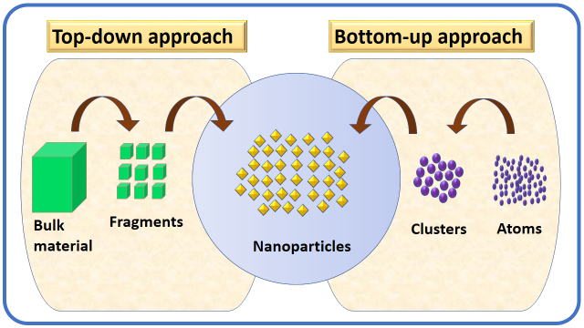
Fig. 1: Schematic representation of nanoparticle preparation and assembly approach

1.0 PREPARATION METHODS FOR NANOMATERIALS

The physicochemical attributes and applications of nanomaterials are largely contingent on the chosen preparation method. Each approach comes with its unique strengths and weaknesses, leading to distinct characteristics in the resulting product. In the literature, a plethora of techniques have been devised for synthesizing both pure and doped ZnO nanomaterials, and we'll provide a brief overview of the most extensively employed methods below.

1.1 Vapor techniques

a) Chemical Vapor Deposition (CVD) Method

Among all the bottom-up methods, the Chemical Vapor Deposition (CVD) process stands out as one of the most widely recognized techniques. It involves the transformation of gaseous molecules through various chemical reactions into solid materials, typically in the form of powders or thin films, which are then deposited onto a heated substrate's surface. This method is commonly employed for preparing thin film materials such as nanowires, nanoflakes, nanotubes, and nanoparticles. There exist several CVD variants suitable for nanoparticle synthesis, including plasma-assisted, metal-organic, conventional, and photo CVD techniques [3]. These CVD methods offer several key advantages, notably in the production of pure, uniform, and reproducible thin films. Figure 2 provides a schematic representation of the CVD deposition process, which comprises several stages. The initial step involves vaporizing the precursors and conveying them into the reactor chamber. The second phase encompasses the diffusion of precursor molecules onto the surface of the substrate, followed by adsorption onto the surface as the third stage. Finally, the process culminates in the decomposition of these molecules and their incorporation into solid thin films, releasing volatile by-products in the form of gases.
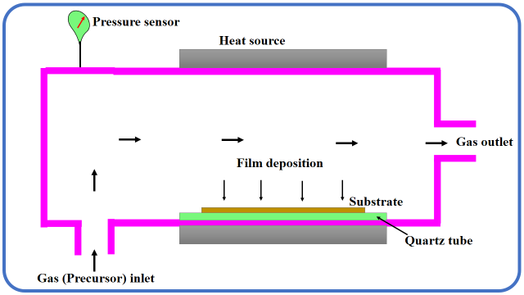
Fig. 2: Schematic illustration of chemical vapour deposition method

b) Physical vapor deposition (PVD) method

The oldest method in the realm of Physical Vapor Deposition (PVD) is an evaporation technique. The fundamental principle of the PVD process involves heating the source material to the point of vaporization, after which the vaporized material condenses on the substrate's surface in the form of a thin film. Consequently, PVD is a coating process that achieves material transfer at the atomic level. This process can be delineated into the following stages:
(i) The material slated for deposition is transformed into a vapor phase through physical means, often involving high-temperature vacuum or gaseous plasma.
(ii) The vapor is then conveyed from its source to the substrate in a low-pressure environment.
(iii) The vapor subsequently condenses onto the substrate, resulting in the formation of a thin film.
Physical vapor deposition techniques are typically employed to produce films with thicknesses ranging from a few nanometers to several thousands of nanometers. Furthermore, these techniques can be utilized to generate graded composition deposits, multilayer coatings, free-standing structures, as well as exceptionally thickdeposits [4]. A conventional physical vapor deposition process is illustrated in Figure 3.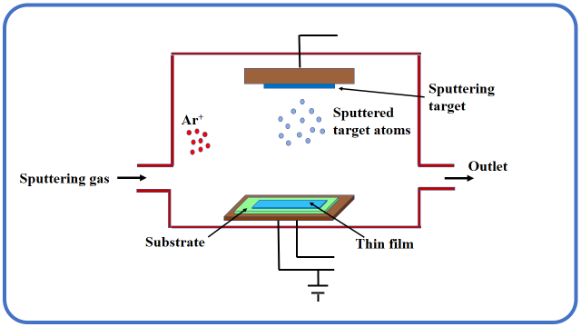
Fig. 3: Schematic representation of physical vapour deposition method

1.2 Hydrothermal/ Solvothermal method

In the hydrothermal method, water serves as the solvent, whereas in the solvothermal process, solvents other than water, typically organic solvents, are employed. The hydrothermal/solvothermal method is a synthesis technique used to produce single crystals (nanoparticles) by leveraging the solubility of minerals in hot aqueous solutions under high vapor pressure conditions. This method is particularly valuable for introducing surface roughness onto a substrate through the application of elevated pressure and temperature. In the process, an autoclave, which is essentially a steel pressure vessel, is used. Precursors, along with either water or an organic solvent, are introduced into the autoclave. A temperature gradient is established within the autoclave chamber, with the hotter end causing the dissolution of the nutrient solute, while at the cooler end, it is deposited onto a seed crystal, facilitating the growth of the desired crystal. Precursors dissolve at the hotter side and are deposited at the cooler side, leading to the growth of the desired crystals. This method offers several advantages, including the ability to create crystalline phases that are not stable at their melting points. Additionally, it is well-suited for cultivating large, high-quality crystals while maintaining control over their composition. However, it also has its drawbacks, such as the high cost associated with autoclaves and the challenges involved in observing the crystal growth process. Figure 4 provides an illustration of the instrumental setup for the hydrothermal/solvothermal method.
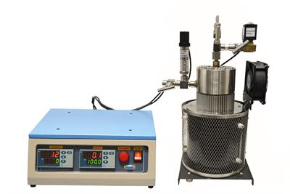

Fig. 4: Instrumental set up of hydrothermal/ solvothermal method

1.3 Spray pyrolysis method

Spray pyrolysis is a process that involves the atomization of a chemical reactant, creating droplets that subsequently evaporate within a heated reactor and ultimately decompose to form thin films and particles [6]. This method was initially documented in the 1980s and has since become a key technology for generating various nanostructures from specific precursor solutions. The spray pyrolysis technique has been employed to craft a wide array of nanostructures, including thin films, nanowires, nanoplates, nanocomposites, multiroom hollow structures, core-shell configurations, yolk-shell structures, plicated spheres, dense spheres, and hollow spheres [7]. Broadly speaking, the spray pyrolysis method comprises three primary stages: the composition of precursor solutions, the generation and transport of aerosols, and the synthesis of materials. The chemical reactants are carefully chosen so that, at the deposition temperature, all desired compounds, except for the final products, are volatile. In the present era, spray pyrolysis is recognized as an accessible and straightforward approach for producing homogeneous composites and a variety of useful nanoscale materials. Figure 5 provides a visual representation of the spray pyrolysis method.
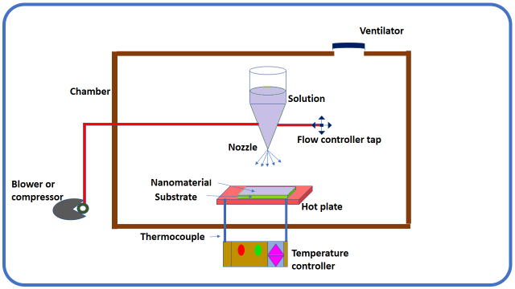
Fig. 5: Diagrammatic representation of spray pyrolysis method

1.4 Successive ionic layer adsorption and reaction (SILAR) method

The Successive Ionic Layer Adsorption and Reaction (SILAR) method represents a modified version of the Chemical Bath Deposition (CBD) method and is regarded as one of the most effective solution-based techniques for depositing various chemical compound materials in the form of thin films onto a substrate. This approach is known for its cost-effectiveness, simplicity, and suitability for large-scale depositions. SILAR primarily relies on the phenomenon of adsorption, which involves the accumulation of one substance on the surface of another. There are three primary adsorption systems: liquid-solid, gas-solid, and gas-liquid. The SILAR technique is specifically associated with adsorption in the liquid-solid system [8]. To obtain thin films of nanomaterials using the SILAR method, the substrate is immersed alternately in anionic and cationic precursor solutions, with rinsing in deionized water between each immersion step. The duration of immersion in ion-exchange water plays a crucial role in forming ion layers. This precise control helps prevent the formation of precipitation, as observed in the CBD method, thereby minimizing material wastage. Figure 6 provides an illustration of a typical SILAR method.

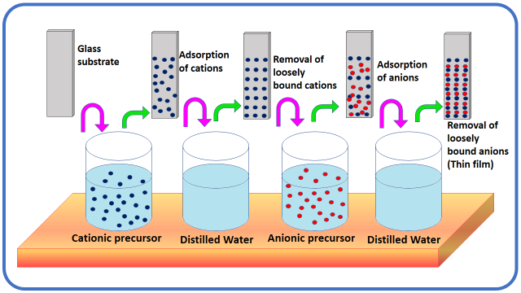
Fig. 6: Schematic illustration of SILAR method

1.5 Mechanochemical method

Mechanochemical preparation is a solid material processing method that combines mechanical and chemical phenomena at the molecular level. This technique is valuable for producing desired nano products using simple mechanical actions, such as applying high pressure and mechanical stress between reactants and balls, either at room temperature or at temperatures lower than those typically required for traditional solid-state preparation methods [9]. In this method, steel balls or refractory materials transfer their energy to the precursor substances, a process influenced by factors like the number and size of the balls, rotational velocity, the ratio of balls to the number of reactants, milling time, and the surrounding atmosphere. Mechanochemical synthesis is highly versatile, suitable for producing various types of materials in large quantities to meet different application needs. It is particularly well-suited for creating nanostructured metals, alloys, or intermetallic compound powders due to its simplicity and the potential to develop composite powders with a consistent distribution of grain sizes [10]. However, one significant drawback of this process is the possibility of contamination from the milling atmosphere or media. Figure 7 provides a visual representation of a typical mechanochemical method.
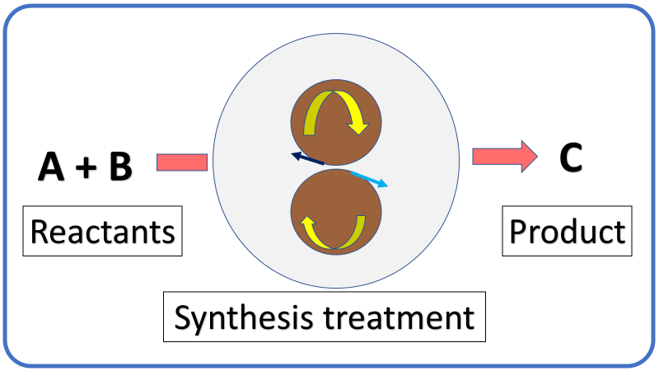
Fig. 7: Typical representation of mechanochemical method

1.6 Microwave-assisted method

A sustainable approach to crafting nanosized materials involves the use of a microwave-assisted process. In conventional heating systems for chemical synthesis, hot plates or oil baths serve as heat sources. Conversely, microwave radiation takes on the role of the heating source in the microwave-assisted procedure [11]. The fundamental mechanisms underlying microwave-assisted synthesis are dipolar polarization and conduction. This method is particularly significant and straightforward for the synthesis of metal oxide nanomaterials. Typically, the microwave-assisted technique excels in producing high-quality nanomaterials by rapidly heating the precursor mixture through direct microwave irradiation. This results in minimal reaction time and allows for the synthesis of transition metal oxides at lower temperatures. A variety of metal oxides, such as ZnO, NiO, CuO, TiO2, and Fe2O3, have been successfully prepared using this approach. Figure 8 provides a visual depiction of the microwave-assisted method.

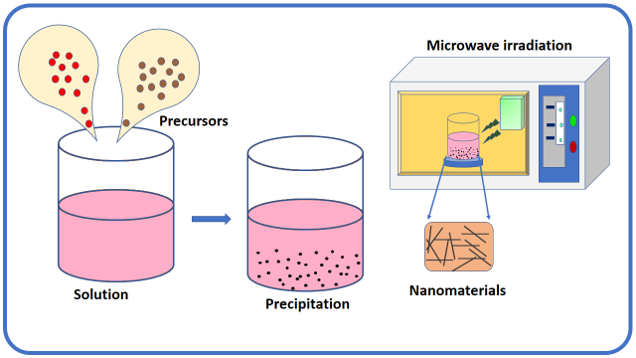
Fig. 8: Diagrammatic representation of microwave-assisted method

1.7 Micro-Emulsion method

The micro-emulsion technique is an exceptionally versatile method that allows for the synthesis of a wide range of nanomaterials, either on its own or in combination with other techniques. Consequently, the preparation of nanoparticles using the micro-emulsion technique has become a highly regarded area of research interest [12]. One of the notable advantages of this method is the biocompatibility and biodegradability of the nanomaterials it produces. Emulsions are formed when two or more immiscible liquids are mechanically mixed or stirred, resulting in a liquid-liquid phase separation. Typically, emulsions appear turbid and are stabilized with surfactants. When water, an organic oil or liquid, and surfactant are combined, micelles or inverse micelles are formed under specific critical concentrations, depending on the quantities of organic oil or liquid and water involved. Emulsions typically have sizes ranging from larger than 100 nm to a few millimeters and fall into two categories: water-in-oil (w/o) and oil-in-water (o/w) emulsions [13]. The micro-emulsion technique has been employed to prepare various types of nanomaterials, using both water-in-oil and oil-in-water micro-emulsions. Figure 9 provides a visual representation of the micro-emulsion technique.

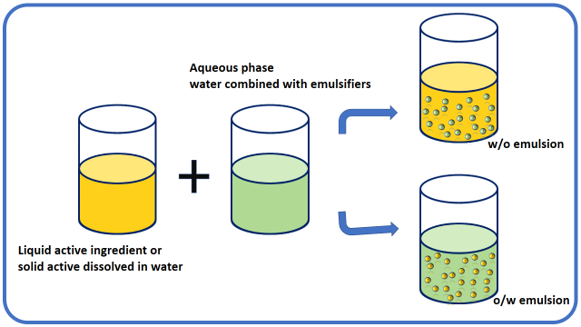
Fig. 9: Pictorial illustration of micro-emulsion technique

1.8 Sol-gel method

The sol-gel method represents an innovative approach to synthesizing novel nanomaterials and is a wet chemical process also known as the chemical solution deposition method. This process involves the transformation of monomers into a colloidal solution (sol), which acts as a precursor for creating an interconnected network (gel) of discrete particles or network polymers in both solid and liquid phases. Metal alkoxides are often used as distinctive precursors in the sol-gel method. The sol-gel process comprises several key steps, including hydrolysis, polycondensation, gelation, aging, drying, densification, and crystallization. The physical and chemical properties of the materials prepared using the sol-gel method depend on the specific experimental conditions applied. This method involves two fundamental reactions:
(i) Hydrolysis of the precursor in either acidic or basic media.
(ii) Polycondensation reaction of the hydrolyzed materials.
Metal alkoxides (M(OR)3) are commonly used as versatile molecules for obtaining oxides. They are favored for their ability to form homogeneous solutions in a wide range of solvents, even in the presence of other alkoxides or metallic derivatives. Additionally, they exhibit reactivity towards nucleophilic substances like water [14]. Figure 10 provides an illustrative diagram of the sol-gel method.
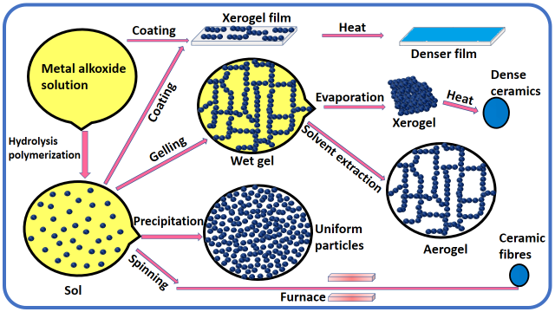
Fig. 10: Pictorial illustration of sol-gel method

1.9 Co-precipitation method

Co-precipitation is a process in which a precipitate carries down substances that are typically soluble under the conditions used [15]. The co-precipitation method is a classical and arguably the simplest and most convenient approach for producing pure or multinary metal oxide nanoparticles. When more than one precursor salt is used in the starting solution, mixed metal oxides can be found in the corresponding hydroxide co-precipitate mode. This method involves lower reaction temperatures and cost-effective equipment. It offers the advantage of rapid preparation of high-purity nanomaterials, energy efficiency, an eco-friendly route, easy control over particle size and composition, suitability for synthesizing large quantities of nanomaterials, and the absence of hazardous organic solvents. While it can be challenging to control particle size and dispersion when the precipitation rate is fast, it has been documented that nanostructured pure and doped metal oxide powder can be synthesized with an improved co-precipitation process by maintaining a constant pH level [16-17]. Key steps in co-precipitation reactions involve the simultaneous occurrence of nucleation, growth, coarsening, and/or agglomeration processes. The co-precipitation technique begins with the dissolution of different salt precursors (nitrate, acetate, sulfate, oxychloride, chloride, etc.) in a desired solvent or water with the goal of developing metal oxide nanoparticles. The resulting metal hydroxides are then precipitated in water or solvent by adding an alkaline solution, such as sodium hydroxide or aqueous ammonia solution. The resulting precipitate is washed with various solvents to remove free salts. To obtain the pure metal oxide compound, the filtered hydroxides are calcined at the required temperature in a muffle furnace. Typically, the co-precipitation reaction product is amorphous at room temperature. To address this issue, various surfactants are now used to gain more control over particle size and morphology. The versatility of co-precipitation chemistry and reaction environments has led to a wide range of particle morphologies, including spheres, rods, cubes, plates, dumbbells, rhomboids, hollow spheres, and others. Some examples of these different morphologies from the literature are depicted in Figure 11 [18]. Currently, several novel co-precipitation approaches have been developed, such as sonochemical and microwave-assisted methods [19-20]. The co-precipitation technique is the most common method for producing both pure and mixed ZnO nanoparticles. ZnO can be chemically combined with one or more doped metals, including Au, Ni, Co, Fe, Ti, Cu, Pd, Cd, and W, etc., and can be suitably synthesized from aqueous solutions of metal salts by adding a base under an oxygen-free atmosphere at either room or an appropriate temperature [21-29]. Due to the numerous advantages of the co-precipitation method, we have utilized it in our current research work for preparing pure ZnO and transition metal-mixed ZnO for gas sensor applications. A schematic representation of the co-precipitation approach is provided in Figure 12.

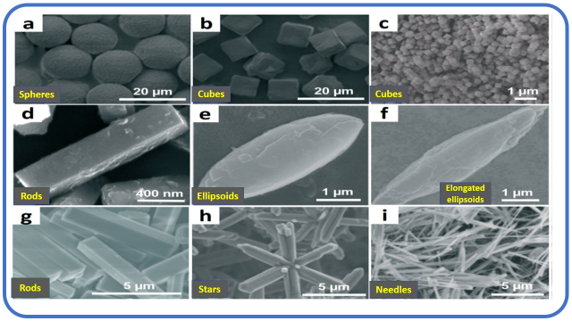
Fig. 11: Particles with different morphologies obtained from co-precipitation reactions

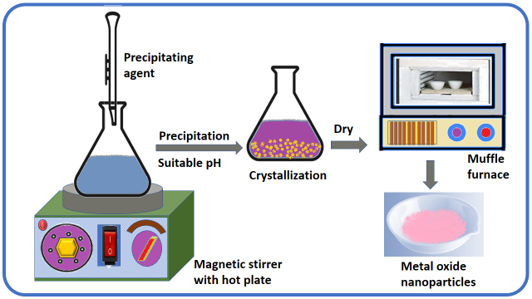
Fig. 12: Diagrammatic representation of co-precipitation method

2.0 Characterization technique

2.1 X-ray diffraction technique (XRD)

The X-ray diffraction (XRD) technique was pioneered by two English researchers, W. L. Bragg and his son W. H. Bragg, back in 1913 [30]. This non-destructive analytical tool is exceptionally potent and is widely employed for various purposes, including the identification of crystalline substances in the form of powders and thin films, determination of bond angles, measurement of unit cell dimensions, exploration of crystal geometry and lattice constants, examination of phase transitions, determination of the orientation of single crystals, assessment of preferred orientation in polycrystalline films, analysis of stress, defects, and more [31].

The XRD technique allows for the recognition and examination of crystalline materials through the phenomenon of diffraction. Essentially, it involves directing a monochromatic beam of X-rays, with a wavelength comparable to atomic spacing, onto a crystal. These X-rays are then diffracted in a specular manner, leading to constructive interference. X-rays are diffracted at specific angles (θ) by lattice planes, resulting in constructive interference for a set of hkl planes where the path difference is an integral multiple of the incident light wavelength.

The fundamental condition for constructive interference is mathematically described by Bragg's equation [32].
nλ = 2d sin (θ) (2.1)

Where, n is order of diffraction and the values are 1, 2, 3… (Usually 1) etc. λ is the wavelength of X-ray in angstrom (Copper = 1.54 Å), d is the inter planar distance, θ is the Bragg’s angle in degrees (also known as glancing or diffraction angle) Fig 13 displays the X-ray diffraction from two planes of atoms in a lattice. The intensity corresponding to constructive interference of the diffracted beam from a crystallographic plane is observed as peak, related to the Bragg angle (θ). The relation between the particle size and width of X-ray diffraction line was first derived by scientist Debye-Scherrer in 1918 [33]. The average crystallite size (D) was estimated using the Scherrer formula given as,
D = $\frac{0.9 λ}{β\cos{θ}}$ ( 2.2)

Where λ, is a wavelength of X-ray (1.54 Å for CuKα), β is full width at half maximum (FWHM) in radian, θ is Bragg’s angle. In present work, Bruker D₂ phaser model was used for XRD study of prepared materials.
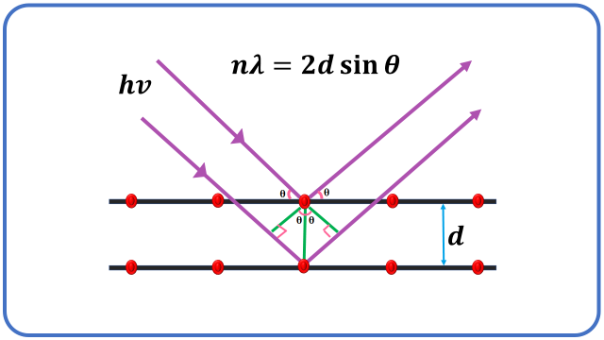
Fig. 13: Schematic illustration of X-ray diffraction set up

2.2 Field Emission Scanning Electron Microscopy (FESEM)

The Field Emission Scanning Electron Microscope (FESEM) is a microscopic instrument that utilizes electrons, specifically negatively charged electrons, instead of light to create images. These electrons are emitted from a field emission source and are used to scan the object in a zig-zag pattern. As the electrons interact with the object's surface, secondary electrons are ejected. The velocity and angle of these secondary electrons are correlated with the surface structure of the material. These secondary electrons are captured by a detector and converted into electronic signals, which are then amplified. These amplified signals are further transformed into a video scan image or a digital image that can be displayed on a monitor, providing valuable information for surface analysis [34]. A schematic representation of the FESEM is depicted in Figure 14. The Field Emission Scanning Electron Microscope (FESEM) is an instrument similar to the Scanning Electron Microscope (SEM), both of which provide a wide range of information about the surface of materials. However, FESEM produces clearer images with higher resolution, typically down to 1 to 1/2 nanometers, which is three to six times better than SEM. This enhanced performance is primarily attributed to the emission source used in FESEM (field emitter or gun) compared to SEM (thermionic emitter) [35]. FESEM is particularly valuable for observing tiny structures as small as 1 nm on the surfaces of prepared samples. This technique is employed to examine various aspects of materials, including particle and grain size, shape, metallographic, topographic information, and imperfections in crystalline bulk materials and powders, especially in the nanomaterials domain. FESEM is also capable of studying the elemental compositions within materials at submicron scales. As a result, FESEM is widely used in the field of material science and related areas. In our present study, we utilized the Zeiss Ultra 55 FESEM model for the analysis of prepared samples.

2.3 High Resolution Transmission Electron Microscopy (HRTEM) and Selected Area Electron Diffraction (SAED)

High-Resolution Transmission Electron Microscopy (HRTEM) is a technique similar to Transmission Electron Microscopy (TEM) imaging, but with magnifications that allow for the clear visualization of lattice spacing in nanomaterials. HRTEM provides direct insights into the atomic structure of materials, a level of detail that is not achievable with conventional TEM. It serves as an invaluable tool for studying various properties of nanomaterials at the atomic level.

HRTEM relies on phase contrast for image development. It offers crystallographic structural resolution down to the angstrom scale, providing data on atomic packing rather than solely the morphology of nanomaterials. HRTEM enables the examination of particle growth, particle size (down to 0.05 nm with aberration correctors), particle shape and arrangement, defects in materials, and crystal phases [36]. Figure 15 presents a schematic representation of HRTEM. In our research, the JOEL JEM 2100 Plus model was used for HRTEM analysis of prepared samples. Selected Area Electron Diffraction (SAED) is an essential crystallographic experimental method within TEM. SAED involves observing the diffraction spot pattern from a randomly oriented particle on the TEM's screen. Such a pattern indicates the crystalline nature of the material under examination. SAED patterns are particularly useful for studying small crystals and partially disordered materials with unit sizes on the order of a few hundred Angstroms [37].
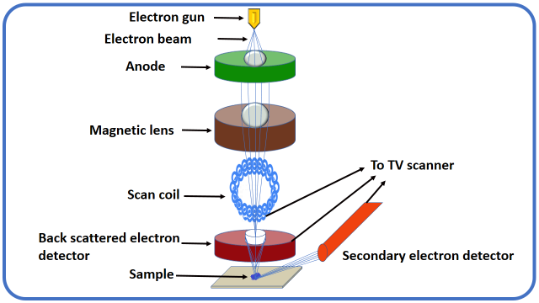
Fig. 14: Schematic representation of FESEM

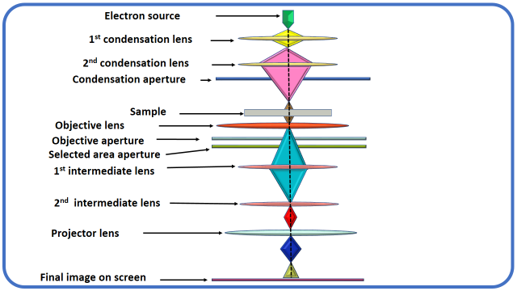
Fig. 15: Schematic illustration of HRTEM

2.4 Fourier-Transform Infrared Spectroscopy (FTIR)

High-Resolution Transmission Electron Microscopy (HRTEM) is a technique similar to Transmission Electron Microscopy (TEM) imaging, but with magnifications that allow for the clear visualization of lattice spacing in nanomaterials. HRTEM provides direct insights into the atomic structure of materials, a level of detail that is not achievable with conventional TEM. It serves as an invaluable tool for studying various properties of nanomaterials at the atomic level. HRTEM relies on phase contrast for image development. It offers crystallographic structural resolution down to the angstrom scale, providing data on atomic packing rather than solely the morphology of nanomaterials. HRTEM enables the examination of particle growth, particle size (down to 0.05 nm with aberration correctors), particle shape and arrangement, defects in materials, and crystal phases [36]. Figure 15 presents a schematic representation of HRTEM. In our research, the JOEL JEM 2100 Plus model was used for HRTEM analysis of prepared samples. Selected Area Electron Diffraction (SAED) is an essential crystallographic experimental method within TEM. SAED involves observing the diffraction spot pattern from a randomly oriented particle on the TEM's screen. Such a pattern indicates the crystalline nature of the material under examination. SAED patterns are particularly useful for studying small crystals and partially disordered materials with unit sizes on the order of a few hundred Angstroms [37].
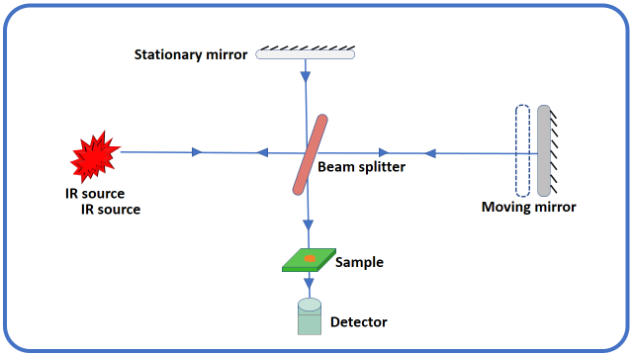

Fig. 16: Diagrammatic presentation of FTIR spectrophotometer

2.5 Ultraviolet-Visible spectroscopy (UV-VISIBLE)

UV-Visible absorption spectroscopy is the more easy and direct technique to study the optical possessions and band structure of metallic and semiconducting materials. This is also beneficial for finding of functional groups, impurity, quantitative and qualitative analysis of nanocomposites. Basically UV-Visible spectroscopy is helpful to determine absorption wavelength across the UV and visible assortments of the electromagnetic radiation passes through the sample. When incident light radiation falls on the matter it can either be absorbed, scattered, transmitted, reflected or it can excite fluorescence. The absorption of UV-Visible light by a sample induces atomic excitation, or the transfer of an electron from its ground energy level to an excited energy level. Absorption study provide a simple means of the estimation of absorption edge, optical band gap, optical transition such as direct/indirect, allowed/forbidden [39]. The energy of photons less than the band gap are transmitted through the sample while the energy of photons greater than the band gap are absorbed by material. Band gap energy is estimated from the Tauc’s relationship as follows,
αhν = A(hν-Eg)^{n} (2.3)
Where α is absorption coefficient (absorbed energy per thickness of the sample) hν is the photon energy, A is constant, Eg is the energy of the optical band gap and the value of the exponent n is the characteristics of the type of radiation. It taken as 1/2, 3/2, 2 and 3 for direct allowed, direct forbidden, indirect allowed and indirect forbidden transitions respectively [40]. The present optical properties of prepared nanostructures were inspected using UV–Vis-NIR (V-770 Jasco, Japan) in assortment of 200–1100 nm. UV-Visible spectrophotometer involves the number of fundamental components such as light sources (UV and visible), monochromator (wavelength selector), sample containers and detector as shown in Fig.17.

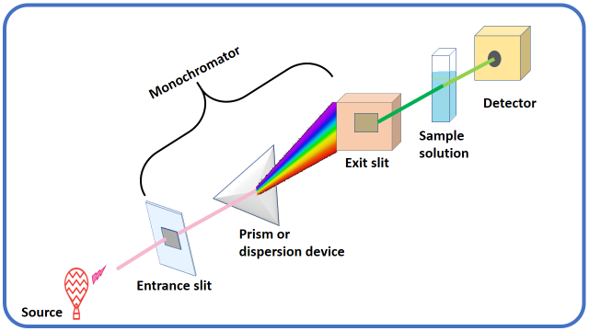
Fig. 17: Representative diagram of UV-VISIBLE spectrophotometer

2.6 Energy Dispersive Analysis of X-rays (EDAX)
Energy dispersive analysis of X-ray (EDAX) sometimes called energy-dispersive X-ray spectroscopy (EDX, EDS, XEDS or EDXS) is an analytical tool used in conjunction with SEM for the chemical characterization or elemental analysis of the material. EDAX is one of the X-ray fluorescence spectroscopy alternatives that depend on electromagnetic radiation interactions with matter to analyze a sample. Its characterization abilities are due in large part to the basic principle that each element has a distinctive atomic structure permitting an exclusive set of peaks on its electromagnetic emission spectrum that is the key principle of spectroscopy [41]. The peak positions are identified by the Moseley's law with precision much better than experimental resolution of a characteristic EDAX tool. Initially, a high energetic beam of charged particles like electrons or X-ray beams, is focused into the sample understudied. At rest, an atom within the sample contains unexcited electrons or ground state in discrete energy levels. Due to the incident X-ray beam an electron in an inner shell may be excited and ejected from the shell and simultaneously created an electron hole where the electron was. An electron from higher energy or outer shell, then fills an electron hole and the in-energy difference between the outer shell and the inner shell may be released in an X-ray form. The number and energy of the X-rays emitted from a sample can be determined by an EDAX. As the energy of the X-rays is characteristic of the difference in energy between the two shells, and of the atomic structure of the element from which they were emitted, this permits the elemental composition of the sample to be measured [42-43]. Fig. 18 shows the instrumental set up of EDAX.
Fig. 18 Instrumental set up of EDAX

2.7 X-ray Photoelectron Spectroscopy (XPS)
X-ray Photoelectron Spectroscopy (XPS), also known as Electron Spectroscopy for Chemical Analysis (ESCA), is a technique rooted in the photoelectric effect discovered by Hertz in 1887. XPS is a surface-sensitive method that is particularly adept at determining the elemental composition and oxidation state of elements on a material's surface. Additionally, it provides insights into the overall electronic structure and density of electronic states within solid materials, including insulators, conductors, and polymers. One of the major strengths of XPS is its ability not only to identify the elements present but also to reveal their chemical bonding partners [44]. In XPS, when a sample is bombarded with X-rays in a vacuum, it results in the emission of electrons. The kinetic energy (Ke) of these emitted electrons can be calculated using the photoelectric effect equation:

Ke = hν - (Be + φ) (2.4)

In this equation, hν represents the photon energy of monochromatic X-rays, Be is the binding energy of the atomic orbital, and φ is the work function (the minimum energy required for an electron to be emitted from the surface) [45]. Each element emits electrons at a specific energy level, leading to the creation of a unique set of electrons. By measuring the number of these electrons as a function of binding (or kinetic) energy, an XPS spectrum is generated. XPS is capable of identifying all elements except for hydrogen and helium. The binding energies of photoelectrons are influenced by the chemical environment of the atoms. Precisely measuring the peak positions of these elements provides information about their oxidation states. A schematic representation of XPS is depicted in Figure 19. In our study, we employed the Thermo Fischer Scientific ESCALAB Xi+ X-ray photoelectron spectrophotometer to analyze the surface atomic composition and chemical states of the prepared nanostructures.
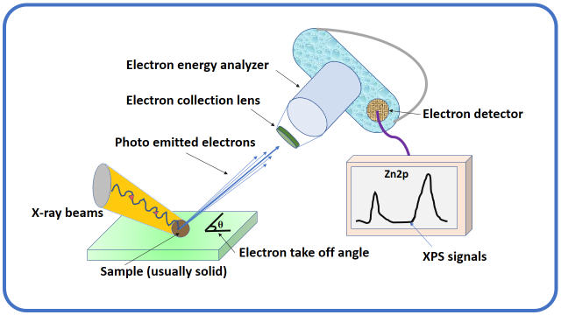
Fig. 19: Schematic representation of XPS

3.0 Conclusion
In conclusion, the realm of metal oxide nanoparticle synthesis is a dynamic field, encompassing a wide array of techniques to tailor materials with desired properties. The distinction between "top-down" and "bottom-up" approaches provide a versatile toolbox for researchers, each offering distinct advantages and challenges. While "top-down" methods allow precise control over particle size and morphology, they often come with complexity and cost. On the other hand, "bottom-up" strategies provide versatility in composition and structure, facilitated by stabilizers and shielding agents.
Characterization techniques such as XRD, FESEM, HRTEM, FTIR, UV-VISIBLE, EDAX, and XPS play a pivotal role in understanding the physical and chemical attributes of synthesized nanoparticles. These methods aid in elucidating crystallographic arrangements, surface morphologies, and elemental compositions. The choice of characterization tools depends on the specific properties being investigated and the nature of the nanoparticles.
Innovations in nanoparticle synthesis and characterization continue to advance numerous applications across various disciplines, including catalysis, electronics, and medicine. The marriage of precise synthesis and comprehensive characterization is essential for harnessing the potential of metal oxide nanoparticles in addressing complex challenges and paving the way for innovative technologies in the future.

4.0 REFERENCES
- C. Dhand, N. Dwivedi, X.J. Loh, A.N.J. Ying, N.K. Verma, R.W. Beuerman, S. Ramakrishna, RSC Adv., 2015, 5(127), 105003-105037.
- C. Daraio, S. Jin, Nanotechnology for biology and medicine, Springer, New York, 2012, 27-44
- B.J. Scott, G. Wirnsberger, G.D. Stucky, Chem. Mater., 2001, 13(10), 3140-3150.
- D.M. Mattox, Handbook of physical vapor deposition (PVD) processing. William Andrew, 2010.
- A.H. Mamaghani, F. Haghighat, C.S. Lee, Chemosphere, 2019, 219, 804-825.
- D.S. Jung, Y.N. Ko, Y.C. Kang, S.B. Park, Adv Powder Technol., 2014, 25(1), 18-31.
- J. Leng, Z. Wang, J. Wang, H.H. Wu, G. Yan, X. Li, Z. Guo, Chem. Soc. Rev., 2019, 48(11), 3015-3072.
- H.M. Pathan, C.D. Lokhande, Bull. Mater. Sci., 2004, 27(2), 85-111.
- F.C. Gennari, J.J. Andrade-Gamboa, J. Electrochem. Energy Convers. Storage, 2018, 429-459.
- K. Wieczorek-Ciurowa, High-Energy Ball Milling, Woodhead Publishing, 2013, 193-223.
- A.S. Grewal, K. Kumar, S. Redhu, S. Bhardwaj, Int. J. Appl. Pharm. Sci. Res., 2013, 3(5), 278-285.
- M.A. Lopez-Quintela, Curr. Opin. Colloid Interface Sci., 2003, 8(2), 137-144.
- J. Eastoe, M.J. Hollamby, L. Hudson, Adv. Colloid Interface Sci., 2006, 128, 5-15.
- L. Baraket, A. Ghorbel, Stud. Surf. Sci. Catal., 1998, 118, 657-667.
- P. Patnaik, Dean’s analytical chemistry handbook. McGraw-Hill Education, 2004.
- A.V. Rane, K. Kanny, V.K. Abitha, S. Thomas, Synthesis of inorganic nanomaterials, Woodhead Publishing, 2018, 121-139.
- H. Ke, W. Wang, Y. Wang, J. Xu, D. Jia, Z. Lu, Z., Y. Zhou, J. Alloys Compd, 2011, 509(5), 2192-2197.
- H. Dong, G.M. Koenig, Cryst. Eng. Comm., 2020, 22(9), 1514-1530.
- S.H. Soytaş, O. Oğuz, Y.Z. Menceloğlu, Polymer Composites with Functionalized Nanoparticles, Elsevier, 2019, 287-323.
- S. Liu, C. Ma, M.G. Ma, F. Xu, Composite Nano adsorbents, Elsevier, 2019, 295-316.
- W. Jinxiao, Y. Jun, H. Ning, Y. Jianfeng Rare Metal Mat. Eng., 2018, 47(6), 1682-1688.
- X. Chu, J. Liu, B. Sun, R. Dai, Y. Pei, M. Qiao, K. Fan, J. Mol. Catal A Chem., 2011, 335(1-2), 129-135.
- X. Su, Y. Jia, X. Liu, J. Wang, J. Xu, X. He, S. Liu, Ceram. Int., 2014, 40(4), 5307-5311.
- Y. Wang, F. Luo, L. Zhang, D. Zhu, W. Zhou, Ceram. Int., 2013, 39(8), 8723-8727.
- H.H. Ko, C.S. Hsi, M.C. Wang, X. Zhao, J. Alloys Compd, 2014, 588, 428-439.
- Y. Tanaka, T. Utaka, R. Kikuchi, K. Sasaki, K. Eguchi, Appl. Catal. A-Gen., 2003, 238(1), 11-18.
- Y. Matsumura, Appl. Catal. A-Gen., 2013, 468, 350-358.
- P. Margan, M. Haghighi, Ultrason. Sonochem., 2018, 40, 323-332.
- H. Zhao, Q. Fang, C. Chen, Z. Chao, Y. Tsang, Y. Wu, Appl. Organomet. Chem., 2018, 32(9), 4449.
- J.E. Chisholm, Mineralogical Magazine, 1998, 62(1), 131-131.
- B.D. Cullity, S.R. Stock, Elements of X-ray Diffraction, Prentice-Hall, 2001.
- P.F. Lindley, D.S. Moss, Acta Crystallogr., Sect. A: Found. Crystallogr. 1970, 26(6), 701-701.
- Y.C. Zhou, M.N. Rahaman, J. Mater. Res., 1993, 8(5), 1680-1686.
- G.J. Janssen, Radboud University Nijmegen, 2015.
- A. Mayeen, L.K. Shaji, A.K. Nair, N. Kalarikkal, Woodhead Publishing,
2018, 335-364
- X. Zhou, G.E. Thompson, Electron and Photon Based Spatially Resolved Techniques, 2017.
- J.P. de Villiers, P.R. Buseck, Mineralogy and Instrumentation, 2003.
- P.R. Griffiths, J.A. De Haseth, FTIR, John Wiley & Sons. 2007, 171.
- A. Goswami, Thin film fundamentals, New Age International 1996.
- C.S. Kumar, (Ed.), UV-VIS & photoluminescence spectroscopy for nanomaterials characterization, Berlin: Springer, 2013, 5-7.
- J. Goldstein, (Ed.), Practical scanning electron microscopy: electron and ion microprobe analysis. Springer Science & Business Media, 2012.
- J.P. Sibilia, A guide to materials characterization and chemical analysis. John Wiley & Sons, 1988.
- D.D. Brandon, W.D. Kaplan, Quantitative Analysis of Microstructure. 1999, 345-397.
- C.S. Fadley, J. Electron Spectros. Relat. Phenomena., 2010, 178, 2-32.
- D.R. Baer, S. Thevuthasan, Handbook of Deposition Technologies for Films and Coatings, William Andrew Publishing, 2010, 749-864.

