Enhanced Nonlinear Ponderomotive Force by Beating of Two Laser Beams in Nanoclustered Plasma
S P Mishra^{1a}, Arvind Kumar², Asheel Kumar² and Ashish Varma^{1b}
¹Laser Plasma and Material Research Group, Department of Physics, K. N. Govt. P. G. College, Gyanpur, Bhadohi-221304, India
²Plasma Physics Research Group, Department of Physics, University of Allahabad, Prayagraj, India-211002
^{a,b}Email: drspmishra2001@gmail.com, varmaashish331@gmail.com,
Abstract
In this chapter, we have studied the nonlinear ponderomotive force by beating of two copropagating laser beam in plasma embedded with nanoclustered medium. The copropagating laser beam with slight difference frequency generates the beat wave. As the lasers beat wave interact with cluster, it is ionised and converts into plasma plume balls. The electron clouds of nanoclustered plasma attain oscillatory velocity. The imparted oscillatory velocity causes the nonlinear ponderomotive force. The effective surface plasmons frequency resonantly enhanced the nonlinear process. This force is controlled and tuned by laser beat wave frequency, electron-neutral collisional frequency, laser beam super-Gaussian index and beam width. Nonlinear ponderomotive force is an important term in nonlinear process such as electron heating, parametric instability and harmonic generation.

Keywords: Electron Bernstein wave, Nanocluster plasma, Beat wave, Supper-Gaussian laser beam, Collisional, Anomalous heating

1. Introduction
In last few years, high power laser beat wave interaction with nanocluster plasma is particular field of interest due to its vast field applications such as current drive experiments, charged particle acceleration, electrostatic wave excitation, laser beam absorption and electron heating [1-7]. Although earlier studied of electron plasma wave excitations have been investigated by several researchers [8-11] but presence of effective surface plasmons resonance in clusters promises the efficient nonlinear property [12]. The plasma embedded with nanoclustered medium attained ambiguous property of matter on nanometer scale regime [13-14]. Clusters are excited and formed by the interaction of laser beam with materials [15]. Ponderomotive force is a type of nonlinear force experienced by the oscillating inhomogeneous charged particle and is applicable in study of various nonlinear phenomenon [4-15]
Kumar [16] analytically studied the parametric coupling of electrostatic waves by extraordinary mode laser beam in magnetized clustered plasma. The electron plasma wave can be generated by the nonlinear interaction of two intense laser beams in nanoclustered plasma [17]. Antonsen et al. [18] have performed PIC simulation of electrostatic waves for electron by the interaction of laser beam with nanoclustered plasma medium. With the occurrence of hydrodynamic expansion of cluster due to the interaction of laser beam, the Rayleigh scattering is taken into place [19]. Tiwari and Tripathi [20] proposed that enhanced third harmonic generation can be obtained by the interaction of laser beam with clustered plasma medium. Parashar et al. [21] predicted that laser third harmonic generation in nanoclustered plasma is occurred via taking the paraxial ray approximation theory.
The present investigation aims to explain the production of nonlinear ponderomotive force by the copropagation of two super-Gaussian laser beam in collisional nanocluster plasma. As the two laser beams having slight difference frequency copropagate might be generated the laser beat wave. This laser beat wave has efficient potential to produce the nonlinear ponderomotive force between the oscillating electrons associated with nanoclustered plasma. The nonlinear ponderomotive force has two components along y-direction and z-direction. Here the we have taken the super-Gaussian laser beam polarization along the y-direction. Hence the y-component of nonlinear ponderomotive force is much efficient. The nonlinear coupling of two laser beams is given in Sec. 2. The results and discussion of nonlinear ponderomotive force is explain in Sec. 3. Finally, the summary and conclusion of this theory is given in Sec. 4.
2. Nonlinear Coupling
Herein, we have considered a gas jet target of nanocluster plasma. The plasma is consisted in rippled form with suitable wave number. Let radius of spherical cluster be taken as $r_{c}$ and the associated density of nanocluster plasma can be taken as
$n_{c}=n_{c0}+n_{cα}$, and $n_{cα}=n_{cα0}e^{iαz}, (1)$
where $α$, $n_{c0}$, $n_{cα0}$ are the wave number of density ripple, equilibrium cluster density and equilibrium rippled nanocluster density respectively. The two high power super-Gaussian laser beams with wave numbers $k_{1}$ and $k_{2}$, frequencies $ω_{1}$ and $ω_{2}$, are copropagating in nanocluster plasma medium in z-direction and polarization along y-direction. The general electric field profile of each super-Gaussian laser can be written as
${\vec{E}}_{j}=\hat{y}E_{0}exp⁡\left[-{\left(y/w_{0}\right)}^{p}\right]e^{-i(ω_{j}t-k_{j}z)}, (2)$
where $w_{0}$ is the beam width parameter of laser, $j=1, 2$, $p$ is the index of super-Gaussian lasers beam with hold $p≥4$, $ω_{p}=n_{0}e^{2}/{ϵ_{0}m}_{e}$, is the electron plasma frequency and $n_{0}$, e, $m_{e}$ are the equilibrium electron density, electronic charge and mass respectively . When the laser beam interacts with nanocluster plasma, then clusters are quickly ionized and become into plasma plume balls. Further, we assume that only electrons cloud of nanoclustered plasma responds to high power laser beam. Since the ions having large mass and thus assume immobile during the whole dynamical process.
The first-order equation of motion of an electron can be written as
$$m\frac{d{\vec{v}}_{j}}{dt}+mv{\vec{v}}_{j}+m\frac{ω_{p}^{2}}{3}{\vec{r}}_{j}=-e{\vec{E}}_{j}, (3)$$
The first term in left hand side of Eq. (3) corresponds to rate change of electron momentum, the second term corresponds to electron-neutral collisional damping and the third term corresponds to imparted plasmons force. The first term in right hand side of Eq. (3) is corresponds to applied laser electric force to the nanoclustered electrons. Where ${\vec{v}}_{j}$, $v$, ${\vec{r}}_{j}$ are the electron oscillatory velocity, electron-neutral collisional frequency and excursion respectively. The term $ω_{p}/\sqrt{3}$ is the effective plasmon frequency present due to nanoclustered plasma. In the quasi-steady state, we can get solution of electron excursion (displacement) and oscillatory velocities as
$${\vec{r}}_{j}=\frac{e{\vec{E}}_{j}}{m\left(ω_{j}^{2}-\frac{ω_{p}^{2}}{3}+ivω_{j}\right)}, (4)$$
$${\vec{v}}_{j}=-\frac{i{eω}_{j}{\vec{E}}_{j}}{m\left(ω_{j}^{2}-\frac{ω_{p}^{2}}{3}+ivω_{j}\right)}. (5)$$
The two copropagating super-Gaussian laser beams in nanoclustered plasma cause to generation of nonlinear pondermotive force to the electrons at the beat frequency $ω=ω_{1}-ω_{2}$ and beat wave number $k=k_{1}-k_{2}$. The expression of nonlinear ponderomotive force and potential can be derived by using following formula
$ϕ_{p}^{NL}=-\left(\frac{m}{2e}\right)\vec{v_{1}}.\vec{v_{2}^{*}},$ and ${\vec{F}}_{P}^{NL}=-\left(\frac{m}{2c}\right)\left(\vec{v_{1}}×\vec{B_{2}^{*}}+\vec{v_{2}}×\vec{B_{1}^{*}}\right)=e∇ϕ_{p}^{NL}, (6)$
$${\vec{F}}_{P}^{NL}=-\frac{e^{2}E_{0}^{2}ω_{1}ω_{2}}{2m\left(ω_{1}^{2}-\frac{ω_{p}^{2}}{3}+ivω_{1}\right)\left(ω_{2}^{2}-\frac{ω_{p}^{2}}{3}+ivω_{2}\right)}\left[-2p\frac{y^{p-1}}{{w_{0}}^{p}}\hat{y}+ik\hat{z}\right]×\exp\left[-{2\left(\frac{y}{w_{0}}\right)}^{p}\right]e^{-i\left(ωt-kz\right)}, (7)$$
3. Results and Discussion
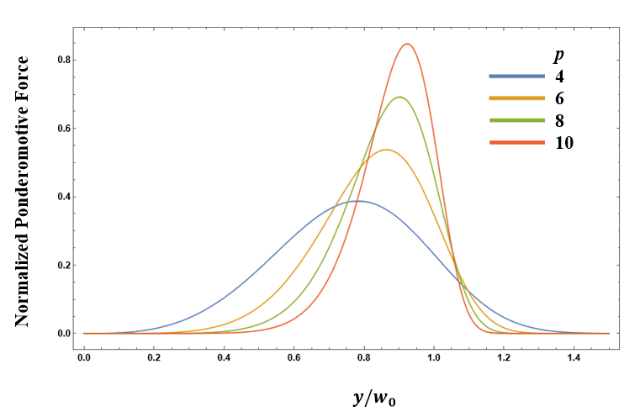
Fig. 1: Variation of normalized nonlinear ponderomotive force as a function of laser beam transvers propagation distance from y-axis, for different values of super-Gaussian index p, when $ω/ω_{p}=0.57$, $v/ω_{p}=0.05$.
The two copropagating super-Gaussian laser beams having slight difference frequency cause to generation of beam wave. The oscillating electronic clouds of clustered plasma experienced nonlinear force which is generally called as ponderomotive force. We have derived an analytical expression of nonlinear ponderomotive force (Eq. (7)). The typical values of laser beam frequencies is taken of the order $ω_{1}\sim {2.3×10}^{14}Hz$, $ω_{2}\sim {1.8×10}^{14}Hz$. In practical purpose, these frequencies can be achieved by CO₂ and N₂O gas lasers respectively.
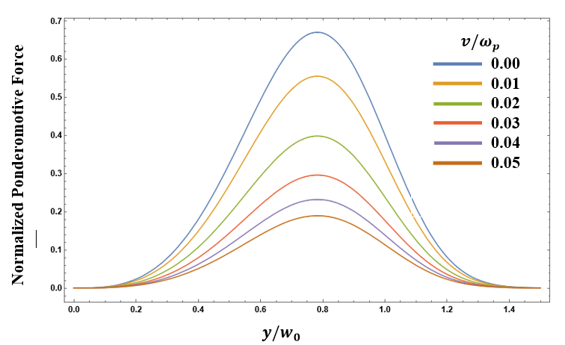
Fig. 1 shows the variation of normalized nonlinear ponderomotive force as a function of laser beam transverse propagation distanced from y-axis for different values of super-Gaussian mode index p. For the value of $p≥4$, the laser beam is in super-Gaussian mode. It is to be noticed that as one increases the super-Gaussian mode index, the peak amplitude of nonlinear ponderomotive force is enhanced. The field amplitude laser beam is enhanced with increase in super-Gaussian mode index. As one increases mode index p=4 to p=6, the peak amplitude of ponderomotive forced is increased upto 37.4 %.

Fig. 2: Variation of normalized nonlinear ponderomotive force as a function of laser beam transvers propagation distance from y-axis, for different values of electron-neutral collisional frequency, when $ω/ω_{p}=0.57$, $p=4$.
In Fig. 2, we have studied the variation of normalized nonlinear ponderomotive force as a function of laser beam transverse propagation distanced from y-axis for different values of electron-neutral collisional frequency. For mode index p=4, peak amplitude of nonlinear ponderomotive force is obtained at transverse beam propagation distance $y/w_{0}\sim 0.77$. Since collision is the integral part of experimental analysis and herein we have considered the electron-neutral collision. The amplitude of ponderomotive force is decreased with increase in collisional frequency. This shows that collision causes the decrease in electron oscillatory velocity and hence results the decrease in ponderomotive force. In this way, we can say that the spatial inhomogeneity and nonlinearity of medium might be decreased with the presence of electron-neutral collision.

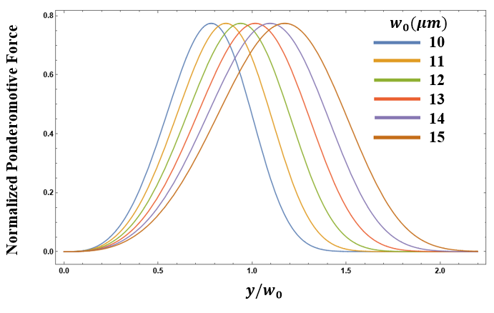
Fig. 3: Variation of normalized nonlinear ponderomotive force as a function of laser beam transvers propagation distance from y-axis, for different values of laser beam width $w_{0}$ , when $ω/ω_{p}=0.57$, $v/ω_{p}=0.05$.
In Fig. 3, we have studied the variation of normalized nonlinear ponderomotive force as a function of laser beam transverse propagation distanced from y-axis for different values of laser beam width $w_{0}$. As one increases the laser beam width, the nonlinear ponderomotive force decreases. The physics behind this phenomenon states that the laser field intensity is very sharp for steeper laser beam width. Hence, the steeper laser beam width imparts larger oscillatory velocity to the electron associated with nanoclustered plasma. This large oscillatory velocity causes to produce of strong nonlinear ponderomotive force due to sharper laser beam width.
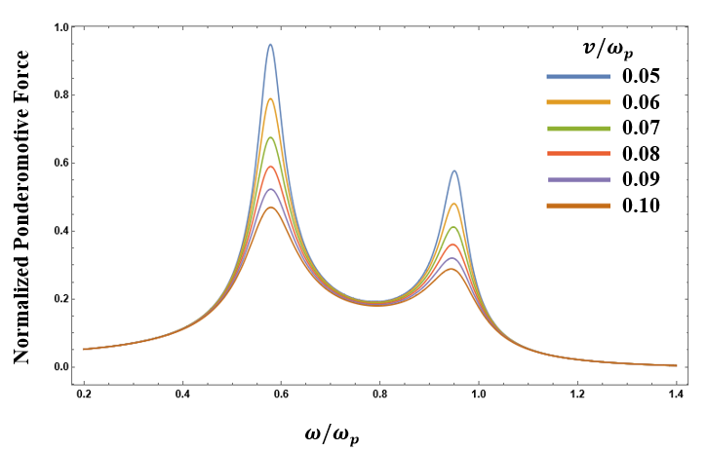
Fig. 4: Variation of normalized nonlinear ponderomotive force as a function of laser beam normalized frequency for different values of electron-neutral collisional frequency, when p=4, $ω/ω_{p}=0.57$, $y/w_{0}=0.5$.
Fig. 4 shows the variation of normalized nonlinear ponderomotive force as a function of normalized laser beam frequency for different values of electron-neutral frequency. The nonlinear ponderomotive force has attain two intense peak profile at normalized laser beam frequency$ω/ω_{p}=0.57$, $ω/ω_{p}=0.95$ respectively. The two intense peak is appeared owing to presence of affective surface plasmon resonance at the surface of nanoclustered plasma. In which the primary resonance is stronger than secondary resonance. This predicts that the contribution of primary resonance is more efficient for production of large amplitude nonlinear ponderomotive force. It is to be noticed that as one increases the electron-neutral collisional frequency, the nonlinear ponderomotive force is decreased. The presence of electron-neutral frequency leads to decrease the dynamics of oscillating species as well as nonlinearity. Therefore, we can say that the presence of electron-neutral collisional frequency causes to negative effect in nonlinear ponderomotive force.
4. Summary and Conclusions
In this present theoretical investigation, we have proposed the production of large nonlinear ponderomotive force by two copropagating high power super-Gaussian laser beam in collisional nanoclustered plasma. The analytic expression of nonlinear ponderomotive force is derived by using the fluid theory. The different graphical profiles depict that nonlinear ponderomotive force can be optimized and controlled by varying the laser beam width, super-Gaussian index, laser beam frequency, laser beam propagation distance and electron-neutral collisional frequency. The presence of effective surface plasmon frequency plays an important role for resonant and efficient production of nonlinear ponderomotive force as the laser beam frequency becomes $\sqrt{3}$times plasma frequency. This enhanced and large amplitude nonlinear ponderomotive force can be used for electrostatic wave excitation [6] and electron heating [4].
Acknowledgement
The authors would like thankful to Prof. V. K. Tripathi (IIT Delhi), Prof. M. S. Tiwari (Dr. H. S. Gaur University, Sagar) for valuable discussions and suggestion and also thankful to Prof. K. N. Uttam (Department of Physics, University of Allahabad, Prayagraj) for discussion in laser. We would like to thank Dr. P. N. Dongre (Principal) of K. N. Govt. P. G. College, Gyanpur-Bhadohi for providing the research facilities.
References
- Asgarian MA, Abbasi M (2018) Excitation of half-integer up-shifted decay channel and quasi-mode in plasma edge for high power electron Bernstein wave heating scenario. AIP Advances 8 045119
- Turikova VA, Umnova AM (2020) Parametric Interaction of High-Power Laser Radiation with Plasma in a Strong Magnetic Field Plasma. Physics Reports 46 859–861
- Kumar A, Pandey BK, Tripathi VK (2010) Charged particle acceleration by electron Bernstein wave in a plasma channel. Laser and Particle Beams 28 409–414
- Sharma S, Vijay (2020) Resonant second–harmonic generation in a magnetized plasma embedded with clusters. Optik 204 164023
- A. Varma and A. Kumar, Electron Bernstein wave aided heating of collisional nanocluster plasma by nonlinear interactions of two super-Gaussian laser beams, Laser Phys. 32 (2022) 016001
- A. Varma, and A. Kumar, Electron Bernstein wave excitation by beating of two copropagating super-Gaussian laser beam in a collisional nanocluster plasma, Optik 240 (2021) 166872
- A. Varma and A. Kumar, Electron Bernstein wave aided beat wave of Hermite-cosh-Gaussian laser beam absorption in a collisional nanocluster plasma, Optik 245 (2021) 167702
- Kumar A, Tripathi VK (2005) Electron Bernstein wave excitation by counterpropagating electromagnetic waves in a plasma. Phys. Plasmas 12 102308
- Bashir M F, Noreen N, Murtaza G, Yoon PH (2014) Relativistic Bernstein mode instability. Plasma Phys. Control. Fusion 56 055009
- Yoon PH, Hadi F, Qamar A (2014) Bernstein instability driven by thermal ring distribution. Phys. Plasmas 21 074502
- Kumar A, Tripathi VK (2007) Parametric up-conversion of an electron Bernstein mode by a relativistic electron beam in a plasma. Phys. Plasmas 14 052310
- Batani D, Joachain CJ, Martellucci S, Chester AN (2001) Atoms, Solids, and Plasmas in Super-Intense Laser Fields Kluwer, New York
- S Sarkar, Gopal R, Kundu M, Gope K, Anand M, and Krishnamurthy M (2019) Measurement of asymmetric electron cloud in cluster nano-plasma. Phys. Plasmas 26 070703
- Saalmann U, Siedschlag C, Rost JM (2006) Mechanisms of cluster ionization in strong laser pulses. J. Phys. B: At. Mol. Opt. Phys. 39 R39–R77
- Fennel T, Meiwes-Broer KH, Tiggesbäumker J, Reinhard PG, Dinh PM, Suraud E (2010) Laser-driven nonlinear cluster dynamics. Rev. Mod. Phys. 82 1793
- Kumar A (2019) X-mode coupling to Bernstein wave in a plasma embedded with clusters. Optik 178 602-609
- Tiwari PK, Tripathi VK (2006) Laser beat-wave excitation of plasma waves in a clustered gas. Phys. Scr. 73 393–396
- Antonsen TH, Taguchi T, Gupta A, Palastro J, Milchberg HM (2005) Resonant heating of a cluster plasma by intense laser lighta. Phys. Plasmas 12 056703
- M Kumar, Tripathi VK (2009) Rayleigh scattering of a Gaussian laser beam from expanding clusters. Phys. Plasmas 16 123111
- Tiwari PK, Tripathi VK (2006) Laser third-harmonic generation in clustered plasmas. Phys. Scr. 74 682–685
- Parashar J (2009) Effect of self-focusing on laser third harmonic generation in a clustered gas. Phys. Scr. 79 015501

