Experimental Investigations on Sustainable Concrete with Bamboo Waste
Niroj Aryal¹, Alok Shah², Chandrashekhar Yadav³, Manu S E⁴
^{1,2,3}UG Students, Department of Civil Engineering, Jain (Deemed-to-be) University, Bangalore
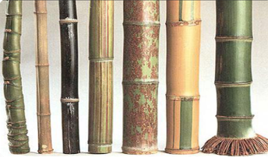
⁴Assistant Professor, Department of Civil Engineering, Jain (Deemed-to-be) University, Bangalore
Abstract –The practice of using sustainable materials has gained popularity worldwide. In the construction sector, cement contributes approximately 7% of global CO2 emissions and many other greenhouse gases, resulting in global warming. So concrete containing sustainable supplementary cementitious materials (SCM) is used to reduce CO2 emissions and attain long-term strength. The bio-waste material of bamboo, i.e., bamboo flakes and bamboo leaves, was procured and dried under the sun. The leaves and flakes were burned separately in a controlled manner in a burn barrel. The chemical tests on bamboo flake ash (BFA) and bamboo leaves ash (BLA) were used to characterize the ash’s chemical characteristics. The findings revealed that the ashes comprise key elements such as SiO2, AL2O3, and Fe2O3. As per ASTM C618:2003, to be classified as pozzolanic material, the combination of SiO2, Al2O3, and Fe2O3 must be greater than 70%. Hence, it satisfies the ASTM condition, as in BFA and BLA, the combination content of SiO2, Al2O3, and Fe2O3 was 80.02% and 80.83%, respectively. Therefore, the ash possessed high pozzolanic activity. Cement was replaced by BFA at 5%, 10%, and 15% by weight of cement. Concrete made by partial replacement of cement with BLA and BFA was tested for compressive strength at 7, 14, and 28 days of curing. And the split tensile test was conducted based on the optimum value obtained from compressive strength. After 28 days, the optimal strength was found to be at 5% replacement. The durability test (water absorption) shows that sustainable concrete has greater durability as compared to conventional concrete. Though several SCMs have been used, the use of bamboo flakes (BFA) as an SCM has been considered new research.
Key Words: Sustainable, Bamboo, Bamboo Flakes Ash (BFA), Bamboo Leaves Ash (BLA), Pozzolanic, SCM

1. INTRODUCTION

This concrete is the major material used for construction worldwide because of its availability, bond strength, low cost, greater life span (durability), and, most importantly, its versatility [1]. It is composed of cement, fine and coarse sand, water, and various admixtures that increase strength and durability by reducing water content. The amount of cement produced around the world is about 41 billion metric tonnes [2]. The production of cement produces carbon dioxide (CO2) and other harmful gases [3].
According to a certain study, for every 1 kg of cement, (0.8-0.9) kg of carbon dioxide is released into the atmosphere [3]. The concrete produced may be having good quality but there is the presence of micro cracks, small voids, and capillary pores in the hardened concrete, in which the deteriorating agent like chloride (Cl) penetrates through the pores or voids and result in a deterioration of the structure [4]. In order to reduce energy and environmental impact on concrete partial replacement of cement with locally available waste material should be used [5]. As our world is moving towards sustainable development so the use of different types of waste cementitious material could be the best alternative to produce Sustainable concrete. Generally, there are two types of supplementary material i.e. hydraulic material, which when reacts with water forms a cementitious material, and pozzolanic material which reacts chemically with the calcium hydroxide Ca (OH) ₂ produced during the hydration of cement. Researchers from all over the world have recently started to look at the usage of low-cost and low-energy alternatives to traditional building materials. Bamboo covers approximately 1.57 crore hectares in India, accounting for approximately 12.8% of the total forest available in India. Bamboo, one of the plants with the quickest growth rates, is one option for such a replacement that has a lot of economic potential. Bamboo generates different types of waste in the form of leaves, flakes, and many more.
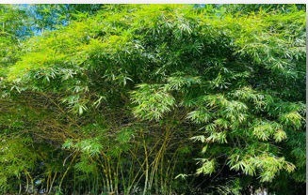
Fig.1. Bamboo Fig.2. Bamboo Species adapted from Dr. Kavitha S, 2018

In this project, we have used bamboo leaves and bamboo flakes as supplementary cementitious material. By-products of bamboo like bamboo leaves and bamboo flakes are agricultural waste that is disposed of in landfills, eventually damaging the environment by polluting the air and occupying useable land. To give a good finish or proper shape the inner and outer surfaces of the bamboo were removed that waste is called Bamboo flakes. Bamboo flakes are an innovative material as no one has used them as cementitious material to date. The chemical composition of BLA and BFA satisfied the specification of ASTM C-618 (2001) and BS EN 197-1 as the addition of the percentage composition of SiO2, Al2O3, and Fe2O3 is greater than 70% [3]. So BLA and BFA are pozzolanic in nature. The hydration of cement produces Calcium Hydroxides as a by-product which is responsible for the deterioration of the concrete structure. The addition of pozzolanic material containing high amounts of amorphous silica in the concrete mix results in a reaction between Ca (OH)2 and oxides of silica, producing the calcium silicate hydrate gel, which is the main constituent responsible for the bonding of concrete-making material [1].

The chemical reaction is as shown below:
C₃S +C₂S+H₂O => C-S-H gel +Ca (OH) ₂
Ca (OH) ₂ + SiO2 (from BFA/BLA) => C-S-H gel [6]

The above reaction shows that the pozzolanic material reacts with the by-product formed i.e. Ca (OH) _{2.} As the replacement percentage of cement increases the amount of by-product formed from the hydration of cement decreases hence less amount of calcium hydroxide will be available to react with silicon dioxide hence unreacted silica will remain resulting in less C-S-H gel formation. This causes a decrease in strength and the strength will go on decreasing as the percentage replacement of pozzolanic material increases. It is applicable to most of the pozzolanic material.

Using this waste (BLA & BFA) as a cement substitute reduces not only the economic and environmental challenges associated with waste disposal but also the cement content, resulting in decreased CO2 emissions and energy required during cement manufacture. Therefore, the main aim of this study was to determine how BLA and BFA blended cement concrete affected the mechanical, workable, and durable characteristics of concrete.

2. RESEARCH GAP IDENTIFICATION
• As per previous research conducted, the use of bamboo leaf ash to replace cement partially to obtain sustainable concrete.
• We have introduced/used bamboo flake ash as a Pozzolanic material for cement replacement, which has been considered new research.

3. OBJECTIVE & METHODOLOGY

3.1. Objective
1. To evaluate the optimized percentage replacement of cement with bamboo flake ash and bamboo leaves ash
2. To find the mechanical properties of concrete by partial replacements of cement and compare them with the properties of conventional concrete.
3. To assess and compare the durability property of sustainable concrete and conventional concrete.

3.2. METHODOLOGY

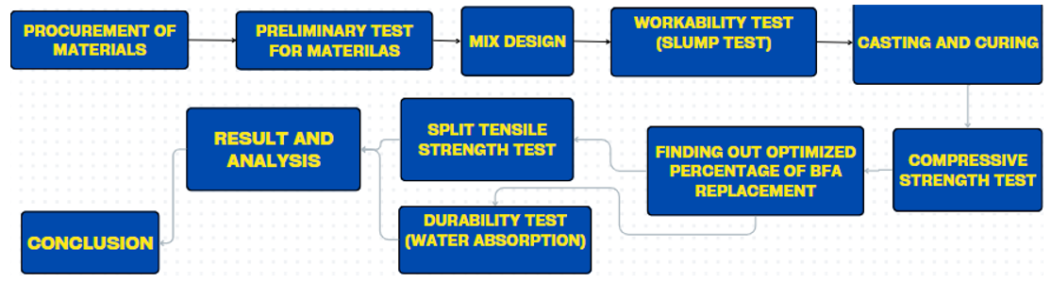
Fig.3 Flowchart for Methodology
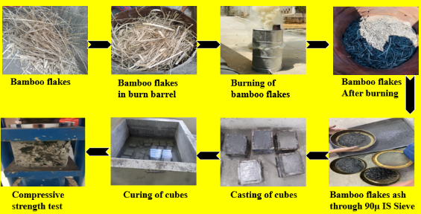

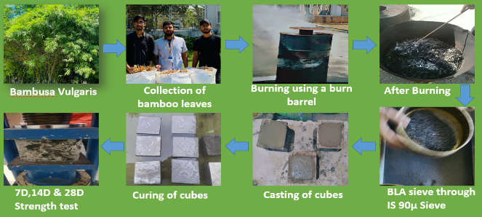
Fig.4 Process of testing of cubes using BFA
Fig.5 Process of testing of cubes using BLA

4. MATERIAL PROPERTIES

4.1. Cement
Ordinary Portland cement (Birla) of Grade 53 was used for this research. The physical properties of the Cement are shown in table-1.
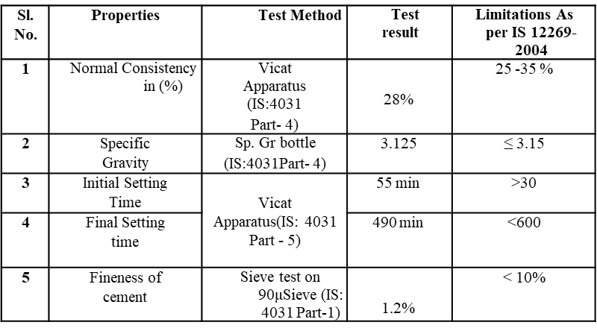
Table 1: Physical Properties of Cement
4.2 Bamboo Flakes Ash
Bamboo flakes are defined as the extruded waste parts of bamboo culms while making bamboo products such as mats, trays, and many more. Mainly they are generated from the bamboo processing industry.
In this research, the Bamboo flakes were collected from the local street of KR market, Bengaluru which is shown in the figure below. The process of ash preparation, storage, sieving, and chemical testing was done. Apart from this, we collected 25kg of bamboo flakes which after burning came out as 1.5kg ashes.
The dry bamboo flakes are sundried and burned using a burn barrel in FCRC (Fire and Combustion Research Center) Lab, at Jain University.

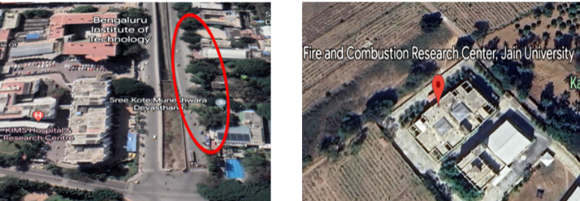
Fig.6 Bamboo Flakes, Fig.7 Bamboo Flakes
K.R Market area burning

4.3 Bamboo Leaves Ash
When bamboo reached the mature stage and becomes mature, its bottom leaves start falling. The bamboo leaves used in this research were collected from the Jain global campus. The fallen leaves are collected and sundried for 1-2 days. After that, the collected bamboo leaves were taken to Fire and Combustion Research Centre, Jain University. Then the leaves were put in the burn barrel for about 1 hour. The burned ash was cooled for some time and kept in an airtight zipper bag by sieving it through a 90µ-IS sieve in order to preserve oxygen. Because the ashes lose their chemical composition as it comes in contact with moist air and reduces strength too.
While burning 28 kg of bamboo leaves and the ash produced from it was 5.535 Kg.

The leaves were burnt in the same lab as BFA as shown in Fig 6 and the same procedure was followed to prepare ash.

4.2.1. Chemical Properties of OPC VS BFA VS BLA

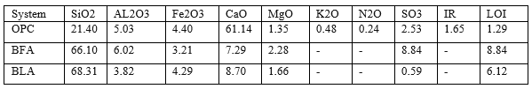
Table 2: Chemical properties of OPC, BFA & BLA

4.3. Water
Portable water available in the Concrete technology lab of the Jain Global campus was used for the experiment.

4.4. Superplasticizer (Builplast-SP)
PEB (Polycarboxylate ether-based) superplasticizer was used in this research. The physical Properties of the superplasticizer are given in table-3.
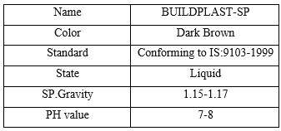
Table 3: Physical Properties of Superplasticizer

4.5. Fine Aggregate
In this experiment, M-sand was used, which was prepared by crushing stones of various shapes and sizes. The physical properties of M-sand are given in table-4.

Table 4: Physical Properties of M-Sand
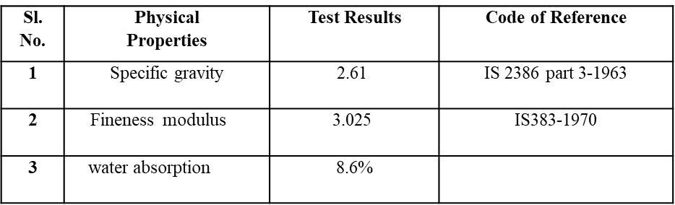

4.6. Coarse Aggregate
In this research, 20mm downsize coarse aggregate having a specific gravity of 2.7 and water absorption capacity of 0.8% was used in this research.

5. MIX PROPORTION

Cement- 404.18kg
Fine Aggregate-664kg
Coarse Aggregate-1220kg
Superplasticizer (BUILDPLAST-SP) - 3.238kg
Water to cement ratio -0.4
Mix Proportion By weight = 1:1.64:3.02

The total amount of dry volume of concrete required to cast 1 cube was 8.2 kg as per calculation. By considering losses we have taken 8.5 kg of concrete cube of size 150mm*150mm*150mm. The quantity of each material required to cast cubes is given below:

Table 5: Mix Proportions to Cast Cubes
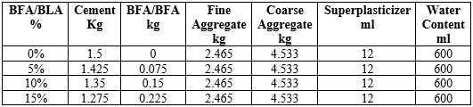

Also, we have cast a cylinder based on the optimum percentage of BFA. The quantity of BFA required to cast a cylinder of size 100mm*200mm (diameter*depth). The total quantity of material we used to cast the cylinder was 4kg. The quantity of each material required to cast the cylinder is given below:

Table 6: Mix Proportion to Cast Cylinders

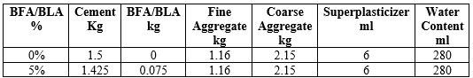

6. MIX PROCEDURE
First, all the concrete making material are dry mixed for 5 minutes, then about 70% of the mixing water is added and mixed for 3-4 minutes,10-15% of water and 60-70% of superplasticizer is added and mixed again for about 2 minutes as superplasticizer.
After adding a superplasticizer don’t mix the concrete for a long time as decreases the setting time and the chances of the early setting are high. The remaining water and superplasticizer are added and mixed for some time.
7. CURING
A total of 36 cubes are cast and curing was done for 7 days, 14 days & 28 days, and 3 cylinders are cast for 5% BFA replacement and cured for the same time as concrete cubes.

8. PROPERTIES OF CONCRETE

A. Fresh concrete properties
i) Workability (Slump Test)
From the experiment, we got a slump value of 105mm at 0.8% superplasticizer by weight of cement. The workability of a concrete mix to make a cube was found to be reduced when the cement was partially replaced with bamboo flakes ash and bamboo leaves ash. The same pattern was seen for all percentages of cement replacement with BFA & BLA. Due to the cellular nature of BFA/BLA particles and their high fineness (Which increases with their surface area), concrete containing BFA & BLA absorbs more water for a given consistency, requiring more water overall. As compared to BLA, the BFA is finer and absorbs more water during mixing.
As a result, a proper dosage of additional water was added to improve the fluidity and consistency of the mix.

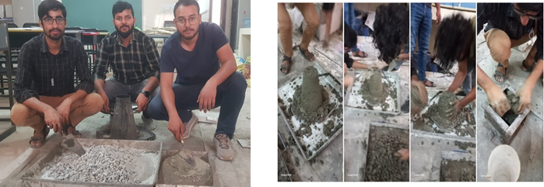
Fig.8. Slump Test on Concrete

B. Mechanical Properties of Concrete

i) Compressive Strength Test

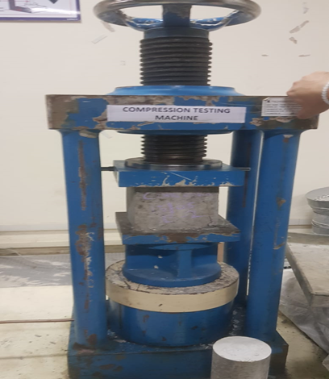
The concrete cubes were formed using normal concrete with BFA and BLA substituting cement at 5%, 10%, and 15% respectively. The compressive strength test was performed on a specimen of cubical size 150mm in a 3000KN Universal Testing Machine. The compression testing figures are shown below.
Fig.9. Compressive Strength Test of Cubes

ii) Split Tensile Strength Test

A split tensile strength test is carried out on conventional concrete with the optimal percentage of bamboo leaves ash (5%) and bamboo flakes ash (5%). The cylinder was placed in a curing tank for 7D, 14D, and 28D and tested after curing.
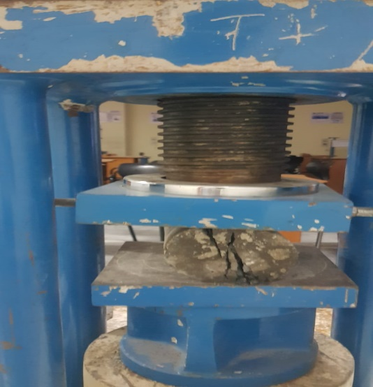

Fig.10 Split Tensile Strength test

C. Durability property of Concrete
i) Water absorption test
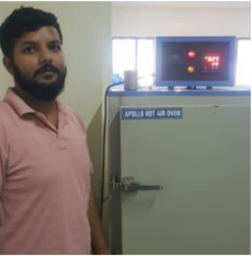
After the concrete cube has been cured for 28 days, it is dried in an oven at 108 degrees Celsius for 24 hours. This ensures that all the moisture is completely removed from the concrete cube. The cube is then weighed to establish the dry weight.
Fig.11. Water absorption test
Then, the dried cube is immersed in water for 24 hours to allow water to penetrate into the concrete. After the immersion period, the cube is weighed again to determine the water weight absorbed. By comparing the dry weight and the weight after immersion, the concrete cube’s water absorption has been calculated. This value reflects the ability of the concrete to resist the ingress of water.

9. RESULT AND DISCUSSION
The average compressive strength for conventional concrete cubes and BFA/BLA-based concrete cubes is given below:

Fig.12 Comparison of compressive strength of conventional cubes and BFA-based cubes at 7D, 14D & 28D.

Fig.13 Comparison of compressive strength of conventional cubes and BLA-based cubes at 7D, 14D &28D
The average split tensile strength for conventional concrete cylinders and BFA/BLA-based concrete cylinders is given below:
Fig.14 Comparison of Split tensile of conventional cubes and BFA-based cubes at 7D, 14D & 28D.
Fig.15 Comparison of Split tensile of conventional cubes and BLA-based cubes at 7D, 14D & 28D.
The water absorption test comparison of conventional cubes, 5% BFA, and BLA-based cubes are shown below.
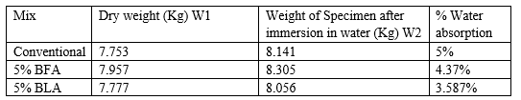
Table 7: Water absorption test

10. CONCLUSION
1. The workability of concrete mix decreases with an increase in the percentage replacement of BFA/BLA. So required amount of water is added to make a mix workable.
2. The 5% of BFA gives the optimum value of Compressive strength result as 27.57 MPa, 35.68 MPa, and 39.03 on the 7th, 14th, and 28th day of curing and 5% BLA gives optimum strength as 30.22MPa,39.55MPa and 42.84 MPa respectively on the 7th, 14th, and 28th day of curing.
3. The split tensile strength for the optimum percentage (5%) of BFA is 2 MPa, 2.48 MPa & 2.75 MPa and 5% BLA is 2.38MPa, 3.1MPa and 3.35 MPa respectively on the 7th, 14th, and 28th day of curing.
4. Superplasticizer helps to increase the workability of concrete as well as the early strength of concrete.

5. The water absorption of conventional is more than 5% BFA cubes and more than 5% BLA cubes. It shows that as compared to conventional and BFA-based concrete cubes BLA based cubes shows good durability property.

REFERENCES

[1] Olutoge, F. A., & Oladunmoye O. M. (2017). Bamboo leaf ash as supplementary cementitious material. American Journal of Engineering Research, 6(6), 1-8.
[2] Onikeku, O, Shitote, S. M., Mwero, J., & Adedeji, A. (2019). Evaluation of characteristics of concrete mixed with bamboo leaf ash. The Open Construction & Building Technology Journal, 13(1).
[3] Odeyemi, S. O., Atoyebi, O. D., Kegbeyale, O. S., Anifowose, M. A., Odeyemi, O. T., Adeniyi, A. G., & Orisadare, O. A. (2022). Mechanical properties and microstructure of high-performance concrete with bamboo leaf ash as additive. Cleaner Engineering and Technology, 6, 100352. [4] Dacuan, C. N., Abellana, V. Y., & Canseco, H. A. R. (2021). Assessment and evaluation of blended cement using bamboo leaf ash BLASH against corrosion. Civil Engineering Journal, 7(6), 1015-1035.
[5] Abebaw, G., Bewket, B., & Getahun, S. (2021). Experimental investigation on effect of partial replacement of cement with bamboo leaf ash on concrete property. Advances in Civil Engineering, 2021, 1-9.
[6] Olanrewaju, S. B. O., Abass, O. J., & Olusola, K. O. Effect of Open Air Burnt Bamboo Leaf Ash Blended Cement Concrete.
[7] Umoh, A. A., & Ujene, A. O. (2014). Empirical study on effect of bamboo leaf ash in concrete. Journal of Engineering and Technology (JET), 5(2), 71-82.
[8] Odeyemi, S. O., Adisa, M. O., Atoyebi, O. D., Wilson, U. N., Odeyemi, O. T., Odeyemi, S. O., ... & Odeyemi, O. (2022). Optimal water-cement ratio and volume of superplasticizers for blended cement-bamboo leaf ash high-performance concrete.
[9] Dhinakaran, G., & Gangava, H. C. (2016). Compressive strength and durability of bamboo leaf ash concrete. Jordan Journal of Civil Engineering, 10(3).
[10] Asha, P., Salman, A., & Kumar, R. A. (2014). Experimental study on concrete with bamboo leaf ash. International Journal of Engineering and Advanced Technology, 3(6), 46-51.
[11] Mujedu, K. A., Lamidi, I. O., Olomo, R. O., & Alao, M. O. (2018). Evaluation of physical and mechanical properties of partially replaced bamboo ash cement mortar. The International Journal of Engineering and Science, 7(3), 35-41.
[12] Olofintuyi, I. O., Oluborode, K. D., & Popoola, O. O. (2016). Green building: exploratory use of bamboo leaf ash to reduce CO2 emission and energy conservation in concrete production. European Journal of Engineering and Technology Vol, 4(2).
[13] Hnin, T. T., Htet, K. L., Kyaw, N. N. M., & Kyaw, M. (2018). Experimental investigation on effect of bamboo leaf ash replacing cement on compressive strength. International Journal of Science and Engineering Applications, 7(10), 406-410.
[14] Utodio, N. F., Ekandem, E. S., Egege, C. C., Ocholi, M., Atakpu, O. D., & Nwaigwe, D. N. (2015). Investigation of the effect of bamboo leaf ash blended cement on engineering properties of lateritic blocks. Journal of Sustainable Development Studies, 8(1).
[15] Villar-Cociña, E., Morales, E. V., Santos, S. F., Savastano Jr, H., & Frías, M. (2011). Pozzolanic behavior of bamboo leaf ash: Characterization and determination of the kinetic parameters. Cement and Concrete Composites, 33(1), 68-73.

