Internet of Things based upon Smart Homes

Muruli A V
Department of Electrical &Electronics Engineering
20211LEE0018
Presidency University
Bengaluru, India
udaya2889@gmail.com

Mahesh M R
Department of Electrical &Electronics Engineering
20211LEE0024
Presidency University
Bengaluru, India
maheshmr733@gmail.com

Bibang Gwar Basumatary/ Research Scholar
Department of Civil Engineering
Presidency University
Bengaluru, India
bibang1999@gmail.com

Dr. Nakul Ramanna
HOD & Professor
Department of Civil Engineering
Presidency University
Bengaluru, India nakul@presidencyuniversity.in

ABSTRACT:
The Web of-Things (IOT) is the spread of internet providers, though shrewd house already simply alluded to the unified and semi-mechanized control of natural frameworks. The IOT is tracking down additional purposes. The IOT climate is quickly taking on new advances. Modern Remote Sensor Organization has proactively made it conceivable. One of the purposes for IOT is the brilliant house. Many issues on the best way to oversee and control the whole framework emerge because of quick headways in innovation and design. Security in brilliant homes, servers, and different spots. The IOT engineering is introduced in this work. houses that can be checked and controlled from good ways are alluded to as savvy houses. The whole framework can be alluded to as a "savvy home in an IOT climate" or "IOT based shrewd homes" when these family gadgets in brilliant homes communicate with the web utilizing fitting organization design and standard conventions. Home mechanization undertakings are made more straightforward by shrewd homes. This paper offers different solutions to a portion of the issues that IOT and shrewd homes frameworks utilizing IOT face notwithstanding a conversation of the issues they raise.

KEY WORDS: Internet of Things (IOT), Smart Home, Radio Frequency Identification RFID.

- INTRODUCTION:
The capacity to connect with anyone, anyplace, whenever thanks to the web has changed human existence. The cost of sensors, processors, transmitters, and recipients has dropped emphatically because of mechanical enhancements. In this way, we can utilize these things in our day-to-day routines. In the event that somebody wishes to expand the quantity of internet providers accessible, the Web of Things may be viewed as an expansion in internet-based administrations.
- Web of Things (IOT) is a latest thing on the present web. Web of-Things: The organization of PCs that will interface with actual things or things utilizing the ongoing web foundation. Things can be any sort of thing, like furnishings, hardware, autos, and so on. Furthermore, the whole framework capabilities when these gadgets interface with the web utilizing a specific foundation and characterized conventions is supposed to be Web of Things (IOT).
- Things will be dynamic members in the whole framework whether they are physical, virtual, moving, or still. Things will converse with different things; this is known as things-to-things correspondence. At the point when articles can draw in or speak with people, this is alluded to as things-to-human correspondence.
- However, the web of things is something other than a modern unrealistic fantasy. It as of now exists and influences something other than innovation progression. These gadgets and things that convey by means of the web can set up their own arrangements and run independently. The IOT design is displayed in Figure 1
- A shrewd home is a position of home or a residing space furnished with innovation that empowers programmed and controller of all machines and family contraptions. Clients of savvy homes may effortlessly screen and deal with all home gadgets and apparatuses on the web. Home machines interface using laid out conventions and a right organization engineering.
- IOT innovation is most regularly related in the shopper market with items connected with the possibility of the "shrewd home," including gadgets and home hardware (counting lighting, indoor regulators, home security frameworks and cameras, and other homegrown home gear) that oversee one or more normal biological systems and can be constrained by gadgets connected with that climate, including advanced mobile phones and savvy sound gadgets. [1]

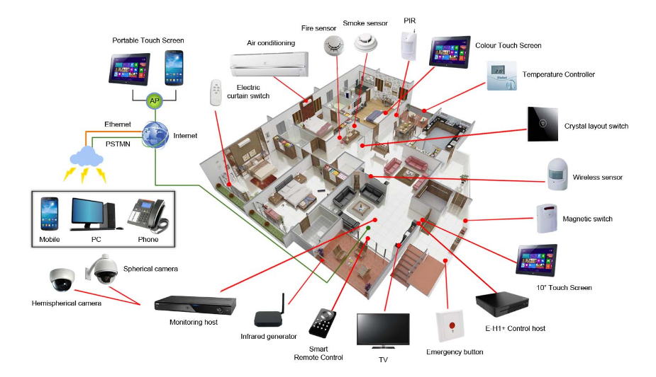
Figure 1: A Smart Home System using Internet of Things (IOT) [4]

- INTERNET OF THINGS FOR SMART HOME: -
The idea of house robotics, which can combine heating, lighting, and media, cooling, and, includes IOT devices as a small part of security systems. By insuring the murder of lights and equipment, long stretch preferences might contribute to vitality project reserves.
- Numerous IOT application, which will be divided into two divisions, are being considered and recognized by endeavours. In the first grouping, the devices are connected, creating a mechanized establishment with Machine-to-Machine importance and communication to people's lives enhance. Iot can be observed anticipating (track, request, and control) behaviour in this category.
- For instance, room temperature, the window and the lighting, the electrical devices, etc., differ in nuclear households. To eliminate the manual processes people must deal with on a daily basis, everything would have the potential of being robotized and operated remotely from a PC. It is widely known that both modern civilization and advancement suffer from the Internet of Things.
- IOT may be viewed as an all-encompassing system in the modern information society that enables and newly created businesses by the partnering virtual and physical devices and the things to begin at most recent and, despite this, best in communication improvements and class information.
- Even if the word "IOT" has been more widely known over the past five years, connecting items to the Internet is unquestionably nothing new. Perhaps the most important use was the Trojan room coffee maker, which was conceived shortly after the web was given serious consideration in 1989. On a phase that controls intelligent mechanical and devices assembly, a smart house or robotized home could be built
- . For instance, producers can use Apple's Home Kit to mandate their home furnishings and décor through an application for iOS devices like the iPhone and the Apple Watch. This could be a specific app or an iOS neighbourhood app, like Siri, which has a range of smart home devices that can be operated by Siri or Apple's Home app without the need for a Wi-Fi link. The overall goal of this article and my investigation is to create smart homes using the internet of things with a high level of security and the inclusion of various devices, sensors, controllers, etc. [2]

AIM & OBJECTIVE

This presents an IOT program approaches developed for home automation’s sector. Common use-cases include regulating home mechanical assembly, monitoring indoor air quality, managing home entrance using, for instance, locking windows with servo locks and RFID cards. Whatever the cases, the main focus on this study is to use IOT to increase home security. Even more specifically, monitoring and managing smoke alarms, and servo door locks, passage sensors, perception cameras and security vehicles, which is in ensuring and enhancing the security and prosperity of residences. Through flexible application, and client can access the following highlights like they are:
- Has the ability to turn LED lights on or off and monitor their health.
- If the entryways are opened or bolted, they can be bolted and opened through servo engines and screens.
- Using IR sensors, determine if the entryways are closed or opened.
- Is informed by email if the entrance is left open for an exceptionally extended period of time.
- Receives a face image from the camera and is notified through email of who entered the building through the entrance.
- Receives email notification if the fire identifier detects smoke.
- prepared to monitor his or her home from wherever by controlling the observation truck.
The purpose of this article is to provide a brief overview in the IOT-based smart home environments and with a focus on the transformative developments, in the system application zones, architectures, and designs in the smart home. The goal is not by provide a detailed and explanation in each topic but rather to provide reader with the core concepts, a brief summary, and a list of sources to consult if they choose to further explore a particular aspect of the topic. [3]

- Enabling Technologies for IOT

The idea of a smart home is now easily attainable because to current developments in statistics and correspondence technology (ICT) caused by computer systems, implanted frameworks, and man-made intelligence. Therefore, it has been possible for practical domestic circumstances to exhibit distinctive types of man-made brainpower by upgrading traditional house Automation systems with new top-notch capabilities. Smart domestic innovation combines administrations and innovations through domestic structure management for a high-tech existence. (RFID)Radio Frequency Identification, internet Protocol (IP), digital Product Code (EPC), Barcode, wireless constancy (wireless), Bluetooth, ZigBee, near Field Communication (NFC), Actuators, wireless Sensor Networks (WSN), and artificial Intelligence (AI) are some of the technological advancements that have made IOT possible. Consider this posting for more information.
- Application Areas of SHAS
The Internet of things offers a flexible and adaptable platform that can support a variety of uses. Its widespread use has led to a variety of applications, including beautiful residences among others. The fundamental the application area for the Smart Home Automation Systems in ecological control with the typical help types of lighting and day lighting or Heating Ventilation and Air melding (HVAC) frameworks, and observing the control, wellbeing and in security, telehealth care, “natural control”, energy conservation, and data access. There are many different applications for smart houses, including smart homes for security, eldercare, human services, childcare, energy efficiency, and smart homes for a better life like (entertainment, music, and etc)

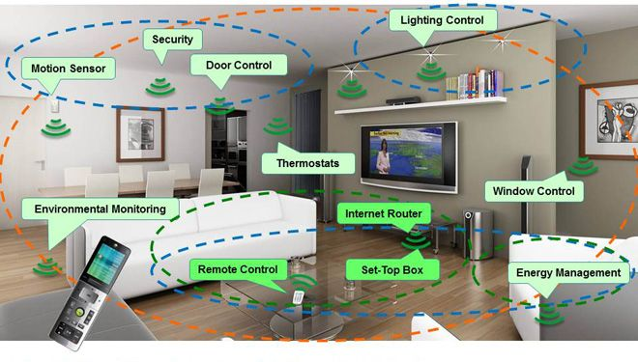
Figure 2: Types of Smart Home Applications[9]
- Structures: -

A dwelling that has intelligent fixtures, a home community that enables data sharing among fixtures, and the residential gateway that connects the intelligent domestic to be outside internet can all be considered smart homes. Innovative products make it possible to interact with or study a population. Technically, a home automation system is made up of 5 components. [4]

- Controlled Devices: -
These devices are made up of all additional components, such as client electronics or domestic household appliances, that are associated and constrained by a house computerization's framework. Different kinds of special connecting innovation, for example, WLAN(wireless region organization), Bluetooth, Z-Wave interfaces, and many others. utilized to establish direct contact with the manipulating community.
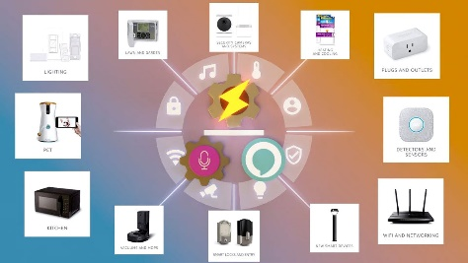
Figure3: controlled device [8]

- Actuators and Sensors: -

The home system may study, observe, and hear sensors. There are sensors for various purposes, including estimating temperature, dampness, light, liquid, and fuel as well as deciding development or upheaval. Actuators are the components that permit the energetic framework to complete its arrangements, as a matter of fact. Mechanical actuators include siphons, electrical engines, and digital actuators include switches with electric motors. The IOT devices equipped with sensors will travel as the government, while those with actuators will travel as entertainers. A system that has both sensors and actuators will be able to observe and act.

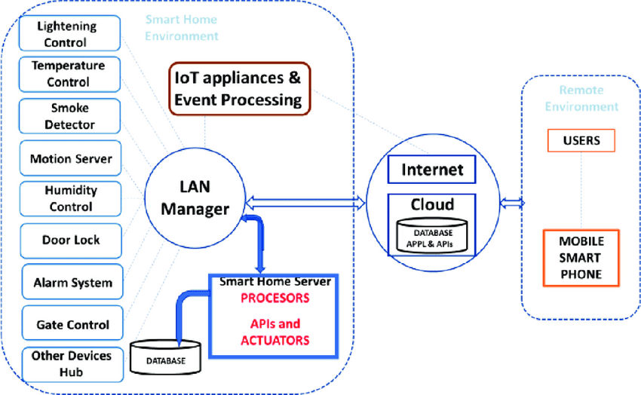

Figure4: Layer design model of IOT-based savvy home control framework [5]

- PROBLEM WITH FORMULATION SECURITY RISK IN SMART HOME:
OCTAVE Allegro technique will be utilized in the resulting districts to reenact a security risk assessment and issue equation for the IOT-based brilliant home. The method and the IOT-based fully intelligent home are already depicted in the earlier sections. Along with its vulnerabilities and capacity issues, the smart home can benefit greatly from basic records. At that point, a connection to downplay these risks will be put forth. Before we start putting the security hazard evaluation system's methods into practice step by step, we need to first define the security risk appraisal itself as well as all the terms that we'll use through the methods of leading the security risk appraisal in order to make it accurate. the usage of guidelines allows for the coverage of class, respectability, and accessibility without compromising the usefulness or ease of use. Here are some definitions of the phrases we'll be using during the device's safety risk appraisal technique. The workbooks that are part of the text "Presenting Octave Allegro: Improving the Statistics Security Threat Evaluation Technique."

  - An asset is a worthwhile possession. It might be a guy or woman, an item, an idea, or something concrete.
  - Facts Asset: This comprehensive data for a corporation can be communicated verbally, physically stored, moved, and handled electronically.
  - The records are saved in the facts beneficial resource compartment, which is the holder for the statistics aid. Holders may be tangible (on documents, CDs, or DVDs), specialized (software, durable products, servers, and systems), or individual (statisticians) in nature.
  - Important information: The greatest assistance results in the greatest harm when an association's safety conditions are breached.
  - Confidentiality: ensuring that only authorized individuals or systems access a records resource.
  - Integrity is the assurance that an information resource continues to be used in the intended context and for the intended reasons. It guarantees the accuracy and precision of the facts.
  - Availability: ensuring that the records assistance is accessible to authorized users.
  - The suggested study may examine data security risks in fully intelligent homes that are based on IOT. This evaluation journey looks at the data security risks while connecting advanced equipment to one another and to the internet while also setting up a smart home in order to alert users to potential security issues, enhance security, and provide a service. [6]

- MODEL DESIGN OF SMART HOME USING IOT DEVICES
The task's most important component became creating a model for modelling, testing, and effect analysis. The different parts of the house version were made with AutoCAD. The design was fed into a laser cutting device, which used it to cut cardboard into the different parts of the pattern. After that, the model was assembled to form the room model that is depicted in the following figures. The following components were used in the simulation of domestic automation:

- Two Raspberry 2 version B: The system's fundamental planning and guiding element. One served as the replacement for the reconnaissance vehicle and the inside version.
- Servo Motor: It works like an entrance lock. The front entryway's current status, including whether it is open or closed, is shown by an infrared (IR) sensor.
- Net camera: This device uses a Raspberry Pi to take orderly photos of the room as a spy camera. It makes use of Open CV's photo preparation to give users the option to make differentiate between the questions inside the session.
- Smoke detector: By spotting fire, it keeps the house secure.
- H-Bridges: To regulate and operate the vehicle's four DC engines, one H-Bridge is employed for each engine.

PROPOSED RESEARCH METHODOLOGY

Following the selection of this topic, the framework design became the main factor that needed to be taken into account. How might be gadgets and machines get orders, speak with the web and convenient programming, and convey their standing? Could it not be smart to have a server-buyer gathering where there could be a prompt association between the customer's gadgets and the application they utilize? What strategy will be utilized to lay out a prompt relationship through the web? The messages should be passed along prior to arriving at the client or the server, or, in all likelihood the client and server should bring through a centre channel. These questions had led to an investigation into various approaches and programs. For the purpose of connecting various sensors and devices to the internet, Raspberry Pi was chosen as the primary control unit. A little computer called the Raspberry Pi was chosen because of its simplicity and capabilities. It contains 40 GPIO ports and is designed for modification. The approach examines how clients or systems use the records. Furthermore, it focuses on the region in which the records are located as well as how threats are presented to them. By determining how they relate to the records resource, other fundamental assets can be identified and surveyed. For directing the chance appraisal, OCTAVE Allegro provides a route, spreadsheets, and surveys.

When the JSON string is received, the Raspberry Pi performs the action specified by that string. This enables complete user control and oversight of all connected devices to the Raspberry Pi, as demonstrated in the earlier example. OCTAVE Allegro's steps are as follows:
- establish chance measurement standards
- expand the Asset Profile records
- Containers for identifying information about assets
- Find potential problem areas
- identify risky circumstances
- Recognize the hazards.
- Consider risks
- Select a mitigation strategy
Compared to other protection hazard evaluation approaches that were taken into consideration, OCTAVE Allegro is satisfactorily appropriate to address the research issues. It consists of eight steps, which may be divided into four tiers and easily mapped to address my academic problems. We might take the aftereffects of each stage in the gamble assessment and use them as contributions for the subsequent stage by utilizing the accounting sheets made accessible by the methodology. Along these lines, it empowers us to look at testing circumstances all the more effectively and keep up with steady spotlight on the resource during the course of chance evaluation.

- USE CASES AND RESULTS
Data is sent and received by both the Raspberry Pi and the mobile application. This is relevant because you can publish and subscribe to the same Pub Nub channel at the same time. This made it possible for two-way data exchange. In order to analyse the results, many use cases were implemented and researched.
- A versatile application made with Ionic was utilized to control the installed LEDs that were associated with the Raspberry Pi through the GPIO sticks and constrained by the model. The program was given a "Light" tab, and the button on it very well might be flipped among "ON" and "OFF" when clicked.
- The button's default setting shows the Drove lights' ongoing condition. The LEDs are presently off assuming the button shows the worth "OFF". The worth switches to "ON" when the button is squeezed, sending a JSON string with the worth "1" for the "drove" property to the channel the application distributes to through Bar Stub and the "distribute key”. The Raspberry Pi in this project is one of the channel's subscribers, and it is sent the JSON string that it has received. Subsequent to getting the JSON string, the Raspberry Pi actually takes a look at the worth of the "drove" property and turns the LEDs as needs be.
- The portable application is likewise a supporter of a similar channel, permitting it to check the latest Drove notices distributed on Bar Stub and show all things considered "ON" or "OFF" as the button's default esteem. Through the GPIO pins, a 180-degree servo engine that filled in as the model room's entryway lock was joined to the Raspberry Pi. To broaden the servo's horn, it was stuck to the model's entryway alongside a cardboard tip. The application presently contains a "Lock" tab with a button that, when clicked, switches among "LOCK" and "Open". When the button is pressed, the servo lock will change its angle, as indicated by the button's default setting. If the button's value is "UNLOCK," the door will be unlocked when the servo motor is set to 0 degrees.
- At the point when the button is hit, the button's worth changes to " LOCK," conveying a JSON string with a worth of 0 for the "lock" characteristic, 'lock':0, to the channel the application distributes to and the "distribute key" provided by Bar Stub. The JSON string obtained through this channel is then transferred to the Raspberry Pi, which receives it, checks the value of the "lock" attribute, sets the servo motor's angle to 0, and unlocks the door by deploying a Board II and a microcontroller at a secondary access point.

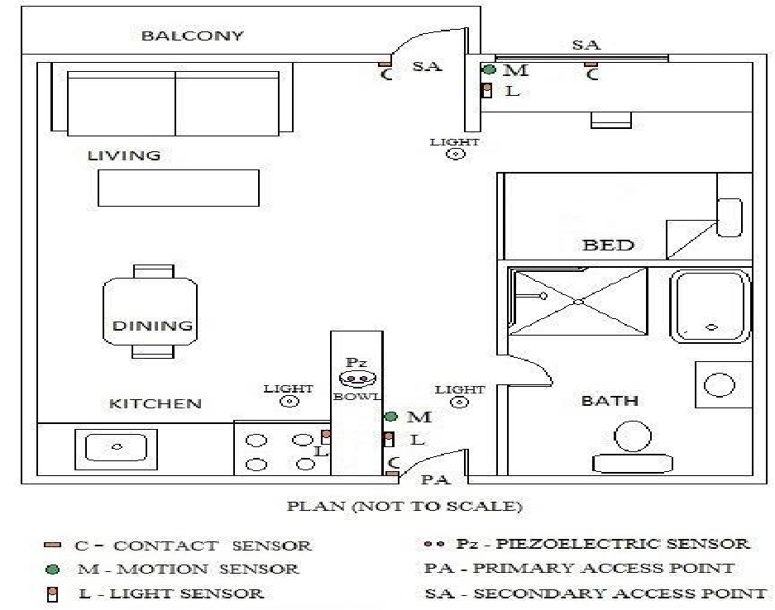

Figure5: Shows the arrangement and area of the sensor organizations in the loft during the legitimate detecting.[11]

The kitchen is where Board III is introduced. It is connected to a DHT 11 temperature and dampness sensor as well as a MQ 9 carbon monoxide sensor. The reason for Board III is to gauge the degrees of temperature, mugginess, and carbon monoxide in the area to search for fire. Board III is fuelled by an Arduino Uno module and conveys over ZigBee, very much like sheets I and II.

- Kitchen installation of figure board three. Board IV is placed close to the bed, and it connected to 2. 0.5-inch-diameter of circular force detecting resistors. Under the mattress, both force sensors are installed. The accuracy of the full-scale measurements for both force sensors is 5%. Furthermore, the force sensors utilized in the experiment are easily accessible, affordable, adaptable, and offer unobstructed force measurements.
- A capacity to every one of the Arduino Uno sheets is steered through a power bank. The Arduino boards require a DC output from the power banks of 9V–1000mA. Any trustworthy power save money with a limit of 5000mAh or more and a 5V-1000mA USB influence result would be adequate to supply the reinforcement influence. At the point when a USB to 2.1mm DC 9V Promoter Link is utilized to interface the power bank to the Arduino board, the power bank's 5V result power is expanded to 9V.

REFERENCES

References

[1] | M. Jyotsna .p . Gabbana , “smart home system using IOT,” Maharashtra, 2017.
[2] | M. S. Thakare, “Issues, Solution and Recent Research Direction,” Maharashtra, 2017.
[3] | A. B. Zia, “A Research Paper on Internet of Things based upon smart home with security risk,” Shimla, 2020.
[4] | google, “smart home”.
[5] | S. Vishwakarma, “smart home efficient home automation system using iot,” Gorakhpur, 2019.
[6] | M. craig, “smart home using iot,” Maharashtra, 2017.
[7] | “Security analysis of emerging smart home applications,” 2016.
[8] | google, “smart home,” google.
[9] | M. Domb, “IOT CYBER SECURITY,” GOOGLE, Israel, 2019.
[10] | D. Kundu, “Smart Home Automation system using Iot,” 2020.
[11] | A. B. zia, “A Research Paper on Internet of Things based upon Smart Homes with Security Risk Assessment using OCTAVE Allegro,” 2020.
[12] | M. K. Chauhan, “internet of things based smart home,” Shimla, 2020.

