Study of Innovative Deep Learning Architectures/Algorithms For Time Series Data And IOT

DaljeetKaur Husnara Khan
Department of Computer Science Department of Computer Science
Gyan Ganga College of Technology Gyan Ganga College of Technology
Jabalpur, M.P, India - 482002 Jabalpur, M.P, India - 482002
Email: daljeetkaurkalsi83@gmail.com Email: husnarakhn@gmail.com

ABSTRACT

A new field of machine learning (ML) study is deep learning. It contains many concealed artificial neural network layers. In big databases, the deep learning methodology applies nonlinear transformations and high-level model abstractions. Deep learning architectures have recently made major strides in a variety of domains, and these developments have already had a big impact on artificial intelligence. An up-to-date overview of the contributions and cutting-edge uses of deep learning is provided in this article. The review that follows shows, in chronological order, the primary applications that deep learning algorithms have been used in. The advantages and benefits of the deep learning approach, as well as its hierarchy of layers and nonlinear operations, are also discussed and contrasted with those of the more traditional algorithms used in everyday applications. the condition of The most effective deep learning architectures for predicting and identifying trends over time, together with data generated by IoT sensors, have been analysed in this paper. In this approach, it is suggested to support applications in industries like smart cities, industry 4.0, sustainable agriculture, robotics, etc. where IoT is advancing technology. LSTM (Long-Short Term Memory) for its high precision in prediction and its capacity to automatically process input sequences; CNN (Convolutional Neural Networks) primarily for the recognition of human activity; hybrid architectures with a convolutional layer for data pre-processing and RNN (Recurrent Neural Networks) for data fusion from various sensors and time series data.

INTRODUCTION
The IoT (Internet of things) is a network of several interconnected devices that can transfer enormous amounts of data. It is now used in a variety of industries, including agriculture, smart cities, smart homes, health care, and human activity identification. More knowledge may be gleaned from these IoT sensors the longer they are in use, which could aid users in predicting the behaviour of machines and other systems, which is helpful for system maintenance, yield performance resource allocation, business planning, and other tasks. However, deep neural networks have recently excelled at complex tasks like image recognition using CNN, comprehending human language utilising LST gaming with reinforcement learning, etc. It is pertinent.
The application of methodologies and strategic data mining in educational environments is the main focus of the analysis field of educational data mining. EDM focuses on investigating, creating, and using machine learning, data processing, and applied math methodologies to find patterns in massive volumes of educational data that will ideally be impossible to study [1].
EDM uses e-learning tools such as Learning Management Systems (LMS), Intelligent Tutoring Systems (ITS), and, more recently, Massive Open Online Courses (MOOC) to collect multimodal data about students' academic learning activities. For instance, these systems track when students use a learning resource, how often they do, whether they provide the right answer to an exercise, or how much time they spend on a particular task.The last 10 years have seen an increase in interest in Deep Learning (DL), which has revolutionised the machine learning field by producing superior results in perception tasks like image and speech recognition.In an effort to take use of the potential of DL in the creation of smart products, major corporations like Google, Facebook, Microsoft, Amazon, and Apple are substantially investing in the development of software and hardware advances in this area.Data-driven learning (DL) is based on neural network topologies with numerous layers of processing units that modify the input data in both linear and nonlinear ways.These architectures can be used with any sort of data, including text, audio, images, numbers, and combinations of these.The use of these technologies has aided numerous research sectors,

The Internet of Things (IoT) is a new paradigm that makes our lives easier by enabling communication between electronic devices and sensors over the Internet. IoT leverages smart devices and the Internet to provide innovative solutions to a variety of challenges and problems related to various businesses, governments, and public/private industries around the world [1]. IoT is becoming an increasingly important aspect of our lives and is felt all around us. Overall, IoT is an innovation that brings together a multitude of intelligent systems, frameworks, intelligent devices and sensors (Figure 1). In addition, it leverages quantum and nanotechnology for storage, retrieval, and processing speeds that were previously unthinkable [2]. Extensive research studies have been conducted and are available both on the web and in print in the form of academic papers and press reports demonstrating the potential effectiveness and applicability of IoT transformation. It can be used as a preparatory step before creating new innovative business plans that consider security, assurance and interoperability.

The Internet of Things (IoT) is a new paradigm that makes our lives easier by enabling communication between electronic devices and sensors over the Internet. IoT leverages smart devices and the Internet to provide innovative solutions to a variety of challenges and problems related to various businesses, governments, and public/private industries around the world [1]. IoT is becoming an increasingly important aspect of our lives and is felt all around us. Overall, IoT is an innovation that brings together a multitude of intelligent systems, frameworks, intelligent devices and sensors (Figure 1). In addition, it harnesses quantum and nanotechnology for storage, retrieval, and processing speeds that were previously unthinkable [2]. Extensive research studies have been conducted and are available both on the web and in print in the form of academic papers and press reports to demonstrate the potential effectiveness and applicability of IoT transformation. It can be used as a preparatory step before creating new innovative business plans that consider security, assurance and interoperability.
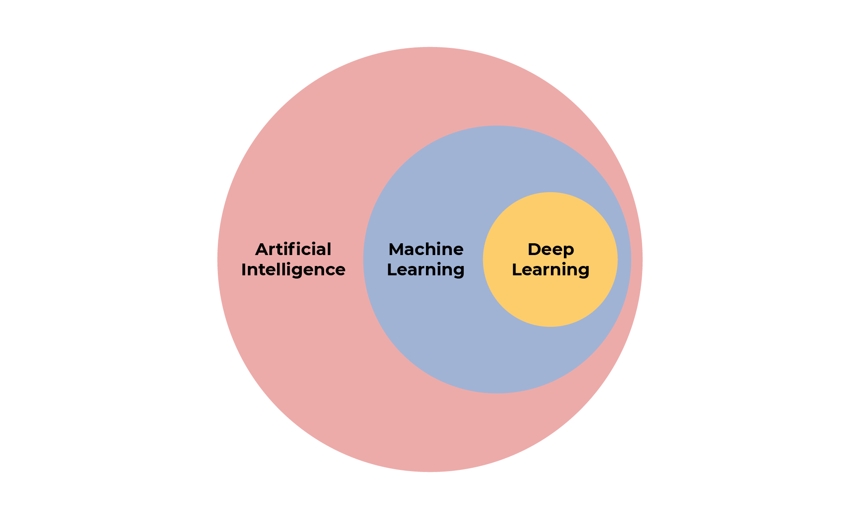

Object localization task. In recent years, there has been a great deal of attention in this field. The definition of the object detection problem is determining where objects are located in a given image (object localization) and to which category each object belongs (object classification). Therefore, the traditional object detection model pipeline can be divided into three main phases:
Information region selection, feature extraction and classification. Selection of profitable regions. Since different objects can appear anywhere in the image and have different aspect ratios and sizes, it makes sense to scan the entire image using a multiscale sliding window. Although this comprehensive strategy can determine all possible positions of an object, its drawbacks are also obvious. The large number of candidate windows complicates the computation and produces an excessive number of redundant windows. However, if only a fixed number of sliding window templates are applied,
Unsatisfactory areas can occur. Feature extraction. Recognizing various objects requires extracting visual features that enable semantic and robust representations. Typical examples are SIFT HOG and hair-like traits. This is due to the fact that these functions can create expressions related to the complex cells of the human brain. However, due to the variety of appearances, lighting conditions, and backgrounds, it is difficult to manually design robust feature descriptors that fully describe all types of objects. classification. A classifier is also necessary to distinguish the target object from all other categories and to make the representation more hierarchical, semantic and conducive to visual perception. The supported vector machines AdaBoost and deformable parts-based models (DPM) are usually good choices. Among these classifiers, DPM is a flexible model that combines object parts and deformation costs to handle severe deformations. DPM combines carefully designed low-level functions and kinematically inspired partial decompositions using a graphical model. Discriminative learning of graphical models also enables the creation of highly accurate parts-based models for various object classes.
Data mining area using DL architecture. This article provides an overview of the literature on DL methods applied to educational data mining from its inception in 2015 to the present. The main contributions of this article are:

1. Summarize most EDM tasks and categorize the actual work with DL applied for each of these tasks.
2. Identify tasks that have received a lot of attention and have not yet been researched. 3. Describe and classify the most common public and private datasets used for training and testing DL models in educational data mining tasks.
4. Presents key DL ideas and technologies and describes the most commonly used techniques and constructs in educational data mining and its specific tasks.
5. Based on the data collected during this study, we discuss future directions for the analysis of DL as applied to educational data mining.

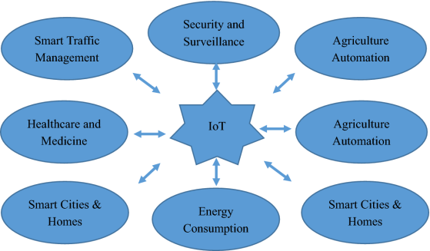

RELATED WORK

The Internet of Things has an interdisciplinary vision to exploit its advantages in various fields such as environmental, industrial, public/private, medical, and transportation. Different researchers describe the Internet of Things differently in terms of particular interests and aspects. The potential and power of IoT can be seen in several application areas. Figure 2 shows some of the possible application areas of IoT. Various important his IoT projects have taken the market by storm in recent years. Figure 3 shows some of the major IoT projects that dominate the market. Figure 3 shows the global distribution of these IoT projects in the Americas, Europe and Asia Pacific. We can see that the Americas contributes more to healthcare and smart supply chain projects, while Europe contributes more to smart city projects [8]. Smart city is one of the application areas of the IoT trend, including smart home. A smart home consists of IoT-enabled appliances, air conditioning/heating systems, televisions, audio/video streaming devices, and security systems that communicate with each other to provide the highest levels of comfort, security, and reduced energy consumption. To do. All communication takes place via an IoT-based central control unit via the internet. The concept of smart cities has grown in popularity over the past decade and has seen a lot of research activity [9]. The smart home economy will cross the $100 billion level by 2022[10]. Smart homes not only ensure the comfort of your own home, but also bring cost savings to homeowners in several ways. H. Due to the low energy consumption, the electricity bill is also relatively low. In addition to smart homes, intelligent vehicles are another category that belongs to smart cities. Modern cars are equipped with smart devices and sensors that control almost every component, from the car's headlights to its engine [11]. IoT advocates the development of new intelligent he car systems that integrate car-to-vehicle and car-to-driver wireless communication to ensure predictive maintenance and a comfortable and safe driving experience[12].
Kajeenasiri et al. [10] conducted a study on IoT intelligent energy control solutions that will benefit smart city applications. They said IoT is currently being used in a very small number of application areas that serve technology and people. The application fields of IoT are very wide, and in the near future IoT will be able to cover almost all application fields. They said energy conservation is an important part of society and IoT could help develop intelligent energy control systems that save both energy and costs. They explained IoT architecture in terms of smart city concept. The authors also discussed that one of the difficulties in achieving this goal is the immaturity of his IoT hardware and software. They suggested that these issues need to be resolved to ensure his IoT system is reliable, efficient and user-friendly.Aravi et al. [13] dealt with the urbanization problem of cities. Migration of people from rural areas to cities leads to urban population growth. Intelligent solutions for mobility, energy, healthcare and infrastructure are therefore required. Smart cities are one of the key application areas for IoT developers. We explore various topics such as traffic management, air quality management, public safety solutions, smart parking, smart lighting, and smart waste collection (Figure 5). You mentioned that the Internet of Things is working hard to address these difficult issues. The need to improve smart city infrastructure in the face of increasing urbanization has opened doors for smart city technology entrepreneurs. The authors concluded that IoT-enabled technologies are of great importance for sustainable smart city development.
The future of deep learning
Unsupervised learning91-98 had the catalytic effect of reviving interest in deep learning, but it has since been overshadowed by the achievements of pure supervised learning. Although this whitepaper does not focus on this, we expect unsupervised learning to become much more important in the long term. Human and animal learning is largely unsupervised.
We discover the structure of the world not by telling ourselves the name of each object, but by observing it. Human vision is an active process that uses a small high-resolution fovea and a large low-resolution environment to sequentially scan optical arrays in an intelligent and task-specific manner. We anticipate that many future vision advances will come from an end-to-end trained system that combines his ConvNet with his RNN using reinforcement learning to determine where to look. doing. Although systems that combine deep learning and reinforcement learning are still in their infancy, they have already outperformed passive vision systems99 on classification tasks, and have produced impressive results in training a variety of video games100. Natural language understanding is another area where deep learning is expected to have a big impact in the next few years. We hypothesize that a system that uses RNNs to understand entire sentences or documents can perform much better when he learns a strategy to selectively edit one part at a time. 76,86. Ultimately, major advances in artificial intelligence will come from systems that combine representation learning and complex reasoning. Deep learning and simple inference have long been used for speech and handwriting recognition, but new paradigms are needed to replace rule-based operations on symbolic expressions with operations on large vectors101. ■

CASE STUDY OF Climate Change Impact on the Global Food Supply

Machine learning technology drives many aspects of modern society.
From web searches to filtering social media content to recommendations on e-commerce sites, they are increasingly being used in consumer products such as cameras and smartphones. Machine learning systems are used to identify objects in images, convert speech to text, tailor news, posts and products to your interests and select relevant search results. These applications increasingly use a class of techniques called deep learning. Traditional machine learning techniques have limited ability to process natural data in its raw form. For decades, to build pattern recognition or machine learning systems, to design feature extractors that transform raw data (such as pixel values ​​in an image) into appropriate internal representations or feature vectors for the learning subsystem. , required painstaking engineering and considerable expertise. A classifier can recognize or classify patterns in the input. Representation learning is a set of methods that feed machines with raw data so that they can automatically understand the representations needed for recognition or classification. Deep learning methods are representation learning methods with multi-level representations obtained by assembling simple but nonlinear modules, each module transforming one level of representation (starting from the raw input) into higher and higher levels. Convert to abstract level representation. . Combining enough such transformations, we can learn very complex functions. For classification tasks, higher-level representations enhance aspects of the input that are important for discrimination and suppress irrelevant variability. For example, an image is in the form of a series of pixel values, and the features learned on the first representation surface typically represent the presence or absence of edges at specific orientations and locations within the image. The second layer typically recognizes motifs by recognizing specific edge placements independently of small deviations in edge positions. A third layer can piece together motifs into larger combinations corresponding to parts of known objects, and subsequent layers perceive the object as a combination of those parts. The key to deep learning is that these functional layers were not designed by human engineers.
These are learned from data using common learning techniques. Deep learning is making great strides in solving problems that have ignored the best efforts of the artificial intelligence community for many years. Proven to be very good at detection
Its ability to parse the complex structures of high-dimensional data has applications in many areas of science, business, and government. Not only have they broken records in image recognition 1-4 and speech recognition 5-7, but they have also been successful in predicting the activity of potential drug molecules 8, analyzing particle accelerator data 9,10, reconstructing brain circuits 11, and studying mutations. We also have excellent machine learning technology for impact prediction. - Coding DNA for gene expression and disease12,13. Perhaps even more surprisingly, deep learning has shown very promising results for a variety of natural language understanding tasks14, especially topic classification, sentiment analysis, question answering15, and language translation16,17. We expect deep learning to become even more successful in the near future, as it requires little manual engineering and can easily benefit from the increased amount of computation and data available. New learning algorithms and architectures currently being developed for deep neural networks will only accelerate this progress. Supervised Learning Deep or not, the most common form of machine learning is supervised learning. For example, imagine you want to build a system that can classify images containing houses, cars, people, pets, etc. First, collect a large dataset containing images of houses, cars, people, and pets.
Subsequently, Heer et al. [15] found a security problem in his IP-based IoT system. You mentioned that the Internet is the backbone of the communication between devices that takes place in IoT systems. Therefore, security issues in his IP-based IoT system are of great concern. Additionally, the security architecture should be designed considering the lifecycle and function of each object in the IoT system. This includes incorporating trusted third parties and security protocols. A security architecture with the potential for scalability from the small to the large scale of IoT is highly desirable. The study notes that the Internet of Things is creating ew ways for multiple things to communicate over a network, so traditional end-to-end Internet protocols cannot provide the necessary support for this communication. increase. Therefore, to ensure end-to-end security, new protocols mnust be designed with transformations at the gateway in mind. Moreover, every level responsible for communication has its own security concerns and requirements. Therefore, security must be maintained at all layers, as meeting the requirements of a particular layer leaves the system vulnerable.
Authentication and access control is another IoT topic that requires promising solutions to enhance security. Liu et al. [16] launched an authentication and access control solution. Authentication is very important to verify who you are communicating with and to prevent leakage of confidential information. Liu et al. [16] provided an authentication scheme based on Elliptic Curve Cryptosystem and checked against various security threats. B. Eavesdropping attacks, man-in-the-middle attacks, key control and replay attacks. They argued that the proposed system would enable better authentication and access control in IoT-based communications. Subsequently, Kothmayr et al. [17] proposed a two-way authentication scheme based on Datagram Transport Layer Security (DTLS) for IoT. Attackers are constantly active on the Internet, stealing secure information. The proposed approach can provide message security, integrity, authenticity and confidentiality, storage overhead, and end-to-end latency in IoT-based communication networks.
Lee et al. [18] proposed a dynamic approach to data-centric her IoT applications from the perspective of cloud platforms. Efficient solutions are needed to support a multitude of IoT applications running on cloud platforms due to the need for suitable devices, software configurations and infrastructure. IoT developers and researchers are actively working to develop solutions that consider both the large platform and the heterogeneity of IoT objects and devices. Oliver et al. [19] described the concept of an architecture based on Software Defined Networking (SDN) that works well even when a well-defined architecture is not available. They suggested that his SDN-based security architecture for IoT would be more flexible and efficient.
Luke et al. [20] states that the main role of a secure sensor network (SSN) is to provide privacy, protection against replay attacks, and authentication. They discussed his two popular SSN services, TinySec [21] and ZigBee [22]. Both his SSN services are efficient and reliable, ZigBee offers relatively high security but consumes a lot of power. TinySec, on the other hand, consumes very little power, but is not as secure as ZigBee, they said. They proposed another MiniSec architecture that supports high security and low power consumption and demonstrated its performance on the Telos platform. Yang et al. [23] states that trust management is an important topic in IoT. Trust management helps people understand and trust IoT services and applications without worrying about uncertainty issues and risks [24]. They explored various aspects of trust management and discussed its importance for IoT developers and users.
Noura et al. [25] emphasized the importance of interoperability in IoT as devices and services from different disparate platforms can be integrated to provide efficient and reliable services. Several other studies have focused on the importance of interoperability and discussed some of the challenges facing the topic of interoperability in IoT [26, 27, 28]. Kim et al. [29] addressed the issue of climate change and proposed an IoT-based ecological monitoring system. They said existing approaches are time consuming and require a lot of human intervention. It also requires regular visits to collect information from the sensors installed at the inspection site. In addition, some information was missing, and the analysis was not very accurate. Therefore, IoT-based frameworks can solve this problem and provide highly accurate analytics and predictions. Subsequently, Wang et al. [30] shows her concern for domestic wastewater treatment. They discussed some shortcomings of wastewater treatment processes and dynamic monitoring systems and proposed effective solutions based on IoT. They showed that IoT can be very effective in wastewater treatment and process monitoring.
Agriculture is one of the most important sectors in the world. Agriculture depends on several factors. B. Geographical, ecological, etc. Qigu et al. [31] stated that the techniques used for ecosystem control are immature and less intelligent. They said this could be a good use case for IoT developers and researchers.
Qiu et al. [31] proposed an intelligent monitoring platform framework for plant agroecosystems based on IoT, which consists of four layers of mechanisms for managing agroecosystems. Each layer is responsible for a specific task, and frameworks work together to enable a better ecosystem with less human intervention.
Another major concern around the world is climate change due to global warming. Fang et al. [32] Introduced the integrated information system "IIS". A service that integrates IoT, geospatial, cloud computing, global positioning system "GPS", and geographic information system "GIS". Electronic science that provides effective environmental monitoring and control systems. They said his proposed IIS would enable better data collection, analysis and decision-making for climate control. Air pollution is also a major global problem. A variety of instruments and techniques are available to measure and control air quality. Chen et al. [33] proposed AirCloud, a cloud-based air quality and monitoring system. They deployed his AirCloud and evaluated its performance using two consecutive months of his five-month data. Temgrid et al. [34] considers quality of service (QoS) to be a key issue and complex task in the evaluation and selection of IoT devices, protocols and services. QoS is a very important criterion for gaining user trust in IoT services and devices. They have developed an interesting approach to distributed QoS selection. This approach was based on a distributed constraint optimization problem and a multi-agent paradigm. Additionally, this approach was evaluated using several experiments in a realistic distributed environment. Another important aspect of IoT is its applicability to environmental and agricultural standards. Talavera et al. Focusing on this direction, [35] showed in research studies his fundamental efforts of IoT to agricultural industry and ecological aspects, and said that his IoT efforts are prominent in these fields. . IoT will enhance current technology and benefit farmers and society. Jara et al. [36] discussed the importance of her IoT-based monitoring of patient health. They suggested that IoT devices and sensors could help monitor patient health with the help of the internet. They also proposed frameworks and protocols to achieve their goals. Table 1 provides an overview and direction of important research.

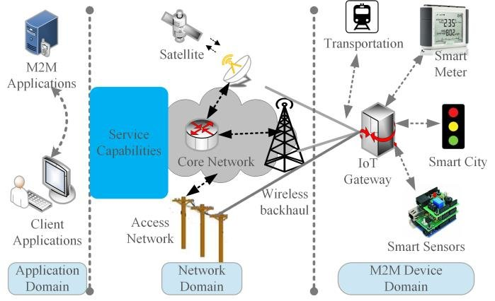

IoT architecture and technologies

The IoT architecture consists of five key layers that define all the functionality of the IoT system. These layers are recognition layer, network layer, middleware layer, application layer and business layer. At the bottom of the IoT architecture is the perception layer, which consists of physical devices. B. Sensors, RFID chips, barcodes, etc. and other physical objects connected to IoT networks. These devices collect information to send to the network layer. The network layer acts as a transmission medium that conveys information from the perceptual layer to the information processing system. Any wired or wireless medium can be used to convey this information, including 3G/4G, Wi-Fi, and Bluetooth. The next layer is called the middleware layer. The main task of this layer is to process information received from the network layer and make decisions based on the results of ubiquitous computing. This processed information is then used by the application layer for global device management. At the top of the architecture is the business layer that controls the entire IoT system, its applications and services. The business layer visualizes information and statistics received from the application layer and further uses this knowledge to plan future goals and strategies. Additionally, IoT architectures can change according to needs and application domains [19, 20, 37]. In addition to the layered framework, an IoT system consists of several functional blocks supporting various IoT activities such as detection mechanisms, authentication and identification, control and management [38]. Figure 6 shows such functional blocks of the IoT architecture.

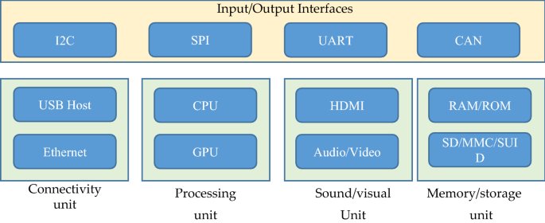
There are several major functional blocks responsible for I/O operations, connectivity issues, processing, audio/video monitoring, and storage management. All these functional blocks together form an efficient IoT system. This is important for optimal performance. Several reference architectures have been proposed along with technical specifications, but they are still far from standard architectures suitable for global IoT [39]. Therefore, no suitable architecture has yet been designed to meet global IoT requirements. The diagram shows the general working structure of an IoT system. 7. Figure 7 shows IoT dependencies on specific application parameters. IoT gateways play an important role in IoT communication as they enable connectivity between her IoT servers and IoT devices for various applications

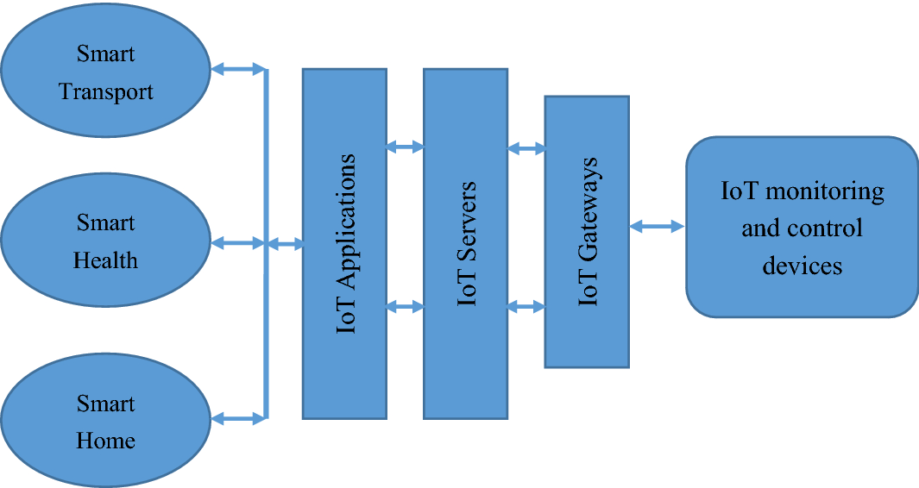

Scalability, modularity, interoperability, and openness are central design themes for efficient IoT architectures in heterogeneous environments. An IoT architecture should be designed to meet the needs of cross-domain interaction, multi-system integration with the potential for simple and scalable manageability, big data analysis and storage, and user-friendly applications. . Also, the architecture should be able to expand functionality and add intelligence and automation to his IoT devices in the system.
Additionally, the increasing amount of data generated by communication between IoT sensors and devices poses new challenges, requiring efficient architectures that can handle large amounts of streaming data in IoT systems. Two popular IoT system architectures are cloud and fog/edge computing, which support processing, monitoring, and analyzing large amounts of data in IoT systems. A modern IoT architecture can therefore be defined as a four-tier architecture.
At Level 1 of the architecture, sensors and actuators play a key role. The real world consists of environments, people, animals, electronic devices, smart vehicles, buildings, etc. Sensors capture these real-world signals and data streams and transform them into data that can be used for further analysis. Moreover, actors can intervene in reality. B. Control the temperature, slow down the car, turn off the music and lights, etc. Stage 1 therefore helps collect real data that may be useful for further analysis. Level 2 is responsible for operating sensors and actuators, gateways and data collection systems. In this phase, the vast amount of data generated in Phase 1 is aggregated and optimized in a structured way suitable for processing. Once a large amount of data is aggregated and structured, it can be passed to Stage 3, Edge Computing. Edge computing can be defined as an open, distributed architecture that enables the use of IoT technologies and vast amounts of computing power from different locations around the world. This is a very powerful approach to streaming data processing, making it suitable for IoT systems. In Stage 3, edge computing technologies process massive amounts of data and provide various capabilities such as visualization, integration of data from other sources, and analysis using machine learning techniques. The final stage includes some important activities such as detailed processing and analysis, sending. Feedback to improve overall system accuracy and precision. Everything in this phase takes place in the cloud his servers or data centers. Big data frameworks like Hadoop and Spark can be leveraged to process this massive streaming data. And machine learning approaches can be used to develop better predictive models that can contribute to more accurate and reliable IoT systems that meet today's needs.

Major key issues and challenges of IoT

With IoT-based systems embedded in every aspect of human life, various technologies related to data transmission between embedded devices have complicated things and created several problems and challenges. These issues have also challenged his IoT developers in a highly smart technology society, and as technology advances, so has the need for his IoT systems, which are both challenging and advanced. Therefore, IoT developers have to think about new problems and provide solutions to them.

One of the most important and challenging issues in IoT is security and privacy due to various threats, cyberattacks, risks and vulnerabilities [41]. Problems leading to device-level data protection are insufficient authorization and authentication, insecure software, firmware, web interfaces, and poor transport layer encryption [42]. From various aspects, security and data protection issues are very important parameters for increasing the reliability of IoT systems [43]. To prevent security threats and attacks, security mechanisms should be built into all layers of the IoT architecture [23]. At each level of the communication channel, multiple protocols have been developed and efficiently deployed to ensure the security and privacy of IoT-based systems [44, 45]. Secure Socket Layer (SSL) and Datagram Transport Layer Security (DTLS) are among the cryptographic protocols implemented between transport and application layers to provide security solutions for various IoT systems [44 ]. However, some IoT applications require another way to secure communication between IoT devices. Additionally, IoT system communications are more vulnerable to security risks when they occur over wireless technology. Therefore, certain methods must be employed to detect malicious actions and enable self-healing or recovery. Privacy, on the other hand, is another major concern that allows users to feel safe and comfortable when using her IoT solution. Therefore, establishing communication between trusted parties requires maintaining authorization and authentication over a secure network [46]. Another issue is that different objects communicating within an IoT system have different privacy policies. Therefore, each object should be able to check the privacy policies of other objects in the IoT system before sending data.

Interoperability/standard issues

Interoperability is the ability to exchange information between different IoT devices and systems. This information exchange is independent of the software and hardware used. Interoperability issues arise because of the heterogeneity of different technologies and solutions used for IoT development. The four levels of interoperability are technical, semantic, syntactic, and organizational [47]. IoT systems offer a variety of interoperability-enhancing features that ensure communication between different objects in heterogeneous environments. Moreover, it is possible to combine different IoT platforms based on their capabilities to provide different solutions for IoT users [48]. Since interoperability is an important issue, researchers have endorsed several solutions, also known as interoperability processing approaches [49]. These solutions may be based on adapters/gateways, virtual networks/overlays, service-oriented architectures, etc. Although the approach to handling interoperability relieves some of the pressure on IoT systems, there are still certain interoperability challenges that may be the subject of future research [25]. ].

Ethics, law and regulatory rights

Another issue for IoT developers is ethical, legal, and regulatory rights. There are certain rules and regulations to uphold standards and moral values ​​and prevent people from violating them. Ethics and law are very similar terms, the only difference being that ethics are standards that people believe in and laws are certain restrictions decided by the government. However, both ethics and law aim to maintain standards and quality and protect people from illegal use. While some real-world problems have been solved by his IoT development, it also raises significant ethical and legal challenges[50]. Data security, privacy, reliability and security, and data usability are some of the challenges. It has also been observed that the majority of IoT users support government norms and regulations on data protection, privacy, and security due to lack of trust in IoT devices. Therefore, this issue needs to be addressed in order to maintain and increase people's confidence in using IoT devices and systems.

Scalability, availability and reliability

Quality of Service (QoS) is another important factor for IoT. QoS can be defined as a measure to evaluate the quality, efficiency and performance of IoT devices, systems and architecture [34]. The important and required QoS metrics for IoT applications are reliability, cost, energy consumption, security, availability and service time [53]. A smarter IoT ecosystem must fulfill the requirements of QoS standards. Also, to ensure the reliability of any IoT service and device, its QoS metrics must be defined first. Further, users may also be able to specifiy their needs and requirements accordingly. Several approaches can be deployed for QoS assessment, however as mentioned by White et al. [54] there is a trade-off between quality factors and approaches. Therefore, good quality models must be deployed to overcome this trade-off. There are certain good quality models available in literature such as ISO/IEC25010 [55] and OASIS-WSQM [56] which can be used to evaluate the approaches used for QoS assessment. These models provides a wide range of quality factors that is quite sufficient for QoS assessment for IoT services. Table 2 summarizes the different studies with respect to IoT key challenges and issues discussed above.

Major IoT applications

A system is scalable if new services, equipment, and devices can be added without impacting system performance. A major problem for IoT is supporting a large number of devices with different memory, processing, storage performance and bandwidth [28]. Another important consideration is availability. Scalability and availability must be provided simultaneously in a layered IoT framework. A good example of scalability is his cloud-based IoT system, which fully supports the expansion of IoT networks by adding new devices, storage and computing power as needed. However, this globally distributed IoT network leads to a new research paradigm for developing frictionless IoT frameworks that meet global needs [51]. Another key challenge is availability of the real object's resources regardless of the location and time of the request. In a decentralized manner, multiple small-scale IoT networks are timely connected to the global IoT platform to leverage its resources and services. Availability is therefore an important concern [52]. Due to the use of various data transmission channels, for example B. satellite communications, the availability of some services and resources may be interrupted. Uninterrupted availability of resources and services therefore requires independent and reliable data transmission channels.

Emerging economy, environmental and health-care

IoT is committed to creating new public and economic benefits and developments for society and people. This includes a wide range of public institutions. B. Economic development, water quality maintenance, welfare, industrialization, etc. Overall, the IoT is striving to achieve the social, health and economic goals of the United Nations Progressive Stage. Another important concern is environmental sustainability. An IoT developer needs to think about the impact that his IoT systems and devices have on the environment in order to overcome the negative effects [48]. Power consumption of IoT devices is one of the pollution-related challenges. The prevalence of internet-enabled services and modern devices is rapidly increasing energy consumption. Research is needed in this area to develop high-quality materials for manufacturing new low-power IoT devices. We can also use green technology to develop efficient and energy-efficient devices for future use. Not only is it environmentally friendly, but it also has a positive impact on human health. Researchers and engineers are working on developing highly efficient his IoT devices for monitoring various health issues such as diabetes, obesity, and depression[57]. There are several studies addressing various issues related to environment, energy and medicine.

Smart city, transport and vehicles

IoT transforms the traditional social structure of society into a high-tech structure with smart city, smart home, intelligent vehicle and transportation concepts. Rapid improvements are being made using assistive technologies such as machine learning and natural language processing to understand the need and use of technology in the home [58]. Various technologies such as cloud server technology and wireless sensor networks that need to be used in conjunction with IoT servers to deploy an efficient smart city. Another important issue is thinking about the environmental aspects of smart cities. Therefore, smart city infrastructure design and planning should also consider energy efficient and green technologies. In addition, smart devices integrated into newly introduced vehicles can detect road congestion and suggest optimal alternative routes to drivers. This will help alleviate urban congestion. In addition, cost-optimized intelligent devices installed in all vehicle classes must be designed to monitor engine operation. IoT is also very effective in keeping vehicles healthy. Self-driving cars may be able to communicate with other self-driving cars using intelligent sensors. This allows traffic to flow more smoothly than human-driven cars, which used to go stop-and-go. It will be some time before this procedure is implemented worldwide. Until then, IoT devices can help by detecting upcoming traffic jams and taking appropriate action. Therefore, the transport company should incorporate his IoT devices into the vehicles it manufactures to benefit society.

Agriculture and industry automation

The growing world population is estimated to reach about 10 billion by 2050. Agriculture plays an important role in our lives. Feeding such a large population requires the evolution of current agricultural approaches. Therefore, agriculture and technology must be combined to improve production in an efficient manner. Greenhouse technology is one of the possible approaches in this direction. Provides a way to control environmental parameters to improve productivity. However, manual control of this technology is ineffective, requires manual effort and expense, and leads to wasted energy and reduced production. As the IoT evolves, smart devices and sensors will make it easier to control the environment inside the chamber and monitor the process, resulting in energy savings and improved production (Figure 9). Industry automation is also an advantage of his IoT. IoT offers breakthrough solutions for factory digitalization, inventory management, quality control, logistics, and supply chain optimization and management.

Importance of big data analytics in IoT

An IoT system consists of various devices and sensors that communicate with each other. With the widespread growth and expansion of IoT networks, the number of these sensors and devices is growing rapidly. These devices communicate with each other and transfer large amounts of data over the Internet. These data volumes are so large that they are streamed every second, hence the name big data. The continued expansion of IoT-based networks raises complex issues of data management and collection, storage and processing, and analysis. The IoT Big Data Smart Building Framework is very helpful in solving various smart building problems, such as: B. Oxygen level control, smoke/noxious gases and brightness measurements [59]. Such frameworks can collect data from sensors installed in buildings and perform data analysis for decision making. Furthermore, IoT-based cyber-physical systems with information analysis and knowledge acquisition techniques can be used to improve industrial production [60]. Traffic congestion is a key issue in smart cities. Real-time traffic information can be collected through his IoT devices and sensors installed in traffic signal systems, and this information can be analyzed in his IoT-based traffic management system [61]. In health analytics, IoT sensors used on patients generate massive amounts of information every second about their health status. To make decisions with high accuracy and speed, this large amount of information must be integrated into databases and processed in real time, and big data technology is the best solution for this task [62]. IoT, together with big data analytics, can also help transform traditional manufacturing approaches into modern ones [63]. Sensor devices produce information that can be analyzed using big data approaches to aid in a variety of decision-making tasks. Additionally, the use of cloud computing and analytics can benefit energy development and conservation while reducing costs and customer satisfaction [64]. IoT devices generate large amounts of streaming data. These data must be effectively stored and further analyzed for real-time decision making. Deep learning is very effective in processing such large amounts of information and can provide highly accurate results [65]. Therefore, the collaboration of IoT, big data analysis and deep learning is very important for the development of high-tech society.

Conclusions

Recent advances in IoT have captured the attention of researchers and developers around the world. IoT developers and researchers work together to extend technology for the greatest benefit to society. However, improvements are only possible when considering various problems and shortcomings of current technical approaches. This research article introduced some issues and challenges that IoT developers need to consider to build improved models. It also covers key IoT application areas for IoT developers and researchers. This is because IoT not only provides services, but also generates vast amounts of data. Therefore, we also discuss the importance of big data analytics that can provide accurate decisions that can be used to design improved IoT systems. Deep learning is a technology that has achieved remarkable success in many research areas. This article presents a systematic review of the literature on the use of when DLing time-series data generated by sensors, the results can be useful in optimizing many industrial processes. Fusion of multimodal sensor data remains a challenging research challengeSuitable for deep learning networks as it can find patterns from raw data and huge amounts of data. In addition, an increasing number of combined approaches have been reported
Predictive model accuracy.Some well-known natural language processing technologies are also used
In predicting time series data such as attentional mechanisms and embeddings Promising results. A combination of CNN and RNN networks (LSTM) is considered a good approach to improve forecasting of time series data. The CNN is used for preprocessing the sensor data and the RNN part is used for processing and retrieval. time pattern. Spatial patterns can also be identified via CNN networks.
Stacked LSTM autoencoders are mentioned for unattended extraction of variables from time series without the need for manual data preprocessing. The challenge in time series forecasting is missing and noisy data.
privacy limitations of datasets, high cost of datasets especially in the medical field,
High computing effort and high demands on his WLAN speed of mobile devices. Applying transfer learning to time series forecasting models is an area that needs to be explored to take advantage of pre-trained models. Other important research themes Time series prediction is learning between time convolution networks and sequences

References

- . Abadi M, Barham P, Chen J, Chen Z, Davis A, Dean J, Devin Ma, Ghemawat S, Irving G, Isard M, et al. Tensorfow: a system for large-scale machine learning. In: 12th {USENIX} Symposium on operating systems design and implementation ({OSDI} 16), 2016; p. 265–283.
- Abdel-Basset M, Hawash H, Chakrabortty RK, Ryan M. Energy-net: a deep learning approach for smart energy management in iot-based smart cities. IEEE Internet of Things J. 2021
- Aggarwal A, Mittal M, Battineni G. Generative adversarial network: an overview of theory and applications. Int J Inf Manag Data Insights. 2021; p. 100004.
- ] N. Homer, S. Szelinger, M. Redman, D. Duggan, W. Tembe, J. Muehling, et al., Resolving individuals contributing trace amounts of DNA to highly complex mixtures using high-density SNP genotyping microarrays, PLoS Genet.
- 4 (2008). [2] R. Wang, Y.F. Li, X.F. Wang, H. Tang, X.Y. Zhou, Learning your identity and disease from research papers. In: formation leaks in genome wide association study, in: CCS ’09 Proceedings of the 16th ACM Conference on Computer and Communications Security, vol. 10, 2009 (1145), 534-544, Chicago, Illinois.
- MAHDAVINEJAD, Mohammad Saeid, et al. Machine learning for Internet of Things data analysis: A survey. Digital Communications and Networks, 2018, vol. 4, no 3, p. 161-175.
- MUANGPRATHUB, Jirapond, et al. IoT and agriculture data analysis for smart farm. Computers and electronics in agriculture, 2019, vol. 156, p. 467-474.
- KIM, Tai-hoon; RAMOS, Carlos; MOHAMMED, Sabah. Smart city and IoT. 2017.
- SAMUEL, S. Sujin Issac. A review of connectivity challenges in IoT-smart home. En 2016 3rd MEC International conference on big data and smart city (ICBDSC). IEEE, 2016. p. 1-4.
- KIM, Yonghee; PARK, Youngju; CHOI, Jeongil. A study on the adoption of IoT smart home service: using Value-based Adoption Model. Total Quality Management & Business Excellence, 2017, vol. 28, no 9-10, p. 1149-1165.
,

