An innovative method of using trash debris to minimize product costs was investigated during an examination of the technological characteristics of a hybrid nano-composite made of an aluminum matrix.

Seshappa A^{1,2}
¹Department of Mechanical Engineering, KG Reddy College of Engineering, and Technology Hyderabad-501514, India.
Email:seshurambollimi@gmail.com

Subbaratnam B³
¹ Malla Reddy Engineering College and Management Sciences
Kistapur, Medchal-501401

Prasanna P²
² Department of Mechanical Engineering, Jawaharlal Nehru Technological University Hyderabad, College of Engineering, Hyderabad-500 085, India.

Naresh Kumar S⁴
⁴Department of Mechanical Engineering, Vardhaman College of Engineering, and Technology Hyderabad-501218, India.

ABSTRACT
Plenty of aluminum composites made of the metal matrix are highly regarded over innovative complementary properties like illumination mass, increased performance, and coefficient of thermal extension, and their actual applications span the aerospace sector, military services, automobiles aerobic activity teaching apparatus, and electronics industries. Aerospace manufacturers make extensive use of the practical Al 7075 alloy for structural mechanism gradual improvement. In this preliminary study, Al-7075 was strengthened using the swirl transmission technique amidst increasing 2, 4, 6, and 8 affect support in terms of privilege to Al₂O₃and 3 affect support in terms of proportional representation of SiC, and of solid waste (PKSA) that was both natural and synthetic. Test specimens for rigidity, the elongation impact, and wear are all set up in line with worldwide norms. After the casting process is complete, Al-HMC may be successfully added to aluminum by a swirl gearbox approach employing up to 8% of silicon carbide and the aluminium oxide residue. This AL-HMC had greater rigidity and tensile strength when Al203 and SiC residues were absorbed into the material. Wear and frictional strength are diminished when AMC deposits of Al₂O₃, SiC, and solid waste (PKSA) accumulate. When the Al₂O₃, SiC, and solid waste (PKSA) percentages in the MMC are drastically raised, the collision intensity fluctuation becomes negligible. Combining the L9 Array with Different DOE Methods This study establishes several WEDM process settings to enhance minimum surface roughness in addition to MRR for Al7075, Al₂O₃, SiC, and solid waste (PKSA). Increases in surface roughness and the percentage of Al₂O₃, SiC, and solid waste (PKSA) pilot must have been independently responsible for the observed decrease in MRR. To produce HMMC of Al 7075 with Al₂O₃, SiC, and solid waste (PKSA) at different weight percentages, the study's results were utilized to choose the quickest as well as most accurate WEDM Process settings.

Key words-HMMC, SEM, WEDM, and L9 Array, Swirl Transmits Method, Wear

INTRODUCTION

Metal Matrix Composite
In addition to combining and acquiring attractive different items like ceramics and metals, propose extending into naughty materials such as metal matrix composite assets. An stronger Exact value of robust component parts underneath manufacturing metal matrix conception structure containing elements accelerated materials survives within the center of ceramic and matrix alloy reinforcement when the two are used together. Materials were selected for their useful properties, such as increased efficiency, the ability to bend under pressure and heat, but sometimes encapsulating less stiffness, and the existence of rigid in addition to resistant, while sensitive, in certain ceramics. In terms of mechanical properties, aluminium, and silicon carbide couldn't be more different. Their respective Young's modules are 70 GPa and 400 GPa, while their respective coefficients of thermal expansion are 24 106/°C and 35 600 MPa. Were metal matrix composites T6 conditioned A-6061/SiC/17p by adequate yielding performance as well as 510 MPa of Young's modulus values, and 96.6 GPa retained as a consequence of integrating listed ingredients[1]. These qualities have the potential to be enhanced further via an increased comprehension of the structure of the comparative quantity and the allocation regarding each element for a compound as well as the circumstances of dispensation. A WEDM technique is single for several mechanisms practises. It is one of the most flexible approaches for complex as well as intricate geometries, and it is the best suited manufacturing practices with difficulty structures made of compound resources. Though, while a result for the dedications of researchers into categorise an variety of MMC via the process of WEDM, very petite laborious occupation have be completed[2]. The tool materials used in WEDM procedures were repeatedly constructed with copper , brass, and the cable thickness range anywhere between 0.1-0.25mm. Although there's no physical interaction across the workpieces-work while the wire's tool during this process, flashes where still produced among an substance of its workpieces along with an cutting wire as a tool for assistance of dielectric liquid. These sparks were constantly provided throughout those machinery operating location, also its operation of manufacturing takes finished because of the high spark generation [3,4]. manufacturing period , present be rejection stress nor resistance formed among that wire and substance objects because of the way the process is designed. The production of tools gauges, and dies, and fixtures often makes use of this process. There are a lot of extremely complicated process parameters involved in wire EDM, and they all rely lying on its substance, this dielectric fluid, and how well the machining is going. Because even little changes may have a significant impact on machining performance, the task of selecting the appropriate progression consideration outline are, MRR, and Ra can be challenging for a research scholar or an engineer [4]. examine the distinct characteristics of materials, such as High Modulus Matrix Composites (HMMCs), in relation to their suitability for component manufacturing using electrical discharge machining. Furthermore, the investigation seeks near conclude its authority for various machining constraints into achieving a superior surface quality over a large surface area [5] discuss the characteristics of composite materials consisting of multiple phases, particularly focusing on the elongated structure of certain phases. Additionally, it highlights the influence of weight fraction or volume ratios on the composite materials, where the presence of reinforced hard materials within the matrix can either enhance the toughness or weaken the composites. These effects are dependent into capacity also excellence for metal matrix composites [6]. availability and affordability of particulate reinforcements are notable advantages. The inclusion of a cast, specifically, seems the necessary element during enhancing an functionality of MMC and a present area. spending diminutions let is attained with an employ for commercial measures like enhancing the component parts at a lower cost, using streamlined multipart manufacturing processes, and leveraging increased automation capabilities. The selection of stir casting as the preferred method has been made. Particulate reinforcements exhibit a lower cost and greater availability. Stir casting has been identified as a very cost-effective processing technology [7].
The industry is experiencing significant demand for innovative geometric product designs and machining of hard materials. This is particularly driven by the introduction of automation for the modernization of existing processes and the increasing demands of new industries. These industries prioritise high productivity and quality of elements, while simultaneously aiming to reduce processing time and costs. Consequently, enhancing an manufacturing characteristics from an designated MMCs for an certain component is of utmost importance, along with achieving a high level of surface smoothness and overall excellence [8].

Matrix-Metal-Aluminum-Stand-Alone Composite
Alloys associated with aluminium have constantly established themselves as the preferred metal matrix material (MMM) with in progression for metal matrix composites. The development was essentially distinguished by its extensive selection of high-end residences, offered at a cost that is deemed affordable and commensurate with market standards. Several attractive characteristics of AMMCs consist of heightened specific rigidity also potency, improved elevated thermal characteristics (in comparison into hard constituents), among a specified heat capacity and thermal expansion. A AMMCs have been utilized within various manufacturing like electronic warm up sinks, engineered for use in aeronautical systems and astronomical receiver reflectors, sheet layers, automotive propel splash fins, and components for explosion condensation element, also Pressured fuel engines. These composites possess versatile properties that make them suitable have an extensive variety regarding relevance. The majority from employment reports within an field of journalism have mostly centred lying on Al also Al many elements, including Al-7075, Al-6061, A-357, A-359, Al-2618, and Al-2214. Chart 1 presents the spectrometric assessments for the Al 7075 effort substance conducted in an current study. The increasing likelihood of heightened exposure and economic detriment resulting from the use of Aluminium Metal Matrix Composites using Al-7075 while an template has spurred ongoing investigate efforts. This process for manufacturing required the incorporation of reinforcing materials keen on a matrix material, which included an liquefy for an compound. An very elevated heat have necessary of its approach. swirl cast technique has been widely used traditional manufacturing technique that exhibits typical versatility, making it particularly well-suited with an manufacture for AMMCs. Figure 1 illustrates the configuration of the stir-casting setup, including the implementation of a stirring rod, and the selection for SS from the rotary material, attributed into AMMCs improved thermal stability at high temperatures [9, 10].

Table. 1. Spectroscopic analysis of Al-7075 alloy composition
constituent | Cr | Cu | Fe | Mg | Mn | Si | Zn | Ti | Al
substance | 0.8 | 1.35 | 0.3 | 2.21 | 0.08 | 0.4 | 5.67 | 0.06 | Bal.

Swir Casting Technique
A detachable stage (little fibers, porcelain materials) is combined by turn to liquid-defined existing conditions metals with motorised magnificence in the process of swirl casting, which is a technique of manufacturing amalgamated materials that takes place in a liquor state. Whenever a liquid amalgamated substance of MMC is communicated, it is possible that is could also represent taken out of action by a talent for making metal that is predictable. In the following facial look, Swirl Casting stands out as a unique option. In the convenience of detached segment live, there is a possibility of non-absolutely standardised homogenous combination of transmission (30% in conditions of quantity various occasion take away their an specified significance). The resultant mixture now has vapour filaments that are quite thin. There is a potential for there to be major separation extraordinary for an removable subdivision during an distinction brought through an attentiveness for a mold subdivision also position separately. One example of a motorised blender that may be utilized with the twirl cast technique represent in image 1. This technique was really effortless also does not cost too much.
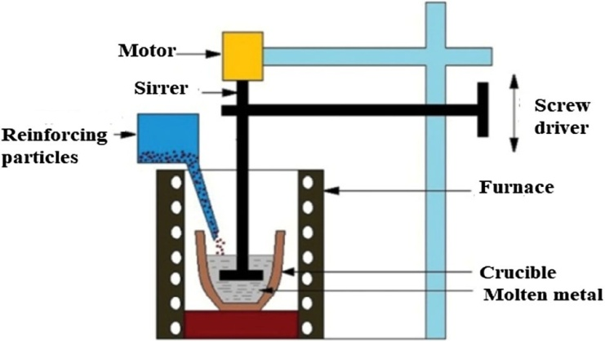
Fig.1. Spiral mould preparation

METHODS AND PROCEDURES
Detailed investigation employed an swirl casting technique to craft a composite substance, central to the study. Specifically, the study utilized an Al 7075 matrix material, which served as the foundation. This matrix material was fortified with reinforcing components, including silicon carbide boasting a granule size of 200 lattices. This additive amalgamation also featured aluminum oxide, contributing fine-grained solid debris known as PSPK. The process entailed several steps. Initially, casting took place, producing a base material with the desired properties. Subsequently, machining transpired on a Wire Electrical Discharge Machining (WEDM) platform, using a 0.25 mm dimension bronze thread for an main cutting component. This machining process led to the creation for MMCs into an dimensions of 100 x 100 x 10 mm, accomplished through the intricate stir casting method.
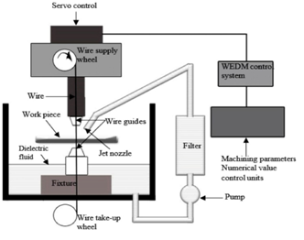
Figure: 2 Wedm Set Up
The innovative aspect of this process lay in the choice of dielectric medium employed to stimulate the sparking phenomenon between the tool and the workpieces. In this scenario, water served as the dielectric medium. This selection introduced a unique element to the machining equation, enhancing the precision and effectiveness of the WEDM process. For a clearer understanding of the setup, Figure 2 provides a schematic representation of the WEDM arrangement. This diagram elucidates the positioning and interaction of the components, shedding light on the intricacies of the process. In conclusion, the swirl casting method, paired with the strategic selection of materials and processes, facilitated the creation of intricate MMCs with noteworthy dimensions and properties.
Table 2 lists all the different variables that may be adjusted throughout the process; from there, we'll use a experimental design (DOE) using a L9 orthogonal array to tweak the other four variables, pulse-off time included. Nanoscale components are cut, and the sample pieces' surfaces are then honed using emery paper of varied grits to get the desired effect. Using disc polishing equipment, we were able to obtain a mirror quality on both an specimen and an alumina postponement among rubbing material. Microstructures are created via optical and scanning electron microscopes (SEMs). Samples of composites may be etched using Keller's reagent. After microstructure images have been collected, the samples are subjected to a Vickers hardness test using a 50-gram weight to determine the level of toughness. The smoothness of the EDM-machined exterior was measured using a Mitutoyo surface area measurement smoothness instrument[11, 12].
Table. 2. Defining the WEDM Procedures
Levels | Process parameters
 | Pulse on Time-TON | Pulse OFF Time-TOFF | Voltage Gap-V | Wire Feed Rate-F
1 | 5 | 9 | 55 | 6
2 | 7 | 7 | 75 | 8
3 | 9 | 5 | 95 | 10

OUTCOME AND DISCUSSIONS

Hardness Test
Employing the swirl casting method, the hardness of Aluminum Matrix Metal Composite (ALMMC) was augmented by introducing Al₂O₃/SiC/PKSA at weight percentages of 2-4%, 4-6%, and 6-8%. The resultant composite's collective hardness distribution is elucidated in Figure 3.a, presenting a clear depiction of hardness changes across different reinforcement concentrations. Notably, the graph unmistakably showcases a substantial upsurge in hardness corresponding to higher Al₂O₃ and SiC solid waste of PKSA contents in the composite. This experiment underscores the effectiveness of the swirl casting technique in tailoring material properties by manipulating reinforcement levels, consequently influencing the mechanical performance of the ALMMC.
Table 3. Elastic strength, toughness, crash, and degradation data
examples | Toughness- VHN | Elastic Strength (Mpa) | Crash Test  (J) | Degradation Rate
Al-7075,Al₂O₃/SiC/PKSA of 2% | 178 | 194 | 2.8 | 410
Al-7075, Al₂O₃/SiC/PKSA of 4% | 184 | 224 | 4.2 | 400
Al-7075, Al₂O₃/SiC/PKSA of 6% | 192 | 310 | 5.6 | 312
Al-7075, Al₂O₃/SiC/PKSA of 8% | 199 | 340 | 9.6 | 288

Tensile Test
Tensile tests are carried out laying taking place the tensometer, through 2,4,6, and 8 wt% Al₂O₃/SiC/PKSA strengthening within an compound. The outcomes for these investigations data shown with table 3, resulting in presents the results of the tests in the standard form. It would seem that the addition of weight fraction Al₂O₃/SiC/PKSA to AMMCs for an reason for reinforcing the addition for weight fraction Al₂O₃/SiC/PKSA also results in an improvement in the material's tensile strength. Figure 3.b demonstrates the potential for an enhancement to be made that will result in an increased add for Al₂O₃/SiC/PKSA weight percent within an matrix.

Impact or Crash Examine
Figure.3.c, indicates with the intention of when a produced composite toughness of the material improves, so does the weight % with strengthening's like Al₂O₃/SiC/PKSA. In this research endeavour, we introduced 8 weight percent of Al₂O₃/SiC/PKSA, which exhibits strong crash potency with in an AMMCs. condition more strengthening's are put within the AMMCs by employing stir casting method, This consist of through an intention for boosting an composite material's hardiness. This fact that a fractured test specimen passed both the Izod and the tensile tests lends credence to the ductile nature of the break. The variation in specimen toughness that results from changing an wt% for Al₂O₃/SiC/PKSA with in compound.

Wear Test
Wear testing is performed on the chosen or sample specimens by means of a pin on disc test arrangement. The results of an testing are recorded. In figure 3.d, a larger degree of decrease occurs when a lower wt% of Al₂O₃/SiC/PKSA is incorporated to Al-7075 while strengthening's. On the other hand, a lower wear rate occurs when a higher wt% throughout Al₂O₃/SiC/PKSA is incorporated to Al-7075 while strengthening's. This is due to the fact that a weight percent of graphite contains a self-lubricating feature.

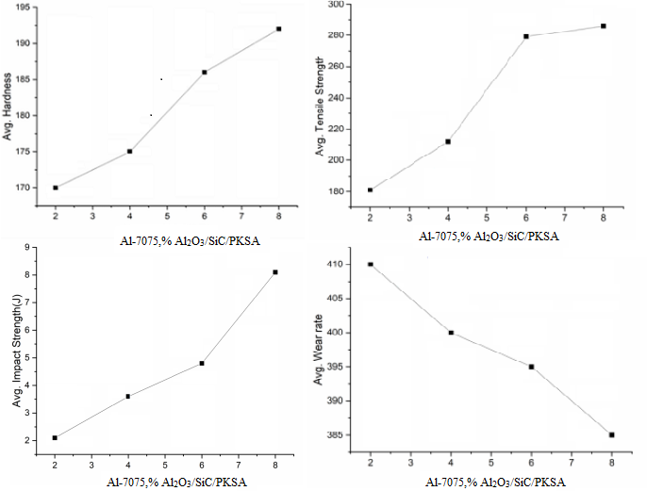

Figure.3.(a) Hardness v/s. Al₂O₃/SiC/PKSA wt. (B) Tensile Strength v/s Al₂O₃/SiC/PKSA wt %
(C) Impact Strength v/s Al₂O₃/SiC/PKSA wt% (D). Wear v/s wt% Al₂O₃/SiC/PSPK Wt %

Manufacturing variables affect effectiveness
Table 4 displays source process settings along with the MRR & Ra experimentation findings, which can be found here. The work being done right now is responsible for controlling 4 consideration are Voltage Gap, Pulse On Time, Pulse Off Time, and Wire feed Rate. All through the process of accuracy manufacturing, the performance of the machine was affected by a variety of process parameters. The values that may be assigned to each parameter fall into one of many predetermined categories[13,14].
Table. 4. Process variables and the interactions with MRR and Ra were investigated.
Ex. No | Input Process variables |  |  |  | Output Response of MRR(mm3/min) |  |  |  | Surface roughness, Ra
 | Pulse on Time | Pulse off Time | Voltage Gap | Wire Feed Rate | Al-7075,  2%  Al₂O₃  /SiC  /PKSA | Al-7075,  4%  Al₂O₃  /SiC  /PKSA | Al-7075,  6%  Al₂O₃  /SiC  /PKSA | Al-7075,  8%  Al₂O₃  /SiC  /PKSA | Al-7075,  2%  Al₂O₃  /SiC  /PKSA | Al-7075,  4%  Al₂O₃  /SiC  /PKSA | Al-7075,  6%  Al₂O₃  /SiC  /PKSA | Al-7075,  8%  Al₂O₃  /SiC  /PKSA
1 | 5 | 9 | 55 | 6 | 24.52 | 23.98 | 24.15 | 25.85 | 0.62 | 0.98 | 1.65 | 1.69
2 | 5 | 7 | 75 | 8 | 18.12 | 20.24 | 21.72 | 21.98 | 1.32 | 1.62 | 1.71 | 1.82
3 | 5 | 5 | 95 | 10 | 16.28 | 20.52 | 17.68 | 17.96 | 1.41 | 1.62 | 1.44 | 1.48
4 | 7 | 9 | 75 | 10 | 19.12 | 22.45 | 21.23 | 21.85 | 1.62 | 1.32 | 1.65 | 1.85
5 | 7 | 7 | 95 | 6 | 18.58 | 16.25 | 14.56 | 14.92 | 1.12 | 1.22 | 1.56 | 1.67
6 | 7 | 5 | 55 | 8 | 33.24 | 28.21 | 21.28 | 21.62 | 1.25 | 1.76 | 1.75 | 1.85
7 | 9 | 9 | 95 | 8 | 18.54 | 21.15 | 15.28 | 15.21 | 1.44 | 1.68 | 1.85 | 1.92
8 | 9 | 7 | 55 | 6 | 29.51 | 28.04 | 22.38 | 22.68 | 0.94 | 1.52 | 1.18 | 1.38
9 | 9 | 5 | 75 | 10 | 19.02 | 21.45 | 21.12 | 21.54 | 1.02 | 1.12 | 1.32 | 1.62

Material Removal Rate (MRR)
As indicated in Fig. 4a-d, the standard Material Removal Rate (MRR) investigational significances caption towards existence are 20.97, 20.87, 18.70, and 18.15 mm³/min, respectively. The average Material Removal Rate (MRR) with an Al-7075 metal matrix composites is virtually starting inside an maintains with 2,4,6, and 8 % of wt% Al₂O₃/SiC/PSPK. In metal matrix composites (MMCs), it was revealed that lowering the material removal rate (MRR) may be accomplished by increasing the weight proportion with Al₂O₃/SiC/PKSA. The MRR has the ability to soften the Al₂O₃/SiC/PKSA particles found within the MMCs. Reinforcements and Al₂O₃ both contribute to a reduction in MRR because to their high heat conductivity and stiffness, respectively. According to the findings of this study, MRR valves may often be recognised by the enhance with Pulse on Time. This is because of the enhance with pulse-on time indicates that a spark has occurred during an wire electric discharge machining variables. superior pulse on time deals with ejections, pulse during increases in deliberation, and the development of deep deprived position taking place specimen substance to superior substance[15,16].
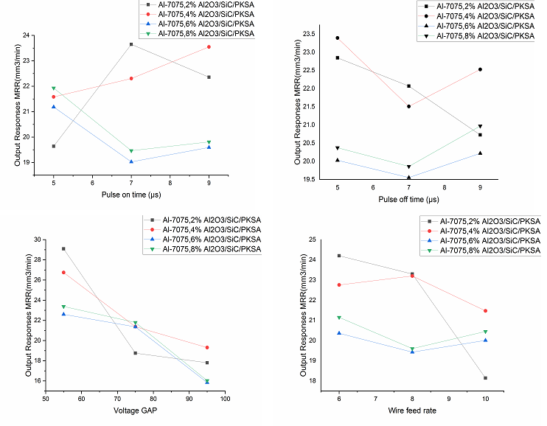
Fig. 4. Graphs Showing the Effect of Material Subtraction

Surface Roughness-Ra
Figure.5 a-d displays an exit variables during an surface roughness study conducted on Al-7075 through Al₂O₃/SiC/PKSA. These responses are comprised from 2,4,6, and 8% weight with an reinforcing constituent part, respectively. An level on the whole surface roughness represents in figures 5a through 5d. As can be observed in figures 5a-d, the surface roughness has an average value of 1.31µm. Detailed surface roughness significances exits improved by using an appropriate amount with Al-7075 in conjunction with 2,4,6, and 8% wt of Al2O3/SiC/PKSA. The resulting PKSA values for these values represents 1.21, 1.28,1.32, and 1.42µm. When can be experimental into figures 5a through 5d, an weight percentage with strengthening exits growing during metal matrix composites( MMCs). This was found that the surface roughness was becoming rougher over time as a direct consequence of the inclusion of hard particles in MMCs as a reinforcement. Because of the spark that was created when the tool and the work components came into contact with one another during an wire electric discharge machining variables, this becomes in addition revealed its surface roughness reduced as the pulse-on time was increased. Surface roughness will rise proportionally with an increase in the pulse-off time. Ejections may be controlled with a longer pulse-on time. pulse through provides deep lowest point on the work components concentration creates increases material likewise higher[17].

Microstructure and SEM Examination
The relationship strengthens sections distribution with Al₂O₃/SiC/PKSA is shown in Figure 6 (a-d), along with its qualities that are associated within the direction that the scanning electron microscope (SEM) aids. Since the Al₂O₃/SiC/PKSA section allocation were consistent across an investigation samples, the SEM parallels may be understood without a problem. Using an electron beam with a high intensity and a raster scan pattern, investigate the specimen's microstructure at the location where the tensile test piece broke. 6th picture, the microstructure of a, b, and c demonstrates strengthening in the matrix the microstructure by using the optical microscope to achieve magnifications of 300 X reveals for higher dispersion. The number of reinforcement particles rises as the wt% with Al₂O₃/SiC/PKSA in the matrix increases, while the amount of space between the reinforcement particles decreases. In agglomerations of certain Al₂O₃/SiC/PKSA Al matrices, the existence of a refusal sign may be uncovered.
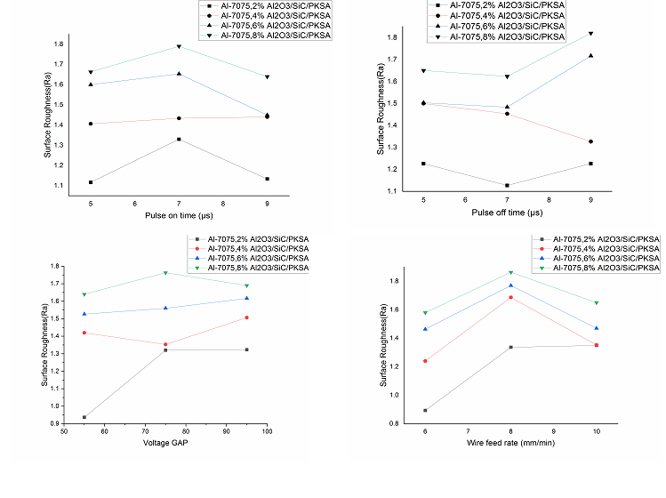
Fig. 5. Graphs of the Reaction to Surface Roughness
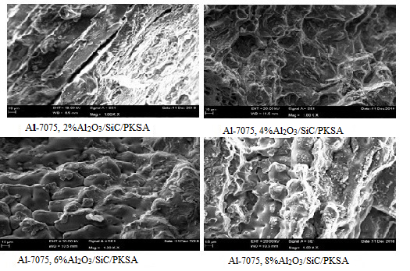
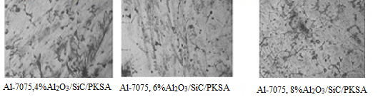
Fig. 6. SEM and Microstructure

CONCLUSIONS
Wire cut electric discharge machining was used to analyse Al-7075/Al2O3/SiC/PKSA that was generated using the liquid-state technique with 2%, 4%, 6%, and 8% weight. Material Removal Rate and Surface Roughness were also taken into consideration during this investigation. The observations have been summed up and are provided below.
- In order to manufacture the Al-7075/Al₂O₃/SiC/PKSA MMCs in a manner that is both efficient and cost-effective, a typical stir casting method is used.
- Compound specimen comprised of Al-7075/Al₂O₃/SiC/PKSA showed with greater hardness value while compare into non reinforced Al-7075 in terms with the comparison.
- The SEM and microstructure data indicated that Al2O3/SiC/PKSA particles were distributed in a regular manner across the Al-7075.
- The pulse-off time with the voltage gap between the tool and the workpieces is the basic machining variables for the MRR trail through wire feed. This is the minimum valve required for this process.
- In addition to the Al2O3/SiC/PKSA reinforcements that are included in Al-7075, the pace at which material is being removed is steadily reducing.
- Since WEDM is able to machine composite materials that are difficult to cut, the percentage of reinforcements in Al-7075 rises with increasing surface roughness of the valve, however the percentage of reinforcements in MMCs remains unchanged regardless of material removal rate.

REFERENCES

- Introduction to Composite Materials, F.C. Campbell, Structural Composite Materials http://machinedesign.com/article/metal-matrix-composites-1115, Nov- 15, 2010
- Pradeep K. Rohatgi (1993) Metal-matrix Composites, Defence Science Journal, Vol 43(4) , pp 323-349.
- N.G. Patil, P.K. Brahmankar, D.G. Thakur, On the effects of wire electrode and ceramic volume fraction in wire electrical discharge machining of ceramic particulate reinforced aluminum matrix composites. Proceedings CIRP 42, 286–291 (2016)
- J. Zhao, J.C. Jie, C. Fei, C. Hang, T. Li, Z. Cao, Effect of immersion Ni plating on interface microstructure and mechanical properties of Al/Cu bimetal. Trans. Nonferrous Met. Soc. China 24, 1659–1665 (2014)
- H.K. Garg, K. Verma, A. Manna, R. Kumar, Hybrid Metal Matrix Composites and a further improvement in their machinability—a review. Int. J. Latest Res. Sci. Technol. 1(1), 36–44 (2012)
- K.B. Vijay, S. Dharminder, S. Puneet, Research work on composite epoxy matrix and Ep polyester-reinforced material. Int. J. Eng. Res. Technol. 2(1), 1–20 (2013)
- B.S. Yigezu, P.K. Jha, M.M. Mahapatra, The key attributes of synthesizing ceramic particulate reinforced Al-based matrix composites through stir casting process: a review. Mater. Manuf. Processes 28(9), 969–979 (2013)
- Y.C. Shin, C. Dandekar, in Mechanics and modeling of Chip Formation in Machining of MMC, ed. by J.P. Davim, Machining of Metal Matrix Composites (Springer-Verlag London Limited, 2012) https://doi.org/10.1007/978-0-85729-938-3-1
- B.C. Kandpala, J. Kumar, H. Singh, Machining of aluminum metal matrix composites with electrical discharge machining—a review. Mater. Today Proc. 2, 1665–1671 (2015)
- A. Kumar, D.K. Bagal, K.P. Maity, Numerical modeling of wire electrical discharge machining of super alloy Inconel 718. Proc. Eng. 97, 1512–1523 (2014)
- S. Prashanth, R.B. Veeresha, S.M. Shashidhara, U.S. Mallikarjun, A.G. Shiva siddaramaiah, A study on machining characteristics of Al6061-SiC metal matrix composite through wire—cut electro discharge machining. Mater. Today Proc. 4(10), 10779–10785 (2017)
- Y. Pachaury, P. Tandon, An overview of electric discharge machining of ceramics and ceramic-based composites. J. Manuf. Process. 25, 369–390 (2017)
- S. Mohanty, B.C. Routara, A review on machining of metal matrix composites using nano-particle mixed dielectric in electro- discharge machining. Int. J. Automot. Mech. Eng. 13(2), 3518–3539 (2016)
- G. Talla, D.K. Sahoo, S. Gangopadhyay, C.K. Biswas, Modeling and multi-objective optimization of powder mixed electric dis- charge machining process of aluminum/alumina metal matrix composite. Eng. Sci. Technol. Int. J. 18, 369–373 (2015)
- P. Sivaprakasam, P. Hariharan, S. Gowri, Optimization of micro- WEDM process of aluminum matrix composite (A413-B4C): a response surface approach. Mater. Manuf. Process. 28, 1340–1347 (2013)
- P. Shandilya, P.K. Jain, N.K. Jain, Prediction of surface rough- ness during wire electrical discharge machining of SiCp/6061 Al metal matrix composite. Int. J. Ind. Syst. Eng. 12(3), 301–315 (2012)
- H. Singh, H. Kumar, Review on wire electrical discharge machining (WEDM) of aluminum matrix composites. Int. J. Mech. Product. Eng., ISSN: 2320-2092 3(10) (2015).
- Michael Oluwatosin Bodunrin, Kenneth Kanayo, Alaneme Lesley Heath Chown(2015), Aluminium matrix hybrid composites: a review of reinforcement philosophies; mechanical, corrosion and tribological characteristics, Journal of materials research and technology, vol 4(4) Dec 2015, pp 434-445.
- H. Warren, Hunt, Darrell R. Herling (2004), Text book, Aluminium Metal Matrix Composites, Advanced Materials and Processes http://www.science.org.au/nova/059/059key.htm
- Yoshiro.Iwai, Hidetomo.Yonede, and Tomomi.Honda, (1995), “Sliding wear behaviour of SiC whisker reinforced aluminum composite”, wear 181-183, pp.594-602.
- Rupa Dasgupta (2010) The Stretch, Limit and Path Forward for Particle Rein-forced Metal Matrix Composites of 7075 Al-Alloys. Scientific research Engineering, vol 2, pp 237-256
- Zeynep TAŞLIÇUKUR, Gözde S. ALTUĞ, Şeyda POLAT (2012) “Characterization of microstructure and fracture behavior of GG20 and GG25 cast iron materials used in valves” metal vol 5 pp 23-25
- Sidney H.Avner. (1986); Introduction to physical metallurgy, McGraw-Hill.]
- N. Mahathaninwonga, T. Plookphola, J. Wannasina, S. Wisutmethangoonb(2012) T6 heat reatment of rheocasting 7075 Al alloy ,Materials Science and Engineering Volume 532, Pages 91–99]
- S.M. Bayazida, , , H. Farhangia, H. Asgharzadehb, L. Radanc, A. Ghahramania, A. Mirhajib Effect of cyclic solution treatment on microstructure and mechanical properties of friction stir welded 7075 Al alloy , Materials Science and Engineering, Volume 649, Pages 293–300
- Siavash gholami, esmaeil emadoddin, mohammad tajally, ehsan borhani(2015) Friction stir processing of 7075 Al alloy and subsequent aging treatment , Transactions of Nonferrous Metals Society of China, Volume 25(9) Pages 2847–2855
- Jin-feng l, zhuo-wei peng, chao-xing li, zhi-qiang jia, wenjing chen zi-qiao zheng (2008) Mechanical properties, corrosion behaviors and microstructures of 7075 aluminium alloy with various aging treatments ,Transactions of Non-ferrous Metals Society of China, Volume 18(4), Pages 755–762.

