Introduction:
Human beings have suffered from painful injuries from time immemorial. Since then, he has constantly strived hard to find some method of treating himself. We will never know with certainty the time when an early homosapien first adjusted a fracture dislocation. Perhaps it happened in the previous Stone Age that a broken extremity was splinted with wood or bamboo sticks embedded in clay that was allowed to harden.
In the era of increasing auto mobilization, industrialization, and technologies, the treatment of maxillofacial injuries has attained a prominent position. Road traffic accidents, which are becoming more and more frequent, particularly have brought about an increase in maxillofacial injuries. The head is the prominent part of the body and has the highest injury rate in the entire body. Other causes of facial injuries include personal injury, falls, sports, and trauma¹. If left untreated or treated incorrectly, fractures can cause many damages such as functional, aesthetic, neurological and psychological.
Although fracture is a difficult term to define, it can be defined as "the disruption of bone continuity due to stress exceeding its elastic modulus, resulting in two or more fractures." The main goal of orthopedic surgery is to improve aesthetics and function, as well as to predict the body's recovery from previous injury. Treatment strategies for maxillary fractures have evolved over the past several decades. These procedures include reduction with maxillomandibular fixation (MMF), open reduction with metal osteosynthesis, open reduction with rigid internal fixation, or adaptive miniplate fixation².
The treatment of mandibular fractures has disadvantages such as failure to achieve reduction and stabilization, poor patient performance, malnutrition, and depression difficulty maintaining oral hygiene and losing weight. It also has effects such as muscular dystrophy, secondary changes in the TMJ, and airway obstruction, with a rate of approximately 40%³.
Open reduction and internal fixation (ORIF) of the mandible with bone plates was first described by Schede in 1888. Those who use plates and screws. Rigid immobilization using plate compression shortens the duration of MMF and restores maxillomandibular function⁴.
Over the years, many plate and screw osteosynthesis techniques have been introduced, such as the AO bicortical late system; 2D mini plate system, absorbable plate and screws, 3D mini plate system and locking mini plate system. Research continues to focus on the size, shape, quantity, and biomechanics of plates/ screws/ systems to improve surgical outcomes. Miniplate osteosynthesis, first proposed by Michelet⁴ in 1973 and further developed by Champy in 1976, is today’s the standard in the care of mandibular fractures. Champy describes the best bones to plate to prevent twisting. The main benefits of this method include eliminating the disadvantages associated with the IMF. A relative disadvantage of traditional plate/screw technology is that the plate must fit the underlying bone perfectly and accurately to prevent segmental and screw alignment changes⁵. Changes in occlusal relationship⁵. As the screw is tightened, the screw head presses the plate against the bone, ensuring the stability of the bone.
The introduction of the 3D system provides and continues to guarantee the treatment of lower jaw fractures. Advantages over other coating methods. These plates work in fixators, providing stability through a 3-dimensional plate. Titanium has proven to be suitable as an implant material for bone plates due to its excellent biocompatibility and corrosion resistance. Titanium is a hardened metal that produces a thick, consistent passivating oxide product that prevents it from penetrating surrounding tissue⁶. From a biomechanical perspective, titanium has high tensile strength and low elastic modulus. Titanium has an elastic modulus approximately half that of stainless steel, so there is less risk of stress resistance in bones⁷.

History:
Hippocrates (460 to 375 B.C.) "Father of Medicine" was the first to describe the basic principles of modern fracture repair, reduction, and stabilization. He described direct re-approximation of the fracture segments with the use of circum dental wires. He also advocated wiring of the adjacent teeth and external bandaging to immobilize the fracture. He had the insight to realize that re-approximation and immobilization are paramount in the treatment of fractures⁸.
Salerno (1180) from Italy described the importance of establishing a proper occlusion.
Guglielmo Salicetti (1492), in his book Cyrurgia introduced the theory of maxillomandibular fixation by stating that 'tie the teeth of the uninjured jaw to the teeth of the injured jaw'.
Gilmer (1881) described the use of two heavy rods placed on either side of the fracture that were wired together. In the middle of the nine-tenth century, Buck, using an iron loop, and Kinlock using a silver wire, treated maxillomandibular fractures with an open reduction⁴.
Hansmann (1886) was the first to develop and present a procedure for the subcutaneous fixation of bone fragments with a plate screw system. He is, therefore, the inventor of plate osteosynthesis. Up to 1886, Hansmann had treated 21 bone fractures and pseudo-arthrosis with this method. Two of these were mandibular fractures making him the first to perform plate osteosynthesis on the mandible. In 1888, Schede (Circa) is credited with the first use of a true bone plate made of steel and secured with 4 screws.^{9,4}
Niederdellmann and Schilli (1972, 1973) modified the plates which possessed two holes located close to the fracture gap for screws to build up axial pressure. Two more holes were angled at 450 to exert compression at the alveolar ridge (Niederdellmann and Akuamoa-Boateng, 1978): once the screws were inserted, the eccentric position of the holes led to compression at the alveolar ridge, the site where tensile stress occurs. For that reason, the plate was named EDCP meaning Eccentric DCP¹⁰.
Champy et al. (1975) modified this method to make it clinically more applicable (Champy and Lodde, 1976, 1977; Champy, 1983, 1992). Various experimental tests with two-dimensional models helped to analyze the bio-dynamics. As soon as tensile stress occurred on the plate which was fixed to the alveolar ridge, a corresponding pressure built up at the base of the tested mandible. This caused an increase in dynamic compression and stability. The dimensions of the plates could be kept small as the mini plates only had to cope with tensile stress. These studies helped to find an ideal line for osteosynthesise a line of maximum tensile stress running from the oblique line along the base of the alveolar ridge to the mental foramen. Here one single miniplate should be sufficient. Additional torque in the region between these foramina required a second (more basal) plate. Originally; these plates were made of stainless steel which was later changed to titanium generally¹⁰.
Edward Ellis (1993) In his retrospective study of mandibular angle fractures that were treated by extra-oral open reduction and internal fixation using the AO reconstruction plate showed that a stronger bone plate with more screws on each side of the fracture can be used without compression to restore the functional integrity to the fractured mandible and was associated with a low rate of post-operative infection and malocclusion⁶.
Nicholas Zachariades, (1996) described that Lag screw osteosynthesis is a form of compression osteosynthesis in which the bone fragments are bound to one another under pressure as a result of traction from the screw. Compared with compression osteosynthesis with bone plates, it is easier to apply because the task of adapting a bone plate is eliminated, it costs less and requires limited surgical exposure and less implant material¹¹.
R. Gutwald (2010) has done a study to compare a combination of locking systems with self-tapping or self-drilling-trapping screws with a combination of conventional mini plates with self-trapping and self-forming screws. He concluded that the improved stability of the osteosynthesis with the ST-L system resulted in early ossification of the osteotomy gap and the smallest amount of callus formation¹²
At the outset of plating for maxillomandibular fractures, there were two schools, one advocating compression and the other one just stability. Miniplate osteosynthesis has changed fracture treatment and has become a valuable option during the last two decades. Advantages are the simple application via an intra-oral approach, no need to expose much bone, and the ease of adapting the plates (sometimes unnecessary) to the surface of the bone. Although over 100 years old, plate osteosynthesis is a focus of research interest in regenerative medicine.

About Metal
Metals for maxillofacial surgery may require specific characteristics and mechanical properties. These include tensile strength, shear stress, elasticity, and yield strength (Table 1). The first introduced metals were vitallium (an alloy of cobalt, chromium, and molybdenum) gold, and stainless steel¹⁴. However, these metals were proved to be problematic because of corrosion and poor handling properties. Thus, in 1967 the use of titanium was introduced and revolutionized the field of maxillofacial reconstruction¹⁵. In the following sections, we will examine the use of each of these metals in maxillofacial surgery (Table 2).
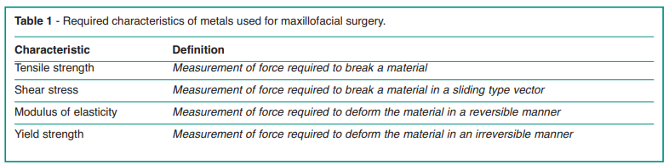
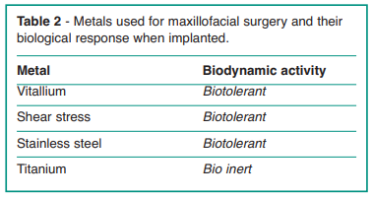

Titanium
Titanium exhibits mechanical properties desirable for internal rigid fixation, and, when combined with its degree of biocompatibility¹⁵, makes it a favorable material for fixation. For these reasons, and to overcome the defects of the other metals previously used, titanium has become the standard gold for the reconstruction of the maxillofacial skeleton¹⁶. Titanium has been used successfully as an implant material and this success with titanium implants¹⁷⁻²¹ is credited to its excellent biocompatibility due to the formation of a stable oxide layer on its surface²²⁻²³. Commercially pure titanium is classified into 4 grades which differ in their oxygen content. Grade 4 has the most (0.4%) and grade 1 has the least (0.18%) oxygen content. The mechanical differences that exist between the different grades of titanium are primarily because of the contaminants that are present in minute quantities. Titanium is a common choice in the repair of orbital floor fractures. In addition, the development of hybrid materials (polyethylene with reinforced titanium mesh) has further increased its use in such fractures28. These materials have the advantage of strength and shape retention offered by titanium while polyethylene provides a porous biocompatible surface that allows for tissue growth. The success of titanium in maxillofacial surgery is certainly due to its biological and mechanical properties. Has been widely reported that biomaterials such as titanium can support bone growth²⁵, as their mechanical properties are similar to bone tissue²⁶⁻²⁷. Titanium is an inert, noncorrosive, and malleable metal. Furthermore, titanium offers the advantage of visibility on postoperative imaging with minimal distortion at MRI²⁸. More recently, titanium mesh cranioplasty has been revealed to be an extremely safe and reliable alternative to autografts and even more preferable to replacement with natural bone autografts in case of large-size cranial defects²⁹⁻³⁰. The disadvantages of this metal are represented by the cost and possibly by aesthetic issues related to the gray color of titanium, which becomes more pronounced when the soft tissue situation is not optimal and the dark color stands out through the thin mucosa.
Plating System
Classification of Plating System³¹
- Luhr Vitallium maxillofacial systems
- Mandibular compression screw system
- Mini system
- Microsystem
- Mandibular reconstruction system
- Champy's system
- AO/ASIF maxillofacial implant system
- DCP, EDCP
- Reconstruction plates
- The Würzburg titanium system for rigid fixation

What are Miniplates³¹
The length of mini plates varies between 2 and 9 cm and their thickness is 0.9 mm. They are available in different lengths such as 2-hole, 3-hole, 4-hole, 6-hole, 8-hole, 16-hole or extension plate. 4 hole and 6 hole plates with intermediate space are available. 2.1 mm is the minimum diameter of the hole in the plate with a tilt angle of 30°. A wide variety of pre-shaped plates like L, X, Y, T, and K, delta shaped, and 3D- and H-shaped plates are also available.
What is Screw³¹ (figure 1)
- All screws are cortical and self-tapping and have a cruciform head.
- Available in lengths of 5, 6, 7, 9, 11, 13, and 15 mm.
- 2 mm is the diameter of the screw with 1.6 core diameter of thread.
- The screw thread is 10/10, so that one turn of the screw corresponds to 1 mm penetration into the bone.
- 2.8 mm is the screw head diameter, and it is designed such that it allows insertion at a 30-degree angle concerning the plate surface.
- The drill has the same diameter as the core of the screws—1.6 mm. This ensures firm anchorage of the self-tapping screws.

Biomechanical Properties of Screw³¹
• The outer diameter or outer part is approximately 0.8 to 2.0 mm. It is the diameter of the head of the screw. Surgical bone screws clamp the plate and bone together.
• The pitch of the screw is calculated from one point of the thread to the corresponding point of the adjacent thread, on the same axis of the screw.
• The difference between the diameter and the outer part is the thread depth.
• The distance between the tip of the screw and the head of the screw is the length of the threadless rod.
• The distance between the screw tip and the plate is the length of the shank and plate.
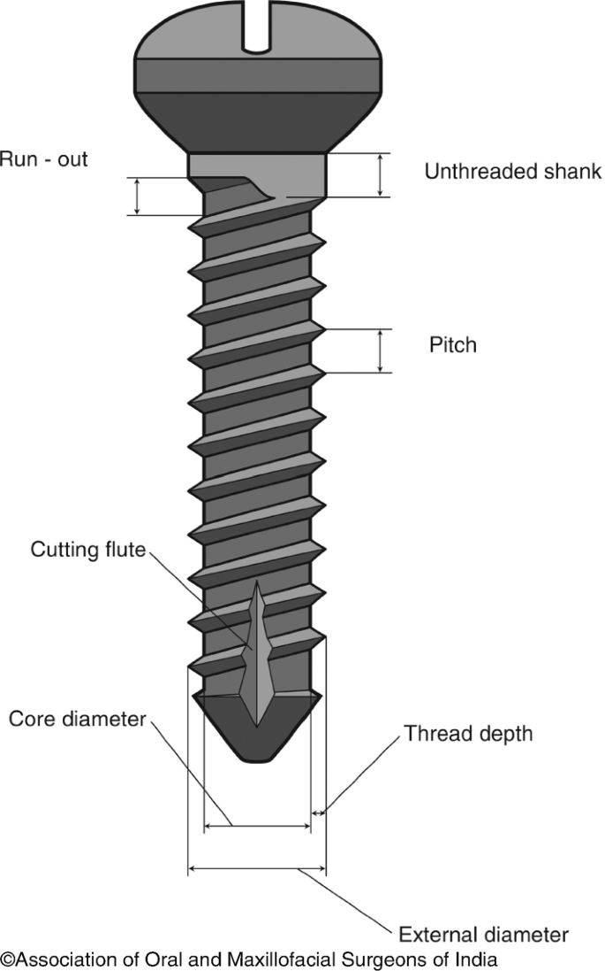
Figure 1 Screw

Three-Dimensional (3D) Plates³¹
The two mini plates are connected by interconnecting crossbars which are used as 3D plates. Technically, they are not three-dimensional structures, but their closed quadrilateral shape provides stability in all three dimensions.

Different types of 3D Plates
- Rectangular plate (fig.13)
- X Shape plate (fig.3)
- Square plate (fig.12)
- Double square plate (fig.12)
- Double or triple rectangle plate (fig.13)
- Double Y shape plate (fig.2)
- I shape plate (fig.5)
- Z shape plate (fig.7)
- H shape plate (fig.6)
- Delta plate (fig.11)
- Trapezoid plate (fig.9)
- Grid plate (fig.8)
- Sub Y shape plate (fig.10)
- Trifix plate (fig.14)
- Struts plate (fig.15)
Double Y Shape X Shape Y Shape I Shape
Figure 2 Figure 3 Figure 4 Figure 5
H Shape Z Shape Grid Plate Trapazoid Condyle Plate
Figure 6 Figure 7 Figure 8 Figure 9
Sub Y Plates Delta Plate Square Plate Rectangular Plate
Figure 10 Figure 11 Figure 12 Figure 13

Trifix Plate Strut Plate
Figure 14 Figure 15

Picture courtesy: orthomax plating brochure

Advantages of 3D Plates
- 3D plates were indeed easy and simple to use.
- Significant reduction in operating time could be achieved with the use of 3D plates which makes it a time-saving.
- Patients treated with 3D plates showed lesser postoperative pain in 1st week, 1st month, and 3rd month.
- Patients treated with 3D plates showed a lower incidence of post-operative infection.
- Other complications were found to be extremely rare.
- This 3-D plating system can be used with satisfactory results, especially in anterior mandible fractures.
- This technique does not require expensive armamentariums.
- These plates ensure 3D stability and the period of immobilization was not necessary as in other systems.
- The morbidity associated with prolonged immobilization is reduced.
- This system is associated with minimal incidence of complications.
- This system requires a lesser area of exposure.
- Close approximation.
- Greater stability across the fracture site.
- Less alteration in the osseous or occlusal relationship upon screw tightening.

Disadvantages
The probable limitations of 3D plates may be excessive implant material due to the extra vertical bars incorporated for countering the torque forces, cases where the fracture line passes through the mental foramina region, and the angle of the mandible where 3D plates cannot be adopted.

References
- Alpert B, Seligson D. Removal of asymptomatic bone plates used for orthognathic surgery and facial fractures. Journal of Oral Maxillofacial Surgery. 1996; 54: 618 - 621.
- Chritah A, Lazow SK, Berger JR. Transoral 2 mm locking miniplate fixation of mandibular fractures plus 1 week of maxillomandibular fixation: a prospective study. Journal of Oral Maxillofacial Surgery, 2005.63; 1737-1741.
- Kuriakose MA, Fardy M, Sirikumara M, Patton DW, Sugar AW A comparative review of 266 mandibular fractures with internal fixation using rigid (AO/ASIF) plates or mini plates. British Journal of Oral Maxillofacial Surgery 1996 34: 315-321.
- Cawood JI Small plate osteosynthesis of mandibular fractures. British Journal of Oral Maxillofacial Surgery, 1985:77-91
- Brown JS, Trotter M, Cliffe J, Ward-Booth RP, Williams ED. The fate of mini plates in facial trauma and orthognathic surgery: A retrospective study. British Journal Oral Maxillofacial Surgery. 1989; 27: 306–15
- Levy FE et al. Monocortical Miniplate fixation of Mandibular Angle Fractures. Arch Otolaryngol Head Neck Surg.1991; 117: 149-154.
- Mukerji R, Mukerji G, and Mcgurk M. Mandibular fractures: Historical perspective. British Journal of Oral and Maxillofacial Surgery. 2006; 44: 222-228
- Fonseca Raymond J and Robert V Walter. Oral and Maxillofacial Trauma, Pennsylvania, W.B. Saunders Company, 2nd Edition Vol 1: 474-478
- Islamoglu kemal et al. Complications and removal rates of mini plates and screws used for maxillofacial fractures. Ann Plast Surg. 2002; 48: 265-268
- Langford JR and Frame W John. Tissue changes adjacent to titanium plates in patients. Journal of Cranio-Maxillofacial Surgery. 2002; 30: 103-107.
- Farmand M and L Dupoirieux. The value of 3-Dimensional miniplates in maxillofacial surgery. Rev Stomatoi Chir Maxillofac. 1992; 93(6): 353-357.
- Anand Shankar, Thangavelu A. Role of indigenous 3-dimensional titanium plating system in oral and maxillofacial surgery. Journal of Oral Maxillofacial Surgery (2004) Vol.3: No. 1.
- Niinomi M. Mechanical properties of biomedical titanium alloys. Mater Sci Eng A. 1998;243(1-2):231-6.
- Saini M, Singh Y, Arora P, Arora V, Jain K. Implant biomaterials: A comprehensive review. World J Clin Cases. 2015 Jan 16;3(1):52-7.
- Gargari M, Comuzzi L, Bazzato MF, Sivolella S, di Fiore A, Ceruso FM. Treatment of peri-implantitis: Description of a technique of surgical 2 detoxification of the implant. A prospective clinical case series with 3-year follow-up. ORAL and Implantology. 2015 Jan;8(1):1-11. 22.
- Elias CN, Lima JHC, Valiev R, et al. Biomedical applications of titanium and its alloys. J Minerals Met Mater Soc. 2008;60(3):46-9.
- Bramanti E, Matacena G, Cecchetti F, Arcuri C, Cicciù M. Oral health-related quality of life in partially edentulous patients before and after implant therapy: A 2-year longitudinal study. ORAL and Implantology. 2013;6(2):37-42.
- Gargari M, Prete V, Pujia A, Ceruso FM. Full-arch maxillary rehabilitation fixed on 6 implants. ORAL and Implantology. 2013;6(1):1-4.
- Gargari M, Prete V, Pujia M, Ceruso FM. Development of a patient-based questionnaire about aesthetic and functional differences between dentures implant-supported and overdentures tooth-supported. Study of 43 patients with a follow-up of 1 year. ORAL and Implantology. 2012;5(4):86-91.
- Milillo L, Fiandaca C, Giannoulis F, Ottria L, Lucchese A, Silvestre F, Petruzzi M. Immediate vs non-immediate loading post-extractive implants: A comparative study of Implant Stability Quotient (ISQ). ORAL and Implantology. 2016;9(3):123-131.
- Spinelli D, Ottria L, De Vico G, Bollero R, Barlattani JrA, Bollero P. Full rehabilitation with Nobel clinician® and procera implant bridge®: Case report. ORAL and Implantology. 2013 Apr;6(2):25-36.
- Tschernitschek H, Borchers L, Geurtsen W. Nonalloyed titanium as a bioinert metal-a review. Quintessence Int. 2005;36:523-530.
- Calcaterra R, Di Girolamo M, Mirisola C, Baggi L. Effects of repeated screw tightening on implant abutment interfaces in terms of bacterial and yeast leakage in vitro: One-time abutment versus the multi screwing technique. International Journal of Periodontics and Restorative Dentistry. 2016;36(2):274-280.
- Diamanti MV, Del Curto B, Barlattani A, Bollero P, Ottria L, Pedeferri M. Mechanical characterization of an innovative dental implant system. Journal of Applied Biomaterials and Biomechanics. 2009;7(1):23-28.
- Giannitelli SM, Basoli F, Mozetic P, Piva P, Bartuli FN, Luciani F, Arcuri C, Trombetta M, Rainer A, Licoccia S. Graded porous polyurethane foam: A potential scaffold for oro-maxillary bone regeneration. Materials Science and Engineering C. 2015;51:329-335.
- Tatullo M, Marrelli M, Falisi G, et al. Mechanical influence of tissue culture plates and extracellular matrix on mesenchymal stem cell behavior: A topical review. Int J Immunopathol Pharmacol. 2016;29:3-8.
- Andreas Bassi M, Andrisani C, Lico S, Ormanier Z, Ottria L, Gargari M. Guided bone regeneration via a preformed titanium foil: Clinical, histological and histomorphometric outcome of a case series. ORAL and Implantology. 2016 Oct-Dec;9(4):164-174.
- Dorri M, Nasser M, Oliver R. Resorbable versus titanium plates for facial fractures. Cochrane Database Syst Rev. 2009;(1): CD007158.
- Jeyaraj P. Efficacy and Versatility of the 3-D Titanium Mesh Implant in the Closure of Large Post-Craniectomy Osseous Defects, and its Therapeutic Role in Reversing the Syndrome of the Trephined: Clinical Study of a Case Series and Review of Literature. J Maxillofac Oral Surg. 2016 Mar;15(1):82-92.
- Marrelli M, Falisi G, Apicella A, et al. The behavior of dental pulp stem cells on different types of innovative mesoporous and nanoporous silicon scaffolds with different functionalizations of the surfaces. J Biol Regul Homeost Agents. 2015;29(4): 991-7.
- Yadav, A. (2021). Principles of Internal Fixation in Maxillofacial Surgery. In: Bonanthaya, K., Panneerselvam, E., Manuel, S., Kumar, V.V., Rai, A. (eds) Oral and Maxillofacial Surgery for the Clinician. Springer, Singapore. https://doi.org/10.1007/978-981-15-1346-6_51

