Balancing Automation and Human Expertise: A Critical Examination of the Need for Human Intervention in the Automation Sector

Govindarajulu Eedara¹, A.Sindhuja², Y.Manjunath Reddy ³ and R.S.S.Bhargav ⁴
govind305@gmail.com¹, sindhu19.nani@gmail.com², reddymanjunath959@gmail.com ³, bhargavravinutala03@gmail.com ⁴
Assistant Professor¹, Student^{2,3,4}
Vignan’s Foundation for Science Technology and Research

Abstract:
The Automation sector has made remarkable strides in recent years, transforming industries and streamlining processes through the adoption of advanced technologies such as Artificial Intelligence (AI), Robotics, and Internet of Things (IoT). While these advancements promise unprecedented levels of efficiency and productivity, they have also sparked discussions surrounding the essential role of human intervention in automation systems. While automation systems excel in repetitive, rule-based tasks, there remain critical aspects of decision-making, adaptability, creativity, and ethical judgment that demand human expertise. The chapter delves into specific areas within the automation sector, such as manufacturing, healthcare, and transportation, to highlight instances where human intervention is indispensable. It examines scenarios where human judgment is irreplaceable, such as complex problem-solving, handling unexpected situations, ensuring ethical considerations, and maintaining quality control.
Moreover, the emphasizes the ongoing evolution of human roles in automated environments, from machine operators to system supervisors and decision-makers. The concept of "human in the loop" or "human on the loop" is explored, where humans work alongside automated systems to complement and enhance their capabilities. The importance of striking a delicate balance between automation and human intervention, acknowledging that the synergy of both can lead to safer, more efficient, and more ethical operations across various sectors. As industries continue to embrace automation technologies, understanding the nuanced relationship between humans and machines becomes pivotal for ensuring success, innovation, and long-term sustainability.
This will serve as a precursor to an in-depth exploration of the need for human intervention in the automation sector. It sets the stage for a comprehensive examination of how the workforce is evolving in response to automation, and how industries can harness the unique strengths of both humans and machines to achieve unprecedented levels of efficiency, productivity, and ethical responsibility.
Keywords—Artificial Intelligence (AI), IOT, Automation Technologies, Human-Machine Relationship, Decision-Making.
- Introduction
The automation sector has ushered in a new era of technological advancement, promising unparalleled levels of efficiency, precision, and productivity across industries. With the rapid integration of cutting-edge technologies such as Artificial Intelligence (AI), Robotics, and the Internet of Things (IoT), automation has not only transformed the way we work but has also redefined the boundaries of what is achievable. Yet, amid this wave of automation-driven progress, a critical question emerges: what is the role of human intervention in this increasingly automated landscape.
Automation systems, known for their unwavering accuracy and tireless operation, excel in executing repetitive, rule-based tasks with remarkable consistency. They promise to eliminate errors, optimize processes, and drive down operational costs. However, in this journey towards full automation, it has become evident that there are dimensions of work that extend beyond the capabilities of machines.
This exploration delves into the pressing need for human intervention in the automation sector. It recognizes that while automation can handle routine operations effectively, there are facets of human judgment, creativity, adaptability, and ethical reasoning that are indispensable. These attributes come to the forefront in scenarios requiring complex problem-solving, addressing unexpected situations, ensuring ethical considerations, and maintaining stringent quality control.
This chapter extends its focus to diverse areas within the automation sector, ranging from the manufacturing floor, where precision meets innovation, to the healthcare realm, where patient care demands compassion and clinical expertise, and to the transportation industry, where safety and decision-making in dynamic environments are paramount.
Moreover, this exploration underlines the dynamic shift in the roles of human workers within automated environments. It acknowledges the transition from traditional machine operators to system supervisors and decision-makers. The concept of "human in the loop" and "human on the loop" is explored, highlighting scenarios where humans work alongside automated systems, complementing and enhancing their capabilities.
In the broader context, this research underscores the imperative of achieving a delicate balance between automation and human intervention. It asserts that the synergy of both elements can lead to safer, more efficient, and ethically responsible operations across a multitude of sectors. As industries continue their rapid adoption of automation technologies, understanding the intricate relationship between humans and machines becomes pivotal for ensuring success, fostering innovation, and securing long-term sustainability.
This introduction lays the foundation for a comprehensive exploration of the necessity for human intervention in the automation sector. It sets the stage for an in-depth analysis of how the workforce is evolving in response to automation and how industries can harness the unique strengths of both humans and machines to attain unprecedented levels of efficiency, productivity, and ethical responsibility in this transformative era.
- The impact of automation on the workforce
As automation is providing many changes and increasing its quality but it also brings change in the work force:
- Job Displacement and Transformation
one of the primary concerns surrounding automation is the ability displacement of sure jobs. Some jobs like repetitive tasks, scheduled tasks etc. can be replaced by the automated machines which may cause the laying of and displacing of jobs.
- Skill Shift:
As most of the physical work can be done through automated machines, the manual labor work can be neglected and the new works like programmer, system designer, monitoring works etc. came into picture.
- Human-Machine Collaboration:
Automation doesn’t mean to entire alternative of human employees. Collaborative robots (cobots) and human-robotic organizations demonstrate a shift toward human-system collaboration. Jobs like judgment, creativity, complex problem-fixing, and emotional intelligence stay crucial and cannot be without problems automatic.
- Changing Work Environments:
Automation causes place of work dynamics by way of changing how work is organized. remote work, flexible hours, and telecommuting grow to be extra possible as automation reduces the need for physical presence in certain duties.
- Ethical Considerations:
Automated machines cannot do critical thinking they don’t know the right path so to consider which may leads to wrong outputs. So, to take ethics into consideration human intervention is needed.
- Training and Education:
Although the automated machines can do the work, but they need some preliminary training. To teach them human presence is needed, which we term it as “Machine learning”.
- Exception Handling:
automatic systems may additionally encounter unforeseen situations that require human intervention. Human workers are answerable for identifying anomalies, making decisions, and implementing corrective moves when the automated system deviates from the norm.
- Need of human work in automation

System design and programming :
Although Automated Machines work on their own. Humans are required for designing, programming, and configuring the automation system. Humans are only responsible for training the machines to do their work.

Monitoring and Supervision:
automatic systems often require human operators to display their performance, make certain that duties are executed effectively, and intrude if any problems stand up. Human oversight guarantees that the automation system is jogging easily and that any anomalies are addressed directly.

Maintenance and Repair:
Automated equipment and structures require regular upkeep to make certain of their right functioning. Human technicians are chargeable for analyzing, diagnosing, and repairing any mechanical or technical problems that can arise. in addition, they perform preventive upkeep to prevent unexpected downtime.

Problem-Solving:
Despite the advancements in AI and automation, complex problems often require human problem-solving skills. If any unexpected situation occurs the AI was unable to take the decision where humans can solve it

Continuous Improvement :

Humans plays a major role in improving the existing machine if we need to improve the automation machine human critical thinking is required.The data refinig by the humans can enhance the automation.

Ethical Considerations:
Automated machines cannot do critical thinking they don’t know the right path so to consider which may leads to wrong outputs. So, to take ethics into consideration human intervention is needed.

Training and Education:
Although the automated machines can do the work, but they need some preliminary training. To teach them human presence is needed, which we term it as “Machine learning”.

Exception Handling:
Automatic systems may additionally encounter unforeseen situations that require human intervention. Human workers are answerable for identifying anomalies, making decisions, and implementing corrective moves when the automated system deviates from the norm.

Adaptation to Change:
Automation can cause modifications in job roles and obligations. Human people want to adapt to new duties, discover ways to engage with automatic structures, and collect capabilities relevant to the evolving work surroundings.

Crisis Management:
If the company gets any unexpected crisis the humans have the ability to take charge on decision – making and manage the crisis time. They manage contingencies and rapidly evolving conditions that may not be inside the scope of automated responses.

Human Oversight:
Automatic systems may on occasion fail or come across conditions they are no longer programmed to handle. Human oversight is vital to step in all through critical moments, stopping mistakes and ensuring safety.
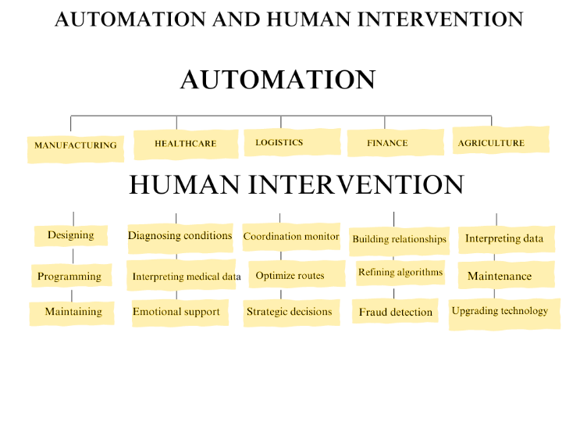

Fig 1.0 Represents the Automation functioning and
the involvement of human in the task
- CASE STUDY
Let’s consider some case studies to understand it in more detail. We have considered HRC (Human Robot Collaboration) to show the need of Humans while working with autonomous things.
HRC in Automotive industry:
Automotive is the largest industrial sector in the world. Considering the UK only, 3.7 million employees are working in the automotive sector and the economical contribution of the UK economy is about $26 billion [1]. In the automotive industry, assembly cells are playing an important role where 83% of production units involve. assembly tasks [2]. However, some manual operations are still needing more flexibility and robustness to be performed efficiently; thus, relying on the industrial robot to perform these tasks alone may not be a practical solution as human abilities can’t be fully replaced [3]. Therefore, the focus is to combine both abilities of humans and robots to work in collaboration while safety is assured to prevent any accident during the work [4]. From [5], in the assembly stage, the collaborative robot is responsible for the screwing task through the sensing integration with a human operator who will be able to share the work area and task. Also, installing the vision system is allowing the collaborative robot to collect information about the working environment and the human intentions that will be used for further improvements such as path planning and human movement predictions. As a result, the implementation of the HRC system is showing the needed capacity to perform complex tasks.
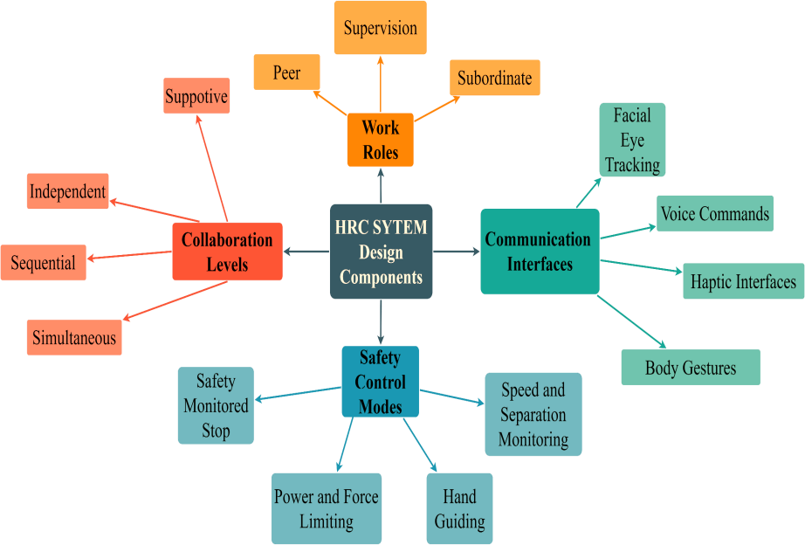
Fig 2.0: describing the Human robot collaboration [6]
- Conclusion
Automation, undoubtedly, enhances efficiency and streamlines repetitive tasks, but it cannot entirely supplant human intervention. The automation process cannot entirely takeover any industrial process, if any issues and any new technology has to be done it will only be possible by humans. Human intervention is much more important in the automation process. Human intervention is not just important; it is paramount in the realm of automation. Even within a fully automated company, human presence is indispensable. This is because automation processes are inherently devoid of human emotions, and emotions often play a critical role in decision-making and interpersonal interactions.

Furthermore, the depth of human intelligence far surpasses that of any machine. In scenarios where tasks or processes require a level of intelligence beyond what machines can provide, it is irrefutable that humans must step in. In essence, the synergy between automation and human expertise is not merely a choice but a necessity. It is the fusion of automation's precision and human ingenuity, emotions, and intelligence that paves the way for progress and innovation in modern industries. This harmonious collaboration between machines and humans ensures that the potential of both is fully harnessed to address the challenges and opportunities of the future.

References
- Wang, S.M., Liu, Y.L. and Kang, Y., 2002. An efficient error compensation system for CNC multi-axis machines. International Journal of Machine Tools and Manufacture, 42(11), pp.1235-1245.
- Wang, S.M., Liu, Y.L. and Kang, Y., 2002. An efficient error compensation system for CNC multi-axis machines. International Journal of Machine Tools and Manufacture, 42(11), pp.1235-1245.
- Mei, B., Wang, H. and Zhu, W., 2021. Pose and shape error control in automated machining of fastener holes for composite/metal wing-box assembly. Journal of Manufacturing Processes, 66, pp.101-114.
- Callegari, M., Amodio, D., Ceretti, E. and Giardini, C., 2006. Sheet incremental forming: advantages of robotised cells vs. CNC machines. In Industrial Robotics: Programming, Simulation and Applications. IntechOpen.
- Vichare, P., Nassehi, A., Kumar, S. and Newman, S.T., 2009. A Unified Manufacturing Resource Model for representing CNC machining systems. Robotics and Computer-Integrated Manufacturing, 25(6), pp.999-1007.
- Lyu, D., Liu, Q., Liu, H. and Zhao, W., 2020. Dynamic error of CNC machine tools: a state-of-the-art review. The International Journal of Advanced Manufacturing Technology, 106, pp.1869-1891.
- Zhu, S., Ding, G., Qin, S., Lei, J., Zhuang, L. and Yan, K., 2012. Integrated geometric error modeling, identification and compensation of CNC machine tools. International journal of machine tools and manufacture, 52(1), pp.24-29.
- Czwartosz, R. and Jedrzejewski, J., 2022. Application of machine learning in the precise and cost-effective self-compensation of the thermal errors of CNC machine tools–a review. Journal of Machine Engineering, 22(3).

