Chemical Basis of Stability of Drug
Authors:Dr.Manisha Ashwin Tayde
Professor,HOD, Pharmaceutical Chemistry Department
SPE’s Smt. Narmadaben Popatlal Thakkar Institute of Pharmacy
Nasik 422003.
Maharashtra, India
Mail Id: mtayde82@gmail.com
ABSTRACT:
Pharmaceutical stability is the ability of a certain drug material or formulated product to continue to meet the defined standards of identification, potency, and purity over the course of its shelf life. The chemical stability of pharmacological compounds in the solid state is the main topic of this chapter. A marketable medicine must maintain its stability under a range of circumstances, such as extremes in temperature and relative humidity. Pharmaceuticals' chemical instability affects their therapeutic efficacy and toxicological effects. The chapter investigates the chemical reactivity of pharmacological compounds, namely those in the crystalline state. It examines solid-state reaction pathways and processes as well as diverse examples of solid-state reactions used in pharmaceutical applications.
Stability testing shows that a drug substance's or product's quality changes over time when it is exposed to different environmental variables. This chapter overviews about the chemical justification for some functional groups' resistance to reactions like hydrolytic and oxidative breakdown within drug molecules and to discuss about ways to maximise their stability during storage.
The chapter goes over the variables that influence how quickly chemical reactions occur. It outlines methods for reducing chemical reactions and/or stabilising medicinal ingredients.
Keywords: Stability of drug, Metabolism, Chemical Reactions,

1. INTRODUCTION
The phrase "drug stability" describes how well a pharmaceutical substance can maintain its therapeutic characteristics over the course of its storage or shelf life. Each of us has probably noticed the expiration dates on the many bottles of pills, liquids, and ointments we keep in our medicine cabinets and pondered why some of them last longer than others. A drug's stability is influenced by a variety of variables, some of which are environmental and others which are connected to the characteristics of the drug itself.
Drug research and development must prioritise safety and efficacy, therefore formulations must be created in a way that ensures a drug's proper bioavailability and physico-chemical stability over the specified shelf-life.(1)
Both chemical and physical changes might occur to a medication product. The first alters the chemical substance's form but not its chemical makeup, so no new or broken chemical bonds are created (2).
A drug's physical instability can occur in a variety of ways, including changes to how it looks, drug release, polymorphic alterations, adsorption, and more. On the other hand, chemical modifications describe alterations in the chemical structure brought on by drug degradation and interactions with excipients in the formulation. These modifications may lessen the drug's strength, raising questions about its usefulness, while also posing a safety risk because the breakdown products may be hazardous.(3,4)
A drug's intrinsic feature of chemical stability is governed by its chemical structure. Due to the addition of other substances (such excipients), the dose form may create drug instability. Drug stability must also be checked during the drug's packaging, storage, and manufacturing processes. In this context, the issue of drug product stability is a crucial one for both new and generic medications when conducting drug research and development. (5)
According to USP, product stability refers to how well a product maintains its original attributes during its entire shelf life. Our compounded preparation shouldn't undergo any alterations after its expiration date. The five categories of stability that make up a compound's overall stability are chemical, physical, microbiological, therapeutic, and toxicological. Chemical stability refers to the preservation of the chemical identity and potency of each active pharmaceutical ingredient (API). Physical stability refers to the preservation of characteristics like appearance, solubility, suspendability, and particle size. Microbiological stability refers to the preservation of resistance to microbial expansion. Therapeutic stability refers to a persistent therapeutic effect. There is no appreciable rise in toxicity, which is referred to as toxicological stability.
Chemical modifications are alterations in the chemical composition that result from medication degradation and interactions with excipients included in formulations. These modifications may lessen the drug's strength, raising questions about its usefulness, while also posing a safety risk because the breakdown products may be hazardous. (6)

1.1Factors affecting stability of drugs
USP 1191 discuses 11 factors that affect the stability of products. Of those 11, four factors are the most critical and common for compounded preparations: heat, light, oxidation and hydrolysis.

1.1.1Heat
In order to prepare several regularly compounded dosage forms, heat is needed. This comprises rapid dissolve tablets (RDTs), troches, lollipops, and suppositories. Compounders must exercise caution since several APIs, such as liothyronine sodium (T3) and oxytocin, are highly prone to degrading at temperatures below or close to those needed to create these dosage forms.
Making oxytocin troches is a common request. Troche bases normally need to melt between 50 and 65 degrees Celsius. At PCCA, we heated oxytocin to 55° C and held it there for five minutes in order to study the oxytocin's deterioration. 10% of the oxytocin's efficacy was lost. This shows that oxytocin shouldn't be exposed to heat and that using a troche instead of another dose form, like sublingual drops or sprays, is a good idea.
Seasonal temperature variations should also be taken into account, particularly if the compound is being delivered. In those weather conditions, insulated shipment packaging might be required. Taking this into account when acquiring chemicals is also important.
Additionally, heat always quickens chemical processes. Each 10° increase in temperature may result in an exponential rise in the pace at which an API degrades when considering processes like hydrolysis and oxidation. For instance, a medicine that is vulnerable to hydrolysis and is exposed to a 20° increase in temperature may lose up to 96% of its shelf life in an extreme scenario detailed in USP Chapter 1191. This scenario does not apply to all hydrolizable compounds, but it does highlight the importance of understanding how heat can impact a medicine.
- The broad temperature ranges needed to prepare different dosage forms that need to be heated are listed below; however, the actual temperature may vary depending on the formula's contents, including the base employed, and the process. For instance, RDTs can be baked at 80° C for 30 minutes instead of the standard 110° C for 15 minutes when utilizing PCCA's basic RDT-PlusTM. The temperature is frequently raised to 160° C for lollipops, but the compounder wouldn't add the API until the temperature has returned to 90° C.
- Suppositories: 38-55° C
- Troches: 50-65° C
- Rapid dissolve tablets: 80-110° C
- Lollipops: 90-160° C

1.1.2 Light
Some APIs are light-sensitive. Both photo-oxidation and photolysis can be brought on by light. Free radicals, which are chemical intermediaries capable of sustaining chain reactions, can also be produced by light. Consequently, if at all possible, it is a good idea to disperse substances in light-resistant containers.
One medication that is susceptible to UV light is retinol. In a study, Del Rosso et al. (2012) found that micronized tretinoin in one type of gel degraded by 9% and another type of gel by 72% after being exposed to UV light for eight hours. Even though there was a sizable variation in the two products' rates of chemical deterioration, the one with 9% degradation still raises questions.(7)

When in water, methylcobalamin is extremely light sensitive. When exposed to light, it will not, however, change in appearance. Beakers and containers should be covered in aluminum foil to reduce light exposure while mixing with methylcobalamin. Additionally, it must always be kept in a light-resistant container.

Contrarily, apomorphine does undergo a color change when exposed to light and water. Compounders should take the necessary steps to minimize its exposure to light as it transforms from a grayish-white look to a dark greenish-black appearance.

Oxidation

Some compounds or drug molecules are susceptible to oxidation. Ex.Hydroquinone has a molecular structure containing two hydroxyl groups directly attached to an aromatic ring. Because of its structure, hydroquinone is more likely to oxidize. Hydroquinone turns dark and loses its medicinal efficacy as it oxidizes. Another frequent compounded ingredient that oxidizes to a brown color and loses its therapeutic efficacy is epinephrine.
Conjugated dienes (free fatty acids) and heterocyclic aromatic rings (nitroso derivatives) are other chemical structures
that can oxidize.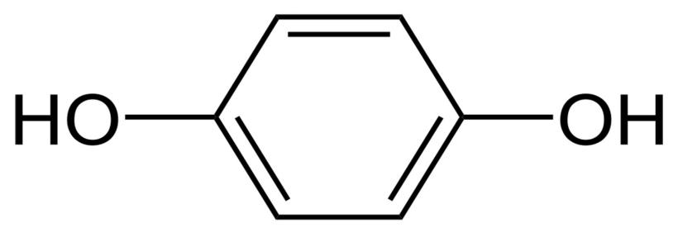
Figure 1: Chemical Structure of Hydroquinone
The chemical structure of hydroquinone (pictured above), with its two hydroxyl groups bonded to an aromatic ring, makes it very likely to oxidize.(8)

1.1.3 Hydrolysis

The chemical linkages that are most likely to hydrolyze in the presence of water are amides and esters. For instance, in the presence of water, aspirin hydrolyzes to acetic acid and salicylic acid, but in a dry environment, aspirin hydrolysis is negligible. When designing formulations that are anhydrous, it is useful to distinguish compounds that include amide and/or ester functional groups in order to spot probable hydrolysis.

Figure 2: Chemical structure of amide
An amide functional group (pictured above) is a chemical structure within a molecule that, among other things, makes that molecule more likely to decompose in the presence of water.
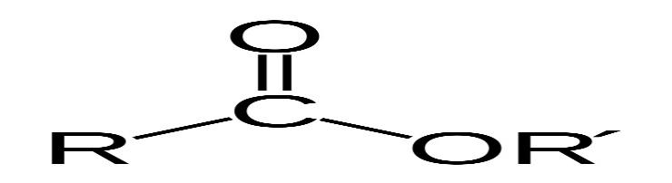
Figure 3: Chemical structure of ester group
An ester functional group (pictured above) is a chemical structure that gives molecules various properties, including the tendency to break down in the presence of water.(9,10)
1.2Chemical aspects of Drug metabolism:
As soon as the injected substance comes into contact with enzymes that have the ability to change its chemical structure, metabolism of the drug happens through fundamental chemical processes. On the other hand, a drug's stability after delivery is primarily caused by the body's enzymes not transforming it. However, many medications are subject to some degree of chemical deterioration, whether as a result of interactions with enzymes or inappropriate handling and storage, and this deterioration frequently results in a loss of effectiveness.
When advising patients on the storage and use of their prescription medications, having a working understanding of the functional groups inside drug molecules, including those that are more likely to be resistant to metabolism and those that are more likely to be vulnerable, should be helpful.
Dispensing medications into monitored dose systems (MDS), when they are taken out of their manufacturer's packaging and put in an environment where stability is unknown, is a typical illustration. Similarly, when alternative medicinal compounds from a particular chemical class are being explored as part of a medicines usage review, knowledge of functional groups is helpful.

1.3 Chemical reactions
Drugs often consist of tiny chemical compounds. The presence of functional groups, their nature, and their interconnectedness are the only factors that distinguish one medication from another. As a result, there is no distinction between pharmaceuticals and other small organic molecules, such as those present in food and household items, since this is true with all organic molecules. The exception is when a medicine has been deliberately developed and optimized to have the necessary pharmacological profile in order to treat a condition (over many years and at a cost of hundreds of millions of pounds) . Given this, it should not come as a surprise that under specific circumstances, medications react chemically in a manner similar to that of other organic substances.
Oxidation and hydrolysis are the principal chemical processes that impact a drug's stability. A molecule undergoes oxidation when its electrons are removed (or added) and such processes can be started by light, heat, or specific trace metals. Since oxidative degradation can frequently be reduced to acceptable levels by storing susceptible drugs in the absence of light (e.g., use of amber vials) and oxygen (e.g., store under nitrogen or argon), or by using antioxidants in the formulation, it has not been studied in as much detail as hydrolysis
Hydrolysis is the more prevalent method of drug breakdown and can be considered in regard to both stability as well as metabolism.

1.3.1 Hydrolysis
The breaking of a chemical bond within a molecule as a result of a molecule's reaction with water is known as hydrolysis. Esters and amides are the functional groups most frequently found in medications that are sensitive to hydrolysis, however there are many other functional groups that are as well. The reaction between an ester (X=OR) or an amide (X=NR1R2, where R, R1 and R2 can each have any arbitrary structure) results in the cleaved reaction products of a carboxylic acid and either an alcohol (XH=ROH) or an amine (XH=R1R2NH), respectively.
Figure 1 depicts the mechanism for this reaction.

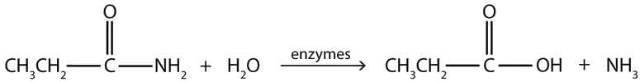
Figure 4: A simplified general hydrolysis mechanism of esters and amides
Since oxygen has a stronger ability than carbon to attract electrons to itself, the C=O double bond in an ester or amide gets polarized, leaving the oxygen with a slight negative charge and the carbon with a slight positive charge. Because unlike charges are drawn to one another as a result of this polarization, the oxygen atom of water's electrons are drawn to the slightly positive charge of the aforementioned carbon atom, which causes hydrolysis . If the carbonyl oxygen is protonated, this polarization and subsequent interactions are amplified.
Water reacts more quickly with esters than amides, and both an acid and a base can catalyze these reactions. The aqueous solution's pH has an impact on the rate. Similar to this, hydrolytic enzymes found in different tissues and plasma catalyze the in vivo metabolism of esters and amides in medicines via a hydrolysis mechanism. The structural distinction between these two functional groups is what causes the variation in the rates of ester and amide hydrolysis. The amide has a nitrogen atom in the same place as the ester, while the ester has an oxygen atom.
Due to this distinction, the carbonyl group's (C=O) carbon is much more positively charged in the ester than in the amide, which increases the attraction between that carbon and a water molecule. The amide, on the other hand, exhibits the opposite property because the nitrogen atom in amides reduces the positive charge on the carbonyl carbon atom, making it less attractive to incoming water molecules.
This difference in the hydrolysis of esters and amides is exemplified with lidocaine and procaine (Figure 5).

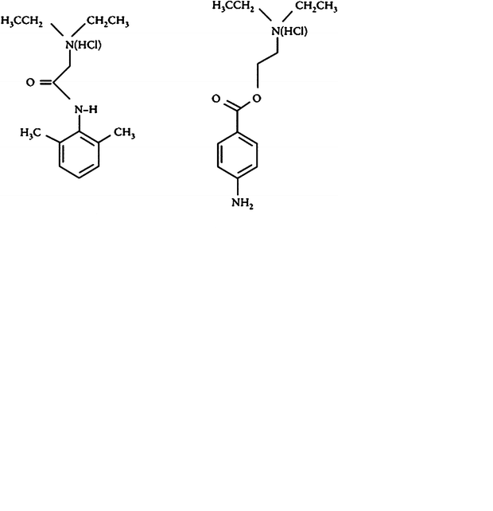
Figure 5: the chemical structures of lidocaine and procaine
Procaine, a local anesthetic that contains an ester, is no longer frequently used. Despite being a good local anesthetic, its effects are short-lived because its ester group hydrolyzes quickly. In contrast, the amide bond in lidocaine is less easily hydrolyzed than the ester of procaine. Since it is more resistant to the effects of hydrolysis, together with its bulkier structure, lidocaine has a longer duration of action than other local anesthetics.
Additionally, the methyl ester in the ADHD medication methylphenidate (Figure 6) is easily hydrolyzed by hydrolytic enzymes to produce ritalinic acid, which is the main (inactive) urine metabolite in people.

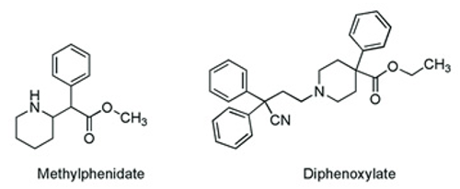
Figure 6: the chemical structures of methylphenidate and diphenoxylate

Since the medicine is rendered inactive by such a readily hydrolysable functional group, maintaining therapeutic levels requires more frequent administration of the drug than once per day. Hydrolysis, on the other hand, has a place. The antimotility medication co-phenotrope contains the ester diphenoxylate (Figure 6), an easily hydrolyzed carboxylic acid in humans that is five times more powerful than the parent ester at preventing diarrhea.

1.3.1.1 Prodrug strategy
Salicylic acid is an effective analgesic. Gastric bleeding, however, results from the presence of the bare alcohol moiety. By disguising this alcohol group as an ester and giving us aspirin, which is then hydrolyzed in the body to release the active ingredient, this impact is avoided. A prodrug strategy is one that employs such a tactic. Acetic acid is another byproduct of aspirin hydrolysis. A persistent vinegar odor in aspirin pills that have been improperly stored indicates that hydrolysis is taking place.
The angiotensin-converting enzyme inhibitor Enalapril, whose ester is hydrolyzed in the body to produce the active carboxylic acid derivative Enalaprilate (used as an intravenous version of Enalapril for hypertensive situations), is an additional example of a prodrug.
Type I statins, such as Simvastatin, which contain a cyclic ester (a lactone), and are hydrolysed by body enzymes to produce the ring-opened, pharmacologically active hydroxy-acid common to these cholesterol lowering drugs.

1.3.1.2 Amide-containing drugs
As was already established, amide-containing medications can also hydrolyze, but this process happens considerably more slowly than it does with esters. One instance is the hydrolysis of the strained cyclic-amide ring of b-lactam antibiotics (amides that are a part of a ring structure are known as lactams). Since penicillin antibiotics are not sufficiently stable to be administered and stored in water over an extended period of time, they are typically prepared as aqueous paediatric suspensions right before dispensing.

For the purpose of minimizing hydrolysis of the strained lactam ring, such suspensions should also be stored in the refrigerator. Through the action of hydrolytic enzymes, b-lactam antibiotics are likewise sensitive to hydrolysis . The selected route of administration may be directly impacted by such chemical instability and its repercussions. To understand why some substances (like penicillins and cephalosporins, which both include a stretched, hydrolysis-prone b-lactam ring) are incompatible with continuous infusion, one only needs to consider them.

1.3.1.3Other functional groups

The two classes of medicines that are most frequently found to be hydrolyzable are esters and amides. But numerous other functional groups can also interact with water in a way that breaks bonds. These functional groups can be found in medications like imines , which are present in Diazepam, acetals which are present in Digoxin, sulphates , which are present in heparin, and phosphate esters, which are present in Hydrocortisone sodium phosphate.

1.3.1.4 Preventing hydrolysis
Although hydrolysis, as mentioned above, can be problematic, there are a number of techniques to prevent or minimize it. The protective measures are a little more difficult to overcome for in vivo metabolism. However, if the troublesome hydrolysis is recognized early enough in the therapeutic development process, it is possible to chemically alter the active compound's structure to prevent hydrolysis.
Preventive efforts, however, may also involve changing the dosage form in a number of ways for medications that are already prone to instability. Drug hydrolysis in liquid dosage forms is dependent on the presence of water, so storing dry powders and reconstituting them in water before administering reduces the amount of hydrolysis.
Similar to this, if a medicine is known to hydrolyze at room temperature, it is advisable to store it in a cold location, and patients can be educated on this practice. Additionally, pharmacists must correctly label the box with the appropriate information.
Additionally, because the rate of hydrolysis is temperature-dependent, heat sterilisation of such medications may be a challenge. By altering the composition of the ointment or cream base, the stability of the active ingredient can be managed for semi-solid dosage forms (ointments and creams). A similar method of controlling a drug's sensitivity to hydrolysis in a solid dosage form is to prepare a salt of the drug that is less hygroscopic or to lower the amount of water present in the excipients that are being utilized in the formulation.
After hydrolysis, oxidation is the second most frequent method of drug breakdown. However, oxidation is difficult to manage since it is mechanistically more complex than hydrolysis and results in a greater variety of breakdown products. Through investigations on forced deterioration, it is possible to determine a drug's tendency for oxidation. Excipients are the most frequent sources of contaminants that have the ability to start oxidation of a solid medicinal product, so accelerated investigations of drug and excipient mixes can provide a more realistic understanding of deterioration in the solid form.
Based on the findings of these investigations, important variables can be determined, and suitable actions can be implemented to prevent the issues that oxidation poses to a medicine product's quality.
1.4 Oxidation:
After hydrolysis, oxidation is the second most frequent method of drug breakdown. However, oxidation is difficult to manage since it is mechanistically more complex than hydrolysis and results in a greater variety of breakdown products.
The types of drugs that are affected include phenols (such as morphine), catecholamines (for example, adrenaline (epinephrine) and noradrenaline (norepinephrine)) as well as polyunsaturated compounds such as oils, fats and fat-soluble vitamins (e.g. vitamins A and E). Radical chain reactions of this type are called autoxidation reactions and can be quite complicated. All, however, proceed via a number of discrete steps, namely, initiation, propagation and termination.
The primary oxidative degradation pathways listed below are
1.4.1Autoxidation (initiated by radicals);
Initiation:
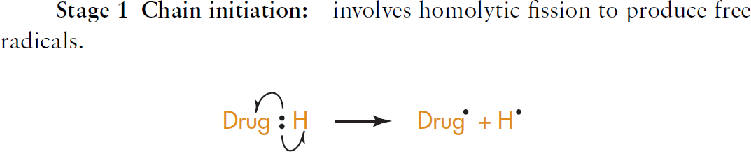
Propagation
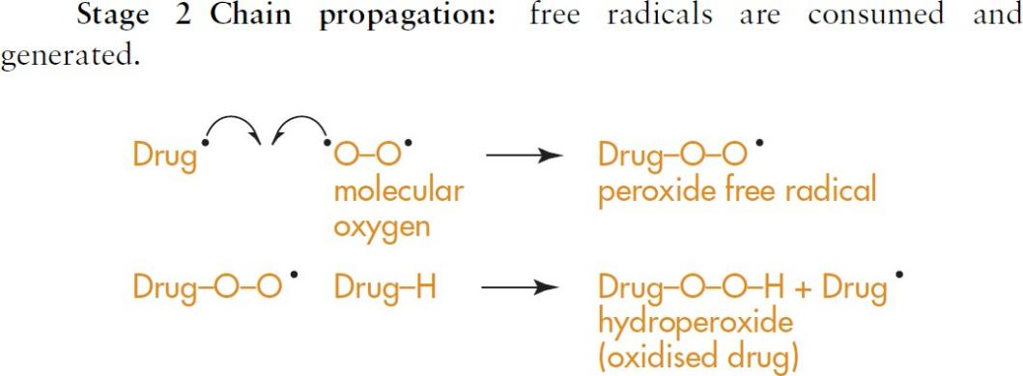

Termination:
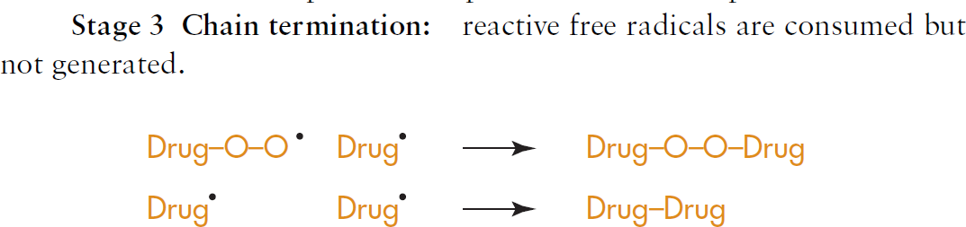
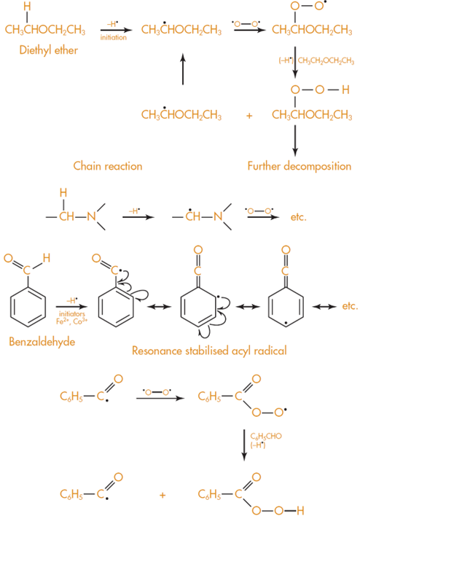

Figure7:Carbon hydrogen bond cleavage in ethers, amines and aldehydes

Other bonds that oxidise easily are the oxygen–hydrogen bond found in phenols and the nitrogen hydrogen bonds found in aromatic amines
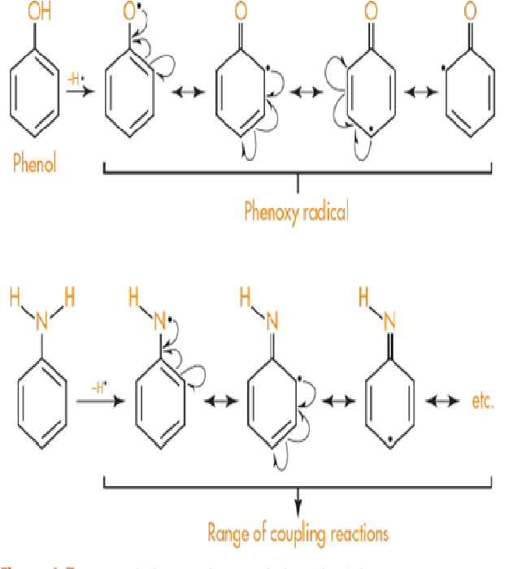
Figure 8: Oxygen hydrogen and nitrogen hydrogen bond cleavage
1.4.2 Nucleophilic/electrophilic Oxidation:
Drugs containing phenolic groups include the analgesics morphine (and related opiates) and paracetamol as well as the bronchodilator salbutamol, widely used in the treatment of acute asthma. (Figure 9).

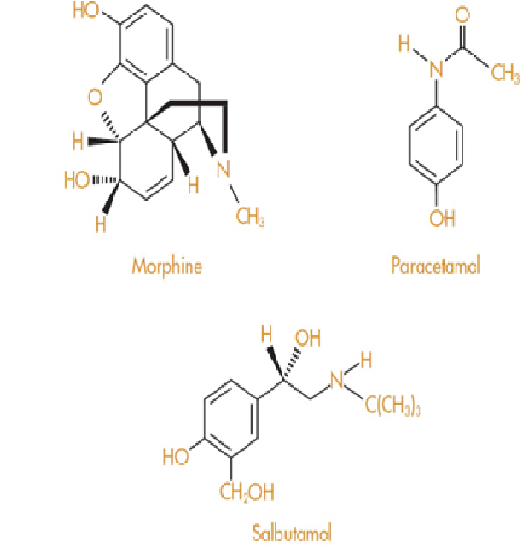

Figure 9: Structure of Morphine paracetamol; and salbutamol containing phenolic groups

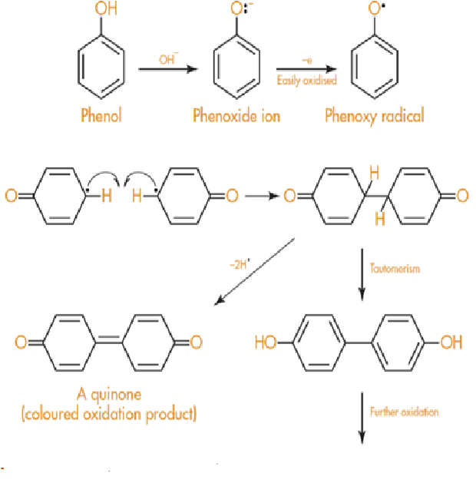
Figure10: Oxidation of phenoxide ion
Drugs that contain two phenolic groups, such as adrenaline (epinephrine) and other catecholamines such as noradrenaline (norepinephrine) and isoprenaline are particularly susceptible to oxidation and have to be formulated at acidic pH. All of these compounds are white crystalline solids that darken on exposure to air.
Adrenaline forms the red coloured compound adrenochrome on oxidation (Figure 11), which can further polymerise to give black compounds similar in structure to melanin, the natural skin pigment.

Injections of adrenaline that develop a pink colour, or that contain crystals of black compound, should not be used for this reason. Adrenaline for injection is formulated as the acid tartrate (Figure 11), which, in aqueous solution, gives a pH of approximately 3.
It is called the acid tartrate since only one carboxylic acid group of tartaric acid is used up in salt formation with adrenaline. This leaves the remaining carboxylic group to function as an acid.

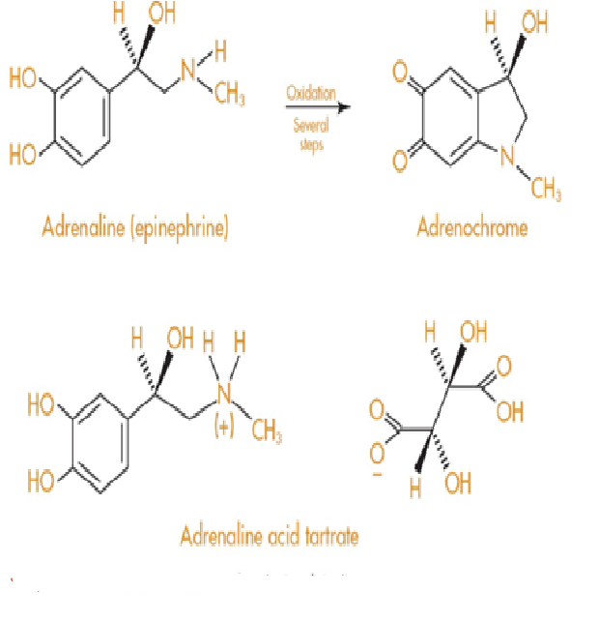

Figure 11:Oxidation of Adrenaline

Cleavage of the nitrogen–hydrogen bond in aromatic amines occurs in a similar manner to that described for phenols, to give a complex mixture of products due to coupling reactions of the type shown in Figure 12.
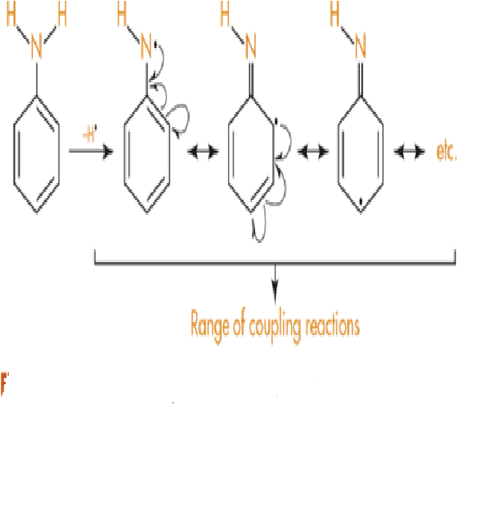
Figure 12:Nitrogen hydrogen bond cleavage in amines

1.4.3Prevention of oxidative deterioration
1.4.3.1Exclusion of oxygen
This is pretty obvious; if oxygen in the air is causing the oxidation, then exclusion of oxygen from the formulation will minimize oxidative deterioration. This is usually achieved by replacing the oxygen with an inert gas atmosphere (e.g. nitrogen or argon). The container should also be well filled with product and closed tightly to minimize the possibility of air getting to the medicine.
1.4.3.2Use of amber or coloured glass containers
Amber glass excludes light of wavelengths 470 nm and so affords some protection to light sensitive compounds. Special formulations, such as metered dose inhalers used in the treatment of asthma, also offer protection from light and oxygen since the drug is dissolved or suspended in propellant and stored in a sealed aluminium container.
1.4.3.3Use of chelating agents
Oxidation reactions can be catalyzed by the presence of tiny amounts of metal ions (for example,
0.05 ppm Cu2_ can initiate decomposition of fats) and so stainless steel or glass apparatus should be used wherever possible during manufacture of susceptible compounds. If the presence of metal ions cannot be avoided, then chelating agents, such as disodium edetate, are used to chelate and remove metal ions. Disodium edetate is the disodium salt of ethylenediaminetetraacetic acid, or EDTA, and is shown in Figure 13.

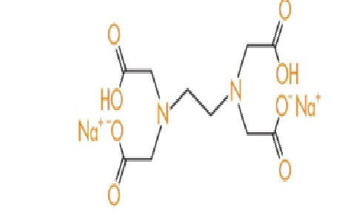

Figure 13: Structure of Disodium EDTA
1.4.3.4Use of antioxidants
Antioxidants are compounds that undergo oxidation easily to form free radicals but which are then not sufficiently reactive to carry on the decomposition chain reaction. They selflessly sacrifice themselves to preserve the drug or medicine. Most antioxidants are phenols and two of the most commonly used are shown in Figure14.

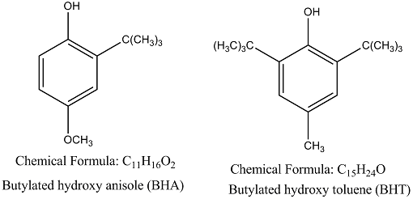
Figure14 : Structure of BHT and BHA

Ascorbic acid (vitamin C) also functions as an antioxidant and is added to medicines and foodstuffs for this reason. Food manufacturers enthusiastically label their products as having ‘added vitamin C’. What they are not so keen to tell you is that the vitamin is not there for the consumers’ benefit but rather as an antioxidant to stop their product decomposing oxidatively (see Figure 15).

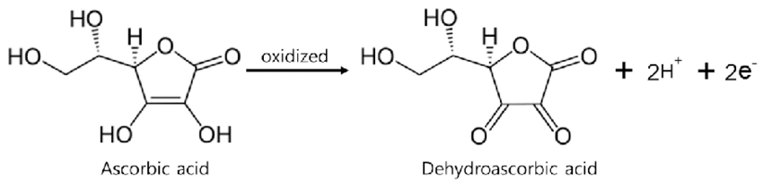
Figure 15: Ascorbic acid oxidation to diketone

2.0 Conclusion:

A stability study is a common practice that assures pharmaceutical products are kept safe, of high quality, and effective throughout their shelf lives. These pharmaceutical goods adhere to the standards set by the World Health Organisation (WHO), International Conference on Harmonisation (ICH), and other organisations. After hydrolysis, oxidation is the second most frequent method of drug breakdown. However, oxidation is difficult to manage since it is mechanistically more complex than hydrolysis and results in a greater variety of breakdown products. Pharmacists must understand the fundamental chemistry underlying drug stability in order to offer patients with a product that is both safe and effective.

2.0 REFERENCES:
1. Guo J.J., Pandey S., Doyle J., Bian B., Lis Y., Raisch D.W. A Review of Quantitative Risk–Benefit Methodologies for Assessing Drug Safety and Efficacy—Report of the ISPOR Risk–Benefit Management Working Group. Value Health. 2010;13:657–666. doi: 10.1111/j.1524-4733.2010.00725.x
2. Zumdahl S.S., Zumdahl S.A. Chemistry. 9th ed. Brooks/Cole, Cengage Learning; Belmont, CA, USA: 2014
3. Rams-Baron M., Jachowicz R., Boldyreva E., Zhou D., Jamroz W., Paluch M. Physical Instability: A Key Problem of Amorphous Drugs. In: Rams-Baron M., Jachowicz R., Boldyreva E., Zhou D., Jamroz W., Paluch M., editors. Amorphous Drugs: Benefits and Challenges. Springer International Publishing; Cham, Switzerland: 2018. pp. 107–157.
4. Sinclair W., Leane M., Clarke G., Dennis A., Tobyn M., Timmins P. Physical Stability and Recrystallization Kinetics of Amorphous Ibipinabant Drug Product by Fourier Transform Raman Spectroscopy. J. Pharm. Sci. 2011;100:4687–4699. doi: 10.1002/jps.22658.
5. Anonymous. ICH Q1A (R2) Stability Testing of New Drug Substances and Products. [(accessed on 24 April 2021)]. Available online: https://www.ema.europa.eu/en/ich-q1a-r2-stability-testing-new-drug-substances-drug-products
6. Ali M.A., Hemingway R., Ott M.A. In Silico Drug Degradation Prediction. In: Bajaj S., Singh S., editors. Methods for Stability Testing of Pharmaceuticals; Methods in Pharmacology and Toxicology. Springer; New York, NY, USA: 2018. pp. 53–73.
7. Del Rosso, J. Q., Harper, J., Pillai, R., & Moore, R. (2012). Tretinoin photostability: Comparison of micronized tretinoin (0.05%) gel and tretinoin (0.025%) gel following exposure to ultraviolet A light. The Journal of Clinical and Aesthetic Dermatology, 5(1), 27-29.
8.United States Pharmacopeial Convention. (2021). General Chapter 1191 stability considerations in dispensing practice. InUnited States pharmacopeia and national formulary 2021. https://www.uspnf.com/
9.United States Pharmacopeial Convention. (2021). Proposed revisions to 795 pharmaceutical compounding — Nonsterile preparations .
10.Handbook of Pharmaceutical Analysis by HPLC
Anissa W. Wong, Aruna Datla, in Separation Science and Technology, 2005.
11.Tiwari R.N., Bonde C.G. LC, LC–MS/TOF and MSn Studies for the Identification and Characterization of Degradation Products of Nelfinavir Mesylate. J. Pharm. Biomed. Anal. 2011;55:435–445. doi: 10.1016/j.jpba.2011.02.020.
12.Beckwith A.L.J., Eichinger P.H., Mooney B.A., Prager R.H. Amine Autoxidation in Aqueous Solution. Aust. J. Chem. 1983;36:719–739. doi: 10.1071/CH9830719.
13. Guerrieri P., Taylor L.S. Role of Salt and Excipient Properties on Disproportionation in the Solid-State. Pharm. Res. 2009;26:2015–2026. doi: 10.1007/s11095-009-9918-y.
14.The Pharmaceutical Journal, Oct 2010.DOI:10.1211/PJ.2021.1.72642.
15. TJ Snape, AM Astles, J Davies, Understanding the chemical basis of drug stability and degradation; Pharm J,2010;28576224106.
16.DW Reynolds, KL Facchine, J Mullaney, Available guidance and best practices for conducting forced degradation studies; PharmTechnol,2002;2624856.

17. Rao G, Goyal A, Development of stability indicating studies for pharmaceutical products: an innovative step; Int.J.Pharm Chem Anal.2016;3(03)110-16.
18. Schmidt, G.M.J. (1971). Photodimerization in the solid state. Pure and Applied Chemistry 27 (4): 647–678.

