SURVEY ON DIABETIC MELLITUS PATIENTS: GATHERING INSIGHTS ON CURRENT MEDICATION USE
Vijayalakshmi P , Partha Pratim Das , Sanglap Maiti, Rahul Saha, Osman SK
Department of Pharmaceutical Technology, School of Medical Sciences, Adamas University, Kolkata.
ABSTRACT
Diabetes mellitus (DM) is a chronic metabolic disorder identified by hyperglycaemia. It occurs due to abnormal insulin secretion, problems with insulin receptor and binding, or both. If the diabetes present in longer period of time in body that may cause several organ failures and ultimately lead to death. The associated problems are retinopathy, nephropathy, and neuropathy and increased risk of cardiac failure.
According to the International Diabetes Federation (IDF), approximately 415 million adults between the ages of 20 to 79 years had diabetes mellitus. DM is proving to be a global public health burden as this number is expected to rise to another 200 million by 2040. Chronic hyperglycaemia in synergy with the other metabolic aberrations in patients with diabetes mellitus can cause damage to various organ systems, leading to the development of disabling and life-threatening health complications, most prominent of which are microvascular (retinopathy, nephropathy, and neuropathy) and macrovascular complications leading to a 2-fold to 4-fold increased risk of cardiovascular diseases. In this review, we provide an overview of the pathogenesis, diagnosis, clinical presentation, and principles of management of diabetes. Type 1 diabetes (T1D) is an autoimmune disorder leading to the destruction of pancreatic beta-cells. Type 2 diabetes (T2D), which is much more common, is primarily a problem of progressively impaired glucose regulation due to a combination of dysfunctional pancreatic beta cells and insulin resistance. The purpose of this article is to review the basic science of type 2 diabetes and its complications, and to discuss the most recent treatment guidelines. My work and study depend on sixty persons which are affected in Diabetes Mellitus Disease

- INTRODUCTION
Diabetes Mellitus, a complex and pervasive chronic condition, stands as a significant health challenge of the 21st century. With an estimated 463 million adults worldwide diagnosed with diabetes in 2019, according to the International Diabetes Federation, the impact of this disease reaches far and wide, affecting individuals, families, and healthcare systems alike. As we confront the diabetes epidemic, it becomes increasingly essential to stay at the forefront of medical knowledge and practices to ensure the best possible care for those living with the condition. In this pursuit, the "Survey on Diabetes Mellitus Patients for the Update on Current Medication" emerges as a vital endeavor, aiming to provide a comprehensive understanding of the experiences, preferences, and needs of individuals managing diabetes.
This survey transcends the mere collection of data; it represents a concerted effort to explore the multifaceted dimensions of diabetes management. Diabetes Mellitus, commonly referred to as diabetes, encompasses a spectrum of conditions characterized by elevated blood sugar levels, most notably Type 1 and Type 2 diabetes. It's a condition that requires diligent attention, often involving a combination of lifestyle modifications, medication regimens, and ongoing medical supervision. The efficacy of diabetes management hinges upon a delicate balance of factors, including personalized treatment plans, patient education, medication safety, and a holistic approach to health.
The landscape of diabetes management is not static; it evolves in response to scientific advancements, emerging treatments, shifting demographics, and changing patient expectations. This survey seeks to capture the dynamic nature of diabetes care by engaging directly with those who bear the burden of the disease—the individuals diagnosed with Diabetes Mellitus. By listening to their experiences, understanding their medication preferences, and recognizing the challenges they face, we can better tailor healthcare strategies and interventions to improve outcomes and enhance quality of life.
In this report, we will delve into the rich tapestry of data collected through the "Survey on Diabetes Mellitus Patients for the Update on Current Medication." We will explore the following key areas:
Prevalence and Demographics of Diabetes: To comprehend the extent of the diabetes challenge, we will examine the prevalence of Diabetes Mellitus and its distribution across different age groups, genders, and regions. This insight serves as the foundation upon which we build our understanding of the disease's impact on diverse populations.
Medication Practices and Preferences: Medication is a cornerstone of diabetes management. We will explore the types of medications patients are using, their preferences, and the factors influencing their choices. By understanding medication practices, we can optimize treatment plans and address potential barriers to adherence. Complications and Coexisting Conditions: Diabetes often comes with a host of complications and associated health conditions. We will delve into the prevalence of complications such as cardiovascular problems, neuropathy, retinopathy, and nephropathy. This exploration will emphasize the importance of comprehensive care in mitigating the impact of these complications. Medication Safety and Side Effects: Medication-related issues are a critical aspect of diabetes management. We will examine patients' experiences with medication safety, side effects, and adverse reactions. This data is invaluable for ensuring the safe use of medications and minimizing potential risks.
Age and Diabetes: Diabetes is often influenced by age-related factors. We will investigate the relationship between age and diabetes susceptibility, emphasizing the importance of proactive screening and tailored interventions for older populations.
Future Directions in Diabetes Management: Armed with insights from this survey, we will explore potential avenues for improving diabetes care and patient outcomes. We will consider the implications of emerging treatments, technological innovations, and evolving healthcare practices.
As we embark on this journey through the realms of Diabetes Mellitus, it is imperative to recognize that our findings extend beyond statistical figures and quantitative measures. At its core, this survey reflects the lived experiences, challenges, and triumphs of individuals navigating the complex terrain of diabetes management. Their stories, concerns, and aspirations are woven into the fabric of this report, reminding us of the human face of healthcare.
Through this survey, we endeavor to empower healthcare providers, policymakers, researchers, and all stakeholders with the knowledge and insights needed to shape a more effective, patient-centered approach to diabetes management. By fostering a deeper understanding of the intricacies of Diabetes Mellitus, we can collectively work towards a future where the burden of diabetes is lightened, and the quality of life for those living with the condition is enhanced.

SYMPTOMS OF DIABETICS

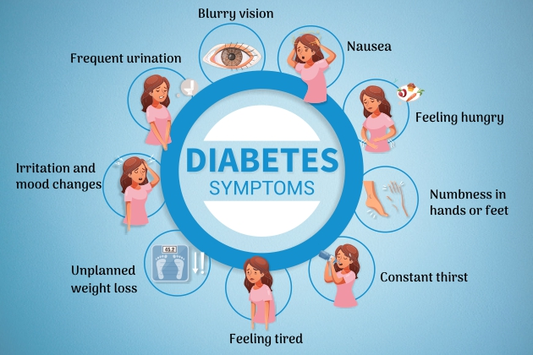

Fig 1.1. – Diabetes mellitus symptoms

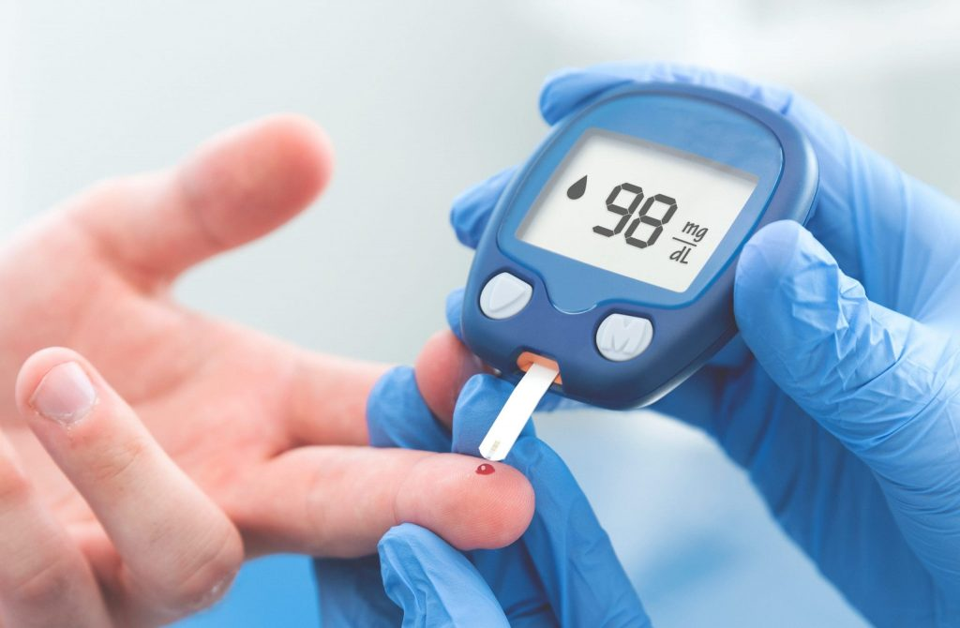

Fig 1.2. – Diabetes mellitus Testing
Treatment
Oral Antidiabetic Drugs
- Inhance Insulins secretion
- Overcome insulin resistance
- Retard carbohydrate absorption
- Miscellaneous drugs
- Inhance Insulins secretion
KAtp channel blockers
- Sulfonylureas
- Tolbutamide
- Glibenclamide
- Glipizide
- Gliclazide
- Glimepiride
- Meglitinide/Phenylalanine analogues
- Repaglinide
- Nateglinide
- Dipeptidyl peptidase-4 (DPP-4) inhibitors
- Sitagliptin
- Vildagliptin
- Saxagliptin
- Teneligliptin
- Alogliptin
- Linagliptin
- Overcome insulin resist
- Biguanide(AMP, activator)
- Metformin
- Thiazolidinedione (PPARvactivator)
- Pioglitazone
- Sod-glucose cotransport-2 (SGLT-2)inhibitor
- Dapagliflozin Canagliflozin
- Dopamine D2 agonist
- Bromocriptine
Modern techniques for Diabetes mellitus
Herbal medicine for Diabetes mellitus
- Herbal Products
- Cinnamomum zeylanicum
- Nigella sativa
- Olea europaea
- Citrus lemon
- Tymusserpyllum
- Herbal teas
- Trigonella foenum-graecum
Current medication prescribed for Diabetics mellitus
- glimepiride (Amaryl)
- glimepiride-pioglitazone (Due tact)
- gliclazide
- glipizide.
- glipizide ER (Glipizide XL, Glucotrol XL)
- glipizide-metformin.
- glyburide (Glynase)
- glyburide-metformin.
Operation for Diabetics mellitus
- Bariatric (weight -loss) surgery

- LITERATURE REVIEW

Ref. | Date | Subjects | Study results
Keinan-Boker et al | 2005 | Representative sample of 3246 individuals from the general Israeli population | In the subgroup of older Arab women, aged 55-64 yr, obesity reached 70%
Abdul-Ghani et al | 2005 | 95 randomly recruited Arab subjects who were overweight and over the age of 40 | 27% had undiagnosed DM, 42% impaired fasting glucose or impaired glucose tolerance, 48% metabolic syndrome
Abdul-Ghani et al | 2005 | 7434 patients from an outpatient clinic in an Arab village | The prevalence of diabetes type 2 in Arab patients younger than the age of 65 was significantly higher among women than men. Diabetic women were younger than men at diagnosis (48 yr vs 59 yr) and had a higher BMI
Kalter-Leibovici et al | 2007 | 880 randomly selected Arab and Jewish patients | The prevalence of obesity was 52% in Arab women compared to 31% in Jewish women and 25% in Arab men compared to 23% in Jewish men
Idilbi et al | 2012 | Review of official health statistics | The incidence rate of diabetes in the Israeli Arab population increased by 9.1 per 1000 persons annually. In contrast, it decreased among Jews
abara et al | 2007 | 546 women (102 Arabs) after cardiac catheterization | Arab women had a higher prevalence rate for diabetes (61% vs 46% in Jews)
Salameh et al | 2008 | 40 Arab and 179 Jewish women hospitalized with coronary artery disease | More Arab patients had diabetes (73% vs 40%)
Telman et al | 2010 | 727 Arab and Jewish patients of working age (< 65 yr) with stroke | There was a higher prevalence of diabetes in the Arab patients
Telman et al | 2010 | 546 patients with a first episode of primary intracerebral hemorrhage | Diabetes was more frequent among the Arab patients.
Aravind et al | 2011 | 1378 Muslim patients from five countries who were treated with sulfonylurea during Ramadan | The highest percentage of hypoglycemia (40%) was reported in patients from Israel
Greenberg et al | 2011 | 2000 patients with a first stroke (237 Arabs) | A high percentage of Arabs had diabetes (51.4% vs 35.8% in Jews)
Gross et al | 2011 | 1540 patients with acute ischemic stroke, 169 Arabs | Arab patients were more likely to have diabetes (OR 1.41)
Chorny et al | 2011 | 523 diabetic patients (Jews and Bedouins) who were examined by an ophthalmologist | The prevalence of maculopathy and retinopathy was higher among the Bedouins (22% vs 13.4%)
Nseir et al | 2013 | 3784 patients from hospitals with predominantly Arab patients | 39% of the hospitalized patients were diabetics. The diabetics had more hospitalizations due to atherosclerotic disease
Rabaev et al | 2014 | 220 patients admitted with diabetic ketoacidosis (19% Bedouins) | There was no difference in outcomes (in-hospital mortality, 30-d mortality) between Jews and Bedouins

- METHODOLOGY
Study Design:
- Understand How many people have hypoglycemia
- This Study focus on Knowing how many people have diabetes
- Which kind of medicine people are used
- What is the percentage of people obesity

Study site:
For The present study, a questionnaire was distributed to people living in the nearby localities mainly,
Tamluk, Barasat and Raiganj Participation in the survey was entirely voluntary and filling in the questionnaire, volunteers agreed in participation in the study.
Sample size:50
Inclusion criteria:Patients with diabetes mellitus is included in the study.
Exclusion criteria:Secondary data is research data that has previously been gathered and can be accessed by researchers. The term contrasts with primary data, which is data collected directly from its source.
Data collection:
Primary data-Primary data refers to the first hand data gathered by the researcher himself. Secondary data means data collected by someone else earlier.
Secondary data-Secondary data is research data that has previously been gathered and can be accessed by researchers. The term contrasts with primary data, which is data collected directly from its source.
Questionnaires:
A Standardized questionnaire was developed based on available literature and available questionnaires
- How many people have hypoglycaemia?
- Which types of medication are you been using for diabetes mellitus?
- Complications you have facing due to diabetes mellitus?
- What percentage people have obesity?
- Is there any kind of side effects using medicine?
Survey Questionnaire:
- Name of Patient
- Age
- Gender
- Have you been suffering from diabetes mellitus
- Have you any family history of diabetes mellitus
- Which types of medication are you been using for diabetesmellitus.
- Which types of medication are you been using for diabetes mellitus
- Name of the medicine which you used
- Is there any side effects of medication which you applied
- If yes which type of side effects you are facing from the mediacions
- Name of the medication which are currently using for diabetes mellitus

- RESULT AND DISCUSSION
THE PIE CHART AND GENDER DISPARITY:
67.9% of the population or group in question is male.
32.1% of the population or group in question is female.
In simpler terms, this chart is illustrating that there are more males than females in the population or group being studied. The percentages indicate the proportion of each gender within that population. The male population is significantly larger, comprising 67.9% of the total, while the female population is smaller, accounting for 32.1% of the total.

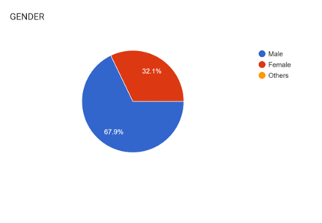
4.1 THE PIE CHART AND GENDER DISPARITY

PREVALENCE OF DIABETES MELLITUS:
Within the selected population, 33.9% of individuals have been diagnosed with diabetes, which means they have high blood sugar levels and require medical management. On the other hand, the remaining 66.1% of the population is categorized as non-diabetic, indicating that they do not currently have this medical condition. It highlights the prevalence of diabetes within the studied group and underscores the importance of diabetes prevention and management efforts, as well as healthcare resources allocation to cater to the specific needs of both diabetic and non-diabetic individuals in the population.
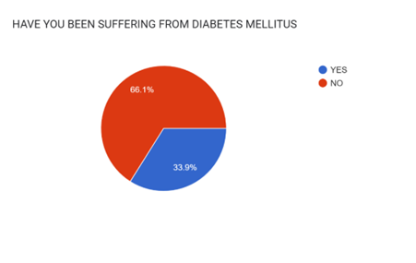
Fig 4.2 PREVALENCE OF DIABETES MELLITUS

FAMILY HISTORY AND GENETIC FACTORS:
Among the selected population 35.7% of the population has the family history of Diabetes Mellitus and 64.3% of them did not have any such history of Diabetes Mellitus.
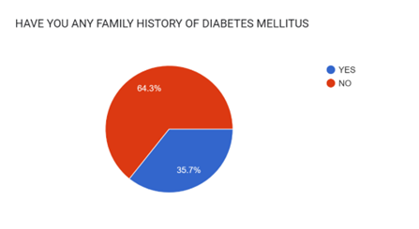
Fig 4.3. FAMILY HISTORY AND GENETIC FACTORS

COMPLICATIONS OF DIABETES MELLITUS:
The data concerning complications associated with Diabetes Mellitus is indeed worrisome. It highlights the multifaceted and potentially severe consequences of this chronic condition.
Cardiovascular Problems: Diabetes is a major risk factor for cardiovascular diseases such as heart attack and stroke. High blood sugar levels can damage blood vessels and increase the buildup of fatty deposits in arteries, leading to atherosclerosis. Comprehensive care should include regular monitoring of blood pressure, cholesterol levels, and blood sugar control to reduce the risk of heart-related complications.
Neuropathy: Diabetic neuropathy is nerve damage that can result in pain, numbness, and tingling in the extremities. It can also affect the digestive system, leading to problems like gastroparesis. Preventive measures include strict blood sugar control and managing risk factors such as smoking and excessive alcohol consumption.
Retinopathy: Diabetes can damage the blood vessels in the eyes, causing diabetic retinopathy and potentially leading to blindness if left untreated. Routine eye exams are crucial for early detection and intervention.
Nephropathy: Kidney damage, known as diabetic nephropathy, is another severe complication of diabetes. It can progress to kidney failure, necessitating dialysis or transplantation. Blood pressure control and blood sugar management are key preventive strategies.
These complications emphasize the critical importance of comprehensive diabetes care, including regular medical check-ups, medication adherence, a balanced diet, physical activity, and lifestyle modifications. Early detection of complications through screenings and the management of risk factors are essential components of diabetes management. Furthermore, patient education on self-care and the importance of regular follow-ups cannot be overstated. By addressing these aspects, healthcare providers can work towards reducing the impact of diabetes-related complications and improving the overall quality of life for individuals living with Diabetes Mellitus.

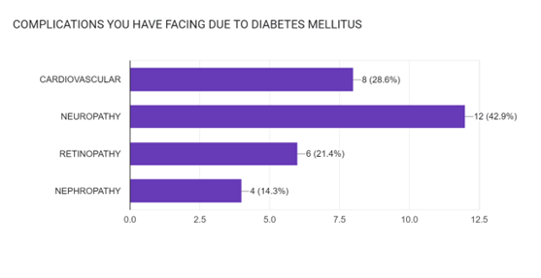
Fig 4.4. COMPLICATIONS OF DIABETES MELLITUS

SYSTEMS OF MEDICINE USED FOR THE MANAGEMENT OF DIABETES
There are several systems of medicine used for the management of diabetes. Here are some of the most prominent ones:
Allopathic or Western Medicine: This is the most common system for diabetes management and includes medications such as insulin, oral antidiabetic drugs (e.g., metformin, sulfonylureas), and newer medications like GLP-1 receptor agonists and SGLT-2 inhibitors. Allopathic medicine focuses on controlling blood sugar levels and preventing complications.
Ayurvedic Medicine: Ayurveda is an ancient Indian system of medicine that uses a combination of herbs, diet, and lifestyle modifications to manage diabetes. Herbs like bitter melon, fenugreek, and cinnamon are commonly recommended. Ayurvedic treatments aim to balance the body's doshas (energies) and improve overall health.
Traditional Chinese Medicine (TCM): TCM includes acupuncture, herbal remedies, and dietary therapy. Acupuncture may help regulate blood sugar levels, while specific herbs like Ginseng and Coptis chinensis are used to treat diabetes. TCM focuses on restoring the body's energy balance.
Homeopathic Medicine: Homeopathy uses highly diluted substances to stimulate the body's healing responses. It offers individualized treatments for diabetes based on the patient's specific symptoms and constitution.
Naturopathic Medicine: Naturopathic doctors use a holistic approach, emphasizing diet, exercise, and natural remedies. They may recommend herbal supplements, dietary changes, and stress reduction techniques for diabetes management.
Unani Medicine: Unani medicine, originating from ancient Greece, employs herbal medicines, dietary advice, and physical therapies. It aims to balance bodily humors (Mizaj) to treat diabetes.
Integrative and Complementary Medicine: Some individuals combine elements of various systems, like using herbal supplements alongside conventional medications or incorporating practices like yoga and meditation for stress management.
Over 62.1% of the population resided on Allopathic medicine for the treatment of Diabetes and 20.7% on ayurvedic medicine, 10.3% on homeopathic medicine, 5% of the population used other system and other 4.9% were not using any type of medicine.

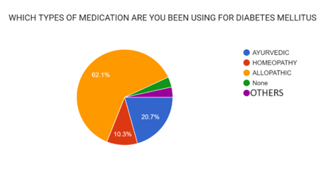
Fig 4.5 SYSTEMS OF MEDICINE USED FOR THE MANAGEMENT OF DIABETES

MEDICATIONS USED FOR THE MANAGEMENT OF DIABETES
There are several medications used for the management of diabetes, and they are categorized based on how they work to control blood sugar levels. Here are some of the common types of medications used for diabetes:
Insulin: Insulin is a hormone that helps regulate blood sugar levels. People with type 1 diabetes typically need to take insulin because their bodies do not produce it. Some individuals with type 2 diabetes may also require insulin therapy, especially if their blood sugar levels are not well controlled with other medications.
Metformin: Metformin is often the first-line treatment for type 2 diabetes. It helps lower blood sugar by reducing the amount of glucose produced by the liver and increasing the sensitivity of muscle cells to insulin.
Sulfonylureas: Medications like glipizide, glyburide, and glimepiride stimulate the pancreas to release more insulin. They are typically used in type 2 diabetes.
DPP-4 Inhibitors: DPP-4 inhibitors like sitagliptin and saxagliptin increase insulin release and decrease glucagon secretion. They are often used in conjunction with other medications for type 2 diabetes.
GLP-1 Receptor Agonists: Drugs like exenatide and liraglutide mimic the action of a hormone called GLP-1, which increases insulin release and reduces glucagon secretion. They also slow down stomach emptying, helping to control blood sugar levels. These are typically injectable medications.
SGLT-2 Inhibitors: Sodium-glucose co-transporter 2 inhibitors like canagliflozin and empagliflozin work by preventing the reabsorption of glucose by the kidneys, leading to increased glucose excretion in urine. They are used in type 2 diabetes.
Alpha-Glucosidase Inhibitors: Medications such as acarbose and miglitol slow down the digestion of carbohydrates, helping to prevent spikes in blood sugar after meals. They are often used in type 2 diabetes.
Meglitinides: Repaglinide and nateglinide are meglitinides that stimulate the pancreas to release insulin, particularly after meals. They are typically taken before each meal.
Thiazolidinediones (TZDs): Pioglitazone and rosiglitazone improve insulin sensitivity in muscle and fat cells. They are used in type 2 diabetes but are less commonly prescribed due to potential side effects.
Combination Medications: Some medications combine two or more diabetes drugs in a single pill, making it more convenient for patients to take their prescribed treatments.
The choice of medication(s) for diabetes management depends on various factors, including the type of diabetes, the individual's overall health, and the specific goals of treatment. It's essential for individuals with diabetes to work closely with their healthcare providers to determine the most suitable treatment plan
Majority of the population resided on Metformin, followed by Insulin and all other drugs were used less compared to metformin and insulin.
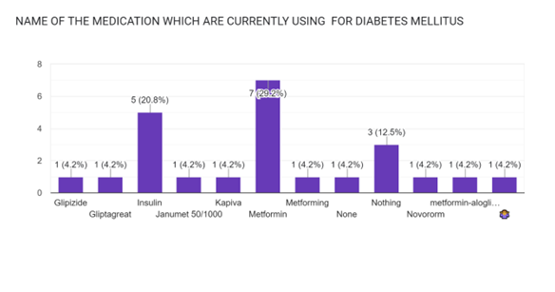
Fig 4.6 MEDICATIONS USED FOR THE MANAGEMENT OF DIABETES

MEDICATION-RELATED HEALTH ISSUES
The discovery of low blood pressure and dizziness among patients following medication use underscores the significance of medication safety and patient education. It's imperative for healthcare providers to inform patients about potential side effects, ensuring they are aware of warning signs like dizziness. This knowledge empowers patients to report adverse effects promptly, allowing for timely adjustments to their treatment plans. Healthcare professionals can also utilize this data to tailor medication choices and dosages more effectively, reducing the risk of undesirable side effects while still effectively managing Diabetes Mellitus. In essence, prioritizing patient education and medication safety measures is pivotal in optimizing diabetes management and enhancing the overall well-being of individuals undergoing treatment.

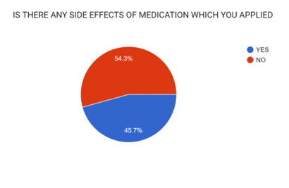
Fig 4.7 MEDICATION-RELATED HEALTH ISSUES

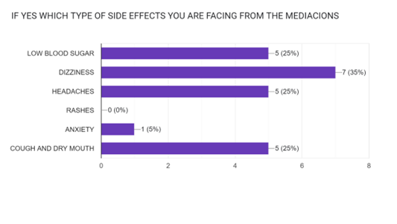
Fig 4.8 SIDE EFFECTS RELATED TO MEDICATION

INFORMATION OF REPORTING OF SIDE EFFECTS
Reporting side effects of medications is crucial for ensuring patient safety and improving the overall understanding of a drug's risks and benefits. Maximum of the patients were aware of reporting the side effects.

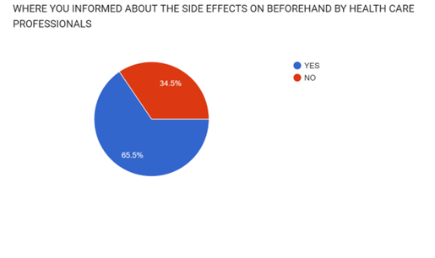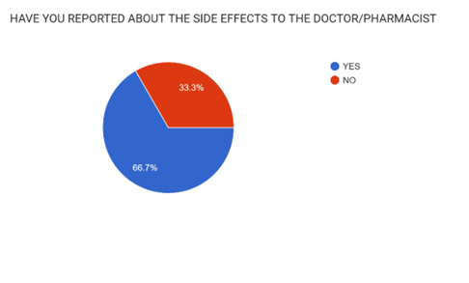

Fig 4.9: Number of patients being informed about side effects Fig 4.10: Number of patient who has informed about their side effects

AGE AND DIABETES
The heightened susceptibility to Diabetes Mellitus in individuals over 40 is in line with established age-related risk factors. As people age, they often experience decreased insulin sensitivity, weight gain, and reduced physical activity, all contributing to type 2 diabetes risk. Genetic predisposition and metabolic changes further amplify this risk. Therefore, there's a pressing need for proactive measures among older populations, including regular glucose monitoring and lifestyle interventions. These interventions, like maintaining a healthy weight and engaging in physical activity, can help mitigate diabetes risk, enhance overall health, and underline the importance of tailored healthcare strategies for aging individuals.

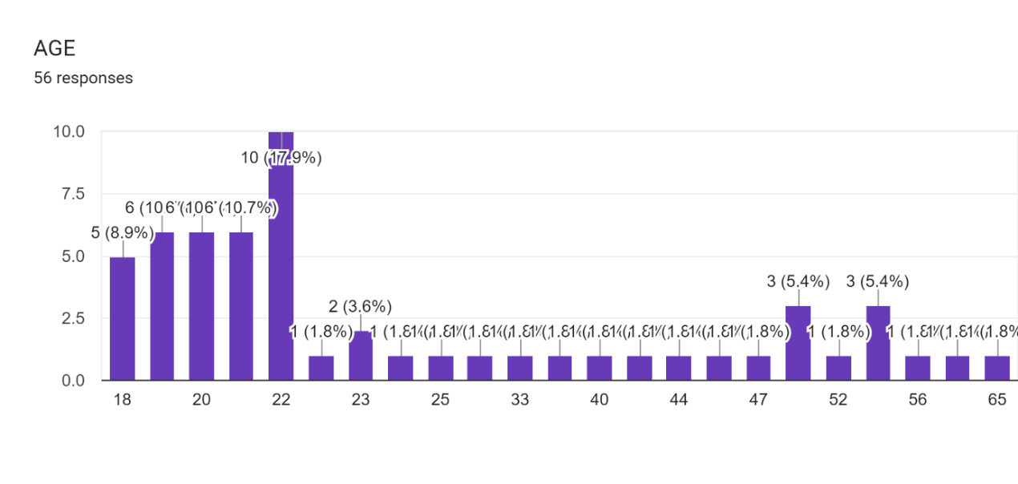
Fig 4.11: Relationship of Age and diabetes

DISCUSSION:
The results of the survey on Diabetes Mellitus patients reveal several significant findings that warrant discussion:
1. The Pie Chart and Gender Disparity:
The pie chart depicting gender distribution among Diabetes Mellitus patients clearly indicates that males are more prone to this medical condition. This observation prompts further investigation into potential gender-related risk factors, lifestyle choices, and genetic predispositions that might contribute to this disparity.
2. Prevalence of Diabetes Mellitus:
With 33.9% of the surveyed individuals suffering from Diabetes Mellitus, it underscores the substantial burden of this chronic condition within the studied population. This prevalence highlights the need for effective diabetes management strategies and awareness campaigns.
3. Family History and Genetic Factors:
A noteworthy 35.7% of patients reported having a family history of Diabetes Mellitus. This finding underscores the genetic component of the disease, emphasizing the importance of early screenings for those with a family history to mitigate risk.
4. Complications of Diabetes Mellitus:
The data regarding complications associated with Diabetes Mellitus is concerning. A significant portion of patients suffer from cardiovascular problems, neuropathy, retinopathy, and nephropathy, underscoring the importance of comprehensive care and preventive measures in managing these complications.
5. Medication Preferences:
The varied use of allopathic, ayurvedic, and homeopathic medicines for diabetes management indicates a diverse range of patient preferences and alternative treatment choices. Healthcare providers should be attentive to patients' preferences and potential interactions between different treatments.
6. Side Effects and Adverse Reactions:
A substantial 45.7% of patients reported experiencing side effects after using diabetes medications. This suggests a need for better monitoring of treatment responses and potentially exploring alternative medications with fewer side effects.
7. Medication-Related Health Issues:
The findings regarding low blood pressure and dizziness in patients after using medication highlight the importance of medication safety and patient education on potential side effects. This information can guide healthcare providers in addressing and managing these issues effectively.
8. Medication Choices:
The distribution of patients using different medications, such as Metformin tablets and insulin, reflects the diversity of diabetes management approaches. It's crucial for healthcare providers to tailor treatment plans to individual patient needs and preferences.
9. Age and Diabetes:
The observation that individuals above 40 years old are more susceptible to Diabetes Mellitus aligns with well-established age-related risk factors. This information reinforces the need for proactive screening and lifestyle interventions among older populations.
In summary, these survey results shed light on various aspects of Diabetes Mellitus, including its prevalence, complications, medication preferences, and associated health issues. These findings can guide healthcare professionals in developing more targeted and effective approaches to diabetes management and prevention. Moreover, they underscore the importance of personalized care and continuous monitoring for patients living with Diabetes Mellitus.
CONCLUSION :
In conclusion, the survey conducted on individuals suffering from Diabetes Mellitus has provided valuable insights into the current medication practices and requirements of this patient population. The findings suggest that there is a diverse range of medications being used to manage diabetes, reflecting the individualized nature of diabetes treatment. Additionally, the survey has highlighted the importance of regular updates and adjustments to medication regimens to ensure optimal glycemic control and overall well-being. It is clear that healthcare providers must continue to closely monitor and adapt diabetes treatment plans based on individual needs and the evolving landscape of diabetes management. The information gathered from this survey will serve as a foundation for healthcare professionals to better tailor their approaches to medication management for diabetic patients, ultimately contributing to improved health outcomes and quality of life for those living with Diabetes Mellitus.

Reference
- 'CDC (2017) Centre for disease control and prevention. National diabetes SCA Mistics report: estimates of diabetes and its burden in the United SCAMes."1.D Atlas (2017) IDF diabetes atlas International Diabetes Federation, Brussels.'Satman (2013) Twelve-year trends in the prevalence and risk factors of diabetes and prediabetes in Turkish adults. European journal of epidemiology 28: 169-180
- "Taylor R. Pathogenesis of type 2 diabetes: Tracing the reverse route from cure to cause Diabetologia. 2008;51:1 781-1789'Despres JP Poirier P. Diabetes: Looking back at a look AHEAD- giving lifestyle a chance Nature Reviews Cardiology. 2013;10:184-186Heinemann L Flemming GA, Petrie JR, Holl
- RW, Bergenstal RM, Peters AL. Insulin pump risks and benefits: A clinical appraisal of pump safety standards, adverse event. Pharmacology-(K.D Tripathi).

