Data Science Tools and Techniques
Mr. Abhineet Samadhiya Dr. Niranjan M Damle
Assistant Professor Assistant Professor
Department of Mechanical Engineering Department of Civil Engineering
Gyan Ganga College of Technology, Jabalpur Gyan Ganga College of Technology, Jabalpur
abhineetsamadhiya@ggct.co.in Niranjanmdamle@ggct.co.in

Abstract:
The Almighty has endowed human beings with diverse wants and needs, which are intricately connected to their own data, choices, and preferences. For the growth and advancement of any business or organization, it is imperative to understand the demands of their clients or customers based on their data. The evolving role of data has elevated it to a vital element within any organization, influencing various essential operations. In this paper, we aim to present a comprehensive study of Data Science and its relevance to Artificial Intelligence, machine learning, and deep learning. The integration of these intellectual disciplines into data science proves highly beneficial for performing a multitude of operations. In our research, we strive to illustrate various data science processes, including data cleaning, data processing, data modelling, data visualization, and techniques for presenting data effectively. To foster the growth of any business, it is essential to understand customer needs and anticipate their future expectations through intelligent decision-making. The application of intellectual algorithms and data operations within the field of data science enhances the effectiveness of decision-making processes and policies. Furthermore, our focus extends to how data science incorporates mathematical and statistical methods, along with logical reasoning, through the utilization of Artificial Intelligence techniques. We also explore the array of data operation tools available in the market, such as Python, SAS, R, and others. In conclusion, we delve into how the field of data science is poised to meet the future expectations of many businesses. This research paper serves as a valuable reference for individuals conducting research and seeking to align with the evolving landscape of data science to make informed business decisions.
Keywords : Artificial Intelligence (A.I.), Machine Learning (M.L.),Internet of Things (IOT’s) Data Science, Data Analysis, Data Processing, Data Presentations and Data Science Careers
INTRODUCTION
Artificial Intelligence (AI) and its Intersection with Data Science:AI is fundamentally concerned with creating systems that possess intelligence comparable to human capabilities. Achieving intelligent systems involves incorporating computers with the ability to learn, process information, and make decisions [1]. These capabilities are underpinned by a wealth of knowledge that enables systems to undergo training and develop intelligent behaviour. AI encompasses a diverse array of approaches to learning, understanding, and processing that can be applied across various problem domains. Some of the most prominent AI techniques include Heuristics, Support Vector Machines, Artificial Neural Networks, and Markov Decision Processes [1]. AI is renowned for its wide-ranging applications, including natural language processing, intelligent data retrieval, expert systems tailored to specific domains, theorem proving, game playing, solving scheduling and combinatorial problems, robotics, and more [2]. The connection between AI and Data Science becomes evident due to the pervasive use of data in nearly all aspects of human life. Data is collected by various businesses and sectors to gain insights into how they can innovate and progress. In this context, Data Science plays a crucial role throughout the data lifecycle, encompassing tasks from data collection to visualization.

Data and Its Operations:
Data serves as the fundamental building block for the growth and development of individuals, organizations, and businesses in the future era [9]. Technology plays an increasingly prominent role in the transformation of raw data into valuable insights across all disciplines of society [9]. The primary objective is to extract utility from data through the application of statistical and logical techniques. These techniques encompass defining the scope of data, describing its characteristics, and processing it to extract meaningful information.
Before delving into the depths of tools, operations, processes, methodologies, algorithms, and techniques for data manipulation, it is imperative to conduct a comprehensive analysis of the data. Data can take various forms, such as text, numerical, pictorial, images, audio, video, and sensor data [8]. These data must undergo specific operations to transform them into valuable assets for society. It's essential to ensure that all data operations adhere to social, professional, and ethical values, as well as legal regulations.
The Evolution of Machine Learning and Its Relevance with Data Science:
To comprehend the definition of Machine Learning (ML), it's essential to trace its historical development over six decades, beginning in 1950 when Alan Turing introduced the concept of machine computing and intelligence [3]. ML is considered a subset of practical AI-based algorithms, focusing on a wide variety of data from various domains. ML systems are designed to learn from existing data samples or derive new rules to identify and process new sets of data efficiently. Unlike traditional algorithms, ML employs supervised, unsupervised, semi-supervised, and reinforcement learning methods [3]. ML has found applications in diverse domains such as game analytics, software, voice recognition, stock trading, and the Internet of Things (IoT) [3]. Data Science plays a pivotal role by providing the necessary data to facilitate effective ML algorithms. ML techniques are employed to automatically uncover valuable patterns within complex data that would be challenging to discern manually.
The Role of Data Science in Conjunction with Artificial Intelligence and Machine Learning:
To address the evolving business needs of individuals and organizations, harnessing data effectively is imperative. Furthermore, rectifying the shortcomings observed in previous data-related projects is a significant concern [8]. Data can be analyzed based on its type, including text, statistical, predictive, and perspective data. Data Science encompasses a multitude of statistical practices, while AI focuses on the intelligent utilization of computer algorithms. AI emphasizes granting autonomy to data models and can be viewed as an amalgamation of traditional fields like statistics, data mining, distributed systems, and databases [4][7].
Ongoing research endeavours should integrate Data Science to benefit individuals, organizations, businesses, society, communities, and educational institutions across various domains [4]. Data Science addresses the challenges posed by big data, involving operations such as data cleaning, training, analysis, processing, modelling, and more. A data scientist collects data from various sources and employs machine learning algorithms to extract valuable insights. Data Science serves as a subset of machine learning and enhances critical thinking, predictive analytics, domain knowledge, and sentiment analysis. It is expected to drive innovation in applied computing, medical sciences, professional and social activities, computing paradigms, data management systems, and more, ultimately facilitating better decision-making [5]. This discipline encourages the development of novel methods to enhance intellectual thinking about data usage, organization, processing, loading, modelling, and visualization [6]. The emerging profession in the field of data science, the data scientist, commands a median salary of $124,000 and is poised for significant growth in the coming years [7].
Various tools are available to execute data science activities, including SAS, Orange, R, Python, Tableau, Tanagra, Rapid Miner, and WEKA [7]. Primary data operations encompass cleaning raw data, loading data onto server systems, data processing, data visualization, and data acquisition from various stakeholders. Below, we delve into techniques related to data requirements, data analysis, data processing, data visualization, and data modelling. Additionally, we explore various tools that support these data science operations for data scientists.
The Significance of Data Science in Conjunction with Artificial Intelligence and Machine Learning: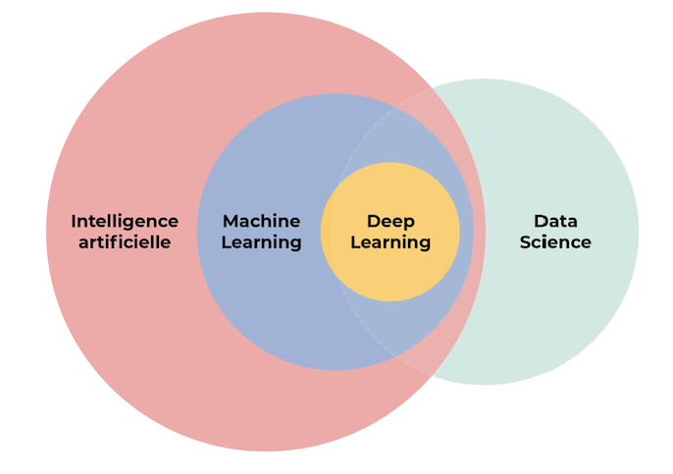
Figure 1. Significance of Data Science with A.I and M.L
The field of Data Science relies on AI algorithms and machine learning to facilitate effective and valuable decision-making. These decisions are tailored to users' preferences regarding how they want their data to be presented, whether in statistical, visual, textual, or other formats. The manner in which data is presented is closely linked to data processing, which is achieved through the application of machine learning and AI algorithms. These algorithms are implemented using statistical, analytical, and mathematical methods.
II. LITERATURE REVIEW
The study of Artificial Intelligence goes beyond just thinking and analysis; it involves the creation of intelligent systems capable of performing intelligent functions, as Peter Norvig and others noted in 2016. These intelligent functions encompass rational thinking and action while considering performance factors like cost reduction and avoiding redundant tasks. These intelligent systems are designed to draw valid conclusions from uncertain computer information, as articulated by Stuart Russell and others in 2016.
Traditional approaches to artificial intelligence seek to bridge the gap between theory and practice, as emphasized by Nilsson and others in 2014. These AI concepts find applications in various areas, including natural language processing, robotics, machine vision, theorem proving, and data retrieval.
The inception of Artificial Intelligence can be traced back to Alan Turing, a British mathematician and philosopher who questioned why machines couldn't think on their own. Samuel discussed machine learning as the study of the ability to learn without extensive programming skills. Machine learning can address a range of problems, including manual data entry, medical diagnosis, financial analysis, and various logical operations on datasets.
Many organizations struggle to effectively utilize the data collected from their customers, often referred to as big data. This data can undergo various processing operations such as saving, processing, transformations, visualizations, loading into servers, and presentation. These operations deal with aspects like data growth, storage, data authentication, data security, and organizational resistance. Data science plays a pivotal role in performing these operations, involving tasks such as data collection, data cleaning, data analysis, data processing, data loading on server-side, and data modelling or presentation. Data science encompasses mathematical and statistical techniques, deep learning, machine learning, artificial intelligence, analytical reasoning, database management, and optimization techniques.
Challenges in data science include data separation, domain-specific knowledge, data structuring, algorithm selection, and result presentation. Data scientists, often a group of software professionals, focus on data acquisition, innovative data analysis methods, data organization, data evaluation, and data presentation. Efficient data operations are essential for businesses, and technology has evolved to provide tools for data acquisition, analysis, processing, loading, and presentation. These tools must address various issues related to big data, memory constraints, interactive environments, algorithm selection, and unstructured data.
To meet business demands, it's crucial to ensure effective data utilization, from data acquisition to data presentation. This involves addressing data capabilities, inefficiencies, and mechanisms. Various tools are available in the market for data operations, each with its strengths and weaknesses. These tools facilitate data acquisition, analysis, processing, loading, and presentation. Additionally, certifications are available for those aiming to become certified data science and analytics professionals. The exponential growth of massive data requires the development of effective algorithms. Big data analytics involves mapping or analyzing internal data with external data, and this process helps in making informed decisions.
As data processing becomes more critical due to the proliferation of the Internet of Things (IoT) and the internet, various technologies track big data changes over its transformation. These technologies mainly provide read access from an analytical system perspective.
However, these data processing tools, such as Weka, Orange, and Rapid Miner, while offering advantages, also have their disadvantages. S.Subhitsha, S.Selvakumar, V.P.Sumathi, and others in 2017 discuss the features, advantages, and disadvantages of these software tools.

III. METHODOLOGY FOR DATA ANALYSIS
The study of Artificial Intelligence goes beyond just thinking and analysis; it involves the creation of intelligent systems capable of performing intelligent functions, as Peter Norvig and others noted in 2016. These intelligent functions encompass rational thinking and action while considering performance factors like cost reduction and avoiding redundant tasks. These intelligent systems are designed to draw valid conclusions from uncertain computer information, as articulated by Stuart Russell and others in 2016.
Traditional approaches to artificial intelligence seek to bridge the gap between theory and practice, as emphasized by Nilsson and others in 2014. These AI concepts find applications in various areas, including natural language processing, robotics, machine vision, theorem proving, and data retrieval.
The inception of Artificial Intelligence can be traced back to Alan Turing, a British mathematician and philosopher who questioned why machines couldn't think on their own. Samuel discussed machine learning as the study of the ability to learn without extensive programming skills. Machine learning can address a range of problems, including manual data entry, medical diagnosis, financial analysis, and various logical operations on datasets.
Many organizations struggle to effectively utilize the data collected from their customers, often referred to as big data. This data can undergo various processing operations such as saving, processing, transformations, visualizations, loading into servers, and presentation. These operations deal with aspects like data growth, storage, data authentication, data security, and organizational resistance.
Data science plays a pivotal role in performing these operations, involving tasks such as data collection, data cleaning, data analysis, data processing, data loading on server-side, and data modeling or presentation. Data science encompasses mathematical and statistical techniques, deep learning, machine learning, artificial intelligence, analytical reasoning, database management, and optimization techniques.
Challenges in data science include data separation, domain-specific knowledge, data structuring, algorithm selection, and result presentation. Data scientists, often a group of software professionals, focus on data acquisition, innovative data analysis methods, data organization, data evaluation, and data presentation.
Efficient data operations are essential for businesses, and technology has evolved to provide tools for data acquisition, analysis, processing, loading, and presentation. These tools must address various issues related to big data, memory constraints, interactive environments, algorithm selection, and unstructured data.
To meet business demands, it's crucial to ensure effective data utilization, from data acquisition to data presentation. This involves addressing data capabilities, inefficiencies, and mechanisms.
Various tools are available in the market for data operations, each with its strengths and weaknesses. These tools facilitate data acquisition, analysis, processing, loading, and presentation. Additionally, certifications are available for those aiming to become certified data science and analytics professionals.
The exponential growth of massive data requires the development of effective algorithms. Big data analytics involves mapping or analyzing internal data with external data, and this process helps in making informed decisions.
As data processing becomes more critical due to the proliferation of the Internet of Things (IoT) and the internet, various technologies track big data changes over its transformation. These technologies mainly provide read access from an analytical system perspective.
However, these data processing tools, such as Weka, Orange, and Rapid Miner, while offering advantages, also have their disadvantages. S.Subhitsha, S.Selvakumar, V.P.Sumathi, and others in 2017 discuss the features, advantages, and disadvantages of these software tools.
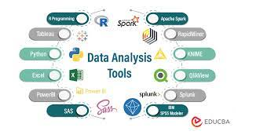
Figure 2. Data Analysis Tools
a. Microsoft Excel: Excel, a product within the Microsoft Office suite, is a versatile tool for performing mathematical, statistical, and analytical operations. Widely used in various organizations, Excel plays a crucial role in analyzing user requirements and presenting information in a user-friendly manner. It is frequently employed in business analytics, facilitating the automatic detection of relationships. Excel is also instrumental in creating budget sheets for personal and business use.
b. R Programming Language: R is a free software programming language supported by the R Foundation for statistical computing. Data analysts extensively utilize the R Language for data mining and statistical analysis. It serves as an analytical tool for extracting and presenting data in diverse ways across many organizations.
c. Tableau Public: Tableau Public is an interactive and free environment that allows users to visualize their data on the web. This software enables users to embed interactive visualizations, known as "vizzes," into web pages, blogs, and share them through social media. Tableau Public does not require extensive programming and can connect to various databases to generate and display information.
d. Python: Python, developed by Guido van Rossum in the early 1980s, is a dynamic, high-level programming language that supports both structured and object-oriented programming. It is known for its rich library of open-source resources and is suitable for implementing a wide range of tasks. Python can seamlessly integrate with various platforms, including MongoDB, JSON, SQL servers, and more.
e. SAS (Statistical Analysis System): SAS, short for Statistical Analysis System, was developed by the SAS Institute in the 1980s and 1990s. It provides a programming environment for data management and analytical operations. SAS is used to handle data from diverse sources, enabling tasks like client profiling and identifying future opportunities. SAS modules are applied in web analytics, social analytics, and market analytics.
f. Apache Spark: Apache Spark originated at the University of California, Berkeley, in 2009 at the AMP Lab of Berkeley. It is utilized for micro-batching in real-time streaming, analyzing vast amounts of data from various sources. Similar to Hadoop, Apache Spark works by distributing data across multiple clusters and processing it in parallel.
These data analysis tools serve as indispensable resources for organizations, allowing them to efficiently manage, analyze, and present data for informed decision-making and business growth.

IV. METHODOLOGY FOR DATA PROCESSING
Data is a critical asset for any organization, and its effective utilization is key to making informed decisions and driving growth. After data collection and analysis, the next crucial step is data processing, which involves several important stages. As outlined in [12], various big data technologies have been developed and categorized into data processing concepts. One commonly used example is Hadoop, which serves as a storage solution for large datasets in many organizations.

a. Data Grouping and Storage: Data must be collected from various sources and stored in appropriate locations. Organizing data based on its intended applications is essential.

b. Cross-Verification: After data collection, it is important to verify the sources from which the data was collected or generated.

c. Data Conversion: Data may need to be converted into specific formats based on its intended application.

d. Data Cleaning and Removal: Data cleaning is a crucial step to remove unwanted or irrelevant data that could lead to inaccurate outputs.

e. Data Separation and Sorting: Data should be categorized into different subsets, and meaningful relationships should be established between these subsets. This can involve identifying patterns and forming connections between groups.

f. Selection of Techniques: Choosing the right data processing techniques is vital to achieving the desired outputs. It's essential to have mechanisms in place to prevent errors and recover from any issues. Applying E.T.L. (Extract, Transform, Load) functions can help validate data sets and groups.

g. Data Summarization and Reporting: Results obtained from different data groups need to be combined and summarized.

h. Data Presentation: After all data processing operations, the data should be presented or modeled in a clear and meaningful way.

i. Maintenance: It's important to test the output against the initial requirements to ensure accurate and effective delivery.

B. Data Processing Operations:
Data processing methods depend on the specific applications for which the data will be used. Different types of data processing include:

a. Data Processing for Scientific Purposes: Data collected and processed for scientific study and research must be accurate and error-free.

b. Commercial Data Processing: This system handles and processes large volumes of data at high speeds. It serves multiple users and minimizes errors. Examples include airports, universities, supermarkets, and online shopping.

c. Automatic vs. Manual Data Processing: Manual data processing involves performing logical, arithmetic, statistical, and analytical operations manually or with the help of machines. It is suitable for small-scale organizations but not efficient for large businesses. Automatic data processing, on the other hand, is computerized and less error-prone, making it suitable for organizations of all sizes.

d. Batch Processing: This method processes jobs from various users in the order they are received, reducing processing costs and ensuring efficiency.

e. Real-Time Data Processing: This type of processing is ideal for real-time applications, providing quick results. It requires an internet connection and is used in sectors like banking and airline reservations.

f. Distributed Processing: Remote workstations are connected to a central server, such as ATM machines. All end-user machines operate according to the central machine.

g. Online Processing: Online data processing allows data entry, processing, and report generation through computerized systems. It is exemplified by automated sales systems.

h. Multi-Processing: Multiple CPUs work in parallel, distributing tasks to increase efficiency and throughput.

i. Time Sharing: Single-core CPUs are allocated time slices for multiple users to execute their processes or jobs.

C. Data Processing Tools:
Data processing tools are essential to streamline and automate data processing tasks. These tools include:

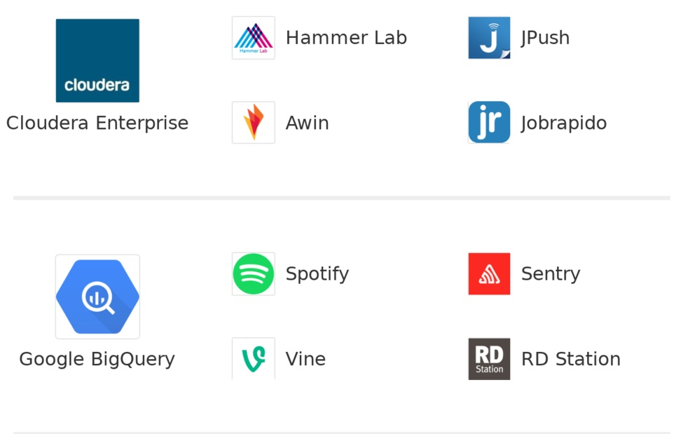
Figure 3: Fig: Data processing tools

a. Google BigQuery: This product, developed by Google, is a comprehensive and fully-managed enterprise data warehouse designed for analytics. It operates on a serverless architecture, allowing organizations to analyze a wide range of data sources. Google BigQuery creates a logical data warehouse over managed, columnar storage, and can process data from object storage and spreadsheets. It supports real-time data ingestion and is built on the Google Cloud Platform. Users can easily share insights using datasets, queries, spreadsheets, and reports.

b. Amazon Web Services (AWS): As mentioned in [17], AWS offers Amazon Redshift, a fully managed data warehouse capable of handling petabyte-scale data. It is compatible with an organization's existing analytics software and simplifies administrative tasks related to cloud data warehousing. Redshift provides continuous, incremental, and automatic backups to Amazon S3. Additionally, it features Redshift Spectrum, enabling users to directly run SQL queries on large volumes of unstructured data without the need for data loading or transformation.

c. Horton works: Horton works, highlighted in [17], specializes in the development and support of Apache Hadoop. Hortonworks DataFlow (HDF) effectively manages streaming data by securely acquiring and transporting it to the Hortonworks Data Platform. The solution offers comprehensive data organization and management across various data types. Hortonworks also collaborates with Microsoft for hybrid deployments and provides an HDP version on Amazon Web Services.

d. Cloudera: Cloudera, as discussed in [17], offers a data storage and processing platform based on the Apache Hadoop ecosystem. It provides both open-source components and proprietary tools for system and data management. Cloudera's platform covers design, deployment, operations, and production management. What sets Cloudera apart is its continued investment in specific capabilities, such as enhancements to Cloudera Navigator, which offers features like metadata management, lineage tracking, and auditing, all while keeping pace with the evolving Hadoop open-source project.

V. METHEDOLOGY FOR DATA PRESENTATIONS

Data presentations serve as the frontend for delivering data after it has undergone the processes of data analysis and data processing. This final step ensures that data is presented in a format that aligns with the preferences of the end user. While there are numerous tools available for data visualization, let's focus on a few of them:

a. Google Public Data Explorer: This tool, as described in [18], offers a free platform for sharing various datasets. It provides an interactive interface for data visualization and presentation, allowing users to track changes in datasets. Google Public Data Explorer enables users to create a wide range of visual elements, including pie charts, bar graphs, color representations, graphs, shapes, and more.

b. Tableau Public: As mentioned in [18], Tableau Public is designed to create a web-based interface for accessing, downloading, and visually representing data. It offers a free version that allows users to work with various datasets and provides multiple formatting options for data representation. Data saved in Tableau can be accessed not only on local computers but also via the internet, ensuring round-the-clock accessibility. Tableau Public boasts over 57,000 accounts from various organizations, making it a popular choice for storing, accessing, and presenting data.

c. Word Clouds: Word clouds, also known as wordles, word collages, or tag clouds, are utilized for visually representing words, as indicated in [19]. Users can create wordle galleries for interactive data visualization and storage across various cloud platforms.

VI. ROLE OF DATA SCIENTIST

A Data Scientist is a professional who specializes in the logical transformation of data into valuable and meaningful forms [10]. With the rapid advancement of various data types, Data Scientists are tasked with various levels of data handling, including data cleaning, data loading, data modeling, data processing, and data evaluation. Given that data is gathered from diverse fields, Data Scientists must possess expertise in a wide range of areas, such as Artificial Intelligence (AI), Machine Learning (ML), robotics, biotechnology, statistical methods, analytical techniques, medical sciences, mathematical procedures, and the Internet of Things (IoT) [10].

**A. Data Scientist's Role in Organizations:**
- Utilize data effectively to drive business growth.
- Develop mechanisms for acquiring data from various sources.
- Cleanse and preprocess data.
- Implement AI algorithms, including deep machine learning.
- Apply analytical, statistical, and logical reasoning methods.

**B. Applications of Data Science, as discussed in [15]:**
Data Science has become integral to virtually all global organizations, as data is a fundamental asset for improving operations. Various sectors, including banking, financial institutions, automation and engineering, transportation, e-commerce, and education, rely on data science.

**C. Role of Data Science in Banking and Financial Institutions:**
Data Science aids banking sectors in making informed decisions, predicting and preventing fraud, and managing customer data efficiently. It assists in customer retention, investment planning, and personalized financial services.

**D. Role of Data Science in Education:**
Data Science plays a crucial role in enhancing educational activities. It improves student learning by analyzing their skills and tailoring learning approaches accordingly. Data helps in assessing students' needs, emotional and social development, cognitive skills, and overall performance.

**E. Role of Data Science in Healthcare:**
Data Science contributes to maintaining patient records, predictive modeling, data visualization, and scalable algorithms. It utilizes cloud computing for data storage and processing, benefiting medical devices like sensors, imaging, spectroscopy, and microscopy.

**F. Data Science in Digital Marketing:**
Data Science has revolutionized digital marketing by leveraging social media platforms like Facebook and Amazon. It enables businesses to connect with customers online and tailor marketing strategies based on customer behavior and preferences.

**G. Role of Data Science in Automated Language Analysis:**
Automated language analysis is in demand, especially for advertisements that depend on customer moods. Data Science helps analyze language sentiment and optimize marketing strategies accordingly.

**H. Role of Data Science in Weather Prediction:**
Data Science employs deep machine learning techniques for weather forecasting and prediction. Accurate data acquisition is essential for making informed decisions related to events, sports, public addressing, and more.

**I. Data Science Contributions for the Future:**
Data Science integrates advanced technologies like AI, IoT, deep learning, and machine learning. It emphasizes the need for statistical, mathematical, and logical reasoning concepts. Proper data handling mechanisms are essential to harness the potential of data effectively.

Reasons for the importance of data science in businesses include data mishandling, data protection, rapid data growth, increased demand for data scientists, natural language processing, automated data cleansing, improved business intelligence, predictive analytics, and the need for enhanced social media applications.

**Data Science Careers:**
The growth of organizations relies heavily on making informed decisions, necessitating the hiring of skilled Data Scientists. Career opportunities in data science include Business Intelligence Developer, Data Architect, Applications Architect, Infrastructure Architect, Enterprise Architect, Data Analyst, Data Scientist, Data Engineer, Machine Learning Scientist, Machine Learning Engineer, Statistician, and more.
VII. RESULTS

The below table is based upon the methodologies discussed for Data analysis, processing & presentation various tools or software’s can be used. This table also focuses on data science perspective, applications of data science over various fields to grow the organizations. It also focuses on data scientist carrier option for the future
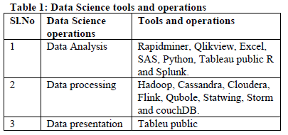

1 Data Analysis Rapidminer, Qlikview, Excel, SAS, Python, Tableau public R and Splunk.

2 Data processing Hadoop, Cassandra, Cloudera, Flink, Qubole, Statwing, Storm and couchDB.

3 Data presentation Tableu public.

VIII. CONCLUSION

Know a day’s data science becomes as a mandatory field which coordinates between multi disciplines like mathematics, statistical approaches, mathematical methods, logical reasoning, intelligence algorithms and machine learning practical’s. All these fields correlate to access the data from various business or organizations and make use of them in effective means. These effective use of data leads to perform proper decision making to grow business further on the basis of customer chooses and satisfaction. Hence we can conclude that rise of data science field can demand more positions of data scientists to grow in each organization. At last we focus on how successful carriers can be built in the field of data science. The main beauty of this field it used to grow all businesses.

REFERENCES

1. Russell, Stuart J., and Peter Norvig. Artificial intelligence: a modern approach. Malaysia; Pearson Education Limited,, 2016.

2. Nilsson, Nils J. Principles of artificial intelligence. Morgan Kaufmann, 2014. 3.

3. Bell, Jason. Machine learning: hands-on for developers and technical professionals. John Wiley & Sons, 2020.

4. Van Der Aalst, Wil. "Data science in action." Process mining. Springer, Berlin, Heidelberg, 2016. 3-23.

5. Dhar, Vasant. "Data science and prediction." Communications of the ACM 56.12 (2013): 64-73.

6. Hazen, Benjamin T., et al. "Data quality for data science, predictive analytics, and big data in supply chain management: An introduction to the problem and suggestions for research and applications." International Journal of Production Economics 154 (2014): 72-80.

7. Wimmer, Hayden, and Loreen Marie Powell. "A comparison of open source tools for data science." Journal of Information Systems Applied Research 9.2 (2016): 4.

8. Islam, Mohaiminul. "Data Analysis: Types, Process, Methods, Techniques and Tools." International Journal on Data Science and Technology 6.1 (2020): 10.

9. Nicolae, Bogdan, et al. "Park, Yoonho. Leveraging Adaptive I/O to Optimize Collective Data Shuffling Patterns for Big Data Analytics. IEEE TRANSACTIONS ON PARALLEL AND DISTRIBUTED SYSTEMS. PP (99) pp: 1-13." (2020).

10. Abas, Zuraida Abal, et al. "Analytics: A Review Of Current Trends, Future Application And Challenges." Journal of Advanced Computer Technology. PP 3560 (2020): 3565.

11. Rani, Bindu, and Shri Kant. "An Approach Toward Integration of Big Data into Decision Making Process." New Paradigm in Decision Science and Management. Springer, Singapore, 2020. 207-215.

12. Bejjam, Suvarnamukhi & Seshashayee, M.. (2018). Big Data Concepts and Techniques in Data Processing. International Journal of Computer Sciences and Engineering. 6. 712-714.

13. Choudhury, .Amitava, and Kalpana Rangra. "Trends and Technologies.

