Chapter Title: Embracing the Digital Era: Transforming Prosthodontics through Technological Innovations
Authors:
Dr. Lakshya Kumar
Additional Professor
Department of Prosthodontics and Crown & Bridge
King George’s Medical University

Dr. Aditi Verma
Senior Resident
Department of Prosthodontics and Crown & Bridge
King George’s Medical University

Dr. Akansha Yadav
PhD Scholar
Department of Oral and Maxillofacial Surgery
King George’s Medical University

Abstract
“In the rapidly evolving field of prosthodontics, a digital revolution is underway, reshaping the way we approach patient care, diagnostics, and treatment planning. The integration of advanced technologies and digital workflows has ushered in a new era, offering unprecedented precision, efficiency, and aesthetic outcomes. This chapter explores the transformative power of the digital era in prosthodontics, highlighting the key advancements, benefits, and implications for both clinicians and patients.”
Introduction:
Dentistry has a rich history dating back to the 18th century when materials like waxes and plaster of Paris were used for dental impressions. The early dental equipment consisted of manually operated motors, which later advanced to water-driven mechanisms. Over the years, extensive research and technological advancements have transformed the field, providing a wide range of options for oral health preservation and achieving natural-looking aesthetics. With improved techniques, reduced treatment duration, minimized risks, and enhanced quality control, modern dentistry has earned the title of the golden age of dentistry. The development of computer-aided design and computer-aided manufacturing (CAD-CAM) ceramics has further revolutionized the field, enabling the possibility of completing restorative dental procedures in a single visit. This remarkable progress is the result of the dedication and visionary efforts of researchers, scientists, and practitioners in the dental community.(1-5)
Prosthodontics, the branch of dentistry dedicated to restoring and replacing missing teeth, has witnessed a remarkable transformation in recent years. The advent of digital technologies has revolutionized the field, empowering clinicians with powerful tools that have fundamentally changed treatment planning, diagnostics, and patient outcomes. From virtual smile design and digital mock-ups to virtual wax-ups and advanced digital diagnostics, these technological innovations have reshaped the way prosthodontic care is delivered. In this chapter, we will explore the profound impact of digital technologies in prosthodontics, examining their benefits, supported by relevant evidence, case studies, and practical examples.
Digital technologies have emerged as game-changers, facilitating precise and predictable treatment outcomes while enhancing patient communication and involvement in the treatment process. Through the use of sophisticated software and hardware, clinicians can now visualize, plan, and communicate treatment options with greater accuracy and efficiency. Digital workflows enable the creation of virtual smile designs, providing a visual representation of the desired aesthetic outcomes and fostering improved communication between clinicians and patients (Abduo and Lyons, 2018). With digital mock-ups, clinicians can digitally simulate proposed dental restorations, allowing patients to actively participate in decision-making and providing them with a realistic preview of the final results before any treatment commences (Abduo and Lyons, 2018).
Moreover, virtual wax-ups have replaced traditional physical wax-ups, enabling clinicians to digitally design the shape and contours of dental restorations, leading to enhanced accuracy, efficiency, and ease of modifications (Liu et al., 2019). These advancements in treatment planning have not only improved outcomes but also significantly reduced chairside time, benefiting both patients and clinicians.
In addition to treatment planning tools, digital diagnostics have played a pivotal role in prosthodontics. Cone beam computed tomography (CBCT) provides detailed three-dimensional information about the patient's dental and skeletal structures, enabling accurate implant placement, bone assessment, and comprehensive treatment planning (Sun et al., 2017). Intraoral scanning has revolutionized the impression process, eliminating the discomfort associated with traditional impressions and enhancing patient experience (Mangano et al., 2019). With digital diagnostics, patients can actively engage in the treatment process, better understand their oral conditions, and collaborate with clinicians to achieve optimal outcomes.
In the rapidly evolving field of prosthodontics, a digital revolution is underway, reshaping the way we approach patient care, diagnostics, and treatment planning. The integration of advanced technologies and digital workflows has ushered in a new era, offering unprecedented precision, efficiency, and aesthetic outcomes. This chapter explores the transformative power of the digital era in prosthodontics, highlighting the key advancements, benefits, and implications for both clinicians and patients.

Background
Imagine a world where traditional plaster models, tedious impressions, and manual wax-ups are replaced by high-resolution digital scans, virtual treatment simulations, and computer-aided design. Welcome to the digital era in prosthodontics, where cutting-edge technologies have unlocked a realm of possibilities that were once confined to the realm of science fiction. As we navigate through this chapter, we will witness the profound impact of digital innovations on the art and science of dental restorations, dentures, and implant prostheses.
Before the advent of digital technologies, prosthodontics, the branch of dentistry dealing with the design and fabrication of dental prostheses, faced several challenges. Traditional methods relied on manual techniques and materials, leading to limitations in terms of accuracy, efficiency, and aesthetics.
Impressions, used to create molds of patients' teeth and oral tissues, were typically made using waxes and plaster of Paris, which had inherent drawbacks. Waxes were prone to distortion and had limited dimensional stability, making it difficult to achieve precise prosthetic fit. Plaster of Paris, although more stable, lacked the accuracy and detail required for complex dental restorations.
The fabrication process also involved hand-driven or water-driven motors for milling and shaping prosthetic materials. These methods were time-consuming and relied heavily on the skills and expertise of the dental technician. Additionally, the selection of materials was limited, which constrained the options available for restoring oral function and aesthetics.
The limitations of traditional prosthodontics necessitated technological advancements to overcome these challenges. The introduction of digital technologies, such as computer-aided design and computer-aided manufacturing (CAD-CAM) systems, revolutionized the field. CAD-CAM systems allowed for precise digital impressions, eliminating the need for manual molds and enhancing accuracy. The use of advanced ceramics and composite materials provided improved aesthetics, durability, and biocompatibility for dental restorations.
By incorporating digital technologies, prosthodontics achieved enhanced efficiency, reduced treatment time, and increased patient satisfaction. The ability to create prostheses in a single visit, thanks to CAD-CAM ceramics, streamlined the restorative process and improved patient convenience.(6,7)

Fundamental principles of digital prosthodontics:
Digital prosthodontics encompasses various technologies and workflows that have transformed the field of prosthodontics. It is based on several fundamental principles that have revolutionized the design, fabrication, and delivery of dental prostheses. Key concepts and principles in digital prosthodontics include intraoral scanning, three-dimensional imaging, computer-aided design and manufacturing (CAD/CAM), and virtual articulation.
Intraoral scanning involves the use of specialized devices to capture digital impressions of the patient's oral cavity. These scanners utilize optical or laser technologies to create a three-dimensional representation of the teeth and surrounding tissues. This eliminates the need for traditional impression materials and provides a more comfortable and efficient experience for patients.
Three-dimensional imaging plays a crucial role in digital prosthodontics. Cone beam computed tomography (CBCT) and other advanced imaging techniques allow for detailed and accurate visualization of the patient's dental and skeletal structures. This information aids in treatment planning, assessment of bone density and quality, and the precise placement of dental implants.
Computer-aided design and manufacturing (CAD/CAM) systems are central to digital prosthodontics. CAD software enables the digital design of dental restorations, such as crowns, bridges, and dentures, based on the patient's specific needs. The digital design is then transferred to CAM software, which controls milling or 3D printing devices to fabricate the restorations. CAD/CAM technology provides greater precision, consistency, and customization compared to traditional manual techniques.
Virtual articulation is another essential aspect of digital prosthodontics. It involves the virtual simulation of the patient's occlusion and jaw movements. By digitally recreating the patient's bite and occlusal relationship, dentists can evaluate and optimize the functional aspects of the prosthesis. Virtual articulation enables accurate planning and adjustments, resulting in improved occlusal stability and patient comfort.
These fundamental principles of digital prosthodontics have transformed the field, offering numerous benefits such as enhanced accuracy, improved aesthetics, faster turnaround times, and better patient outcomes.(8-11)

Benefits of digital approaches:
Digital approaches in dentistry offer a multitude of benefits, revolutionizing the field and enhancing patient care. The advantages of digital technologies include improved accuracy, enhanced communication, streamlined workflows, reduced chairside time, and superior aesthetic outcomes. These benefits can be demonstrated through specific examples and case studies.
Improved Accuracy: Digital technologies, such as intraoral scanners and CAD/CAM systems, provide exceptional accuracy in capturing digital impressions and fabricating dental restorations. This reduces the need for remakes and adjustments, resulting in precise and well-fitting prostheses. For instance, a study comparing conventional and digital impressions found that digital impressions exhibited higher accuracy and less distortion, leading to improved clinical outcomes and patient satisfaction (Mangano et al., 2019).
Enhanced Communication: Digital workflows enable seamless communication between clinicians and dental laboratories. Through digital platforms, dental professionals can share patient data, discuss treatment plans, and collaborate on designing and fabricating restorations. This streamlined communication improves efficiency and ensures that the final prostheses meet the patient's specific needs and expectations.
Streamlined Workflows: Digital technologies streamline the prosthetic fabrication process, reducing turnaround times and enhancing efficiency. CAD/CAM systems allow for the rapid design and production of restorations, eliminating the need for manual labor and multiple appointments. This saves time for both clinicians and patients, enabling faster treatment completion and improved patient satisfaction.
Reduced Chairside Time: Digital approaches in prosthodontics minimize the need for chairside adjustments and remakes. With accurate digital impressions and precise virtual articulation, dentists can design and fabricate restorations that require minimal chairside adjustments. This significantly reduces the time patients spend in the dental chair and improves overall treatment efficiency.
Superior Aesthetic Outcomes: Digital technologies offer advanced tools for designing highly aesthetic restorations. Through digital workflows, clinicians can customize the shape, color, and translucency of prostheses to achieve natural-looking results. CAD/CAM ceramics, such as lithium disilicate or zirconia, provide excellent aesthetics, durability, and biocompatibility. Case studies have shown exceptional aesthetic outcomes using digital approaches in smile makeovers and full mouth rehabilitations (Yuzbasioglu et al., 2018; Fabbri et al., 2020).
These benefits of digital approaches in prosthodontics contribute to improved patient experiences, enhanced treatment outcomes, and increased efficiency in dental practices.(12,13,14)

Impact on treatment planning and diagnostics:
Digital tools have had a significant impact on treatment planning and diagnostics in prosthodontics, revolutionizing the way clinicians approach patient care. These tools, such as virtual smile design, digital mock-ups, and virtual wax-ups, play a crucial role in facilitating precise and predictable treatment outcomes. Furthermore, digital diagnostics enhance patient communication and involvement in the treatment process, leading to improved patient satisfaction.
Virtual Smile Design: Digital technologies allow clinicians to create virtual smile designs, enabling them to visualize and plan the desired aesthetic outcomes for patients. Through specialized software, clinicians can modify various parameters, such as tooth shape, size, and color, to customize the smile design according to the patient's preferences and facial features.
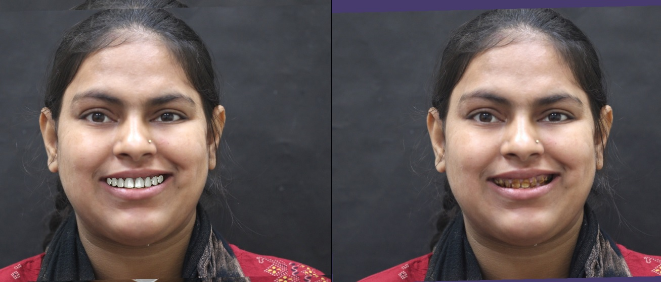
This visual representation enhances communication between the clinician and the patient, ensuring that the final result aligns with the patient's expectations (Abduo and Lyons, 2018)
Figure 1: Digital Smile design

Digital Mock-ups: Digital mock-ups provide a valuable tool for treatment planning in prosthodontics. Using digital software, clinicians can create a three-dimensional virtual representation of the proposed dental restorations on a digital model of the patient's dentition. This allows both the clinician and the patient to evaluate and assess the proposed treatment outcome before any invasive procedures are performed. Digital mock-ups aid in decision-making, as they provide a preview of the final result and allow for modifications based on patient feedback (Abduo and Lyons, 2018).
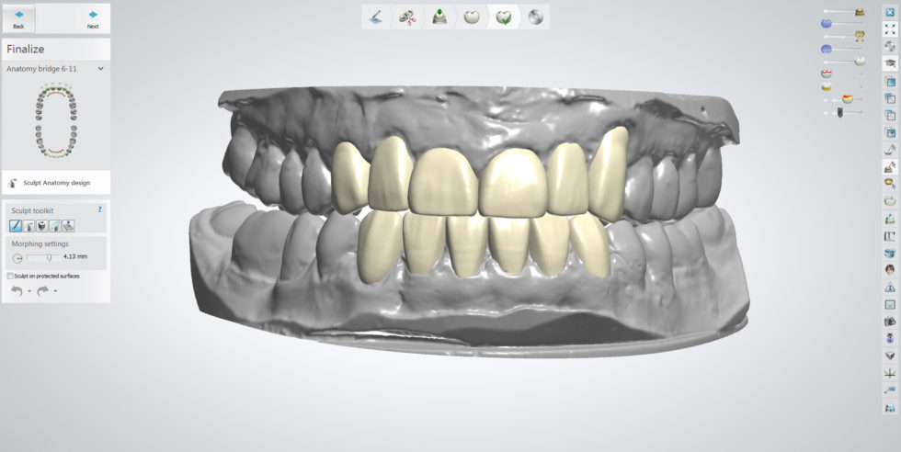
Figure 2: Digital Mockup
Virtual Wax-ups: In the past, physical wax-ups were used to plan the shape and contours of dental restorations. Digital technologies have replaced this traditional approach with virtual wax-ups, where the clinician digitally designs the wax-up on a computer screen. Virtual wax-ups offer several advantages, including enhanced accuracy, efficiency, and the ability to make modifications easily. By visualizing the final result digitally, clinicians can optimize the functional and aesthetic aspects of the restorations (Liu et al., 2019).
Digital Diagnostics: Digital diagnostics, including cone beam computed tomography (CBCT) and intraoral scanning, have greatly improved treatment planning and patient communication. CBCT provides detailed three-dimensional information about the patient's dental and skeletal structures, aiding in accurate implant placement, bone assessment, and treatment planning (Sun et al., 2017). Intraoral scanning allows for precise digital impressions, eliminating the discomfort associated with traditional impressions and improving patient experience (Mangano et al., 2019). These digital diagnostic tools enhance patient understanding and involvement in the treatment process, as they can visualize their own oral condition and actively participate in treatment discussions.
The integration of digital tools in treatment planning and diagnostics has revolutionized prosthodontics by enabling precise, predictable, and patient-centered treatment outcomes. These advancements improve communication, enhance patient satisfaction, and ultimately lead to better treatment outcomes.(15-18)
Digital impression and models:
Digital impression, also known as digital scanning or intraoral scanning, is a technique used in dentistry to capture precise 3D images of a patient's oral structures, including teeth, soft tissues, and occlusal relationships. It replaces the conventional method of using impression materials, trays, and biting records to capture molds of the patient's dentition.
There are several benefits associated with digital impression compared to traditional impressions:
Accuracy: Digital impression offers improved accuracy and precision in capturing the patient's oral structures. The digital scanning technology can capture fine details and reproduce the anatomical surfaces with high fidelity, resulting in more accurate restorations and better-fitting prostheses.
Patient Comfort: Digital impression eliminates the need for traditional impression materials, which can be messy, uncomfortable, and cause gag reflexes in some patients. Intraoral scanners are smaller and more comfortable, making the scanning process less invasive and more tolerable for patients.
Time Efficiency: Digital impression is generally faster compared to traditional impressions. The scanning process is quick, and there is no need for the setting time of impression materials. This saves chairside time for both patients and clinicians, leading to improved workflow efficiency in the dental practice.
Improved Communication: Digital impressions can be easily shared and communicated electronically between the clinician, dental laboratory, and other involved parties. This facilitates more efficient collaboration, reduces the chances of errors or misinterpretations, and allows for better treatment planning and coordination.
Digital Integration: Digital impressions seamlessly integrate with other digital technologies in dentistry, such as computer-aided design and manufacturing (CAD/CAM) systems. The digital data from the impression can be directly used for designing and manufacturing restorations, such as crowns, bridges, and aligners, using CAD/CAM technology.
Figure 3: Intra oral Scanning

Digitalisation in implant prosthetics:
Digital implant impression and prosthesis designing have revolutionized the field of implant dentistry, offering numerous advantages over traditional methods. This approach utilizes digital technologies, such as intraoral scanners and computer-aided design and manufacturing (CAD/CAM) systems, to capture implant impressions and design prostheses with precision and efficiency.
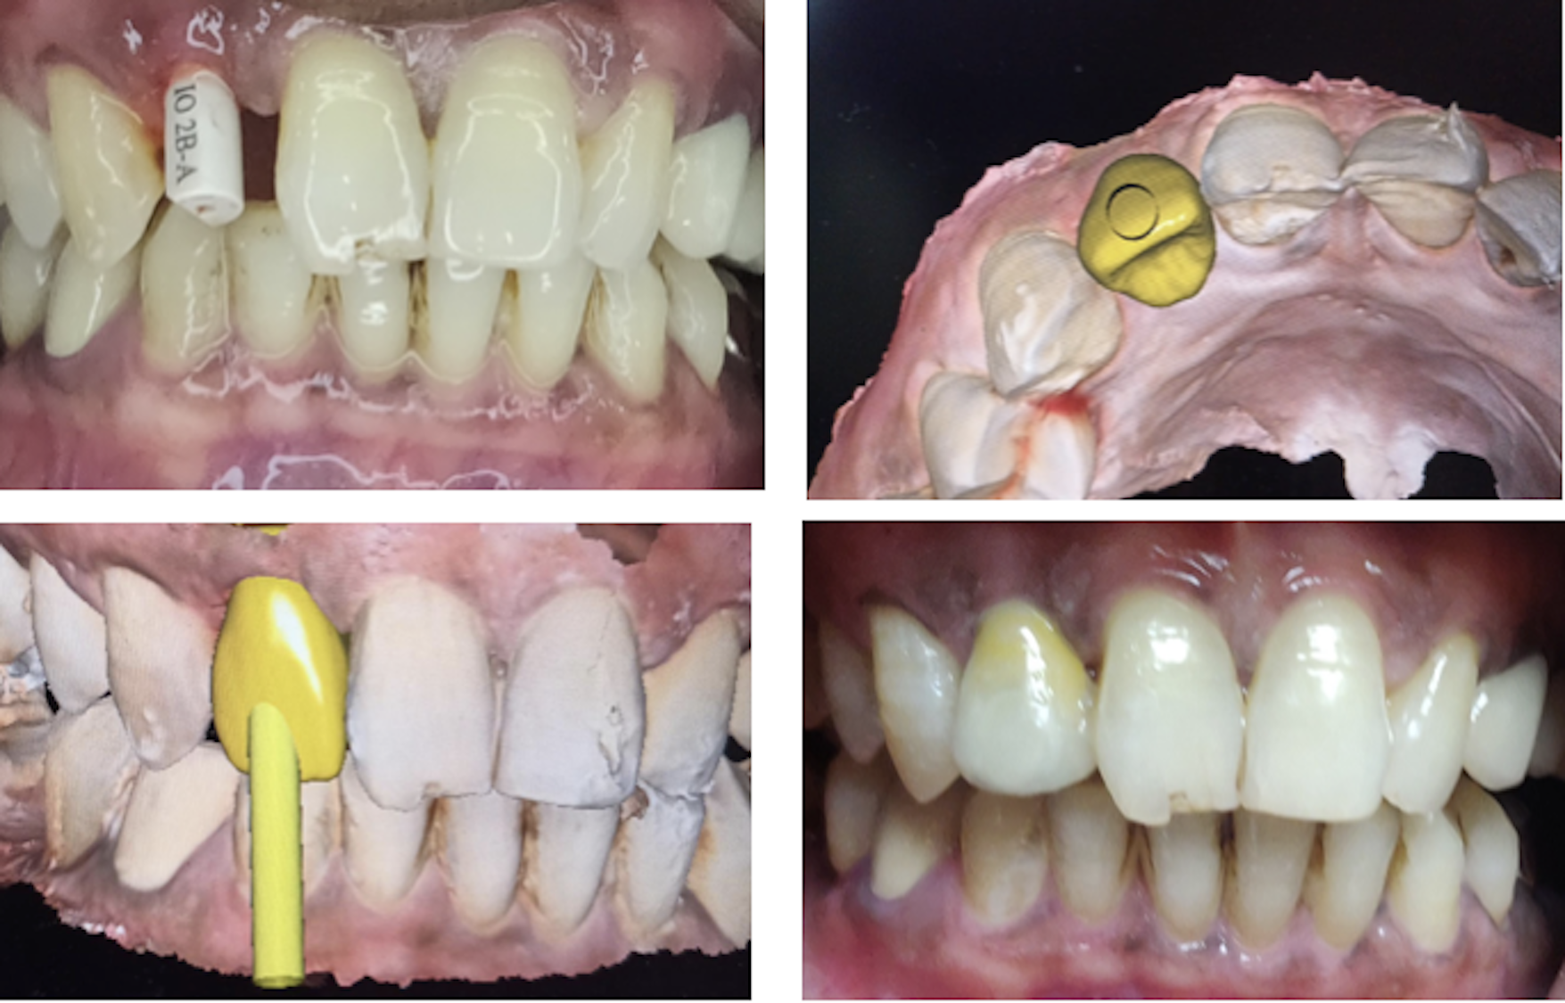
The benefits of digital implant impression and prosthesis designing are manifold. Firstly, the digital workflow offers improved accuracy and fit of the prosthesis, leading to better long-term clinical outcomes and patient satisfaction. Secondly, it allows for efficient communication between the clinician, dental laboratory, and other team members, ensuring a collaborative approach and streamlined workflow. Additionally, digital techniques enable customization and personalization of the prosthesis design, taking into account the patient's unique anatomical and esthetic considerations.

Figure: Digital approach for screw retained implant prosthesis
Challenges and considerations:
While the digital era in prosthodontics brings numerous benefits, it also presents several challenges and considerations that need to be acknowledged and addressed. Clinicians and practices must be aware of these factors as they embrace digital technologies. Some of the key challenges and considerations include initial investment costs, learning curves, integration of digital workflows into existing practices, and data security.

Initial Investment Costs: Embracing digital technologies in prosthodontics requires a significant initial investment in hardware, software, and training. The cost of acquiring intraoral scanners, CAD/CAM systems, and other necessary equipment can be substantial. Additionally, ongoing costs for software updates and maintenance should be considered. However, it is important to note that while there may be upfront expenses, the long-term benefits and efficiencies of digital workflows often outweigh the initial costs.
Learning Curves: Transitioning to digital workflows requires clinicians and staff to acquire new skills and knowledge. Training and education on how to operate the digital equipment, utilize software platforms, and integrate digital workflows into practice routines are essential. The learning curve can vary for different individuals and may require dedicated time and effort. However, with proper training and support, clinicians can overcome these challenges and become proficient in utilizing digital technologies.
Integration into Existing Practices: Integrating digital workflows into existing prosthodontic practices may require adjustments and adaptations. Incorporating new technologies and workflows can disrupt established routines and workflows. Clinicians and staff may need to restructure their treatment processes, workflows, and communication methods to accommodate digital tools effectively. It is crucial to have a well-planned implementation strategy, including staff training and gradual integration, to ensure a smooth transition and optimal utilization of digital technologies.
Data Security: With the digitization of patient records and sensitive clinical data, ensuring data security and privacy becomes paramount. Practices must implement robust security measures to protect patient information from unauthorized access or breaches. This includes secure data storage, encrypted communication channels, and adherence to data protection regulations and standards. Collaborating with reputable vendors and service providers who prioritize data security is essential to mitigate potential risks.
Addressing these challenges and considerations requires a proactive approach and strategic planning. Practices should carefully evaluate the potential benefits and weigh them against the associated challenges. Implementing a comprehensive plan that includes financial considerations, staff training, workflow integration, and data security measures will help maximize the benefits of digital technologies while mitigating potential risks.

In conclusion, the digital era has revolutionized prosthodontics, bringing about remarkable advancements in treatment planning, diagnostics, and patient outcomes. The benefits of digital approaches, such as improved accuracy, enhanced communication, streamlined workflows, reduced chairside time, and superior aesthetic outcomes, have been well-established. Through virtual smile design, digital mock-ups, and virtual wax-ups, clinicians can achieve precise and predictable treatment outcomes, while involving patients actively in the decision-making process.
However, embracing the digital era in prosthodontics also entails certain challenges and considerations. Initial investment costs, learning curves, integration into existing practices, and data security are important factors to address. Despite these challenges, the long-term advantages and efficiencies offered by digital technologies often outweigh the initial investments and learning efforts.
As the field continues to evolve, it is essential for prosthodontic practitioners to stay abreast of the latest digital advancements, continually update their skills, and adapt their practices to harness the full potential of digital technologies. By embracing digital workflows and incorporating them into everyday practice, clinicians can deliver improved patient experiences, achieve optimal treatment outcomes, and remain at the forefront of modern prosthodontics.

The future of prosthodontics is undeniably intertwined with digital technologies, and as we move forward, continued research, innovation, and collaboration among clinicians, researchers, and manufacturers will pave the way for even more exciting developments. The transformative power of digital technologies has ushered in a new era in prosthodontics, propelling the field towards higher levels of precision, predictability, and patient-centered care.

References

1) Birnbaum NS, Aaronson HB(2008) Dental impression using 3D digital scanner: virtual becomes reality,compend Contin EducDent 29(8):494-505.

2) Feuerstein P (2004) How dental practitioners can benefit from the internet.J.Mass Dent Assoc 135(Suppl):11S-16S.

3) Gutmann JL (2009) The evolution of America’s Scientific advancement in dentistry in the past 150 years.J.Am Dent Assoc 140(Suppl 1) 8S-15S.

4) Reinitz JR (2007) From plaster to polyvinyls :a review of impression materials.

5) Kaur I, Datta K (2006) CEREC the power of technology. J. Indian Prosthodont Soc.6:115-119.

6) Sailer I, Pjetursson BE, Zwahlen M, et al. A systematic review of the survival and complication rates of all-ceramic and metal-ceramic reconstructions after an observation period of at least 3 years. Part II: Fixed dental prostheses. Clin Oral Implants Res. 2007;18 Suppl 3:86-96.

7) Fasbinder DJ. Computerized technology for restorative dentistry. J Am Dent Assoc. 2006;137 Suppl:13S-22S.

8) Zarone F, Ferrari M, Mangano F. The Advantages of Digital Dentistry: A Brief History. Dent Clin North Am. 2019;63(2):165-177.

9) Kattadiyil MT, Alhelal A, Yilmaz B. Digital Dentistry: An Overview of Recent Developments for CAD/CAM Generated Restorations. Austin J Dent. 2018;5(3):1106.

10) Sailer I, Balmer M, Hämmerle CH. Zirconia dental implants: a clinical and radiographic evaluation. Periodontol 2000. 2017;73(1):228-240.

11) Bidra AS, Taylor TD, Agar JR. Computer-aided technology for fabricating complete dentures: systematic review of historical background, current status, and future perspectives. J Prosthet Dent. 2013;109(6):361-366

12) Mangano FG, Hauschild U, Veronesi G, et al. Trueness and precision of four intraoral scanners in oral implantology: a comparative in vitro study. PLoS One. 2019;14(8):e0224333.

13) Yuzbasioglu E, Kurt H, Turunc R, et al. Comparison of digital and conventional impression techniques: evaluation of patients' perception, treatment comfort, effectiveness and clinical outcomes. BMC Oral Health. 2014;14:10.

14) Fabbri G, Zarone F, Dellificorelli G, et al. Clinical evaluation of CAD/CAM ceramic veneers for the esthetic treatment of discolored teeth after orthodontic treatment. J Prosthet Dent. 2020;124(5):625-631

15) Abduo J, Lyons K. Clinical considerations for increasing occlusal vertical dimension: A review. Aust Dent J. 2012;57(1):2-10.

16)Liu X, Wang W, Zhou Y, et al. Digital Prosthetic Planning and Designing for the Full-Arch Immediate-Loaded Implant Prosthesis: A Clinical Report. J Prosthodont. 2019;28(7):746-750.

17) Sun Y, Lü P, Wu Y, et al. Assessment of implant positioning and damage of adjacent structures in completely edentulous mandibles based on digital diagnostic implant templates. J Prosthodont Res. 2017;61(1):34-42.

18)Mangano FG, Hauschild U, Veronesi G, et al. Trueness and precision of four intraoral scanners in oral implantology: a comparative in vitro study. PLoS

19) Ali AO, Taher NM, Bahrani AA. Integration of digital dental records and 3D cone beam computed tomography images: case study. J Dent. 2014;12(1):35-41.

20) Bartlett D, Wetherell JD, Shamsi M, et al. Evaluating the digital transition of prosthodontics in a UK tertiary education setting: students' perceptions. Eur J Dent Educ. 2017;21(1):e1-e7.

21) Brawek PK, Wolfart S, Endres L, et al. Treatment outcome with implant-supported crowns: a systematic literature review. Dtsch Arztebl Int. 2016;113(6):85-92.

22) Goodacre CJ, Garbacea A, Naylor WP, et al. CAD/CAM fabricated complete dentures: concepts and clinical methods of obtaining required morphological data. J Prosthodont. 2012;21(1):27-34.

