Consumption of Roadside Vender Fruit juices are traits for Public Health
Chetan A. Wankhede
Head of Department of Microbiology
Mahatma Gandhi College of Science, Gadchandur 442908

Fruit juices are foods that are nutrient-dense and ready to eat. Fruit juices, a mainstay of the common person's diet, are the most popular beverages offered at roadside stalls. People consume a lot of fruit juice in urban areas. Consuming contaminated fruit juices might have catastrophic effects on one's health. The aim of the study is to assess the quality and safety of the fresh fruit juices sold at roadside vendors. In a tropical region of India, it gets very hot during the summer. Mango juice, lime juice, and sugarcane juice are all in great demand throughout India during the summer. The study discovered that street vendors' sugarcane juice was contaminated with Shigella, Salmonella, Escherichia coli, Bacillus spp., Staphylococcus spp., and other microorganisms. All these discoveries show that the sugarcane juices were produced in unhygienic settings and with subpar ice used for dilution. The consumption of bacterially contaminated sugarcane juice had a severe influence on human health, and immediate action is needed. We discuss techniques for analyzing fruit juices in this chapter.

Introduction

Fruit juices are fully cooked, freshly made food. Fruit juices are widely known for their great nutritional value and are a staple of the human diet. Fruit juice demand is rising daily all around the world. In a tropical area of India, experiences high summer temperatures. During the summer, sugarcane juice, lime juice and mango juice is in high demand throughout the India. Despite having a high nutritional value, fruit juices prepared improperly are a likely source of bacterial infection. Drinking fruit juices tainted with microorganisms can be harmful to one's health, due to poor water quality, handling, and washing, the food is ready to consume and poses a concern to public health. Fruit juice consumption has been linked to numerous incidences of food-borne disease in India. Incorrect washing of fruits and utensils increases the risk of contamination. A source of infection can also come from the use of contaminated water and ice for dilution, unclean surroundings, tainted fruits, lengthy preservation, swarming fruit flies and houseflies, vehicle traffic, and dust. Fruits contain large amounts of microorganisms, up to 1.0 105 CFU/cm2. E. coli (27.7%), Shigella (16.6%), Salmonella (38.8%), and Streptococcus faecalis (6.2%), according to a study on fruit drinks sold in Visakhapatnam. According to studies by Buchanan et al. (1999), Ryu et al. (1998), and Sandeep et al. (2001), contaminated fruit juices have the potential to be a source of bacterial pathogens such E. coli O157:H7, Salmonella, Shigella, and Streptococcus aureus. According to a study fruit juices are contaminated with coliform, faecal coliform, and other dangerous pathogens, necessitating the preparation and implementation of hygienic standards compared to preserved juices sold in stores under the company brand, fruit juices sold by roadside vendors are tainted (Sharma, 2013). While the infectious dosage for these bacteria found in fruit juices has not yet been determined, it depends on the standards set for drinking water (ISI standards, 1973; ICMR, 1975; WHO, 1984), the number of bacteria needed to cause an infection with coliform and streptococci is minimal. The fruit juices sold at roadside shops in Meerut, Uttar Pradesh, India were found to be tainted with E. coli, Salmonella, Streptococcus aureus, and Bacillus cereus according to a study. Fruit juices consumption can affect consumers in both positive and bad ways. Consuming fruit juices of high quality helps to strengthen the immune system and prevents dehydration. The strong demand for fruit juices in many cities is exacerbated by the hot weather, which lasts for a significant portion of the year. Although the majority of roadside businesses serve juices in hygienic settings, their microbiological quality is still debatable in the market, close to colleges, and at wayside shops. After being diluted with water and ice in these businesses, juices squeezed from a variety of fruits, such as oranges, lime, mangoes, and sugarcane, are offered. However, the nutrient-richness of fruit juices is an excellent substrate for bacterial development in the absence of adequate production practices, which results in food borne disease. There are several cases of food-borne sickness in the India. A quick examination of fruit juices sold on the street was conducted in order to determine their suitability for human consumption and any potential sources of bacterial contamination in light of the strong demand for fruit drinks in various sections of the city. Due to its great demand in the city, the purpose of the chapter was to evaluate the juice's quality as it was being sold in India.

Methods of Collection of sample and Isolation of Bacteria

Sample Collection
Fruit juices from the locations where they are most in demand were gathered for study. The sample is selected at random from several sites. The freshly prepared sample was taken in sterile containers that should have a maximum temperature of 4°C to avoid the fruit juice becoming spoil. To prevent contamination, safety precautions must be implemented. The sample is promptly examined after collection.

Serial Dilution
To make the stock solution, 1ml of the juice sample was mixed with 9ml of sterile, distilled water. The test tubes were then assigned the numbers 10¹, 10², 10³, 10⁴, 10⁵ and 10^{6.} In order to ensure that the microorganisms were distributed equally, 1 ml of the stock solution was then placed into the first tube, which was 10-1, and well shaken. After then, 1ml from test tube 10¹ was transferred to test tube 10² and shaken once more. In order to finish the serial dilution up to 10⁶, the operation was repeated.

Spread Plate Method
Three petri plates with Nutrient agar are created when the serial dilution procedure is complete and are labelled as a 10^{4,} 10⁵ and 10-⁶. The test samples from test tubes 10^{4,} 10⁵ and 10-⁶ totaling 0.1 ml each were then transferred to the relevant plates. All the plates were incubated at 37 °C for 24-48 hours. The colonies on the plates were then counted and noted for future study.
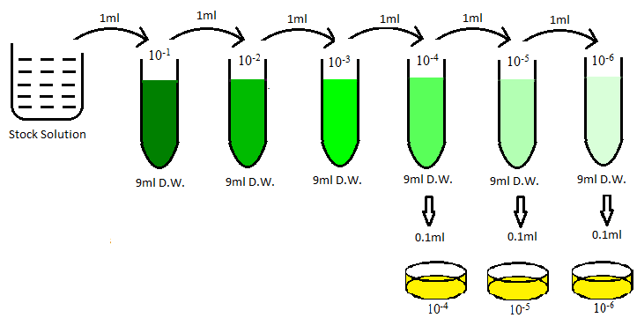
Gram staining
After isolating colonies on Nutrient agar plate 10^{4,} 10⁵ and 10-⁶, make stock culture of isolated colonies on nutrient agar slant and performed Gram staining according to the guidelines provided by Christen Gram to distinguish between gramme positive and gramme negative bacteria. Gramme positive bacteria were represented by the purple-colored colony, while gramme negative bacteria were shown by the pink-colored colony.
Procedure of Gram Staining
- Take a clean glass slide, free from the grease
- Prepared the smear from freshly prepared stock culture from nutrient agar plate 10^{4,} 10⁵ and 10-⁶.
- Smear is prepared by taking loopful of culture from stock solution and suspended with water drop on glass slide.
- Air dry the slide and heat fix by moving slide over gentle flame
- Primary stain crystal violet pours on the glass slide and kept for 30 sec
- Rinse the slide with tap water or distilled water for 2 min
- Then add gram iodine solution on smear for 1 min
- Rinse with the distilled water for 1 min
- Wash the slide with 95% alcohol for 30 sec
- Again, rinse the slide with distilled water and add safranine for 30 to 60 sec
- Rinse the slide and dry it. After drying the slide observe it in microscope.

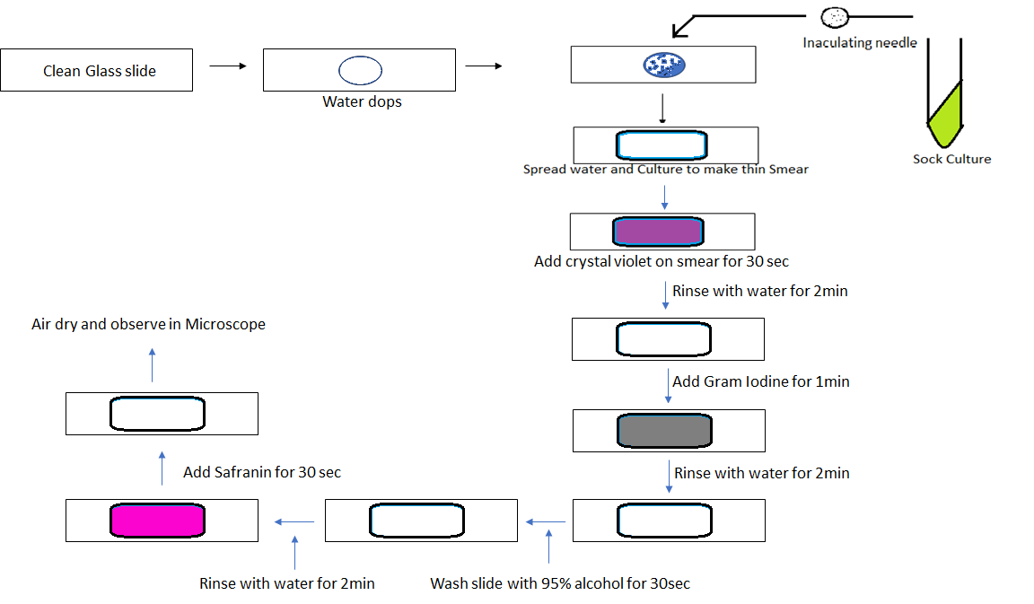

Motility test
The motility test for isolates is performed as per the Hanging drop method. In this process freshly prepared broth culture is used. Broth culture is made from the stock culture. In this procedure a loopful broth culture is taken on the cavity slide and cover with cover slip. Observed the motility under dark mode of microscope.

Biochemical analysis
To confirm and characterize the isolates several biochemical tests were carried out. Most of the methods were done according to the microbiological laboratory manual (Cappuccino & Sherman, 2005). The biochemical tests performed were IMViC test (Indole test, Methyl red test, Voges-Proskauer test, Citrate utilization test) and Triple sugar iron test.

- Indole test

Take tryptone broth, which includes the amino acid tryptophan, is inoculated with the test isolate and then left to grow for the night at 37 degrees Celsius for 24 hours. A few drops of Kovac's reagent are added after incubation. After addition, red or pink coloured ring apper at the top is taken as positive.

- Methyl red test

Take MRVP medium, which includes peptone and dextrose is inoculated with test isolate and then left to grow for the night at 37 degrees Celsius for 48 hours. Over the 48 hours the mixed-acid producing organism grow in MRVP medium and produce. The pH of the medium is tested by the addition of 5 drops of Methyl Red reagent. Development of red color is taken as positive. MR negative organism produce yellow color

- Voges-Proskauer test

Take MRVP medium, which includes peptone and dextrose is inoculated with test isolate and then left to grow for the night at 37 degrees Celsius for 48 hours. 0.6 ml of alpha-naphthol is added to the test test tube mex well and then add 0.2 ml of 40% KOH in the broth and shaken. The tube is allowed to stand for 15 minutes. The presence of red color is regarded as a positive test result. The negative tubes must be kept for an hour since the highest amount of color change happens an hour after the reagents are added.

- Citrate utilization test

Simmon's citrate agar slant is inoculated with test isolated that have been picked up by inoculating needle and then incubated at 37°C overnight. The medium turns blue if the organism can use citrate, changing from green otherwise. If the medium's color changes to blue, citrate test is present.

- Triple sugar iron agar test

Pick up an isolated colony with a straight inoculating needle. Inject to the TSI slant by piercing the butt all the way to the bottom, removing the needle, and then streaking the surface. To allow air to enter, use a closure that fits loosely. After 18 to 24 hours of incubation at 37°C, read the results. Change in the color of medium indicated positive test and tested isolated use carbohydrate.

Bacterial Identification
Bacteria were identified and confirmed utilizing the growth in specific media, such as Nutrient agar, MacConkey agar, Eosin methylene blue agar (EMB), Baird Parker agar, Salmonella-Shigella agar (SS agar) and Bismuth sulfite agar. EMB agar selective media for E. coli, SS agar for Salmonella and Shigella. Baird Parker agar is selective media for Bacillus spp.
Result and Discussion
The chapter includes all the standard procedure to analysis the fruit juices sold on roadside shop. These analysis report gives idea about standard of fruit juices sold on roadside shop. If you reported any cases due to fruit juices then followed same procedure. After performing morphological test and biochemical test on fruit juices sample gives idea about mode of contamination and traits for contamination. Mainly contamination is occurring due to use of unhygienic utensils, using poor quality of water for washing, using contaminated ice and bad practice of vender. If you observed any cases, report it, and discuss with the municipal corporation or any governing body. The governing body requested to call and explained them what precaution should they taken during preparation of fruit juices.
After biochemical tests, for identification isolates were grown on selective media. Escherichia coli grow on EMB agar and shows green metallic shine colony while no growth of Bacillus spp. on it, Staphylococcus spp. gives black color colonies on Baird Parker agar, Salmonella spp. showed black color colony on Bismuth sulfite agar and Shigella spp. give black center colony. The high ambient temperature reduces shelf-life fruit juice and seems to favor the growth of bacteria. The presence of pathogenic E. coli, Salmonella spp. and shigella spp. in juice samples showed that consumption of fruit juices is unhealthy to humans and needs immediate action. It was put forward that regular monitoring of quality of street selling fruit juices to avoid outbreaks of pathogen in the future.

References
(n.d.).
Anshika Tonk, S. K. (2018, may). Isolation and identification of bacteria from fresh fruit juice prepared in local areas. European Journal of Biotechnology and Bioscience, 6, 12-15.
Buchanan R. L., E. S. (1999). Contamination of intact apples after immresion in an aqueous environment contaning Escherichia coli O157:H7. J. Food Prot., 444-450.
Geldrich, E. E. (1974). Microbiological criteria concepts for coastal bathing. Ocean Management, 3, 225.
Haftom Kebede, H. H. (2018). Public health risks and bacterial safety of fruit juices. Journal of Pharmacy Research, 12, 509-515.
Harrigaan, W. F. (1998). Laboratory Methods in Food Microbiology. Academic Press London.
Joy E. Lewis, P. T. (2006). Human Bacteria In Street Vended Fruit Juices: A Case Study of Visakhapatnam City, India. Internet Journal of Food Safety, 8, 35-38.
Kamal Rai Aneja, R. D. (2014). Microbes Associated with Freshly Prepared Juices of Citrus and Carrots. International Journal of Food Science.
Muhammad Naeem Iqbal, A. A. (2015). Assessment of Microbial Load of Un-pasteurized Fruit Juices and in vitro. The Open Microbiology Journal, 9, 26-32.
Ryu J.H., B. L. (1998). Influence of acid tolerance responses on survival, growth and cross protection of Escherichia coli O157:H7 in acidified media and fruit juices. Internet Journal of Food Microbiology, 45, 185-193.
Sandeep M., D. A. (2001). Microbiological Analysis of Street Vended Fresh squeezed Carrot and Kinnow-Mandarian Juices in Patiala City, India. Internet Journal of food safety, 3, 1-3.
Sharma, P. U. (2013). Bacteriological analysis of street vended fruit juices available in Vidarbha. International Journal of Current Microbiology and Applied Sciences, 2, 178-183.
Sherman, J. G. (2005). Microbiology Laboratory Manual (Vol. 8).
Umar Asghar, M. N. (2018). Microbiological Assessment of Fresh Juices Vended in Different Areas of Lahor city. Electronic Journal of Biology, 14(4), 106-110.

