A highly selective chromogenic probe
for Hg²⁺

Hossein Tavallali
Department of Chemistry
Payame Noor University, PNU
19395-4697 Tehran, Iran
tavallali@yahoo.com

Shiva Rajaei Dastghaib
Department of Chemistry
Payame Noor University, PNU
19395-4697 Tehran, Iran
shivarajaei@yahoo.com

Abstract
The detection and quantification of mercury (II) in various environmental samples is of utmost importance due to its detrimental effects on human health and the ecosystem. Traditional methods for mercury detection often involve complex instrumentation, high costs, and time-consuming procedures. Therefore, the development of a simple, cost-effective, and reliable method for mercury detection is crucial. Indigo carmine (IC), a water-soluble dye commonly used in various industries, has recently emerged as a promising candidate for colorimetric chemosensing applications. Its unique chemical properties make it an ideal candidate for detecting heavy metal ions such as mercury (II). The chromogenic probe IC exhibits a strong affinity towards Hg²⁺ ions, leading to a distinct color change that can be easily observed with the naked eye. The range of linear and the limit of detection of Hg²⁺ were 0.15-20.2 μM and 0.06 μM, respectively. Also, the relative standard deviation (RSD) based on ten replicates calculated for two different concentrations of 7.4 μM and 15.8 μM of Hg²⁺ was 2.1% and 1.4%, respectively. The proposed method has advantages such as: simplicity, low cost, high accuracy, wide linear concentration range, low limit of detection, high sensitivity and selectivity, no separation and preconcentration steps, and can be used in neutral water media. The concentration of Hg²⁺ in tap water, mineral water and plasma samples can be easily detected and determined using this method. It should be noted that this ideal colorimetric chemosensor for Hg²⁺ has not been reported before.
Keywords: chromogenic probe, colorimetric chemosensor, mercury (II) detection, indigo carmine (IC).

- Introduction
Mercury ion (Hg²⁺) is known to be highly toxic and can cause severe health issues in humans and other organisms. It is released into the environment through various industrial processes, such as mining, coal combustion, and waste incineration. Additionally, natural sources like volcanic eruptions and weathering of rocks also contribute to the presence of mercury in the environment [1, 2]. Due to its toxicity and widespread occurrence, it is crucial to develop selective and sensitive chemosensors for detecting mercury ions. These chemosensors can be designed to specifically recognize and bind with mercury ions, allowing for their detection even at very low concentrations. The development of such chemosensors is essential for several reasons. By detecting and quantifying the presence of mercury in water bodies, soil, or air samples, we can assess the extent of contamination and take appropriate measures to mitigate its harmful effects [3, 4]. Brain damage is one of the most concerning effects of Hg²⁺ exposure. Even at very low concentrations, Hg²⁺ can disrupt normal brain function, leading to cognitive impairments, learning disabilities, and behavioral disorders. The gastrointestinal system is another target for Hg²⁺. When ingested through contaminated food or water, this toxic ion can cause various gastrointestinal diseases. It can irritate the lining of the stomach and intestines [5, 6]. The strict regulation by the United States Environmental Protection Agency (EPA) highlights the potential dangers associated with water-soluble divalent mercuric ion (Hg2+). The fact that even low concentrations of Hg2+ (maximum Hg2+ contaminant level in food and drinking water of 0.002 ppm or 0.01 μM) can lead to severe health issues underscores the need for stringent monitoring and control measures [7].
Colorimetric chemosensors are a promising alternative for the detection of Mercury ions due to their ability to provide a cost-effective, rapid, and real-time monitoring system. Unlike traditional methods such as AAS [8], ICP-AES [9], ICP-MS [10], and HPLC [11], which can be time-consuming and expensive, colorimetric chemosensors offer a more efficient and affordable solution [12]. Colorimetric chemosensors work by utilizing specific chemical reactions that result in a visible color change when exposed to Mercury ions. These sensors are designed with ligands or receptors that selectively bind to Mercury ions, triggering a detectable color response. This color change can be easily observed with the naked eye or measured using simple optical instruments [13]. One advantage of colorimetric chemosensors is their simplicity and ease of use. They do not require complex instrumentation or extensive sample preparation procedures, making them suitable for on-site monitoring applications. Additionally, these sensors can provide real-time results, allowing for immediate action to be taken. The use of Indigo Carmine (IC) (schem 1) as a chemosensor is based on its unique properties that allow it to selectively interact with specific analytes and produce a measurable response. In the previous studies, Indigo Carmine has shown potential in spectroscopic applications for the determination of certain cations [14- 16]. In the mentioned study, Indigo Carmine was utilized as both a fluorescent and colorimetric chemosensor for the detection of Cu²⁺ and HPO₄²⁻ ions in a mixed solvent system of H₂O/DMSO [17]. This choice of solvent is crucial as it provides an environment where the analytes can readily interact with the dye molecule. The detection mechanism involves the binding of Cu²⁺ or HPO₄²⁻ ions to specific sites on the Indigo Carmine molecule, leading to changes in its fluorescence and color properties. These changes can be easily monitored using spectroscopic techniques, allowing for sensitive and selective detection of these analytes.

Scheme 1. Structure of IC.

- Experimental
- Chemical substances and reagents
The choice to purchase analytical grade chemicals from Merck ensures the highest level of purity and quality for the experiments. Indigo Carmine dye, di sodium salt, was specifically selected for preparing the solutions due to its known properties and suitability for the desired analysis. To prepare the solution of Hg²⁺ and all cations, including Na⁺, K⁺, Mg²⁺, Ca²⁺, Sr²⁺, Ba²⁺, Fe²⁺, Fe³⁺, Co²⁺, Ni²⁺, Cu²⁺, Zn²⁺, Ag⁺, Cd²⁺, Pb²⁺, their respective nitrate salts were used. Nitrate salts are commonly employed in such experiments as they readily dissolve in deionized water, ensuring a homogeneous solution.

- Apparatus
Shimadzu 1601 PC UV-Vis spectrophotometer with 10.0 mm diameter quartz cuvettes was used to record and measure all absorption spectra. Deionized water was used in the reference cell. A Jenway 3510 digital pH meter calibrated with two standard buffer solutions was used to measure pHs. Using a 50 μL Hamilton syringe, the desired amount of analyte solution was introduced into the cuvette.

- Measurement methods
After preparing the stock solutions of IC and Hg(NO₃)₂ with concentrations of 1.0 × 10⁻³ M and 1.0 × 10⁻² M in deionized water, respectively, the next step was to perform the measurement. To begin, 3-540.0 μL of the Hg(NO3)2 solution with a concentration of 0.1 mM was added to 2.0 mL of IC with a concentration of 25.0 μM. The two solutions were carefully mixed to ensure thorough blending. Once the mixing was complete, UV-vis spectra were taken at room temperature using an appropriate spectrophotometer or UV-visible spectrometer. This allowed for the analysis and characterization of the resulting solution.The UV-vis spectra provided valuable information about the absorption and transmission properties of the solution at different wavelengths within the ultraviolet and visible regions of the electromagnetic spectrum.

- Results and discussion

The observation suggests that the interaction between IC and Hg²⁺ ions is unique compared to the other metal ions tested. The color change from indigo to light blue, along with the distinct spectral shift at 610.0 nm, indicates a specific chemical reaction or complex formation between IC and Hg²⁺. The lack of color change and spectral shift with the other metal ions implies that they do not have a strong affinity for IC or do not form stable complexes under experimental conditions. This could be due to differences in their electronic structures, charge densities, or coordination preferences. The specific interaction between IC and Hg²⁺ could be attributed to factors such as the size and charge of the Hg²⁺ ion, as well as its ability to coordinate with the functional groups present in IC. These factors may facilitate a unique coordination geometry or electronic transition that leads to the observed color change and spectral shift. (Fig. 1).
(a)
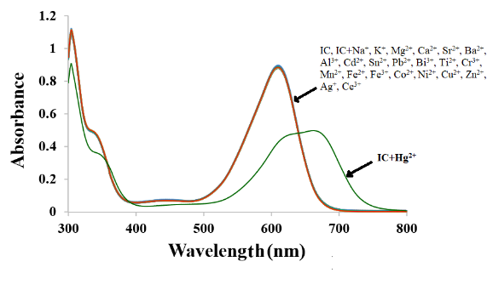
(b)
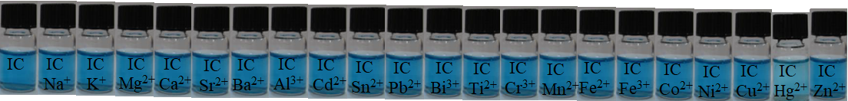
Fig. 1. (a) Absorption spectrum, (b) The color changes of IC (25.0 µM) with the various cations (1.0 equiv.).

The UV-vis titration experiment revealed important information about the interaction between IC and Hg²⁺. As Hg²⁺ was added to IC, the absorption band at 610.0 nm gradually decreased in intensity. Simultaneously, a new absorption band emerged at 666.5 nm. This observation suggests that the addition of Hg²⁺ caused a change in the electronic structure of IC, leading to a shift in its absorption spectrum. An interesting feature of the obtained curve is the presence of an isosbestic point at 640.5 nm. An isosbestic point indicates that during the course of the reaction, only two species are involved, and their concentrations change in a stoichiometric ratio. In this case, it suggests that there is a direct interaction between IC and Hg²⁺, resulting in the formation of a stable complex. The molar extinction coefficients provide additional insights into the nature of this interaction.
The molar extinction coefficients provided suggest that there are two distinct peaks in the absorption spectrum of the compound being studied. The first peak, with a wavelength of 610.0 nm, has a higher molar extinction coefficient of 3.58 × 10⁴ M⁻¹cm⁻¹, indicating a stronger absorption at this wavelength. This peak is attributed to a mercury-based d-d transition. A d-d transition refers to an electronic transition within the d-orbitals of a metal ion. In this case, the presence of mercury suggests that it is the central metal ion involved in this transition. The specific energy required for this transition corresponds to a wavelength of 610.0 nm. On the other hand, there is a second peak observed at 666.5 nm with a lower molar extinction coefficient of 4.36 × 10³ M⁻¹cm⁻¹. This lower value indicates weaker absorption at this wavelength compared to the first peak.
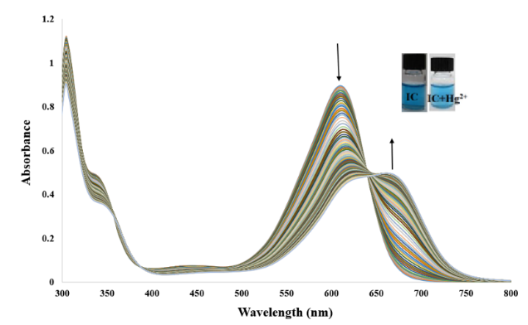

Fig. 2. UV–vis IC spectrum (25.0 μM) with stepwise addition of Hg²⁺ (0.15–21.26 μM) and
the color change of IC.

Benesi-Hildebrand analysis [18] was used to determine the stoichiometry of IC binding to Hg²⁺. Absorption titration data (Fig. 3) show that the complex formed between IC and Hg²⁺ has a stoichiometric ratio of 1:1 (Eq. 1) and the binding constant of Hg²⁺ is 2.77×10³ M⁻¹.

Eq. 1 $\frac{1}{(A{-A}_{0})}=\frac{1}{{(A_{max}-A}_{0})}\left[\frac{1}{K_{ass}{\left[{Hg}^{2+}\right]}^{n}}+1\right]$

Fig. 3. Benesi-Hildebrand plot of IC (1/(A₀-A) change at 610.0 nm versus 1/[Hg²⁺] function) based on 1:1 binding stoichiometry with Hg²⁺.

The observation suggests that the pH of the environment plays a crucial role in the interaction between IC and Hg²⁺ ions. At acidic pH levels (2.5-7.0), IC remains stable and does not exhibit any changes in absorption even in the presence of Hg²⁺ ions. However, at pH 7.0, there is a noticeable increase in absorption upon the addition of Hg²⁺ ions. This pH dependence of IC-Hg²⁺ interaction has significant implications for environmental systems. It indicates that the presence or absence of Hg²⁺ ions can be influenced by the pH level of the environment. In environments with acidic conditions, such as acid mine drainage or polluted water bodies, IC may not effectively interact with Hg²⁺ ions, potentially leading to their accumulation and persistence. On the other hand, at neutral pH (7.0), where many natural aquatic systems are typically found, IC shows an increased absorption when exposed to Hg²⁺ ions. The study aimed to understand how the proposed method would perform in different pH conditions, particularly in environmental systems. To achieve this, experiments were conducted both in the absence and presence of Hg²⁺ at various pH levels ranging from 2.5 to 12.6. Fig. 4 illustrates the results obtained from these experiments, showcasing the effect of pH on the detection of Hg²⁺. The data collected revealed that the proposed method remained effective and reliable within a wide range of pH values (5.2-9.0), without any significant alteration in its ability to detect Hg²⁺. Based on these findings, it was decided that pH 7.0 would be selected as the standard for all colorimetric measurements. This choice was made due to its compatibility with environmental conditions and its consistent performance in Hg²⁺ detection. By investigating the impact of pH on the proposed method's functionality, this study has provided valuable insights into its potential application in real-world environmental scenarios. This observation suggests that the presence of Hg²⁺ ions somehow affect the behavior of the IC. Without Hg²⁺ ions, the IC remains stable and does not show any significant changes in absorbance across the pH range of 2.5-7.0. However, when Hg²⁺ ions are introduced, there is a noticeable increase in absorbance specifically at pH 7.0. This change in absorbance indicates that the interaction between the IC and Hg²⁺ ions is pH-dependent, with pH 7.0 being particularly favorable for this interaction. Based on these findings, it can be concluded that pH 7.0 provides optimal conditions for the proposed method involving the IC and Hg²⁺ ions. This specific pH value likely enhances the sensitivity or selectivity of the IC towards Hg²⁺, leading to a more pronounced change in absorbance.

Fig. 4. Effect of pH.

The interaction time of the IC sensor with Hg²⁺ was investigated (Fig. 5). The results showed that the reaction occurs in the first few seconds and remains constant for the next 40 minutes at the absorption wavelength of 610.0 nm.

Fig. 5. Effect of time.

To verify the linear range of the proposed method, a calibration curve was plotted (Fig. 6). The linear range was 0.15-17.36 μM, and the regression equation for the data was A_{610.0} = 0.8766–0.025C_{Hg} (μM) with R² = 0.9901. The limit of detection and limit of quantification for the measurement of Hg²⁺ were calculated to be 0.06 and 0.22 μM, respectively. The relative standard deviation for two concentrations of Hg²⁺, 7.4 and 15.8 μM and 10 replicate measurements, was 2.1% and 1.4%, respectively.

Fig. 6. Calibration curve.

Furthermore, the use of different metal cations in determining selectivity for Hg²⁺ in Figure 7 highlights the versatility and reliability of the proposed method. By testing various metal cations, it becomes evident that the IC exhibits a high degree of selectivity towards Hg²⁺ ions. This selectivity is crucial in analytical chemistry as it ensures accurate and precise detection of specific target analytes. The results obtained from these experiments demonstrate that the proposed method holds great potential as a chemosensor for detecting Hg²⁺. The ability to selectively detect Hg²⁺ ions is particularly significant due to their harmful effects on both human health and the environment. The use of the IC as a potential chemosensor offers several advantages. Firstly, its selectivity ensures that false positives or false negatives are minimized, leading to more reliable detection results.
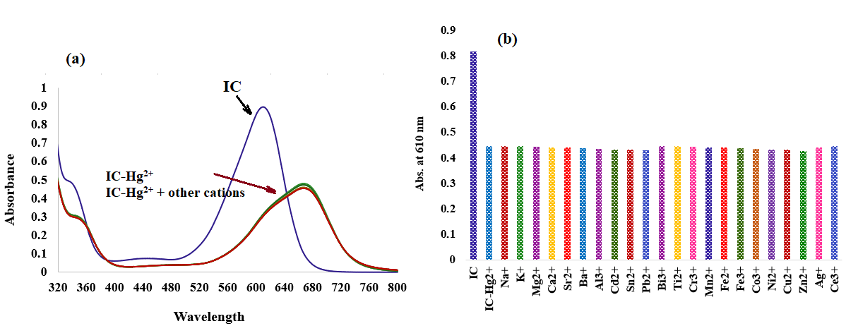
Fig. 7. Effect of coexisting substances on (a) Absorption spectrum,
(b) absorbance of IC in the presence of Hg²⁺.

To determine Hg²⁺, the proposed method was used in real samples, but Hg²⁺ could not be detected in the samples. Therefore, the spiking method was carried out. The measurement of Hg²⁺ in the samples was repeated three times, and the recovery values between 96.00 and 103.90% showed good accuracy of the proposed method (Table 1). The results show that this method can be used to measure Hg²⁺ in real samples.

Table. 1. Determination of Hg²⁺ in real samples by spiking method.
Sample  (n = 3) | Hg²⁺ (μM) |  | Average recovery (%) | Relative error (%)
 | Amount added | Amount found
Tap water | 0.00 | - | - | -
 | 4.00 | 3.98 ± 0.02 | 99.50 | -0.50
 | 8.00 | 8.31 ± 0.05 | 103.90 | 3.00
 | 10.00 | 10.15 ± 0.03 | 101.50 | 3.88
Mineral water | 0.00 | - | - | -
 | 4.00 | 3.95 ± 0.03 | 98.75 | -1.25
 | 8.00 | 8.08 ± 0.02 | 101.00 | 1.00
 | 10.00 | 9.76 ± 0.04 | 96.00 | -2.40
plasma | 0.00 | - | - | -
 | 4.00 | 4.01 ± 0.04 | 100.25 | 0.25
 | 8.00 | 8.06 ± 0.05 | 100.75 | 0.75
 | 10.00 | 10.10 ± 0.06 | 101.00 | 0.06

- Conclusion

The proposed method using IC as a chemosensor for the detection of Hg²⁺ offers several additional benefits. Firstly, its simplicity allows for easy implementation in various settings, including field testing or on-site monitoring. This is particularly advantageous when rapid and real-time detection is required. Secondly, the absence of separation and preconcentration steps reduces the overall analysis time and eliminates the need for complex sample preparation procedures. This not only saves time but also minimizes the risk of sample contamination or loss during these additional steps. Moreover, the low cost associated with this method makes it accessible to a wider range of users, including resource-limited laboratories or environmental monitoring agencies with budget constraints. The affordability factor also enables frequent monitoring and surveillance of Hg²⁺ levels in different water sources or industrial effluents. The high accuracy achieved by this method ensures reliable and precise measurements of Hg²⁺ concentrations. This is crucial in environmental monitoring scenarios where even trace amounts of toxic substances can have significant impacts.

References

- B. Kaur, N. Kaur, S. Kumar, “Colorimetric metal ion sensors – A comprehensive review of the years 2011–2016,” Coord. Chem. Rev., vol. 358, pp. 13-69, 2018.
- G. Guzzi, A. Ronchi, P. Pigatto, “Toxic effects of mercury in humans and mammals,” Chemosphere, vol. 263, pp. 127990, 2021.
- H.F. Cheng, Y.A. Hu, “Mercury in municipal solid waste in China and its control: a review,” Environ. Sci. Technol., vol. 46, pp. 4695-4696, 2012.
- D. Naftz, C. Angeroth, T. Kenney, B. Waddell, N. Darnall, S. Silva, C. Perschon, J. Whitehead, “Anthropogenic influences on the input and bio-geo-chemical-cycling of nutrients and mercury in Great Salt Lake, Utah USA,” Appl. Geochem., vol. 23, pp. 1731-1744, 2008.
- T. Takeuchi, N. Morikawa, H. Matsumoto, Y. Shiraishi, “A pathological study of Minamata disease in Japan,” Acta Neuropathol., vol. 2, pp. 40-57, 1962.
- V. Bhardwaj, V.M. Nurchi, S.K. Sahoo, “Mercury toxicity and detection using chromo-fluorogenic chemosensors,” Pharmaceuticals, vol. 14, pp. 123, 2021.
- Mercury Update: Impact on Fish Advisories, EPA Fact Sheet EPA-823-S2-01-011, EPA, Office of Water, Washington, DC, 2001.
- C. Yu, “Interference from soluble iron on mercury determination in water by cold vapor atomic absorption spectrometry (CV-AAS) with sodium borohydride as reductant,” Anal. Sci., vol. 37, pp. 1181-1184, 2021.
- M. Faraji, Y. Yamini, M. Rezaee, “Extraction of trace amounts of mercury with sodium dodecyle sulphate-coated magnetite nanoparticles and its determination by flow injection inductively coupled plasma-optical emission spectrometry,” Talanta, vol. 81, pp. 831-836, 2010.
- G. Chen, H.W. Chen, X.Z. Jin, H.T. Chen, “Determination of ultra-trace amount methyl-, phenyl- and inorganic mercury in environmental and biological samples by liquid chromatography with inductively coupled plasma mass spectrometry after cloud point extraction preconcentration,” Talanta, vol. 77, pp. 1381-1387, 2009.
- Z.B. Gao, X.G. Ma, “Speciation analysis of mercury in water samples using dispersive liquid-liquid microextraction combined with high-performance liquid chromatography,” Anal. Chim. Acta, vol. 702, pp. 50-55, 2011.
- L.N. Suvarapu, S.O. Baek, “Recent studies on the speciation and determination of mercury in different environmental matrices using various analytical techniques,” Int. J. Anal. Chem., Vol. 2017, pp. 1-28, 2017.
- A. Loredo, L. Wang, S. Wang, H. Xiao, “Single atom switching as a general approach to designing colorimetric and fluorogenic probes for mercury ions,” Dyes Pigm., vol. 186, pp. 109014, 2021.
- H. Tavallali, E. Shaabanpur, P. Vahdati, “A highly selective optode for determination of Hg (II) by a modified immobilization of indigo carmine on a triacetylcellulose membrane,” Spectrochim. Acta A Mol. Biomol. Spectrosc., vol. 89, pp. 216-221, 2012.
- A. Massoumi, H. Tavallali, “Kinetic Spectrophotometric Determination of Vanadium by Catalytic Effect on the Indigo Carmine-Bromate Reaction,” Anal. Lett., vol. 31, pp. 193-206, 1998.
- H. Tavallali, A. Massoumi, “Simultaneous kinetic spectrophotometric determination of vanadium(V) and iron(III),” Talanta, vol. 47, pp. 479-485, 1998.
- H. Tavallali, G.Deilamy-Rad, A. Moaddeli, K. Asghari, “Indigo Carmine-Cu complex probe exhibiting dual colorimetric/ fluorimetric sensing for selective determination of mono hydrogen phosphate ion and its logic behavior,” Spectrochim. Acta A Mol. Biomol. Spectrosc., vol. 183, pp. 319-331, 2017.
- H. A. Benesi, J. H. Hildebrand, “A spectrophotometric investigation of the interaction of iodine with aromatic hydrocarbons,” J. Amer. Chem. Soc., vol. 71, pp. 2703-2707, 1949.

