Analysis of the Situation of Ghaziabad Metropolitan Area Surface and Ground Water Quality

Padam Singh
Department of Electrical Engineering
JSS Academy of Technical Education, Noida, Uttar Pradesh Padamsingh835@gmail.com

Devid Kumar
Department of Information and Technology
JSS Academy of Technical Education, Noida, UP
devidkuamr86@gmail.com

Rahul Kumar Gupta
Department of Electronics and Communication
JSS Academy of Technical Education, Noida, UP
rahul.sporty2008@gmail.com

ABSTRACT
Groundwater and surface water are among the principal resources used by all sectors for home, agricultural, and industrial purposes in the Uttar Pradesh district of Ghaziabad. The current study looked on Ghaziabad's groundwater and surface water quality. A total of five samples of surface water from the Hindon River and the Sahibabad Industrial Area were taken during the month of March 2020. Following analysis of samples using BIS 2012, it was found that the groundwater samples complied with IS 10500 and were suitable for use as drinking water. Contrarily, the water sample from the Hindon River is contaminated and unfit for drinking, bathing, swimming, fishing, etc. The government is urged to issue public notifications forbidding the use of this water in appropriate locations. Therefore, it is vital to periodically examine the water's properties from the perspective of different parameters like TDS, pH, Total Hardness, and others. Metallic heavy (i.e., Zinc, Lead, Iron, and Arsenicetc), A thorough assessment of amphibian-level organisms can reveal information about the quality of the water which is analysed using modern instruments of Noida Testing Laboratory under the ministry of Environment, Forest and Climate Change.

Keywords— Heavy Metals, Hindon River, Ground Water, Sahibabad Industrial Area, Physicochemical Parameters

INTRODUCTION

An approach used to determine if water is suitable for drinking is the Ground and Surface Water Quality Index [1]. It will also help in drawing a relative picture of water quality for any area to improve water issues [2].
It has been observed that the groundwater level in Ghaziabad city of Uttar Pradesh [14] is continuously falling due to high consumption in industrial and residential areas. Since city populations are increasing day by day the consumption of water is in the same ratio too. Food processing, rubber, plastics, and petroleum, chemicals and chemical products, electric machinery equipment, and Ghaziabad are among of the major industries that have been created in the district [8]. The majority of the water is used for farming, which includes growing important crops like wheat, mustard, rice, sugarcane, etc. Water quality is declining due to overuse of pesticides and fertilisers on the farm.
In this Study includes Ghaziabad district of western Uttar Pradesh is located between 77º12 to E to 77ʹ42 and E and latitudes 28 and36ºN and 28ʹ55ʹN. It shares a strong relationship with Noida, which is located on the former Hindon River flood plain in the Ganges-Yamuna basin. The Ganges and Yamuna, as well as their preferred tributaries Kali and Hindon, which are supported by irrigation, run through the district. Based on the year 2020, District Ghaziabad has an area of 1179 sq km.

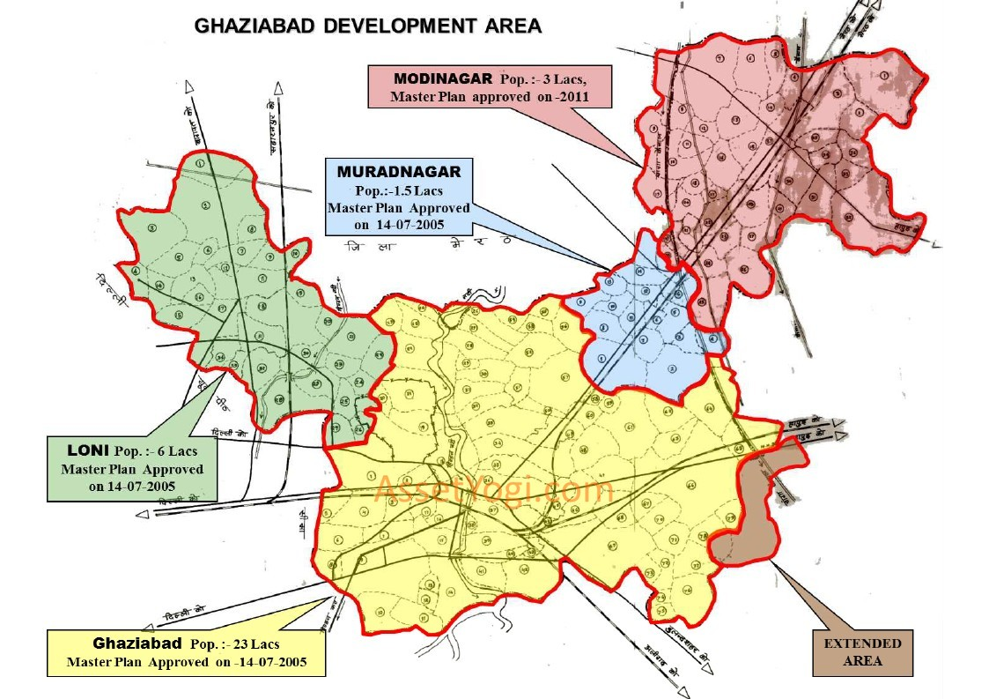

Figure 1:- Ground and Surface Monitoring Location Map

LITERATURE REVIEW

The water quality index is a single number that is used to indicate water quality [3]. This approach aims to offer a succinct and uncomplicated means of expressing the water quality for diverse needs. It enhances the generality of general water quality issues by keeping track of the variety of seasonal water quality indexes of a few well chosen surface water bodies. It has been discovered that during the course of the investigation, the change in WQI value consistently exhibits the same pattern. During both seasons, the lake water is reported to be of good quality (WQI - 67.7 to 78.5). It has been discovered, however, that the lake's water quality somewhat declines from winter to summer due to an increase in microbial activity and an increase in the quantity of contaminants.
From January to December 2008, the quality and index (WQI) for numerous lakes in Nagpur City, Maharashtra, India [4], were evaluated. The dominant seasons throughout this time period were summer, winter, and monsoon. The selection of sampling points was based on their significance. The National Sanitation Foundation (NSF) consulting services' water quality index calculator was used to determine the water quality index. According to calculated (WQI) for a variety of lakes under study, the water quality is less polluted than it is during the monsoon season. According to WQI, water contamination is weak in the summer and moderate in the winter. All seasons, except the monsoon season, revealed an average water quality grade for Gorewada Lake. The Futala, Ambajhari, and Gandhinagar lakes are also of poor quality over the past decades. Therefore, water quality management is required to assess water quality.
Lake water in India's rural and urban areas is primarily used for drinking and household purposes [5]. This study's major goal was to rate the potability of water from two lakes in India: Porur Lake in Chennai and Hussain Segar in Hyderabad. In order to achieve this, lake water samples from five different locations were collected and tested for various parameters, including pH, turbidity, electrical conductivity (EC), total dissolved solids (TDS), total alkalinity (TA), total hardness (TH), and calcium hardness (Ca-H), as well as dissolved oxygen (D.O. ), sulphate (as SO42-), nitrate (as NO3), and chloride (C These samples also underwent analysis for the presence of several heavy elements, including iron, zinc, cadmium, mercury, nickel, and chromium. At various locations, there were differences in the following parameters: EC (141-1041), turbidity (2-9 NTU), TDS (107.1-935.8 mg/L), SO42- (4-8 mg/L), TA (42-410 mg/L), TH (41-280 mg/L), Ca-H (14- 10 mg/L), BOD (5-9 mg/L), COD (4-32 mg/L), NO 3(1.1-3.6 mg/L), and Cl- (49 According to water pollution, these values were above the WHO and BIS standard-set limits [11].
A two-stage time-variable model for the adjustment of seasonal changes in pH and alkalinity levels in acidic lakes model [6]. This model sinks into the body of water and incorporates the CO2/HCOJ/CO5 [13] symmetry with internal sources. The Bickford Reservoir in Massachusetts and the Adirondack Park, Woods Lake, and Panther Lake in New York both employ the modelling framework. This model predicts that alkalinity is primarily created in the summer. This model is used to track the response to the springtime release of ice areas in Woods Lake and Panther Lake. A personal computer system effectively runs these model programmes.
A cost-effective pollution control strategy to maintain water quality for the Great Lakes [7]. Some mathematical models are used to estimate pollutant flow and water reduction with a very firm determination. For this project, data is collected from diversity lakes to check the status of water quality over the next twenty years. To facilitate communication and comprehension of Great Lakes water quality data between technical and non-technical parties, a collection of management tools is used to compile a number of near-shore water quality indices and environmental quality maps. The aforesaid study is effectively supported to control pollution of the Great Lakes, thereby implementing the most cost-effective programs and assessing their outcomes.
During the year 2008, studies and efforts have been made to assess the Physicochemical characteristics [12] for irrigation and seasonal changes in the water quality of the Pravar river for irrigation [9]. The research demonstrates that for the five sites chosen, the physicochemical parameters exhibit moderate seasonal change in their concentration.
The water quality index (WQI) created by the Canadian Council of Ministers of the Environment (CCME) was applied to Hebbal Lake in Mysore, Karnataka State [10], India, where aquatic life attempts to understand the primary effect on livestock and to determine whether it is suitable for recreation, irrigation, and drinking. This lake index is found to be weak for drinking and irrigation, and similarly for drinking and livestock, is excellent for aquatic life and irrigation purposes. It is found that water quality is progressively deviating from natural levels and is not suitable for aquatic life which is a matter of worry. The incidences of Fishkill are gradually increasing due to the contamination of water.

METHODOLOGY

To investigate the water quality (Ground and Surface water) in the Ghaziabad area and near to its surroundings, five sampling sites will be selected for bio-monitoring comparatively free from anthropogenic stresses and thus considered as a control site. The rest of the sites will be more or less disturbed due to various human activities. The samples will be collected periodically in plastic stoppered bottles for bio-monitoring seasonally covering one season (i.e. winter) during an investigation. The identification of phytoplankton and zooplankton will be made according to Shrinivas and Duthie, 1973. All physicochemical parameters shall be analyzed as per IS 10500.
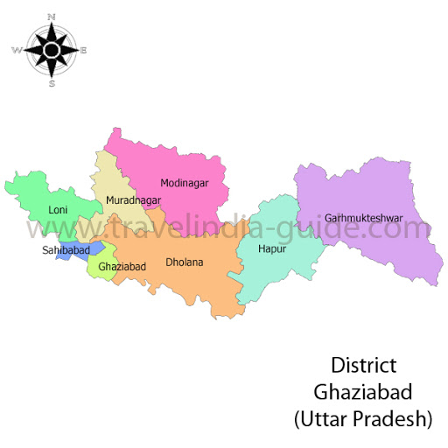

Figure 2: Ground and Surface Monitoring Location Map

Figure 3:- Flowchart Representing Research Methodology
Table 1: Ground and Surface water samplings sites of Ghaziabad district
S.No | Sampling Code | Sampling Location | Land Use Type
1. | GW1 | Sahibabad Industrial Area | Industrial
2. | GW2 | Vijay Nagar | Residential
3. | GW3 | Vasundhara | Residential
4. | GW4 | Mohan Nagar | Commercial
5. | SW1 | Hindon River | Commercial

Chemical parameters were used for regression analysis through dependent variables and TDS as Ca, Mg, Cl, and SO4. It can be used to predict the values of dependent variables. This model used ionic concentration and TDS of the groundwater samples at different locations. The water quality index is determined by considering whether groundwater is fit for human consumption.

RESULTS AND DISCUSSION

Ghaziabad city has a large industrial area. The waste wastewater run-up directly into the natural water body as the Hindon River. The sustainability scores of 5 groundwater and surface water concerning drinking and irrigation purpose has been depicted in Table 1.

Table 2: Results of all parameters
Parameters | Sample 1 Sahibabad Industrial Area | Sample 2 (Vijay Nagar) | Sample 3 (Vasundhara, Sector 9) | Sample 4 (Mohan Nagar) | Sample 5 (Hindon River)
Color | <5.0 | <5.0 | <5.0 | <5.0 | 8
Odour | UO | UO | UO | UO | UO
Taste | Agr | Agr | Agr | Agr
Turbidity (NTU) | 1 | 1 | 2 | 4 | 12
pH value | 7.6 | 7.1 | 7.4 | 7.8 | 7.6
Total dissolved solids ( TDS) | 659 | 662 | 674 | 697 | 2178
Calcium (as Ca) | 81.4 | 80.1 | 82.6 | 85.1 | --
Chloride (as Cl) (Mg/liter) | 116 | 112 | 119 | 128 | 538.6
Magnesium (as Mg) | 36.9 | 35.1 | 36.7 | 40.2 | --
Copper (as Cu) | <0.05 | <0.05 | <0.05 | <0.05 | --
Nitrate (as NO₃) | 11.2 | 10.8 | 10.4 | 12.9 | --
Manganese ( as Mn) | <0.01 | <0.01 | <0.01 | <0.01 | --
Sulphate (as SO₄) | 47.8 | 46.6 | 45.2 | 47.1 | 93.8
Fluoride (as F) | 0.7 | 0.6 | 0.5 | 0.8 | 2.4
Alkalinity ( as Ca CO₃) | 302.8 | 300.1 | 299.6 | 301.7 | --
Total hardness (as CaCO₃) | 356 | 353 | 350 | 356 | --
Arsenic (as As) | <0.01 | <0.01 | <0.01 | <0.01 | <0.01
Cyanide (as CN) | <0.05 | <0.05 | <0.05 | <0.05 | <0.05
An. Detergent (as MBAS) | <0.05 | <0.05 | <0.05 | <0.05 | --
The pH of the samples that were evaluated is 7.6, which is within the permissible range outlined by the CPCB in 1979 and the Bureau of Indian Standards in 1982. The TDS level of the analyzed sample is 2178 mg/l and is well above the prescribed limit specified by CPCB, 1979, and the Bureau of Indian Standards, 1982.
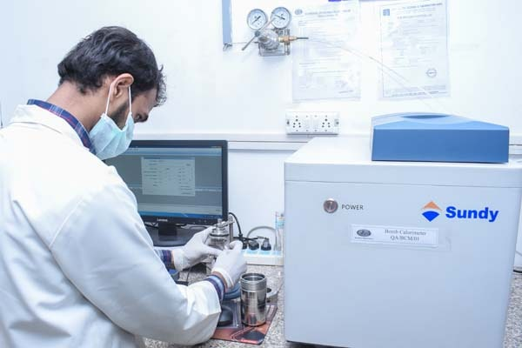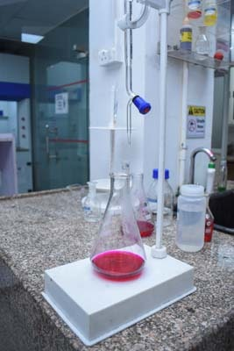
          - (b)
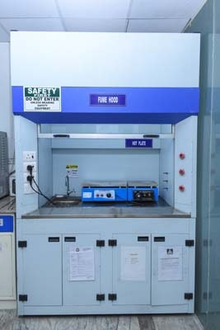
(c)
Figure: 4(a-c) Different Instrument of Noida Testing Laboratory used for Water Testing
The sample under analysis has a chloride level of 538.6 mg/land, which is barely above the legal limit set by the CPCB in 1979 and the Bureau of Indian Standards in 1982. The measured sample's sulfate concentration, 93.6 mg/l, is within the permissible limit established by the CPCB in 1979 and the Bureau of Indian Standards in 1982. The fluoride level of the analyzed sample is 2.4 mg/l and is well above the prescribed limit specified by CPCB, 1979, and BIS, 1982. The measured sample's BOD value of 58.2 mg/l is significantly higher than the permitted limit set by the CPCB in 1979 and the Bureau of Indian Standards in 1982, indicating the presence of organic pollution loading. The amount of several heavy metals in the sample under analysis exceeded the detectable limit, proving that the water is completely unfit for your purposes. The concentration of cyanides and phenolic compounds in the analyzed sample was below the detectable limits. The examined sample's total coli form is also much above the limit that was established by the CPCB in 1979 and the Bureau of Indian Standards in 1982.

CONCLUSION AND DISCUSSION
The water of the Hindan River, according to the current study, is inappropriate for human consumption and irrigation due to heavy metals and physiochemical parameters as EC, TDS, TH, CL, and F. Through the impact of urbanization and industry on water quality, the greater quantities of the aforementioned metals are degrading. According to IS 10500 criteria, the quality of groundwater was assessed for drinking purposes, and it was discovered that the majority of samples were suitable for drinking water following adequate distillation. Government should focus on reducing pollution through land use activities and heavy metal pollution.
The analysis of the Hindon River sample indicates that water is polluted and cannot be used for drinking, bathing, swimming, fishing, etc. The relevant government authorities are advised to erect public notices at suitable places prohibiting the use of this water. All the analysis has been done using the modern tools and instruments from Noida Testing Laboratories under the Ministry of Environment, Forest and Climate change.

REFERENCES

- Asadi S.S., Vuppala, and P. Reddy, “Remote Sensing and GIS Techniques for Evaluation of Groundwater Quality in Municipal Corporation of Hyderabad (Zone-V), India”, Public Health, Vol. 4, PP. 45–52, 2007.
- Bordalo, A.A. Teixeira, R. Wiebe, and W.J., “A Water Quality Index Applied to an International Shared River Basin: The Case of the Douro River”, Environmental Management, Vol. 38(6), PP. 910–920, 2006.
- B. N. Tandel, Dr. J. Macwan, and C. K. Soni - "Assessment of Water Quality Index of Small Lake in South Gujarat Region, India": International Journal of Engineering Research and Applications, Vol 3, pp 2029-2035, 2013.
- Rana D.B., Yenkie M.K.N., Khati N.T., Haldar A.G, and Puri P.J., "Greywater Treatment by Constructed Wetland: A New Age Technique'': International Conference on Science and Engineering for Sustainable Development, Vol 7, pp 31-34, 2016.
- Chandra, S., Singh, A. and Tomar, P.K. ., “Assessment of Water Quality Values in Porur Lake Chennai, Hussain Sagar Hyderabad and Vihar Lake Mumbai, India”: Chemical Science Transaction, Vol 1, 508-515.
- Wu-Seng Lung, A. M. Asce - "Lake Acidification Model: Practical tool", Journal of Environmental Engineering 1987.
- Heidtke T. M., Asce A. M. and Sonzogni W. C. "Water Quality Management for the Great Lakes": Journal of Water Resource Planning and Management, Vol 112, pp 48-63, 1986.
- Chabukdhara M., Gupta S. K., Y. Kotecha, and Nema A. K., “Groundwater Quality in Ghaziabad District, Uttar Pradesh, India: Multivariate and Health Risk Assessment”, Chemosphere, Vol. 17, PP. 1-25, 2017.
- Pradhan V., Mohsin M., and Gaikwad B. H. "Assessment of physico chemical parameters of Chilika Lake water": International Journal of Research in Environmental Science and Technology, 2(4), pp 101-103, 2012.
- Dr. M. K. Mahesh, Sushmitha B. R., and Uma H. R. "Assessment of Water Quality for Hebbal Lake of Mysore", Vol 2, pp 2277 – 2285, 2013.
- Singh, P.K., Tiwari, A.K., Panigary, B.P. and Mahato, M.K., “Water Quality Indices Used for Water Resources Vulnerability Assessment Using GIS Technique: A Review”, International Journal of Earth Sciences and Engineering, Vol. 6(1), PP. 1594–1600, 2013.
- Thitame S. N. and Pondhe G. M. - "Assessment of seasonal variation in Physico-chemical characteristics and quality of Pravara River water for irrigation use in Sangamner, Dist Ahmednagar, Maharashtra": Journal of Chemical and Pharmaceutical Research, 2(2): 316-320, 2010.
- Singh S. and Hussain A., “Water quality index development for groundwater quality assessment of Greater Noida sub-basin, Uttar Pradesh, India”: Civil and Environmental Engineering, Vol 3, pp 1-17, 2016.
- CGWB, 2009, Central Groundwater Board, Groundwater Brochure of Ghaziabad District, U.P. Online at: http://cgwb.gov.in/District_Profile/UP/Ghaziabad.pdf. Accessed at: 11 April 2018.

