BOOK CHAPTER- I
MOUNTAGE IN SILKWORM COCOON PRODUCTION
Author:Dr. Himangshu Barman, Scientist, Central Silk Board
Guwahati, Kamrup, India

- INTRODUCTION
Silk, a commercial fiber of animal origin akin to wool and cotton, is considered one of nature's gifts to humanity. It holds special significance in the modern era due to its eco-friendly, biodegradable, and self-sustaining properties. An intriguing historical account relates the discovery of silk to Xilingji (Hsi-ling-chi), the wife of China's 3rd Emperor, Huangdi (Hoang-Ti), back in 2640 B.C. Legend has it that while preparing tea, Xilingji accidentally dropped a silkworm cocoon into a cup of hot water and, to her amazement, found that the silk fiber could be gently loosened and unwound. By twisting fibers from multiple cocoons together, she fashioned a strong thread suitable for weaving into fabric. Xilingji's revelations extended beyond the art of unraveling silk; she uncovered the techniques for raising silkworms and utilizing their precious silk to craft garments. Over time, sericulture spread across China, and silk became a highly sought-after commodity worldwide. Another account tells of a Chinese princess who married an Indian prince and, as part of her dowry, carried silkworm eggs and mulberry cocoons within her ornate headdress. By sharing the secrets of silkworm cultivation, silk production was introduced to India.

Sericulture stands as an agro-based cottage industry characterized by a network of interdependent activities spanning rural, semi-urban, and urban areas. Women play a prominent role in this industry, accounting for an estimated 60% of the workforce. All facets of the sericulture sector, including mulberry cultivation, silkworm seed production, silkworm rearing, silk reeling and weaving, as well as the collection and processing of by-products, generate significant employment opportunities. This industry serves as a vital source of livelihood for rural and tribal communities. Unlike many other agro-based professions, sericulture prominently features the active participation of women, contributing to the advancement of their roles within family enterprises. Notably, India is the sole country worldwide where all four types of silk, namely Eri, Muga, Tasar, and Mulberry, are produced. The northeastern region of India uniquely produces all four silk varieties. Various sericigenous insects are commercially harnessed by humanity in this context.
(i) Mulberry silk worm
• Bombyx mori (Bombycidae)
• Bombyx mandarina (Bombycidae)
(ii) Tasar silk worm
• Antheraea mylitta (Saturnidae)
• Antheraea pernyi (Saturnidae)
• Antheraea yamamai (Saturnidae)
• Antheraea paphia (Saturnidae)
• Antheraea royeli(Saturnidae)
(iii) Muga Silkworm
• Antheraea assama (Saturnidae)
(iv) Eri silk worm
• Philosamia ricini (Saturnidae)
• Philosamia canningi (Saturnidae)
• Philosamia cyanthea (Saturnidae)
Natures in regards to food plants, habitats behaviour, climate preferences and product outputs are different in these four types of silkworms. Mulberry silkworm has narrow food plant selection preferring only on mulberry leaves and fully indoor habitation. Rest species of silkworm are of wild, outdoor habitation having wide range of food plant selection. For this reason they are wild in natural habitats and have wild counterpart species indicating that they have specific habitats conditions in alike climate. Similar to other members of group Insecta, all these four silkworms pass through four stages viz. egg, larvae, pupa and adult, to complete their life cycle. Of these stages pupal stage is very important that is termed as ‘economic stage’ of silkworms.

- PUPAL STAGE
Larvae are the immature form of an animal that hatches from an egg and undergoes several moults before becoming a pupa. Pupae are the transitional stage between the larva and the adult. The pupa is typically immobile and enclosed in a cocoon or chrysalis. Fifth-instar larvae, also known as the pre-pupal stage, fall dormant and cease feeding just before ecdysis. At last, the larva uses its anal organ to adhere to a chosen surface, initiating the pupation process. In case of silkworm, such fifth instar larvae ready for pupation is termed as ripen larvae. These ripen larvae before sitting for pupation, release all excreta including litters with urine they inside their body. This stage is also called as holy stage of silkworm. Ripen larvae thus become lighter in weight and have sufficient silk juice in their silk gland. Once ripen larvae release all excreta from body, they search for safe and convenient place for cocooning. The silkworm wraps its net around itself to support itself. Subsequently, it pivots its head, whirling a protein fiber into a silk fiber. The cocoon is the protective covering that many caterpillars create around the pupa.
Following the completion of cocoon formation, the larvae enter a period of physical inactivity or dormancy. During this phase, a complex physiological and biochemical process known as metamorphosis occurs, leading to the transformation of their bodies into pupae and ultimately adult moths. Metamorphosis encompasses a wide array of changes, involving structural, physiological, and biochemical aspects. These changes are characterized by the disintegration and atrophy of certain structures, cellular death in specific tissues, the morphogenesis and differentiation of new structures, and the remodeling of others. Notably, tadpole hemoglobin undergoes a transition into adult hemoglobin during this process, resulting in altered oxygen binding and release kinetics. Additionally, changes in liver enzymes reflect the shift in the habitat.
Metamorphosis is initiated by the digestion of the caterpillar itself, with the release of enzymes that dissolve its tissues. If one were to open a cocoon or chrysalis at the precise moment, it would reveal a semi-fluid substance resembling caterpillar soup. However, within this fluid, organized groups of cells known as imaginal discs survive the digestion process. These imaginal discs were developed by the caterpillar during its earlier stages within the egg, each disc corresponding to a specific body part required in its adult form, including eyes, wings, legs, and more. In some species, these imaginal discs remain dormant throughout the caterpillar's life, while in others, they begin to take on the characteristics of adult body parts even before cocoon formation.
Once the caterpillar has disintegrated nearly all of its tissues, except for the imaginal discs, these discs utilize the protein-rich medium around them to facilitate rapid cell division, culminating in the formation of adult features such as wings, antennae, legs, eyes, and genitals. The preservation of certain caterpillar muscles and segments of the nervous system is observed in the resulting adult butterfly, with some studies suggesting that moths may retain knowledge acquired during their caterpillar phase.
The pupation process is under the control of hormones. Analyzing pupal powder composition, it was found to contain approximately 7.6% moisture, 71.9% crude protein, 20.1% fat, and 4.0% ash on a dry matter basis. Mineral analysis indicated a high potassium (K) content, with a low sodium-to-potassium (Na/K) ratio, and minimal heavy metal content.
Top of Form
Larval structures disintegrate and adult structures, like wings, emerge for the first time during pupation. The pupal skin (cocoon) is split apart by the adult, or it chews its way out or secretes a fluid that softens the silk protein inside the cocoon. The pupa is white and fragile when it first emerges from the womb, but its skin gradually gets firmer and darker brown. big compound eyes, big antennae, fore and hind wings, and legs are the main morphological features that are visible on the pupa. The environmental factors that affect silkworm growth and development during pupation include humidity, temperature, the physical environment surrounding them, and disturbances. Moreover, physical health of ripen larvae which in turn influenced by feeding on food plant leaves, diseases incidences at pre-ripen stage, greatly affect pupation process. In low environment temperature condition prevail during winter season slower pupation process resulting prolong pupation period. Unlike winter season, pupation is faster in summer season resulting shorter pupation period. If disease or undernutrition condition prevail in larval stages, it also greatly influences pupation process. Resultant is underdeveloped, crippled adults. This also influences cocoon size sometimes flimsy cocoons. Further, if pupation is in normal way, may also express trouble in coupling and laying.

- COCOON
The silkworm uses a net to hold itself together while it is a pupa. Subsequently, it pivots its head, whirling a protein fiber into a silk fiber. The cocoon is the protective covering that many caterpillars create around the pupa. Just before metamorphosis process starts, cocoon formation process initiate. This cocoon formation process takes several days. This period also depends upon species and prevailing ambient environment conditions. In cocoon formation process, one special organ called “spinneret’ present at mouth part play key role. During larval development stages, silk juice comprising fibroin and sericin proteins got accumulated in silk gland. With this silk juice of silk gland, cocooning larvae built around a highly compactly unknotted protective cover so called ‘cocoon’. With just one spinneret organ, the silkworm weaves the cocoon. The two components of liquid silk are produced by two glands inside the worm, and when they come into touch with air and one another, they solidify into a fiber.The cocoon is a single, uninterrupted silk strand that measures around one kilometer in length. Every fiber is made up of two fibroins that have a layer of sericin on them. The cocoon is a multilayered, three-dimensional (3-D) nonwoven structure. Sericin serves as an adhesive to keep the entire cocoon's multi-layered structure and random fibers in place. Once cocoon is formed, it remains dormant inside the cocoon for considerable period. During this period metamorphosis occurs through physio-biochemical changes. Inside the cocoon it transform into pupa and then adult moth. Thus, cocoon not only provide protection but also create a congenital environment maintaining constant temperature and humidity inside it for successful metamorphosis phenomena.
Cocoons exhibit unique characteristics arising from the diversity of genes, environmental factors, diet, and the life cycle of silkworms, leading to variations in their shape, size, structure, and properties. These distinct attributes are essential to the cocoon's performance in mechanical protection, humidity regulation, temperature buffering, and UV protection. The study of the structural features and differences in each cocoon layer's performance is vital.
Cocoons represent a remarkable class of biopolymer composites in nature, featuring exceptional microstructure and ecological functions. They are produced by silkworms in a highly organized and purposeful manner, involving coordinated movements of the head and body to adapt to diverse environments, which have evolved over an extended period due to natural selection. Despite their thin and lightweight appearance, cocoons serve as a formidable defense against various threats in the natural world while providing a conducive environment for silkworm metabolism.
Cocoons exhibit a subtle multi-layered structure with hierarchical tensile properties from the outer layer to the innermost layer. The inner layer, characterized by finer silk and denser microstructure, offers superior static and dynamic qualities. The structure of the cocoon is intimately related to its stretching, compression, and gas diffusion properties. Silkworm cocoons possess intriguing unidirectional gas transfer features, which contribute to the survival of silkworm pupae.
The outer surface of cocoons is adorned with calcium oxalate crystals that play a distinctive role in providing protective functions. The cocoon's special structure and components endow it with the capacity to regulate and control temperature and humidity effectively. Within the cocoon layers, sericin, silk fibroin, and calcium oxalate exhibit the ability to adsorb UVA, UVB, and UVC radiation from sunlight, respectively.

03.1. COCOON TYPE
There are four types of silkworms commercially rear cocoons which are used in silk industry. These are Mulberry silk, Muga silk, Eri silk and Tasar silk. As these silkworms are genetically different, their cocoons are also different in terms of colour, size, shape and types of yarn yields. In cases of Mulberry, Muga and Tasar, the cocoon is a continuous thread when reel. Unlike these three silks, Eri cocoon is fragmented threads and is spanned to yarn. Mulberry cocoons are fine silver glossy in colour and smaller in size having fine oval shape. Muga cocoon is also like Mulberry cocoon in shape but elongated one and bright whitish brown in colour that yield golden glossy yarn. Alike to Muga cocoon Tasar cocoon is fine oval in shape and bigger one.

Commercially, silkworm cocoons are classified into three categories, green cocoon, reel cocoon, pierce cocoon. Green cocoons are living cocoons while pupa inside it remain alive. Green cocoons are used for grainage to produce eggs for next crops. Reel cocoons are dead cocoonsin which pupae were killed by stifling process. Stifling is a process whereby pupae inside cocoons are killed by artificial heating or sometimes by sundry. These cocoons are stored for reeling into yarn. While adult moths are emerged from cocoon they pierce the cocoon making a hole to escape leaving the cocoon shell. These cocoon shells re called as pierce cocoons. Pierce cocoons are difficult to reel to have continuous thread. Pierce cocoons are spanned into yard like Eri yarn and are of lower grade. But Eri pierce cocoons have same value to span cocoon.

Yagi (1926) classified cocoons into four types by their formation of the exit hole of the adults and the modes of attachment. They were: (1) stalked and closed, (2) stalkless and closed, (3) stalkless and open, and (4) stalked and open. In silkworm, Mulberry cocoons are stalkless and closed whereas Muga and Tasar cocoons are stalked closed. Eri cocoons are stalk less and open.

- MOUNTAGES
Mounting is a pivotal stage in the sericulture process, crucial for achieving abundant yields and high-quality cocoons. As the fifth-stage larvae complete their larval life cycle, they expel all their excreta, including liquid and semi-solid waste. At this point, the matured larvae undergo noticeable changes – they become translucent, their bodies contract, they cease feeding, and restlessly search for a suitable spot to anchor themselves for cocoon spinning and pupation. The worms are now prepared for cocoon production.
Matured silkworms emit a distinct hollow sound when gently rubbed between fingers, signaling their readiness for the next step. This is the opportune moment to select the ripe worms and place them onto mounting surfaces. During cocoon spinning, it becomes evident that the worms require at least two supportive surfaces. They release silk fluid in small quantities through continuous head movements, which subsequently solidifies into a continuous filament. The initial phase of cocoon construction involves the creation of a preliminary web, establishing the necessary foothold for the larva to craft the robust cocoon shell. Through characteristic head movements, the silk filament is deposited in a sequence of short waves, forming a distinctive figure-eight pattern. These layers accumulate to build and fortify the compact cocoon shell.
Once the sturdy cocoon shell reaches completion, the contracting larva proceeds to envelop itself within and detaches from the shell, entering the pupal or chrysalis stage.
The primary objective of this task is to explore improved materials for creating the frames on which silkworms perch to spin their cocoons. To facilitate cocooning and mounting, specific criteria for mounting frames must be established. An ideal mounting unit should possess the following characteristics:
Mounting operations represent a time-sensitive and labor-intensive aspect of silkworm rearing. Mature silkworms require mounting frames as support structures for cocoon spinning. The process of relocating mature larvae to these cocoon frames is referred to as mounting. Streamlining the mounting process is essential due to its labor-intensive nature. Delaying the mounting process when larvae reach maturity can lead to silk loss and the production of subpar quality cocoons. Various mounting methods exist, with the most common ones being the "pick up" method, the natural method, the "shoot shaking" (Jobrai) method, and self-mounting. Among these options, the methods most frequently employed by South Indian farmers involve placing individual mature larvae onto bamboo mountages or utilizing collapsible plastic mountages on the rearing bed for self-mounting. Between these two methods, the "pick up" method has proven to be the preferred choice for mounting due to the superior quality of cocoons it yields in comparison to the self-mounting method. This is primarily because the silkworms are selected at the right stage of maturity. However, it's important to note that the pick-up method demands more space and a higher labor investment, making it relatively costly. The material and design of the mounting frames have a significant impact on the quality of the cocoon filament and the labor required for mounting and cocoon harvesting.The fundamental idea behind mounting frames is to provide a consistently angular and uniform space for silkworms, facilitating smooth cocoon formation. The construction and type of mounting frames are influenced by the availability of materials in the respective regions. If the materials and structure of the mounting frames are inadequate, it can result in irregular cocoon shapes and sizes, increased instances of double, deformed, or soiled cocoons, and the wastage of silk in the form of floss.The spinning phase is the final stage of the rearing process and necessitates the use of suitable mounting devices to obtain high-quality cocoons for reeling. This stage holds paramount importance in silkworm rearing, as it involves the mounting of mature worms onto appropriate cocooning devices. Inattention to this stage can adversely affect both the quality and quantity of the cocoons produced.
In the northeastern region of India, many farmers traditionally use a bundle of dried leaves known as 'JALI' for cocooning in eri-culture. Commonly used mounting frames include chandraki, baskets filled with dry leaves, jali (bundles of semi-dried leaves from plants like mango, jackfruit, and ornamental species), and gunny bags filled with dry leaves. The leaves should not be entirely dried; semi-dried leaves are suitable for the spinning process. Once the optimal number of worms is placed in their respective mounting frames, they are covered with newspaper or cloth to create a supportive, calm, and semi-dark environment conducive to cocooning.
However, any disturbance during this phase can temporarily halt the spinning process. Factors like unavailability of a suitable environment and disturbances can result in the larvae spinning defective cocoons or even failing to spin cocoons entirely. Abnormal physiological conditions in the larvae can lead to their death without pupation.
The quality of cocoons is also influenced by the type of mounting frames, worm density during mounting, and various mounting methods/models. During spinning, temperature, relative humidity, and aeration also play pivotal roles in determining cocoon quality. While several studies have examined different types of mounting frames for mulberry silkworms and muga silkworms in various parts of the country, there is a lack of detailed research in eri culture regarding the fabrication and performance of mounting devices, except for preliminary studies conducted by Debaraj & Brahma (2003) and Patil & Savanurmath (1994).
Many workers have been putting effort to develop suitable mounting device for silkworms and reported some advantageous mountage for mulberry silkworm as well as Muga silkworm. But in Eri sector very less number of workers reported their works on Eri mountage devices e. g. Debaraj & Brahma (2003);Patil & Savanurmath (1994).According to many workers, humidity and temperature of the mountage play great significant rules in cocoon qualities. Subhas V. Naik et al., 2008 reported that reeling characteristics, raw silk yield and quality of raw silk are significantly better in the case of cocoons spun under low temperature and low humidity condition. They found that high temperature and high humidity particularly without air circulation have affected severely reelability, raw silk yield, raw silk neatness & cleanness and tensile properties of raw silk. G. V. Prasad et al., 2011 designed and develop Radial Mountage for mulberry silkworm to minimize manpower investment, transportation, spinning & storage space, disinfection & maintenance.

An ideal mountage system should have the following characters.
Convenient space with suitable dimension for spinning proper-sized cocoon.
Should not allow formation of double or malformed or flimsy cocoons.
Should have provisions for cleaning the excreta of spinning larvae.
Should be suitable for easy harvesting of cocoons.
Should be cheap, durable and easy to handle.
For better cocooning in mountage systems, following cares are to be taken during mountage.
Ripe worms alone ought to be mounted. Overripe worms quickly spin out inferior, deformed, flattened, and sticky cocoons, whereas unripe worms ruin other cocoons with their excrement.
The ideal temperature for spinning should be kept at 24°C. The silk's color, gloss, and texture are all impacted by too low a temperature, which also delays the production of cocoons. Thick filamentous cocoons are created at excessively high temperatures.
For spinning, a humidity of 60–70% is optimum. Ventilation is necessary to evaporate the water or excrement that the worms emitted during spinning and to dry the wet silk into a solid cocoon.
Cleaning the mountages both before and after usage is recommended.
It is important to avoid disturbing the spinning worms as this could cause the spinning to stop and the thread to break.

Cocoonage, also known as mountage, is the most crucial tool for assisting or supporting silkworms (larvae) in comfortably spinning their cocoon. It determines how many and what kind of cocoons there are. In different locations of India, different kinds of cocoonages are employed. These are typically constructed from grass, dry leaves, twigs, cardboard, bamboo, plastic, and other materials. Transferring the ripe worms to the mountages is called mounting. The ripe worms on the mountage release silk, make a cocoon around themselves, and change inside to become pupae. The pupa emerges from the cocoon by puncturing it after changing into an adult moth.The goal of silkworm rearing is to provide the greatest environment and mountages possible for the silkworms to spin quality cocoons with the highest possible silk content.
Ripe worms are often hand-collected in a tray and subsequently moved to the mountages. With this procedure, only ripe worms may be collected and more evenly disseminated across the mountages, even though some worms may get hurt during the picking and handling process.
An alternative technique involves the simultaneous collection of several adult larvae and their transfer to the mountage. Because the worms are placed together, whether the cocoon they produce is uniform or not depends on the maturity of the individual worms.
Straw rope nets, rush nets, or cleaning nets are occasionally laid over the training beds in the rearing tray and left for a while, once the worms have ripened. While unripe worms continue to feed, ripe worms crawl alone on the nets. The mature worms are subsequently transferred without human contact by shaking the nets containing them on the mountages.
In yet another manner, the raising bed is covered in tiny mulberry branches. Then, on the mountages, the worms that are crawling over them are shaken off. In addition to branches, the ripe worms can also be transferred to mountages using chopped straw (Japan) or dried weeds (Russia).It matters a lot how many ripe worms there are in each mountage. To spin its cocoon, a single ripe worm typically needs an area the size of its body length squared.

In Sericulture, generally used mountages can be divided into two groups, viz. Traditional Mountages and Modern or Scientific Mountages.

  - TRADITIONAL MOUNTAGE

04.01.01.PLANT LEAFY TWIGS

Sericulture itself is a traditional cultural practices adopted by various ethnic groups living in nuke and corner of the world. At present era there are several technological interventions at various stages of this traditional cultural practice. In general villagers used dry leaves of different plant species for cocooning of ripen larvae of Mulberry, Muga and Eri silkworm. During the culturing process prior to collecting ripen larvae of the crop, tree twigs are cut and dried. For this purpose leaves of several locally available plant species have been used. Generally Mango tree, Jackfruit tree, Banana tree etc are locally available in villages. Dried plant leaves used for silkworm cocooning in Muga and Eri is colloquially called as “Jali”. Dried twigs are kept in a room either in hip or remain hanging from bamboo bars. Ripen larvae are released on these twigs and larvae remain settled on leaves for cocooning. After 6/7 days cocooning is completed in normal temperate seasons, however in winter when temperature is low it takes more days cocooning to be completed. Cocoons from leaf mountage are harvested manually one by one.

This traditional mountage has some advantages and disadvantages. Advantages of using “Leaves Mountage” are easily available materials and eco-friendly in nature. Different plant species are easily available to the farmers in their surrounding environment. Being raw plant material this has no after use disposal problem as well as no bad effect on spinning silkworms. But this type of mountage has certain disadvantage that directly affect cocoon economy. Collection of plant leaf twigs and drying in sunlight is time consuming and labour intensive. Rainy climate at the time of culturing process further harassed it, no sunlight to dry the twigs. As a result semi dried or non-dried plant leaf twigs are used in mountage. This result loss in cocoon harvest as a good numbers of larvae cannot spin to good cocoons or flimsy cocoons or cannot spin into cocoon. Cocoons harvested are also not good enough up to expectation. This is because fresh leaves or semi-dried leaves create heating conditions inside the mountage by raising humidity inside mountage. Moreover, aeration inside mountage is not sufficient that’s needed for spinning larvae. This also resulted fungal growth on the cocoons.Further, leafy twigs once used for mountage cannot be used in next time as leaves shade from its twigs. So each time of cocooning activities fresh plant leaf twigs are to be used which is of labour expensive, not economically helpful to farmers as more money is to invest on labour in each crop. Thus, this traditional mountage system is not commercially viable in sericulture practices.
Sometimes farmers use Gunny Bags for mountage where dry plant leaf twigs are kept inside where larvae are to spin into cocoons. Nylon net is also used for this purpose instead of Gunny Bags.

04.01.02. CHANDRIKA

This mountage, which can be round or rectangular in shape, is composed of bamboo mat and is held up on both sides by split bamboo reapers. A 4-5 cm wide bamboo tape is twisted in a spiral pattern on the mat. On this mountage, about 1000 worms can be mounted. These may be handled with ease, are recyclable, and the cocoons spun on Chandrika are of high quality.But since bamboo is a protected plant these days, chandrika is expensive and scarce. When not in use, it takes up a lot of space and is vulnerable to damage from rodents. Additionally, there are more stained cocoons in Chandrika. West Bengal and South India are big fans of Chandrika (SanchitaKad).
04.01.03. SCREEN-TYPE MOUNTAGE
It is constructed from bamboo, wooden, or plastic reapers that have longitudinal strips with triangular peaks positioned on them in place of spiral bamboo tape. It is possible to fold and store the screen.
Because this mountage can be maintained clean and well-ventilated, high-quality cocoons can be spun on it. It's stronger than Chandrika. However, twin cocoon occurrences are common there (SanchitaKad).
  - MODERN OR SCIENTIFIC MOUNTAGES
04.02.01. PLASTIC MOUNTAGE OR COLLAPSIBLE MOUNTAGE
Similar to the Chandrika mounting frames, the Netrika Sericulture Nets are designed for the breeding of silkworms, with some notable distinctions. Instead of bamboo, they are constructed from durable plastic, resulting in increased longevity, ease of cleaning, and resistance to rodent damage. Moreover, these nets tend to yield a lower number of double cocoons, reducing the need for ongoing maintenance or additional expenses after the initial investment. However, it's important to note that these plastic mountages are relatively more expensive than the Chandrika frames. The cocoons produced on the plastic mountages are somewhat delicate and not consistently uniform in size, which may explain why they are not as commonly favored by farmers (as per Sanchita Kad).
Netrika Sericulture Nets have gained significant popularity within the sericulture industry due to the pivotal role they play in facilitating the formation and harvesting of silkworm cocoons. They provide a hygienic environment for these processes and offer several advantages over traditional bamboo mountages.
One key advantage is their versatility when compared to bamboo frames. These nets are machine-made, resulting in uniform corrugation that promotes consistent cocoon formation and simplified harvesting. Additionally, the nets are easy to clean, helping maintain a hygienic environment. They are built to be long-lasting and can be reused for several years. Unlike bamboo mountages, they are non-biodegradable, ensuring an extended lifespan. Finally, they are convenient to store and transport, further enhancing their utility in sericulture operations.
04.02.02. JAPANESE LOW COST MOUNTAGE

This modified Japanese mountage has a hardwood frame with four longitudinal rods joined to a central axis through cross-spokes at both ends. There are several pegs spaced equally apart on each pole. Long threads of twisted rice straw, resembling charpoy in pattern, connect these pegs.The rearer's requirements can be taken into consideration while modifying the frame's size and peg count. This mounting is less likely to spread disease, more affordable, and more robust.

04.02.03. BAMBOO STRIP MOUNTAGE

composed of bamboo strips that are either inserted into the grooves of wooden reapers or tacked onto them. These frames are stacked one on top of the other, with the bottom frame resting on four identical brick or wooden blocks. These mountages are affordable, strong, lightweight, and simple to use for gathering cocoons (SanchitaKad).

04.02.04. BOTTLE BRUSH MOUNTAGE

This freshly introduced mountage is made up of 6–9 sticks (the midrib of coconut leaves) put extremely closely into a thick rope made of coconut or jute fiber.The worms employ these as structural support. In the void created by the sticks, the worms weave their cocoons. Compared to Chandrika, this mountage is far less expensive, easier to make, and takes up less space (SanchitaKad).

04.02.05. PLASTIC BOTTLE BRUSH

With support from JICA, researchers at the Central Sericulture Research and Training Institute (CSR&TI), Mysore, invented this improved bottle brush. Each plastic rope in this instance has eight 1.5 cm-long branches and two 9 cm-long sub-branches.In a circular pattern, the branches are equally spaced 1 cm apart at the base and 4 cm apart at the ends. The diameter of the circle made up of branches and subbranches is 24 cm. To reduce floss loss during spinning, their surfaces are rough and granular to provide the worms a hold.To keep the entire mountage in the proper place, fifty of these separate components are joined together with an iron rod, and a steel stopper is firmly secured at the end of the rod. After disinfection, this mountage can be reused because it is robust. It makes harvesting simple and permits self-mounting when using the shoot-rearing technique.

Indian sericulture is currently incorporating many additional mountages that are well-liked in several other nations. For instance, rotary mounting from Japan, folded bamboo strip mounting from China, folded straw mounting, straw rope mounting, etc. (SanchitaKad).

- MODERN MOUNTAGES DEVELOPED IN INDIA

  - PULL STRIPS MOUNTAGE
“Pull Strips Mountage” has been developed by Barman H. et al in 2014 at Regional Sericulture Research Station, Mendipather, Meghalaya. Proper mountage system not only facilitates ripen Eri silkworm to spine cocoon to fullest extent but also minimizes cocoon harvesting labour investment. Materials used as well as interior environment with convenient facilities in mountage system are two important factors that directly influence cocooning process.According to many workers, humidity and temperature of the mountage play great significant rules in cocoon qualities. It is reported that reeling characteristics, raw silk yield and quality of raw silk are significantly better in the case of cocoons spinning under low temperature and low humidity condition. It is also found that high temperature and high humidity particularly without air circulation have affected severely reelability, raw silk yield, raw silk neatness & cleanness and tensile properties of raw silk (Barman H. et al, 2014).
Considering all these necessary points, a convenient mountage has been designed and developed which has named as “Pull Strips Mountage”. It is fabricated with materials like wooden plank finish with sand mica, strips of sand mica and, perforated muslin cloth. It is of 2′x 1½′x 4″size (size varied according needs) and covered on both bottom and upper sides by perforated cloth foldable by wood stick frame. The entire inner chamber is divided into many elongated chambers to facilitate cocooning with several strips that can be removed by pulling out after cocooning is completed(Barman H. et al, 2014).

TABLE – 1: Comparative performance in different mounting parameters of Pull Strip Mountage and other generally used mountages for Eri Silkworm spinning.

Sl. No. | Types of Mountage | Free Area of Mountage (sq. feet) | Nos. of ripen larvae | Good Cocoon  (%) | Flimsy Cocoon  (%) | Dead/non-spinning larvae  (%) | Double Cocoon  (%) | Cocoon Weight (gram) | Shell Weight (gram) | Silk Ratio (%) | Time require to harvest  (minutes)
01 | 02 | 03 | 04 | 05 | 06 | 07 | 08 | 09 | 10 | 11 | 12
1. | Bamboo Chandrika | 3 | 200 | 93.5±0.7 | 1.5±1.7 | 2±0.7 | 1±0.1 | 2.32±0.094 | 0.29±0.017 | 12.5±0.202 | 15±0.4
2. | Plant Leave (Jali) | 3 | 200 | 91±1.8 | 4.5±1.3 | 3.5±0.8 | 1±0.1 | 2.36±0.054 | 0.30±0.007 | 12.71±0.008 | 17±2.4
3. | Pull Strip Mountage | 3 | 200 | 98±5.2 | 0.5±2.7 | 1±1.7 | 0.5±0.4 | 2.67±0.256 | 0.36±0.053 | 13.48±0.778 | 2±12.6
4. | Gunny Bag with plant leaves | 3 | 200 | 90.5±2.3 | 5.5±2.3 | 3±0.3 | 1±0.1 | 2.35±0.064 | 0.28±0.027 | 11.91±0.792 | 20±5.4
5. | Jali covered with nylon net | 3 | 200 | 91±1.8 | 4±0.8 | 4±1.3 | 1±0.1 | 2.37±0.044 | 0.306±0.001 | 12.91±0.208 | 19±4.4
SD |  |  |  | 2.804 | 1.887 | 1.150 | 0.2 | 0.1291 | 0.0278 | 0.5132 | 6.5299
P-value at 0.05 level |  |  |  | 0.53216 | 0.57636 | 0.9292 | 0.0228 | 0.0239 | 0.0294 | 0.0643 | 0.0268

Note: p- value has been calculated against data of Pull Strip Mountage.
During cocooning period the mountage is kept vertical either in stand or hanging in air to facilitate more aeration. Cocooning performances of this mountage has been compared with some traditionally used mountages by Eri rearers of North Eastern region of India, like Plant Leave (Jali), Bamboo Chandraki, Gunny Bag with plant leave, Jali covered with nylon net.Good cocoon spinning is maximum achieving 98% in PSM. Flimsy and double cocoon formation restrict at 0.5% only, whereas dead/non-cocooning larvae are found 1%. Good cocooning in PSM is 6.5% higher at an average than the other mountage systems tested. PSM exhibits a discrepancy in fragile cocoon production of 3.375% less than the 3.875% average in alternative mounting techniques. PSM has been determined to have a 2.125% economy over other systems that are taken into account in the experiment in the situation of dead or non-cocooning larvae. Therefore, PSM is determined to be a more advantageous system in terms of quantitative characteristics for Eri silkworm mounting. Because of this, the cocoon spine in PSM is of higher quality than that of cocoons in other systems, as evidenced by the higher silk ratio of 13.4 and the superior cocoon and shell weight (Barman H. et al, 2014).
Since cocoon harvesting operation is labour intensive and time consuming process the time required in this process is a very important economy parameter. If time require to harvest cocoon is less then labour investment will also be less. Time require to harvest cocoons from mountage is very less in case of PSM. Since, this is labour intensive process PSM facilitate 88.73% less labour cost over rest of systems in an average. Time require to harvest cocoons from mountage is very less in case of PSM that accounts only 2 minutes to harvest 197 nos. cocoon. Whereas it takes 20 minutes to collect 192 nos. cocoon in Gunny Bag with plant leaves, 19 minutes in Jali covered with nylon net to collect 190 no’s cocoon, 17 minutes in Jali to collect 191 nos. cocoon and, 15 minutes in Bamboo Chandrika to collect 190 nos. cocoon. Thus, PSM facilitate 88.73% less labour cost over rest of systems in an average (Barman H. et al, 2014).

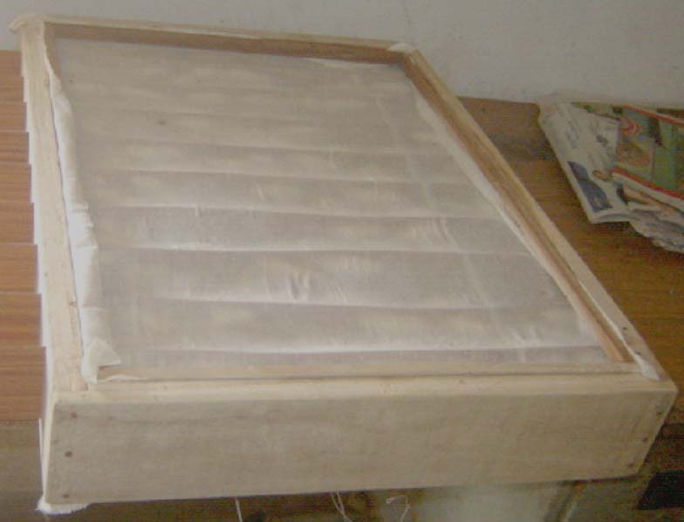
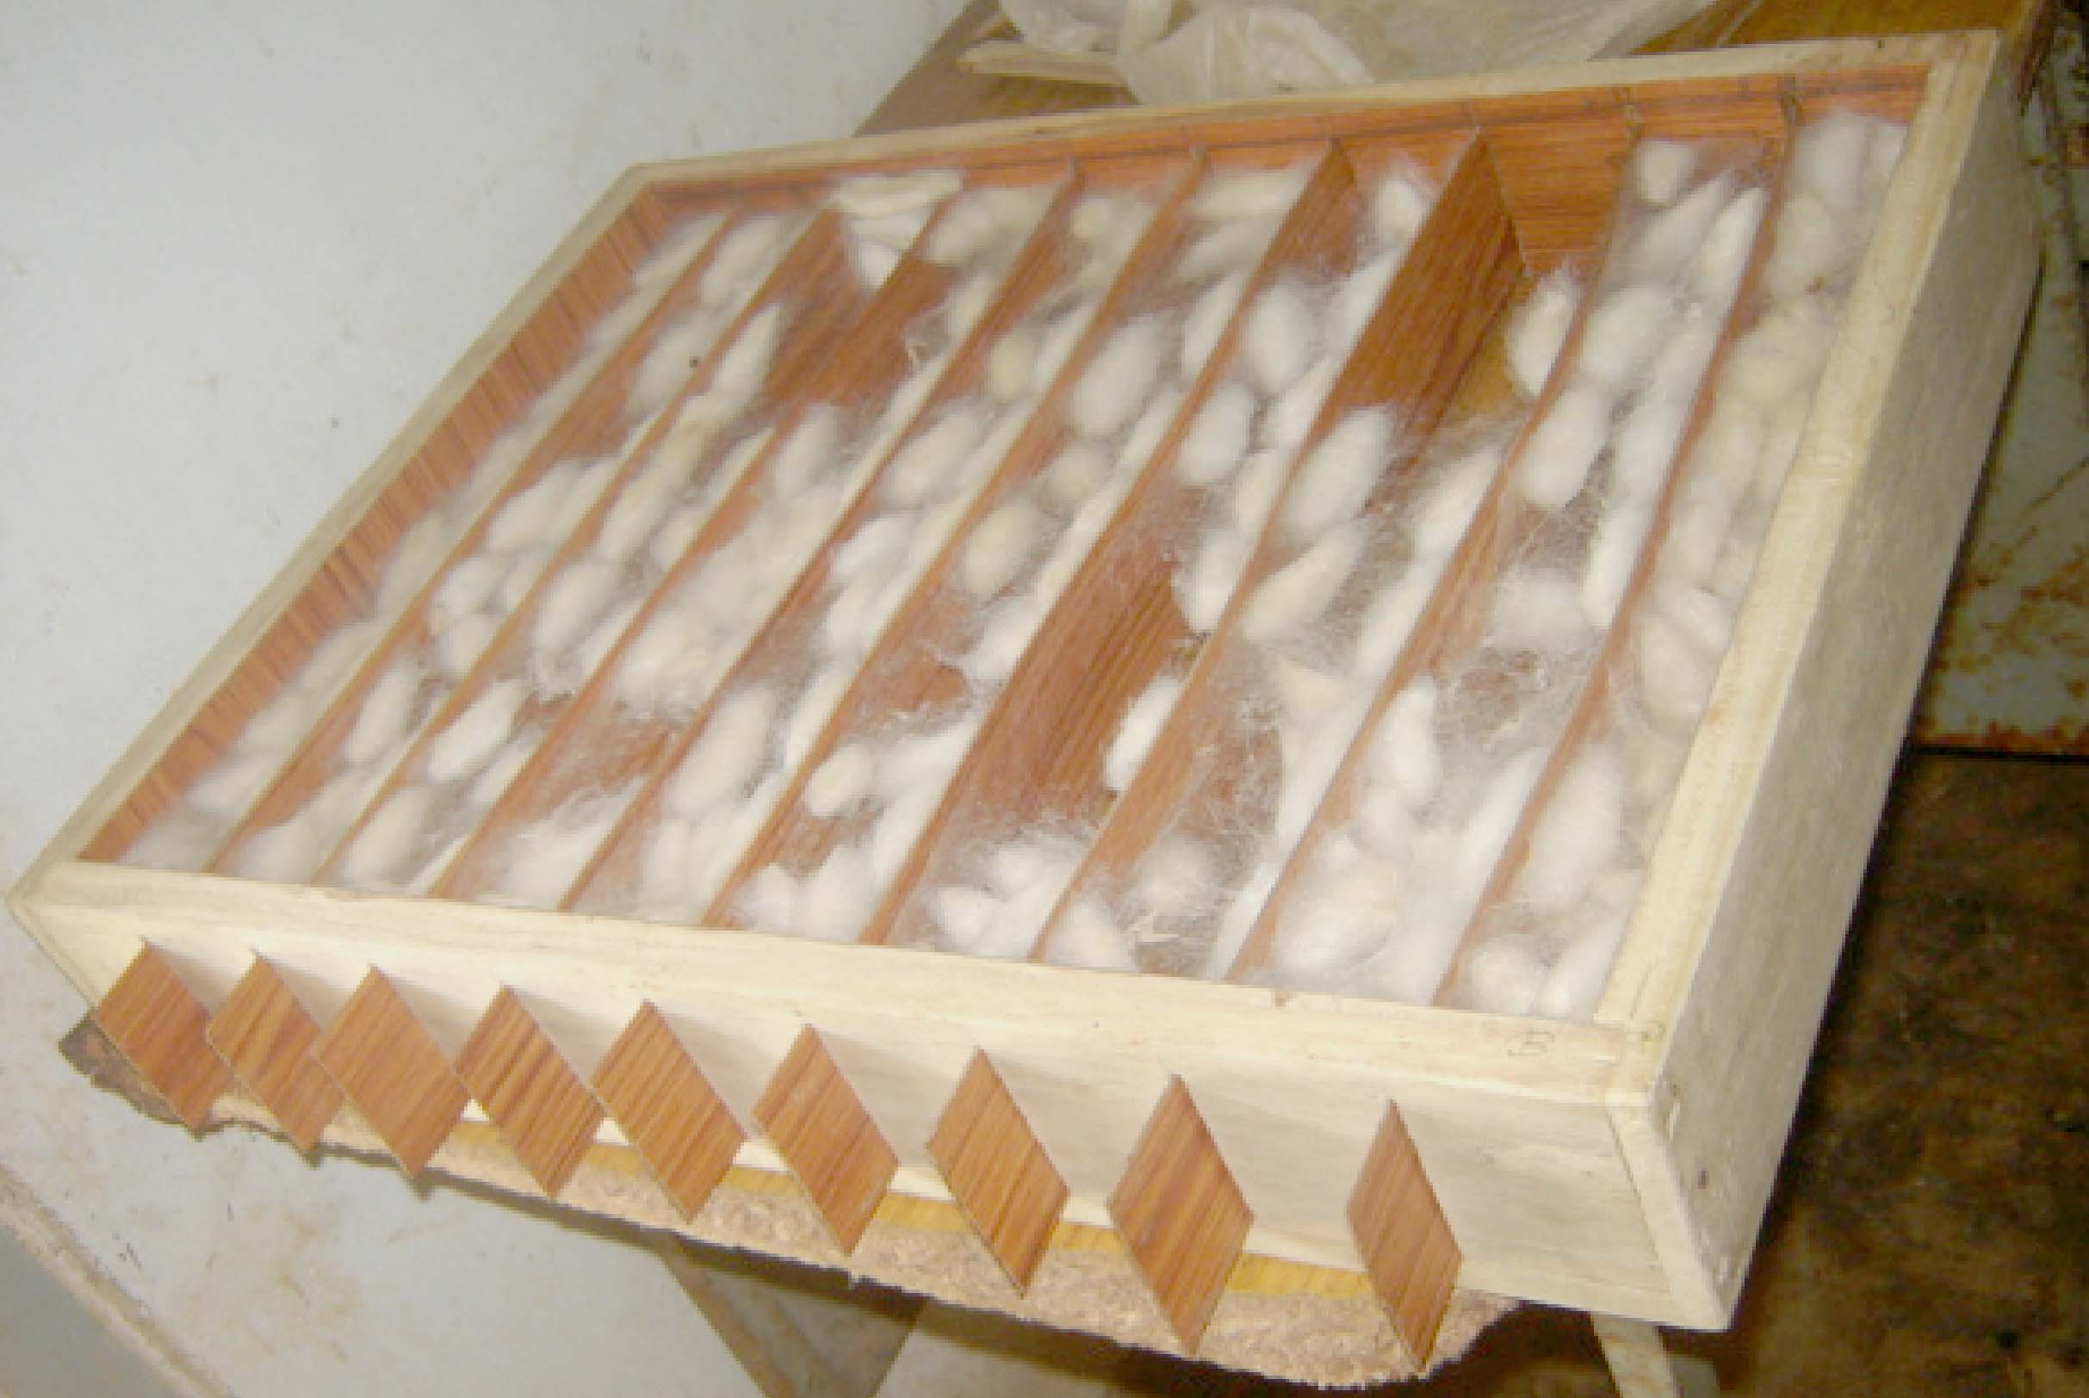
FIGURES: Eri silkworm Cocoon formation in Pull Strips Mountage.

  - STORAGE AND COCOONING DEVICE FOR ERI, MUGA AND MULBERRY SILKWORM
A new Mountage technology had been developed under DST (seed) project “Socio-economic uplifting of farmers through adoption of improved technologies and skill development in Eri culture” by Dr. Himangshu Barman and Miss Meghasree Baishya at Regional Sericulture Research Station, Boko, Kamrup.This technology has been applied for patenting vide Patent Application No.201931027256Date/Time: 08/07/2019 05:07:45. In this technology, invented device not only perform mountage of silkworms of Muga, Eri and Mulberry but can also be carried other activities of silkworm culture like early stage rearing of Eri and Mulberry silkworm, cocoon shell storage, green cocoon storage and moth emergence. Storage and Cocooning Device for Eri, Muga and Mulberry Silkworm’ had been designed and developed so as to overcome all difficulties face during mountage to produce good cocoons. It can be used repeatedly for several years providing more durability depending upon materials used in its fabrication. Cocoons can be harvested easily in very short time minimizing labour investment. No moisture and heating problem inside this mountage and have good aeration. Cocoons produced are neat and clean with more shell weight and silk recovery. Flimsy cocoons and dead larvae are very negligible or almost nil. Needs minimum ground floor area. Thus, in comparison to other conventional method and existing technical method, this method is technically advantageous and required small area, and several operations can be carried in one device. Such a device of 6000 cocooning capacity (double stepped) requires only 3 feet X 3 feet floor area. To increase capacity, it may be double, quadruple stepped and so on,that requires same floor area(Himangshu Barman and MeghasreeBaishya,2019).
.

This device has so developed that all following processes can be done in the same device, such as :- A) Cocooning

C) Early stage rearing

D) Green Cocoon Storage & Moth emergence

F) Cocoon and cocoon shell Storage

Otherwise all these sericulture activities are to be carried separately with specific infrastructure facilities and spaces. Present rearing equipment used for rearing purposes is not distinguish operations of early and late stage rearing. Same are the cases for cocooning and grainage activities that require separate equipment. Thus, a poor and marginal farmer cannot afford financially to have all these facilities for himself. This new device called “Storage and Cocooning Device for Eri, Muga and Mulberry Silkworm” can be used for early stages rearing, cocooning, seed cocoon storage and moth emergence, and reeling cocoon storage in Eri and Mulberry-culture, whereas early stage rearing of Muga silkworm cannot be carried in this device(Himangshu Barman and MeghasreeBaishya,2019).
.
05.02.01 Cocooning
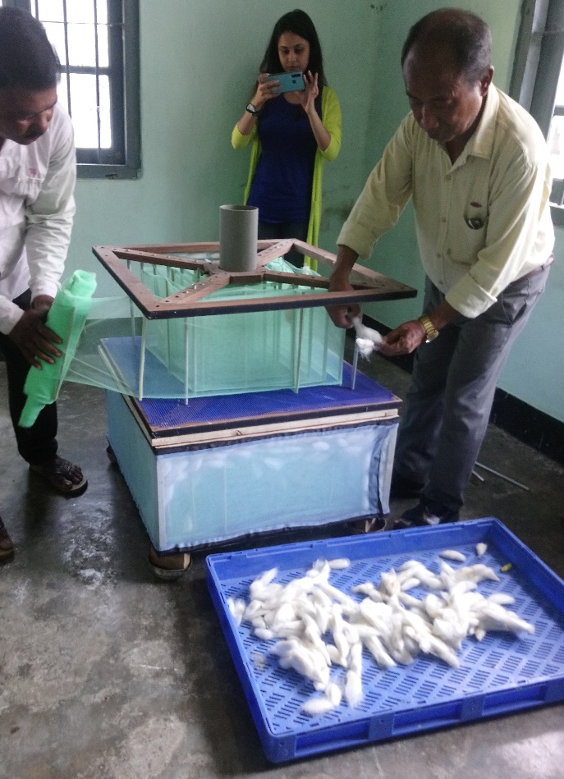
Cocooning stage of insect is important where ripen larvae search for a suitable place and form a loose thermostatic cover around the body by secreting silk juice in thread form netting into cocoon. Inside cocoon, larvae remain active physio-chemically and undergo physical changes of its body transforming into pupa and then into moth before piercing out of cocoon. Thus, a suitable place for cocoon formation is important for silkworm larvae. If the ripen larvae do not get a protected suitable place or otherwise disturbed by physical or mechanical changes, cocoon forming process will not be scientifically complete. This will affect in metamorphosis process of larvae that ultimately negatively influence in health of emerged moth affecting coupling and egg laying activities. On other hand, as cocooning process is incomplete, cocoon shell will have less silk thread or silk recovery will be less. This is very important from economic point of view in commercial rearing of silkworm as well as labour investment involved in the process. In “Storage and Cocooning Device for Eri, Muga and Mulberry Silkworm” all these difficulties have been overcame. It is fully protected, even ants cannot disturb cocooning larvae. Larvae get two surface support to form cocoon and ensure no physical and mechanical disturbances, no fluctuating moisture and heat generation. Being folding and permanent, it can be used repeatedly in each rearing and in any weather conditions without difficulties. Space, time required and labour investment is very less. Moreover, it is neat and clean process(Himangshu Barman and MeghasreeBaishya,2019).
At the time of ripening of larvae, the device is arranged in a suitable place and ripen larvae are to be kept in the system by lifting the lid. Naturally, larvae remain wondering and finally select place for cocooning. After required period of cocooning, cocoons are to harvest by dismantling cocooning system. If larvae number is high, another device can be arranged above in the system and so on to accommodate more larvae.

REFERENCE

1. Zhang J., Kaur J., Rajkhowa R., Li J.L., Liu X.Y., Wang X.G. Mechanical properties and structure of silkworm cocoons: A comparative study of Bombyx mori, Antheraea assamensis, Antheraea pernyi and Antheraea mylitta silkworm cocoons. Mater. Sci. Eng. C Mater. Biol. Appl. 2013;33:3206–3213.doi: 10.1016/j.msec.2013.03.051. [PubMed][CrossRef] [Google Scholar]
2. Chen F., Porter D., Vollrath F. Structure and physical properties of silkworm cocoons. J. R. Soc. Interface. 2012;9:2299–2308.doi: 10.1098/rsif.2011.0887. [PMC free article] [PubMed] [CrossRef] [Google Scholar]
3. Reddy N., Zhao Y., Yang Y. Structure and Properties of Cocoons and Silk Fibers Produced by Attacus atlas. J. Polym. Environ. 2013;21:16–23. doi: 10.1007/s10924-012-0549-8. [CrossRef] [Google Scholar]
4. Reddy N., Yang Y. Structure and properties of cocoons and silk fibers produced by Hyalophora cecropia. J. Mater. Sci. 2010;45:4414–4421. doi: 10.1007/s10853-010-4523-3. [CrossRef] [Google Scholar]
5. Zhao H.-P., Feng X.-Q., Cui W.-Z., Zou F.-Z. Mechanical properties of silkworm cocoon pelades. Eng. Fract. Mech. 2007;74:1953–1962. doi: 10.1016/j.engfracmech.2006.06.010. [CrossRef] [Google Scholar]
6. Zhang J., Rajkhowa R., Li J.L., Liu X.Y., Wang X.G. Silkworm cocoon as natural material and structure for thermal insulation. Mater. Des. 2013;49:842–849. doi: 10.1016/j.matdes.2013.02.006. [CrossRef] [Google Scholar]
7. Chen F., Porter D., Vollrath F. Silk cocoon (Bombyx mori): Multi-layer structure and mechanical properties. Acta Biomater. 2012;8:2620–2627. doi: 10.1016/j.actbio.2012.03.043. [PubMed] [CrossRef] [Google Scholar]
8. Roy M., Meena S.K., Kusurkar T.S., Singh S.K., Sethy N.K., Bhargava K., Sarkar S., Das M. Carbondioxide Gating in Silk Cocoon. Biointerphases. 2012;7 doi: 10.1007/s13758-012-0045-7. [PubMed] [CrossRef] [Google Scholar]
9. Kusurkar T.S., Gangwar A., Bawankar M., Mandal A., Dethe D., Thakur A.K., Singh S.K., Bhargava K., Khurana S., Sethy N.K., et al. A glowing antioxidant from tasar silk cocoon. RSC Adv. 2015;5:104563–104573. doi: 10.1039/C5RA14148F. [CrossRef] [Google Scholar]
10. Blossman-Myer B., Burggren W.W. The silk cocoon of the silkworm, Bombyx mori: Macro structure and its influence on transmural diffusion of oxygen and water vapor. Comp. Biochem. Physiol. A Mol. Integr. Physiol. 2010;155:259–263. doi: 10.1016/j.cbpa.2009.11.007. [PubMed] [CrossRef] [Google Scholar]
11. Gheysens T., Collins A., Raina S., Vollrath F., Knight D.P. Demineralization Enables Reeling of Wild Silk moth Cocoons. Bio macromolecules. 2011;12:2257–2266. doi: 10.1021/bm2003362. [PubMed] [CrossRef] [Google Scholar]
12. Jin X., Zhang J., Gao W., Li J., Wang X. Cocoon of the silkworm Antheraea pernyi as an example of a thermally insulating biological interface. Biointerphases. 2014;9 doi: 10.1116/1.4890982. [PubMed] [CrossRef] [Google Scholar]
13. Kaur J., Rajkhowa R., Tsuzuki T., Millington K., Zhang J., Wang X. Photo protection by Silk Cocoons. Bio macromolecules. 2013;14:3660–3667. doi: 10.1021/bm401023h. [PubMed] [CrossRef] [Google Scholar]
14. Yagi, N. (1926). The cocooning behaviour of a saturnian caterpillar (Dictyoploca japonica); a problem in analysis of insect conduct. J. Exp. Zool. 46, 245–259. doi: 10.1002/jez.1400460205.
15. Barman H., Gohain P. N., B. C. Choudhury and Giridhar K. (2014): Development of Pull Strips Mountage for Samia ricini Donovan and Mounting Performances Over Traditionally Used Mountages. International Journal of Life Sciences, Vol.3, No.1, January-April, , pp. 34-40.
16. Devaraj Y., Singh N. I., Sarmah M. C., and Singh R. (2012): Fabrication of suitable low coat bamboo mountages for Eri silkworm, Samia ricini Donovan. Mun. Ent. Zool. Vol. 7, No. 1, 646-649 pp.
17. Geetha Devi, R. G., Himantharaj, M. T., Vindhya, G. S. & Mathur, V. B. (1990): Can plastic collapsible mountages replace the bamboo mountage? Indian silk, 10 : 26-28.
18. Singh G. B., Rajan, R. K., Inokuchi, T., Himanthraj M. T. and Meenal A. (1994): Studies on the use of plastic bottle brush mountages for silkworm mounting and its effect on cocoon characters and reelability. Indian J. of Seric. 33(1), 405-408.
19. Himantharaj, M. T., Meenal, A., Rajan, R. K., Muroga, A. & Kamble, C. K. (1995): Rotary mountage for quality cocoons. Indian silk, 34 (2): 25-27.
20. Singh, G. B.(1995): Silkworm mountages. Indian silk, (May issue), p. 13-16.
21. Kumaresan, P., Hiriyanna, Y. K., Balakrishnappa, Y. K. & Geetha Devi, R. G. (2007): Performance of different types of mountages in Tumkur district of Karnataka – an economic analysis. Indian J. Seric., 46 (2): 169-172.
22. Barah, A. & Samson, M. V.(1990): Effect of various mountages on the cocooning of the muga silkworm, Antheraea assama Westwood. Sericologia, 30 (3): 313-321.
23. Sahu, A. K., Singha, B. B., Rajkhowa, G. & Das, P. K. (1998): Improvement in muga silkworm seed technology: The box type mountage, a new model for cocooning of muga silkworm Antheraea assama Westwood. Sericologia, 38 (2): 331-341.
24. Patil, G. M. & Savanurmath, C. J. (1994): Eri silkworm – The Poor Man’s Friend. Indian Silk, 33 (4): 41-45.
25. Subhas V. Naik and Somashekar T. H. (2008): Influence of temperature and humidity maintained during cocoon spinning on reeling performance and quality of raw silk of Indian bivoltine hybrid cocoons. Sericologia 48(4)376- 389.
26. Prasad G. V., Monohar Reddy R., Raghupathi M., Mogili T., Raju Ch. S., and Qadri S. M. H. (2011): Radial mountage (RM) – a simple self mounting and cocoon spinning tool of domestic mulberry silkworm, Bombyx mori (Linn). Sericologia 51(4) 485 – 494.
27. Velayudhan, K*., Balachandran, N., RadhaKrishnan, S., Singh, B.K. and Jayaprakash, P ( 2013); Biodiversity in eri silkworm Samiaricini (Donovan) genetic resources and its conservation, Journal of Aquatic Biology and Fisheries Vol. 2/2014/ pp. 817 to 824.
28. S.T. Naphade , C.J. Hiware and S.B. Avhad (2010); Development of improved mountage using mango plant twigs during lack of sufficient number or absence of mountages on field for silkworm cocoon. Recent Research in Science and Technology, 2(7): 05-08.

29. SanchitaKad; Mountage: Meaning and Types | Sericulture; https://www.notesonzoology.com/sericulture/mountage-meaning-and-types-sericulture/200.

30. Himangshu Barman and MeghasreeBaishya (2019); Storage and Cocooning device for Eri, Muga and Mulberry Silkworm, a new technology developed under DST (SEED) project, Technical Booklet, 03 – 09.

---------------------------------------------------------------------- X XXXXXXXXXXX----------------------------------------------------------------

