Cover page:

Title: Accuracy assessment of Artificial Neural Network classifier, Support Vector Machine classifier & Maximum Likelihood classifier in Land Cover Classification of Sentinel-2 Satellite Image, Nagpur District, Maharashtra.

Susan John, Ph.D., Associate Professor, St. Francis De Sales College Seminary Hills, Nagpur 440006, Maharashtra State. Email I.D.: susanjohnphy@gmail.com
ORCID ID: 0000-0002-1446-9497 - Susan John

ABSTRACT:
Classification of remotely sensed images with overlapping and mixed pixels are complex in nature. Many algorithms have been developed to classify these images for better accuracy. Accurate classification of the land use/cover classes such as Built-up area, water body, agricultural land, open land, forest, regained vegetation etc., is one of the biggest challenges in front of remote sensing communities. As accuracy of image classification is affected by parameters such as selection of data set with proper sensor parameters, presences of mixed landscapes, proper selection of classifying algorithms etc. The main aim of this paper is to compare the accuracy of three supervised machine learning classifiers Artificial Neural Network classifier (ANN), Support Vector Machine (SVM) classifier & Maximum Likelihood classifier (ML) in classifying the Sentinel-2, satellite heterogeneous image. From the analysis of result, the highest overall accuracy and kappa coefficient equals 97.40 % & 0.96 respectively was obtained for SVM classifier, on the other hand ANN classifier also performed similarly with Overall accuracy equals 97.13% & Kappa coefficient equals 0.96, whereas ML classifier yielded lowest overall accuracy equals 94.89% & Kappa coefficient equals 0.92.

Keywords: Maximum Likelihood Classifier (ML), Support Vector Machine (SVM) Classifier, Artificial Neural Network Classifier (ANN), Supervised Classifier, Sentinel-2 Image, Classification, Overall Accuracy, Kappa Coefficient.

Accuracy assessment of Artificial Neural Network classifier, Support Vector Machine classifier & Maximum Likelihood classifier in Land Cover Classification of Sentinel-2 Satellite Image, Nagpur District, Maharashtra.

- Introduction:
Remote sensing technologies are cost effective as it continuously monitors the Earth’s surface with different spatial, temporal and spectral resolutions, which helps in feature extraction for updating the map more frequently and in less time. Some of commonly used remotely sensed optical data are Satellite Pour l'Observation de la Terre, or Satellite for observation of Earth (SPOT 5 with 10 meters resolution), Landsat-8 with spatial resolutions 30 meters, Advanced Space borne Thermal Emission and Reflection Radiometer (ASTER-15 meters spatial resolutions, and Moderate Resolution Imaging Spectroradiometer (MODIS-250 meters for band 1 and 2, 500 meters for bands 3 to 7 and 1000 meters for bands 8 to 36 etc., which differs in resolutions, scales etc., and the primary mission is to obtain the imagery of Earth for various applications such as forestry, geology, water resource management GIS applications etc. The proper choice of suitable sensor data is needed because for a specific purpose only certain particular remotely sensed data can be used for e.g., a spatial resolution more than 5m gives better accuracy of heterogeneous data for land use and land cover classification mapping (Welch, 1982).
The European Space Agency (ESA), launched Sentinel-2 (equipped with a multi-spectral instrument, MSI) satellite, works on sunlight which measures the sunlight reflected from the Earth, in the visible and infrared part of the electromagnetic spectrum Two identical Sentinel-2 satellites in a sun-synchronous orbit phased at 180° to each other at a mean altitude of 786 km operate simultaneously and its position in its orbit are measured by dual- frequency Global Navigation Satellite System (GNSS) receiver. It can be freely downloadable form: scihub.copernicus.eu (Sentinel-2, downloaded on 2023).
Also, the result of land use & land cover classification depends on both the imagery appropriateness as well as on the proper choice of classification method and its parameters (Lu and Weng, 2007). As per literature survey various classification methods have been developed and tested on remotely sensed data for better interpretation of the features (Friedl & Brodley, 1997; Waske & Braun, 2009; Li et al.2014), as classification of remotely sensed data is complex in nature. According to Lu & Weng, apart from the imagery appropriateness, use of correct classiﬁcation method is also needed which affects the results of land cover mapping (Lu D. & Weng Q., 2007). Hence another factor that affects the accuracy of image classification is the proper choice of image classification algorithms. Image classification is divided into two i.e., supervised classification and unsupervised classification. Supervised classification requires prior knowledge of classes, as it teaches the classifier to determine decision boundaries in feature space by training samples in the form of pixels.
In this technique the classification result is compared with the ground truth. Finally, the accuracy is calculated by computing the confusion matrix and the result is compared with the ground truth i.e., the accuracy of the decision boundary depends upon the number of training samples and type of classes (Mather P. and Tso B., 2010).
Many classifiers have been developed and evaluated on remotely sensed data for better interpretation. As per Szuster et al., 2011, for the tropical coastal zone SVM showed highest accuracy as compared to the artificial neural network techniques and maximum likelihood classiﬁer. But the maximum likelihood approach faces the disadvantage of overestimating the class values even though it shows better accuracy (Al-Ahmadi & Hames, 2009). Accuracy of SVM depends on inclusion of appropriate training data set and hence a large number of training sets are needed (Foody & Mathur, 2004). Now-a-days artificial neural network classifiers have shown their potential in classifying heterogeneous images correctly, but it faces serious disadvantages of misclassification which further affects its performance. Apart from these issues other issues such as mixed pixel problems, overlapping classes still remain and have not been solved completely. These various problems have driven much research for improving the various algorithms to increase the accuracy level to predicate the feature correctly.
Here attention is focused on performances of three supervised classifiers. The overall objective of this study is to evaluate the performances of three supervised classifiers namely Maximum Likelihood Classification, Support Vector Machine classification and Artificial Neural Network Classification on freely available Sentinel-2 satellite imagery. As this type of satellite imagery is new, more research is necessary to conduct and to evaluate the usefulness of this imagery, as only few studies are available in literature for land use & cover mapping. The results from this study can provide insights into proper selection of classifiers in classifying Sentinel-2 remotely satellite data for land cover classification.

2. Study area and Data set used.
2.1 Data and data preparation:
The study area is situated in Nagpur district of Maharashtra state, in the central part of India.. The satellite data were procured from http://scihub.copernicus.eu. The study was conducted on freely available satellite imagery Sentinel-2 using ENVI PRO software.
2.2 Study area: The test site is in central India, Nagpur, Maharashtra, India; its geographical location coordinates selected for study are 21.05 N & 80.33 E. Figure 2. Downloaded Image of Sentinel-2 Image of Nagpur, Maharashtra state, India captured on 23-07-2022.
2.3 Land cover detection and analysis: To work out the land cover classification on sentinel-2 satellite data classification was accomplished using ENVI software. With the help of Google earth, ground verification was done for doubtful areas. Four land cover types were identified for the study area: Water body, Built-up area, Open land & Vegetation. Nearly 150 training areas were selected for each class using regions of interest in the ENVI PRO software; all the classifications were conducted by these training sites. For accuracy assessment, ground truth information collected from the field was used.
3. Proposed Method.
We aimed at evaluating the performance of three classifier algorithms on Sentinel-2 image. In the following subsections, a brief explanation of the algorithms is provided.
- Maximum likelihood
Maximum Likelihood (ML) is a supervised classification method, based on Bayes theorem, which assumes that the statistics for each class in each band are normally distributed and calculates the probability that a given pixel belongs to a specific class. And also assumes that the distribution of the data within a given class obeys a multivariate Gaussian distribution (Tso & Mather, 2001). Firstly, several types of land cover are determined in the study area followed by the training pixels for each of the desired classes by determining the Jeffries-Matusita (JM) distance which is a measure of class separability of the training pixels. Then the mean vector and covariance matrix of each class are estimated followed by classification of every pixel. Thus, a probability threshold is selected, which determines the classification of pixels to a particular class. If the selected pixel is equal to the probability threshold, then it is assigned a class otherwise the pixel remains unclassified. The Maximum likelihood function describes ellipsoidal, i.e., equi-probability contours are decision boundaries and its shape depends upon the orientation and relative dimensions of the axes of the ellipse (Tso & Mather, 2001), to represent feature space of the pattern of pixels belonging to a given class.
- Support Vector Machine
In a binary classification for linearly separable classes, SVM maximizes the distance from the data points of each class thus helps to create the optimal separating linear hyperplane from each variable. Any training data points on the two hyperplanes viz, parallel and either side to optimum hyperplane, are termed as support vectors, (Mathur & Foody 2008). This optimum hyperplane not only separates the training data set with a maximal margin. And for classes which are not linearly separable, the training data cannot be separated without error, hence in such case the training set should be separated with minimal number of errors by mapping the input data onto a higher dimensional space called feature space or Hilbert space which is dot product space. Thus, SVM is optimized using a kernel function such as linear, polynomial, radial basis function (RBF) & sigmoid in order to search hyperplane in a multidimensional feature space. Some studies (Huang et.al. 2002) conclude that the most commonly used kernels functions are the non-linear polynomial and radial basis kernels. So far RBF kernel is the best choice for practical applications (Patle and Chouhan, 2013). Thus, the SVM with RBF kernels is used in this study.

- Artificial Neural Net Classifier:
Artificial Neural Network replicates the mechanism of the human brain, where the intelligence is stored not only in artificial neural pathways but also in the memory. In this, knowledge is applied in the forms of weights applied to a node hence multiplicative values are applied to an input. A supervised network is presented so that the Artificial Neural Net learns itself, like human beings learn by experience, by setting weights which will produce a specified output. When the new data is presented, an artificial neural network applies the weight, and the output generated after comparing with the previous experience. There are many types of artificial neural networks which can be used for classification purposes, the most widely used is multilayer perceptron (MLP). It faces serious disadvantages such as large computation is needed, requires greater training time etc. Hence Artificial Neural network first trains a small portion of randomly selected pixels from a specific image under study which is network and then further it is applied to the remaining part of the image. In order to optimize the accuracy of Artificial neural networks, a good and proper selection of network design is needed which will automatically reduce the training time. As it faces a wide range of factors that limit the use of Artificial Neural networks. Another commonly used algorithm is the back-propagation algorithm supervised training algorithm, which is based on minimization of the error between the actual network outputs and the outputs of training input or output pairs. Thus, as a result error is propagated back to the input layer from the output. Thus, it helps in renewing the weights of the backward path i.e., it is based on trial-and-error process of changes of model parameters.

4. Results and Discussion
In order to evaluate the classifier performance, the assessment methods plays a vital role which are divided into three process such as training the data set using input pattern classifier fits the training data and to predict class labels for unseen data, since the class labels of testing samples are unknown, in order to evaluate the performances of the trained model, validation is done which provide an unbiased evaluation of the trained model. And the last process is testing its accuracy in terms of percentage.
The study area involved the number of classes such as Water body, Built-up area, Open land & Vegetation i.e., it is multi-class classification problem not the binary classification which involves only two classes.
The classification model was trained to predict the true classes of unknown data sets, in the training phase. This classification model produces outputs by generating a confusion matrix or a contingency table. The left to right-diagonal elements represents correct predictions and the rest are incorrect predictions.
The confusion matrix or error matrix is a square matrix that contains statistics for assessing accuracy by showing the degree of misclassification among the different feature class which compares relation between classification result and reference data on a class-by-class basis. Information of overall accuracy can be obtained from the confusion matrix. The overall accuracy is obtained by dividing the sum of main diagonal entries of the error matrix by the total number of samples.

The present study deals with multiclass classification in which the classes selected were waterbody, Built-up area, Open land Area & Forest. In the training phase, the classification model was trained to predict the true classes of unknown data sets. Confusion matrices of classifications based on different kernels (with highest accuracy) are given in Table 1. Overall accuracy and kappa coefficient of different kernels and its parameters are also given in Table 1.
From the analysis of table, no 1, SVM classifier correctly classified Water body, Open land & Vegetation with cent percent and also reported overall accuracy and kappa coefficient equals to 99.63% & 0.99 respectively. Followed by ANN classifier, which classified Water body, Built-up area & Open land with cent percent and vegetation with 94.74 %. It also reported overall accuracy and kappa coefficient equals to 99.27% & 0.99. Whereas ML classifier classified Built-up area, Open land & Vegetation with cent percentage but failed to classify water body it accurately classified water body with 62.22%. It reported lowest overall accuracy and kappa coefficient equals 93.84% & 0.90.
The presence of mixed pixels and close class boundaries resulting from high spectral resemblance to other classes which hinders the performance of maximum likelihood classifier. After testing and verifying the effectiveness of the trained classifiers, classified thematic maps are produced as shown in fig no 4, 5 & 6.

Conclusion:
SVM classifier addresses the nonlinear patterns and effectively classifies the image with higher accuracy. The result obtained from the present study underlines the fact that proper kernel and selection of its parameters influence the accuracy of classification.
The result obtained from the present study underlines the fact that SVM classifier and artificial neural network classifier performed nearly the same whereas maximum likelihood classifier performed poorly.
SVM requires proper selection of kernels and its parameters which influence the accuracy of classification. Hence in this study of classification of sentinel-2 image of Nagpur, SVM classifier is found to be more robust in classifying the image.

References:

- Al-Ahmadi F. S. And Hames A. S. (2009), Comparison of Four Classification Methods to Extract Land Use And Land Cover From Raw Satellite Images For Some Remote Arid Areas, Kingdom Of Saudi Arabia; Earth Sci. 20(1) ,167–191.
- Foody G M & Mathur A (2004) A relative evaluation of multiclass image classification by support vector machines. IEEE Transactions on Geoscience and Remote Sensing, 42(6):1335–1343. https://doi.org/10.1109/tgrs.2004.827257
- Friedl M A & Brodley C. E. (1997) Decision tree classification of land cover from remotely sensed data. Remote Sensing of Environment, 61(3): 399–409. https://doi.org /10.1016/s0034-4257(97)00049-7
- Li C, Wang J, Wang L, Hu L & Gong P(2014) Comparison of Classification Algorithms and Training Sample Sizes in Urban Land Classification with Landsat Thematic Mapper Imagery. Remote Sensing; 6(2):964-983. https://doi.org/10.3390/rs6020964
- Lu D & Weng Q (2007) A survey of image classification methods and techniques for improving classification performance. International Journal of Remote Sensing, 28(5): 823–870. https://doi.org /10.1080/01431160600746456
- Mather P. and Tso B. (2010), Classification methods for remotely sensed data. CRC press.
- Szuster B.W., Chen Q. and Borger M.(2011), A comparison of classiﬁcation techniques to support land cover and land use analysis in tropical coastal zones. Applied Geography, 31, 525–532.
- Waske B and Braun M (2009) Classifier Ensembles for Land Cover Mapping Using Multitemporal SAR Imagery. ISPRS Journal of Photogrammetry and Remote Sensing, 64: 450-457. http://doi.org/10.1016/j.isprsjprs.2009.01.003
- R. Welch (1982) Spatial resolution requirements for urban studies, International Journal of Remote Sensing, 3:2, 139-146, DOI: 10.1080/01431168208948387
- Sentinel-2: https://sentinel.esa.int/web/sentinel/missions/sentinel-2, downloaded on 10th July 2023

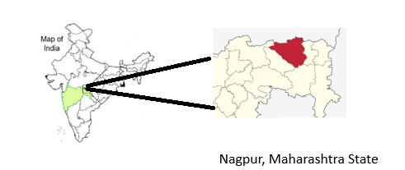

Figure 1. Nagpur, Maharashtra state, India

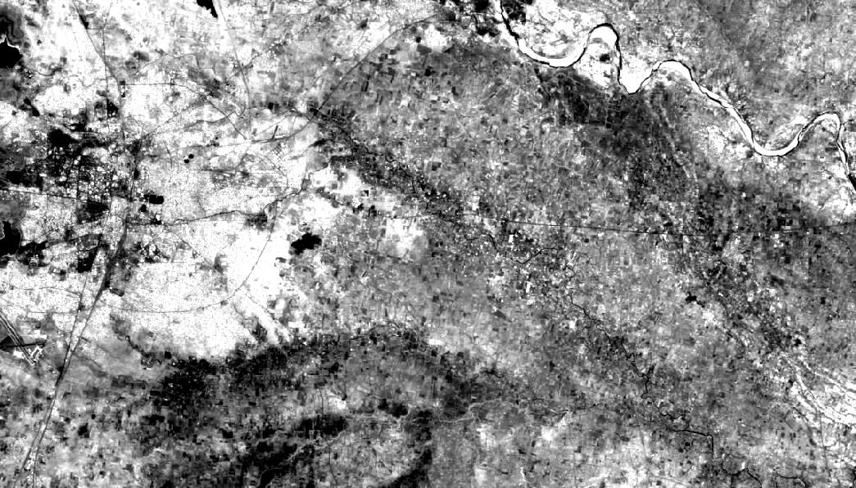
Fig 2: Original Image of Sentinel-2 Image of Nagpur, Maharashtra state, India captured on 23-07-2022.
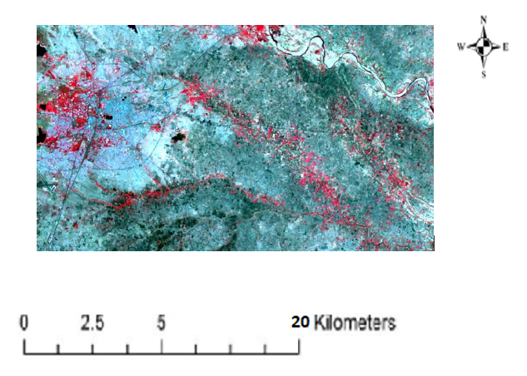

Fig. No. 3: RGB color composite of Fig no.1.

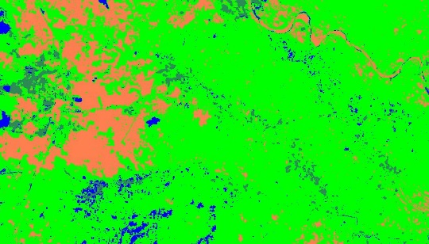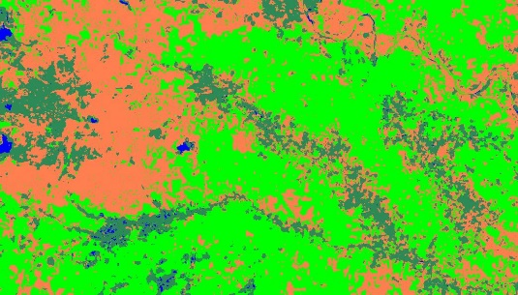
Fig. No. 4 Fig. No. 5
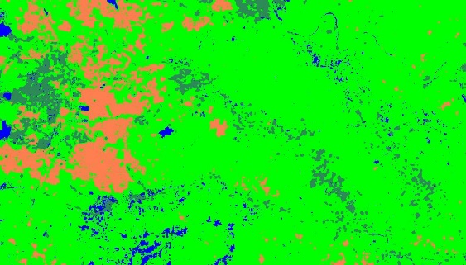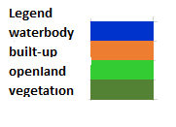
Fig. No. 6
Fig. No. 4: Classified output obtained using SVM with Radial kernel.
Fig. No. 5: Classified output obtained using ml classifier.
Fig. No. 6: Classified output obtained using Artificial Neural Network (ANN) Classifier

Kernel |  | Artificial Neural Network classifier  (%) |  |  |  | Maximum Likelihood classifier  (%)
 | Land cover class | 1 | 2 | 3 | 4 | 1 | 2 | 3 | 4
1 | Water body | 100 | 0 | 0 | 0 | 62.22 | 0 | 0 | 0
2 | Built-up area | 0 | 100 | 0 | 0 | 0 | 100 | 0 | 0
3 | Open land | 0 | 5.79 | 100 | 0 | 0 | 10.62 | 100 | 0
4 | Vegetation | 2.04 | 0 | 0 | 94.74 | 2.04 | 0 | 0 | 100
 |  | Overall accuracy 99.27%  Kappa coefficient 0.98 |  |  |  | Overall Accuracy = 93.84%  Kappa Coefficient = 0.90
Kernel |  | SVM with Radial basis Function classifier  (%)
 | Land cover class | 1 | 2 | 3 | 4
1 | Water body | 100 | 0 | 0 | 0
2 | Built-up area | 0 | 99.22 | 0 | 0
3 | Open land | 0 | 7.53 | 100 | 0
4 | Forest | 2.04 | 0 | 0 | 100
Overall accuracy 99.63%
Kappa coefficient 0.99

Table no. 1: Confusion matrix of classifications based on SVM with different kernels & ANN classifier.

