Fish Scales
Kamei Lanthaimeilu
Ph.D. scholar, FRM
ICAR – Central Institute of Fisheries Education
Mumbai – 400061, India
e-mail- lanthaimeilukamei@gmail.com
Abstract
Fish scales are the small, flat, overlapping structures covering most fish species' skin. It is a vital part for the fish, but as for humans, it is the unwanted part, and it is termed fish waste. Fish scales are of many types and have different modifications for their survival instinct in which ecological environment they thrive; it protects against physical damage, parasites, and infections.

Keywords: Types of fish scales, fish scales modification, importance of fish scales.

Introduction
Fish scales are usually the first thing we as humans remove or discard and throw away which is the common practice when preparing fish as a waste product, but these scales play a vital role in fish life. The principal purpose of scales in fish is to protect against predators and parasites, so they are relatively complex and present in the outermost layer of the fish which is in contact with the environment. The way the scales overlap each other aids in streamlining the fish’s body so that there is less resistance to water and the fish during its migration. The scientific study of scales is termed “Squamatology”
The outer body of many jawed fish is adorned with scales, which are part of the fish's integumentary system. These scales developed from the mesoderm and may share similar in structure to teeth. Some species are covered with scutes (bony external Plate or scale overlaid with horn), e.g., Sturgeon. Some fishes are devoid of scales, e.g., freshwater catfish. Certain species display an intermediate, generally naked condition but possess scales in restricted areas. As such, in the case of paddlefish (Polydon), scales are present in the region of the throat, pectoral, and base of the tail.
In certain fish species, scales have adapted for various purpose such as; teeth, bony armour plates (Sea horse) or spiny stings (stingray). In freshwater eel (Anguilla), scales are minute and deeply embedded, arrangement is mosaic pattern the scales wed their neighbouring ones at their margins so that the fish appear naked. Almost all fish are covered in a slime (mucus) protective layer. Scales are arranged in an imbricate manner and overlap with a free margin directed towards the tail that minimises friction with the water.
Upon hatching from the egg, the fish's body becomes enveloped in diminutive scales. Nevertheless, these scales persist in number throughout their lifespan, yet any lost scales have the potential to regenerate over time. Within these scales, a minuscule circular growth ring materialises, referred to as a "circulus" or "circuli" in the singular form. Circuli originating during the summer exhibit a notable breadth, whereas those arising in the winter intertwine intricately. A black circle was formed in that densely enclosed region, known as the annulus. The age of the fish is known by counting the number of annuluses on the scales.

Formation of scale
Scales are plate-shaped dermal or epidermal structures in the outermost layered fish bodies. Numerous vertebrates possess a dual classification of scales: epidermal and dermal scales. Epidermal scales trace their origins to the Malpighian layer within the epidermis, while dermal scales surface from the fish's mesenchyme. These scales consist of petite, slender, spiky, and compacted plates, which interlock securely. The external framework of a fish is recognised as its scales. Thin scales cover the body of an ideal fish. The scales form as outward projections of the epidermis, also known as the skin. Within the epidermal layer are abundant mucus cells that produce and release mucus or slime, serving as a protective barrier against the easy intrusion of parasites, fungi, pathogens, and more.

Figure1: Formation of scales

Type of Scales in Fishes:
Scales are derivatives of mesenchymal cells of the dermis
There are four main types of scales and numerous variations of each kind.
- Cosmoid (lungfish and some fossil fishes)
- Placoids are of Plate shape (sharks and rays)
- Ganoids are of rhombic or diamond-shaped (bichirs, bowfin, paddlefishes, gars, sturgeons)
- Leptoid scales are of two types: - Cycloid and Ctenoid (most bony fishes)

Four primary categories of fish scales exist.
- Placoid scales, known as dermal denticles, resemble teeth in structure, comprising dentin enveloped in enamel. These are characteristic of cartilaginous fish (though chimaeras only possess them on claspers).
- Ganoid scales are level and exhibit a basal appearance, enveloping a fish's body with gentle overlapping. These scales are common to gar and bichirs.
- Ctenoid scales exhibit similarities to cycloid scales due to their possession of growth rings. What sets them apart is the presence of spines covering one of their edge. This scale variety characterises Halibut.
- Cycloid scales, on the other hand, are small and oval-shaped, displaying growth rings reminiscent of tree rings. Fish like bowfin and remora possess cycloid scales.
A less common scale type is the scute, an outer bony plate resembling a shield, a modified and thickened scale often featuring keels or spines, or a projecting scale with rough and prominent ridges. Scutes are commonly located along the lateral line but can also be found on the caudal peduncle (where they create caudal keels) or the ventral profile. Certain fish, like pinecone fish, may sport scutes that cover them partially or entirely.
The arrangement and characteristics of scales not only facilitate the identification of the species they originate from but also influence the behaviour of the fish.

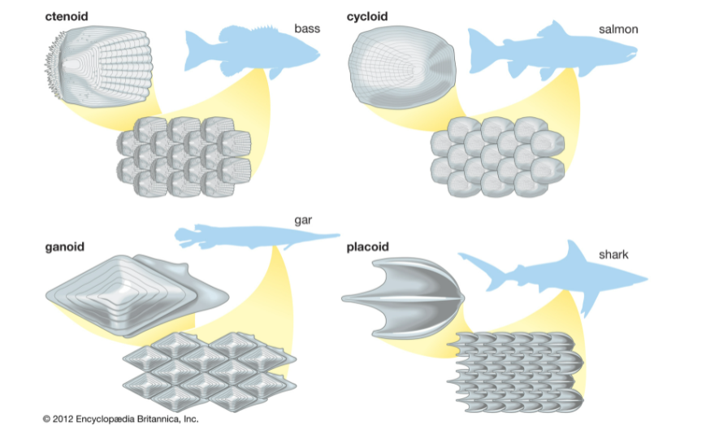
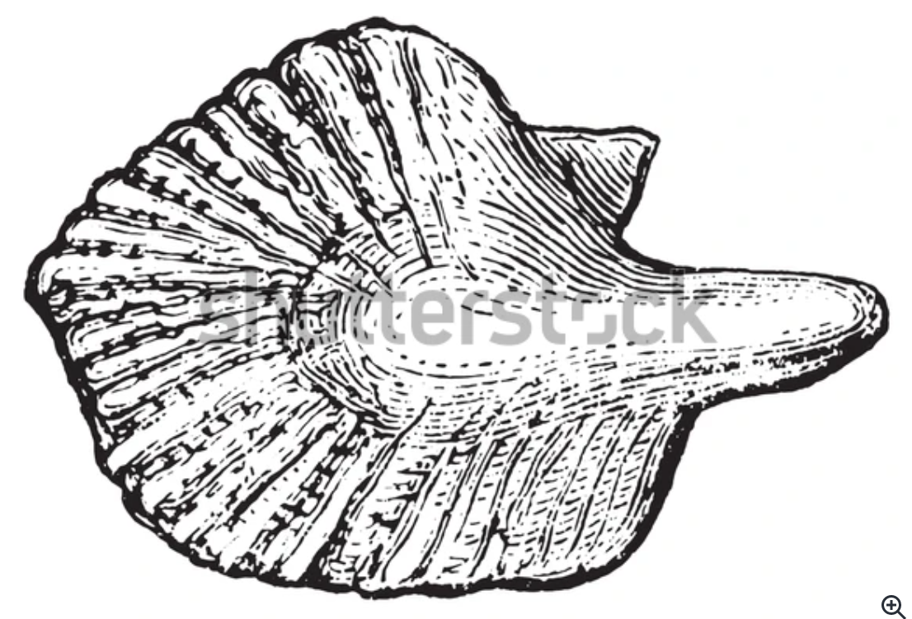Cosmoid Scales
Figure 2: Different types of fish scales

Cosmoid Scales:
These scales were not found in any extant fish species but in certain ostracoderms, placoderms, and extinct sarcopterygians. These scales exhibit a layered structure comprising four distinct levels. Outermost are thin, enamel-like spines and a hard vitrodentin layer; a complex and acellular cosmin layer is beneath this. Internally, the isopedine layer consists of the duct and ossicular layer. Scale growth occurs along the periphery due to the absence of viable cells at the base. In the case of lungfish, the original cosmoid structure has transformed into cycloid scales.
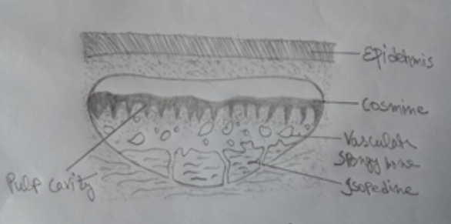
Figure3: Cosmoid scales

Placoid scales:
Placoid scales are characteristically found among the sharks and other Elasmobranches. They are small denticles that remain embedded in the skin. Each scale has two parts: an upper part known as the ectodermal cap or spine. The scales enrobe the skin akin to grains of sand. Placoid scales are organised into separate rows, combining to create the external framework. Underneath each scale is a foundational plate and a backward-curved, pointed spine that originates from this base. This curvature functions to shield the skin against abrasive harm. Each foundational Plate comprises tissue abundant in calcium. The spiky structures are anchored within the dermis through the assistance of sharp fibres and other connecting fibres. The design consists of dentin covered by an enamel coating.
The basal Plate has a small aperture through which blood vessels and nerves enter the pulp cavity. The placoid scales are modified in jaw teeth in sharks, spines in dorsal fins, Squalus (spiny dogfish), stingrays, and saw teeth in the Pristis.
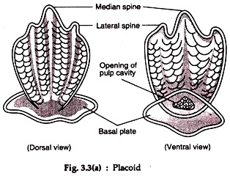
Figure 4: Placoid scales

Ganoid scale:
The ganoid scales are thick and rhomboid, usually diamond-shaped plates. They consist of an outer layer of a hard inorganic substance called ganoine, different from the vitreodentine of placoid scales. A cosmine-like layer with many branching tubules follows the ganoid layer.
A bony layer of isopedine occupies the innermost layer. These scales grow at the edges and unwind at the surface. The growth takes place by the addition of new layers of isoprene.
The ganoid scale is best found in the Polypterus and Lepidosteius. These fishes’ ganoid scales are rhombic plate-like, from the right edge to edge, and invest the entire body. In Acipencer, the ganoid scales are modified into large bony scutes arranged into five rows.
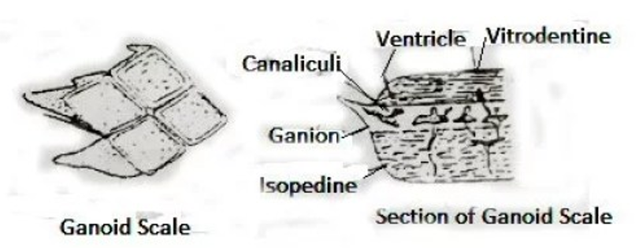
Figure 5: Ganoid scales

Leptoid scale
Such scales are thin and piercing. It does not have an enameloid and dentinal layer. This type of scale is found in most living bony fish (Osteichthyes). It is of two types, namely: Ctenoid and Cycloid Scale.

Ctenoid scale:
They have characteristic teeth in their posterior part. Ctenoid scales are found in spiny-rayed teleost. They are arranged obliquely so that the rear end of one scale overlaps the anterior edge of the scale present behind. The chromatophores are present in the posterior part of these scales.
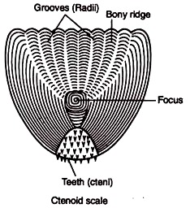
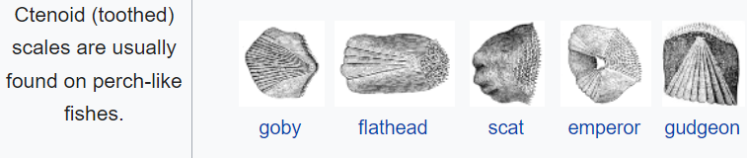
Figure 6: Ctenoid scale
Cycloid scale:
The cycloid scales are devoid of teeth or spines and hence seem cyclic. They are found in soft-rayed teleost and modern lobe-finned fishes. But some spiny-rayed fishes, i.e., Lepidosteius, show the presence of cycloid scales. In Micropterus, both cycloid and ctenoid scales are found.
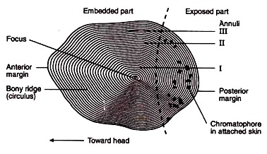
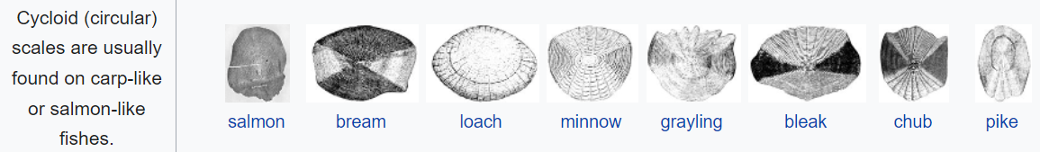
Figure 7: Cycloid scale
Some fish, such as Jewfish (Johnius), flatfish (Cynoglossus), and flounder fish, have cycloid and ctenoid types. These fish have ctenoid scales on the surface and cycloid scales on the numerical side.

Modification of Scales
Various forms of adaptations are observed within fish scales, showcasing their versatility. Certain fish, including electric fish, catfish (Siluriformes), and eels (Anguilliformes), feature diminutive scales embedded in the dermal layer. In specific cases (chimaeras), these scales become localised. Some fish scales transform distinct structures. The teeth in the jaws of sharks, dorsal spines of dogfish (Squalus) and chimerids (Chimera), tail spines of stingrays (Dasyatidae), saw teeth of saw sharks (Pristis), and the gill rakers of basking sharks (Cetorhinus), among others, are derived from modified placoid scales.
The surgeonfish (Acanthurus) possesses a lancet formed by converting tinoid scales, which are modified into sharp cutting blades. The abdominal scutes of herring (Clupeidae) transform into cycloid scales. Lepidotricia found in fins and dermal bones represent adaptations of the bony ridge. Numerous bony fish scales have been altered to create a sturdy groove for the lateral line organ. Bone plates or scutes of sturgeon fish (Acipenser) also modify scales. In coffer fish, Ostracion, the scales form polygonal bony plates articulating with one another to form a rigid protective box. In the globefish, Tetrodon and the porcupine fish, Diodon, the scales are elongated to form spines for protection. The jointed fin rays, leptotrichia of the bony fishes, are also modified scales. The scales change in the basking shark, Cetorhinus, to form gill-rakers. The scales along the fish's lateral line become perforated to provide an exit for the canal in the sea-horse. The hippocampus and the pipe-fish Syngnathus scales are fused to form protective bony rings around the body. Multiple transformations of scales have occurred due to the urge to live, mainly due to self-defence, food intake, etc.

Table1: Difference Between Placoid scale and Cycloid scale

Placoid scale | Cycloid scale
These scales are plate-shaped. | These scales are round and circular.
These scales are found in the skin of cartilaginous fish. | Cycloid scales are found in soft-feathered, hardy fish such as Labeo, Catla, Punteus, etc.
Such scales are called dermal denticles. | This is called a bony ridge.
Such scales have disc or disc-shaped base plates. | Such scales have no base plate.
These scales originate from the epidermis and dermis. | These scales form from the dermis.
Such scales have a thorn that is exposed in the epidermis. | Such scales do not have any thorns.
Such scales do not have circular chromatophores. | Such scales contain numerous circles, radii and chromatophores.
The scales contain an enamel-like hard and transparent material called vitrodentine | The scales do not contain hard and transparent ingredients like enamel, called vitrodentin.
It does not have a growth line. | There are growth lines.
It is transformed into a bone-like structure, especially the dorsal fins of the Squalus, the tail thorns in the stingrays (Dasyatidae), and the saw-like teeth in the saw sharks. | It is transformed into an abdominal squat (Clupeidae)

Uses and Functions of Scales
Scales serve as external structures with defensive capabilities and have a wide range of functions and uses. The following points outline their roles and applications:

- Fish Classification: Scales are of utmost importance in classifying fish. The quantity of scales varies among different species, and the arrangement of scales above and below the lateral line is crucial for determining the fish's position in the hierarchy of family, genus, and species.

- Life History of Fish: Scales grow as fish mature, leading to the formation of concentric circular lines known as growth rings. These rings document physical changes in the fish across seasons. The annual formation of a distinct line called the annulus reflects winter slowdown in fish development, providing insights into breeding, seasonal growth, and yearly changes. Atlantic salmon scales also bear spawning marks, revealing the number of times a fish has spawned.

- Self-Defense and Feeding: Fish adapt scales into thorns for self-defense and feeding purposes. Modified scales also serve as a protective shield against parasites, forming a defensive barrier between the fish's skin and the external environment.

- Gender Selection: Some mature male fish, such as Punteus species, exhibit different colors during the breeding season.

- Adaptation: Different types and colors of fish scales aid in their adaptation to various environments. Some scales have reflective or iridescent properties, allowing fish to blend into their surroundings for camouflage from predators or prey.

- Locomotion: Scales reduce friction as fish move through water. Their streamlined shape and arrangement minimize water resistance, optimizing swimming efficiency. Certain scales, like those in Anabas species, assist in fish movement.

- Osmosis: Scales, due to their impermeability, help regulate the intake or expulsion of water from the fish's body, maintaining water balance.

- Thermoregulation: Fish scales contribute to regulating body temperature by insulating against heat loss and helping maintain a stable internal environment.

- Sensory Function: Some fish scales are associated with nerve endings, enabling fish to detect changes in water pressure, temperature, and other environmental factors.

Regenerate

Significance of Scales:
Scales play a significant role in the categorization of fish species, making them extremely valuable for ichthyologists. Lampreys and hagfishes do not have scales, while sharks are characterized by placoid scales, primitive bony fishes have ganoid scales, and more advanced bony fishes possess ctenoid or cycloid scales. The number of scales on a fish is crucial for taxonomy, and the specific count of scales along the lateral lines and around the body is unique to each species. Fish age can be determined by measuring the spacing in the annual growth rings of their scales.
In certain species, such as Atlantic Salmon, scales display marks related to spawning events, indicating the number of times the fish has spawned and the timing of its first spawning. Most fish have scales, with the exceptions being Agnatha and catfish, which lack scales on their bodies. Some fish, like paddlefish (Polyodon) and mirror carp (Cyprinus carpio), have partial scales, while others, like trout and freshwater eel, have small scales that primarily cover their bodies, providing protection against injuries.
It's important to note that larger scales offer better protection but can limit a fish's mobility, whereas smaller and lighter scales, while offering less protection, allow for greater maneuverability. Fish scales contain a diverse range of pigments that contribute to their various colors. These scales collectively form a lateral line along the fish's body, running along its side, and play a crucial role in sensing water vibrations, serving as sensory receptors.
References
Briggs, J.C. in Paxton, J.R. & W.N. Eschmeyer (Eds). 1994. Encyclopedia of Fishes. Sydney: New South Wales University Press; San Diego: Academic Press [1995]. Pp. 240.
Helfman, G.S., Collette, B.B. & D.E. Facey. 1997. The Diversity of Fishes. Blackwell Science. Pp. 528.
https://biologyeducare.com/fish-scales/
https://www.britannica.com/science/scale-zoology
Michael, S.W. 1998. Reef Fishes. Volume 1. A Guide to Their Identification, Behaviour, and Captive Care. Microcosm. Pp. 624.
Roberts, C.D. 1993. Comparative morphology of spined scales and their phylogenetic significance in the Teleostei. Bull. Mar. Sci. 52(1):60-113

