Image Enhancement with Optimized Gamma Correction through Weighted Distribution via Differential Evolution Algorithm

Chenigaram Kalyani, Assistant Professor, Balaji Institute of Technology and Science, Narsampet, Telangana, E-mail:kalyanichenigaram@gmail.com

Manda Sridhar, Assistant Professor, Balaji Institute of Technology and Science, Narsampet, Telangana, E-mail: mandasridhar550@gmail.com

Vemireddy Nagamalleshwari, Assistant Professor, Balaji Institute of Technology and Science, Narsampet, Telangana, E-mail:gurralamalli49@gmail.com

Abstract
When an image obtained contains faults such as noise, poor quality, or a bad visual impression to the eyes. To improve the aesthetic appeal, we need to apply image enhancement. Goal of an image enhancement is to eliminate the flaws from an image while retaining the crucial features. Studies proposed the various types of improvement procedures that had the favourable outcomes. In this approach, we just combine the Differential Evolution DE method along with the Adaptive Gamma Correction [19] through the Weighted Distribution AGCWD to form a new hybrid method known as Optimised Gamma Correction through the Weighted Distribution OGCWD. The proposed method it is an automated modification operation which attempts to increase the image brightness. Terms like Structural Similarity Index (SSIM), Mean Square Error (MSE) as well as Peak Signal to Noise Ratio (PSNR), the proposed OGCWD algorithm gives the contemporary image improvement approaches.
Keywords: Image Enhancement, AGCWD, DE.

- Introduction
Digital image processing systems are used in day-to-day life for video monitoring, industrial production, military applications, remote sensing tracking and the other objectives. While processing an image, there are a few uncontrollable factors that are considered as faults. These are due to the image being captured in poorly lit conditions, during night, on a cloudy day, inside or with a little light reflecting off the object's surface. As a result, the image quality gets deteriorated and was regarded as a flaw. As a result, we use image enhancement techniques to correct these issues. One of the greatest frequent uses of fundamental image processing elements is to emphasize an image's traits in order to bring attention to it and make it appear consistent. Most importantly, since the method for judging image quality is subjective, it needs human judgment. However, this system must be made objective in order to minimize the need for human input. As a result, it is essential to offer a feature that facilitates image evaluation by objectively evaluating the quality in terms of improvement. Therefore, it is tough to find a fitness function so as to can help with image evaluation by offering a numerical assessment of the image's quality. Differential evolution algorithm is a technique for enhancing image contrast. In image processing, a dynamic role is played by the differential evolution algorithm, a tool for optimization with natural inspiration. Additionally, it improves image production, creation of images, segmentation, detection, and enhancement of images.

- Literature Review on Existing Enhancement Technique
Many reasons for poor image contrast, for example quality of capture devices, partial observable environment, or operator knowledge. Due to low image quality, it is not easy to extract the information that exist in the image. By increasing the dynamic range of digital pixel values contrast enhancement eliminates the problem. An adaptive gamma correction through weighting distribution is a hybrid histogram modification strategy by integrating TGC-transform dependent gamma correction and THE-traditional histogram equalization approaches [8]. Inadequate illumination can result in image failure or bad image fragmentation when using this automated approach of transformation. Current methods have several impacts that can be reversed, such as low Peak SNR and a high MSE. When images are not presented, for instance, weak image segments may develop. To increase contrast and get rid of bad image quality, we need to utilize an automatic transformation method.

- EXISTING METHODS
The present augmentation approaches are extensively described in this section.
3.1 Existing Methods of Image Enhancement
Over the past decade, a number of academics introduced a variety of enhancement techniques to alter an image appearance depending on a viewer. As a consequence, this study employed and reported on two picture enhancing strategies. The following are the two directions for improvement:
• Image enhancement through AGCWD
• Image enhancement through DE
3.1.1 Adaptive Gamma Correction through the Weighted Distribution
Brief information is given on contrast enhancement approach as well as image segmentation of an image. Development of an algorithm is being going on to efficiently advance the contrast and to maintain the brightness of an input image. On an augmented AGCWD image, segmentation is conducted. The proposed method is depicted in the flowchart. In adaptive gamma correction method, values of the adaptive gamma are automatically selected based on image statistics, which is recommended to improve image contrast. We all know that the main drawback of the power-law transformation method is the manual entry of the gamma value for image enhancement. To solve the issue the gamma value should be calculated automatically , this can be with an adaptive correction through the weighted distribution method.
3.1.2 Differential Evaluation to Enhace Image
Image contrast may be improved using the differential evolution approach. A dynamic approach to optimization that takes insights from nature is the differential evolution algorithm. It also improves other processes such as segmentation, image detection, image fusion, image pattern recognition, image threshold, image enhancement, along with image restoration. Additionally, it aids in reducing the visual noise and also the blurriness. Differential evolution it tries to enhance the fitness function by adjusting the intensity vary function variables. Enhanced imaging is assessed subjectively and objectively in our DE-based methodology and outperforms previous techniques [12–16]. The Differential Evolutionary Algorithm is a well-known, effective, and mathematically sound Evolutionary computing method created to address practical numerical optimisation challenges. DE is reliable and rather easy to use. Natural optimization methods are essential in the area of image processing. By lowering image noise and blurriness, it also aids in the improvement of photographs. For various image processing systems, numerous optimization methods have so far been devised. This article offers a succinct analysis of the Differential Evolution method, a nature-inspired optimization technique.

- Proposed Method:
4.1 Optimized Gamma Correction through the Weighted Distribution (OGCWD)
The suggested OGCWD algorithm beats cutting-edge methods for image boosting in terms of the Structural Similarity Index, Mean Square Error and the Peak Signal to Noise Ratio. It combines gamma correction with a transform-based histogram equalization technique [18]. The probability distribution and gamma correction in darkened image brightness may be improved using this strategy. Determination of gamma value is by using an optimum is shown below.
(9)
The factor T can be altered by the supplied image pixels supplied intensity I. With the gamma modification various images may change its intensity if the contrast of the image is adjusted manually or alter instantly. The following equation is the description of probability density function:
(10)
Number of I-intensity pixels is shown as ‘n_{I}’. MN represents the total number of a pixels in an image. Generating the cumulative distribution function using probability density function is shown below:
(11)
Cumulative distribution function shown directly as,
(12)
Formula for proposed optimized gamma correction is given as,
(13)
Formula for weighted distribution function is shown n below,
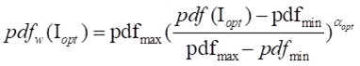 (14)
Reformulated cdf is estimated as follows:
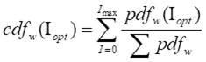 (15)
The sum is seen as,

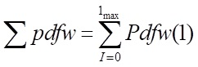 (16)
Enhanced optimized gamma parameter is subsequently described below, depending on the cumulative distribution function in equation (8):
(17)
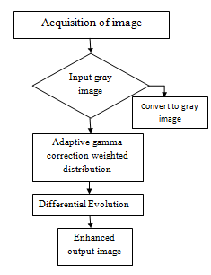
Figure 1: Image Enhancement Process
- Simulation
Discussion has been had over the simulation findings for both current and suggested improvement techniques. Optimized Gamma Correction through the Weighted Distribution results are contrasted with those of cutting-edge enhancement techniques, namely Adaptive Gamma Correction through the Weighted Distribution, which is depicted in figure 2. The analysis takes into account variables including the Structural Similarity Index (SSIM), Mean Square Error (MSE), and Peak Signal to Noise Ratio (PSNR). The proposed enhancement method outperforms the current enhancement strategies, producing better outcomes. Higher SSIM values produce better performance, and lower values produce the worst outcomes for enhancement (SSIM values between 0 and 1). Similar to this, the values of MSE and PSNR must be low and extremely high, respectively, for effective enhancement outcomes. The wickedest outcomes for enhancement are obtained with greater MSE and lower PSNR values. The evaluation parameters for the suggested approach, which outperform the AGCWD approach currently in use, are shown in Table 1.
Conclusion and Future Scope
The research suggests an innovative hybrid strategy called Optimal Gamma Correction through the Weighted Distribution (OGCWD), which takes into account the variations between weighted distribution and gamma correction. The improvement of contrast and brightness in low-quality images is suggested using a computer-assisted transformation technique. Modern image enhancement methods are outperformed by the suggested OGCWD approach in terms of SSIM, MSE, and PSNR values. The average values of the outcomes of the current AGCWD approach are also 0.6880, 2.1055, and 12.8265. Last but not least, we can say that the suggested technique works better than the current way in terms of average PSNR value, yielding positive enhancement outcomes. Utilizing hybrid optimization methods like PSO-DE, PSO-DE-GA, and DE-GA, among others, will increase image improvement in the future.
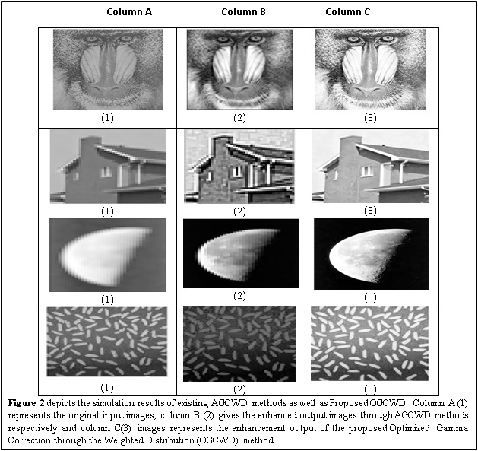

Table 1: Performance Metrics for the Enhanced Method
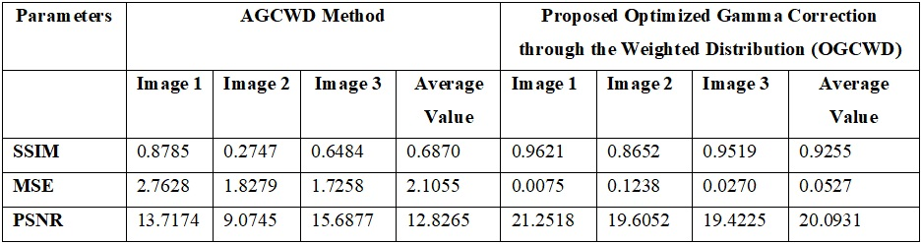

References:
- Patel S., Bharath K.P., Balaji S., Muthu R.K. (2020) Comparative Study on Histogram Equalization Techniques for Medical Image Enhancement. In: Das K., Bansal J., Deep K., Nagar A., Pathipooranam P., Naidu R. (eds) Soft Computing for Problem Solving. Advances in Intelligent Systems and Computing, vol 1048. Springer, Singapore
- S. H. Gangolli, A. Johnson Luke Fonseca and R. Sonkusare, "Image Enhancement using Various Histogram Equalization Techniques," 2019 Global Conference for Advancement in Technology (GCAT), BANGALURU, India, 2019, pp. 1-5, doi: 10.1109/GCAT47503.2019.8978413.
- Somal S. (2020) Image Enhancement Using Local and Global Histogram Equalization Technique and Their Comparison. In: Luhach A., Kosa J., Poonia R., Gao XZ., Singh D. (eds) First International Conference on Sustainable Technologies for Computational Intelligence. Advances in Intelligent Systems and Computing, vol 1045. Springer, Singapore
- Raju. A, Dwarakish. G. S and D. Venkat Reddy, “A Comparative Analysis of Histogram Equalization based Techniques for Contrast Enhancement and Brightness Preserving,” International Journal of Signal Processing, Image Processing and Pattern Recognition Vol.6, No.5 (2013), pp.353-366.
- Vijay A. Kotkar, Sanjay S. Gharde, “Review of Various Image Contrast Enhancement Techniques,” International Journal of Innovative Research in Science, Engineering and Technology Vol. 2, Issue 7, July 2013
- Rana, S. B., &Rana, S. B. (2015). A Review of Medical Image Enhancement Techniques for Image Processing. International Journal of Current Engineering and Technology, 5(2), 1282-1286.
- Sengupta S., Negi A. (2020) Comparative Analysis of Contrast Enhancement Techniques for MRI Images. In: Pandian A., Palanisamy R., Ntalianis K. (eds) Proceeding of the International Conference on Computer Networks, Big Data and IoT (ICCBI - 2019). ICCBI 2019. Lecture Notes on Data Engineering and Communications Technologies, vol 49. Springer, Cham
- Pooja Patel ,ArpanaBhandari (2019)A Review on Image Contrast Enhancement Techniques, IJO-SCIENCE (INTERNATIONAL JOURNAL ONLINE OF SCIENCE) ISSN 2455-0108 VOL. 5, ISSUE 7, JULY 2019
- MagudeeswaranVeluchamy, BharathSubramani (2019) “Image contrast and color enhancement using adaptive gamma correction and histogram equalization”, Optik (Elsevier) Vol: 183, April 2019, Pages 329-337.
- Shih-Chia Huang, Fan-Chieh Cheng, Yi-Sheng Chiu, ”Efficient Contrast Enhancement using Adaptive Gamma Correction with Weighting Distribution, ”IEE histogram equalization E.Trans. Image Process. VOL.No.22; .pp.1032-1041. IEEE Transactions on Image Processing, Volume. 22, NO. 3, March 2013.
- Dhal, K. G., Ray, S., Das, A., & Das, S. (2018). A Survey on Nature-Inspired Optimization Algorithms and Their Application in Image Enhancement Domain. Archives of Computational Methods in Engineering, 1-32.
- K. V. Price, "An introduction to differential evolution," in New Ideas in Optimization. London, U.K: McGraw-Hill Ltd., 1999, pp. 79-108.
- R. Storn and K. Price, "Differential Evolution: A Simple and Efficient Heuristic for Global Optimization over Continuous Spaces," Global Optimization, Kluwer Academic Publishers, vol. 11, pp. 341-359, 1997.
- S. Das and P. N. Suganthan, "Differential evolution: a survey of the state-of-the-art," IEEE Transactions on Evolutionary Computation, vol. 15, pp. 4-31, 2011.
- storn. (2014) Differential Evolution (DE) for Continuous Function Optimization (an algorithm by Kenneth Price and Rainer Storn). [Online]. http://www.icsi.berkeley.edu/~storn/code.html (Last accessed in Jan. 2014)
- V. Aslantas and M. Tunckanat, “Differential evolution algorithm for segmentation of wound images,” in Proceedings of the IEEE International Symposium on Intelligent Signal Processing (WISP ’07), Alcala de Henares, Spain, October 2007
- A. Kumar, S. V. RaghavendraKommuri, H. Singh, A. Kumar and L. K. Balyan, Piecewise Gamma Corrected Weighted Framework for Fuzzified Dynamic Intensity Equalization for Optimal Image Enhancement, 2019 International Conference on Communication and Signal Processing (ICCSP), Chennai, India, 2019, pp. 0480-0484, DOI: 10.1109/ICCSP.2019.8697947.
- Kalyani Chinegeram, Ramudu Kama, Ganta Raghotham Reddy. "Enhancement and Segmentation of Medical Images Using AGCWD and ORACM", International Journal of Online and Biomedical Engineering (iJOE), 2020
- Ganta Raghotham Reddy, Azmeera Srinivas, S.P Girija, R.Nirmala Devi. "Enhancement of Images Using Optimized Gamma Correction with Weighted Distribution Via Differential Evolution Algorithm", 2022 First International Conference on Electrical, Electronics, Information and Communication Technologies (ICEEICT), 2022

