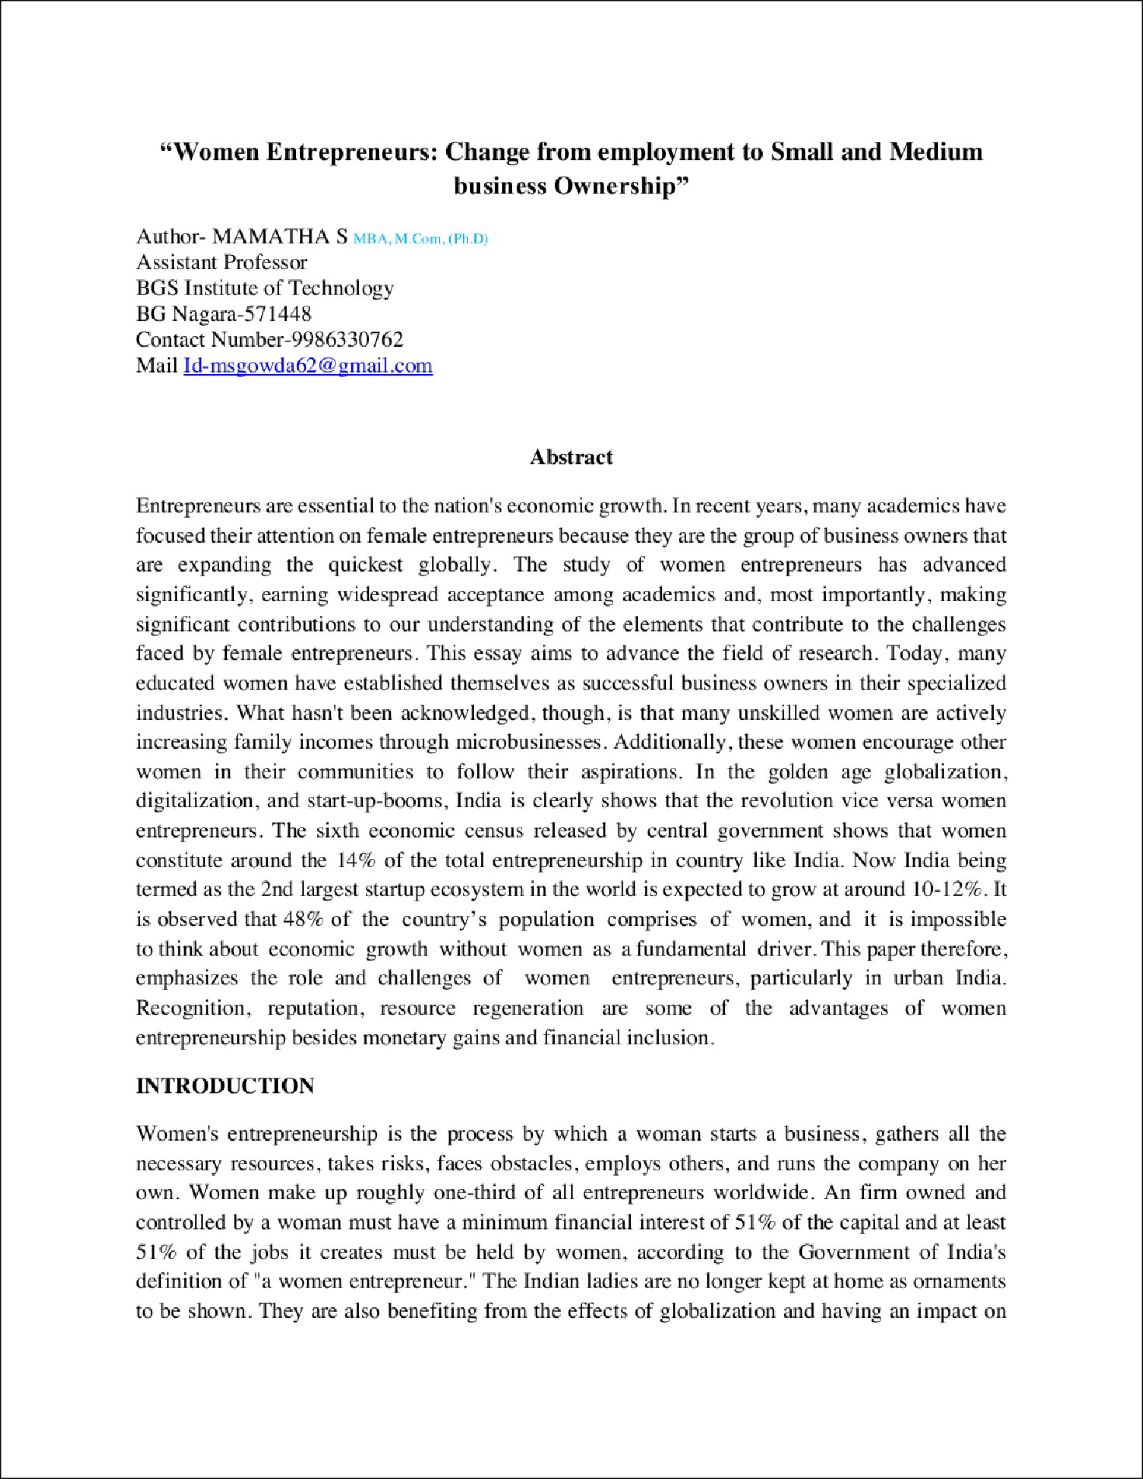
13

7
7

6

2

12

9

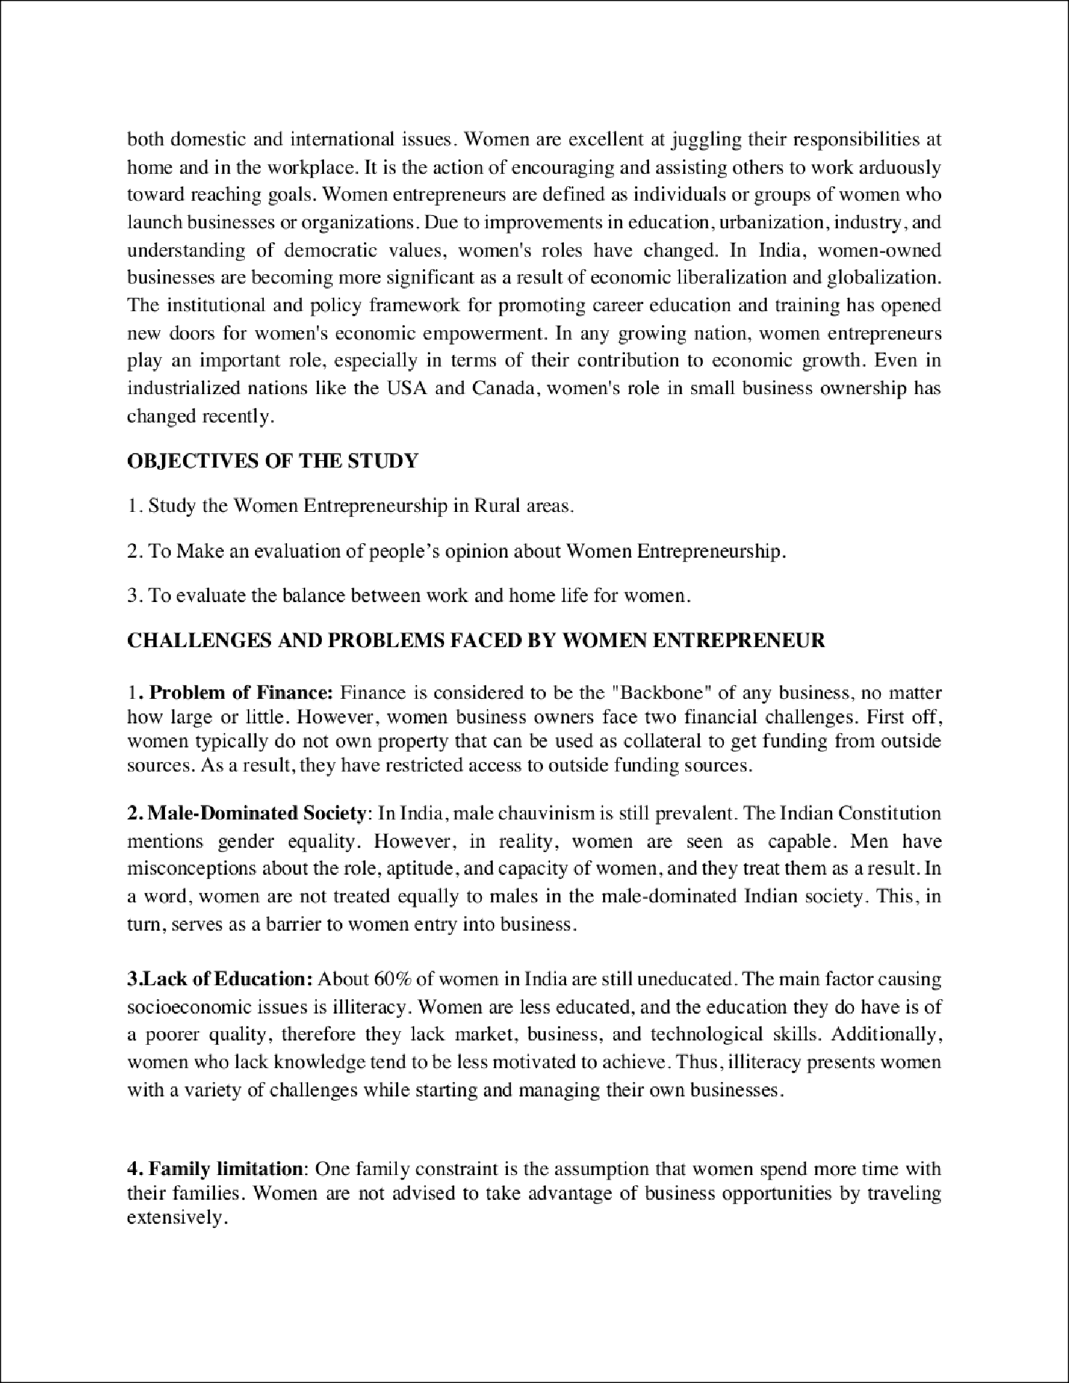

3

3

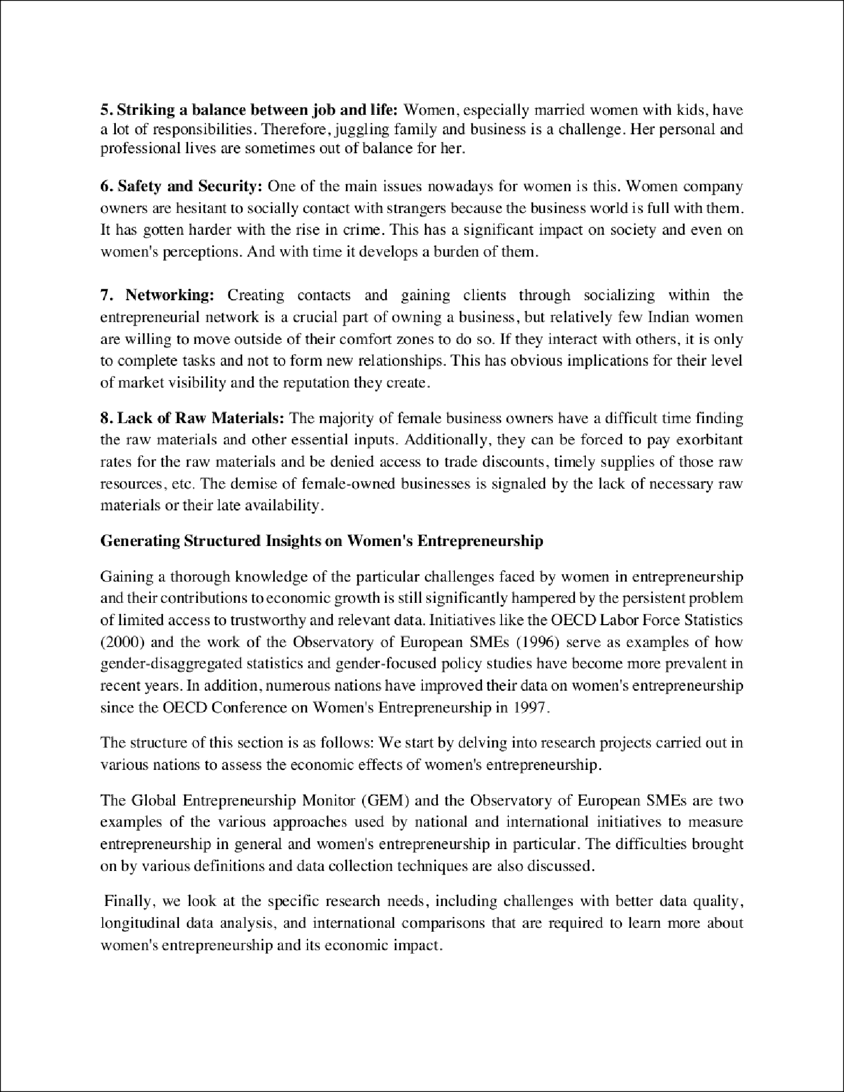

14

1
1

1

1

1

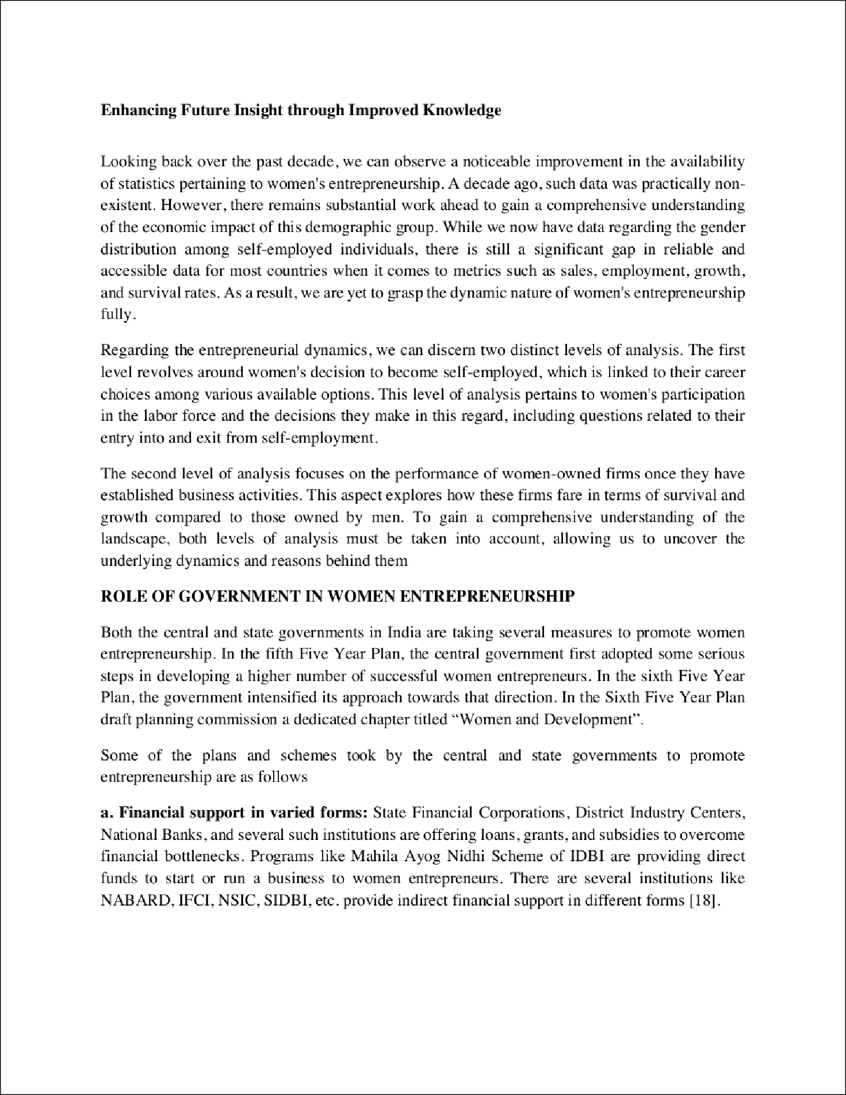

1
1

1
1

1

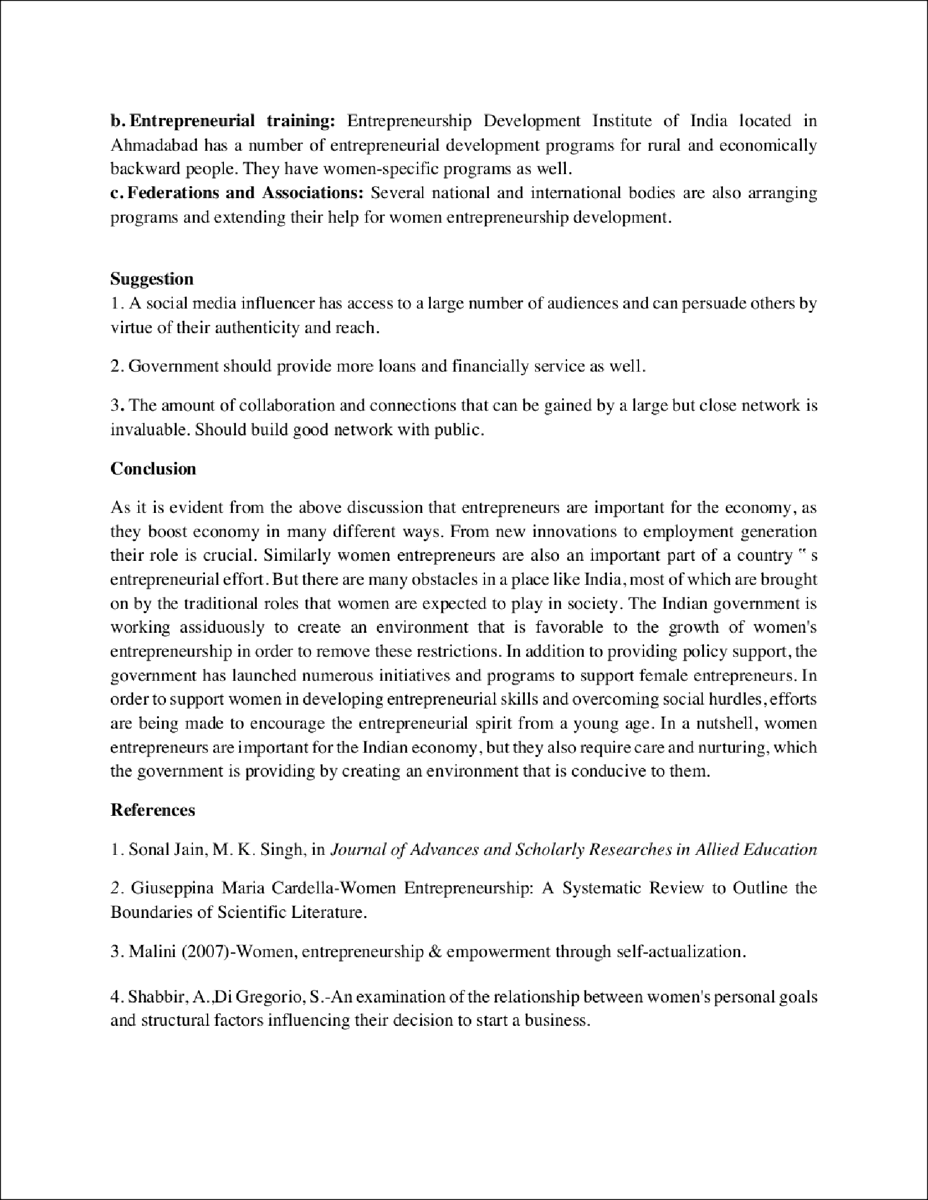

8

10

4

4

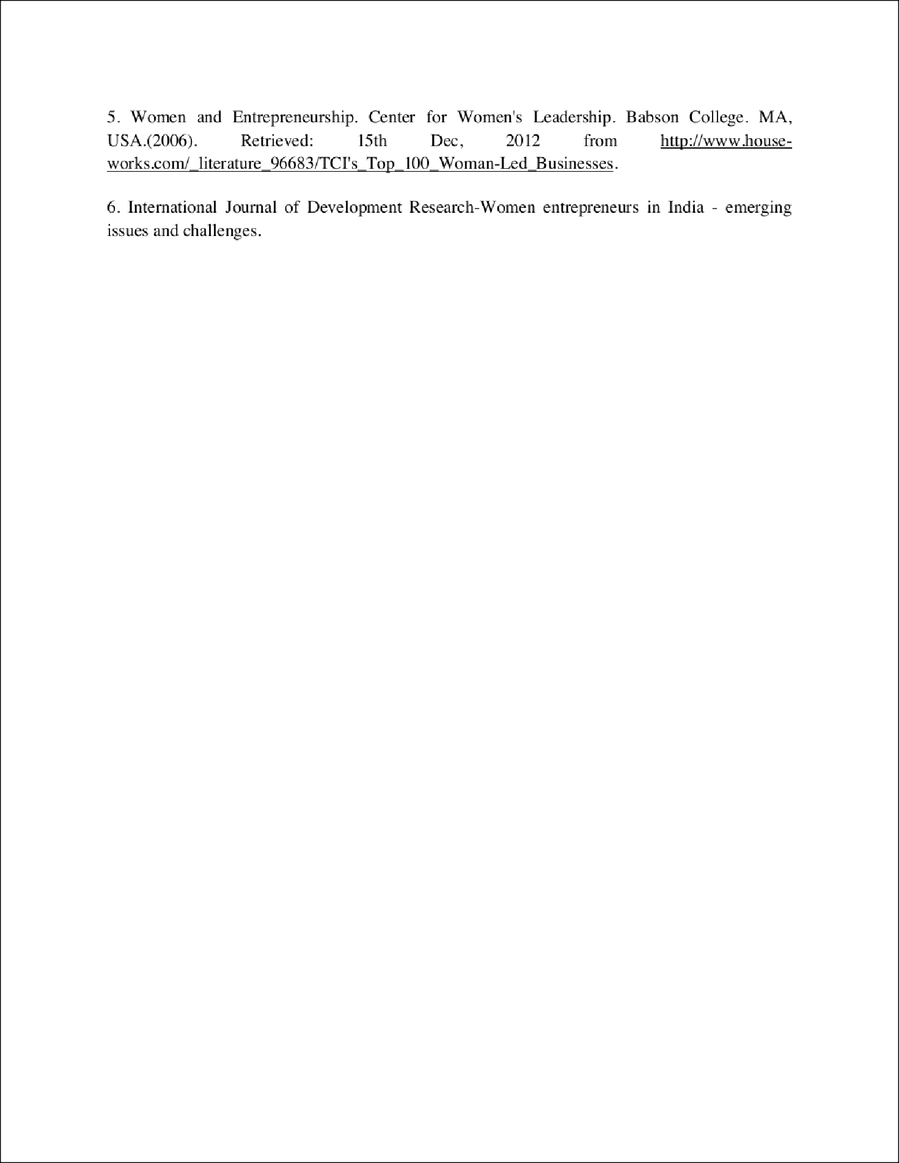
5

11

1003.docx
ORIGINALITY REPORT

%
23
SIMILARITY INDEX

PRIMARY SOURCES

1 es.scribd.com
Internet

2 papers.ssrn.com
Internet

3 Geeta Sachdeva. "chapter 11 Indian Women's Entrepreneurship", IGI Global, 2023
Crossref

4 www.mdpi.com
Internet

5 s3.amazonaws.com
Internet

6 www.businessworld.in
Internet
107 words — 5%
80 words — 4%
66 words — 3%
37 words — 2%
32 words — 2%
27 words — 1%

7 Sweety Mishra, Nimit Ranjan Chowdhary. "chapter 3 Gushing Through the Challenges", IGI Global, 2023
Crossref

8 www.appypie.com
Internet

9 bsum.edu.ng
Internet
25 words — 1%
23 words — 1%
21 words — 1%

10

11

12

13

14
www.ignited.in
Internet

journalijdr.com
Internet

www.esijournals.com
Internet

cyberleninka.org
Internet

uobrep.openrepository.com
Internet
15 words — 1%
13 words — 1%
10 words — < 1%
9 words — < 1%
8 words — < 1%

EXCLUDE QUOTES OFF EXCLUDE BIBLIOGRAPHY OFF
EXCLUDE SOURCES OFF
EXCLUDE MATCHES OFF

