Technological Advances in Pharmaceutical Manufacturing

Nilesh Kumar Upadhyay

Assistant Professor,

Smt. Fulehra Smarak College of Pharmacy,

Kamtailla, Rasra, Ballia, U.P.

Email- nileshupadhyay827@gmail.com

Himanshu Singh

Assistant Professor

Babu Sunder Singh College of Pharmacy, Lucknow

Email- himanshusingh.bph@rediffmail.com

ABSTRACT

Global patient healthcare is poised to undergo a transformation thanks to the digitalization of the healthcare industry. Virtual tools from various technologies, such as artificial intelligence, block chain, virtual reality, and augmented reality, to name a few, are offering significant advantages to both patients and the pharmaceutical industry, including bettering real-time diagnoses and treatments as well as improving access to clinicians and medications. The industrial sector has undergone a significant disruptive transformation due to the rise of novel technologies, which is symbolised by the development of industry 4.0. Treatment philosophies have changed in the healthcare industry as a result of virtual technologies. Particularly among physicians, chemists, and patients, there has been a discernible growth in the use of these virtual systems. The adoption of digital health could expedite the creation of customised drugs with superior outcomes.

Keywords- Healthcare, Research, Drug Innovation, Drug developments techniques

- INTRODUCTION

In addition to the pharmaceutical industry, it is possible to speculate that other industries, such as public health, may also have profited from the early warning of the pandemic. Emerging technology is reshaping not just new means for providing healthcare but also operations, research, and new methods of providing healthcare. As a direct consequence of this, a variety of companies have developed cutting-edge methods for the early diagnosis of illness and the provision of preventative medical treatment using a wide range of methodologies. It is also usual practice to make use of a variety of other cutting-edge technologies, such as artificial intelligence (AI), data analytics, bioprinting, system biotechnology, and a great deal of other examples. As a consequence of this, the creation of one-of-a-kind technologies will unquestionably supply pharmaceutical companies with the essential support they require to encourage development, present novel ideas, and work toward enhancing public health through the introduction of enhanced services and solutions. Although it was formerly thought that a perfect society would accept new technologies with open arms, this point of view is becoming less popular in favor of the notion that technological advancement is impossible without the inclusion of such innovations. More than seventy percent of respondents to a survey that was carried out by Global Data a couple of years ago anticipated that the use of intelligent technology will have the most significant influence on the production of medicines. In this issue of Pharmaceutical Technology, we take a look at some of the technological developments and activities that may bring about significant shifts in the pharmaceutical industry by the time 2023 is through. Traditional pharmaceutical companies have been slow to accept new technologies, but recent breakthroughs in health care provide evidence that the sector is getting ready to go through a significant paradigm change. Pharmaceutical companies are increasingly adopting cutting-edge technologies such as artificial intelligence (AI), augmented reality (AR), virtual reality (VR), big data (Big Data), and 3-D printing drugs in order to create individualized products, hasten research and development (R&D), and enhance user experience (UX). Other examples of these technologies include big data (Big Data), and virtual reality (VR). According to the findings of a survey that was carried out by Global Data in the preceding year, the pharmaceutical industry is of the opinion that the use of intelligent technology would have the greatest influence on the production of drugs. At least seventy percent of people who participated in the survey had this viewpoint. It is projected that the pharmaceutical industry will keep adjusting to new circumstances and undergoing rapid change in order to keep up with the increasing demand for medical services in different parts of the world.

- HIGH DEMAND FOR QUALIFIED HEALTHCARE DEVELOPERS

As a consequence of the digital revolution that is occurring inside the pharmaceutical business, the need for software developers in the healthcare sector is growing. There is a larger need for pharmaceutical software as a direct result of the expanding number of pharmaceutical companies now operating in the market. The use of information technology in the pharmaceutical industry helps businesses to improve efficiency and increase revenue. In this industry, there is a wide variety of software that may be utilized for a variety of purposes, such as the distribution of medications, the creation of new drugs, the administration of supply chains, and the quality control of pharmaceuticals. The need for healthcare developers is expected to stay relatively unchanged over the next few years as a result of the significant growth in the pharmaceutical industry. Consider this for a moment: analysts estimated that the worldwide market for pharmaceuticals would reach $1.42 trillion in the year 2021. Furthermore, it was $390 billion when we looked back ten years ago.

- TRENDS IN PHARMA HEALTHTECH THAT WILL CHANGE THE INDUSTRY

The below-mentioned medication research and formulation technologies are now seeing rapid expansion with the intention of improving patient adherence. The investments made by companies from other industries have resulted in an increase in both the capacity and the lead time of these industries.
- Artificial Intelligence
- Integration of Wearable Technology
- Management of Data and Analytical Processes
- Procedures with a Single Intended Use
- Precision Medicine
- Data from the Real World
- AR-VR
- IoT Integration
- Blockchain Integration
- 3-D Printing medicines
- Quantum Computing
- Technology for Continuous Production of Goods

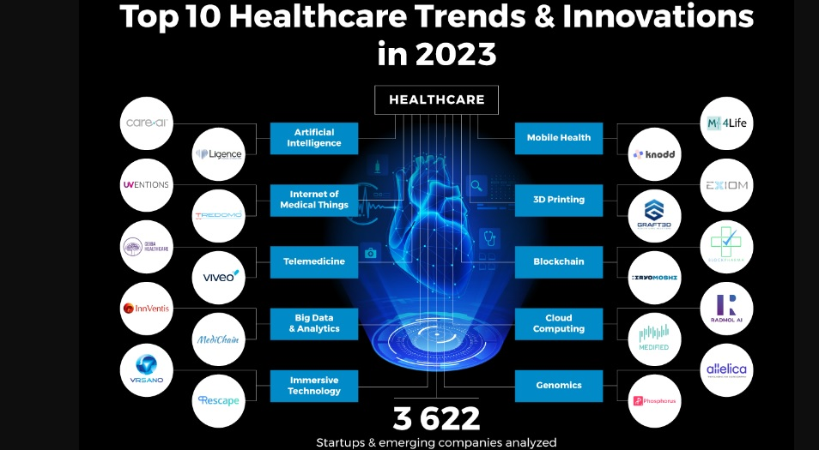Figure 1: Medication research and formulation technologies
- Artificial intelligence & Machine Learning

Figure 2: AI in Pharmacy
In the medical sector, artificial intelligence is becoming more and more significant. Grand View Research's analysis revealed that between 2018 and 2025, the artificial intelligence (AI) healthcare market is expected to grow at an astounding Compound Annual Growth Rate (CAGR) of 41.5%.
The immense predictive and data-analytic capabilities of AI are already being used to benefit the industry. Professionals in the healthcare sector may now use AI technology to apply patterns in data sets to better understand the effects, advantages, and success rates of new pharmaceuticals before they are put on the market.
The British start-up Pangaea Data combines machine learning (ML) and artificial intelligence (AI) technology for application in real-world evidence (RWE) investigations and clinical trials. Pangea Data uses software that is powered by machine learning (ML) to identify patients. This tool examines medical notes that are difficult to read as well as electronic health data. Additionally, the company is attempting to create a library of AI models that will cover a wide range of illness categories.
A Canadian start-up company called Invivo AI conducts research on novel drugs and chooses the most promising candidates for use in the development of new medications using cutting-edge machine learning techniques like representation and few-shot learning (extrapolating conclusions from short quantities of data). These procedures eliminate the need for massive datasets, which considerably speeds up the process of finding new drugs.
“ Without a doubt, machine learning and artificial intelligence will be the next big things in the pharmaceutical industry. Healthcare organizations are already using AI to automate repetitive tasks like data entry, lab test analysis, data management, analysis of healthcare systems to find flaws or inefficiencies, medical consultations provided by AI-based applications, medication management controlled by an AI-based system, etc. Machine learning is used in research on clinical trials, personalized medicine, the identification of rare diseases, the development of novel medications, radiography, and radiation planning in addition to the detection and diagnosis of disease.
What has to be determined is how AI and ML will impact the upcoming transformation in the pharmaceutical business as a whole. Since the pharmaceutical sector has a lot of data silos that contain patient information, these technologies really have the most potential to change things in the future. For instance, it will take months to watch how a drug affects the behaviors of thousands of people, however it will simply take seconds to study how a medicine impacts billions of simulations of the physiology of the human body that have been built from patient records.
It is anticipated that most, if not all, pharmaceutical research and development procedures would make use of AI and ML. The percentage of attempts to create new treatments that are successful must thus increase, and the R&D processes must become more efficient. Theoretically, AI might also assist in precisely identifying the patient subgroup that would benefit from a certain drug. It's probable that taking this measure may lead to a timely and successful launch in addition to a significant drop in the failure rate.
However, in order to get there, the current research and development approaches will need to be changed. It is more important to confirm the findings than to try to figure out how artificial intelligence computers solve a problem.

- Wearable health devices
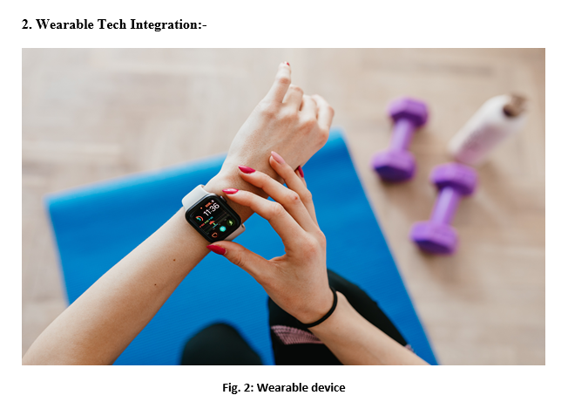
Figure 3: Wearable health devices

In recent years, pharmaceutical corporations all around the world have come to the conclusion that simply generating and researching pharmaceuticals is no longer sufficient. Recent developments indicate that they must provide a full bundle in addition to only the physical aspect of their medications. These digital products—mobile health apps, gadgets, or services—that could be prescribed by a doctor or included with a prescription medication are already referred to as "around the pill" options.
Some packages include a wearable monitoring gadget and an app that patients can use to get good feedback from their doctors and from the app's automatic, personalised feedback. We already have a variety of remote patient monitoring tools that enable clinicians to check blood pressure, glucose, and other vital signs as well as chronic illnesses like diabetes and asthma.
Apps that help people manage chronic conditions through exercise, find free medical facilities and clinics, order medications online, check for drug interactions between various medications, connect patients in social networks, and more are already commonplace in app stores. Pharma businesses can now do more with wearable technology integration than just create, promote, and sell pharmaceuticals. The use of technology allows patients more control over how they manage their ailments and make important choices.
It is now typical to find apps in app stores that assist users in managing chronic diseases through exercise, locating free medical facilities and clinics, ordering prescriptions online, checking for drug interactions between different medications, connecting patients in social networks, and many other functions. With wearable technology integration, pharmaceutical companies can now accomplish more than just produce, market, and sell drugs. The use of technology gives patients greater influence over how they treat their conditions and make crucial decisions. With the aid of the device, patients may log in and carry out easy tasks that let them monitor their blood sugar levels. The method offers patients a better experience than simply waiting for answers and is original, useful, and efficient.
Furthermore, lengthy procedures for document authentication and other types of verification can be eliminated via mobile apps that link patients with health insurance providers. Through a smartphone app, insurance firms are able to obtain prescriptions and other medical records from their customers, which they use to determine whether or not a certain expense is covered by insurance. Hence, more digital apps are coming with the rising of new technologies. Undoubtedly, healthcare apps are the next big thing for pharmaceutical industries.

- Data Management & Analytics
One of the main obstacles to the commercialization of novel pharmaceuticals is the expense of research and development. A novel molecular molecule or biological treatment, for instance, may cost as much as $2.6 billion to develop. Lack of appropriate drug development and distribution has a cascading effect that makes it difficult to treat patients. Researchers in the pharmaceutical industry can accelerate the discovery and dissemination of novel medicines by utilising big data to shorten exploration cycles. Big data can also be used to predict a drug's side effects, which cut down on the time needed for clinical studies. Shortening R&D cycles can help patients pay less for their prescriptions because the expenditures of research and development drive up the price of medications. By combining big data with a machine learning system that can test and analyse different medications, Carnegie Mellon University is enhancing research and development. Technology can speed up the drawn-out discovery and development process.

- Single-Use Processes
Single-use technology (SUT) is becoming more widely used in pharmaceutical businesses' manufacturing processes. The industry is continuing to change as more players become aware of the amazing benefits of this technology. High-level processes can be facilitated at a greater scale using bioreactors powered by SUT. Technology also enables the production of more dependable goods, which eliminates the need to sterilise containers.
Pharmaceutical businesses that already use SUT report quicker turnaround and development periods as well as streamlined operations due to the reduced maintenance procedures.
In contrast to stainless setups, which can take several days, equipment that runs on SUT is simple to set up, taking just one or two hours. Furthermore, there is no requirement for sterilisation validations, annual cleaning, or minimal monitoring, thus system maintenance is rather simple. It is simple to maintain a sterile production environment using single-use methods since they lower the possibility of product cross-contamination.
SUT is a relatively new technology, yet because of how useful it is, pharmaceutical companies cannot ignore it. More pharmaceutical companies will go on board in 2023 and beyond because SUT has a promising future. Single-use bioreactors are becoming a more and more common method of streamlining procedures.

- Precision Medicine
A novel approach to illness diagnosis, treatment, and prevention is provided by precision medicine. This technology aids physicians in making precise, fact-based recommendations by using the patient's DNA and lifestyle. By 2024, the market for precision medicine will be worth more than $96 billion, with a CAGR of 10.7%. The success of modern targeted medicines is largely responsible for this growth. Precision medicine will revolutionise cancer when it is completely applied, enabling patients to receive personalised care.
Even if precision medicine is still in its infancy, providing patients with truly customised care would necessitate a complete transformation of the way medical professionals provide and create remedies. A new legislative, clinical, economic, and technical framework is needed for the successful application of precision medicine. By doing this, medical professionals may give the appropriate therapy to the appropriate patient at the appropriate time. This will be one of the year's most disruptive trends in pharma and healthtech, if growth predictions are to be believed.

- Real-World Data
One of the new trends in pharma and healthtech, real-world data (RWD), is essential to making judgements about medical care. For instance, before making regulatory decisions, the U.S. Food and Drug Administration (FDA) uses RWD in conjunction with real-world evidence (RWE) to assess a product's safety and pinpoint adverse events. These two technologies are used by healthcare professionals to support coverage choices and establish recommendations for the usage of medical devices in clinical settings. Additionally, RWD and RWE are used by producers of medical products to assist clinical trial designs such pragmatic clinical and large simple trials. Observational research and fresh treatment approaches are both supported by the creators' use of RWD and RWE. The health care industry may analyse data and apply the findings to improve the procedures for product development and approval thanks to the sophistication and analytical capabilities of RWD and RWE.
Health-related data is gathered and stored by biosensors, computers, wearable technology, and mobile devices. As a result, better clinical trials can be planned and carried out thanks to the data, which helps researchers find answers to topics that were previously thought to be intractable. Since data is so inextricably related to technology across all sectors, we can anticipate that RWD will continue to be a key element of pharma healthtech trends for the foreseeable future.

- AR-VR
AR-VR has a lot to offer the pharmaceutical industry, which is struggling to engage physicians and whose research timetables are being sucked dry by an expanding number of investigations. Due to their ability to create a compelling virtual world with fine details, AR and VR are promising technologies that can achieve a number of goals for the pharmaceutical industry.
In contrast, the Giant pharmaceutical firm "GSK" created an augmented reality program to simulate a migraine so that others might better understand what a migraine patient goes through. These programs can address crucial problems in today's healthcare environments, such empathy and trust. This was a really great application of augmented reality.
Only so far can AR-VR technology be used to forecast drug-target interactions. Virtual reality can increase the effectiveness of the pre-development phases of medicine through improved interface visualisation and subsequent molecular redesign and re-engineering in line with site needs.

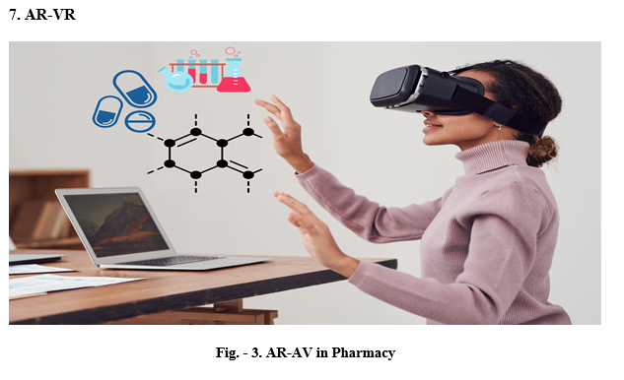
Figure 4: AR-VR in Pharmacy
The production sector of the pharmaceutical business may gain from AR-VR. such as remote monitoring and maintenance, complex machine handling training, etc. The DAQRI smart helmet was created by the California-based augmented reality company DAQRI and is suitable for usage in industrial situations. This product exemplifies the value of augmented reality (AR) in manufacturing, especially in demanding settings like pharmaceutical production.”

- IoT integration

IoT is expanded by the Internet of Things. It is the process of incorporating the internet into devices like computers, digital devices, and other machinery. The devices have unique identifying numbers and may communicate data via a network.

The main advantage of IoT is that it can execute any intermediary task without requiring a link between humans or computers. Several businesses and sectors are actively using IoT technologies to improve the efficiency of their processes.

H.1 Working of IoT
Web-enabled, Internet of Things network-connected, intelligent gadgets that include integrated hardware such as sensors, central processing units (CPUs), and other systems. These tools are helpful in the processes of data collection, transmission, and processing.
An Internet of Things gateway enables Internet of Things devices to communicate with one another and transmit the information that sensors have gathered to the cloud or another place of the user's choosing. Only the feeding instructions require interaction from a human, whereas all of the other steps may be completed entirely independently.
H.2 Latest IoT technologies
Integration of the internet of things can be of assistance to the manufacturing sector of the pharmaceutical business with activities such as the management and monitoring of materials during the creation of medications. Installing data collection devices that are enabled by the internet of things at shipping and receiving stations allows for the collection of data from barcodes and RFID tags, as well as the correlation of data from many locations, such as warehouses and manufacturing facilities, to guarantee that the data is accurate.
Because of the spectacular developments in nanotechnology and IoT integration in the pharmaceutical industry, one possible development that might emerge in the not-too-distant future is the production of "digestible IoT Devices" as part of the process of making medications. This could be the beginning of a trend. These small gadgets or tablets, when paired with a sensor, would be able to detect how quickly and effectively medications are absorbed after being taken. Therefore, it would be beneficial for this sector if we could anticipate seeing further stimulation of advanced IoT integration in the not too distant future.

Blockchain
As a consequence of the remarkable advancements in nanotechnology and IoT integration in the pharmaceutical sector, one potential trend that might arise in the near future is the production of "digestible IoT Devices" during the process of making medications. This is one of the prospective trends that could emerge in the near future. When combined with a sensor, these minute devices or tablets can be put to use for the purpose of determining the rate of medication absorption as well as its efficiency.
As a result, we have reason to believe that the stimulation of sophisticated IoT integration will occur in the not too distant future for the benefit of this industry.
It is estimated that the process will take between eight and twelve years, and might go on for much longer, and will cost between 800 million and 2.5 billion dollars each medicine. Only one in every fifth medicine attempts is successful in making it to market. Return: 3.2%; just one in every three new pharmaceuticals that are introduced to the market is considered to be "profitable."
Blockchain technology provides an opportunity to reduce these costs while also enhancing transparency and confidence for all parties engaged in the process. This is accomplished by protecting data relating to intellectual property. Because of the present regulations around intellectual property, cross-collaboration is illegal, which makes the process far more challenging. The blockchain technology may be able to provide a platform for the facilitation and protection of intellectual property, as well as the facilitation of payments, royalties, and incentive models that may drive participants to contribute ideas to the research and development process. Blockchain technology may also be able to facilitate the protection of intellectual property.
Tracking helps improve the outcomes of cross-collaboration, which in turn accelerates the entire process, which in turn leads to faster breakthroughs and is more efficient in terms of both time and money for everyone involved. Another advantage brought about by blockchain technology is more transparency in the consent process for clinical trials. A digital identity that is enabled by blockchain will give traceability after the identity of a patient has been verified. This will improve data quality by enabling the monitoring of patient data that is related with a particular drug research, all while maintaining the greatest degree of data protection possible.
Blockchain technology has the potential to make substantial contributions in a number of important areas. One of these areas is the manufacture and distribution of medicines, which may be maintained through tracking and tracing to prevent instances of fraud and counterfeit drugs. It is a single source of truth that may be used to trace medications, products, and medical equipment at all points throughout the supply chain. In addition to this, it is able to provide monetary support in the areas of price, payment, discount, rebate, and refund monitoring.
To put it succinctly, the patient and customer experience will almost immediately undergo a profound transformation thanks to blockchain technology. As a result, companies involved in the pharmaceutical industry have to contemplate making use of the possibility given by blockchain.

3D-Printing Drugs
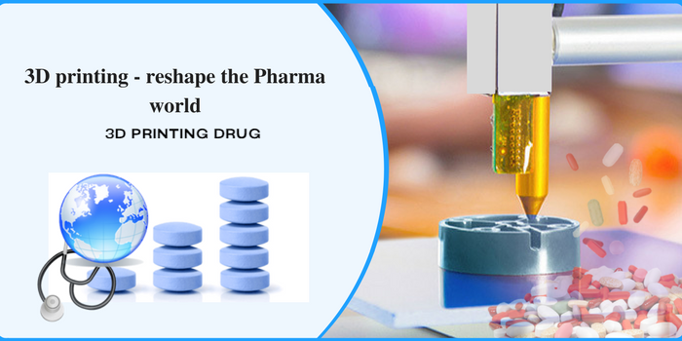
Figure 5: 3D Printing Drug
Until recently, 3D printing was an idea that mainly appeared in science fiction books. Zipdose, a patented process for 3D printing medications that enables the printing of high-dose prescriptions in a form that dissolves fast, was created by Aprecia medications in 2015. Now that it has gained greater traction, this idea has been applied. They were able to create Spritam, a medication for epilepsy, using this method later on. The first 3D-printed medication was approved by the Food and Drug Administration. The pharmaceutical industry's supply chain operations are anticipated to undergo a full paradigm shift if this type of production becomes more widespread.
In addition, the University College London is looking at the feasibility of printing cartoon character-shaped prescriptions for kids. It has the potential to turn into a lucrative business opportunity if you make it simpler for them to take.
Pharmaceutical items may be produced in three dimensions using digital designs and a technique called "3D printing." One of the conventional pharmaceutical techniques that has been in use for a long time is tablet compression. Traditional pharmaceutical techniques frequently adhere to predetermined regulatory pathways. Despite being widely used, these procedures lack the flexibility and process skills needed for contemporary manufacturing. Three-dimensional printing as a platform technology offers competitive advantages for complicated items, goods that are tailored to the needs of the client, and products that are created on demand. These advantages provide the possibility for enhancing the security, effectiveness, and accessibility of medicine.
Even though traditional production techniques for solid oral dosage forms differ from 3D printing, risk-based approaches may still be created. By illustrating how such an understanding may be put into reality, this review demonstrates how having a solid understanding of items and processes may make it simpler to build control strategies for a range of 3D printing techniques.
These recent developments may soon open up a wide range of new income and profit streams for B2B businesses engaged in the marketing, sales, and administration of pharmaceuticals.
Clinical trials no longer involve the costly and time-consuming drug testing on people or animals that was formerly standard practice. The newest craze in the sector is "Organs on Chips." Consider a clinical study where the properties of living things can be precisely imitated, allowing the experiment to be completed in less time and with fewer resources while yet producing high-quality results. This approach, which goes under the label "silico trial," makes use of silico. It might be applied as a kind of customized computer simulation for regulatory evaluation, enabling the creation of a medical product, technology, or intervention. With the technology and biological knowledge that are now available, fully simulated clinical trials are not possible; nonetheless, it is believed that the development of these trials will provide significant gains over the in vivo clinical trials that are currently used.

Quantum computing

Despite the fact that leveraging ultra-efficient quantum computers to locate previously undiscovered compounds is a promising new strategy, the employment of computational approaches in the process of drug discovery is not a novel notion. Instead, this approach has been around for quite some time.

In contrast to traditional computers, which make use of "bits" that can either be "on" or "off," quantum computers make use of "qubits," which have the ability to be "on," "off," or both at the same time. This concept is referred to as superposition. Due to the superposition property of quantum computers, the technology holds a great deal of promise for the development of novel medications. Quantum computers may significantly accelerate testing and improve forecasts in a number of ways.

One of the companies working on commercializing drug discovery powered by quantum mechanics is the Australian-German business known as quantum brilliance. The new venture, which began operations in 2019, is working toward the production of diamond quantum accelerators that are capable of simulating interactions between various molecules for the purpose of in silico drug creation.
Marcus Doherty, the chief scientific officer of Quantum Brilliance, stated that "our goal for 2022 is to demonstrate the concept and value of distributed quantum computing (QC) for computational chemistry as part of our software stack." This objective is intended to be accomplished by the end of the year 2022.Doherty claims that stakeholders in the business have recognized the potential of QC to change medical research, despite the fact that the field is still in its infancy. According to him, the fact that a flurry of agreements has been signed this year between large pharmaceutical companies and QC groups is evidence that the pharmaceutical business is not waiting to become engaged.
Since January, Boehringer Ingelheim and Google Quantum AI have been collaborating on the development of quantum methods for use in in silico drug modelling and medicine formulation. A month later, Roche, the largest pharmaceutical company in the world, made the announcement that it will be collaborating with Cambridge Quantum Computing to speed up the process of developing treatments for the early stages of Alzheimer's disease.

- Technology for Continuous Production of Goods
The pharmaceutical business has just recently adopted the strategy of continuous production. Large pharmaceutical companies are boosting their degree of competition in order to assure that prices will be reduced and that treatments will be authorized more rapidly as the demand for novel and cutting-edge pharmaceuticals grows. Commercial pharmaceutical finished product production is now underway, and both the European Union and the United States have approved the use of small-molecule medications. In the APAC area, it is still in its infancy, and only a small number of providers are actively using it in their operations.
Both the United States and Europe are home to 80% of the suppliers. In APAC, there aren't many businesses that use continuous production. Many businesses have invested in this technology recently in an effort to increase their capacities and capabilities.
There are a number of possible benefits, but the following are some of the more significant ones: • a cheaper cost; fewer employees; less waste; a shorter development time; and less costly utilities.
Only 30% more space is needed for continuous manufacturing than for batch manufacturing. Less product is at risk at any given time due to the equipment's smaller size, higher quality, and decreased likelihood of scaling-up problems. This is also due to the flexibility of batch size, the smaller product footprint, a more efficient use of the equipment, the potential for real-time release, the ease of automation, the enclosed process, and the decreased operator exposure.
L.1 Disadvantages include
Cleaning equipment that is smaller could require disassembly, and a single CM line might only be able to handle a limited selection of products, both of which would make product switching a more challenging process.
Greater than sixty percent of companies provide this technology for APIs. However, there are just a few businesses that really manufacture pharmaceuticals. Within eight years, 70 percent of the commodities with the highest volume as a whole implemented CM, this resulted in a 33 percent increase in output thanks to the reduction of waste and the acceleration of the manufacturing and testing cycles.

Final Thoughts

The COVID-19 pandemic's one and only saving grace may be that it provided the pharmaceutical and healthcare industries with a dire need for a wake-up call. Pharmaceutical and healthcare companies are currently reviewing their procedures and seeking for innovative ways to increase productivity.
The section labeled "Pharmaceutical Industry Trends & Startups" is an example of how little of the patterns we discovered throughout our extensive study are included in this report. Nanotechnology, vaccination technologies based on mRNA, and low-volume manufacturing will all fundamentally alter how business is conducted today. A corporation needs to be open to embracing new opportunities and developing technologies as they emerge if it wants to gain a competitive edge.
Companies must first make every effort to assist in overcoming the difficulties now faced. To build a strong foundation for cyber resilience and make sure that your team has the skills necessary to effectively implement digital transformation, it is essential to undertake a security assessment.
It's probable that the number of mergers, acquisitions, and initial public offerings (IPOs) in the healthtech sector may rise as investors swarm to support new businesses and healthcare initiatives.

REFERENCE

- Resource allocation to brain research in Europe: a comprehensive report. Sobocki P, Lekander I, Berwick S, Olesen J, and Jönsson B. (2006) 24:2691-3 Eur J Neurosci. doi: 10.1111/j.1460-9568.2006.05116.x CrossRef Detailed Text Use Google Scholar
- Tiwari S, Atluri V, Kaushik A, Yndart A, and Nair M. Pathogenesis, diagnostics, and treatments of Alzheimer's disease. 2019;19:5541–54. Int J Nanomedicine. CrossRef Full Text | 10.2147/IJN.S200490 Use Google Scholar
- Zibly Z, Shaw A, Harnof S, Sharma M, Graves C, Deogaonkar M, et al. Therapeutic neuromodulation for cognitive impairment by mind-modulation. (2014) 21:1473–7 J Clin Neurosci. doi: 10.1016/j.jocn.2013.11.040 CrossRef Full Text | Google Scholar | PubMed Abstract
- Khan IS, D'Agostino EN, Calnan DR, Lee JE, and Aronson JP. Deep brain stimulation for memory modulation: a new frontier. World Neurosurg. (2019) 126:638–46. doi: 10.1016/j.wneu.2018.12.184 PubMed Abstract | Google Scholar
- Henze LJ, Koehl NJ, O'Shea JP, Kostewicz ES, Holm R, and Griffin BT. The pig as a preclinical model for predicting oral bioavailability and in vivo performance of pharmaceutical oral dosage forms: a PEARRL review. J Pharm Pharmacol. (2019) 71:581– 602. doi: 10.1111/jphp.12912 PubMed Abstract | CrossRef Full Text | Google Scholar
- Renfro LA, and Sargent DJ. Statistical controversies in clinical research: basket trials, umbrella trials, and other master protocols: a review and examples. Ann Oncol. (2017) 28:34– 43. doi: 10.1093/annonc/mdw413 PubMed Abstract | CrossRef Full Text | Google Scholar
- World Health Organization. 20 Million Children Miss Out on Lifesaving Measles, Diphtheria and Tetanus Vaccines in 2018. (2019). Available online at: https://www.who.int/newsroom/detail/15-07-2019-20-million-children-miss-out-on-lifesaving-measles-diphtheria-andtetanus-vaccines-in-2018 (accessed September 18, 2019). Google Scholar
- Venter H, Henningsen ML, and Begg SL. Antimicrobial resistance in healthcare, agriculture and the environment: the biochemistry behind the headlines. Essays Biochem. (2017) 61:1– 10. doi: 10.1042/EBC20160053 PubMed Abstract | CrossRef Full Text | Google Scholar
- Zottel A, Videtič Paska A, and Jovčevska I. Nanotechnology meets oncology: nanomaterials in brain cancer research, diagnosis and therapy. Materials. (2019) 12:E1588. doi: 10.3390/ma12101588 PubMed Abstract | CrossRef Full Text | Google Scholar
- Antoszczak M, and Huczynski A. Salinomycin and its derivatives - A new class of multipletargeted “magic bullets”. Eur J Med Chem. (2019) 176:208–27. doi: 10.1016/j.ejmech.2019.05.031 PubMed Abstract | CrossRef Full Text | Google Scholar
- Kwon OS, Kim W, Cha HJ, and Lee H. In silico drug repositioning: from large-scale transcriptome data to therapeutics. Arch Pharm Res. (2019) 42:879–89. doi: 10.1007/s12272- 019-01176-3 PubMed Abstract | CrossRef Full Text | Google Scholar
- Vaccaro L. Green chemistry. Beilstein J Org Chem. (2016) 12:2763–5. doi: 10.3762/bjoc.12.273 PubMed Abstract | CrossRef Full Text | Google Scholar
- https://masschallenge.org/articles/pharma-healthtech-trends/#:~:text=The%20latest%20technologies%2C%20like%20AR,conduct%20testing%20in%20innovative%20ways.\
- Healthcare-Startups-TrendResearch-InnovationMap-StartUs-Insights-noresize.webp (1280×960)
- https://www.softermii.com/blog/the-future-of-pharmaceutical-information-technology#form
- https://brainstation-23.com/pharmaceutical-industry/
- https://www.beroeinc.com/article/technology-trends-in-pharmaceutical-manufacturing/
- https://www.pharmaceutical-technology.com/features/how-technology-could-transform-drug-research-in-2022/
- https://www.startus-insights.com/innovators-guide/top-10-pharma-industry-trends-innovations-in-2021/#artificial-intelligence
- https://www.analyticssteps.com/blogs/9-applications-iot-pharmaceutical-manufacturing
- https://www.wipro.com/pharmaceutical-and-life-sciences/nextgen-pharma-takes-smart-strides-with-internet-of-things/
- https://www.startus-insights.com/innovators-guide/top-10-pharma-industry-trends-innovations-in-2021/
- http://www.adanipharma.com/articles/how-3d-printing-can-reshape-the-pharmaceutical-world-completely.html
- https://builtin.com/wearables

