Battery Monitoring Protection Optimization and Management System for Electric Vehicle Applications

Sreenivasappa B. V., Department of ECE, Presidency University, Bangalore, Karnataka, India

sreenivasappabv@presidencyuniversity.in
Abstract— Electric vehicles (EVs) powered by rechargeable batteries have grown in popularity in recent years as a result of the finite nature of fossil fuels and worldwide environmental challenges. There are many different kinds of EVs, including hybrid, plug-in hybrid, and fuel cell electric vehicles. In all the EVs mentioned above, the battery, which might be made of lead-acid, nickel-metal hydride, nickel-cadmium, lithium, or another material, is the most significant and crucial part of the device. The monitoring, protection and optimization of battery management system (BMS) for electric vehicle applications is presented in this paper. Accurate battery monitoring allows for more effective battery utilization, which extends runtime and reduces battery cost and size. Performance and safety are primary objectives for battery packs consisting of lithium-ion or lithium-polymer materials, as is well known. The protection system is necessary to safeguard the battery against fault conditions like overvoltage charge, under voltage discharge, overcurrent charge, overcurrent discharge, temperature, and short circuit, whether in single-cell or multi-cell batteries, in order to increase battery pack safety. To improve the performance of in terms of energy density and to reduce charge time, optimization of battery material plays an important role. The use of nanomaterials in battery construction has various benefits, including (i) a shorter discharge time (this is accomplished by covering an electrode with nanoparticles), (ii) a longer battery life (this is accomplished by separating liquids from the electrodes using nanoparticles).
Index Terms—Electric vehicles, Battery, Protection, Monitoring, Optimization, Nanomaterials

INTRODUCTION

An essential part of a big scale lithium ion battery is a battery monitoring system. The electrolyte's flammability, which can result in a cell venting flammable gases during a battery failure, is one of the most serious risks associated with battery failure. A battery cell emits heat and oxygen on its own when it approaches thermal runaway. Since a cell's thermal runaway temperature can be higher than the auto ignition temperature of the solvents in the electrolyte, the electrolyte contributes to battery failure. Another significant concern is propagation, which happens when one battery dies and prompts other cells to follow suit. The entire cell pack or even neighbouring modules may experience this. When the cells begin to grow, the energy in a single module can cause a spectacular and disastrous firestorm. With the use of a good battery monitoring system, these risks can be avoided or minimised. A battery failure shouldn't happen if cells are balanced correctly, kept under observation, and treated as intended. Batteries are, however, handled in the most peculiar ways by their final users. Even if batteries are handled carefully for the rest of their lifespan, manufacturing flaws might still result in failures. The final form of a battery management system is a circuit board with discrete inputs, predetermined logic, and control capability. More information regarding the battery system's health can be gleaned from additional battery system monitoring, in addition to electrical testing and temperature data. It is advantageous in this situation to have battery monitoring systems. A typical battery-powered monitoring system can have fire detection, visual and aural alarms, and redundant heat sensing to turn on sprinklers and other fire suppression equipment at the room level. In addition to smoke, heat, and flame detection, a cutting-edge battery monitoring system may also include off-gas detection in order to identify battery problems before they worsen [1-4].
A rechargeable battery is monitored and controlled by an electrical system known as a BMS. It keeps the battery from operating outside of its safe operating range by keeping track of its state, computing secondary data, reporting that data, regulating its surroundings, authenticating, and balancing it. A BMS may employ a variety of indicators to check the health of the battery, including the average temperature, coolant intake and output temperatures, or individual cell temperatures, for liquid-cooled batteries, as well as current moving into or out of the battery. the current cellular chemistry, or the overall health of each cell. Battery management systems can be cooled using air, liquid, or a phase-shifting substance. There are quiet and aggressive types of them. Given its ease of use, air cooling is helpful. These systems can be passive, relying only on the convection of the surrounding air, or active, utilising fans to create airflow. Its inefficiency is the main drawback of air conditioning. Compared to active liquid cooling, the cooling technique consumes a lot more energy to function. The extra parts for the cooling mechanism contribute to the BMS's weight, which lowers the power of the transportation batteries. Since liquid coolants usually exhibit better thermal conductivities than air, they provide a greater opportunity for natural cooling than air cooling does. Either the coolant can run through the BMS without ever coming in contact with the batteries, or the batteries can be immediately submerged in the coolant. Because the cooling channels have been lengthened, indirect cooling can result in significant heat gradients across the BMS [5-8]. Additional factors that a BMS may consider when computing values include the minimum and maximum cell voltage, State of Charge, State of Health, Depth of Discharge, Maximum Charge Current, Maximum Discharge Current, Energy Delivered, Internal Impedance, Operating Time, Battery Life, Temperature Monitoring, and fluid flow for batteries.

II. COMPONENTS OF BATTERY MANAGEMENT SYSTEM

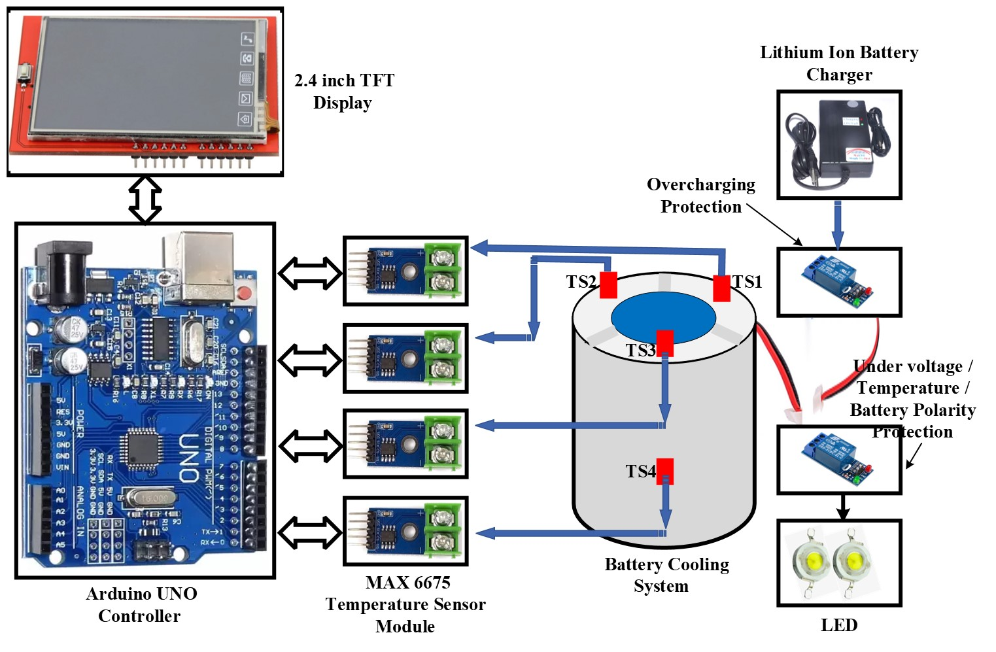

Figure 1: Block diagram of Battery Management System

2.1 Battery System

A battery is a device that uses an electrochemical oxidation-reduction cycle to directly transfer chemical energy from its active components into electric energy. The actual electrochemical unit that is used to produce or store electric energy is referred to as a cell, despite the fact that the term "battery" is frequently used. An electrochemical cell with anode and cathode terminals on either end makes up a battery, a type of energy storage. Electrical energy is created in electrochemical cells through the conversion of chemical energy. A conducting substance called an electrolyte, which is found in batteries, often contains soluble salts or acids. For electrical charges to pass through batteries, it acts as a conduit. The battery experiences an imbalance in charge when connected to an external resistance or device, which forces electrons through the device's conductive substance to the battery's positive end. When a battery is disconnected, there is no electric current since the charge at the positive and negative terminals of the battery is equal.
A single battery can power a variety of gadgets, including automobiles, telephones, lightbulbs, laptops, and uninterruptible power supply, depending on its voltage and load. For the majority of electronic equipment, working with the wrong voltage might prevent your gadget from turning on or put its electrical components in danger of harm, which is often irreparable. The best battery would be able to power a device without impairing its functionality or causing hardware damage. A single battery charge can also keep you going for anywhere from a few hours and many days, depending on the energy usage of the device and the pressure on the battery. The key components of the battery management system are shown in Figure 1.

2.1.1 Battery Construction and Working Mechanism
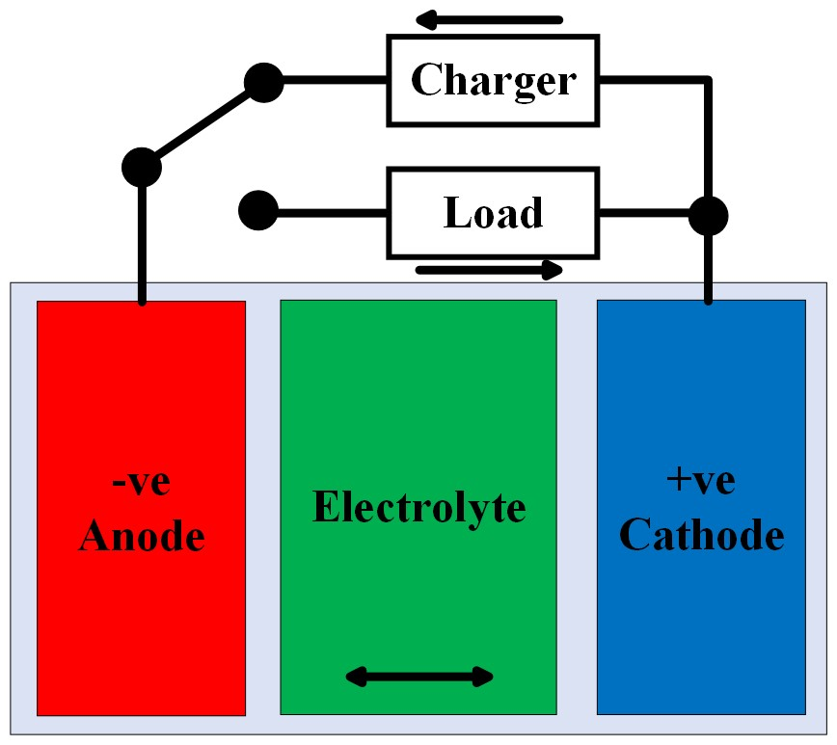
Figure 2: Battery working mechanism
An electrolyte reacts with metals in an electrochemical battery to produce oxidation and reduction. When two different metallic materials, known as electrodes, are combined with a dilute electrolyte, the electrodes go through an oxidation or reduction reaction depending on the electron affinity of the metals used to create the electrodes. A positively charged electrode called an anode is produced by a reduction reaction, whereas a negatively charged electrode called a cathode is produced by an oxidation reaction. The cathode and anode are respectively the negative and positive terminals in a battery. When two distinct metals are submerged in an electrolyte solution as shown in Figure 2, one of them will absorb electrons while the other will release them. Depending on these metals' electron affinities, some metals (or metallic compounds) will gain electrons while others will lose them. The electrolyte solution's negative ions will donate electrons to the metal with a low affinity for electrons. However, the metal with a high affinity for electrons will liberate electrons, which then mix with the positive ions in the electrolyte solution. One of these metals acquires electrons as a result, whereas the other loses them. As a result, these two metals will have different electron concentrations. The difference in electron concentration leads to the development of an electrical potential difference between the metals. Any electronic or electrical circuit can employ this electrical potential difference, also known as the electromotive force, as a source of voltage. The general and essential concept behind how batteries work is this.
2.1.2 Battery Types and Materials

Essentially, all batteries may be divided into two groups: primary (also known as non-rechargeable or disposable) batteries, and secondary (sometimes known as rechargeable) batteries.

(A) Primary (non-rechargeable/disposable) Batteries

For a variety of portable electrical and electronic equipment, including lights, cameras, watches, toys, radios, etc., a primary battery is one of the cheap and practical power sources. They come in a wide range of uses and cannot be electrically recharged. Primary batteries are usually inexpensive upfront, compact, lightweight, and easy to use with little to no maintenance. Most batteries used in residential applications are single cell primary batteries, which typically have a cylindrical shape. These different primary batteries are listed:
i. Zinc – Carbon: These are used in Toys, Radios, Instruments
ii. Magnesium (Mg/MnO2): These batteries find applications in military and aircraft radios
iii. Alkaline (Zn/Alkaline/MnO2): These are used in wall clocks, remotes etc.
iv. Mercury (Zn/HgO): These are used in photography, hearing aids, pacemakers etc.
v. Lithium/Soluble Cathode: These finds applications in torches, alarm clocks etc.
vi. Lithium/Solid Cathode: These are used in where wide capacity and range is needed
vii. Silver/Zinc (Zn/Ag2O): Applications of these batteries are in pagers, medical electronic equipment
viii. Lithium/Solid Electrolyte: These are used in memory circuits

Other primary battery types include lithium batteries, lemon/potato batteries, pennies, lithium-air batteries, magnesium batteries, trough batteries, weston cells, water-activated batteries, zinc-air batteries, mercury batteries, molten salt batteries, zinc-carbon batteries, nickel oxyhydroxide batteries, organic radical batteries, oxyride batteries, paper batteries, solid-state batteries, pulvermacher's chains, silver-oxide batteries, and voxel batteries.

(B) Secondary (rechargeable) Batteries

Secondary batteries are frequently referred to as rechargeable batteries since they may be electrically recharged after being discharged. When an electrochemical cell is discharged, its chemical state can be restored by passing a current through it in the opposite direction. Secondary batteries are used in essentially two different ways: (i) as energy storage devices that are connected electrically to a primary energy source so that they can draw power from it as needed and be charged by it; and (ii) as backup power sources. Examples of such uses include uninterruptible power supplies (UPS), hybrid electric vehicles (HEV), and others. The secondary batteries are utilized in situations where the battery is used and discharged in a similar way to a primary battery. After being fully (or almost fully) exhausted, the battery is recharged using the proper charging mechanism. These usages may be seen in all modern portable electronics, including electric cars, computers, and cellphones. The following is a list of various secondary batteries:
i. Lead – Acid Batteries: These are based on lead dioxide (PbO2) and lead. Sulfuric acid (H2SO4) is the electrolyte utilised in these kinds of batteries. These batteries are available in a range of sizes, including small sealed cells and big sealed cells having a 12kAh capacity. One of the key businesses that uses lead-acid batteries is the automotive industry. Energy storage, communication systems, electric vehicles (EVs), and emergency lights are some other uses for lead-acid batteries.
ii. Nickel – Cadmium Batteries: These are based on Nickel Oxide and Cadmium metal. The electrolyte solution is the alkaline solution of Potassium Hydroxide. Ni-Cd batteries, as previously indicated, use cadmium metal (Cd) as the anode and nickel oxide (NiOOH) as the cathode. Online voltage for consumer-grade batteries is typically 1.2V. Due to their superior dependability, long life, flat discharge voltage, low maintenance requirements, and performance in low temperatures, nickel-cadmium batteries are only second to lead-acid batteries in industrial applications. Ni-Cd batteries' ability to withstand high discharge rates and function across a wide temperature range are two of their key benefits. Additionally, Ni-Cd batteries have an incredibly long shelf life. These batteries cost more per Watt-hour than lead-acid batteries but less than other alkaline battery types.
iii. Nickel – Metal Hydride Batteries: These batteries, which are still quite new, are an improved version of the Nickel-Hydrogen electrode batteries that were previously only employed in satellite applications. The cell's positive electrode is made of nickel oxide hydroxide, and the negative electrode, where hydrogen is reversibly stored, is made of a metal alloy. Their increased specific energy and energy density over Ni-Cd batteries is one of nickel-metal hydride batteries' key advantages. Portable electronics employ small, cylindrical, sealed Nickel-metal hydride batteries, which are commercially accessible.
iv. Lithium – Ion Batteries: Over the past 20 years, lithium-ion batteries have developed at a truly remarkable rate. The usage of these batteries has been approved by more than 50% of the consumer market. These batteries are most frequently found in gadgets like laptops, cell phones, cameras, etc. Higher specific energy, greater energy density, and longer cycle life are all characteristics of lithium-ion batteries. Additionally, lithium-ion batteries operate well in a wide variety of temperatures and self-discharge slowly.
v. Li-ion Polymer Batteries: The polymer battery, also referred to as a Li-Po battery, utilises a polymer electrolyte rather than a liquid electrolyte. Electrolyte is employed in the form of a high conductivity gel polymer. Considering their weight, these batteries are highly energy dense. These are frequently utilised in drones because of their small weight and great energy density.
vi. Lithium–Sulfur Batteries: The lithium-sulfur battery is being developed and is a type of lithium-ion battery. Its advantage is that it has a far larger potential energy density than a typical lithium-ion battery, with an open circuit voltage of 2 V and a weighted potential energy density of 2600 Wh/kg.
Other types of secondary batteries include Aluminum-ion batteries, Lithium-nickel-manganese-cobalt oxides, Lithium-nickel-cobalt-aluminum oxides, Lithium-iron-phosphate, Lithium-titanate batteries, lithium-sulfur batteries, calcium batteries, vanadium redox batteries, flow batteries, zinc-cerium batteries, zinc-bromine batteries, lithium-ion lithium cobalt oxide lithium-metal rechargeable battery, cells with metal-air electrochemistry, Magnesium-ion batteries, Lithium-air batteries, Germanium-air batteries, Aluminum-air batteries, Beryllium-air batteries, Microbial fuel cells, Molten-salt batteries, Nickel-iron batteries, Silver-zinc batteries, Sand batteries, Silver-calcium batteries, Sodium-ion batteries, Silver-cadmium batteries, Zinc-ion, Nickel-cadmium and Nickel-hydrogen batteries.
The future of many sectors depends on the creation of improved materials for use in rechargeable batteries. Manufacturers are presently developing the next generation of rechargeable battery materials that will be safer, lighter, more durable, quicker to charge, more powerful, and more cost-effective using extensive knowledge of catalysis and materials at the nanoscale, product development to fully industrialised manufacturing at the ton-scale.

2.2 Monitoring System
Electric vehicles (EVs) and other energy storage applications frequently employ battery monitoring systems to manage and track a battery's performance. To make sure the battery functions safely and effectively, a monitoring for lithium ion batteries is in charge of keeping track of the battery's SoC, state of health, cell balancing and other important parameters. Hardware and software elements work together in a typical battery monitoring data terminal to control the battery. Sensors that measure the temperature, voltage, current, and other characteristics may be among the hardware components, along with circuits that regulate the battery's charging and discharging. Algorithms and control systems that assess the monitoring data terminal data from the sensors and modify the battery's performance may be included in the software component. The Internet of Things (IoT) might then be used to communicate this data to the cloud.

2.3 Protection System

i. Under voltage discharge protection: This keeps the battery voltage from discharging too much below a safe level.
ii. Over voltage charge protection: This avoids overcharging the battery by the charger voltage, which might harm or even kill the cells.
iii. Short circuit protection: This guards against short circuits between cells or between an electrode and the earth, which can damage the battery. This might lead to the battery overheating and possibly igniting. If the short circuit protection detects a short circuit, it will disconnect the battery.
iv. Thermal runaway protection: This protection will turn on and shut down the battery if a cell's temperature rises too much to stop it from overheating. When lithium-ion battery cells become excessively hot, a condition known as thermal runaway protection may manifest. The battery may overheat during a thermal runaway event, which could result in an explosion or fire. Most lithium-ion batteries contain a BMS thermal runaway protection function to stop this from occurring.
v. Cell balancing: This helps to avoid uneven discharge and cell damage and guarantees that each battery pack cell is charged similarly. When the BMS detects that one or more cells have achieved a higher state of charge than others, it typically performs cell balancing protection. The impacted cells will then receive a charge or discharge current from the BMS until they are charged to the same level as the other cells in the pack.
vi. Over charge current protection: This safeguards the battery from high charge currents. Make sure your BMS over charge current protection threshold exceeds the maximum charging current multiplied by the safety factor two or three. The overcharge current protection will always be turned off before any damage may happen thanks to this.
vii. Over discharge current protection: This safeguards the battery from high discharge currents. Make sure your BMS over discharge charge current protection threshold exceeds the maximum current drawn by the load multiplied by the safety factor two or three when choosing one for your application. The over discharge current protection will always be turned off before any damage may happen.

2.4 Optimization System

Our primary goal is the development and improvement of cathode materials that meet the increasingly pressing problems associated with cost and the raw material supply chain. As time goes on, the battery cells degenerate. This deterioration, which affects battery characteristics like voltage and current, is taken into account by an intelligent EV BMS. For instance, a battery cell may begin to charge at a lower voltage than the other cells when it suffers minor heat damage. In order to ensure that all cells are charged at the lower voltage, the battery management system is in charge of locating this issue and optimizing the charging procedure. This prolongs the life of the battery pack as a whole and lessens its overall stress. Naturally, the BMS diagnostics will also record this problem as a trouble code so that it may be repaired later. Additionally, the battery management system (BMS) adjusts to these changes to get the best performance out of the battery. Oxidation in the battery terminals may result in a reduction in voltage.

III. MEASUREMENT OF BATTERY PARAMETERS

3.1 Battery Voltage
Voltage divider circuits are the most fundamental and widely used individual battery monitoring method in use today. A source (battery) voltage is applied across the ends of two resistors that are linked in series to create a voltage divider circuit. According to the ohmic values of the two resistors, voltage is distributed between them. It is simple to measure the battery voltage using any microcontroller and display the results on an LCD, OLED, or TFT screen. The majority of microcontrollers on the market today operate on 5 volts or 3.3 volts. The pins of the microcontroller operate on 5 volt TTL logic if the operating voltage of the microcontroller is 5 volts. Over 5 volts of voltage has the potential to damage the pin or destroy the microcontroller. The typical voltage of a solar panel, an automobile, a UPS, a generator, and backup batteries is 12 volts. The 12 volts cannot be directly measured by a microcontroller. Therefore, a voltage divider is employed to divide the voltage into two equal parts while making sure that the one half voltage cannot, under any circumstances, grow by 5 volts. The microcontroller receives this half voltage in order to measure the voltage. The Battery voltage measurement and display setup using voltage divider method is given in Figure 3 and using voltage sensor method is given Figure 4.
As there is no isolator between the battery and controller, the voltage divider approach is advised if the battery voltage is less than or equal to 12V. Because the ground of the controller and the ground of the battery are interconnected, a higher battery voltage could harm the controller. Such situations call for the adoption of the voltage sensor technique, which isolates the controller's ground from the battery's ground.
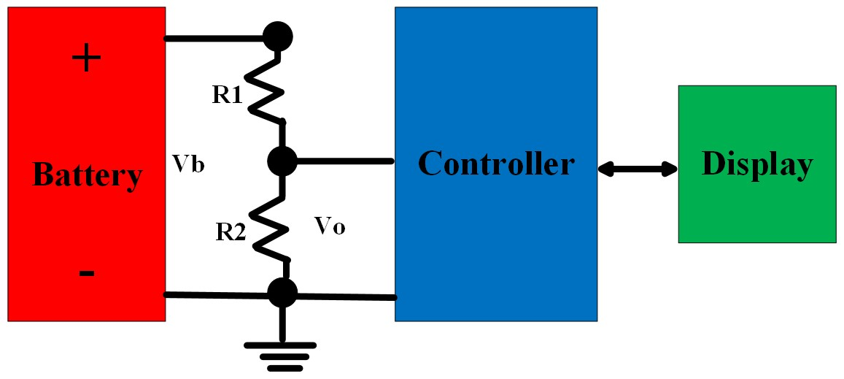
Figure 3: Battery voltage measurement and display setup using voltage divider
Below is an explanation of how voltage divider resistors are calculated.
$$V_{o}=\frac{V_{b}}{R_{1}+R_{2}}R_{2}$$
If $V_{b}=12V$ and $V_{o}=5V$, Assume $R_{1}=10kΩ$
$$\frac{V_{o}}{V_{b}}=\frac{R_{2}}{R_{1}+R_{2}}$$
$$\frac{5}{12}=\frac{R_{2}}{R_{1}+R_{2}}$$
$$R_{2}=7.14kΩ$$
Current through $R_{1}$ and $R_{2}$ can be calculated as
$$I=\frac{V_{b}}{R_{1}+R_{2}}=\frac{12}{17.14kΩ}=0.7mA$$
Wattage of $R_{1}$ and $R_{2}$ can be calculated as

$P_{R1}=I^{2}R_{1}=0.0049 Watts$ and $P_{R2}=I^{2}R_{2}=0.0034986 Watts$

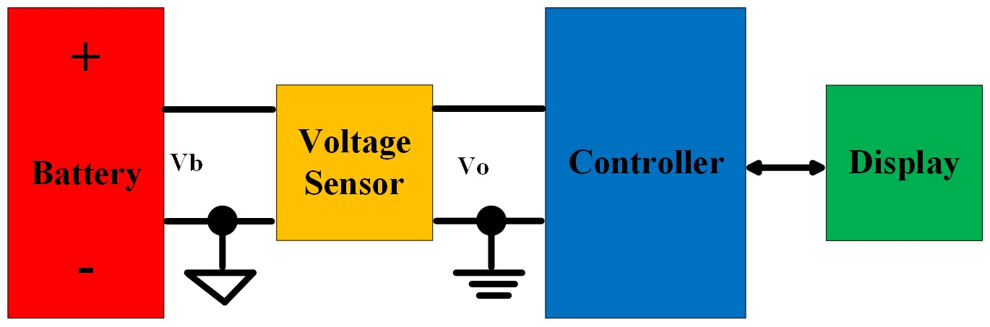
Figure 4: Battery voltage measurement and display setup using voltage sensor

3.2 Battery Current

A low-ohm resistor called a shunt can be used to gauge current. When the measured current exceeds the range of the measuring equipment, shunts are always used. The measurement instrument is next linked in parallel with the shunt. The entire current is directed through the shunt, producing a voltage drop that is measured. The current can then be calculated from this measurement using Ohm's law and the known resistance. Shunts need to have extremely low resistance values that are measured in milliohms in order to minimize power loss and, consequently, heat creation. The Battery current measurement and display setup using Shunt Resistor method is given in Figure 5.
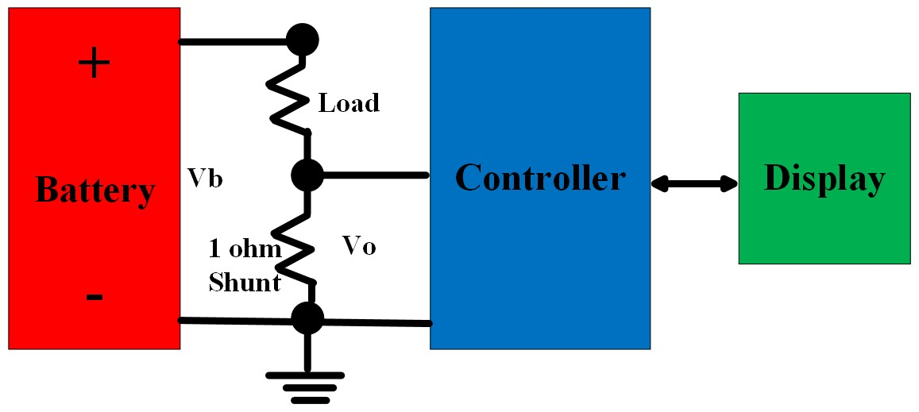
Figure 5: Battery current measurement and display setup using Shunt Resistor
A current sensor detects current and converts it into a measureably proportionate output voltage and flows across the path being monitored. Every type of sensor has a certain current range and set of environmental conditions that it is appropriate for. When using a current sensor to measure current, one of two methods is used: open loop or closed loop. The magnetic flux generated by the primary current is in a magnetic circuit and monitored by a hall device in an open loop current sensor. The hall device's output signal is conditioned to faithfully represent the primary current.
In a closed-loop sensor, an active coil produces a magnetic field produced by the current being monitored. When utilised as a null-detecting device, the hall sensor produces an output signal that is proportional to the current pushed into the coil proportional to the current being measured. Figure 6 shows the battery current measurement and display configuration utilising the current sensor technique.

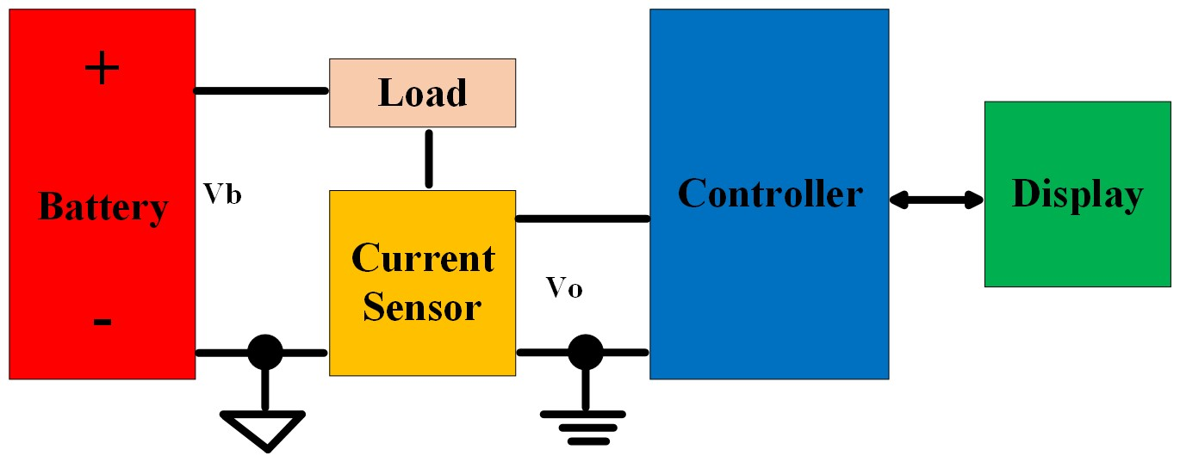
Figure 6: Battery current measurement and display setup using current sensor
3.3 Battery Temperature

A battery's main danger comes from rising temperatures. When the air around the battery warms up, it poses a concern in addition to when the battery itself experiences high internal temperatures. In light of this, it is crucial to keep an eye on the battery's temperature. The ambient temperature is converted to voltage by the temperature sensor. After reading the voltage from the temperature sensor, the microcontroller translates the voltage to degrees Celsius and displays the result on the display. The Battery temperature measurement and display setup using temperature sensor is given in Figure 7.
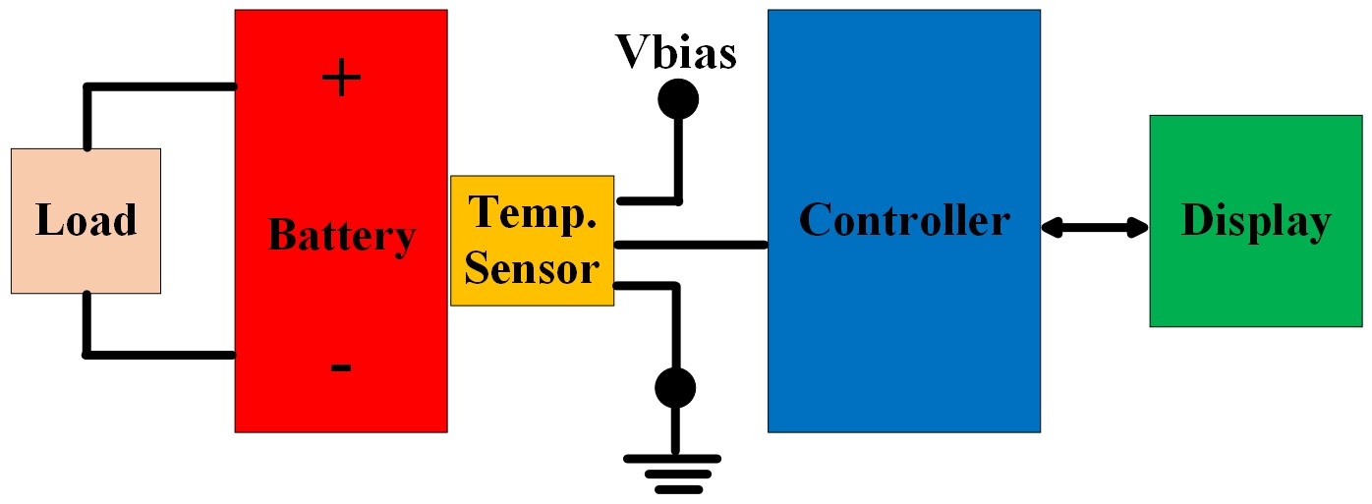
Figure 7: Battery temperature measurement and display setup using temperature sensor
3.4 State of Charge (SoC)
State of Charge, or SoC as it is commonly abbreviated, provides information on a battery's current condition and, more precisely, the amount of charge it has left. For all battery-operated systems and devices, it serves as the equivalent of a fuel gauge for the battery pack.
There are several methods for precisely identifying the SoC in a battery, including the voltage method, the Coulomb counting method, the Kalman filter method, the specific gravity method and the internal impedance measuring method. Even though SoC can be calculated using any of the aforementioned techniques, only the voltage and coulombs counting techniques are covered in detail in the next section.
Voltage method: This method is straightforward and produces findings that are generally correct. It essentially transforms a battery voltage reading to SoC and shows it to the user. Consider a Li-ion battery, which has a 3.6 V maximum voltage and a 3.3 V minimum voltage. In order to guarantee that the battery has its maximum practical capacity, it displays 100% SoC at 3.6V and 0% SoC at 3.3V.
Coulomb counting method: In this method current is measured during charge and discharge and integrated over usage period. The mathematical expression for SoC calculation by this method is given by the equation
$$SoC=SoC\left(t_{0}\right)+\frac{1}{C_{rated}}\int_{t_{0}}^{t_{0}+τ}{{(I}_{b}-I_{l}) dt}$$
Where $SoC\left(t_{0}\right)$ is initial SoC, $C_{rated}$ is the rated capacity, $I_{b}$is the battery current, $I_{l}$ is the current consumed by loss reaction. However, since losses while charging, discharging, and self-discharge are not taken into account in this manner, inaccuracies may accumulate. In order to overcome these problems, an enhanced coulomb counting method has been proposed for estimating the SoC. As a result, the SoC is described as the ratio of the battery's actual capacity ($C_{actual}$) to its manufacturer's stated rated capacity.
$$SoC=\frac{C_{actual}}{C_{rated}}X100 \%$$
3.5 Depth of Discharge (DoD)

The percentage of a battery that has been discharged compared to its total capacity is known as the depth of discharge (DoD) of the battery. DoD is the opposite of SoC; for example, if SoC is 100%, DoD is 0%, and vice versa if SoC is 0%, DoD is 100%. DoD can be estimated by using SoC as indicated in the equation
$$DoD=100-SoC$$
3.6 State of Health (SoH)

A State of Health (SoH) indicates where it stands in relation to a brand-new battery and the point in its life cycle at which it has arrived. The SoH is used to show how well a battery will operate under its current conditions or to show how much of its useful lifetime has already been used up and how much is still left before it needs to be replaced.
One of the best ways to assess SoH is to evaluate its impedance. By measuring impedance, you can learn more about the internal resistance and general health. An internal resistance, or impedance, typically increases with time, indicating cell degeneration. The SoH of a battery can also be measured using the equation
$$SoH=\left(1-\frac{C_{actual}}{C_{rated}}\right)X100 \%$$
3.7 Energy Delivered (Wh)

The energy delivered by the battery is often expressed in Watt-hours (Wh). A Watt-hour is equal to the battery's voltage output (V) times its maximum continuous current output (Amps), which is often measured in hours. Wh = Voltage * Amps * Hours.

3.8 Battery Internal Impedance

The internal resistance and reactance (L or C) of a battery are combined to form its impedance. The impedance of a battery can be measured by using Electrochemical Impedance Spectroscopy.

3.9 Battery Operating Time

Battery operating time (BoT) (charging or discharging) will be given in hours if the capacity is specified in amp-hours and the current is given in amps.
$$BoT=\frac{Capacity (Ah)}{Current (A)}$$
3.10 Life cycle of the Battery

The life cycle of the battery can be calculated using the formula:
$$Life (in cycles)=\frac{Capacity X100}{Discharge rate X Depth of discharge}$$

IV. CONCLUSIONS

The monitoring, protection and optimization of battery management system for electric vehicle applications is presented in this paper. Due to issues with battery life cycle, temperature, safety and cost, battery monitoring protection optimization and management are a crucial concern for EV adoption. Various battery management system techniques, features, needs, functions, parameters and comparisons are presented in this study. This study guarantees that EV adoption will be difficult unless present problems are fixed and better battery management systems are developed. The comprehensive discussion, analysis, and recommendations offered will be useful to EV manufacturers, engineers and researchers.

REFERENCES

- Lee, J.; Kim, J.-M.; Yi, J.; Won, C.-Y. Battery management system algorithm for energy storage systems considering battery efficiency. Electronics 2021, 10, 1859.
- Gabbar, H.A.; Othman, A.M.; Abdussami, M.R. Review of battery management systems (BMS) development and industrial standards. Technologies 2021, 9, 28.
- Cui, Z.;Wang, L.; Li, Q.;Wang, K. A comprehensive review on the state of charge estimation for lithium-ion battery based on neural network. Int. J. Energy Res. 2022, 46, 5423–5440.
- Ge, M.-F.; Liu, Y.; Jiang, X.; Liu, J. A review on state of health estimations and remaining useful life prognostics of lithium-ion batteries. Measurement 2021, 174, 109057.
- Zhou, W.; Zheng, Y.; Pan, Z.; Lu, Q. Review on the battery model and SOC estimation method. Processes 2021, 9, 1685.
- Mc Carthy, K.; Gullapalli, H.; Kennedy, T. Real-time internal temperature estimation of commercial Li-ion batteries using online impedance measurements. J. Power Sources 2022, 519, 230786.
- Uzair, M.; Abbas, G.; Hosain, S. Characteristics of Battery Management Systems of Electric Vehicles with Consideration of the Active and Passive Cell Balancing Process. World Electr. Veh. J. 2021, 12, 120.
- Lee, J.; Nam, O.; Cho, B. Li-ion battery SOC estimation method based on the reduced order extended Kalman filtering. J. Power Sources 2007, 174, 9–15.

