STUDIES ON PHYSICOCHEMICAL PARAMETERS AND USE OF NATURAL COAGULANTS FOR WASTEWATER TREATMENT IN INDUSTRIAL AREA OF MAHASAMUND DISTRICT, CHHATTISGARH (INDIA)
¹Anjali Patel*, ²Sonal Choubey
¹⁻²Shri Rawatpura Sarkar University Raipur (C.G.)
*Corresponding author. E-mail address: choudharyanjali18.ac@gmail.com (A.Patel)
ABSTRACT
Turbidity is an accomplished challenge in water treatment. Moringa oleifera and Dolichos lablab were applied as locally accessible congenital coagulants in this reverie to break the turbidity of artificial water. After dosing, water-accountable extracts of Moringa oleifera and Dolichos lablab busted turbidity to 6.1 and 11.8 NTU, singly, from 100 NTU and 5.2 and 9.3 NTU, after dosing and filtration. Among the natural coagulants applied in this trance for turbidity abatement, Moringa oleifera was set up most effectual. It degraded up to 94.8% turbidity of the raw, muddy water. Natural coagulants answered better with altitudinous, muddy, water analogized to average muddy, water. Applying locally accessible natural coagulants, capable, effortless, and terrain- close accessories for water treatment were obeyed.
Keywords: water quality, turbidity, natural coagulants, Moringa oleifera, Dolichos lablab.

1. INTRODUCTION
Although groundwater is a reliable source of fresh water, policymakers' most significant challenge is how to use it sustainably. Groundwater has been purified by soil and sand to remove any organic contaminants. Evaporation and irrigation return flow both have an impact on the major ion chemistry of groundwater. Due to human activity, the quality and quantity of groundwater are rapidly declining. The flow of groundwater and its storage in hard rock locations, as well as any resulting changes to its quality and quantity, are a major source of concern for the general public, researchers, and water management. The sustainability of groundwater resources over a long period is a significant problem. (Tamrakar et al., 2022) Water contamination is regarded as an important problem for humankind because it has contributed to numerous deaths and illnesses around the planet. Rapid industrialization, urbanization, and population increase in some Indian regions have made the issue harsher by increasing the amount of pollutants released into the environment. The physical, chemical, and biological properties of the dissolved or suspended constituents must fall below specific thresholds, which are regarded as the allowed limits, for water to be useful for a specific purpose. The water resources in numerous countries are in critical condition due to changes in their physicochemical nature. These changes cause damage to human beings, plants, and animals. Upon consumption, the poor quality of water may cause diseases or toxic health effects to human beings and livestock. To meet the country's municipal, agricultural, and industrial water needs, groundwater is essential. India is the country that uses the most groundwater globally, which is also a reality. Groundwater is frequently used directly for drinking purposes, particularly in developing nations, as it is typically assumed to be free of toxins due to its relatively lower exposure than surface water sources. However, several anthropogenic and natural factors have put the quality and quantity of groundwater in danger of declining. ​(Kumar Sahu & Jain, 2023) Surface water is more accessible in India than groundwater. However, due to groundwater's distributed availability, it is readily available and makes up the majority of India's agricultural and drinking water supplies. About 50% of the water is needed for residential purposes in cities and 85% of the water needed for domestic purposes in rural areas is supplied by groundwater. However, in recent years, groundwater contamination and harm have quickly become an issue in India. Groundwater contamination has been increased by the quick rise of industry, the use of agricultural pesticides, the disposal of urban and industrial waste, and the rapid increase in human population. The water quality index (WQI) approach is a technique for grading water quality and an effective tool to express water quality that provides a simple, accurate unit of measurement and delivers information on water quality to concerned people and policy-makers. (Kumar​​ Dewangan et al., 2022)​ The living ecology is severely harmed by the contaminated water, which results in genetic and functional alterations that affect the physical and chemical properties of living things. The general state of the water and whether it is fit for consumption is determined by water quality parameters. The dissolved oxygen, pH, alkalinity, salinity, electrolytes, total hardness, biological oxygen demand (BOD), chemical oxygen demand (COD), and other variables are combined to create the water quality index or WQI​.(Yadav et al., 2012)Groundwater pollution has occurred in many geological terrains with rapid industrialization, urbanization, population growth, agricultural development, excessive fertilizer use, significant evaporation, and little rainfall.(Hayek et al., 2020) Groundwater in depthless aquifers is commonly capable for application for disparate ambitions and is substantially of Calcium bicarbonate and hybrid breed. Still, different classes of water are correspondingly acquirable embracing Sodium Chloride water. Groundwater grade debilitation can exist caused in astronomically two customs ;( i) anthropogenic- those caused by manmade conditioning like diligence, local sewage and extravagance tips, mining,etc.( ii) geogenic. ​(Zafar et al., 2022) Organic matter, sediments, minerals, nutrients, disease-causing organisms, and other contaminants are reduced or removed from wastewater during the multi-stage process of wastewater treatment, which is used to restore the quality of the water. One stage of this treatment is coagulation-flocculation, which combines the suspended particles into a bigger mass (floc) that can be separated by filtration and sedimentation procedures. ​​(Villabona-Ortíz et al., 2023) Two independent steps that must be completed one after the other make up the coagulation-flocculation therapy. The first phase in this procedure, called coagulation, destabilizes colloidal suspensions and solutions with the main objective of removing stability-promoting elements. This procedure, which makes use of an appropriate chemical, uses the so-called coagulant. In the second subprocess, flocculation is the process of getting destabilized particles to group up, make contact, and eventually form enormous agglomerates.(Sinsinwar & Verma, 2023) It is not an original idea to utilize organic substances with a plant origin to clarify cloudy raw waterways. In tropical rural areas, natural coagulants have been employed for domestic usage in traditional water treatment for centuries. The natural coagulants found in Nirmali seed, maize mesquite bean, Cactus latifaria Cassia angustifolia seed, and other leguminous plants are described in some recent papers.However, the substance that has recently drawn the most attention is the seed of the Sudanese native Moringa oleifera. M. oleifera seed water extract beats aluminum salt in comparison.​(Vijayaraghavan et al., 2011)​

2. STUDY AREA
Mahasamund is Located in the central-east part of the Chhattisgarh State. It is situated between the Latitude 20º49'30": 21º33'07"N and Longitude 81º59'56":83º16'10" E. The district forms a part of the Mahanadi basin. The tributaries of the Mahanadi River drain the district. The Mahasamund district forms a part of the Chhattisgarh central plains. A major part of the district exhibits pediment / pediplain landforms. The other landforms are structural plains, structural hills, and valleys, denuded slopes, denuded hills and valleys, floodplains etc. The total population of the study area as per the 2011 Census is 10,32,754, out of which the rural population is 9,12,602 and the urban population is only 1,20,152. Mahasamund district is a backward aspirational district. It is an important district for minor minerals. These minerals are Quartz, Quartzite, Granite, Limestone, Flagstone, Sand, Soil, and Laterite. There are 1178 localities in total. These towns are divided into 5 different community development blocks for administrative convenience. The district's overall geographic area is almost 43% covered by forest. The Mahanadi basin includes the district. The general slope on the eastern half of the region has been towards the southeast, the center portion of the territory is towards the north, and the western section is towards a northwestern direction. Along the Mahanadi River is the district's western border. The Jonk River passes through the center section of the district and runs in the northern direction.

3. METHODOLOGY

3.1 Sample Collection Area
The samples were collected from the industrial area Birkoni (stone cutting industries) Mahasamund, Chhattisgarh (India).

3.2 Coagulation
The best immediate solution is to start using point-of-use (POU) technologies like coagulation because these rural or poor populations have sufficient water treatment infrastructure. Surface water and industrial wastewater treatment both need the use of coagulation. Utilizing alum (AlCl₃), ferric chloride (FeCl₃), and poly aluminum chloride (PAC) as conventional chemical-based coagulants, it is used to remove dissolved chemical species and turbidity from water. Even though the efficiency of these chemicals as coagulants is widely acknowledged, there are drawbacks associated with their use, such as their inefficiency in low-temperature water, their relatively high cost of purchase, their negative effects on human health, the production of large volumes of sludge, and the fact that they have a significant impact on the pH of treated water. Additionally, there is compelling evidence connecting aluminum-based coagulants to the emergence of Alzheimer's disease in people. To address the problems mentioned above, it’s preferable to switch out these artificial coagulants for plant-based ones. (Vijayaraghavan et al., 2011)​

3.3 Natural Plant-Based Coagulants and Coagulation Mechanisms
The direct assets of using naturally being factory- grounded coagulants as POU water treatment accoutrements are evident; they're economizing, improbable to produce acted water with an farthest pH, and largely biodegradable. These assets are especially amended if the factory from which the coagulant is deduced is aboriginal to a pastoral area. Environmental scientists hold so far been competent to identify several factory breeds for this use. Factory- grounded coagulants have been used for acting cloudy water for further than a many centuries. (Vijayaraghavan et al., 2011) They could be produced using the seeds, leaves, and roots of shops. These naturally being organic polymers are interesting because they pose no threat to mortal health in comparison to artificial organic polymers made with acrylamide monomers, and they're also less precious than conventional chemicals because they're readily available in the maturity of pastoral Mahasammund neighborhoods. There are several effective coagulants with botanical origins Nirmali, Okra, rosy bean, sugar and red sludge, Moringa oleifera, Cactus latifera, and seed greasepaint of Prosopis juliflora. Natural coagulants have a bright futurity and are accounted by multifold experimenters because of their abundant source, low price, terrain- familiar, multifunction, and biodegradable character in water cleansing. ​(Asrafuzzaman et al., 2011).

Moringa oleifera
M. oleifera (horseradish or forelimb tree) is an equatorial manufactory that's nontoxic (at low attention) and can be set up in India, Asia, sub-Saharan Africa, and Latin America. Its seeds bear an eatable oil painting and a water- explainable material, and it's really the most delved natural coagulant in the field of environmental wisdom. It's well known for having a variety of uses, and virtually every element of its factory system can be put to good use. In lower developed societies, moringa is most generally used as a food and drug source. The phenomenon tree, Moringa oleifera, is a equatorial multi-use tree that's also understood as the phenomenon seedbed. Among its multiple different rates, M. oleifera seeds contain a coagulant protein that can be used in either wastewater treatment or drinking water explanation. It's spoke to be one of the most effectual natural coagulants, and exploration into these classes of water treatment agencies is amplifying at the occasion.

Dolichos lablab
Dolichos lablab commonly known as lablab bean, hyacinth bean, or dolichos bean, is a leguminous plant that has been traditionally used for various medicinal purposes in different parts of the world. The plant contains certain compounds, such as phenolic compounds and flavonoids, which have antioxidant potential. Antioxidants help neutralize free radicals in the body and may play a role in protecting cells from oxidative stress. Some research suggests that dolichos lablab extracts may possess antimicrobial properties, which could potentially help combat certain types of bacteria and fungi.
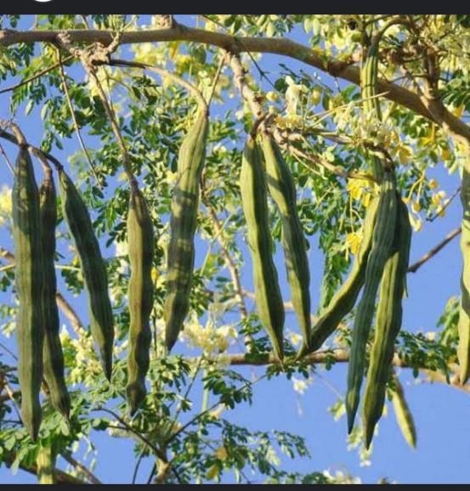
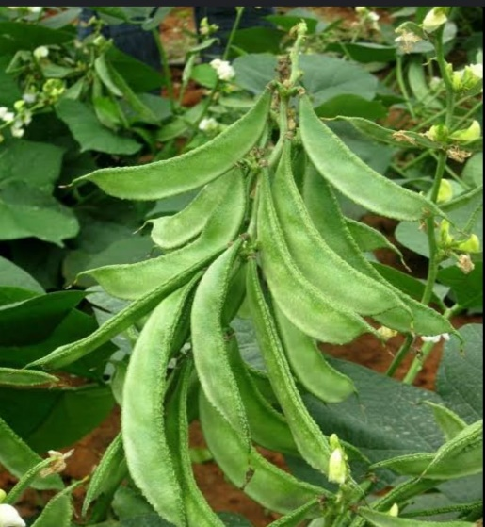

Fig. 1 Moringa oleifera Fig. 2 Dolichos lablab

3.4 Jar Test
By dissolving 0.30 g of clay in deionized water and mixing this solution for an hour at 200 rpm, synthetic turbid water was created. The solution was then allowed to hydrate for 21 hours. Each solution was then diluted in 1.90 dm3 and combined, producing water that was 32.30 NTU turbid. A jar test apparatus was utilized for the coagulation-flocculation tests, in which the prepared turbid water solution was brought into contact with the natural coagulant. ​​(Villabona-Ortíz et al., 2023) ​(Www et al., 2012)

3.5 Stock Solution of Natural Coagulants
Moringa oleifera seed capsules are permitted to progress and dry intrinsically to a brown shade on the tree. The seeds were peeled from the capsules, and kept for sundry, and accidental capsules were peeled. Full-blown seeds displaying no signs of abrasion, debilitating, or farthermost desiccation were applied. The seedbed kernels were base to a fine greasepaint applying a kitchen blender to make it of the comparative size of 600 µm to score solubilization of operating constituents in the seed. Adult seeds of Dolichos lablab were operated in the study. After sunlight- drying, accidental capsules were doffed and seedbed kernels were attained. Using a grinder, dusty greasepaint is attained from the seed kernel. To make a 1% suspense of the greasepaint, distilled water was added. To encourage water birth of the coagulant proteins, the suspense was fleetly agitated for 45 twinkles using a glamorous stirrer. This result was also run through sludge paper (Whatman no. 42, 125 mm dia.). The filtrate fragments were employed to administer the necessary cure of coagulants from nature. To offset the goods of aging, fresh results were produced each day and stored in the refrigerator. Before operation, results were roundly shaken.

3.6 Jar Test Operation
The most popular experimental technique for coagulation-flocculation is the jar test. The studies involved employing certain coagulants to coagulate a sample of synthetic turbid water in a typical jar test equipment. It was conducted as a batch test using several six-beakers and six-spindle steel paddles. The sample was evenly mixed before running the jar test. The samples should then have their turbidity assessed to represent an initial concentration. In the beakers, coagulants in a range of concentrations were applied. The entire jar test method was carried out at various speeds of rotation. The suspensions were allowed to settle for 20–60 minutes after the agitation was stopped. Finally, a sample from the middle of the precipitate was taken using a pipette for physicochemical analyses that indicate the final concentration. All tests were conducted for three different turbidity ranges: higher (90-120 NTU), medium (40-50 NTU), and lower (25-35 NTU) NTU, at an ambient temperature of between 26 and 32 C. ​(Asrafuzzaman et al., 2011).
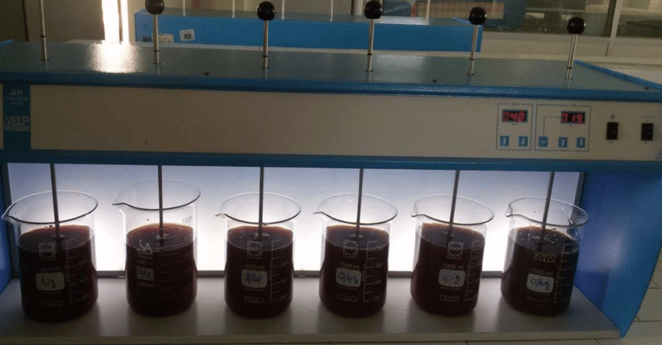Figure 3: A conventional jar test apparatus for the treatment of turbid water by natural coagulants.

4. Results and Discussion
4.1 Reduction of Turbidity Using Natural Coagulants
The jar test operations exercising dissimilar coagulants were packed out in dissimilar turbidity ranges videlicet developed-( 90 – 120) NTU, average-( 40 – 50) NTU, and junior-( 25 – 35) NTU of man-made muddy water. The effectiveness of the excerpts of Moringa oleifera and Dolichos lablab formed them employed as congenital coagulants for the explanation of water. Pharmaceuticals startled from 50 mg/ L to 100 mg/ L for writing six teacups. Turbidity existed scaled ahead and after treatment. Numbers 3 – 5 exhibit the aftereffects of distinguishable boluses of coagulant treatment in jar experiment. From Figure 3, it’s set up that the raw water turbidity was 100 NTU. Turbidity degraded to12.3, 11.6, 10.5, 9.2, 7.6 and 6.1 NTU writing to 50, 60, 70, 80, 90, and 100 mg/ L Moringa oleifera boluses independently. After filtration, turbidity demoted to 10.4, 9.5, 8.2, 7.6, 6.8, and 5.2 NTU, independently. For middle- turbidity water (turbidity 48 NTU), the even boluses break turbidity to 14.5, 13.9, 12.5, 12.1, 11.8, and 11 NTU, independently, after dosing. And, after filtration, it existed 12.3, 11.8, 11.3, 10.4, 9.7, and 9.1 NTU, independently. Moringa oleifera works effortlessly in improved- turbidity water than in mean- turbidity water. Turbidity deduction increases with adding boluses. Aftereffects for the junking of turbidity using colorful boluses of Dolichos lablab are displayed in Figure 5. Dissimilar boluses were exercised for disparate turbidity pastures, and turbidity existed scaled after dosing. From Figure 5, it’s set up that the raw water turbidity existed 100 NTU. Turbidity reduced to 16.3, 15.9, 14.8, 13.2, 12.3, and 11.8 NTU writing to 50, 60, 70, 80, 90, and 100 mg/ L Dolichos lablab boluses. After filtration, turbidity degraded to 14.4, 13.8, 12.7, 11.6, 10.2, and 9.3 NTU, independently. For middle- turbidity water (turbidity 49 NTU), the equal capsules degrade turbidity to 18.2, 17.7, 17.3, 16.4, 15.8, and 15.3 NTU, independently after, dosing. After filtration, it was 15.5, 14.9, 14.1, 13.9, 13.2, and 13 NTU, independently. Dolichos lablab works well in developed- turbidity water than in middle- turbidity water. Turbidity abatement increases with adding boluses. Accordingly the use of locally obtainable accoutrements like sap provides a better accessory for antiseptic, all right water affordable to rustic people.

Table 1: Reduction efficiency of turbidity using different coagulants in different turbidity ranges.
Coagulants | Dose used (mg/L) | % of turbidity reduction (High-∗turbidity water) | % of turbidity reduction(Medium-∗turbidity water)
Moringa oleifera | 50  60  70  80  90  100 | 87.7  88.4  89.5  90.8  92.4  93.9 | 69.7  71  73.9  74.7  75.4  77
Dolichos  lablab | 50  60  70  80  90  100 | 83.7  84.1  85.2  86.8  87.7  88.2 | 62.8  63.8  64.6  66.5  67.7  68.7
∗For Moringa oleifera (high turbidity = 100 NTU, medium turbidity = 48 NTU); Dolichos lablab (high turbidity = 100 NTU, medium turbidity = 49 NTU).

- Raw water turbidity (NTU)
- Turbidity after filtration (NTU)
- Turbidity after dosing (NTU)
Fig.3: Removal of turbidity using various doses of Moringa oleifera and Dolichos lablab (for highly turbid water).
Table 2: Reduction efficiency of turbidity using different coagulants in different turbidity ranges. (After filtration)
Coagulants | Dose used (mg/L) | % of turbidity reduction (High-∗turbidity water) | % of turbidity reduction(Medium-∗turbidity water)
Moringa oleifera | 50  60  70  80  90  100 | 89.6  90.5  91.8  92.4  93.2  94.8 | 74.3  75.4  76.4  78.3  79.7  81
Dolichos  lablab | 50  60  70  80  90  100 | 85.6  86.2  87.3  88.4  89.8  90.7 | 68.3  69.5  71.2  71.6  73  73.4
∗For Moringa oleifera (high turbidity = 100 NTU, medium turbidity = 48 NTU); Dolichos lablab (high turbidity = 100 NTU, medium turbidity = 49 NTU).

- Raw water turbidity (NTU)
- Turbidity after filtration (NTU)
- Turbidity after dosing (NTU)
Fig.4: Removal of turbidity using various doses of Moringa oleifera and Dolichos lablab (for medium turbid water).
4.2 Turbidity reduction efficiency of different coagulants in different turbidity ranges: A relative trance of turbidity deduction effectiveness of dissimilar coagulants in dissimilar turbidity ranges is carried in Table 1. And Table 2. In every case 50 to 100 mg/ L boluses were applied. It existed set up that Moringa oleifera degraded consummate turbidity among all coagulants applied. It broke up to 93.9% for largely muddy water and 94.8% after filtration accordingly, it existed set up most effective among the boned congenital coagulants. In medium turbidity water, it was reduced up to 77% and 81% after filtration. In the case of Dolichos lablab, it was found that 88.2% and after filtration found that 90.7% reduced for high turbidity water. For medium turbidity water, it reduced up to 68.7%, and after filtration 73.4% reduced. All of the studied natural coagulants were efficient in higher-turbidity ranges than in medium-turbidity waters.
5. Conclusion
Applying some locally accessible congenital coagulants, for illustration, Moringa oleifera and Dolichos lablab, expressive enhancement in dousing turbidity from man-made raw water existed set up. Most turbidity deduction existed set up for largely muddy waters. After dosing, water- explainable excerpt of Moringa oleifera and Dolichos lablab busted turbidity to 6.1 and 11.8 NTU, independently, from 100 NTU and 5.2 and 9.3 NTU, independently after dosing and filtration. Among the congenital coagulants employed in this trance for turbidity deduction, Moringa oleifera existed set up most effectual. It degraded up to 94.8% turbidity from the raw muddy water. Congenital coagulants command a encouraging futurity and are of significance to multiple experimenters due to their broad vacuity, equatorial cost, ecologically close inflexibility, and biodegradability in the sanctification of water. Their efficiency in treating wastewater, aquatic plants, and seed materials is gaining attention. The technologies involved are affordable, conventional, simple to use, and excellent for rural locations. Due to the biological nature of the process, no untreatable wastes are produced. These procedures require little to no maintenance and are simple to use.

6. References

- Ahmed, S. I., Sonkar, A. K., Kishore, N., & Jhariya, D. (2022). Evaluation of groundwater quality in Jampali coal mine, Raigarh, Chhattisgarh, India. Environmental Quality Management, 31(3), 9–17. https://doi.org/10.1002/tqem.21767
- Asrafuzzaman, Md., Fakhruddin, A. N. M., & Hossain, Md. A. (2011). Reduction of Turbidity of Water Using Locally Available Natural Coagulants. ISRN Microbiology, 2011, 1–6. https://doi.org/10.5402/2011/632189 ​
- Cruz, D., Pimentel, M., Russo, A., & Cabral, W. (2020). Charge neutralization mechanism efficiency in the water with a high color turbidity ratio using aluminum sulfate and flocculation index. Water (Switzerland), 12(2). https://doi.org/10.3390/w12020572
- ​Gupta, N., Pandey, P., & Hussain, J. (2017). Effect of physicochemical and biological parameters on the quality of river water of Narmada, Madhya Pradesh, India. Water Science, 31(1), 11–23. https://doi.org/10.1016/j.wsj.2017.03.002
- ​Hayek, A., Tabaja, N., Andaloussi, S. A., Toufaily, J., Garnie-Zarli, E., Toufaili, A. El, & Hamieh, T. (2020). Evaluation of the Physico-Chemical Properties of the Waters on the Litani River Station Quaraoun. American Journal of Analytical Chemistry, 11(02), 90–103. https://doi.org/10.4236/ajac.2020.112007
- ​Isaac, R., & Siddiqui, S. (2022). Application of water quality index and multivariate statistical techniques for assessment of water quality around Yamuna River in Agra Region, Uttar Pradesh, India. Water Supply, 22(3), 3399–3418. https://doi.org/10.2166/WS.2021.395
- ​Kanase, D., Shaikh, S., & Jagadale, P. (2016). Physico-Chemical Analysis of Drinking Water Samples of Different Places in Kadegaon Tahsil, Maharashtra (India). Pelagia Research Library Advances in Applied Science Research, 7(6), 41–44. www.pelagiaresearchlibrary.com
- ​Kumar Dewangan, S., Minj, N., & Nayak, N. (2022). International Journal of Research Publication and Reviews Physico-Chemical Analysis of Water taken from Well Located in Morbhanj Village, Surajpur District of Chhattisgarh, India. In International Journal of Research Publication and Reviews (Vol. 3). http://www.elmhurst.edu/~chm/vchembook/184ph.htm
- ​Kumar Sahu, Y., & Jain, M. (n.d.). Study of Seasonal Physiochemical Parameters and Quality Assessment of Lake Water in Raipur City, Chhattisgarh. http://ymerdigital.com
- ​Ladokun, O. A., & Oni, S. O. (2015). Physico-Chemical and Microbiological Analysis of Potable Water in Jericho and Molete Areas of Ibadan Metropolis. Advances in Biological Chemistry, 05(04), 197–202. https://doi.org/10.4236/abc.2015.54016
- ​Lukubye, B., & Andama, M. (2017). Physico-Chemical Quality of Selected Drinking Water Sources in Mbarara Municipality, Uganda. Journal of Water Resource and Protection, 09(07), 707–722. https://doi.org/10.4236/jwarp.2017.97047
- Othmani, B., Rasteiro, M.G. & Khadhraoui, M. Toward green technology: a review on some efficient model plant-based coagulants/flocculants for freshwater and wastewater remediation. Clean Techn Environ Policy 22, 1025–1040 (2020). https://doi.org/10.1007/s10098-020-01858-3

- ​Patil, V. T., & Patil, P. R. (n.d.). Physicochemical Analysis of Selected Groundwater Samples of Amalner Town in Jalgaon District, Maharashtra, India (Vol. 7, Issue 1). http://www.e
- ​Prasad, N. R., & Patil, J. M. (2008). A study of physico-chemical parameters of krishna river water particularly in western maharashtra. In RJC Rasayan J. Chem (Vol. 1, Issue 4).
- Rahmanian, N., Ali, S. H. B., Homayoonfard, M., Ali, N. J., Rehan, M., Sadef, Y., & Nizami, A. S. (2015). Analysis of physiochemical parameters to evaluate the drinking water quality in the state of perak, Malaysia. Journal of Chemistry, 2015. https://doi.org/10.1155/2015/716125
- ​Roy, R. (2018). An Introduction to water quality analysis. ESSENCE – International Journal for Environmental Rehabilitation and Conservation, 94–100. https://doi.org/10.31786/09756272.18.9.2.214
- ​Saleem, M., Hussain, A., & Mahmood, G. (2016). Analysis of groundwater quality using water quality index: A case study of greater Noida (Region), Uttar Pradesh (U.P), India. Cogent Engineering, 3(1). https://doi.org/10.1080/23311916.2016.1237927
- ​Sarita, S., & Brahmaji Rao, P. (2020). Water Quality Index for the Groundwater Analysis in Pedana Mandal, Krishna District, Andhra Pradesh, India. Applied Ecology and Environmental Sciences, 8(6), 336–339. https://doi.org/10.12691/aees-8-6-2
- ​Shukla, D. (2013). “Physicochemical Analysis of Water from Various Sources and Their Comparative Studies.” IOSR Journal Of Environmental Science, Toxicology And Food Technology, 5(3), 89–92. https://doi.org/10.9790/2402-0538992
- ​Shyamala, R., Shanthi, M., & Lalitha, P. (2008). Physicochemical Analysis of Borewell Water Samples of Telungupalayam Area in Coimbatore District, Tamilnadu, India (Vol. 5, Issue 4). http://www.e
- Sinsinwar, R. S., & Verma, M. (2023). Turbidity Reduction and Eco-friendly Sludge Disposal in Water Treatment Plants. Nature Environment and Pollution Technology, 22(1), 277–283. https://doi.org/10.46488/NEPT.2023.V22I01.027
- ​Smitha, Ajay D, & Shivashankar P. (2013). International Science Congress Association 59 Physico Chemical Analysis of the Freshwater at River Kapila. In India International Research Journal of Environment Sciences (Vol. 2, Issue 8). https://www.researchgate.net/publication/304169686
- ​Smitha, P. G., Byrappa, K., Ramaswamy, S. N., & Com, B. (2007). Physico-chemical characteristics of water samples of Bantwal Taluk, south-western Karnataka, India. In Journal of Environmental Biology.
- ​Tamrakar, A., Upadhyay, K., & Bajpai, S. (2022). Spatial variation of Physico-chemical parameters and water quality assessment of urban ponds at Raipur, Chhattisgarh, India. IOP Conference Series: Earth and Environmental Science, 1032(1). https://doi.org/10.1088/1755-1315/1032/1/012034
- Verma, P., Singh, P. K., Sinha, R. R., & Tiwari, A. K. (2020). Assessment of groundwater quality status by using water quality index (WQI) and geographic information system (GIS) approaches: a case study of the Bokaro district, India. Applied Water Science, 10(1). https://doi.org/10.1007/s13201-019-1088-4
- ​Vijayaraghavan, G., Sivakumar, T., & Kumar, A. V. (2011). Application of plant based coagulants for wastewater treatment. In International Journal of Advanced Engineering Research and Studies E-ISSN2249-8974 IJAERS.
- ​Villabona-Ortíz, A., Tejada-Tovar, C., Ortega-Toro, R., Dager, N. L., & Anibal, M. M. (2023). Natural coagulation as an alternative to raw water treatment. Journal of Water and Land Development, 56, 21–26. https://doi.org/10.24425/jwld.2023.143740
- ​Www, W. :, Choubey, S., Rajput, S. K., & Bapat, K. N. (2012). International Journal of Emerging Technology and Advanced Engineering Comparison of Efficiency of some Natural Coagulants-Bioremediation (Vol. 2, Issue 10). www.ijetae.com
- ​Yadav, K. K., Kumar, V., Arya, S., Gupta, N., & Singh, D. (2012). Physicochemical analysis of selected groundwater samples of Agra city, India Desciptions about sciencitific terms used in environmental sciences View project Pollution load in river Yamuna View project Physico-chemical analysis of selected ground water samples of Agra city, India. 4(11), 51–54. http://recent-science.com/
- ​Zafar, M. M., Sulaiman, M. A., Prabhakar, R., & Kumari, A. (2022). Evaluation of the suitability of groundwater for irrigational purposes using irrigation water quality indices and geographical information systems (GIS) at Patna (Bihar), India. International Journal of Energy and Water Resources. https://doi.org/10.1007/s42108-022-00193-1
​

