TECHNIQUES OF BLOOD CONSERVATION IN CARDIAC SURGERIES ASSOCIATED WITH CARDIOPULMONARY BYPASS

Mr. Raghul R
Department of Perfusion Technology
School of Allied Health Sciences, Vinayaka Mission’s Research Foundation - DU
Salem, India
E-mail: raghulsmart39@gmail.com

ABSTRACT
This book chapter presents a complete evaluation of blood conservation strategies, exploring the modern-day advancements and their implementation in contemporary healthcare settings. With rising worries over blood shortages, escalating healthcare expenses, and the potential dangers associated with transfusions, the need for powerful blood conservation techniques has become more and more crucial. The chapter delves into diverse blood conservation strategies in intra-operative period encompassing pharmacological agents, miniaturized circuits and patient blood management programmes. It sheds light at the present-day evidence-based practices which have validated to minimize blood loss, optimize red mobile mass, and enhance patient results at the same time as ensuring the utmost protection. Moreover, the chapter discusses the role of revolutionary technology, together with Autologous blood salvage systems and factor-of-care diagnostics, in allowing healthcare experts to preserve blood and reduce the reliance on allogenic transfusions. These cutting-edge tools have shown great promise in improving patient care and reducing the burden on blood banks. Strategies for overcoming limitations and promoting considerable adoption of those practices are also discussed. In conclusion, this book chapter provides readers with a comprehensive understanding of blood conservation techniques and their potential to transform modern healthcare delivery.
KEYWORDS; Blood Conservation Techniques, Cardiac Surgery, Autologous Blood Priming, Retrograde Autologous Blood Priming, Cell Saver, Hemoconcentrator, Reduced blood transfusion.

- INTRODUCTION

An increase in the need for blood supplies was accompanied by an increase in the number of surgeries needing cardiopulmonary bypass..[1]About 60,000 coronary bypass surgeries are done annually in India.[2]In maximum of the elective cardiac surgeries, if the patient begins with a regular hematocrit, there may be no need for blood transfusion, providing the blood loss is less than 1 Litre, and it is replaced with intravenous fluids. However, approximately two thirds of all blood transfusions are given in the perioperative period, and a full-size portion of this blood is transfused in the course of cardiac operations. Blood Loss during cardiac surgery is an inevitable cause but we have to find more ways to minimize the blood loss during CPB. To overcome the blood loss and to satisfy the basic needs of our body during CPB, Blood transfusion to be done.[3] However transfusions of blood product may result in life threatening complications. The danger of the use of the banked blood has been identified and there may be a developing way to locate new methods to conserve blood.[4] Manufacturer’s contributions like decrease prime oxygenators, circuits and different equipments are fast turning into the day-to-day practices.This chapter describes the numerous blood conservation techniques available to reduce homologous blood product transfusion in cardiac surgery patients.

- BLOOD CONSERVATION AS PERFUSION ASPECTS

The first and foremost thing that a perfusionist ought to worry about the blood conservation is to lessen the priming volume used in the circuit. In patients like Jehovah’s Witness, they usually refuse blood transfusions and as a perfusionist we have to manage the blood loss that has been occurring throughout the CPB. Much of the reduced blood usage has come from the perfusionists growing way to get rid of all blood from the perfusion circuit at the end of the case. Usage of cell saver, Hemoconcentrator and other Auto-transfusion devices during CPB has been a big concern in the perspective on perfusionist to conserve the blood.
- MINIATUARIZED CPB CIRCUITS

Minimized extracorporeal flow is intended to lessen the terrible outcomes related to cardiopulmonary bypass (CPB). Haemodilution is a widely analyzed and reported consequence of CPB. Excessive haemodilution is identified as the main motivation behind the impairment of hemostasis. It leads to reduced levels of coagulation and fibrinolytic proteins at some stage in CPB. It has additionally been identified as a important contributor to organ dysfunction at some stage in CPB and will increase the hazard of long-term morbidity and quick-term mortality. A minimized extracorporeal circuit (MECC) refers to a layout technique that goals to lessen the size of the components and tubing used within the cardiopulmonary bypass circuit.[5] The intention is to reduce the contact between the patient blood and the artificial surfaces of the circuit, which can assist lessen the hazard of complications such as clotting, infection, and other negative reactions. MECC systems normally involve using smaller tubing, decreasing the volume of the circuit, and employing numerous strategies to reduce the surface area exposed to blood.[6]
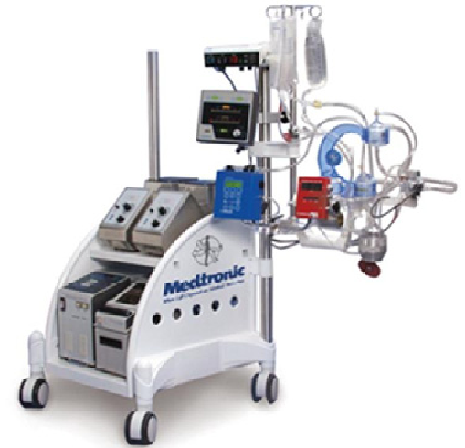

Figure 1 : Miniaturized CPB (ECC) Circuits
This can cause reduced blood-cell trauma, reduced need for anticoagulation (blood-thinning), and potentially progressed patient consequences for the duration of and after surgical operation. The mini-cardiopulmonary bypass (MCPB) system has thecapacity to replaces the use of Cardiotomy suction with a cell - saver device, has a biocompatible coating for itscircuits, and makes use of a centrifugal pump.[7] There is no of need for blood products and their transfusions, thus maintaining a good hematocrit levels when minimized cardiopulmonary bypass is used.

Where the MECC to be Utilized;

Although the selection criteria for MECC surgery in place of CCPB usually fluctuates widely from centre to centre, excessive-hazard victims have a tendency to be excluded from MECC, as it is principally done in Elective CABG cases. Aortic valve replacement via MECC has also been reported [8]; MECC has also been used in isolated cases of CABG with AVR, Atrial Septal defect closure, mitral procedures and Thoracoabdominal aortic aneurysm repair.

- PRE-OPERATIVE BLOOD CONSERVATION

To preserve the blood in pre operative period the patient tends to donate his/her blood before a week of surgery for a number of occasions until the required number units has been taken from an individual. Thus, it helps to patient to avoid homologous blood transfusions. The first and foremost aim of blood conservation strategies is to avoid the blood transfusions during cardiac surgeries. Thus, the blood is screened and stored for reinfusion based on the demand of the patient crisis.
- AUTOLOGOUS BLOOD PRIMING

Autologous blood priming is defined as the technique in which the patient own blood is used to prime the circuit instead of priming with the priming solutions. It is usually of two types of autologous priming. They are
- Antegrade Autologous Priming
- Retrograde Autologous Priming

- ANTEGRADE AUTOLOGOUS PRIMING

Antegrade autologous priming (AAP) is a technique used in cardiopulmonary bypass (CPB) procedures during open-heart surgery. Antegrade autologous priming is a technique designed to reduce the dilution effect. Instead of employing a mixture of fluids and blood products, AAP primes the heart-lung machine's circuit with the patient's own blood. The heart-lung machine's circuit is primed for use by displacing the air with the patient's blood, which is typically drawn from a peripheral vein.

Antegrade Autologous priming (AAP) has the following advantages:

Utilizing the patient's own blood for priming reduces the requirement for donor blood products, such as packed red blood cells, which can be especially helpful in lowering the risk of problems connected to transfusions. Utilizing the patient's own blood reduces haemodilution, or the dilution of the patient's blood. Maintaining proper amounts of clotting factors in the blood can help the blood coagulate more effectively both during and after the procedure, lowering the risk of problems related to excessive bleeding.
- RETROGRADE AUTOLOGOUS PRIMING
Retrograde Autologous priming is a blood conservation technique used in cardiopulmonary bypass during open heart surgeries in which it helps to prime the circuit by patient own blood by displacing the circuit priming volume in to the waste bag. The blood is drawn retrograde from the patient aorta through the aortic cannula and displaces the priming volume from the tubing’s used in the circuit. There are three steps involved in retrograde autologous priming. [9]

- Drains the priming fluids from Arterial Line.
- Drains the priming fluids from the venous reservoir and also from the Oxygenator.
- Drains the priming fluids in the venous line before introduced into the venous reservoir.
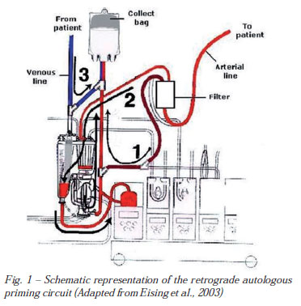

Figure 2: Retrograde Autologous Blood Priming

- INTRA-OPERATIVE BLOOD CONSERVATION TECHNIQUES

- HEMOCONCENTRATOR

Hemoconcentrators are the primary means of blood preservation throughout the intra - operative phase of cardiopulmonary bypass. Hemoconcentrator is a medical device in which it helps to manage the blood volume and also concentrate the blood components due to excessive haemodilution. Hemoconcentrators are blood filters that primarily consist of a hollow fibre membrane that is semi permeable, allowing water and electrolytes from the blood to flow through to a filtrate chamber and then into the waste bag. During extracorporeal circulation, hemoconcentrators are used to remove extra fluid and electrolytes (such as excessive potassium levels), eliminate inflammatory mediators produced, and increase hematocrit. Water, electrolytes, heparin, and numerous inflammatory mediators are just a few examples of the molecules that the Hemoconcentrators blood filter removes. The size of the molecules that are removed depends on the pore size of the hemoconcentrators membrane. However, because the mass of the plasma protein molecules is greater than 65 000 Daltons, hemoconcentrators filters are unable to extract plasma proteins and blood coagulation factors. (Albumin, ATIII, Immunoglobulin’s, Etc.)[10]
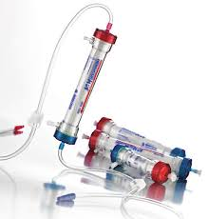

Figure 3: Hemoconcentrator
ADVANTAGES OF HEMOCONCENTRATOR
Hemoconcentration aids in the preservation of vital plasma constituents including clotting factors as well as blood components like red blood cells and platelets. [11] This is particularly beneficial in lowering coagulation issues and bleeding challenges both before and after surgery. An elevated hematocrit is the outcome of hemoconcentration, which increases the proportion of red blood cells in the blood. This increased red blood cell content improves the blood's ability to carry oxygen, boosting tissue oxygenation and minimizing the risk of oxygen shortage.

- PHARMACOLOGICAL APPROACHES TO BLOOD TRANSFUSION
WITHDRAWAL OF ORAL ANTICOAGULANTS
Anticoagulant of one form or another form is almost same for the patient who undergoes each and every cardiac surgery and a withdrawal therapy is often appropriate.[12] A hazard analysis is vital in all patients earlier than preventing certain drugs earlier than surgical operation, but the beneﬁts of decreased bleeding and the decreased exposure to allogenic blood within the perioperative length often outweigh the risks of brief-time period cessation of anticoagulation.
HEPARIN
Heparin is a compound of highly sulphated polysaccharide located in mast cells, and has the highest negative charge density. The biological molecule which is strongly acidic, and is widely used as an injectable anticoagulant.Heparin was used in cardiopulmonary bypass as an anticoagulant, it is rapid, and can be rapidly neutralized by protamine. Inhibition of micro vascular coagulation is important to prevent clotting and decrease the inflammatory response for cardiopulmonary Bypass. The mechanism of heparin action is to prevent thrombin formation. Inadequate dosing of heparin leads to thrombosis, intravascular clotting, oxygenator dysfunction and consumption of clotting factors.
ASPIRIN
Aspirin remedy is used in many patients presenting for coronary artery pass grafting (CABG) as it has been proven to lessen the occurrence of myocardial infarction.[13] The disadvantage of persevering with aspirin remedy until the day of operation is that there may be an expanded danger of blood loss and blood transfusion.
TICLOPIDINE, CLOPIDOGREL
Ticlopidine, clopidogrel and different platelet receptor antagonists, frequently used when coronary artery stents are located, will also growth the threat of bleeding and ought to be stopped pre-operatively if feasible.
APROTININ
There is a basic polypeptide isolated from the bovine lung. It’s a broad-spectrum serine protease inhibitor that can be used to treat a wide range of diseases.Evidence is starting to show that aprotinin may have a protective effect on the platelets. The broad spectrum of activity distinguishes it from the analogues. The efficacy of aprotinin in patients who use cardiopulmonary bypass has improved. The chest drain loss has been reduced by 50 per cent and the exposure to blood transfused has been reduced.
DESMOPRESSIN
Desmopressin is an engineered simple of vasopressin that is without signiﬁcant antidiuretic or vasopressor impacts. It has been demonstrated to be successful at lessening blood loss. In spite of the fact that it is known that desmopressin will build levels of variable VIII and von Willebrand factor after cardiopulmonary detour, it is unsure assuming this is all there is to it mechanism of action. It might have other direct platelet-safeguarding impacts. [14] Desmopressin will reliably diminish post operative bleeding that there is platelet disability as shown by the Thromboelastography.
- CELL SAVER
Cell Saver is an auto-transfusion device in which it collects all the waste and shed blood from the patient intra operatively and centrifuge it with the Latham bowl and separate the Rbc’s and reinfuse it back to the patient post operatively.

- PROCESS OF CELL SAVER
- Collection
- Separation
- Washing
- Reinfusion

- COLLECTION

The blood is collected from the operative field through the dual lumen suction tubing. The Dual Lumen suction tubing consists of two major significant parts.

- Larger Lumen
- Smaller Lumen

Larger Lumen collects the blood from the Operative Field where as the Smaller Lumen collects the heparin from the saline bag which has 0.9% of Nacl and it consist of 30000 units of Heparin that is equivalent to 6ml of Heparin. Both the Suctioned blood and the heparin are blended at the tip of the catheter. The anticoagulated blood slowly sucked by the suction reservoir through the vacuum.[15]Thus, the reservoir contains a defoamer in which the cellular debris, removed clots, body tissues and other mass components to be filtered out.
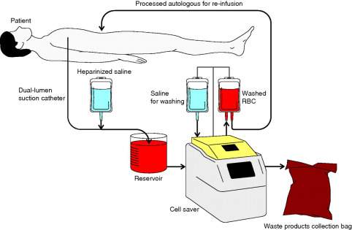

Figure 4: Cell Saver process
- SEPARATION

The aspirated anticoagulated blood from the dual lumen suction tubing enters into the spinning bowl (Centrifuge bowl). In this centrifuge bowl, the blood is usually separated in to constituent components, and that separation should be completely based on the different densities of the components. High dense components (Rbc’s) usually stay at the bottom and also at the perimeter of the bowl where as the lower dense components (Plasma, Wbc’s & Anticoagulants) will float inwards towards the centre of the bowl. Thus, filling of the centrifuge bowl occurs, Once filling starts simultaneously the low dense components keep on moving towards the outlet line and collected in the waste bag. [16]

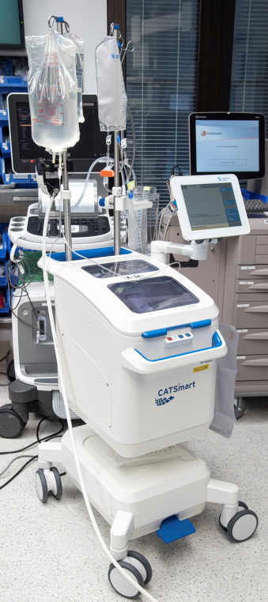

Figure 5: Cell Saver
- WASHING
Once the bowl is filled with high concentrations of Rbc’s, Infusion of Normal saline (0.9% of Nacl) into the centrifuge bowl and circulated through the red cell layer, to displace the remainder contaminants that weren’t removed during the separation phase. The remaining components and the excessive normal saline which has been overflows through the outlet port and enters into the waste bag.[17] Once the wash cycle gets completed, the centrifuge stops, allowing the Rbc’s to flush away into the transfusion kit and it has a hematocrit of up to 60%.

- REINFUSION
The Washed Rbc’s usually has a high concentration of Rbc’s and small traceable amount of Wbc’s and Platelets but it is completely devoid of all clotting factors. Thus, it can’t be stored for a longer period of time. At Room Temperature it can be stored up to more than 4 hours, at 6°C it can be stored up to 24 hours. Reinfusion of washed Rbc’s directly in to the patient.

- INDICATIONS OF CELL SAVER
- Patient with rare blood groups or with multiple antibodies.
- Massive Blood loss during Cardiac Surgery.
- Low Pre – Operative Haemoglobin
- Low Hematocrit
- Jehovah’s Witnesses
- Used in Aortic Aneurysm patients.
- Risk of Bleeding.

- CONTRAINDICATIONS OF CELL SAVER
- Blood Contaminated with bacterial infections.
- Patient has malignant cells.
- Use of topical haemostatic agents.
- Caesarean Section [Amniotic Fluid may get aspirated]
- Blood contaminated with the gastrointestinal content in the surgical fields.
- Patient suffers from Sickle Cell disease.
- Abnormal red blood cell function.

- FACTORS AFFECTING THE PROCESSOR USE
- Antibiotics that had been aspirated should be washed slowly and thoroughly.
- Betadiene solutions should not get aspirated because of it has severe effect on haemolysis.
- Hot solutions should not be aspirated due to haemolysis.

- CONCLUSION

In conclusion, blood conservation techniques play a crucial role in enhancing patient outcomes and reducing complications in cardiac surgeries. The implementation of strategies such as preoperative optimization, meticulous surgical techniques, advanced haemostatic agents, and Autologous blood recovery systems has significantly minimized the need for allogenic blood transfusions. By preserving the body's natural resources and minimizing the risks associated with transfusions, these techniques contribute to shorter hospital stays, faster recovery times, and improved overall patient well-being.[18] As cardiac surgery continues to evolve, the integration of innovative blood conservation approaches remains essential for achieving successful surgical outcomes and advancing the field as a whole.

REFERENCES
- Utley JR, Moores WY, Stephens DB. Blood conservation techniques. The Annals of Thoracic Surgery. 1981 May 1;31(5):482-90.
- Kaul U, Bhatia V. Perspective on coronary interventions & cardiac surgeries in India. The Indian journal of medical research. 2010 Nov;132(5):543.
- Yousuf MS, Samad K, Ahmed SS, Siddiqui KM, Ullah H, Yousuf MS. Cardiac Surgery and Blood-Saving Techniques: An Update. Cureus. 2022 Jan 13;14(1).
- Guyton RA, Mora CT, Finlayson DC, Rigatti RL, editors. Cardiopulmonary bypass: principles and techniques of extracorporeal circulation. Springer Science & Business Media; 2012 Dec 6.
- Gourlay T, Gunaydin S, editors. Minimized cardiopulmonary bypass techniques and technologies. Elsevier; 2012 Apr 19.
- Gourlay T, Gunaydin S, editors. Minimized cardiopulmonary bypass techniques and technologies. Elsevier; 2012 Apr 19.
- Stalder M, Gygax E, Immer FF, Englberger L, Tevaearai H, Carrel TP. Minimized cardiopulmonary bypass combined with a smart suction device: the future of cardiopulmonary bypass? InThe heart surgery forum 2007 Jan 1 (Vol. 10, No. 3, pp. E235-8).
- Remadi JP, Rakotoarivello Z, Marticho P, Trojette F, Benamar A, Poulain H, Tribouilloy C. Aortic valve replacement with the minimal extracorporeal circulation (Jostra MECC System) versus standard cardiopulmonary bypass: a randomized prospective trial. The Journal of thoracic and cardiovascular surgery. 2004 Sep 1;128(3):436-41.
- Kay P, Munsch CM. Techniques in Extracorporeal Circulation 4E. CRC Press; 2004 Apr 30.
- Guyton RA, Mora CT, Finlayson DC, Rigatti RL, editors. Cardiopulmonary bypass: principles and techniques of extracorporeal circulation. Springer Science & Business Media; 2012 Dec 6.
- Guyton RA, Mora CT, Finlayson DC, Rigatti RL, editors. Cardiopulmonary bypass: principles and techniques of extracorporeal circulation. Springer Science & Business Media; 2012 Dec 6.
- Kay P, Munsch CM. Techniques in Extracorporeal Circulation 4E. CRC Press; 2004 Apr 30.
- Cardone D, Klein AA. Perioperative blood conservation. European Journal of Anesthesiology| EJA. 2009 Sep 1;26(9):722-9.
- Yousuf MS, Samad K, Ahmed SS, Siddiqui KM, Ullah H, Yousuf MS. Cardiac Surgery and Blood-Saving Techniques: An Update. Cureus. 2022 Jan 13;14(1).
- Guyton RA, Mora CT, Finlayson DC, Rigatti RL, editors. Cardiopulmonary bypass: principles and techniques of extracorporeal circulation. Springer Science & Business Media; 2012 Dec 6.
- Guyton RA, Mora CT, Finlayson DC, Rigatti RL, editors. Cardiopulmonary bypass: principles and techniques of extracorporeal circulation. Springer Science & Business Media; 2012 Dec 6.
- Wang G, Bainbridge D, Martin J, Cheng D. The efficacy of an intraoperative cell saver during cardiac surgery: a meta-analysis of randomized trials. Anesthesia & Analgesia. 2009 Aug 1;109(2):320-30.
- Kay P, Munsch CM. Techniques in Extracorporeal Circulation 4E. CRC Press; 2004 Apr 30.

