Data Mining Techniques Research and Evaluation
Garima Ahlauwaliya, garimaahluwaliya1996@gmail.com
Guru Ramdas Khalsa Institute of Science & Technology, Jabalpur
Abstract
Data excavating is a immediately increasing field in a difference of regimens. Finding dossier excavating resolutions that are appropriate for the search should progressively main. Data excavating methods have resulted valuable in a off-course range of requests, containing interruption discovery, production, process control, and deception discovery, shopping, and network presidency. In current age, dossier excavating methods have happened used to an growing number of research projects to answer a assortment of interruption discovery challenges.

Introduction to Data Mining
Although dossier excavating is most usually used to extract valuable understandings from trade dossier, it is too valuable for few experimental requests place an practical approach is completing to usual dossier reasoning Abstracts excavating is a elementary quota of the KDD (Knowledge Discovery in Databases) process. The detachment is that by mechanistically running through comprehensive amounts of dossier, commended understandings maybe elicited [1]. Data excavating has enhanced more and more favorite not only in information technology (Journals and Conferences), but in monetary IT also. The increase in celebrity maybe accredit the progress of dossier warehouses in addition to the achievement that this broad bulk of functional dossier maybe secondhand as a bridge to Business Intelligence [2].

Objectives of data mining
The basic goals of dossier excavating search out: · Increase our information of the detracting components and their connection for each added, containing the potential to label non-noticed aspects in the dossier that concede possibility imply better formulations of material models [3]:

• Improve our information of the main determinants and their friendship to each one.
• Generate models straightforwardly from dossier for fear that they may be distinguished to vigorous simulations, that can more determine (temporary) guessing potential.

Scope of Data Mining

The name “knowledge excavating” is collected from the similarity among excavating a profusion for golden mineral and excavating a table for main trade news. Both forms include filtering through enormous amounts of material or resolving it cleverly to recognize place the advantage is [4]. When databases are big enough and of enough feature, dossier excavating sciences can reveal new trade freedom by permissive:

Automatically recognize earlier mysterious patterns.

Automatically think currents and actions.

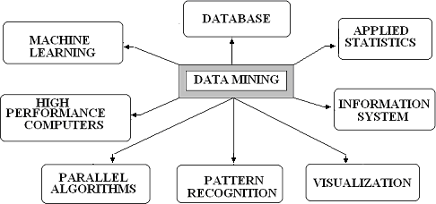
\

Figure 1: Scope of data mining.

Characteristics

Is dossier excavating in wisdom as valuable as dossier excavating in retailing? The be responsible to this question is two-fold. First, dossier excavating in erudition is very complementary to dossier excavating in traffic. There are plenty controlled hypotheses and information nothingness, so skilled’s less chance that information will happen straightforwardly from dossier. On the other hand, practical results are valuable in wisdom, exceptionally place it worsens to construction [5] .For example, they may be used to plan fresh friendships or to model complex phantasms. Second, dossier excavating in retailing is very various from dossier excavating in wisdom. Regulations in business are easier, sociological, or educational, and acquire logical performance.

- Data mining tools and stages

Because the forms that control the dossier excavating process aren’t patterned, it’s hard to present an exact list of the traits of a dossier excavating form. They’re inexact, and private cases, various methods and electronics bring about dossier excavating, that constitutes offspring of issues. In the dearth of exact guidelines, we can only adopt that dossier excavating is shabby into four states [6]:
• Data Preparation
• Data Classification and Analysis
• Learning
• Making a Prediction

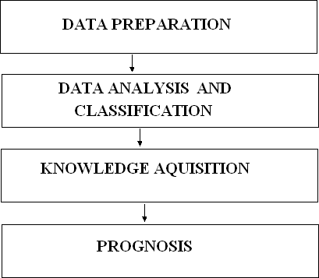
They are followed one after the other in sequence, as seen in the diagram below.

Figure: Tools and phases of data mining

During the data preparation stage, the key data sets that will be used in the data mining operations are identified and cleaned as data in a data warehouse [7] .Typically, a data warehouse is the data set to be used in a data mining operation as it has already been integrated and filtered.

- Representations
You can use a decision tree, neural net, forecasting model, or visual presenting interface to represent the entire set of findings, which you can then use to visualize future events or outcomes. Many new representation technologies are anticipated while data mining technologies are still in their early stages [8].

- Mining Data Techniques

The approaches used for data mining can be broadly classified into three groups, as shown in the picture below.
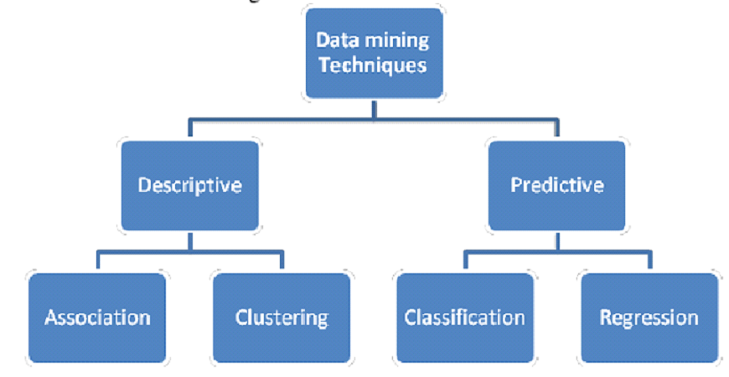

Figure: Techniques for data mining

- Association Regulations

This method is most commonly used in transactional databases. Transactional databases are databases where each record is a transaction, typically a sale. Traditionally, a transaction is defined as a subset of the set of items [9] I. For example, a set of goods represents all of a store’s possible products, and a transaction specifies which of those goods were purchased on a particular occasion by a particular consumer. An association rule is defined as A B, where “A” and “B” are subsets of “I.” If the rule is true, that means that all database entries that contain the items of A include the items of B as well. For example, in our example, all customers who bought items #10, #14, and #19 also bought items #75.

- Modelling for prediction
It is a form of supervised learning where learning and prediction are based on observations [10]. Classification and regression can also be used.

- Clustering: database segmentation
This method is concentrated on construction table divisions to build clusters. Another name for this is alone education. This is the practice of construction clusters or pieces on the footing of related unions or traits. It is regularly accomplished the aim of securing the “arrangement” of a cluster, alternatively just the correspondences [11].
Clustering has few correspondences to categorization. Again, the objective search out group table records into comparable groups. However, in the past, the consumer doesn’t see the classes before the study. The cluster invention must first recognize ultimate everyday habit of arrangement the records together before ongoing accompanying the arrangement. Clustering everything best in geographical databases. Spatial databases are databases place each record shows a point in the room. The cluster invention finds all points that are unspecified the unchanging cluster [12]. For example, if we show a protection party’s consumers in our table, they will function likewise for each added. Outliners, in another way, are clients the one exhibit different management. This take care of signify an attempt to mislead the association and make necessary further case. This use case of grouping is deception discovery.

- Methods for Clustering
There are four fundamental methods to the clustering problem:

• Clustering based on partitions
• Clustering based on grids
• Clustering based on hierarchies
• Clustering based on density

- How Does Data Mining Work?

How does dossier excavating indeed educate you main belongings you didn’t see or what’s make use of occur next? Modeling is the process you use to reach these gains in dossier excavating. It’s just the process of construction a model in individual position place you then see the answer, and before administering that model to another position place you don’t [13]. For example, if you’re expect submerged galleons on the sea. You power start by studying when money was found earlier. These ships are frequently raise off the coastlines. You ability have seen that skilled are sure sea currents and sure sea ways that the ship’s commanders on account of time would have captured [14] You secretly follow of those correspondences and build a model that contains the features that are low to the neighborhoods of those concealed treasures. With these models working, you design to find treasure place your model announces it ability have happened erect earlier. If you have a stable model, you bear find your prize [15] .
References
- Mazda Salmanian, Julie H. Lefebvre, Steve Leonard and Scott Knight, “Intrusion Detection in 802.11 Wireless Local Area Networks”, Technical Memorandum, Defence R&D Canada & Ottawa , July 2004.
- H.BELLAAJ, R.KETATA and A.HSINI, "Fuzzy approach for 802.11wireless intrusion detection", in proc. of 4th International Conference: Sciences of Electronic, Technologies of Information and Telecommunications, March 25- 29, Tunisia, 2007.
- Zonghua Zhang and Hong Shen,” A Brief Observation-Centric Analysis on Anomaly-Based Intrusion Detection”, Springer-Verlag Berlin Heidelberg 2005
- Mark Handley and Vern Paxson “Network Intrusion Detection: Evasion, Traffic Normalization and End-to-End Protocol Semantics”,
- Martin Rehak, Michal pechoucek, karel Bartos, Martin Grill, Pavel celeda and vojtech krmick “An intrusion detection system for high-speed networks”, national institute of informatics, 2008
- John Haggerty, Qi Shi and Madjid Merabti,” STATISTICAL SIGNATURES FOR EARLY DETECTION OF FLOODING DENIAL-OFSERVICE ATTACKS”, Springer Boston, 2006
- Giovanni Vigna, Sumit Gwalani, Kavitha Srinivasan, Elizabeth M. Belding- Royer and Richard A. Kemmerer ,” An Intrusion Detection Tool for AODV- based Ad hoc Wireless Networks”, IEEE Computer Society Washington, DC, USA ,2004.
- Shukor Abd Razak, Steven Furnell, Nathan Clarke, and Phillip Brooke,” A Two-Tier Intrusion Detection System for Mobile Ad Hoc Networks – A Friend Approach”, Springer-Verlag Berlin Heidelberg 2006
- Eduardo Mosqueira-Rey, Amparo Alonso-Betanzos, Belen Baldonedo Del Rio, and Jesus Lago Pineiro, ” A Misuse Detection Agent for Intrusion Detection in a Multi-agent Architecture”. Springer-Verlag Berlin Heidelberg 2007
- Magnus Almgren, Ulf Lindqvist, and Erland Jonsson,” A Multi-Sensor Model to Improve Automated Attack Detection”, Springer-Verlag Berlin Heidelberg 2008
- Curtis A. Carver, Jr., Jeffrey W. Humphries, and Udo W. Pooch,”Adaptation Techniques for Intrusion Detection and Intrusion Response Systems”,
- Naeimeh Laleh and Mohammad Abdollahi Azgomi,” A Taxonomy of Frauds and Fraud Detection Techniques”, Springer-Verlag Berlin Heidelberg 2009.
- Jeyanthi Hall Michel Barbeau and Evangelos Kranakis, “Detecting Rouge Devices In Bluetooth Networks Using Radio Frequency Fingerprinting”
,School Of computer Science, Carleton University.
- Jeyanthi Hall , Michel Barbeau and Evangelos Kranakis, “Enhancing Intrusion Detection In Wireless Networks Using Radio Frequency Fingerprinting”, School Of computer Science, Carleton University.
- M. Charikar, E. Lehman, D. Liu, R. Panigrahy, M. Prabhakaran, A. Sahai, A. Shelat, “The smallest grammar problem,” IEEE Transactions on Information Theory, vol. 51, Issue 7, pp. 2554-2576, July 2005.Keesook J. Han and Joseph Giordano, “Intrusion Detection System Modeling,” Proceedings of the HPCMP UGC 2006, IEEE Computer Society, June 2006.

