3D printing of PLA material for passive prosthetic finger for hand rehabilitation
Nitin Sahai^{1,2}, Pynwanjanai Marbaniang¹, Mariabiang Marwein, ¹ Browinson Ksoo¹ Damankhraw Nongrem¹,
¹Department of Biomedical Engineering, North Eastern HillUniversity, Shillong, Meghalaya
²3D Printing and Visualization Center; University of Pecs; H-7624, Pecs, Boszorkany str. 2, Hungary

Abstract
This case report explores the ease of utilising patient-specific design in computer-aided software, open-source 3D printed design software. Participants were recruited and examined using subjective and objective analysis to guide the prosthetic designs. The measurements of the particular finger (i.e. index finger) were obtained and fed into computer software to develop computer-aided design drawings of the required prosthetics. This report uses CAD (Computer-Aided Design) software and additive technology to produce a low-cost mechanical finger prosthesis. The goal was to use Autodesk Tinkercad and Ultimaker Cura software which are freely available, to design and develop an index finger prosthesis from PLA (polylactic acid) material using a 3D printer. The prosthetic finger should be suitable and comfortable for the users depending on the size, weight and overall shape or model of the device and with the use of parametric modelling measures, which is a great help in producing specific and suitable prosthetics for the patient. To enable the lost gripping of the missing joints and to make it function well, the mechanical finger prosthesis will give a proper flexion and extension performance, the same as the movement of an excellent healthy finger. The designed and developed prosthetic finger has a simple construction consisting of components made on a 3D printer; a specifically attached cable system takes its movement and function into action. The model of the finger prosthetic was printed with an adequately designed socket to make it look like a healthy finger which will give a successful extension and flexion of finger movement using a cable system. After analyzing, we found that the prosthetic functions as an anatomically healthy finger. Therefore, the current 3D printing technology significantly impacts producing prosthetics devices that are uniform scaling to fit the prostheses of different users.
Keywords: - CAD, Additive Manufacturing, 3D printing, Finger prosthesis,
- Introduction: -
3D printing plays a crucial role in developement of patient specific 3D printed prosthetics and orthotic devices[1]–[5]. Prosthetic limbs or finger prosthetics used for human needs to overcome limb loss are used widely . Prosthetic demands, or finger prosthetics used for human needs to overcome the loss of limbs, are widely demanded. The global upper limb prosthetics market is projected to grow at a CAGR of 4.97%, reaching $1131.36 million by 2030, as confirmed by Strategic Market Research. Prosthetic hands can help give patients subjects a sense of actual limb and increased ability to perform everyday tasks. Unfortunately, many prostheses are expensive and require more repetitive servicing and maintenance.
Therefore, they are more expensive financially and locally unavailable to most of the population living in developing countries. A 3D-printed upper limb is one possible method for its low cost and potential for customisation. However, the finger must be appropriate for developing countries' environmental conditions and lifestyles. For the characterisation of the functionality of the 3D-printed finger, a series of experiments and object tests were carried out.

It is widely believed that three-dimensional printing is part of an additive manufacturing method that can build objects directly from a computer model. It forms any solid shape from a digital model. 3D printing is a sub-type of additive manufacturing technology. A three-dimensional model is made by developing the addition of successive layers by a layer of material, which forms the final object. 3D printers enhance product designers' ability to print models, parts and components made from variable materials with variable mechanical and variable physical characteristics in a single developed object. The highly advanced 3D printing methods currently develop models that are very much similar in the appearance and functionality of the final product.
Moreover, it is the main because three-dimensional printing is an advance and different manufacturing methodology based on the latest technological innovations. It will develop variable parts additively in layers by layers at the millimetre of scale size. This fundamentally differs from traditional product manufacturing techniques[6]–[9].

Using additive manufacturing (i.e., 3D printing), low-cost and high-performance prosthetic devices can be established. 3D printing is an advanced technology that enhances and develops innovation with innovative design freedom while using less mechanical assembly. The 3D printing method is a technology that decreases prohibitive money and lead times and reduces product delivery time. Components of products can be modelled explicitly to reject assembly requirements with a specific geometry and complicated features developed at negligible extra cost. Three-dimensional printing is also emerging as an energy-efficient methodology that can provide environmental efficiencies in manufacturing, utilising up to 90% of standard materials and throughout the product's operating life through lighter and more robust design.
Three-dimensional printers are the latest generation of types of equipment that can make daily usable things. They are remarkable because they can produce different objects in different materials, all from the same device [10]–[12]. A 3D printer can make anything from alphabet letters to numerical digits, plastic toys, metal machine parts and more.
  - Computer Aided design

CAD or Computer Aided Design allows designing a variety of realistic models in different fields of work virtually[2]–[4], [13], [14]. It uses computer-based software to aid in design processes. CAD allows engineers to build 3D computer models, design, and layout of products; it also allows the designing of 2D physical components, which after completion, can be simulated for functional results[15]. Computer-Aided Design (CAD) is an important tool for biomedical engineering applications, enabling scientists, doctors, engineers, and researchers to think, design, model, and simulate various medical equipment/ devices, implants, and systems. CAD for biomedical engineering plays a significant role in developing and optimising medical products and technologies. Several examples show the application of CAD in biomedical engineering in some ways, like in the development of medical device design. CAD creates detailed and accurate 3D models of biomedical devices consisting of orthotics, implants, prosthetics, high-end surgical instruments, and patient-specific diagnostic equipment. Engineers can iteratively design and modify these models to meet specific requirements, functionality, and ergonomic considerations. Human implant and prosthesis design comprises CAD designs of patient-specific tissue or organ implants and prosthetics tailored to patients’ anatomies. By the utilization of medical imaging data (CT, MRI scans), CAD software can create custom implants that fit perfectly into a patient's anatomy, improving the success of surgeries and reducing complications[16]–[19]. 3D models can also be developed from medical images like, Magnetic resonance imaging, Ultrasound, and X-ray computed tomography (CT), as described in Figure 1 and Figure 2.

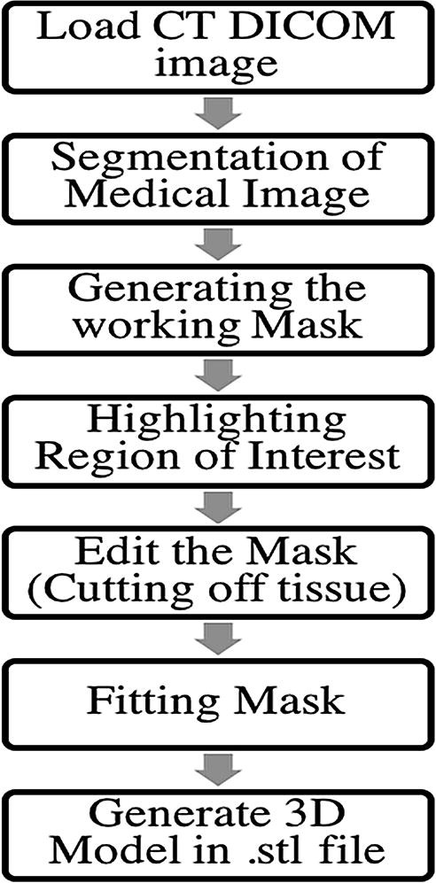
1. Figure stepwise method for generating cad model from medical images reproduced with permission form[13].

The sequential stepwise systematic procedure for developing and generating a computer-aided three-dimensional model for cartilage tissue is shown in Figure 2
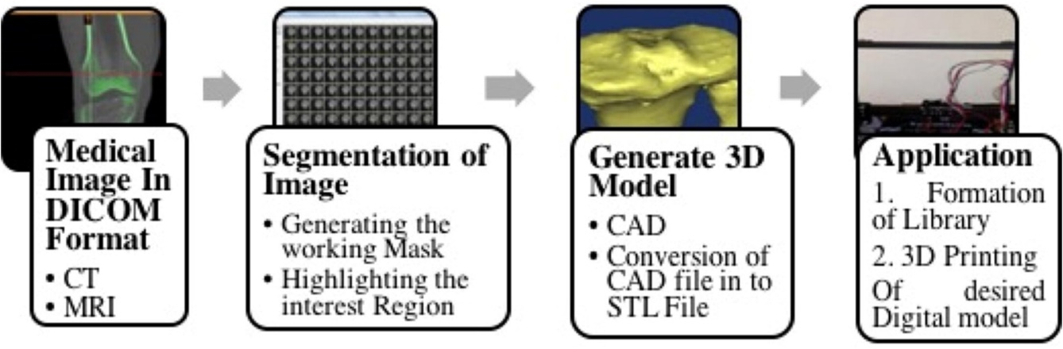
2. Figure development of cartilage model from the medical image reproduced with permission form[13]

CAD software/tools

Several CAD development tools exist to assist designers, technicians and engineers. Some CAD tools are customised to fit specific applied cases and specific industries, such as design and architecture. Different computer-aided software can be applied to assist a variety of industries and different types of projects. Some widely used CAD tools are:
- AutoCAD (offered by Autodesk)
- CorelCAD
- IronCAD
- CADTalk
- SolidWorks
- Onshape
- Catia
- LibreCAD
- OpenSCAD

  - Finite Element Analysis (FEA) Integration: CAD models can be integrated with FEA software to analyse biomedical devices' structural integrity and mechanical behaviour under different loading conditions. This helps identify potential failure points, optimise designs, and ensure safety and reliability. Tissue and Organ Modeling: CAD can create 3D models of tissues, organs, and anatomical structures. These models are helpful in medical education, surgical planning, and simulation, providing insights into complex anatomy and pathology. Medical Prototyping: CAD allows engineers to create virtual prototypes of medical devices before physical production. This enables rapid prototyping using techniques like 3D printing, reducing development time and costs. Surgical Planning: CAD models, combined with medical imaging data, aid surgeons in planning complex surgeries. They can simulate procedures, evaluate different approaches, and assess potential risks before operating on the patient. Biomechanical Simulations: CAD models can affect the biomechanical behaviour of tissues, joints, and organs under various conditions, providing insights into physiological responses and aiding in developing bio-inspired devices. Customized Medical Instruments: CAD facilitates the design of specialized surgical instruments and tools tailored to specific procedures and patient needs. Regulatory Compliance: CAD documentation and models are crucial in meeting regulatory requirements for medical device approval, ensuring compliance with safety standards and guidelines. Overall, CAD is a fundamental tool that enhances biomedical engineering projects' efficiency, accuracy, and safety, leading to advancements in medical technology, patient care, and treatment outcomes[20]–[26].

Prosthesis
A prosthesis is an artificial part of the body that changes some of the function and appearance of the missing part. The prosthetic lower limb, hand, finger or arm type will majorly depend on the position and length of your remaining hand or finger and your day-to-day lifestyle and other activities also functional.
A prosthetic finger and hand will be helpful in different methods and can:
- restore and
- maintain length to a half-amputated finger.
- Enable opposition between a finger and a thumb and a finger.
- Allow a hand amputee to stabilize and hold objects with bendable fingers.
Partial hand loss comprises about 90 per cent of all upper limb extremity amputations and may be involved in the loss of one or more digits. In the past, Three Dimensional printed prostheses for limb absence were typically basic designs, relying on the person’s remaining thumb or fingers to grasp objects against a static prosthetic platform. However, recent technological advances have led to the development of smaller, more robust components that steadily improve body-powered and electrically powered designs.

Types of prosthetics

Passive Prosthetics
Passive silicone prosthetic devices are designed to emulate the natural look and texture of a non-prosthetic hand or finger. Often covered in different qualities of high- or low- definition silicone that can be custom-painted, passive prosthetics are incredibly lightweight. However, they don’t provide any actual active movement and offer limited grasping abilities, but they do sometimes improve the wearer’s functionality by providing a stabilized surface. For these reasons, passive prosthetics are generally selected for more aesthetic or cosmetic purposes rather than high-performance functional ones.

Myoelectric Prosthetics
As mentioned, externally powered prostheses are electronically controlled, functional, and highly responsive devices. At the partial-hand amputation level, this design typically comprises multiple full-length prosthetic fingers or a full-length prosthetic thumb as required, and a lightweight, rechargeable onboard Li-ion battery system typically powers them. Because of how lightweight and high-tech they are, they’re an excellent option for light to moderate day-to-day performance.

Body-powered partial hand prosthesis
There are mainly three types of body-powered prostheses for partial hand amputees:
- Cable controlled
Joint driven
- Wrist-driven
The 3D-printed prostheses exhibit remarkable durability and boast a sophisticated, high-tech aesthetic. A notable advantage lies in their functional capabilities, where the exertion of force is precisely regulated through the user's wrist or the residual part of their hand. This intricate control mechanism bestows a strikingly natural feel to movement and operation, greatly enhancing the user's overall experience with the prosthetic device.

Hybrid Prosthetics
Hybrid prosthetics, like this Bebionic hand from Ottobock, combine body power and myoelectric control to allow the user to control the elbow and writing simultaneously. Hybrid prosthetics often combine the high grip force of a myoelectric device with the bio-feedback of body-controlled devices without extra bulk. This combination can reduce the weight and complexity of the trans-humeral prosthetic system while allowing quick elbow operation to place the terminal device.

  - Finger Prosthesis

The prosthesis will be positioned as the hand's second digit; the index finger ranks among the most frequently employed digits, along with the thumb and middle finger. Its significance arises from many functional applications, including sensory touch and gripping tasks, rendering it an indispensable tool in daily activities. Furthermore, the index finger is vital in expressive gestures, making it a versatile and crucial element in human interaction and communication. Nonverbal hand gestures generally express this. As a result, the index finger may be called an example of a "pointer." The human finger consists of three phalanges that stretch from the second metacarpal of the side. The proximal phalanx lies at the finger’s base, forming a crucial connection with the intermediate phalanx through the knuckle joint. Positioned at the tip of the hand finger, the distal phalanx plays a pivotal role in supporting the delicate pulp of the fingertip. Additionally, specific muscles aid in the finger's movement: the palmar interosseus contributes to adduction, drawing the index finger inward, while the extensor facilitates extension, allowing for outward movements. Finger shown in Figure 3.

Ensuring the finger's vitality, the normal palmar artery, branching from the palmar arch and linking the ulnar and radial arteries, efficiently supplies oxygenated blood, sustaining its overall health. The median nerve accomplishes innervation of the finger's skin, ensuring proper sensory perception and responsiveness in this intricate and versatile part of the hand.
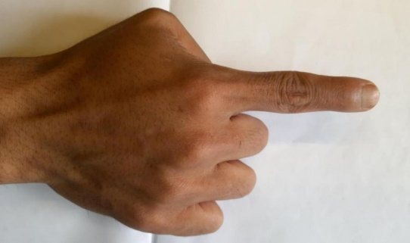
3. Figure index finger representation
Passive 3D-printed prosthetic devices are designed to emulate a non-prosthetic finger's natural look and texture. Emilio Soto et al. created a 3D-printed neural network hand. The 3D-printed tendon was developed for finger prosthesis, which cannot grow by conventional methods. Silicon finger prostheses use a new method for the development of suspension. The design incorporated a fabrication technique for the socket of the finger prosthesis, which involved reducing its size by 2 mm from the original measurement. Moreover, a central tunnel was meticulously created, measuring 4 mm in both width and depth, with a length precisely matching the distance between the end of the stump. Additionally, a nail section was introduced in the design to allow the silicone material to extend over the stump, ensuring a commendable suspension and secure fit for the prosthesis.3D printed tendon-driven robotic finger was developed, which can restore normal function. The cost-effective index finger was 3D printed for carpenters using polyurethane. The patient-specific partial body-powered prosthetic finger was extended, commercially available in the market[27]–[31]. Present prosthetics, particularly lower limbs, fingers and hands, require significant manufacturing and assembly operations. Using additive manufacturing (i.e., 3D printing), low-cost and high-performance 3D-printed prosthetic devices can be developed. In this current study, we report on a fully compliant finger 3D printed with a modified, cost-effective three-dimensional printer based on the Fused Deposition Modelling (FDM) technique. Before the finger fabrication, the bending behaviour of some well-known flexure hinges was modelled and experimentally validated to find the most specific design for a fully compliant prosthetic finger. In this current research article, a 3D-printed mechanical prosthetic finger was developed. The prosthetic device is a low-cost, lightweight set without any electronic devices. The prosthetic figure was designed for long-lasting and smooth movement with a comfortable, harmless fitting socket and the wrist.

- Materials and methods

  - Polylactic Acid

The fused deposition modelling method was applied to produce the 3D-designed prosthetic figure. PLA (Polylactic Acid) is a versatile commercial biodegradable thermoplastic based on Lactic Acid used as material for 3D printing. A 3D printer made from 3D Dexter was used, as shown in the figure 4.

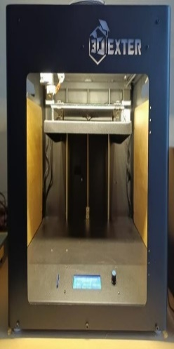
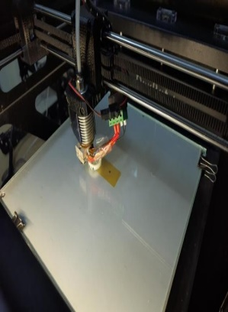
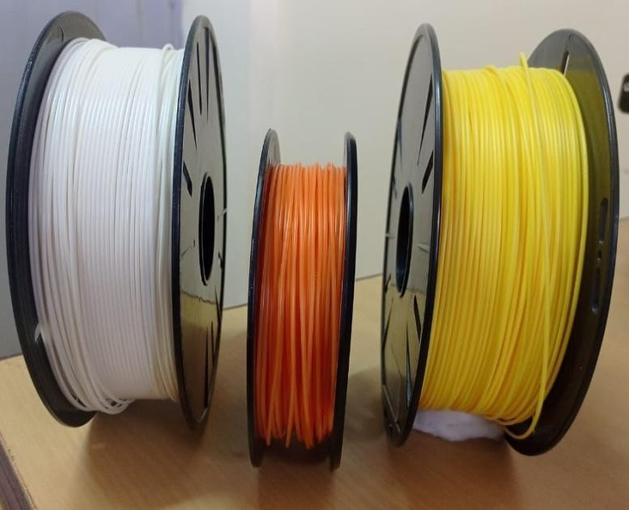

4. Figure 3D printer and PLA material

PLA's physical and mechanical properties vary according to the types of polymers, from amorphous glassy polymer to semi or highly crystalline polymer.
The property of this acid makes it so desirable for use in the domain of 3D printing because it has a low melting point, and there are minimal dangers therefore connected to the use of this acid.
The general properties of PLA are summarised in Table (1) below.

1. Table Characteristics of PLA
Characteristics | Unit
Molecular weight (Mw) | g/mol | 66,000
Specific gravity |  | 1.27
Solid Density | g/cm3 | 1.252
Melting Density | g/cm3 | 1.073
Glass Transition temperature (Tg) | ℃ | 55
Melting Temperature (Tm) | ℃ | 165
Young’s Modulus E | GPA | 3.5
Elongation at break | % | 6
Yield Stress σy (MPa)
Tensile Strength σts | (MPa) | 36-55
Ultimate Tensile Strength UTS | (MPa) | 35
Thermal expansion | (μm/m­K)
Strength-to-weight ratio | (kN•m/kg) | 40
Shear modulus G | (GPa | 2.4

The range of motion for different joints in the development of the CAD model was considered, as shown in the Table. DIP (Distal Interphalangeal Joint), PIP (Proximal Interphalangeal), MCP (Metacarpophalangeal Joint), CMC (Carpometacarpal Joint) shown in table 2

Table2: Range of motion

Joint | Motion | Index
DIP | Flexion | 80
 | Extension | 11
PIP | Flexion | 110
 | Extension | 12
MCP | Flexion | 83
 | Extension | -22

  - Prosthetic finger parameters
The design for the prosthetic finger has been done from the open-source Tinker CAD, which is free to use to create and modify the model. The human hand’s second digit (2D), commonly known as the index finger, is positioned between the thumb and the middle finger. It is typically considered the most dexterous, practical, and sensitive finger after the thumb. To measure the index finger, digital callipers were employed, applying them to two specific locations: the basal crease at the bottom of each finger and directly at the fingertip. The index (= 2D) of both the left and right hands will be assessed. To initiate the design process, precise measurements were taken for both the intact left finger and the remaining right finger, which served as the basis for designing the prosthetic. These measurements were meticulously recorded to ensure an optimal fit for the prosthetic device. Subsequently, the Tinker cad software utilized these measurements as input to generate a comprehensive 3D representation of the various components, as depicted in the figure. Once the design views were finalized, the files were exported in STL format, which was input for the Ultimaker Cura software responsible for operating the 3D printer.

2.3 3D printing
The STL file containing the model of the index finger was exported to the Ultimaker Cura Software to prepare it for 3D printing. The measurements were used to ensure the model was adequately scaled and positioned on the build plate within the software. Careful attention was given to arranging the model's position and adjusting the print profiles or settings to ensure it was ready for 3D printing. Once all the settings were optimised correctly, the models were sliced and saved as a Gcode file, which was then sent to the 3D printer for printing. Shown in figure 5 the different CAD model.

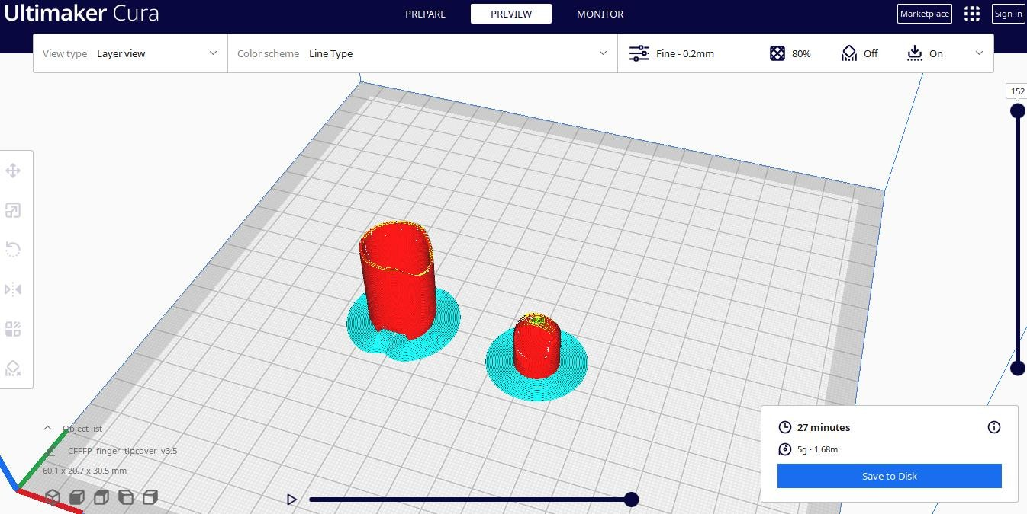
5. Figure 3D CAD Models
A
B
D
C

PLA, the ideal material for 3D printing, was inserted into the extruders of the 3D printer. The extruder, equipped with a stepper motor, controlled the amount of filament fed into the nozzle. The nozzle melted the filament, and the 3D printing process commenced.

  - Finite Element Analysis

Finite Element Analysis (FEA) is a numerical technique used to analyse the behaviour of complex systems and structures by dividing them into more minor, more superficial elements. FEA is crucial in simulating and understanding the mechanical behaviour of various biological tissues, implants, medical devices, and other biomedical structures in biomedical applications. Here are some typical applications of FEA in the biomedical field: Biomechanics of Tissues: FEA can study the mechanical properties of biological tissues like bones, cartilage, ligaments, and tendons. By applying FEA to these tissues, researchers can gain insights into their stress, strain distribution, and deformation under different loads and predict failure or damage conditions. Implant and Prosthesis Design: FEA aids in optimizing the design of implants and prosthetic devices. It helps evaluate the performance and safety of implants by analyzing their stress distribution, stability, and potential for wear or fatigue over time. Orthopaedic Applications: FEA is widely used in orthopaedic biomechanics to study joint mechanics, spinal biomechanics, fracture healing, and the performance of orthopaedic implants such as hip replacements, knee replacements, and spinal implants. Dental Applications: FEA is utilized in dental research to understand the biomechanical behaviour of dental implants, bridges, and dentures, as well as to study the stress distribution in teeth under different loading conditions. Cardiovascular Simulations: FEA can simulate blood flow patterns in arteries, predict stress distribution in blood vessels, and assess the mechanical performance of stents and other cardiovascular devices. Soft Tissue Modeling: Besides studying rigid structures, FEA can also be extended to model soft tissues like heart muscles, brain tissues, and skin to study their behaviour and response under different mechanical forces. Biomechanical Testing Validation: FEA is often used to validate experimental testing results, providing a complementary method to verify and enhance empirical findings. It is important to note that FEA requires accurate material properties, boundary conditions, and meshing techniques to provide reliable results. Additionally, it should be used in conjunction with experimental data to validate and calibrate the models for accurate simulations.
In biomedical applications, FEA can significantly aid in improving medical devices, understanding biomechanical responses, and optimizing treatment strategies, leading to advancements in healthcare and patient outcomes.
In later studies, Structural analysis of the prosthetics joint figure model was performed by ANSYS Workbench 2020 R1(ANSYS et al., 275 Technology Drive, Canonsburg, PA, USA). All standard parameters were used to find the mechanical characteristics of PLA, such as Young’s Modulus of 2850 MPa, Poisson ratio of 0.25, and a pressure of 0.64 pascals applied on the boundaries while keeping the limits fixed. The standard mesh was created with tetrahedral elements with regular intervals[32]–[34].
- Results

Once the 3D models have finished printing, the parts are detached from the printer's work platform and thoroughly cleaned shown in figure 6. Subsequently, all supporting structures are carefully ground down and smoothed to facilitate the proper assembly of the prototype prosthesis. The finger phalanges are interconnected using pegs in the DIP, PIP, and MCP joints.
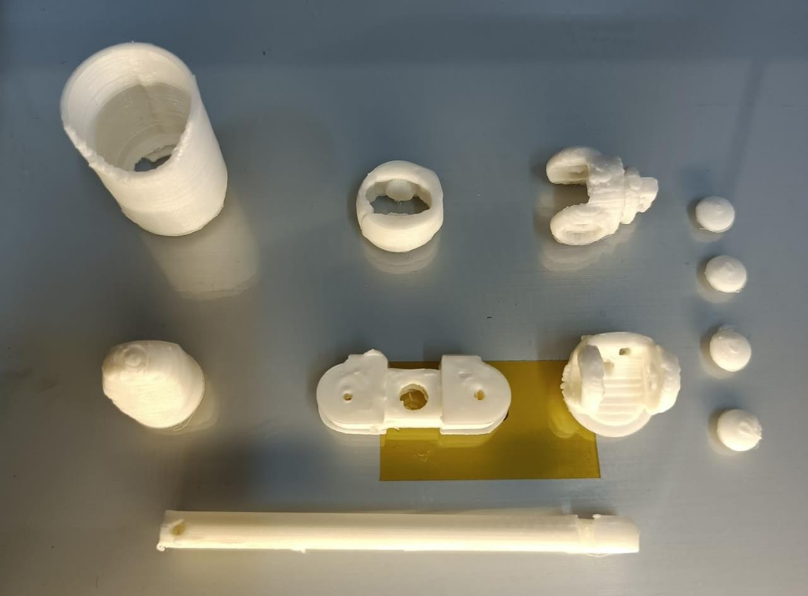
6. Figure Different components of Finger Prosthetic

The complete flexion performance of a finger prosthesis with a cable system enables finger prosthetic movement as the user wants to, and it can hold objects firmly as a healthy finger shown in figure 7.

7. Figure The Complete model of a Finger prosthetic.

- Conclusion and prospects

This project used additive manufacturing to create a functional mechanical index finger prosthesis. The proposed design closely mimics the structure of a natural finger and features a straightforward and efficient movement mechanism. The prosthesis can be easily attached to the arm, and its size and construction resemble that of a healthy anatomical finger. Leveraging 3D printing, this technology enables the efficient and rapid production of personalised prosthesis components. By employing this approach, the aim is to enhance the aesthetic appeal and achieve improved functionality in the prosthesis. Finger prosthetics produced through 3D printing have become widely utilised today. From the early stages of CAD programming and 3D printing, these prosthetics have evolved from essential to advanced designs, with ongoing developments. Overstudy aims to create lightweight and cost-effective figure prosthetics, optimising them for superior outcomes compared to existing structures. This optimised design aims to alleviate the emotional distress caused by the absence of a figure due to birth, accidents, or amputation while restoring the lost fingers’ functionality and reducing pain associated with depression, grief, or PTSD.
This study yields a functional and durable prosthetic finger. There is potential for future model enhancement. Additionally, there is an opportunity to develop complementary components, such as cable-free prosthetics that enable wrist movement without hindrance.

References

[1] A. Saikia, S. Mazumdar, N. Sahai, S. Paul, and D. Bhatia, “Performance Analysis of Artificial Neural Network for Hand Movement Detection from EMG Signals,” IETE J Res, 2019, doi: 10.1080/03772063.2019.1638316.
[2] A. Saikia et al., “Recent advancements in prosthetic hand technology,” J Med Eng Technol, vol. 40, no. 5, 2016, doi: 10.3109/03091902.2016.1167971.
[3] N. Sahai, T. Jain, S. Kumar, and P. K. Dutta, Development and selection of porous scaffolds using computer-aided tissue engineering. 2015. doi: 10.1007/978-81-322-2511-9_13.
[4] N. Sahai and M. Gogoi, Techniques and software used in 3D printing for nanomedicine applications. 2019. doi: 10.1016/B978-0-12-815890-6.00002-5.
[5] T. Sarma, D. Pandey, N. Sahai, and R. P. Tewari, “Material selection and development of ankle foot orthotic device,” in Materials Today: Proceedings, 2019. doi: 10.1016/j.matpr.2019.07.107.
[6] T. Sarma, K. Kumar Saxena, V. Majhi, D. Pandey, R. Prakash Tewari, and N. Sahai, “Development of active ankle foot orthotic device,” Mater Today Proc, 2020, doi: 10.1016/j.matpr.2020.01.143.
[7] N. Sahai, R. P. Tewari, and L. Singh, “Mechanical behaviour of muscles during flexion and extension of the lower limb on variable age group by using BRG.LifeMod,” in IFMBE Proceedings, 2010. doi: 10.1007/978-3-642-12020-6-12.
[8] S. Mazumdar, A. Saikia, N. Sahai, S. Paul, and D. Bhatia, “Determination of significant muscle in movement of upper limb using maximum voluntary contraction of EMG signal,” in 2017 4th International Conference on Signal Processing and Integrated Networks, SPIN 2017, 2017. doi: 10.1109/SPIN.2017.8049923.
[9] A. Saikia, S. Mazumdar, N. Sahai, S. Paul, and D. Bhatia, “Comparative study and feature extraction of the muscle activity patterns in healthy subjects,” in 3rd International Conference on Signal Processing and Integrated Networks, SPIN 2016, 2016. doi: 10.1109/SPIN.2016.7566678.
[10] M. Lin, N. Firoozi, C. T. Tsai, M. B. Wallace, and Y. Kang, “3D-printed flexible polymer stents for potential applications in inoperable esophageal malignancies,” Acta Biomater, vol. 83, 2019, doi: 10.1016/j.actbio.2018.10.035.
[11] Y. Yang, M. Ding, H. Gong, H. Hanken, J. Zhao, and L. Tian, “Portable fluid circuit device containing printed silicone microvessels as a training aid for arterial microanastomosis,” Int J Oral Maxillofac Surg, vol. 51, no. 8, 2022, doi: 10.1016/j.ijom.2021.12.001.
[12] N. S. Alkaltham et al., “Effect of Denture Disinfectants on the Mechanical Performance of 3D-Printed Denture Base Materials,” Polymers (Basel), vol. 15, no. 5, p. 1175, Feb. 2023, doi: 10.3390/polym15051175.
[13] N. Sahai and M. Gogoi, “3D tissue scaffold library development form medical images for bioprinting application,” Mater Today Proc, 2020, doi: 10.1016/j.matpr.2019.12.063.
[14] N. Sahai, K. K. Saxena, and M. Gogoi, “Modelling and simulation for fabrication of 3D printed polymeric porous tissue scaffolds,” Advances in Materials and Processing Technologies, vol. 6, no. 3, 2020, doi: 10.1080/2374068X.2020.1728643.
[15] N. Sahai, M. Gogoi, and R. P. Tewari, “3D Printed Chitosan Composite Scaffold for Chondrocytes Differentiation,” Current Medical Imaging Formerly Current Medical Imaging Reviews, vol. 17, no. 7, 2020, doi: 10.2174/1573405616666201217112939.
[16] R. P. Tripathi et al., Stockwell Transform Based Time-Frequency Analysis of the ECG Features for Assessment of Risk of Left Ventricular Hypertrophy in Hypertension Patients, vol. 587. 2020. doi: 10.1007/978-981-32-9775-3_74.
[17] N. Sahai, A. B. Chandran, A. Bhuyan, B. Das, S. Mandal, and T. Sarma, “Effect of yoga on physical and physiological parameters,” International Journal of Innovative Technology and Exploring Engineering, vol. 8, no. 10, 2019, doi: 10.35940/ijitee.J9326.0881019.
[18] G. S. Hutchinson et al., “Evaluation of an osteoconductive resorbable calcium phosphate cement and polymethylmethacrylate for augmentation of orthopaedic screws in the pelvis of canine cadavers,” Am J Vet Res, vol. 66, no. 11, pp. 1954–1960, 2005, doi: 10.2460/ajvr.2005.66.1954.
[19] A. Fontana, A. Bistolfi, M. Crova, and G. Massazza, “Primary stability of a PGLA/Polydioxanone membrane for potential autologous chondrocyte implantation in the hip joint. A cadaveric study,” Hip Int, vol. 23, no. 3, pp. 337–342, 2013, doi: 10.5301/hipint.5000023.
[20] S. Vyavahare, S. Teraiya, D. Panghal, and S. Kumar, “Fused deposition modelling: a review,” Rapid Prototyping Journal, vol. 26, no. 1. 2020. doi: 10.1108/RPJ-04-2019-0106.
[21] N. Shahrubudin, T. C. Lee, and R. Ramlan, “An Overview on 3D Printing Technology: Technological, Materials, and Applications,” Procedia Manuf, vol. 35, pp. 1286–1296, Jan. 2019, doi: 10.1016/J.PROMFG.2019.06.089.
[22] Z. Xu, Y. Wang, D. Wu, K. P. Ananth, and J. Bai, "The process and performance comparison of polyamide 12 manufactured by multi-jet fusion and selective laser sintering," J Manuf Process, vol. 47, pp. 419–426, Nov. 2019, doi: 10.1016/J.JMAPRO.2019.07.014.
[23] V. Tagliaferri, F. Trovalusci, S. Guarino, and S. Venettacci, “Environmental and economic analysis of FDM, SLS and MJF additive manufacturing technologies,” Materials, vol. 12, no. 24, 2019, doi: 10.3390/ma1224161.
[24] L. R. Holmes and J. C. Riddick, “Research summary of an additive manufacturing technology for the fabrication of 3D composites with tailored internal structure,” JOM, vol. 66, no. 2, 2014, doi: 10.1007/s11837-013-0828-4.
[25] S. Terekhina, T. Tarasova, S. Egorov, L. Guillaumat, and M. L. Hattali, “On the difference in material structure and fatigue properties of polyamide specimens produced by fused filament fabrication and selective laser sintering,” International Journal of Advanced Manufacturing Technology, vol. 111, no. 1–2, 2020, doi: 10.1007/s00170-020-06026-x.
[26] J. Huang, Q. Qin, and J. Wang, “A review of stereolithography: Processes and systems,” Processes, vol. 8, no. 9. 2020. doi: 10.3390/PR8091138.
[27] M. A. T. Sheikh, K. P. S. Pereira, B. K. Gopalakrishnan, and K. Raju, "Design and fabrication of automated prosthetic arm," in AIP Conference Proceedings, 2020. doi: 10.1063/5.0007070.
[28] C. Dally, D. Johnson, M. Canon, S. Ritter, and K. Mehta, “Characteristics of a 3D-printed prosthetic hand for use in developing countries,” in Proceedings of the 5th IEEE Global Humanitarian Technology Conference, GHTC 2015, 2015. doi: 10.1109/GHTC.2015.7343956.
[29] G. Borghesan, G. Palli, and C. Melchiorri, “Design of tendon-driven robotic fingers: Modeling and control issues,” in Proceedings - IEEE International Conference on Robotics and Automation, 2010. doi: 10.1109/ROBOT.2010.5509899.
[30] M. Arazpour, M. A. Mardani, M. A. Bani, F. Zarezadeh, and S. W. Hutchins, “Design and fabrication of a finger prosthesis based on a new method of suspension,” Prosthet Orthot Int, vol. 37, no. 4, 2013, doi: 10.1177/0309364612465428.
[31] E. Soto, O. Baez, and S. Sosa, “Modeling, design and construction of articulated hand for use in prosthetics, with adaptive control in neural networks based on mathematical model for finger,” in Proceedings of Special Session - 9th Mexican International Conference on Artificial Intelligence: Advances in Artificial Intelligence and Applications, MICAI 2010, 2010. doi: 10.1109/MICAI.2010.34.
[32] N. M. Shah, M. D. Pool, and A. T. Metters, “Influence of network structure on the degradation of photo-cross-linked PLA-b-PEG-b-PLA hydrogels,” Biomacromolecules, vol. 7, no. 11, pp. 3171–3177, 2006, doi: 10.1021/bm060339z.
[33] R. A. Miller, J. M. Brady, and D. E. Cutright, “Degradation rates of oral resorbable implants (polylactates and polyglycolates): Rate modification with changes in PLA/PGA copolymer ratios,” J Biomed Mater Res, vol. 11, no. 5, pp. 711–719, 1977, doi: 10.1002/jbm.820110507.
[34] E. Girard et al., “Evaluation of a biodegradablePLA-PEG-PLAinternal biliary stent for liver transplantation: in vitro degradation and mechanical properties,” Journal of Biomedical Materials Research Part B-Applied Biomaterials, vol. 109, no. 3, pp. 410–419, 2021, doi: 10.1002/jbm.b.34709.

