SMOKE DETECTOR USING ARDUINO AND

SMOKE SENSOR.

PROJECT TEAM:

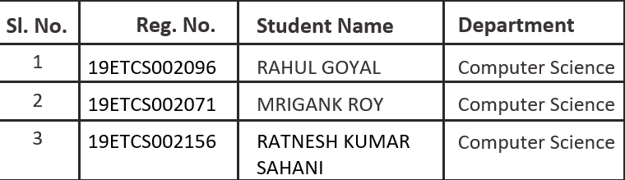

B. TECH

2019-2023

FACULTY OF ENGINEERING AND TECHNOLOGY

M.S RAMAIAH UNIVERSITY OF APPLIED SCIENCES

BENGALURU - 560054

Arduino Smoke Detector Project: -

Overview
Carbon monoxide (CO) has been called the “silent” or “invisible killer” because it is a scentless, colourless, and tasteless toxic gas. Smoke Detector using Arduino.
It is the number one cause of death due to poisoning in America.
Any time you burn something—like gasoline, natural gas, wood, oil, propane, or charcoal—carbon monoxide is released into the air. In outdoor spaces, vehicle Exhaust is the main source of CO.
A carbon monoxide detector can alert you to high levels of carbon monoxide you’re surrounding and help you get to safety immediately.
Hereby using Arduino smoke detector, we detect and measure Carbon monoxide gas.
Arduino smoke detector is a part of the IOT project, for perfect Internet of Things project we have to make this CO measurement wireless and monitor using App through mobile.
But for start here we are going to monitor through LCD display board.

Components Used in smoke detector Project:

- Arduino UNO development board
- 16×2 LCD
- MQ-7 Smoke Sensor (CO Sensor)
- Breadboard
- Connecting wires

MQ-7 Smoke Sensor:
This Carbon Monoxide (CO) gas sensor detects the concentrations of CO is in the air and gives output reading in the form of an analog voltage. The sensor can measure concentrations of 10 ppm to 10,000 ppm. The sensor consumes less than 150 mA at 5 V.
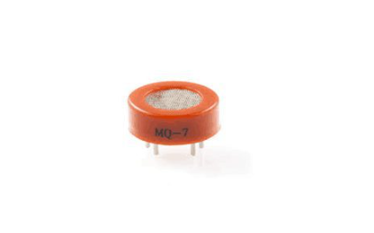

Key Features:
- Good sensitivity to Combustible gas.
- High sensitivity to Natural gas.
- Long life.
- Low cost.
- Simple drive circuit.

Smoke Sensor Connections:
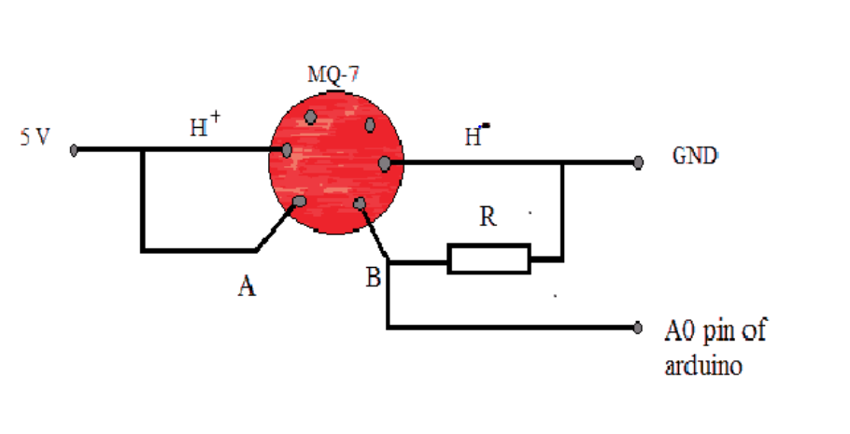
Five volts Connected across the heating (H) pins will keep the sensor hot enough to function correctly.
5 volts connect at either the pin A or pin B, this will result in the sensor to emit an analog voltage on the other pins.
A resistor between the output pins and ground sets the sensitivity of the detector.
The resistive load should be calibrated for your particular application using the equations in the datasheet, but a good starting value for the resistor is 10 kΩ.

Arduino Smoke detector connection diagram
In-circuit connection
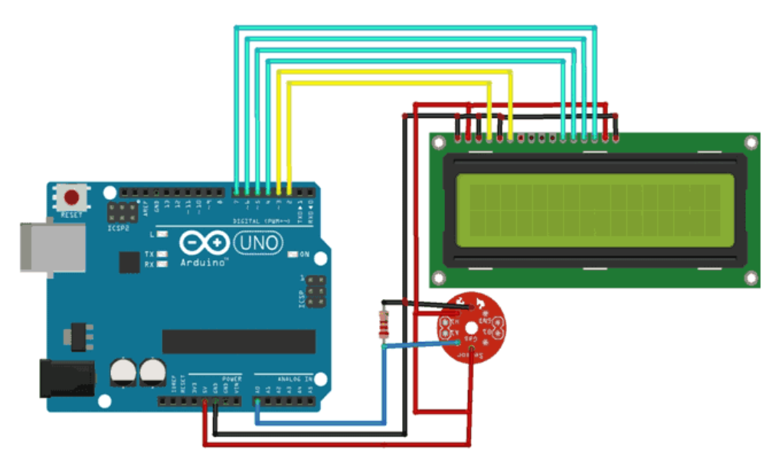

MQ-7 gas sensor’s
- Connect H pin to +5V Supply and the other one to Ground GND).
- Pin A is connected to the 5V pin. And the
- B pin is connect to the GND Pin and Pin A0 as shown on the pictures.

16×2 LCD connected in 4-bit mode as
- RS – pin 2
- En–pin 3
- D4-D7 –pin 4- pin7
- RW, LED-, Vss– GND and Vdd, LED+ – 5V

