Mini-implants are anchorage reinforcement products that are safe, minimally intrusive, and can be used to supplement orthodontic anchorage. Mini-implants are exempt from the traditional extraoral anchorage's compliance requirements. Mini-implants work better than traditional implants in as they are implanted into the bone, traditional intraoral anchorage designs. To address orthodontic malocclusion in the anteroposterior, vertical, and transverse dimensions, mini-implants can be inserted at various places in the maxilla and mandible.(1)

Titanium mini-screws have become extremely common in orthodontics during the past 20 years and are frequently used as a source of absolute intraoral anchorage, expanding the potential goals and range of orthodontic therapy. Another benefit is the potential for providing quick loading, which shortens the overall length of orthodontic therapy.(2) TADs give more consistent outcomes when compared to other anchorage mechanisms.

A novel type of orthodontic anchoring that uses orthodontic mini-implants (OMIs), also known as mini-screw implants and temporary anchorage devices, has emerged at the beginning of the twenty-first century (TADs). The average body (endosseous) dimensions of these modified bone screws are 1.5–2 mm in diameter and 6–10 mm in length. When opposed to dental implants, their surfaces are polished and smooth. They therefore rely on mechanical retention within the cortical layers of the alveolar and palatal bones rather than osseointegration.(3)

Orthodontic mini-implants were initially appealing because of the potential for them to offer dependable anchorage that is not dependent on the teeth and requires no more patient compliance than regular fixed appliance treatment. OMIs give anchorage in all three dimensions, which has only lately been realised.(3)

There have been many significant developments in orthodontics over the course of its century-long history, but few can compare to the therapeutic effect produced by micro-implants and the new orthodontic bone screws for the ***buccal shelf (BS) and infra-zygomatic crest (IZC).***(Figure 7.1a, 7.1b and 7.2) In the last ten years, the notion of absolute anchorage has been revitalised by the use of micro-implants and extra-radicular bone screws in orthodontics. An experienced physician may use it as an additional tool in their toolbox to meet new clinical difficulties and transition even surgical situations that are on the verge of becoming nonsurgical without sacrificing the outcomes attained.(4)

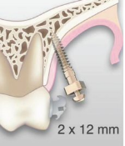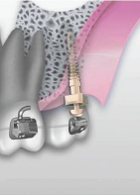

**Figure 7.1a; IZC**

**(Infrazygomatic Crest Implant)**

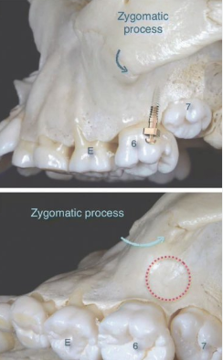

**Figure 7.1b; Infra‑Zygomatic Crest, Mini Screw**

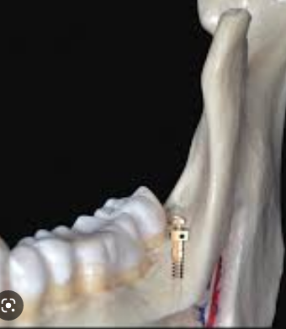

Figure 7.2Buccal Shelf, Mini Screw

**Micro‑Implants and Their Difference with Extra Radicular Bone Screws**

Although extra-radicular bone screws (IZC, BS) are positioned outside of these gaps in the infra-zygomatic sections of the maxilla and the buccal shelf portions of the mandible, micro-implants are still categorised as temporary anchorage devices.Micro-implants are typically positioned inside the radicular spaces between teeth. However, they are both used as skeleton anchors.(Figure 7.3)(5)

According to the therapeutic setting it must be utilised for, the average size of a micro-implant varies between 6 and 11 mm in length and 1.3-2 mm in diameter. Bone screws are frequently greater in size, with a minimum diameter of 2 mm and a length of 10 to 14 mm. Similar to how a micro-implant can have either a short or long head, depending on the anatomic site and the clinical circumstance, depending on the anatomic site, either a short or long collar was purchased. Like micro-implants, their head forms can also vary, with the typical shape being mushroom-shaped.

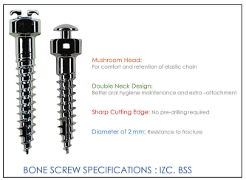

Figure 7.3; Bone Screw Specifications:

Infra‑Zygomatic Crest, BSS

**BONE SCREWS AND MICRO-IMPLANTS USE DIFFERENT TYPES OF MATERIALS.**

Although pure stainless steel is the desired material, the majority of micro-implants on the market are made of an alloy of titanium, aluminium, and vanadium (Ti6 Al4 Va), and bone screws are also available with comparable compositions. IZC and BS areas frequently receive bone screws which have DI (>1250 HU) grade bone, necessitating more fracture resistance. (Table 7.1)

The ideal material is stainless steel since it has stronger fracture resistance than Ti alloy.

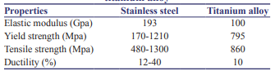

Table 7.1: Comparison of properties of stainless steel and titanium alloy

**COMPARISON OF COMPLICATIONS AND SUCCESS RATE OF BONE SCREWS TO MICRO‑IMPLANTS**

With the exception of minimal bleeding, inserting bone screws virtually ever results in problems. Screw tip breakage can be prevented by using high quality pure stainless steel screws. Gingival overgrowth on the screw and early screw loosening are two most frequent problems with bone screws. Maintaining good dental hygiene is essential to preventing complications caused by gingival expansion. With bigger heads on screws, gingival overgrowth is far less common. If a screw becomes prematurely loose, it is best to replace it at a different location.

Because of their bigger size and implantation locations with outstanding cortical bone quality, bone screws are significantly more stable and successful than micro-implants.

**NANOTECHNOLOGY IN TEMPRORY ANCHORAGE DEVICES**

The method of modifying matter at the nanoscale is known as nanotechnology. It has guaranteed positive outcomes in a variety of medical specialties, including dentistry.

In future, the concept of nanotechnology might be applied to dentistry and orthodontics. The periodontium will be traversed by nanorobots with particular motility mechanisms to be changed directly,increasing orthodontic tooth movement. This method can also be used to reduce root resorption while receiving orthodontic treatment.

The bone contains attachment sites for tads and if they function as independent anchorage, they directly improve orthodontic anchorage; if not, they do so indirectly by supporting and bolstering the anchoring teeth.(6) As a biologic barrier against microorganisms, healthy peri-implant tissue is essential. With the insertion of tiny screws, tissue irritation, mild infection, and peri-implantitis might develop.(7)

Peri-implantitis is an inflammation of the mucosa that surrounds the implant, and it is characterized by increasing mobility, loss of bone support that is clinically and radiographically visible, bleeding upon probing, suppuration, and infiltrations of epithelia. An increase of 30% in failure rate has been linked to inflammation of the soft tissue around the implant.(8)

Nanotechnology may be used to build temporary anchoring devices that can reduce the incidence of pain and suffering with just little alterations to their functional features. Pre-incorporated antibacterial agents or compounds, such as antibiotics, antiseptics, metal ions, or organic molecules, are used to modify the surface.This could change the implant from a medical device that is passive and pharmacologically inert to something that is more analogous to a drug agent, with uncertain long-term consequences and challenging regulatory difficulties. (9)

**NANOPARTICLES IN TEMPORARY ANCHORAGE DEVICES**

Today, TADs are made with titanium surfaces that are flat. Orthodontic loading and mini screw placement both have the potential to cause stability and patient safety issues. Pain, inflammation, infection, and peri-implantitis are common soft tissue concerns, along with aphthous ulceration, soft tissue covering of the tiny screw head and auxiliary, and others. Consequently, it is essential to lessen the discomfort and danger of peri-implant infection linked to the implantation of temporary anchoring devices. This can be done by making surface alterations utilizing pharmacologically active compounds.

Traditionally, "contact killing" and "drug eluting" have been the two major approaches suggested for efficient antibacterial surface treatment. Metals like silver, zinc, copper, etc, non-metal elements like iodine, selenium, organic chemicals like antibiotics, anti-infective peptides, chitosan, and other substances), can all be used in antibacterial surface technologies. The most common metal used in biomedical applications is silver.

Another intriguing technique focuses on titanium alloy alteration, which is a widely used alloy.

It has been extensively studied and demonstrated in vitro that titanium dioxide films have anti-infective properties, either alone or in combination with other chemicals. Because of their antiinfective qualities, nonmetal elements like oxygen, hydrogen, chlorine, or iodine are frequently used in biomedicine. Staphylococcus aureus and Staphylococcus epidermidisadhesion to titanium or titanium alloy implant discs has been found to be prevented by selenium bonded covalently to those surfaces without impacting osteoblast viability.(11)

**TADs SUPPORTED FROG APPLIANCE(Figure 7.4)**

One of the most typical situations seen in orthodontic clinics is class II malocclusion. Class II Div.2 malocclusion is characterised by mandibular retrognathism rather than maxillary prognathism, horizontal growth pattern, skeletal deep bite, retroclination of upper incisors, and wide soft tissue chin.(12) The available treatments include orthognathic surgery, growth modification, and orthodontic concealment. Premolar extraction or distalization of the maxillary molars might be used for camouflage.

Molar distalization has been achieved via a variety of methods.(12) TADs (temporary anchoring devices) are preferable because they require less patient cooperation. while minimizing unintended tooth movement and accomplishing planned tooth movement.

The components of a frog appliance kit are a screw, a premade spring, and a screwdriver. The frog screw should be positioned between 10 and 12 millimeters from the occlusal surface. As a result of the appliance being roughly at the centre of the molars' resistance, this causes movement of the teeth. Furthermore, lingual sheaths are soldered to the lingual surface of the upper first molar bands, and the frog appliance's anterior portion is soldered to the miniscrew cap. A multi-cure glass ionomer orthodontic band cement was utilised to bond the upper first and second molar bands during appliance insertion. The anterior portion of the appliance was then adjusted in TAD before the spring was put into the posterior portion. The ends of the distalizing spring were then inserted into the lingual sheaths of the molar bands.

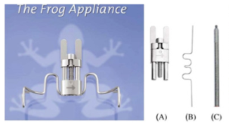

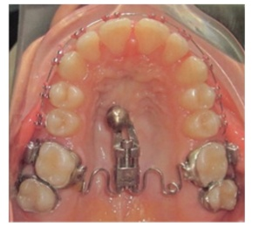

**Figure 7.4: Frog Appliance**

Palatal appliance, skeletal anchoring, hygienic movement in three dimensions, the ability to gauge the degree of distalization, ease of activation, and adjustable arms are some of the benefits of the frog appliance (not solder to bands).(13)

**MAXILLARY PROTRACTION THROUGH SKELETAL ANCHORAGE IN GROWING PATIENTS.**

A maxillary protraction face mask is typically used for early treatment of skeletal Class III patients. Due to the forces being delivered mostly to the teeth for 12 to 16 hours per day for 9 to 12 months, Dentoalveolar and skeletal movements used in this procedure result in a favourable overjet. The results of this orthopaedic therapy typically come with negative dentoalveolar side effects, such as proclination of the maxillary incisors, mesialization and extrusion of maxillary molars, and retroclination of mandibular incisors.Temporary anchoring devices (TADs), which are frequently employed in orthognathic surgery and fracture treatment, have become more popular in recent years. In recent studies, skeletal anchorage devices have been offered applications in orthopaedic therapies. They have been successfully used in orthodontics to induce a variety of motions, including molar distalization, open bite correction, and dental intrusion(14). TADs are used as skeletal anchoring in skeletal class III patients who have hypoplasia of the maxilla as determined by cephalometric examination and soft tissue profile evaluation, in addition to having class III molars and a negative overjet. (Figure 7.5)

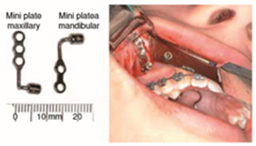

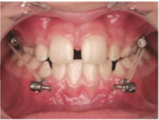

Figure 7.5: Class III Correction By Tads

These patients must be between the ages of 9 and 14 years old and in the pre-pubertal stage. (15) A different option for treatment is skeletal anchorage, which makes use of intermaxillary elastics, two titanium plates fixed with tiny implants inserted in the maxillary zygomatic process, and two side plates between the lower canines on the right and left. As a result, the maxilla advance, facial aesthetics improve, and dentoalveolar side effects are diminished.(16)

**MAXILLARY DISTALIZATION WITH TADs**

Temporary anchoring devices (TADs) are now a standard part of orthodontic treatment mechanics in the modern era. These tiny skeletal anchors, also known as mini-implants or mini-screws, have widened the range of non-surgical, non-extraction, and non-compliance treatment protocols by providing "absolute" anchorage and reducing the side effects of conventional orthodontic mechanics.(17)

The provision of anchoring for maxillary molar distalization is one of the TADs' more often used applications. Although it is not a cutting-edge therapeutic approach, there were a number of significant unexpected consequences previous to the use of skeletal anchorage, including dental tipping, bite opening, and anterior anchorage loss. Numerous appliances, such as the Distal Jet appliance, Pendulum appliance, Carriere® appliance, and Cetlin appliance, have been created in an effort to distalize employing dental anchoring efficiently.

**Technique One: Two-Stage Stabilizing Wire (Figure 7.6)**

The first premolar is stabilised by this system's inter-radicular TADs on the palate during distalization, and the first molar is stabilised during retraction.

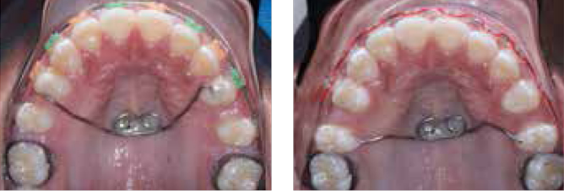

**Figure 7.6: Stage Mid Palatal TADS Based Stabilization**

No lab equipment is needed, and following sterilisation, the TAD can be used again and placed on the same patient, this distalization device is both easy to use and economical. The biggest drawback is the lengthy amount of "doctor-time" required at the chairside to create, bond, and remove and replace the TAD.

**Technique Two: TAD-Based Distal Jet (Figure 7.7)**

A modified version of the common tooth-borne distal jet device serves as the method's basis. (Allesee Orthodontic Appliances). The main source of anchoring is provided by the placement of two palatal TADs. In early appliance designs, wires were adhered to the palatal surface of the first premolars. Nevertheless, TAD anchoring is now the only option preferred.

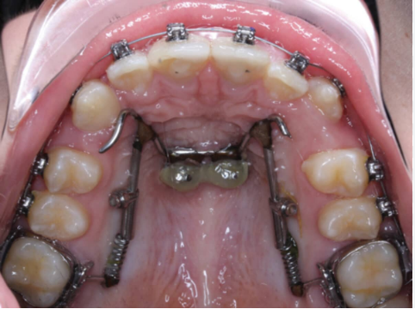

**Figure 7.7: Mid Palatal TAD Supported Distal Jet**

**THE SPIDER SCREW**

Since many conventional anchorage methods rely on patient participation, their success rates can be variable. The optimum anchorage solution that satisfies the clinical requirements of the orthodontist may be titanium miniscrews.Their advantages include dependability, patient acceptance, immediate loading, ease of insertion and ejection, and conformity to the orthodontist's anchorage requirements. The Spider Screw is a self-tapping, commercially pure titanium miniscrew made by the HDC Company in Sarcedo, Italy (hdc goldnet.it). Forces between 50 and 300 g are immediately capable of being applied to the screw. With this anchorage technique, complete osseointegration is neither anticipated nor desired. When orthodontic tooth movements require maximum anchorage due to extraction cases, poor cooperation, or mutilated dentitions in clinical settings, the Spider Screw anchorage system can be employed to support a range of orthodontic tooth movements. The diameters of this system are 1.5 mm or 2.0 mm. While the 2.0-mm diameter screw is available in lengths of 7.0, 9.0, or 11.0 mm, the 1.5-mm diameter screw is available in 6.0, 8.0, or 10.0 mm. Spider Screws are given out in single-use, packed, hygienic packets. To accommodate the soft tissues, both sizes are offered in low profile, low profile flat, and conventional transmucosal designs (Figure 7.8). The low profile flat screw has the same head combined with a short collar and is recommended in the thin tissue of the patient's anterior segments, while the regular design has an intermediate length and a round head. The low profile screw is used in the thick soft tissues of the posterior segments.(18).



**Figure 7.8 Different Heights Of Spider Screw**

**Head And Collar**



**Figure 7.9 Spider Screw Characteristics**

The Spider Screw's head is constructed with external and internal rectangular slots that range in size from 0.021 to 0.025 inches. Additionally, it contains a round interior vertical hole with a diameter of 0.025 inch (Figure 7.9). The extramucosal head of the screw is large enough to permit orthodontic attachments while being small enough to prevent soft tissue discomfort.

**Complications**

Inflammation of the peri-implant tissues, particularly in locations where there is frenum tissue or muscle tissue, is one potential consequence.With good oral hygiene and topical administration of a 0.2% chlorhexidine rinse, these issues can be managed. The insertion of the miniscrew high in the vestibule might occasionally result in difficulties with the mucosa. In these situations, the clinician should make an effort to adopt anchorage mechanics that call for little changes at the screw's orthodontic head. If the miniscrew becomes mobile, a longer, larger miniscrew can be used in its stead. If this is insufficient, another placement site should be selected. The patient will exhibit signs of pain on percussion or mastication if the periodontal ligament is unintentionally invaded during the miniscrew's insertion. The patient will become sensitive to heat and cold if a root is come in contact with during insertion. In these circumstances, the miniscrew ought to be taken out, and anti-inflammatory and perhaps antibacterial medication ought to be started. Only one study has been done so far on the variables affecting the stability of titanium screws.Three crucial criteria were identified by the study's findings. Screw diameter is the first factor, followed by peri-implant soft tissue inflammation and bone quality. This same study recommends using a longer, thicker-diameter screw and applying lesser forces to verify the screw's stability in the context of poor bone quality before applying bigger stresses. The management of inflammation appears to be a crucial aspect in all situations.Avoiding the frenum and placing the miniscrews in areas of keratinized gingiva will increase natural tissue resistance and make it easier for the patient to practise proper peri-implant hygiene while reducing inflammation. Finally, choose a screw with a collar length that is appropriate for the thickness of the local soft tissues.(19)

**REFERENCES**

1. Recent Advancements in Orthodontic Anchorage Using Mini-Implants. Int J Dentistry Res. 2021 Dec 30;6(3):78–80.

2. Jiman PA, Prodan D, Moldovan M, Muntean A, Sarosi C, Tarmure V, et al. New and Recovered Temporary Anchorage Devices, In Vitro Assessment of Structural and Surface Properties. Materials. 2021 Oct 21;14(21):6271.

3. Cousley RRJ, Sandler PJ. Advances in orthodontic anchorage with the use of mini-implant techniques. Br Dent J. 2015 Feb;218(3):E4–E4.

4. Ghosh A. Infra-Zygomatic Crest and Buccal Shelf - Orthodontic Bone Screws: A Leap Ahead of Micro-Implants – Clinical Perspectives. J Indian Orthod Soc. 2018 Dec 1;52(4_suppl2):127–41.

5. Lin JJJ, White LW. Creative orthodontics: blending the Damon System & TADs to manage difficult malocclusions. Taipei, Taiwan: Yong Chieh Company; 2007. 324 p.

6. Chawla K, Lamba AK, Gupta M, Khanna N. Treatment of peri-implantitis around orthodontic miniscrew using Er,Cr: YSGG Laser. Journal of Dental Lasers. 2012 Jul 1;6(2):66.

7. Joshi R, Shyagali TR, Jha R, Gupta A, Tiwari A, Tiwari T. Evaluation and Comparison of the Effect of Elastomeric Chain and Stainless Steel Ligature Wire on Maxillary Orthodontic Miniscrew Failure. Int J Appl Basic Med Res. 2021;11(2):100–5.

8. Yamaguchi M, Inami T, Ito K, Kasai K, Tanimoto Y. Mini-Implants in the Anchorage Armamentarium: New Paradigms in the Orthodontics. Int J Biomater. 2012;2012:394121.

9. Romanò CL, Scarponi S, Gallazzi E, Romanò D, Drago L. Antibacterial coating of implants in orthopaedics and trauma: a classification proposal in an evolving panorama. J Orthop Surg Res. 2015 Oct 1;10:157.

10. De Stefani A, Bruno G, Preo G, Gracco A. Application of Nanotechnology in Orthodontic Materials: A State-of-the-Art Review. Dent J (Basel). 2020 Nov 9;8(4):126.

11. Gallo J, Holinka M, Moucha CS. Antibacterial Surface Treatment for Orthopaedic Implants. Int J Mol Sci. 2014 Aug 11;15(8):13849–80.

12. Hilgers JJ. The pendulum appliance for Class II non-compliance therapy. J Clin Orthod. 1992 Nov;26(11):706–14.

13. Management of class II div.2 malocclusion using TADs supported frog appliance. This case report describes the effect of Temporary Anchorage Devices Supported Frog Appliance on Class II div2]. 2019 Dec 2 [ 2023 Mar 16];Volume 10

14. Cornelis MA, Scheffler NR, De Clerck HJ, Tulloch JFC, Behets CN. Systematic review of the experimental use of temporary skeletal anchorage devices in orthodontics. Am J Orthod Dentofacial Orthop. 2007 Apr;131(4 Suppl):S52-58.

15. De Clerck HJ, Proffit WR. Growth modification of the face: A current perspective with emphasis on Class III treatment. Am J Orthod Dentofacial Orthop. 2015 Jul;148(1):37–46.

16. González IGH, López EG. Maxillary protraction through skeletal anchorage in growing patients. Literature review. Revista Mexicana de Ortodoncia. 2016 Jul 1;4(3):e153–6.

17. Werner A. Maxillary Distalization with TADs [Internet]. Orthodontic Products. 2014 [cited 2023 Mar 14].

18. Maino BG, Bednar J, Pagin P, Mura P. The Spider Screw for Skeletal Anchorage. 2003;(2).

19. Kravitz ND, Kusnoto B. Risks and complications of orthodontic miniscrews. Am J Orthod Dentofacial Orthop. 2007 Apr;131(4 Suppl):S43-51.