ADVANCED PHYSIOTHERAPY IN THE MANAGEMENT OF VARIOUS PROBLEMS IN DOWN SYNDROME
Author - Dr.J. Ayesha ( Lecturer in East point College of physiotheraphy, ID - EPCPH029 ) , Dr . G.Sai Chetan ( Lecturer and clinical Physiotherapist in Vydehi Institute of Medical Sciences and Research center, ID - VIRC- 842 ).

INTRODUCTION

The objective of this program is to improve the quality of life for children with Down syndrome through the provision of early stimulation and developmental physiotherapy. These interventions are designed to expedite the attainment of developmental milestones.
Many infants with Down syndrome often exhibit low muscle tone, limited attention engagement, and restricted mobility. This apparent lack of curiosity and interest in their surroundings is a characteristic of Down syndrome, and it suggests that these children may benefit from increased sensory input. It's easy for these children to miss opportunities for exploration and learning during a crucial period of rapid brain and musculoskeletal growth and development, potentially preventing them from reaching their full potential. Interacting with and playing with the child is crucial in helping them become more aware of their body, their social and physical environment, and the relationships between them. In addition to these general activities, the child may also require specific activities to help them experience the sensations of normal movement.

It is essential to avoid overexerting the child, focusing on short and frequent bouts of exercise. This is particularly crucial for babies with heart issues, as they can fatigue more easily. The activities should be fun and enjoyable for the child.As the child matures and their curiosity about the world around them grows, it's important to provide a diverse array of objects and activities that are readily available to encourage and support their ongoing learning journey.

The program we've outlined serves as a guideline, highlighting fundamental principles to assist children with Down syndrome.

DOWN SYNDROME:
Down syndrome is a genetic condition and the most common autosomal chromosomal abnormality in humans. It arises when extra genetic material from chromosome 21 is introduced into a developing embryo. This surplus genetic material and genetic changes can result in differences in the development of the embryo and fetus, leading to physical and cognitive variations. It's crucial to recognize that each person with Down syndrome is unique, and the extent of their symptoms can differ considerably.

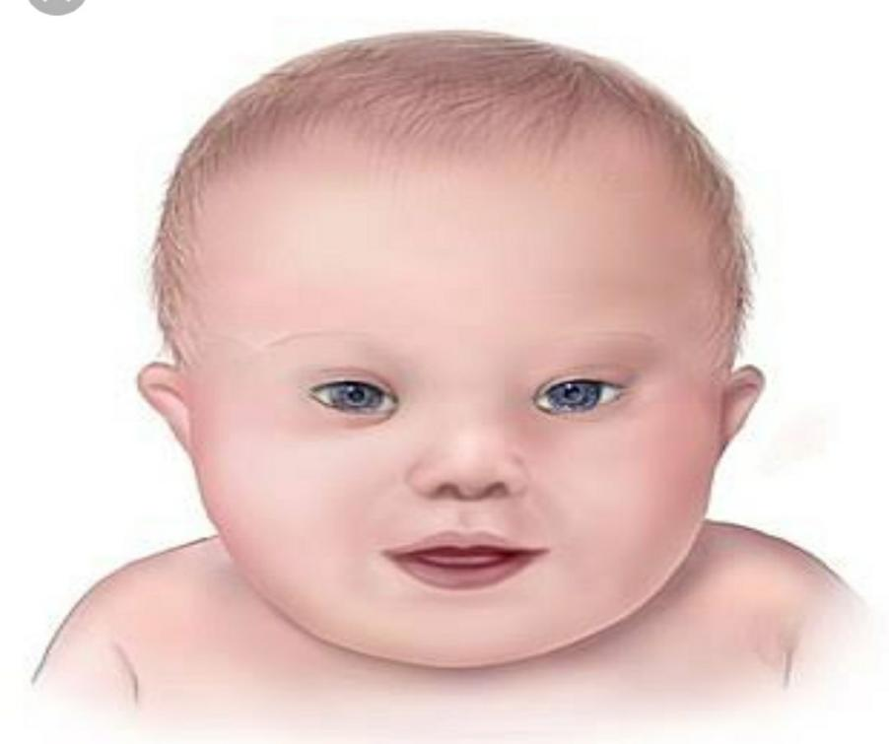

- Incidence
Roughly 1 in 800 to 1 in 1,000 live-born children, irrespective of gender, ethnicity, or racial background, are impacted by Down syndrome. While the commonly cited incidence of Down syndrome is approximately 1 in 660 live births, the documented occurrence in New Zealand between 1995 and 1998, as reported by the New Zealand Birth Defects Monitoring Programme, stands slightly above 1 in 1,000. This variation is attributed to both natural incidents and elective terminations. The incidence remains consistent across different ethnic groups, but it does escalate with the increasing age of the mother. Rates are approximately 1 in 1,500 for ages 15-29, 1 in 800 for ages 30-34, 1 in 270 for ages 35-39, 1 in 100 for ages 40-44, and 1 in 50 for ages over 45. It's notable that the majority of children with Down syndrome are born to mothers under 30 years of age, primarily due to the higher number of pregnancies in this age group.

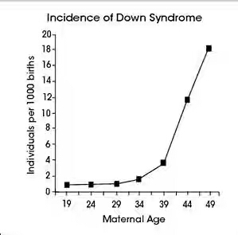
- causes
Down syndrome arises from a chromosomal anomaly in a baby's genetic makeup. Typically, a person possesses 46 chromosomes, but in most cases of Down syndrome, there is an extra chromosome, resulting in a total of 47 chromosomes. In rare instances, abnormalities in other chromosomes can also lead to Down syndrome. The presence of these additional or irregular chromosomes disrupts both brain and body development.

The specific cause of Down syndrome lies in irregular cell division processes involving chromosome 21. These abnormalities in cell division lead to the presence of an extra chromosome 21, either in part or in full. This surplus genetic material is responsible for the unique characteristics and developmental hurdles associated with Down syndrome. Three genetic variations can lead to the occurrence of Down syndrome.

- Trisomy 21- about 95% of the time Down syndrome caused by trisomy 21 the person has three copies of chromosome 21. Instead of usual two copies in all cells. This is caused by abnormal cell division during the development of the sperm cell or egg cell.
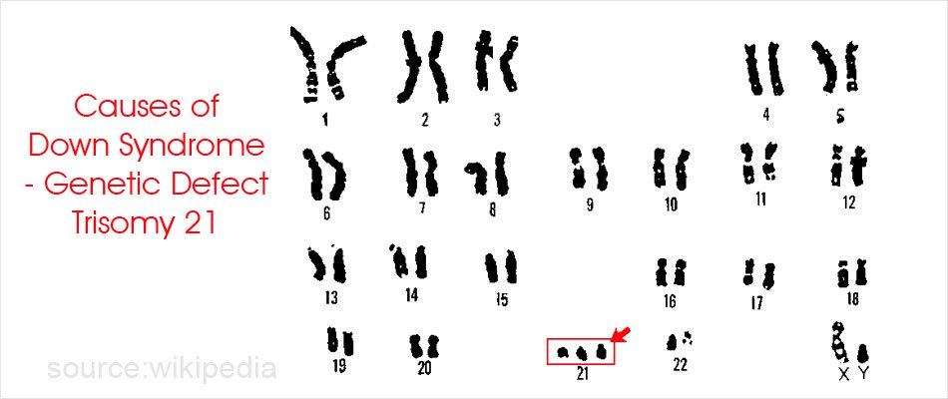

- Mosaic down syndrome- Mosaic Down syndrome, a less common variant of the condition, occurs when an individual possesses extra copies of chromosome 21 in only some of their cells, creating a mosaic pattern of both normal and abnormal cells. This mosaic of cells with different chromosomal compositions arises from irregular cell division that takes place after fertilization.
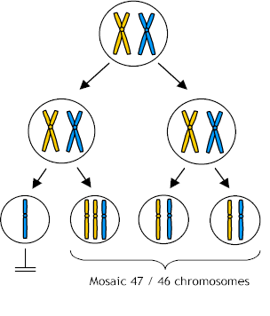
- Translocation down syndrome- Translocation Down syndrome can occur when a segment of chromosome 21 becomes attached (translocated) to another chromosome either before or during conception. Individuals with this form of Down syndrome possess the standard two copies of chromosome 21, but they also have supplementary genetic material from chromosome 21 affixed to another chromosome. It's important to note that there are no identified behavioral or environmental factors responsible for causing Down syndrome .

- Risk factors:
- Advancing maternal age – Maternal age plays a significant role in the risk of having a child with Down syndrome. The likelihood of this condition occurring rises as a woman gets older because older eggs are more prone to experiencing faulty chromosomal division. The risk of conceiving a child with Down syndrome notably escalates after the age of 35.
- Being carrier of the genetic translocation for Down syndrome- both men and women can pass the genetic translocation for Down syndrome to their children.Both men and women have the potential to transmit the genetic translocation associated with Down syndrome to their offspring.
- Signs & symptoms
Individuals with Down syndrome may experience a range of health issues, some of which may become more apparent as they age. These complications include:
- Cardiac abnormalities
- Gastrointestinal issues
- Immune system disorders
- Sleep apnea
- Excess weight or obesity
- Spinal concerns
- Leukemia
- Cognitive decline or dementia

Cardiac abnormalities
Heart defects are quite common among children with Down syndrome, affecting approximately 50% of them at birth. Some of these heart issues can pose serious risks to the child's health and might necessitate early surgical intervention in infancy.

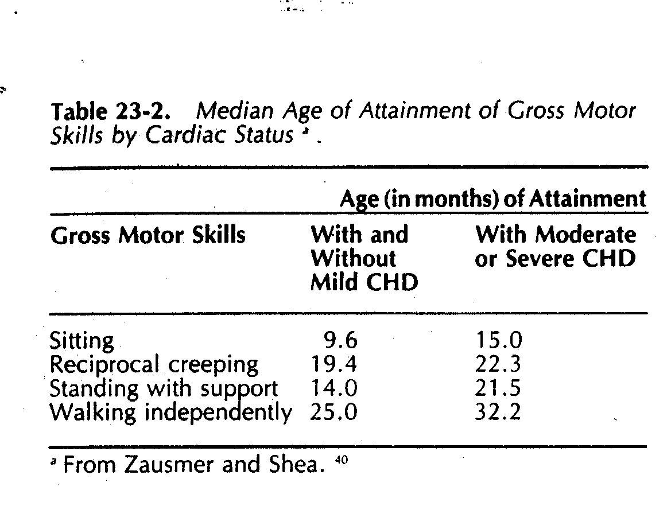
Gastro intestinal Issues:
Children with Down syndrome may experience digestive irregularities, which can affect various parts of their gastrointestinal system, including the intestines, esophagus, trachea, and anus. They have an increased susceptibility to developing digestive problems such as gastrointestinal obstructions, gastroesophageal reflux (commonly known as heartburn), and celiac disease.
Immune disorders:
People with Down syndrome may have immune system irregularities that increase their vulnerability to autoimmune conditions, specific cancers, and infectious diseases such as pneumonia.
Sleep apnoea:
Due to changes in soft tissue and skeletal structures that can result in the obstruction of their airways, individuals with Down syndrome are at a higher risk of experiencing obstructive sleep apnea.
Obesity
Individuals with Down syndrome have a heightened susceptibility to obesity in contrast to the general population. .
Spinal problems:
Some individuals with Down syndrome may encounter a condition called Atlanto-axial instability, which involves the misalignment of two neck vertebrae. This condition elevates the risk of severe spinal cord injuries due to the overextension of the neck.
leukemia
Young children with Down syndrome face an elevated risk of developing leukemia.

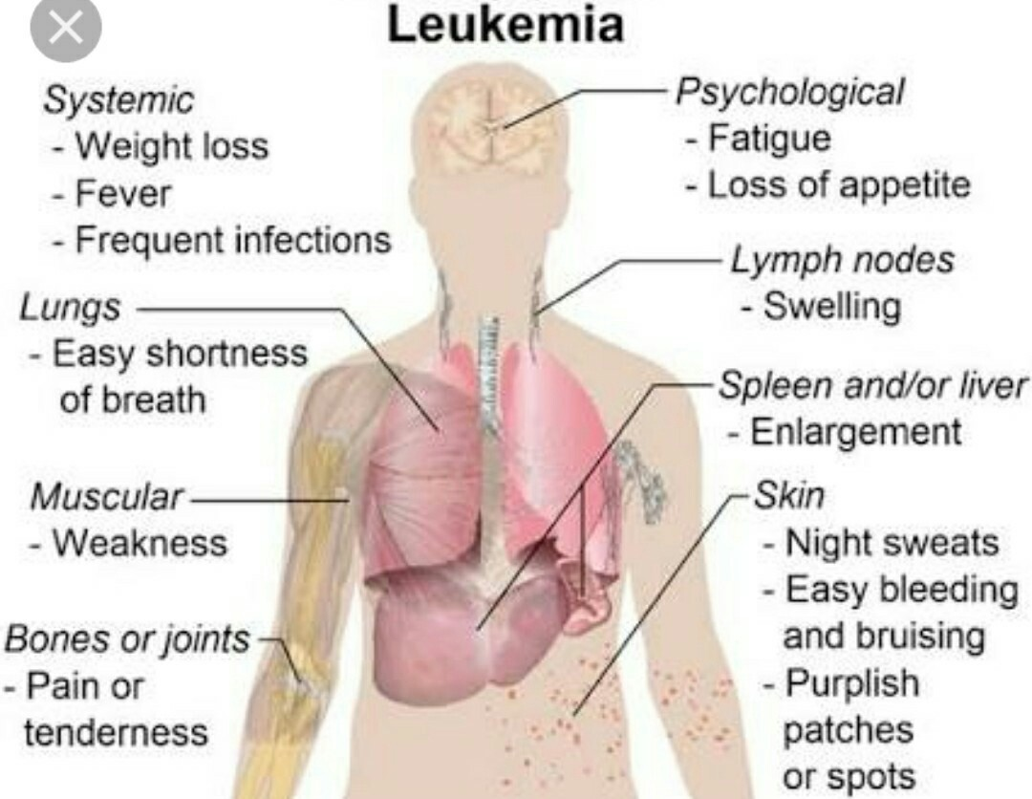
Dementia:
Individuals with Down syndrome are considerably more prone to developing dementia, with signs and symptoms typically appearing around the age of 50. Having Down syndrome elevates the probability of developing Alzheimer's disease.

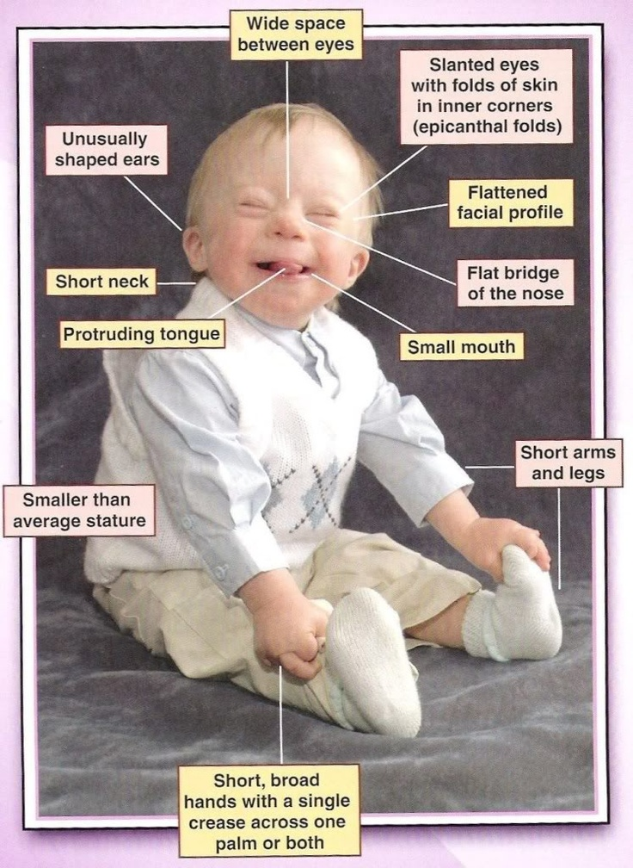
Other Health Concerns:

- Endocrine issues
- Dental complications
- Seizures
- Ear infections
- Hearing and vision impairments
- Infections
- Hypothyroidism
- Hypotonia (reduced muscle tone)
- Blood disorders
- Upper spinal problems
- Disrupted sleep patterns and sleep disorders
- Gum diseases and dental issues
- Epilepsy
- Digestive difficulties
- Celiac disease (gluten intolerance)
- Emotional and mental health challenges
Vision Issues:
A majority, over 60%, of children with Down syndrome encounter vision-related problems, including congenital cataracts. The risk of cataracts tends to increase with age, and other potential eye issues may include nearsightedness, strabismus (crossed eyes), and nystagmus (rapid, involuntary eye movements).

Hearing Impairment:
Around 70-75% of children with Down syndrome experience some level of hearing loss, sometimes attributed to ear structural issues. Furthermore, children with Down syndrome are more susceptible to recurrent ear infections.

Susceptibility to Infections:
Individuals with Down syndrome face a significantly elevated risk, approximately 12 times higher, of succumbing to untreated and unmonitored infections. Down syndrome often leads to immune system challenges, making it harder for the body to combat infections. Newborns with Down syndrome have a substantially increased risk, approximately 60 times higher, of developing pneumonia, especially during the first year of life.

Hypothyroidism:
Hypothyroidism, a condition characterized by insufficient or absent thyroid hormone production, is more commonly observed in children with Down syndrome.

Blood Disorders:
Children with Down syndrome face a significantly increased risk, approximately 10-15 times greater than other children, of developing leukemia. Moreover, individuals with Down syndrome are more susceptible to conditions like anemia, polycythemia, and other blood-related disorders.

Hypotonia:
Insufficient muscle tone and reduced strength contribute to the delay in achieving developmental milestones such as rolling over, sitting up, crawling, and walking, which are common in children with Down syndrome. Weak muscles can also lead to various digestive issues, including difficulties with swallowing and constipation.

Upper Spinal Problems:
Between one and two out of every five children with Down syndrome may have malformations in the upper part of their spine, located beneath the base of the skull.

Sleep Disruptions and Sleep Disorders:
Children with Down syndrome frequently experience disrupted sleep patterns and are prone to obstructive sleep apnea, characterized by significant interruptions in breathing during sleep.

Gum Diseases and Dental Issues:
Children with Down syndrome may exhibit delayed tooth development compared to their peers. They might also experience variations in the sequence of tooth eruption, have fewer teeth, encounter misalignment issues, and face an elevated risk of gum disease.
Epilepsy:
Children with Down syndrome have a higher likelihood of developing epilepsy, a condition characterized by seizures. The risk of epilepsy increases with age, with seizures typically occurring either during the first two years of life or after the third decade of life.
Digestive problems
Digestive Issues:
Digestive problems in individuals with Down syndrome encompass a range of issues, which can include structural abnormalities within the digestive system or its organs. Some individuals with Down syndrome may require a specialized diet that they need to adhere to throughout their lifetime.

Celiac Disease:
People with celiac disease experience digestive problems when they consume gluten, a protein found in wheat and barley.

Mental Health and Emotional Challenges:
Children with Down syndrome may encounter behavioral and emotional difficulties, which can encompass conditions like anxiety, depression, and attention deficit hyperactivity disorder. Additionally, they may exhibit repetitive movements, aggression, autism spectrum disorder, psychosis, or social withdrawal.

Intellectual Disability:
Virtually all babies with Down syndrome experience some degree of intellectual disability, typically falling in the mild to moderate range. This intellectual delay begins in the first year of life, with the average age for sitting (11 months) and walking (26 months) being approximately twice that of typically developing children. First words typically emerge around 18 months. IQ tends to decline during the first decade of life, reaching a plateau in adolescence that continues into adulthood.

Growth:

Individuals with Down syndrome typically exhibit lower weight and length compared to the general population.
Their growth rate is reduced.
Interestingly, the prevalence of obesity is higher in individuals with Down syndrome.
Infants with Down syndrome tend to have a weight that is lower than expected for their length, but it increases disproportionately over time, leading to obesity by the age of 3-4 years.
Eye Problems:
The most common eye disorders in individuals with Down syndrome include:

Refractive errors, affecting 35-76% of them.
Strabismus, observed in 25-57%.
Nystagmus, occurring in 18-23%.
Cataracts are present in 5% of newborns, and this frequency tends to increase with age.

Reproduction:
Women with Down syndrome maintain their fertility and can conceive.
In contrast, nearly all males with Down syndrome are typically infertile due to impaired spermatogenesis.
Skeletal Abnormalities:

An increased range of motion in the atlas (C1) and axis (C2) vertebrae can lead to atlanto-axial instability, a condition characterized by cervical spine subluxation.
Diagnosis of this condition is usually established through lateral neck radiography.
Other skeletal anomalies may include flat feet, dysgenesis of the middle phalanx in the little finger, a narrow maxilla, and syndactyly.
Skin Disorders:
Common skin conditions observed in individuals with Down syndrome encompass:
Palmoplantar hyperkeratosis.
Seborrheic dermatitis.
Fissured tongue.
Cutis marmorata.
Geographic tongue.
Xerosis.
- Signs
Physical features that are often associated with Down syndrome include:

- A single crease in the palm of the hand.
- Small ears.
- A small mouth.
- Upward-slanting eyes.
- Short, broad hands with stubby fingers.
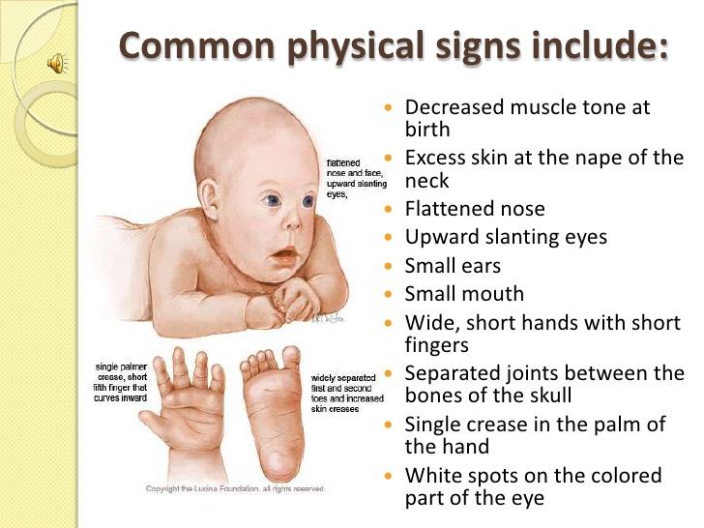

Mental
- Impaired judgment.
- Slower learning ability.
Medical:

- Congenital heart defects.
- Ocular issues often requiring glasses.
- Hip problems.
- Hypothyroidism.
Neonatal Features:

- Flat facial profile.
- Limited Moro reflex.
- Excessive skin at the nape of the neck.
- Slanted palpebral fissures.
- Hypotonia.
- Joint hyperflexibility.
- Pelvic dysplasia.
- Unusual ear features.
- Dysplasia of the middle phalanx of the fifth finger.
- Presence of a transverse palmar crease (simian crease).
NERVOUS SYSTEM:-
- Reduction in brain weight by 76%.
- Brainstem and cerebellum size approximately 66% of the normal size.
- Simplification of the convolutional pattern in the brain.
- Thinner dendrites, shorter spines, and fewer dendritic spines.
- Lower synaptic density in the visual cortex, ranging from 1 to 28% less than typical.
- Diminished surface area of synaptic connections in the brain.
- Presence of abnormal neurons in the cerebrum, often in reduced numbers.
- Occasional delays in myelination, although not in all cases.
- Premature aging characterized by mineral deposits in approximately 33% of cases, the presence of spinal plaques, and the occurrence of neurofibrillary tangles similar to those found in Alzheimer's disease.
Progression of Motor Skills
• Delayed but with significant variability.
• Early motor development is influenced by factors such as muscle tone and overall health.

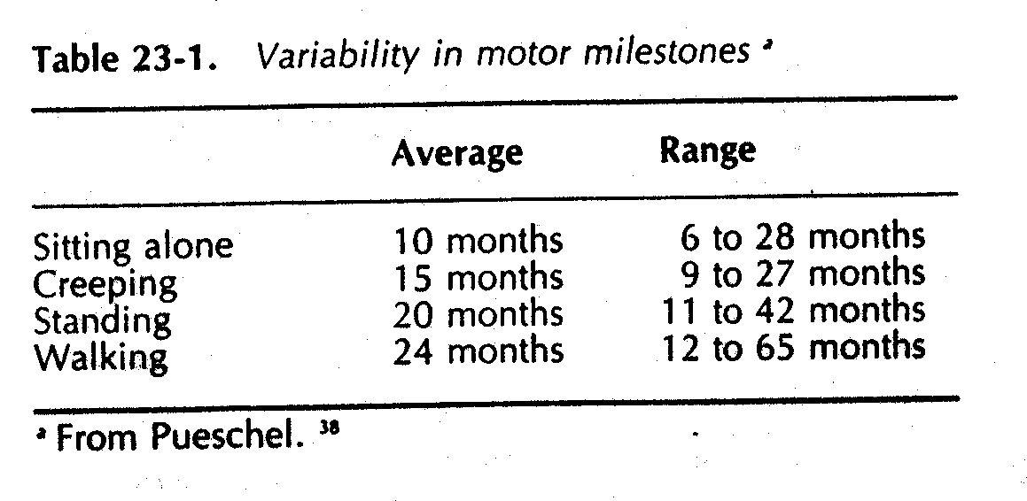
Contributing Factors to Motor Delay
• Diminished muscle strength and reduced capacity to activate muscles.
• Some joints exhibit ligamentous laxity.
• Slower reaction time in the central nervous system (CNS).
• Impairments in processing and integrating information across various sensory modalities, including visual, proprioceptive, and auditory.
• Gradual development of righting and equilibrium responses.
• Heightened sensitivity in the hands and knees.
Early Motor Development
• Frequently during infancy, performance on cognitive scales exceeds that on motor scales.
• Infants often demonstrate proficiency in maintaining postures but struggle with weight-shifting and rotational components of movement crucial for transitional actions.
• They may spend more time in a supine position, resulting in a more limited range of movement experiences.
• More often than typical children (who also spend time in a supine position), they may exhibit hypersensitivity in their hands and feet.

Gait
• Often exhibit flat-footed contact rather than heel-to-toe.
• Experience reduced push-off during walking.
• May demonstrate out-toeing of the feet.
• Display smaller step lengths.
• Spend less time with weight on one leg.
• Show increased hip and knee flexion during the stance phase.
• Delayed development of calf strength, affecting the transition to push-off.
• Greater variability in gait characteristics among children with Down syndrome.
Muscle Tone:
• The degree of resistance to passive movement.
• Assessment methods??
• Compare muscle consistency using foam rolls.
• Sustaining joint angles when exposed to external loads. Individuals with Down syndrome often exhibit less voluntary stiffening and lack of damping.
• The effects of training are inconclusive, but difficulties in muscle activation have been observed.
Postural Control
• Delay in the development of equilibrium reactions.
• Prolonged onset latency of postural reactions.
• Slower and less efficient postural responses compared to typical children when exposed to a moving platform, resulting in increased muscle sway (Shumway-Cook).

Sensory Factors
• Asymmetrical pointing disrupts spatial sense.
• Reduced integration of information across sensory modalities, such as visual and proprioceptive.
• Consistently, auditory processing lags behind visual task performance.
• Greater reliance on visual cues for balance, with an extended need for a higher level of vestibular input.
• Improvement observed with practice.
• Approximately 78% may have hearing impairments.
• Relative strength in visual imitation skills.

TRUNK POPSITIONING:
Trunk positioning is another noteworthy example. The presence of ligamentous laxity, hypotonia, and diminished trunk strength all play a role in the development of kyphosis, which is often evident as children with Down syndrome learn to sit. These children frequently adopt a sitting posture characterized by a posterior pelvic tilt, a rounded trunk, and the head reclining backward on the shoulders. They struggle to actively adjust their pelvis into an upright position, which, consequently, hampers their ability to maintain proper alignment of the head and trunk. If this posture persists, it can eventually result in compromised breathing and a limited capacity to rotate the trunk.
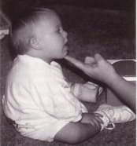
Diagnosis
The American College of Obstetricians and Gynecologists recommends offering all pregnant women the choice to undergo screening and diagnostic tests for Down syndrome, regardless of their age.

Screening Tests: These tests can offer an estimate of the likelihood that a pregnant mother is carrying a baby with Down syndrome. However, it's important to note that screening tests cannot definitively confirm or diagnose the presence of Down syndrome in the baby.

Diagnostic Tests: Diagnostic tests are capable of confirming or ruling out the presence of Down syndrome in the baby. Your healthcare provider can discuss the different testing options, their advantages and disadvantages, potential benefits and risks, and the significance of the test results with you. If deemed appropriate, your provider may recommend consulting with a genetic counselor.

Prenatal Screening for Down Syndrome

Screening for Down syndrome is a standard component of prenatal care. Although screening tests alone cannot definitively diagnose Down syndrome, they play a crucial role in helping you make informed decisions about whether to proceed with more precise diagnostic tests.
Screening tests include the first trimester combined test and the integrated screening test.
Types of Screening Tests
Screening tests for Down syndrome include the first trimester combined test and the integrated screening test.
First Trimester Combined Test:
This two-step test involves the following:
Blood Test: It assesses the levels of pregnancy-associated plasma protein-A (PAPP-A) and human chorionic gonadotropin (HCG), a pregnancy hormone. Abnormal levels of these substances may indicate a potential issue with the baby.
Nuchal Translucency Test: This test uses ultrasound to measure a specific area at the back of the baby's neck, referred to as the nuchal translucency. An accumulation of more fluid than usual in this neck tissue may suggest abnormalities. Based on your age and the results of both the blood test and the ultrasound, your physician or genetic counselor can estimate your risk of having a baby with Down syndrome.

Integrated Screening Test

The integrated screening test is conducted in two parts during the first and second trimesters of pregnancy. The combined results are used to estimate the risk of your baby having Down syndrome.

First Trimester: In the first trimester, the initial phase consists of a blood test to measure PAPP-A levels and an ultrasound examination to assess nuchal translucency.

Second Trimester: During the second trimester, the quad screen evaluates your blood levels of four pregnancy-related substances: alpha-fetoprotein, estriol, HCG, and inhibin A. These results are important in the comprehensive risk assessment for Down syndrome.

Diagnostic tests during pregnancy

If your screening test results are positive or indicate a potential concern, or if you are at an increased risk of having a baby with Down syndrome, you might consider pursuing additional tests for a definitive diagnosis. Your healthcare provider will guide you through the advantages and disadvantages of these tests.

Diagnostic tests that can confirm Down syndrome include:

Chorionic Villus Sampling (CVS): CVS involves the retrieval of cells from the placenta for the examination of fetal chromosomes. This procedure is typically performed during the first trimester, usually between 10 and 13 weeks of pregnancy. Importantly, the risk of miscarriage associated with CVS is extremely low.

Amniocentesis: Amniocentesis entails the extraction of a sample of amniotic fluid that surrounds the fetus by using a needle inserted into the mother's uterus. The fluid sample is then used for the analysis of the fetus's chromosomes. This test is usually conducted during the second trimester, after 15 weeks of pregnancy. Similar to CVS, the risk of miscarriage associated with amniocentesis is very low.

For couples undergoing in vitro fertilization and facing an elevated risk of transmitting specific genetic conditions, there is also the option of Pre-implantation Genetic Diagnosis (PGD). This procedure involves screening the embryo for genetic abnormalities before it is implanted in the uterus.

Diagnostic tests for newborns
After birth, the initial diagnosis of Down syndrome is often based on the physical characteristics of the baby. However, it's important to note that these features can also be found in infants who do not have Down syndrome. Consequently, your healthcare provider will typically recommend a chromosomal karyotype test to confirm the diagnosis. This test involves the examination of your child's chromosomes using a blood sample. If the test shows the presence of an additional chromosome 21 in either all or some of the cells, the diagnosis of Down syndrome is confirmed

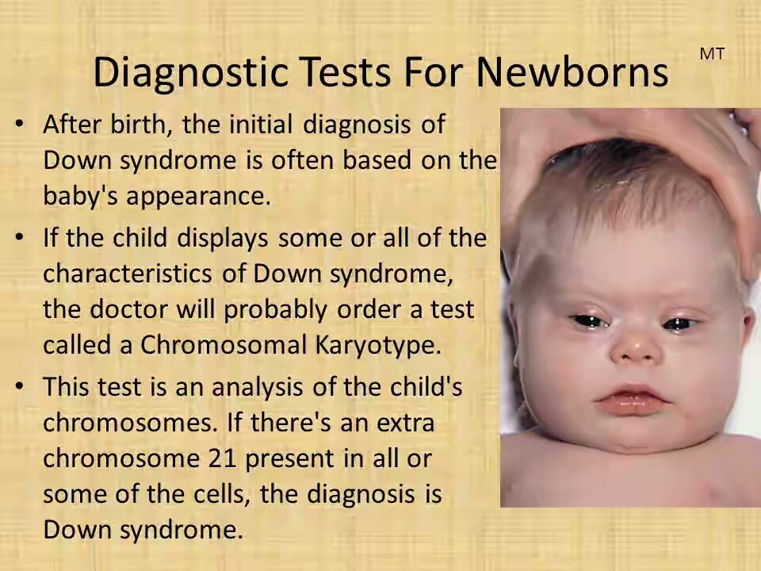

Treatment

Early intervention for infants and children diagnosed with Down syndrome is crucial to improve their overall quality of life. Since each child with Down syndrome is unique, treatment plans should be personalized to meet their specific needs. Additionally, different stages of life may require different types of services.

Collaborative Care Team:

If you have a child with Down syndrome, you will likely rely on a multidisciplinary team of healthcare professionals who can provide medical care and support to help your child reach their full potential. Depending on your child's individual needs, your healthcare team may include a range of specialists, such as:
- A primary care pediatrician who coordinates and provides routine childhood care.
- Pediatric cardiologist specializing in heart-related issues.
- Pediatric gastroenterologist with expertise in digestive health.
- Pediatric endocrinologist focused on hormonal concerns.
- Developmental pediatrician who specializes in child development.
- Pediatric neurologist addressing neurological matters.
- Pediatric ear, nose, and throat (ENT) specialist for ear, nose, and throat issues.
- Pediatric eye doctor (ophthalmologist) managing vision and eye health.
- Audiologist specializing in hearing and auditory issues.
- Speech pathologist to assist with speech and language development.
- Physical therapist providing physical development support.
- Occupational therapist helping with daily life skills and activities of daily living.

These experts can work together to assess your child's needs and provide guidance on available resources in your community, as well as information on state and federal programs designed to support children and adults with disabilities.

You'll have to make significant choices regarding your child's medical care and educational opportunities. Assemble a team of healthcare providers, educators, and therapists whom you have confidence in. These experts can assist in assessing the available resources in your locality and provide information about state and federal initiatives designed for children and adults with disabilities.

MEDICATIONS

- Medications can be utilized to address specific health issues that may surface in individuals with Down syndrome.
- For example, in the instance of a person with Down syndrome dealing with a seizure disorder, anti-seizure medications can offer relief and benefits.
- Individuals with thyroid problems frequently rely on thyroid replacement hormones.
- It's important to note that while these medications effectively manage their respective medical conditions, they do not have any influence on Down syndrome itself.
- It's essential to understand that there is currently no medication available that can cure Down syndrome.

MEDICAL TREATMENT:

People with Down syndrome are at an increased risk of specific medical conditions.

Common health issues for individuals with Down syndrome include heart defects, thyroid problems, as well as muscular, joint, vision, and hearing difficulties.

Less frequently encountered conditions in individuals with Down syndrome involve leukemia and seizures.

SURGICAL TREATMENT:

Certain medical conditions observed in children with Down syndrome may necessitate surgical procedures.

For example, around 40% of children with Down syndrome are born with congenital heart defects. While some of these defects may be mild and self-resolving, others are more severe and require surgical intervention.

Children with Down syndrome may also develop intestinal abnormalities that demand surgical treatment.

Importantly, the need for surgery is unrelated to the cognitive impairment associated with Down syndrome. In simpler terms, the necessity for surgery does not indicate a more severe form of Down syndrome.

SYMPTOMATIC PROBLEMS& TREATMENT IN DOWN SYNDROME:
- In Down syndrome, short stature is nearly always present, and its origin is multifaceted. While genetic factors play a role, it can also be associated with conditions like hyperthyroidism, celiac disease, renal diseases, or nutritional deficiencies. However, in most cases, its precise cause cannot be conclusively identified
TREATMENT:
Administering human recombinant growth hormone (hrGH) therapy to children with Down syndrome boosts their growth rate and overall stature.
- Immunology and auto immune disease
Immunology and Autoimmune Disorders: In Down syndrome, irregularities in the immune system are a persistent and intricate aspect.
TERATMENT:
Administering zinc supplements to children with Down syndrome has demonstrated favorable effects on certain immune parameters and a decrease in recurrent infections.
Similarly, selenium supplementation can also lower the frequency of infections in children with Down syndrome.

- COELIAC DISEASE:
It is relatively infrequent and arises from gluten intolerance.
In the context of Down syndrome, its occurrence is significantly higher, specifically at 62%.

TREATMENT:
The treatment involves the complete elimination of gluten from the diet, resulting in full recovery.
However, it's crucial to maintain the gluten-free diet for an extended and indefinite duration.

- LEUKEMIA:
Down syndrome children accounts for approximately 3% of children with acute lymphoblastic leukemia and 5-8% of children with acute myeloid leukemia.
- CONGENITAL MALFORMATION:
Close to 50% of infants born with Down syndrome exhibit congenital heart conditions, which often include atrioventricular canal defects or endocardial cushion defects.
TREATMENT:
Surgical correction is a viable treatment option.
- RESPIRATORY PROBLEMS:
Among individuals with Down syndrome, cardiac anomalies with heightened pulmonary flow are the prevailing issue. Symptoms typically manifest early, and pulmonary artery hypertension rapidly ensues, resulting in conditions like cardiomegaly, hepatic cirrhosis, heart failure, and recurrent respiratory infections.
Treatment:
Surgical corrections are employed as the primary method of treatment.

- GASTRO INTESTINAL MALFORMATIONS:
Gastrointestinal malformations are more prevalent in individuals with Down syndrome, with duodenal stenosis constituting about half of all congenital duodenal stenosis cases.
-Urinary tract malformations such as congenital hydronephrosis and obstructive uropathy can be found in individuals with Down syndrome. Early diagnosis is crucial for these conditions, and surgical corrections are typically required.

- ORTHOPEDIC DISORDERS:
The most prevalent orthopedic disorder in individuals with Down syndrome is ligamentous laxity. Atlanto-axial instability has garnered significant attention.
Common problems include flat feet, patella instability, and genu valgum. Atlanto-axial instability is typically asymptomatic, but there is an increased risk of dislocation after cervical trauma or sudden, forceful head movements.
Compression of the cervical medulla can lead to neurological complications such as an unsteady gait, paraplegia, quadriplegia, and urinary incontinence, often preceded by head deviation.
- Retardation of skeletal maturation
- Retardation in growth of cranium
- Narrow palate-100%
- Rib anomalies
- Decreased acetabular and iliac angles (most)
- Instability patello-femoral joint-4 to 8%
- Increased incidence mild scoliosis
- Foot anomalies; metatarsus primus varus, pes planus, hindfoot valgus
- Increased incidence of muscles missing (finger and wrist flexors,psoas minor)
- Lack of differentiation of midface musculature
- Hyperflexible joints due to ligamentous laxity (deficit in collagen)
- Abnormally large space and excessive movement between first and second cervical vertebrae
- Cord may become compressed.
- 12-20% of children with down syndrome
- estimated 1 to 2% may be symptomatic
- Abnormal gait
- Head tilt, limited neck motion, neck pain
•Symptoms related to the pyramidal tract, including challenges with walking, spasticity, heightened reflexes, lack of coordination, awkward movements, and potential loss of bladder or bowel control.
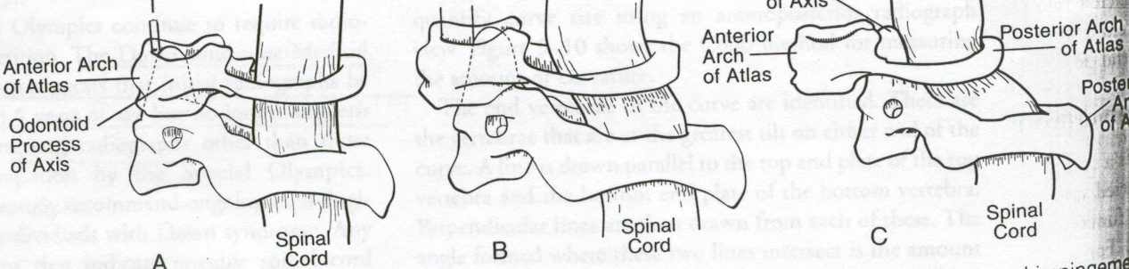

TREATMENT:
Children with an elevated risk of dislocation should avoid engaging in hazardous sports or activities.
For symptomatic cases, surgical stabilization can yield positive outcomes.
- SENSORY DEFICITS:
Sensory deficits, be they visual or auditory, hold significant importance in the mental development of children with Down syndrome.
Ocular abnormalities are more prevalent in this group compared to other children, and there is an elevated incidence of middle ear pathology.
Treatment:

Spectacles and hearing aids can provide positive outcomes.
In severe cases, surgical correction may be required.
10)MUSCULO SKELETAL ABNORMALITIES:
Reduced Muscle Strength: Motor function in individuals with Down syndrome is distinguished by hypotonia and hyperflexibility, which heightens the risk of joint dislocation and delays the development of motor skills.
11) VITAMIN-D DEFICENCY
Their is a damaging effect of vitamin –D insufficiency on musculo skeletal health in children and adolescences.
- BONE MASS:
Skeletal abnormalities are observed in individuals with Down syndrome due to factors such as low bone mineral density, limited physical activity, reduced muscle strength, inadequate sunlight exposure, and low levels of
vitamin D.

Physiotherapy management &assessment in Down syndrome
Physical therapists collaborate with families and healthcare experts to alleviate or prevent these symptoms. Ensuring a robust educational setting and comprehensive medical care, including therapy from preschool through high school and into adulthood, is crucial. The support of families is instrumental in maintaining the health of adults with Down syndrome at optimal levels.
Assessment & evaluation includes:
- Birth and Developmental History:
Physiotherapists will inquire about the child's birth and developmental milestones, including when they achieved head control, rolled over, sat up, crawled, and walked, among other milestones. This assessment assists the physiotherapist in designing a rehabilitation plan that facilitates the child's ability to engage in various activities with greater ease.
- Physical Examination: The physical examination encompasses measurements of the child's height and weight, observation of their movement patterns, hands-on assessments of muscle strength, tone, and flexibility, as well as evaluations of the child's balance and coordination.

- General Health Questions: The physiotherapist may inquire about your child's health, including whether they have been unwell or hospitalized, and if any health issues were discussed during those visits. Additionally, they may ask about your child's most recent visit to a physician or healthcare professional.

- Motor Development Tests: The physical therapist will conduct targeted assessments to evaluate the child's motor development, which may include their ability to sit, crawl, stand up, and walk. Additionally, the physical therapist may assess your child's hand coordination, vision, language skills, cognitive abilities, and other aspects of their development.
As needed, your physiotherapist may collaborate with other healthcare experts to form a comprehensive team dedicated to meeting the child's requirements. A physical therapist plays a vital role in the healthcare and physical fitness aspects of your child's growth. They assist individuals with Down syndrome in building strength and mobility to optimize their performance across all life stages.
Physical activity is an integral component of a child with Down syndrome's overall health, fitness, and well-being. It plays a crucial role in enhancing bone development, refining motor skills, and fostering balance and coordination abilities. Furthermore, engaging in physical activity fosters the growth of social skills, encourages independence, and contributes to maintaining a healthy body weight.
Sufficient physical activity can lead to improved sleep, concentration, academic performance, and self-esteem. Beyond these immediate benefits, regular physical activity offers enduring advantages by reducing the risk of developing conditions such as heart disease, type 2 diabetes, osteoporosis, depression, and obesity. These long-term health benefits are especially significant for individuals with Down syndrome, given their elevated susceptibility to these conditions.

Activity guidelines for children with Down syndrome
According to these guidelines:

Toddlers (1-3 years) and preschoolers (3-5 years) should engage in daily physical activity for a minimum of three hours. This should involve activities like standing, moving about, active play, running, and jumping.
Primary school-aged children (5-12 years) and adolescents (12-18 years) should participate in at least sixty minutes of activities that are of moderate and vigorous intensity each day. For additional health benefits, they should engage in twenty minutes or more of vigorous activity on at least three to four days per week. Moderate activities are those that elevate heart rate and breathing and lead to a mild perspiration.
The provided guidelines represent the minimum recommended thresholds for children's physical activity. Some research indicates that these guidelines may be somewhat conservative and that children and adolescents might benefit from engaging in closer to 120-150 minutes of daily physical activity. As the adage goes, while any amount of physical activity is beneficial, more physical activity offers even greater advantages!
Assessment
  - History: health, progress, current status, caregivers,
  - Observation of spontaneous movement, quality of movement, positioning and handling by parent
  - Postural alignment, resistance to passive movement, strength, range of motion, postural reactions, response to sensory stimuli
Tests
Testing involves the use of standardized assessments, and it's important to avoid placing excessive emphasis on specific developmental ages. Overemphasizing certain developmental milestones may lead to disappointment when later results are expected to be relatively lower. This decrease in performance can be attributed in part to the reduced complexity of tasks at later stages of development
Barriers to physical activity
Parents have reported several common obstacles to their children with Down syndrome participating in physical activity, including:

- The inherent characteristics often linked to Down syndrome, such as reduced muscle strength and cardiovascular fitness compared to typically developing children.
- Juggling competing family responsibilities and parental concerns, including worries about their child's safety.
- The child with Down syndrome having diminished physical or behavioral skills.
- A scarcity of available programs that are easily accessible.
Encouraging physical activity
The top four factors that encourage physical activity, as frequently reported, include:
- The favorable role and impact of the family.
- Opportunities for social engagement with peers.
- Well-structured, inclusive programs that offer adaptations for children with Down syndrome.
- Children who display determination to excel, possess physical abilities, and receive encouragement from both parents and coaches.
Practical Strategies for Promoting Physical Activity

- It is crucial for families to foster a habit of physical activity in children from an early age, whether through organized exercises, sports, or active play. These early habits are more likely to persist into adulthood. When encouraging physical activity in children with Down syndrome, consider the following strategies:
- Opt for active toys and activities over sedentary options. For preschoolers and primary school children, choose toys that help develop essential skills like kicking, throwing, and catching, such as balls, bats, tricycles, and kites.
- Promote traditional childhood games like hopscotch, skipping ropes, hula-hoops, hide-and-seek, obstacle courses, follow the leader, stuck in the mud, or tag, which also enhance movement and skill development.
- Select activities that your child enjoys—music and dance are popular choices among individuals with Down syndrome.
- Keep it simple—activities like running, jumping, dancing, and trampolining provide excellent aerobic exercise.
- Encourage walking or cycling instead of driving, especially for trips to school.
- Opt for stairs over elevators when navigating larger buildings.
- Foster outdoor time for your child, as spending more time outdoors naturally increases physical activity.
- Engage the entire family and use physical activity as an opportunity for social interaction among family members.
- Establish a routine—many children thrive on routines and repetitive behaviors, which allow them to master tasks and skills.
- Offer your child plenty of positive feedback and encouragement.
- Start with small exercise goals and gradually increase them over time.
- Physical activity is vital for overall health, so get moving and stay active.
Parent education
- Guidance on physical handling techniques to encourage the desired movements and postures.
- Enhance and build upon the activities parents engage in by incorporating visual, vestibular, and tactile stimuli.
- Provide additional information and education to parents regarding Down syndrome.
- Intermittent assessment and proactive advice could prove to be satisfactory.
BENEFITS OF PHYSICAL ACTIVITY
Engaging in physical activity doesn't require it to be strenuous in order to attain health benefits.
• Individuals of all ages, both men and women, can derive advantages from a moderate amount of daily physical activity. This level of activity can be accomplished through extended periods of moderately intense activities (such as 30 minutes of brisk walking) or shorter intervals of more vigorous activities (like 15-20 minutes of jogging.
• Engaging in greater amounts of physical activity can offer additional health advantages. Adults who maintain regular, longer, or more intense physical activity routines are likely to experience greater benefits. However, it's essential to be cautious about excessive activity as it can increase the risk of injury.
- For individuals who have been leading a sedentary lifestyle and intend to initiate physical activity programs, it's advisable to commence with brief sessions lasting 5-10 minutes and progressively work toward their target activity level.
- In the case of adults with chronic health conditions such as heart disease, diabetes, obesity, or those at elevated risk for these conditions, it is essential to seek guidance from a healthcare professional before embarking on a new physical activity program. Additionally, men over the age of 40 and women over the age of 50 who are planning to engage in strenuous activities should also consult a physician to ensure they do not have underlying heart disease or other health-related concerns.
Physiotherapy goals:-
- Enhance muscle tone
- Enhance stability
- Strength training
- Transitional and rotational motions
- Static and dynamic balance
- Prevent atypical postures and movements
STAIR WALKING:
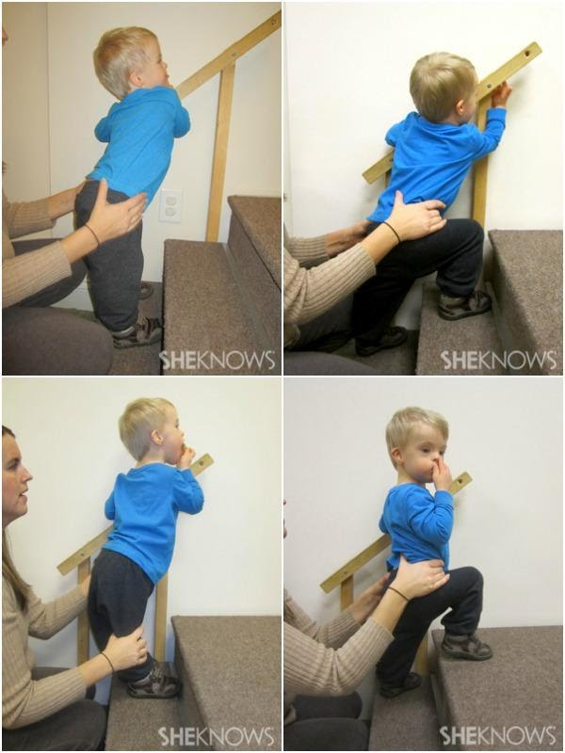
Children with DS often struggle with generalization, which means that a skill they've mastered in one environment may not automatically translate to another. For instance, a child who can confidently climb stairs at home might revert to a less effective technique when encountering stairs in a different place. They may need to reacquire the skill in the new setting before using it consistently.
Learning abilities:-
Children with DS often benefit from receiving information in small, easily digestible portions. When it seems like a child's progress has stalled, it's usually because the next piece of information is too complex, and it should be further divided into smaller, more manageable parts.
GAIT:
In early physical therapy, the emphasis should be on instructing young children with Down syndrome in the correct standing posture. This entails positioning their feet under the hips, pointing them straight ahead, and maintaining a gentle knee bend. By implementing appropriate physical therapy techniques, it is feasible to mitigate or prevent gait-related issues.
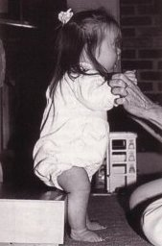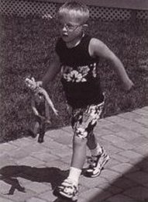

PHYSIOTHEARPY FOR TRUNK COIMTROL:
In the realm of physical therapy, it's crucial to provide early guidance on the correct sitting posture for children with Down syndrome. This guidance involves offering support at multiple levels until they can sit unaided. The progression typically includes upper trunk support, middle trunk support, support between the scapula and the waist, waist support, and pelvic support. These supportive measures help maintain the right spinal and pelvic alignment until the child develops the strength to do so autonomously. With the implementation of suitable physical therapy, concerns related to trunk posture can be effectively minimized.

Key Elements of a Successful Exercise Regimen
Adolescents and young adults with Down syndrome should aim to incorporate the following elements into their exercise regimen.

Strengthening-

The goal of muscle strengthening is to steadily enhance the muscle's strength over time. This can be accomplished through various means, such as incorporating weights, gym machines, resistance bands, or utilizing one's own body weight, all tailored to the individual's starting fitness level.
Aim to strengthen all parts of the body —The objective is to improve the strength of different body regions, encompassing the arms, legs, and core. You might consider engaging in a structured exercise program designed by a physical therapist or exercise physiologist. Alternatively, seek advice from resources such as a physical education instructor or consider participation in an adaptive physical education class to establish a personalized workout routine
Cardiovascular exercise
Physical activity is highly beneficial for individuals with Down syndrome, and while ongoing research continues to investigate their specific responses to exercise, the advantages are evident. Cardiovascular exercise, in particular, contributes to enhanced endurance, allowing for activities like sustained school day walking without frequent breaks, the ability to climb hills, engage in play without breathlessness, and improved performance in various sports activities.
There are various ways to incorporate cardiovascular exercise into your child's daily routine, including:

- Enrolling in a swimming program.
- Utilizing exercise equipment like a treadmill, recumbent bike, or elliptical machine (with proper supervision when necessary).
- Participating in recreational activities such as walking, biking, and jogging.
For children with Down syndrome who are not currently engaged in physical activity, it's advisable to commence gradually. For instance, encourage your child to begin with a brief five-minute walk and then progressively extend the duration or distance. If the individual with Down syndrome is under the care of a cardiologist, it's crucial to seek guidance from their physician before embarking on a structured endurance exercise program.

Balance activities

Balance exercises are often the most enjoyable part of a workout routine, offering benefits for sports performance and overall mobility in daily life. Encourage your child to partake in:
- Stationary activities such as balancing on one leg with hands on their hips, and as they become more adept, challenge themselves by attempting it with their eyes closed.

- Engage in dynamic tasks that test coordination and motor planning, like skipping, playing hopscotch, or walking along a balance beam. You can also explore more structured options like yoga, martial arts, or dance classes to further enhance their balance skills.

- 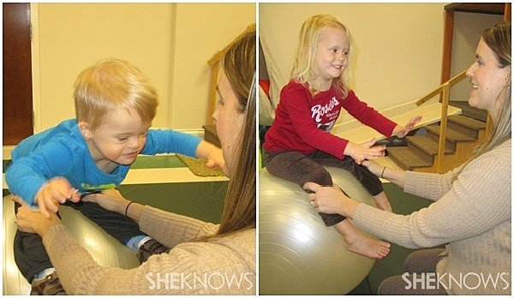

60 minutes a day

Aim for 60 minutes of daily physical activity for your child. This can encompass a mix of strength-building, cardiovascular, and balance exercises and doesn't have to occur in a single continuous session. For instance, your child's daily activity could consist of a 10-minute walk to school, 20 minutes of basketball during recess, and a 30-minute yoga session after dinner.

When strategizing for a sustainable, effective exercise program catering to a child with Down syndrome, it's crucial to take into account their inclinations and the activities that resonate with them, providing enjoyment and significance.

Explore Interests: Take the child's individual interests into consideration. For instance, if they have a passion for group activities and music, enrolling them in a dance class can be an enjoyable means to elevate their heart rate and maintain their engagement.

Water-Based Pursuits: For children who have a fondness for being in the water, consider the possibility of enrolling them in swimming lessons or getting them involved in programs like Special Olympics, which can impart valuable aquatic skills for lifelong exercise.

Family Quality Time: In instances where a family's busy weekday schedule leaves limited room for shared activities, plan regular family outings during weekends, such as summer bike rides or autumn hikes. These endeavors not only encourage physical activity but also foster stronger family connections.

Personal Meaning: Choose activities that hold personal meaning for you or your child. By incorporating these activities into daily life, you can maintain their interest in physical exercise.

Professional Guidance: If the child has any exercise restrictions or specific needs, consult with a physiotherapist to initiate an exercise program tailored to their requirements.

Preventing Abnormal Posture and Movement:

• Encouraging weight shifting in prone position.
• Promoting sitting with a stable and well-balanced base.
• Assisting with smooth transitions between sitting and crawling.
• Maintaining proper head and trunk posture.
• Facilitating the exploration of new movements and sensory experiences.
• Fostering the development of independent motor skills and self-help abilities, with a focus on safety.
• Encouraging physical activity for play, social interactions with peers, and overall fitness.

TIPS FOR GIVING PHYSIOTHERAPY IN DOWN SYNDROME CHILDREN:
a)Create an optimal setup, recognizing the importance of structure, consistency, and a familiar environment for children with DS to perform their best. Avoid introducing new or challenging activities when the child is fatigued or hungry. Prioritize quality over quantity, and minimize distractions in the surroundings.
b) Align with the child's motivation. Ensure that the child is genuinely interested in acquiring a specific skill.
c) Observe the child's response to learning new gross motor skills. Some children may be cautious, seeking stability, while others are adventurous and enjoy movement. Tailor your approach accordingly; a cautious child may require more support and may become upset if they fall, whereas a risk-taking child may embrace movement and be less concerned about support or falls.
d) Recognize when it's time to stop. Some children may only attempt a skill a few times before wanting to move on. Set up activities for success to prevent frustration.
e) Strategically plan the session. Concentrate on skills that the child is ready to learn, addressing the most challenging ones early in the session when the child is at their freshest. Alternate between more difficult and easier skills to allow the child to recover.
f) Offer strategic support. Minimize assistance to the minimum necessary for success and gradually reduce it, as children with DS can become overly reliant on support.
g) Understand that skills are initially acquired in a more generalized manner and are later refined. For instance, when learning to walk, children may initially have a wide stance with outwardly rotated feet. This pattern should be permitted initially and refined as the child progresses.
h) Avoid intervening with established skills where the child has achieved independence. Instead, focus on making improvements at the next stage of motor development. For instance, if a child has developed a unique crawling pattern, it's best to address enhancements at the subsequent developmental stage.
Children with DS exhibit optimal learning when following a gradual progression:
a) Introduction: Initiate the process by gently introducing the new skill, focusing on helping the child build tolerance for the movement.
b) Familiarization: Enable the child to become accustomed to the skill and comprehend the activity.
c) Cooperation: Foster growing collaboration and cooperation while reducing the level of support provided.
d) Autonomy: The concluding phase is achieved when the child has attained mastery of the skill and can independently execute it without requiring assistance.
Highlighted Activities for Infants with Down Syndrome in the Pre-Walking Phase:

i. Back-Lying on Your Lap
ii. Back-Lying and Reaching Upward Independently
iii. Hip Flexibility Exercise
iv. Assisted Kneeling with a Sofa Cushion

Back-Lying Activities for Infants from Birth to the Walking Stage
Key Aspects
When your baby is in a back-lying position, the essential components to encourage her development include:

a) Keeping her head centered and gently tucking her chin.
b) Guiding her hands towards her chest (at the midline) and initiating reaching for toys.
c) Supporting her legs close together, with hips and knees bent, feet resting on the floor, and knees touching; this also includes engaging in kicking movements.

These skills will evolve over time and require full support during the initial stages. When provided with proper support, she can focus her attention on the therapist and respond effectively.

Typical Patterns

The natural inclinations in a baby's behavior may include:

i) Displaying a preference for turning her head to one side and keeping it in that position.
ii) Often resting her arms on the surface, with infrequent attempts to bring them towards the midline.
iii) Engaging her legs as they are usually the stronger part, which can inhibit arm movements, as infants of this age often struggle to coordinate both arms and legs simultaneously.
iv) Adopting a "frog leg" stance when at rest, with hips and knees bent and knees wide apart; consistent use of this posture can lead to muscle tightness over time.
v) Utilizing an arching pattern involving the head, arms, and trunk, which can impede chin tucking and hinder efforts to bring hands to the midline.

Without proper support, the baby may exhibit behaviors such as keeping her head turned to one side, resting her arms and hands on the surface, and positioning her legs with hips and knees bent, knees wide apart, or engaging in kicking movements. The activity of her legs may limit her ability to center her head to interact with the therapist or lift her arms towards her chest. The arching tendency may cause her to squeeze her shoulder blades together, puff up her upper chest, and consequently hinder chin tucking and moving her arms towards the midline. Additionally, she might stabilize her arms against the surface to focus more on kicking her legs.

Activity: Back-Lying in Your Lap

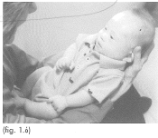
a) Position the baby in the therapist's lap while the therapist is seated on a comfortable chair or couch with adequate back support.

b) Place the baby with her head nestled between the therapist's knees, her hips snugly against the therapist's abdomen, and her legs gently supported against the therapist's chest.

c) Gradually slide the hands along the sides of the baby's body and under her arms until they cradle her head. Maintain her head at the center and tilt it upward, allowing her to have a clear view of you.

d) With this arm support, she will be able to bend her elbows and bring her hands closer to her chest or mouth.

e) Utilize the elbows to provide support to her legs, ensuring that her knees are aligned with her hips and not in a wide, splayed position.

f) Lean the baby's head and trunk forward, creating proximity between the therapist and the baby, facilitating eye contact. Talk, sing, or engage with her for as long as she comfortably tolerates.

2.Back-Lying and Reaching Upward without Support

Activity: Back-Lying and Reaching Upward
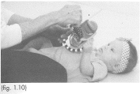
Activity: Back-Lying and Reaching Upward

i) Lay the baby on the floor, ensuring her head is facing straight ahead and not turned to either side.

ii) The therapist should assume a seated position with their heels in front of the baby.

iii) Place a sizable toy on the baby's chest and encourage her to reach out and touch it using either one or both of her hands.

iv) If her legs are overly active, provide support to help calm them down, as this will enhance her ability to reach for the toy.

v) As she consistently reaches for the toy on her chest, gradually elevate the toy slightly above her chest, requiring her to reach higher.

vi) Keep an eye on her leg movements, and provide support if she tends to keep them apart.

3.HIP STRETCH

Activity: Hip Stretch
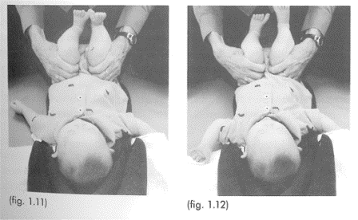
a) Gently bend the baby's hips and knees to approximately 90 degrees and hold the back of her thighs with the palms of your hands. Carefully move her thighs towards a neutral rotation position, with her knees pointing upward to the ceiling. If you encounter resistance, pause and allow her legs to relax. Once relaxation occurs, proceed to move her thighs further, aiming for 5-10 degrees of internal rotation, where her knees are turned slightly inward toward each other.

b) Engage in conversation with her and maintain this stretching position for 1-2 minutes.

c) Repeat this exercise 2-3 times a day, gradually noticing reduced stiffness with each practice.

d) Discontinue this exercise when she can independently move her hips to a neutral rotation and adduction position, with her knees pointing up to the ceiling and knees held together

- Supported Kneeling at a Sofa Cushion

Supported Kneeling Exercise
Key Objectives:
When providing maximal support for your baby in a kneeling position, the components you aim to encourage include:

i) Elevating her head in the midline and sustaining this position.
ii) Initiating weight-bearing on her elbows.
iii) Maintaining an upright and well-supported trunk.
iv) Stretching her hips to achieve neutral rotation and commencing weight-bearing on her legs.

Typical Tendencies:
Your baby's natural inclinations may involve:

a) Arching her head and trunk without precise control or collapsing onto the surface.
b) Sudden and abrupt loss of head control, resulting in a rapid descent to the surface.
c) Reluctance to bear weight on her elbows.
d) Placing her knees wide apart.
e) Demonstrating fussiness when asked to bear weight on her knees, often requiring a softer surface for support.

Activity: Supported Kneeling at a Sofa Cushion
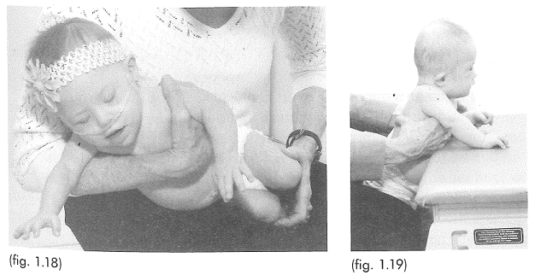

a)To start, choose a cushioned surface to kneel on. Place a sofa cushion measuring 7 inches (approximately 18 cm) in front of you. Kneel on your heels and cradle your baby in a sideways position across your lap, ensuring that she faces away from you. Use one hand to support her beneath her arms and the other to gently bring her knees together, keeping her hips and knees bent (consult fig. 1.18 for a visual reference).

b) Arrange your baby in a kneeling posture with her knees together, and snugly position your knees alongside hers to maintain stability. Her buttocks should rest on your thighs, slightly elevating her pelvis rather than resting on her heels.

c) Assist her in propping herself up on her elbows by guiding her elbows onto the sofa cushion. Support her upper trunk under her arms as she does this. This positioning will place her elbows ahead of her shoulders, aligning them (as depicted in the side view in fig. 1.19).

d) Once her legs, trunk, and arms are securely in place, introduce a toy or another person in front of her to inspire and motivate her. Encourage her to raise her head. Initially, she might lift her head with a slight bobbing motion, but as her strength develops, she will be able to lift and maintain her head while focusing on the stimulating object. Should she lift her head too far, gently lean your body forward to prevent her from tilting her head backward.

- Dance Therapy in Conjunction with Physical Therapy for Children with Down Syndrome: Assessing the Effects on Bilateral Toe-Standing Balance and Single-Point Static Balance Skills.

- The study aimed to investigate the impact of a dance program that integrates both dance and conventional physical therapy methods on the development of bilateral toe-standing balance and single-point static balance skills in children with Down Syndrome. The hypothesis underlying this research was rooted in the anticipation of cumulative cognitive and motor advantages resulting from the synergistic use of these two therapeutic approaches.

The program included elements such as tactile guidance, voluntary control, rhythm, and repetition, incorporating both visual and auditory cues to enhance motor learning

Conclusions

There is a consensus within the literature that engaging in physical exercise provides significant advantages for individuals with Down Syndrome, contributing to improvements in both cardiovascular and neuromuscular functions. Furthermore, exercise not only enhances fundamental physical abilities but also has a positive impact on vocational performance, ultimately fostering greater independence in both leisure activities and work opportunities, as proposed by Mendonca et al. in their 2010 study.
It is vital to initiate exercise programs with uncomplicated tasks that offer appropriate physical challenges. Wang et al., as highlighted in their work from 1997 and 2001, have identified the benefits associated with activities such as jumping exercises. Nevertheless, for exercise programs designed for the long term, maintaining diversity and sustaining interest are pivotal for ensuring ongoing engagement. To this end, Wang et al. have recommended steering clear of activities that are excessively intricate or conspicuously perceived as formal exercise routines..An example of an engaging program is demonstrated by Lin et al (2012), who combined walking/jogging with virtual reality Wii game console exercises. Shields et al (2008); (2013) also presented two effective exercise intervention options for individuals with Down's Syndrome. In one approach, participants engaged in group-based training, involving two to three individuals with Down Syndrome exercising under the guidance of a supervisor. The alternative approach featured programs led by student mentors. This method actively promotes social interaction and physiological adaptation, effectively circumventing the common challenges typically associated with structured exercise programs, as evidenced in studies conducted by Millar et al. (1993), Monteiro et al. (1997), and Varela et al. (2001).
In light of the barriers that individuals with Down Syndrome encounter, exercise programs must be both cost-effective and motivating. The notably high attendance rate of 92% in Shields et al.'s (2008) and (2013) programs, as well as the exceptional 100% adherence observed in Lin et al.'s (2012) study, underscores the efficacy of this approach.

References
- Gardner, H (1983). Frames of Mind: the Theory of Multiple Intelligences.Basic Books.
- Kumin, L (2001). Classroom Language Skills for Children with Down Syndrome: A Guide for Parents and Teachers. Woodbine House.
- Oelwin, P (1995). Teaching Reading to Children with Down Syndrome: A Guide for Parents and Teachers. Woodbine House.
- Winders, P (1997). Gross Motor Skills in Children with Down Syndrome: A Guide for Parents and Professionals. Woodbine House.
- Wishart, JG (1995). Cognitive Abilities in Children with Down Syndrome. In: CJ Epstein, T Hassold, I Lott, L Nadel & D Patterson (eds.) Etiology and Pathogenesis of Down Syndrome. Wiley-Liss Inc.
- Wishart, JG (1991). Taking the initiative in learning: a developmental investigation of children with Down syndrome. International Journal of Disability, Development and Education, 38, 27-44.
- Alesi M, Battaglia G, Roccella M, Testa D, Palma A, Pepi A. (2014) Improvement of gross motor and cognitive abilities by an exercise training program: three case reports. Neuropsychiatric Disease and Treatment 10: 479-485
- Almeida GL, Corcus DM, Latash ML. (1984) Practice and transfer effects during fast single-joint elbow movements in individuals with Down syndrome. Physical Therapy 74: 1000-1012
- American College of Sports Medicine. (1993) Position Stand: Physical Activity, Physical Fitness and Hypertension. Medicine and Sports and Exercise. 25: i
- Angelopoulou N, Matziari C, Tsimaras V, Sakadamis A, Souftas V, Mandroukas K. (2000) Bone mineral density and muscle strength in young men with mental retardation (with and without Down syndrome). Calcified Tissue International. 66(3):176-80
- Astrand PO, Rohdal K, Dahl HA, Stromme SR. (2003) Textbook of Work Physiology: Physiological basis of exercise. 4th Canada, Human Kinetics
- Badke MB, DiFabio RP. (1990) Facilitation: New theoretical perspective and clinical approach. In: Basmajian JV, Wolfe SL eds. (1990) Therapeutic exercise. 5th, Baltimore MD, Williams and Wilkins. 77-91
- Bartlo P, Klein PJ. (2011) Physical activity benefits and needs in adults with intellectual disabilities: Systematic review of literature. American Journal on Intellectual and Developmental Disabilities 116(3): 220-232
- Bassett DR, Howley ET. (2000) Limiting factors for maximum oxygen uptake and determinants of endurance performance. Medicine and Science in Sports and Exercise. 32: 70-84
- Baynard T, Pitetti KH, Guerra M, Fernhall. (2004) Heart rate variability at rest and during exercise in persons with Down syndrome. Archives of Physical and Medical Rehabilitation. 85(8):1285-90
- Baynard T, Pitetti KH, Guerra M, Unnithan VB, Fernhall B. (2008) Age-related changes in aerobic capacity in individuals with mental retardation: A 20-yr review. Physical Fitness and Performance 40(11): 1984-1989
- Beange H, McElduff A, Baker W. (1995) Medical disorders of adults with mental retardation: A population study. American Journal on Mental Retardation. 99: 595-604
- Bergh C, Ekblom B, Astrand PO. (2000) Maximal oxygen uptake "classical" versus "contemporary" viewpoints. Medicine and Science in Sports and Exercise. 32: 85-88
- Blair SN, Brodney S. (1999) Effects of Physical Activity and Obesity or Morbidity and Mortality: Current evidence and research issues. Medicine and Science in Sports and Exercise. 31: 46-62
- Bodde AE, Seo D-C. (2009) A review of social and environmental barriers to physical activity for adults with intellectual disabilities. Disability and Health Journal 2: 57-66
- Bopma TO. (1999) Periodisation: Theory and Methodology of Training. 4th, Human Kinetics USA
- Braddock D. (1999) Aging and developmental disabilities: Demographic and policy issues affecting American families. Mental Retardation. 4: 155-161
- Climstein M, Pitetti KH, Barrett PJ, Campbell KD. (1993) The accuracy of predicting treadmill VO2max for adults with mental retardation, with and without Down's syndrome, using ACSM gender- and activity-specific regression equations. Journal of Intellectual Disability Research. (6):521-31
- Cooper CB, Storer TW. (2001) Exercise Testing and Interpretation: A practical approach. 1st ed. Cambridge. Cambridge University Press
- Cowley PM, Ploutz-Snyder LL, Baynard T, Heffernan K, Jae SY, Hsu S, Lee M, Pitetti KH, Reiman MP, Fernhall B. (2010) Physical fitness predicts functional tasks in individuals with Down syndrome. Medicine and Science in Sports and Exercise 42(2): 388-393
- Crespo CJ, Ainsworth BE, Keteyian J, Heath GW, Smit E (1999) Prevalence of physiological activity and it’s relation to social class in U.S. adults: Results from the 3rd National Health and Nutritional Examination Survey 1988-1994. Medicine and Science in Sports and Exercise. 31: 1821-1827
- Croce RV, Pitetti KH, Horvat M, Miller J. (1996) Peak torque, average power, and hamstrings/quadriceps ratios in nondisabled adults and adults with mental retardation. Archives of Physical and Medical Rehabilitation. 77(4):369-72
- Dodd KJ, Shields N. (2005) A systematic review of the outcomes of cardiovascular exercise programs for people with Down’s syndrome. Archives of Physical Medicine and Rehabilitation 86: 2051-2058
- Eberhard Y, Eterradossi J, Foulon T, Groslambert P. (1993) Changes in plasma lipoproteins in adolescents with trisomy 21 in response to a physical endurance test]. Pathology and Biology (Paris). 41(5):482-6
- Fletcher GF, Balady G, Blair SN, Blumenthal J, Caspersem C, Chaitman B, Epstein B, Sivarajan S, Froelicher ES, Froelicher VS, Pina IL, Pollack ML. (1996). Statement on exercise: benefits and recommendations for physical activity programs for all Americans. A statement for health professionals by the Committee on Exercise and Cardiac Rehabilitation of the Council on Clinical Cardiology, American Heart Association. Circulation. 15: 857-862
- Fernhall B, McCubbin JA, Pitetti KH, Rintala P, Rimmer JH, Millar AL, De Silva A. (2001) Prediction of maximal heart rate in individuals with mental retardation. Medicine and Science in Sports and Exercise. 33: 1655-60
- Fernhall B, Otterstetter M. (2003) Attenuated responses to sympathoexcitation in individuals with Down Syndrome. Journal of Applied Physiology. 94: 2158-2165
- Frey GC, Stanish HI, Temple VA. (2008) Physical activity of youth with intellectual disability: Review and research agenda. Adapted Physical Activity Quarterly 25: 95-117
- Fujiura GT. (1998) Demography of family households. American Journal on Mental Retardation. 103: 225-235
- Gordon D, Caddy O, Merzbach V, Gernigon M, Baker J, Scruton A, Keiller D, Barnes R. (2015) Prior knowledge of trial number influences the incidence of plateau at VO₂max. Journal of Sports Science and Medicine. 14: 47-53
- Guerra M, Llorens N, Fernhall B. (2003) Chronotropic incompetence in persons with down syndrome. Archives of Physical and Medical Rehabilitation. 84: 1604-8
- Hakkinen K, Alen M, Komi PV. (1985) Changes in isometric force-and relaxation time, electromyographic and muscle fibre characteristics of human skeletal muscle during strength training and detraining. Acta Physiologica Scandinavia. 125: 573-585
- Heinonen A, Kannus P, Sievnan H, Pasanen M, Oja P, Vuori I. (1999) Good maintenance of high-impact activity-induced bone gain by voluntary, unsupervised exercises: An 8-month follow-up of a randomized controlled trial. Journal of Bone Mineral Research. 14: 25-8
- Heller T, Hsieh K, Rimmer JH. (2004) Attitudinal and psychosocial outcomes of a fitness and health education program on adults with down syndrome. American Journal of Mental Retardation. 109(2)175-85
- Hikuri HV, Jokinen V, Syvanne M, Niemenen MS. (1999) Heart rate variability and progression of coronary atherosclerosis. Arteriosclerosis Thrombosis and Vascular Biology. 19: 1979-1985
- Johnson CC. (2009) The benefits of physical activity for youth with developmental disabilities: A systematic review. American Journal of Health Promotion 23(3): 157-167
- Jones AM, Carter H. (2000) The effects of endurance training on parameters of aerobic fitness. Sports Medicine. 29: 373-386
- Kronhead AC, Moller M (1998) Effects of physical exercise on bone mass, balance skill and aerobic capacity in women and men with low bone mineral density, after one year of training--a prospective study. Scandinavian Journal of Medicine and Science in Sports. 8: 290-298
- Kubukeli ZN, Noakes TD, Dennis SC. (2002) Training techniques to improve endurance exercise performances. Sports Medicine. 32: 489-509
- Lin H-C, Wuang Y-P. (2012) Strength and agility training in adolescents with Down syndrome: A randomized controlled trial. Research in Developmental Disabilities 33: 2236-2244
- Martin JE, Dubbert PM. (1985) Adherence to Exercise. Exercise and Sports Science Reviews. 13 : 137-164
- Martinsen EW (1993) Therapeutic implications of exercise for clinically anxious and depressed patients. International Journal of Sports Psychology. 24: 185-199
- Matsumoto T, Miyawaki T, Ue H, Kanda T, Zenji C, Moritani T. (1999) Autonomic responsiveness to acute cold exposure in obese and non obese young women. Int J Obesity Related Metabolic Disorders. 23: 793-800
- Mendonca GV, Pereira FD. (2009) Influence of long-term exercise training on submaximal and peak aerobic capacity and locomotor economy in adult males with Down’s syndrome. Medical Science Monitor 15(2): CR33-39
- Mendonca GV, Pereira FD, Fernhall B. (2010) Reduced exercise capacity in persons with Down syndrome: cause, effect, management. Therapeutics and Clinical Risk Management 6: 601-610
- Millar AL, Fernhall B, Burkett LN. (1993) Effects of aerobic training in adolescents with Down syndrome. Medicine and Science in Sports and Exercise. 25: 270-274
- Monteiro CP, Varela A, Pinto M, Neves J, Felisberto GM, Vaz C, Bicho MP, Laires MJ. (1997) Effect of an aerobic training on magnesium, trace elements and antioxidant systems in a Down syndrome population. Magnesium Research. 10: 65-71
- Noakes TD. (2001) Lore of running. 5th edition. Human Kinetics USA
- Pastore E, Marino B, Calzolari A, Digilio MC, Giannotti A, Turchetta A. (2000) Clinical and cardiorespiratory assessment in children with Down syndrome without congenital heart disease. Archives of Pediatric and Adolescent Medicine. 4:408-410
- Peran S, Gil JL, Ruiz F, Fernandez-Pastor V. (1997) Development of physical response after athletics training in adolescents with Down's syndrome. Scandinavian Journal of Medicine and Science in Sports. 7:283-288
- Pett M, Clark L, Eldredge A, Cardell B, Jordan K, Chambless C, Burley J. (2013) Effecting healthy lifestyle changes in overweight and obese young adults with intellectual disability. American Journal on Intellectual and Developmental Disabilities 118(3): 224-243
- Phillips AC, Holland AJ. (2011) Assessment of objectively measured physical activity levels in individuals with intellectual disabilities with and without Down’s syndrome. Plos One 6(12): 1-7
- Pomeranz B, McCauly RJ, Caudill MA. (1985) Assessment of autonomic function in humans by heart rate spectral analysis. Journal of Applied Physiology. 248: 151-153
- Rimmer JH, Heller T, Wang E, Valerio I. (2004) Improvements in physical fitness in adults with Down syndrome. American Journal of Mental Retardation. 2: 165-174
- Robinson JL, Rogers MA. (1994) Adherence to exercise programs: Recommendations. Sports Medicine. 17: 39-52
- Robergs RA, Landwher R. (2002) The surprising history of the “HRmax = 220-age” equation. Journal of Exercise Physiology. 5: 1-10
- Sale DG (1988). Neural adaptations to resistance training. Medicine and Science in Sports and Exercise. 20: 135-145
- Shields N, Taylor NF, Dodd KJ. (2008) Effects of a community-based progressive resistance training program on muscle performance and physical function in adults with Down syndrome: A randomized controlled trial. Archives of Physical Medicine and Rehabilitation 89: 1215-1220
- Shields N, Taylor NF, Wee E, Wollersheim D, O’Shea SD, Fernhall B. (2013) A community-based strength training programme increases muscle strength and physical activity in young people with Down syndrome. Research in Developmental Disabilities 34: 4385-4394

