Ethnobotany and Biotechnology: From tradition to Modern aspects
*Krati Tandon, *Ashok Kumar and ¹S. K. Katiyar
*Department of Botany, School of Sciences, IFTM University, Moradabad
¹Department of Botany, Government Degree College, Tanakpur (Uttarakhand)

Abstract: Biotechnology boasts a wide array of applications, with a particular focus on Medicine and agriculture. The investigation of plants and the identification of natural compounds through ethnopharmacology, coupled with advanced analytical techniques, remain pivotal in the ongoing pursuit of characterizing and confirming potential drug candidates. The scientific study of traditional plant knowledge, or ethnobotany, has been crucial in the development of several therapeutics. However, the development and study of these treatments—whether they take the form of monoclonal antibodies or synergistic combinations—have proven challenging. Currently, advancements in analytical instruments, metabolic engineering, and bioreactor technology are enhancing these treatments' scientific understanding, production, and manipulation. Medicinal plants serve as the primary provider of life-saving medications for most of the global population, secondary metabolites derived from plants are vital constituents in numerous industries., including pharmaceuticals, perfumes, dyes, food additives, and pesticides, contributing significantly to the economy. Biotechnological instruments have a crucial function in the choice, growth, enhancement, and examination of medicinal plants. Microbial cells or chemical synthesis cannot match the abundant and stable supply of valuable therapeutic compounds, tastes, fragrances, and colors that plant cell culture methods offer. Many medicinal plants have successfully demonstrated the in-vitro synthesis of secondary metabolites in plant cell suspension cultures, and bioreactors are a key component in the advancement of plant biotechnology's ability to produce these chemicals on an industrial scale.
Genetic transformation, especially utilizing Agrobacterium tumefaciens, serves as a potent method for increasing the production of novel secondary metabolites. Combinatorial biosynthesis offers an alternative strategy for creating new natural products and manufacturing rare and expensive compounds found in nature. DNA microarrays and other DNA profiling methods are useful high-throughput instruments for the simultaneous investigation of many genes and the measurement of gene expression levels. These techniques provide important new understandings of metabolic pathways, regulatory mechanisms, and general cellular activities.
Introduction:
Across history, the story of pharmacy and drug discovery has been closely intertwined with the tales of pharmacognosy and ethnobotany. Inspired by stories of curare, quinine, morphine, and later artemisinin, ethnopharmacology has leveraged a wide array of natural products and plant extracts. India, in particular, holds a diverse heritage of human-plant connections that biotechnology has greatly enhanced. Ethnomedicinal plants have taken center stage in the search for new natural compounds, but their utilization has sparked worries about conservation.

Biotechnology, however, extends its applications beyond conservation efforts to encompass the enhancement of natural product research and the augmentation of the value of beneficial products. For almost a thousand years, diverse plant species have been investigated as potential sources for the development of therapeutic agents. Even in the present day, a significant proportion of pharmaceutical drugs originate from plants. Potential drug discovery and development anchored in plants and natural goods has its roots in historical records, such as old manuscripts from as far back as 2600 BC that describe the medicinal qualities of herbs and the ancient medicinal plant records of Mesopotamia. One notable example is the "Ebers Papyrus," a 2900 BC Egyptian traditional medicine record that contains 700 medications made from plants and is remarkably well-preserved. This legacy has also been enhanced by traditional Chinese medicine and the Indian Ayurvedic system, whose records date back to around the first millennium BC. It's worth noting that according to global statistics, approximately 80% of the world's population predominantly relies on ethnobotanical remedies. Examples include analgesics like morphine and codeine, antineoplastic agents such as camptothecin and taxol, antidiabetic compounds like allicin, antimalarials including artemisinin and quinine, cardiac depressants like quinidine, antigout medications such as colchicine, and substances affecting brain function like nicotine and caffeine. The broad and adaptable pharmacological impacts of medicinal plants fundamentally rely on their phytochemical components.
Ethnobotany and Biotechnology:
Ethnobotany represents an interdisciplinary domain encompassing the traditional utilization of plants by human populations. A significant portion of the global population heavily relies on herbal remedies. The majority of locally utilized or traded medicinal and aromatic plants (MAPs), frequently acquired from natural environments, constitute a principal means of sustenance for millions of individuals. Ethnobotanical knowledge and information are thought to have played a significant role in Contributing to the development of roughly 30% of contemporary pharmaceuticals.
Lately, the growing demand for herbal medicines in industrialized nations has been driven by an increasing consumer interest in natural products. The exploration of the relationships, interactions, and interdependencies between ethnic human communities, particularly tribal groups, and the plant life in their surroundings is known as 'ethnobotany' or aboriginal botany. The term 'ethnobotany' was first introduced in 1896 by Harshberger, a prominent figure in the early days of economic botany in the United States. In contemporary terms, ethnobotany is defined as the study of the intricate relationship between plant ecosystems and indigenous societies.
Ethnobotany includes several subdisciplines, each dedicated to examining different facets of tribal plant utilization. These subdisciplines include ethnoagriculture, ethnotaxonomy, ethnomedicobotany, ethnoecology, ethnomycology, ethnogynaecology, ethnotoxicology, ethnopharmacology, ethnopharmacognosy, ethnophytotaxonomy, ethnoveterinary medicine, and various others.
Biotechnology, commonly known as biotech, entails the utilization of living systems and organisms to develop valuable products or the application of biological systems, living organisms, or their derivatives in technological contexts to create or alter products and processes for specific objectives. On the contrary, plant biotechnology involves the utilization of plant cells, tissues, and frequently small organ explants to create advantageous products or services.

These cellular elements are either consistently cultivated in a controlled in vitro environment or undergo various stages, ultimately leading to the regeneration of whole plants that are later transplanted to the field.
In the past century, there has been a growing inclination towards the application of biotechnology in therapeutic contexts, particularly in the realm of medicinal plants. Numerous studies have delved into the advanced biotechnological techniques employed to identify and synthesize active compounds with medicinal significance. Furthermore, recent investigations have explored the therapeutic potential of diverse medicinal plants from various geographic regions worldwide. These studies have documented the presence of antiviral properties in medicinal plants against specific pathogenic microbial strains. These pharmacological characteristics have a significant impact on uncovering new bioactive substances, facilitating the advancement of medications to address human conditions like diabetes, cardiovascular ailments, and hypertension. Moreover, in the context of the COVID-19 pandemic, the examination and recognition of natural compounds derived from medicinal plants for potential applications against coronavirus diseases have become of utmost significance in the field of drug discovery.
In recent times, plant breeders have sought to address these deficiencies by implementing various breeding approaches, with a particular emphasis on the adoption of faster biotechnology-based breeding methods (BBBMs). Forward genetic techniques based on next-generation sequencing (NGS) have proven invaluable in pinpointing key genetic components involved in the biosynthetic pathways of valuable bioactive compounds. In vitro-based BBBMs, which encompass techniques such as in vitro micropropagation, gene transformation, and the induction of polyploidy, have gained widespread utilization for augmenting the production of valuable secondary metabolites in medicinal plants.
CRISPR/Cas9 technology holds significant promise for simultaneously targeting multiple key genes, enabling the creation of plants with desired profiles of secondary metabolites. Agrobacterium rhizogenes-mediated hairy root transformation stands out as an ideal approach for the large-scale in vitro accumulation of valuable bioactive compounds from medicinal plants. When combined with bioreactors, this strategy becomes an optimal method for the scalable in vitro production of these valuable bioactive compounds from medicinal plants.
When it comes to the identification, propagation, and conservation of critical genotypes in the field of medicinal plants, biotechnological methods are indispensable. For the production of superior plant-based pharmaceuticals, in-vitro regeneration holds great potential. There is a great chance to preserve endangered species of medicinal plants using the process of cryopreservation, which involves storing specimens in liquid nitrogen for an extended period of time. The promise of this method has been highlighted by reports of secondary metabolite formation in plant cell suspension cultures in vitro from a variety of medicinal plants. A critical step on the route to using plant biotechnology to produce secondary metabolites on an industrial scale is the use of bioreactors. Genetic transformation is a powerful method for increasing the yield of novel secondary metabolites and increasing the productivity of medicinal plants. This is especially true when Agrobacterium rhizogenes induces hairy roots.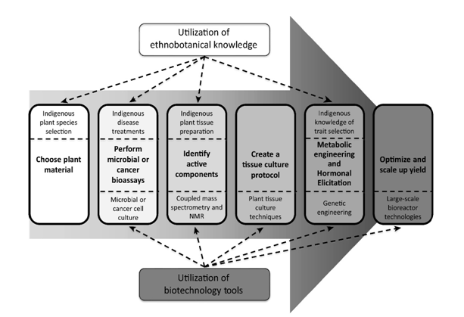
Plant in vitro propagation, of which micropropagation is a fundamental technique, has great potential for producing high-grade plant-based medicines. Micropropagation provides several benefits when compared to conventional methods of vegetative propagation, which are encumbered by various constraints. One of the notable benefits of micropropagation is its substantial increase in the multiplication rate of plants, along with the capacity to produce pathogen-free materials. Many documented examples of the successful micropropagation of various plant species, including many medicinal plants, exist.
Plants cloned from living meristems bear genetic similarities to the donor plants. It is important to note that in the case of medicinal plants like Catharanthus roseus, Cinchona ledgeriana, Digitalis spp., Rehmannia glutinosa, Rauvolfia serpentina, and Isoplexis canariensis, plant regeneration from shoot and stem meristems has produced encouraging results. Many elements, such as the impact of auxins and cytokinins on shoot multiplication, have been found to influence the success of in-vitro propagation for a variety of medicinal plants. Benjamin et al., for example, showed that 6-Benzylaminopurine (BA), especially at higher doses (1–5 ppm), increases the growth of shoot tips and axillary meristems in Atropa belladonna.
One useful method is the cryopreservation of medicinal plant cultures grown in vitro. A long-term preservation technique called cryopreservation involves keeping things in liquid nitrogen (-196 °C), which stops cell division, metabolism, and biological reactions. This method facilitates the preservation of a significant amount of cultured materials in liquid nitrogen. Significantly, cryopreservation provides a means to protect endangered medicinal plant species by allowing the regeneration of complete plants from frozen cultures.
For instance, the efficacy of low-temperature storage has been reported in preserving cell cultures of medicinal plants, including those producing alkaloids such as- Rauvollfia serpentine, D.lanalta, A.belladonna, Hyoscyamus spp.
Various bioactive compounds derived from diverse plant sources have demonstrated efficacy against a wide spectrum of diseases. For instance, taxol, vinblastine, and vincristine exhibit antitumor and anticancer properties. Camptotheca acuminate yields topotecan and irinotecan, known for their anticancer effects. Curcuma longa produces curcumin, which has anticancer, anti-inflammatory, and hepatoprotective properties. Silybum marianum contains the flavonoid silymarin (silibinin), which exhibits anticancer, anti-inflammatory, and liver tonic characteristics, especially valuable for hepatic disorders. Conversely, Ricinus communis offers ricinine and lectin (ricin), recognized for their hepatoprotective, antioxidant, hypoglycemic, and antitumor properties.
Terminalia chebula contains tannins, shikimic acid compounds, triterpenoids, and ellagic acid, providing it with antioxidant, antidiabetic, renoprotective, and hepatoprotective properties. Withania somnifera produces steroidal lactones, particularly withaferin A, known for its chemopreventive, anticancer, memory-enhancing, and immunomodulatory effects, making it suitable for the treatment of conditions such as Parkinson's and Alzheimer's diseases.
Zinziber officinalis yields mono and sesquiterpenoids, zingerone, and gingerols, exhibiting anticancer, antioxidant, hepatoprotective, hypercholesterolemic, and anti-atherosclerotic effects. Moringa oleifera produces limonoids, di- and triterpenoids, which serve as carcinoma inhibitors, chemopreventive agents, colon cancer inhibitors, antiallergics, and blood purifiers. Piper nigrum contains piperidine and dehydropipernonaline, which are anticarcinogenic and anti-hyperlipidemic, useful in epilepsy.
Tinospora cordifolia contains diterpenoid furanolactones (tinosporin) and isoquinoline alkaloids, which act as immunomodulators, chemopreventive agents, cardioprotective agents, and antidiabetic agents. Aloe vera contains aloin, emodin, campesterol, β-sitosterol, known for their therapeutic properties, including antiviral, antitumor, antidiabetic, hepatoprotective, and antiseptic effects. Ocimum sanctum contains apigenin, taxol, ursolic acid, and citral, which demonstrate properties such as antidiabetic, hepatoprotective, antibacterial, antifungal, antipyretic, and anticancer effects.
Berberine, which has hepatoprotective, antibacterial, and antidiabetic properties, is produced by Berberis vulgaris. Digoxin is produced by Digitalis lanata and is used to treat heart conditions. Thymoquinone, which is found in Nigella sativa, has been linked to antidiabetic, anticancer, antibacterial, hepatorenal protective, and gastroprotective effects. Quinine, an antimalarial and antiparasitic medication, is derived from Cinchona robusta, and artemisinin, another antimalarial substance, is produced from Artemisia absinthium.
Opelic acid, sawertiamarine, mangeferin, and amarogenitine—found in swertia—have been shown to possess hepatoprotective, antiviral, and antidiabetic qualities. Allicin, found in Allium sativum, has anti-inflammatory and cardio-protective properties. Arjunic acid, tannic acid, tannins, saponins, gallic acid, and phytosterols are produced by Terminalia arjuna, which also possesses hepatoprotective, cardioprotective, and anticancer properties. Emblemacanin A, Emblemacanin B, Punigluconin, and Pedunculagin are produced by Phyllanthus emblica and are recognized for their antiviral, antibacterial, anticancer, hepatoprotective, and antidiabetic properties. Rauvolfia serpentina contains ajmalicine and reserpine, which exhibit hypotensive properties, while Gynura procumbens contains phenolic compounds, recognized for their antidiabetic effects, among other beneficial effects.
Secondary Metabolites:
The therapeutic uses of herbs are grounded in plant chemistry. A deep comprehension of the chemical makeup of plants enhances our overall understanding of their potential medicinal attributes. In the realm of modern chemistry, there has been an elucidation of the roles played by Primary plant metabolites are involved in essential life processes, including cell division, growth, respiration, storage, and reproduction. These primary metabolites constitute the integral components of crucial processes like glycolysis, the Krebs cycle, also known as the citric acid cycle, photosynthesis, and the pathways that are associated with them include primary metabolites. Small molecules including sugars, amino acids, tricarboxylic acids (also known as Krebs cycle intermediates), proteins, nucleic acids, and polysaccharides are included in this group of primary metabolites. The fact that basic metabolites are fundamentally similar in all living cells cannot be overstated.
Primary and secondary are the two main groups into which plant metabolites can be divided. Primary metabolites are present in all living cells and are essential for growth and development. Examples of these include proteins, carbohydrates, amino acids, nucleic acids, and polysaccharides.
Secondary metabolites, on the other hand, stem from the primary metabolic pathways but do not participate in growth processes. These secondary metabolites have demonstrated diverse biological effects and are commonly employed in traditional medicine practices.
The Nobel laureate in physiology or medicine in 1910, Albrecht Kossel, first developed the idea of secondary metabolites. Many years later, Czapek described them as byproducts, indicating that they result from nitrogen metabolism by'secondary alterations,' which include deamination. Technological developments in the mid-1900s, including chromatography, made it possible to isolate a wider variety of these substances, which in turn accelerated the development of phytochemistry.
Secondary plant metabolites encompass various classes, which include:
- Phenolics
- Simple
- Tannins
- Coumarins
- Flavonoids
- Chromones & Xanthones
- Stilbens
- Lignans
- Alkaloids
- Nicotine
- Caffeine
- Vinblastin
- Saponins
- Terpenes
- Hemiterpenes
- Monoterpenes
- Sesquiterpenes
- Diterpenes
- Sesterterpenes
- Triterpenes
- Lipids
- Fixed oils
- Waxes
- Essential oils
- Carbohydrates

Advantages of Tissue Cultures in Production of Useful Bioactive Compounds:

- Given the growing market demand for innovative plant-derived products, in vitro culture has emerged as a dependable method for the large-scale production of plant materials. Several advantages associated with plant cell culture further drive its adoption for the industrial-scale manufacturing of crucial bioactive compounds. These advantages can be succinctly outlined as follows:
- Plant cell cultures remain unaffected by environmental factors.
- Production levels can be adjusted more precisely in accordance with market demand.
- Through the utilization of well-defined cell lines, it becomes possible to uphold a consistent level of product quality and yield.
- Novel products may potentially emerge from the exploration of new synthesis pathways found within mutant cell lines.
- Cell culture can alleviate the strain on medicinal and economically significant plants that are already heavily exploited.
- The benefit of this approach lies in its potential to offer an uninterrupted and dependable supply of natural products in the long term.
- The advantages of using cell cultures include the ability to produce bioactive secondary metabolites in a regulated setting, independent of soil and climate.
- Significant progress has been achieved in the field of chemical and pharmaceutical production through the utilization of in vitro plant cell culture, capitalizing on advancements in plant science.
- Achieving commercially sustainable levels of product production will be based on the expanding use of genetic tools and improving knowledge of the composition and control of secondary metabolism pathways.
- The field of large-scale plant cell culture has seen a resurgence in attention due to the growing demand for natural therapeutic goods, supply-related problems related to plant harvesting, and difficulties related to low product yields.
- Understanding the biosynthetic pathways of desired phytochemicals, both in plants and cultures, is often at an early stage of development. Consequently, strategies are required to establish information at the cellular and molecular levels. These results illustrate the capacity of in vitro plant cell cultures to be used for the industrial-scale production of secondary metabolites.

The utilization of sophisticated molecular biology methods to create transgenic organisms and manage the expression and control of biosynthetic pathways is anticipated to signify a noteworthy progression in broadening the potential of cell cultures for the industrial synthesis of secondary metabolites.

Novel Bioactive Agents and Herbal Formulation:

Funding has been granted to initiatives aimed at advancing the creation of products and procedures employing medicinal and aromatic plants through a multidisciplinary strategy. Here are some representative instances:
- Tribulus terrestris and Achyranthes aspera were subject to comprehensive investigation regarding their potential influence on renal injury related to kidney stones. According to the study, they effectively prevent the demineralization of pre-existing mineral phases and the nucleation of calcium phosphate (CaP).

.
- Momordica charantia, Azadirachta indica, Costus speciosus, Gymnema sylvestre, and Syzygium cumini were all examined to find a powerful chemical that had anti-diabetic and anti-adipogenic properties. S. cumini was used to isolate oleanolic acid 3-glucoside (OAG) by structural characterisation and a bioactivity-guided fractionation technique. It was found that OAG is a bifunctional compound that partially agonizes PPARγ and inhibits PTP1B to produce antidiabetic and antiadipogenic actions.
- A diagnostic kit based on a dipstick has been created at CSIR-CIMAP, Lucknow, for the early identification of Begomovirus infection in mint (Mentha arvensis) using the viral coat protein.
- The Dolphin Institute of Biomedical and Natural Sciences, Dehradun, in collaboration with the Centre for Aromatic Plants (CAP), Dehradun, has jointly formulated a topical solution with anti-dermatophytic properties, featuring Trachyspermum ammi (Ajwain) essential oil as its primary ingredient. In comparative testing, this formulation demonstrated superior efficacy when compared to specific widely recognized antimycotic ointments and antifungal medications already available in the market.
- A topical solution including extracts from four distinct plant sources—Piper betle, Terminalia bellerica, Boswellia serrata, and Bergenia ciliata—has been developed with antibacterial and anti-inflammatory qualities.
Tissue Culture Producing Pharmaceutical Products of Interest Case Studies:
Research in the field of plant tissue culture technology has produced a large number of pharmacological compounds for new treatments. Developments in cell cultures devoted to the synthesis of medicinal compounds have made it possible to synthesize a wide range of pharmaceuticals, including steroids, alkaloids, terpenoids, flavonoids, saponins, phenolics, and amino acids. Efforts to successfully produce significant amounts of several of these important medications using cell cultures are examples.
Taxol: Taxol (plaxitaxol), a complex diterpene alkaloid naturally occurring in the bark of the Taxus tree, emerges as a notably encouraging anticancer compound, chiefly due to its unique impact on the microtubular cell system. Presently, extensive research in the realm of plant cell cultures has concentrated on producing taxol utilizing cells sourced from diverse Taxus species. This research direction is motivated by the significant economic worth of taxol, the restricted accessibility of Taxus trees, and the costly synthetic production methods linked to it.

Morphine and Codeine: The latex derived from the opium poppy, Papaver somniferum, is utilized as a commercial reservoir for manufacturing analgesic substances such as morphine and codeine. At present, scientists are investigating callus and suspension cultures of P. somniferum as an alternative approach to produce these compounds. Remarkably, the production of morphine and codeine has been accomplished in cultures that do not display morphological differentiation.
Ginsenosides: Panax ginseng, commonly referred to as ginseng, has a long history of being employed as a tonic and esteemed medicinal remedy. Ginseng has earned recognition for its remarkable contributions to health and the promotion of longevity. The principal bioactive components within ginseng have been identified as ginsenosides, which belong to a category of triterpenoid saponins. Among these ginsenosides, ginsenoside Rg1 stands out as a significant active compound derived from Panax ginseng.
Berberine: Antibacterial properties are exhibited by berberine, an isoquinoline alkaloid found in the cortex of Phellondendron amurense and the roots of Coptis japonica. Numerous cell cultures, most notably those of Coptis japonica, Thalictrum spp., and Berberis spp., have shown evidence of this alkaloid. The optimization of the nutrient content in the growth medium and the modulation of phytohormone levels led to an increase in the production of berberine in these cell cultures.
Diosgenin: In the pharmaceutical industry, diosgenin plays a crucial function as a precursor in the chemical synthesis of steroidal medicines. A few research works have looked into the use of Dioscorea deltoidea cell cultures in diosgenin synthesis. Their results showed that the amounts of nitrogen and carbon had a major effect on the build-up of diosgenin in a particular cell line.
Vinblastine and Vincristine: Dimeric indole alkaloids, specifically vinblastine and vincristine, have emerged as key players in cancer chemotherapy because of their strong antitumor characteristics, which are effective against a variety of solid tumors and leukemias. These substances are typically taken out of Catharanthus roseus in large amounts. But since entire plants only have 0.0005% concentrations of these alkaloids, plant cell cultures have emerged as a workable substitute for large-scale synthesis.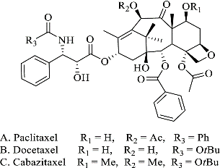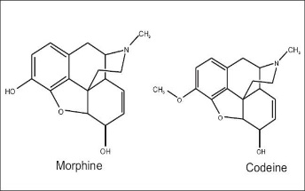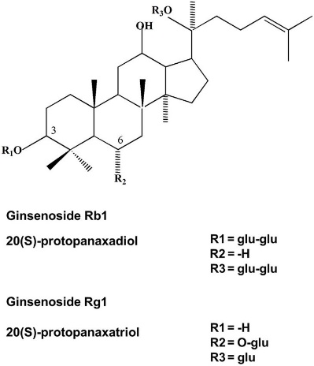
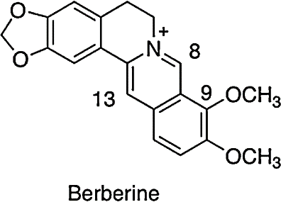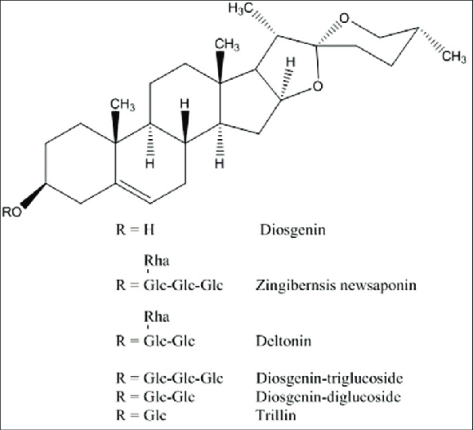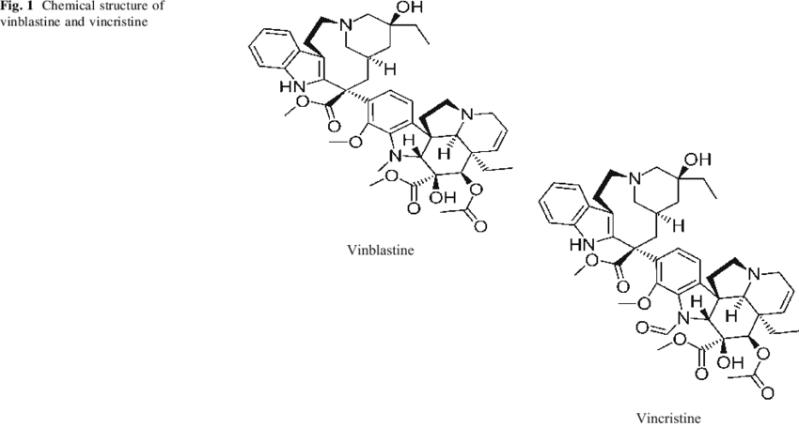

Conclusion:
Medicinal plants are extensively utilized by people in both urban and rural settings. The process of globalization has reignited interest in herbal medicines. The combination of modern science and technology with in-depth studies of traditional plant medicines, using contemporary theories and techniques, has significantly enhanced the utilization of herbal medicines. As a result, traditional plant medicine concepts have been enriched by the infusion of new ideas and perspectives, and these enriched practices are now employed worldwide. Consequently, there has been a substantial expansion of the herbal medicines industry, leading to increased employment opportunities over the past few decades.
Moreover, the techniques of plant cell and tissue culture have taken on crucial roles in the modification of plants to create enhanced crop varieties. Propagating medicinal plants in vitro to increase bioactive components and employing cell culture methods for targeted metabolite production have demonstrated significant advantages in the industrial manufacturing of medically valuable substances. The potential for increasing yields through metabolic engineering is also promising. Nevertheless, this approach requires a comprehensive comprehension of the control mechanisms governing secondary metabolite pathways, including aspects such as product levels, enzymes, genes, as well as considerations of transport and compartmentalization.

References:
Yaseen Khan, M., S. Aliabbas, V. Kumar andS. Rajkumar, 2009. Recent advances in medicinalplant biotechnology. Indian J. Biotechnol., 8: 9-22.
Vanisree, M., and H.S. Tsay, 2004. Plant Cell Cultures- An Alternative and Efficient Source for theProduction of Biologically Important SecondaryMetabolites. International J. Appl. Sci. Engin.,2: 29-48.
Planta Med. 2018 Aug;84(12-13):834-838.
Newman DJ, Cragg GM. Natural products as sources of new drugs from1981 to 2014. J Nat Prod 2016; 79: 629–661
Renneberg R. Biotech history: Yew trees, paclitaxel synthesis and fungi.Biotechnol J 2007; 2: 1207–1209
American-Eurasian J. Agric. & Environ. Sci., 11 (3): 439-444, 2011
Yu, K.W., W.Y. Gao, E.J. Hahn and K.Y. Paek, 2002.Jasmonic acid improves Ginsenoside accumulation inadventitious root culture of Panax ginseng C. A.Mayer. J. Biochem. Eng., 11: 211-215.
Berin A. Boughton, DinaizThinagaran, Daniel Sarabia, Antony Bacic & Ute Roessner. Mass spectrometry imaging for plant biology.Phytochemistry Reviews volume 15, pages445–488 (2016)
Chumakov, M.I.,Moiseeva, E.M. Technologies of Agrobacterium plant transformation In planta(Review) Applied Biochemistry and MicrobiologyVolume 48, Issue 8, December 2012, Pages 657-666
Pamela J. Weathers, Melissa J. Towler & Jianfeng Xu: advances in plant cell culture forproducing useful products. Applied Microbiology and Biotechnology volume 85, pages1339–1351 (2010)
Bronson, J.; Black, A.; Dhar, M.; Ellsworth, B. A.; Merritt, J. R.; Peese, K.; Pashine, A. In 2015 Medicinal Chemistry Reviews; Desai, M. C., Ed.; Medicinal Chemistry Division ACS: Washington DC, 2015; Vol. 50, pp 461−576.
SA Nigro, NP Makunga and OM Grace. Medicinal plants at the ethnobotany–biotechnology interface in Africa. South African Journal of Botany 2004, 70(1): 89–96.
Will C. McClatcheya, *, Gail B. Mahadyb, Bradley C. Bennettc, Laura Shielsa, and Valentina Savod. Ethnobotany as a Pharmacological Research Tool and Recent Developments in CNS-active Natural Products from Ethnobotanical Sources. Pharmacol Ther. 2009 August; 123(2): 239–254.
Carlini EA. Plants and the central nervous system. Pharmacology, Biochemistry and Behavior. 2003; 75:501–512.
Choudhuri S, Valerio LG., Jr Usefulness of studies on the molecular mechanism of action of herbals/botanicals: The case of St. John’s wort. Journal of Biochemistry and Molecular Toxicology. 2005; 19:1–11.

