Reference ID: IIPER1679640777
Book Series: "IIPV3EBS13_G21 Futuristic Trends in Network & Communication Technologies"
==================================================================
Title of the Chapter: “High Power Microwave Sources and Applications”

Author Name & Designation, Phone Number, Email:
Dr. Mukesh Kumar Alaria, Sr. Scientist, Email: mka.gyro@gmail.com

Abstract:
Gyrotron has proven to be an efficient microwave source for RF generation at high power and very high frequency level. Gyrotron has very significant and specific role to play, particularly, in plasma, material, spectroscopy and energy research. At present the Gyrotron is used almost in every plasma fusion machines as a high power millimeter wave source for electron cyclotron resonance heating (ECRH). High frequency is the ECRH frequency of very ambitious plasma fusion reactor named International Thermonuclear Experimental Reactor (ITER). ITER is an international effort (including India) to develop the technology which can convert nuclear energy by plasma fusion process into electricity efficiently. The research in the field of microwave sources including the Gyrotron is a strategic area and thus the international design and development technology is exclusive.

Keywords: Gyro-devices, RF window, Beam wave interaction, Modes, Oscillations

1.1 Introduction
Microwave is serving today the world community in almost every sphere, starting from kitchen to communication, space exploration to future electricity generation and so on and so forth. Microwave tubes are basically microwave sources in the microwave frequency band providing high output power. These microwave devices are available with a long list; some popular devices are travelling wave tube, klystron, crossed-field amplifier, gyro-travelling wave tube, gyro-klystron, etc. as amplifiers; while magnetron, backward wave oscillator, gyrotron etc. as oscillators. Microwave tubes are performing vital role leading towards creating quality life style as well as environment for human kind. The scenario of finding newer and newer applications using these devices for better world, today one cannot imagine the world without microwave tubes. This aspect perhaps motivated the author and several other researchers to stay, expand, grow, and consolidate the knowledge in this strategic area.
Microwave tube continues to be leader in high power, high frequency regime in spite of challenges continuously coming from solid state devices due to inherent capability of the former in terms of thermal management, reliability, life and cost too if estimated for the same power level, efficiency at the frequency range of application, as well as from EMI and EMC considerations. The applications of microwave tubes cover wide horizons, such as, communication, radar, electronic warfare, missile tracking and guidance, remote sensing, directed energy weaponry (DEW) using high power microwaves (HPM), industrial heating, cooking, material processing, hyperthermia, waste remediation, plasma heating for controlled thermonuclear energy research, atmospheric purification of freon, ozone generation, advanced electron accelerators in high energy physics research, satellite power station, and so on [1]-[4]. It is now possible to construct finely grained ceramics of a more uniform microstructure yielding to the development of stronger and less brittle ceramics and new ceramic composite materials that retain their high strength under high temperature and corrosive conditions with the application of medium and high power millimetre waves generated from the microwave tubes, which gives the advantage of the volumetric and selective heating utilising the property that the absorptivity of a material increases with frequency and therefore, yielding faster and better ceramic sintering. This helped now to make
light weight ceramic engines for aircrafts and automobiles as well as
strong and long-lived ceramic walls for thermonuclear power reactors [5].
Due to increasing attenuation coefficient of the atmosphere with frequency, the existing communication system is required to be enhanced and changed to fulfil the future requirement of high information density communication systems and provide high powers for millimetre-wave radars for their increased range and resolution. Microwave tube, particularly, gyro-devices operating at high frequencies are ready to serve, for this specific purpose. Also, these devices are the potential candidates for providing microwave power in the

space-debris removal and phased-array mapping radars as well as for the ground probing radars, the latter for the detection of underground materials, like the gun emplacements, bunkers, mines, geological strata, pipes, voids, etc. Further, these devices are the heart of the impulse radar for the range resolution as well as for the detection of stealth aircraft, etc. and also for the
cloud-radar used as a sensor in environmental research, it being believed that clouds can dominate the effect of greenhouse gases in global warming. In addition, it is to be noted that by the middle of the present century, high power microwave tubes in the millimetre-wave frequency range required for electron cyclotron resonance heating of plasma would greatly contribute to electric power production using controlled thermonuclear fusion bypassing the fission that is associated with the problem of disposing a large quantity of radioactive waste. The first venture to address the technological and scientific tasks of finding alternative source of energy by exploring the fusion power through an International Thermonuclear Experimental Reactor (ITER) program is already in process [6].
Through the development and use of advanced design, materials and technology, the capability of conventional slow-wave microwave tubes, like, the travelling-wave tube (TWT), klystrons, magnetrons, etc. has been enhanced many fold. Moreover, it is interesting to mention here that the realisation of newer devices, such as, microwave power module and micro-fabricated vacuum electronic tubes has added new dimensions to the area of microwave tubes because these devices possess some inherent advantages of the both, solid-state as well as vacuum-electronic devices. Some other unconventional tubes, like, the VIRCATOR, the MILO, the relativistic backward-wave oscillator (BWO), the OROTRON, etc., which are driven by intensive relativistic electron beam (IREB), provide HPM sources, which, for instance, can cater to the need of DEW Also, there are some other unconventional tubes, like, the gyromonotron or gyrotron the gyro-klystron and the gyro- travelling-wave tube (gyro-TWT) [7], based on fast-wave cyclotron resonance maser (CRM) instability as well as the slow-wave cyclotron amplifier (SWCA) based on Weibel instability, and the cyclotron auto-resonance maser (CARM) based on both the CRM and Weibel instabilities, which can provide high powers in the millimetre-wave and sub-millimetre wave frequency range.
Here, it is worthy to mention that the renewed interest in the gyrotron, lies with joining of the world community to create TOKAMAK (artificial sun) through ITER program, collectively with USA, Russia, European Union, China, Japan, South Korea and India as global partners, to create the facility to produce electricity from fusion power with an aim to solve the problem of future energy generation to a great extent. Megawatt gyrotrons at different frequencies such 120GHz, 140GHz and 170GHz would be required for electron cyclotron resonance heating of plasma in this program.
1.2 History of Microwave Tubes
The history of microwave tubes, which are basically vacuum electron tubes, is almost hundred years, however, its prominence was felt for the first time in World War II, when magnetrons were extensively used in radar systems. Later on, other devices like the klystron, travelling-wave tube (TWT), backward wave oscillator (BWO) and crossed field amplifier (CFA) were invented and used in other specific defence and communication systems [8]. In fact at one stage, microwave tubes faced stiff competition from solid-state devices, the latter based on highly developed semiconductor technology. In fact, around seventies it was apprehended that microwave tube technology would yield place to semiconductor technology. However, the scenario changed in eighties to see the growth of microwave tubes, overshadowing the earlier apprehension, and fortunately this growth continues even today and is believed to do so even for years to come. This is because the performance characteristics of microwave tubes with respect to the power, operating frequency, gain, bandwidth, efficiency, reliability, life, etc. continue to improve, accruing from the advancement in relevant technology, the development of micro-fabrication technique, the emergence of new materials including high quality ceramics, the advent of special rare-earth magnets, the development of new generation, long-life and high emission density cathodes, the availability of modern CAD tools and software simulation packages, and so on. Thus, microwave tubes will continue to be important in spite of competitive incursion from solid state devices. For radar, microwave tubes provide large powers with high efficiency. Microwave tubes (e.g., helix TWTs) provide very wide bandwidths ~ 2-3 octaves required in electronic warfare (EW) (like, electronic counter measure (ECM) and electronic counter counter measure (ECCM)) systems. Microwave tubes meet the requirement of the communication sector by way of providing moderate CW power, relatively narrower bandwidth as compared to the requirement of the EW sector, high gain, low group delay, low AM-to-PM conversion coefficient, good reliability, long life, high efficiency (for instance, for space applications), etc. For applications, such as, plasma heating and electron acceleration, the demand is for very high CW power ~ 250kW to 1MW as well as for very high pulsed power upto ~ multi megawatts. Microwave tubes are also in demand for industrial heating in various industries, like tea, paper, wood, leather, food grains, etc. Microwave tubes find applications in the medical sector as well, for instance, as applicators in hyperthermia for the treatment of cancer. Microwave tubes are based on the mechanism of conversion of spontaneous radiation from individual electrons into coherent radiation by bunching the electrons in proper phase with respect to the RF wave by adjusting the electron beam, DC magnetic field and RF interaction structure parameters. Accordingly, microwave tubes are classified in different possible ways, such as (i) O-type and M-type; (ii) slow-wave and fast-wave types; (iii) longitudinal space-charge wave, transverse space-charge wave, and cyclotron mode interaction types; (iv) kinetic and potential energy conversion types; and (v) Cerenkov, transition, and bremsstrahlung radiation types [9].
In an O-type microwave tube, a DC axial magnetic field constrains the electrons to move in the interaction structure as a linear beam. The device is hence also called a linear beam tube. In such a type of tube, the magnetic field does not take part in the beam-wave interaction process; the longitudinal space-charge wave interaction takes place; the axial kinetic energy of the electron beam is converted into electromagnetic waves; and a slow wave mode is destabilised. On the other hand, in an M-type tube, a DC magnetic field, applied perpendicular to the electric field, takes active role in the beam wave interaction process. In this type, the transverse space-charge wave interaction takes place and the potential energy of the electron beam is converted into electromagnetic waves. The microwave tubes, like TWT and klystron belong to the O-type, while those like magnetron and CFA belong to the M-type. In the devices, like, gyrotron, a fast cyclotron wave interacts with a fast waveguide mode, and the magnetic field takes a dominant role in the cyclotron resonance instability mechanism of the device. The TWT may also be classified as a Cerenkov radiation type of microwave tube in which the electron beam velocity is synchronised with the phase velocity of electromagnetic waves in the interaction medium. Similarly, klystron belongs to the family of transition radiation type of microwave tubes, in which the electrons pass through the boundary between two media with different refractive indices or pass through perturbations in a medium in the form of conducting grids or a gap between conducting surfaces. Similarly, one may have a class of microwave tubes belonging to bremsstrahlung radiation type, in which the electrons bremsstrahlung, that is, move with an acceleration or deceleration in an electric field, as in a virtual cathode oscillator (VIRCATOR), or in a magnetic field, as in a gyrotron.
The magnetrons, which belong to the M-type, are most extensively used as oscillators in early radars, usually as pulsed power sources, and are available from 0.5GHz to 50GHz operating frequencies with reported power upto 5GW. In the simplest configuration, the magnetron has a cylindrical cathode surrounded by a cylindrical thick anode with resonator slots, which open towards the cathode. In other configurations, they are available as the coaxial, inverted, and rising-sun magnetrons. A typical millimetre-wave rising-sun magnetron has reportedly delivered 100kW at 48GHz. The CFA is another useful M-type tube. The tube is highly efficient though at a low gain value, and enjoys the attractive features, such as low operating voltage, small size, light weight, and moderate bandwidth making them suitable for transportable and airborne applications. The S-band CFAs have been developed giving typically 1MW peak and 20kW average powers, with efficiency as high as 80% with a nominal gain of 30dB. The CFAs are often preferred to the TWTs in certain applications, such as, in the final amplifier stage of a radar transmitter. It is however felt that, as the operating frequency is increased to the millimetre wave range, the beam interception as well as RF losses at the anode-cum-slow-wave structure makes a CFA less competitive, with respect to the average power capability than an O-type tube, such as, klystron or TWT.
The klystrons belonging to the family of the O-type tubes find wide applications in communication systems and accelerators, have been built at frequencies from 0.5 to 35GHz, yielding CW power over 1MW and pulsed power over 100MW with gain values ranging from 10dB to 70dB. The multi-megawatt, multi-beam klystrons have also been built yielding several tens of kilowatts or megawatts of power at several hundreds of megahertz frequency, for the linear accelerators and synchrotrons for the study of high-energy physics.
The TWT is similar to the klystron in that it belongs to the family of O-type in one of the different ways of classifying microwave tubes already discussed. However, in another way of classifying microwave tubes, the TWT belongs to the Cerenkov radiation type of tubes, unlike the klystron that belongs to the transition radiation type. The power capabilities of TWTs range from few watts to the ~ megawatts, and they are available at lower microwave frequencies as well as at millimetre waves. The two types of TWTs are most extensively used in numerous applications. They are, the coupled-cavity and the helix TWTs, the former using a coupled cavity and the latter a helix as the slow-wave interaction structure. Unlike a helix TWT, which uses a non-resonant helix interaction structure that has a wideband potential, a coupled-cavity TWT has a limited bandwidth, as it uses, a stack of resonant cavities with suitable coupling between adjacent cavities, as the interaction structure. Coupled-cavity TWTs, however, have a higher power capability than a helix TWT, and they are used in surface and airborne radars, as well as in high power, millimetre-wave communication systems.
The transverse cross section of the conventional slow-wave microwave tubes decrease with the operating frequency. This limits the power capability of these tubes at high frequencies, specially, in the millimetre-wave frequency range. In sixties, gyrotrons used for heating fusion plasma, which are based on the principle of cyclotron resonance maser instability (CRM), came into being. The sizes of these devices do not shrink as much as do those of the conventional slow wave microwave tubes. Subsequently, other gyro-devices (CRM instability based devices), like, gyro-klystron and gyro-TWT, etc. were also developed. Thus, with the advent of gyro-devices, there has been a quantum jump in the high frequency and high power capability of the microwave tubes. The name “gyrotron” was originally used by the Russians for a single cavity oscillator, now often referred to as gyro-monotron. The name now refers to a class of devices including both oscillators and amplifiers. Gyrotron is basically a fast wave device, which uses a smooth wall circular waveguide (large resonator) in which no attempt is made to reduce the velocity of the wave, so here the phase velocity, v_{p}, is more than the velocity of light, c. Here, the electron beam is injected into the electromagnetic field in a manner such that sustained beam wave interaction takes place.There is intense interest in these fast wave devices at present time. It stems from the simplicity of the RF structure and the fact that the electron beam is normally placed well away from the RF structure. The result is that the size limitation is significantly relaxed. With larger dimension, the power handling capacity is also significantly increased.
1.3 Principle of Gyrotron
Fast wave devices generate or amplify coherent electromagnetic radiation by stimulated emission of bremsstrahlung from a beam of relativistic electrons. Electrons radiate because they undergo oscillations transverse to the direction of beam motion by the action of an external force (field), for such waves, the force is mainly transverse to the propagation direction. The condition for coherent radiation is that the contributions from the others reinforce the original emitted radiation in the oscillator or the incident electromagnetic wave in the amplifier. This condition is satisfied, if a bunching mechanism exits to create electron density variations of a size comparable to the wavelength of the imposed electromagnetic wave. To achieve such a mechanism, a resonance condition must be satisfied between the periodic motion of electrons and the electromagnetic wave in the interaction region given as
(1.1)
Here, is the wave angular frequency, k_{z} is the characteristic axial wave number, v_{z} is the translation electron drift velocity, s is the harmonic number, is the effective frequency which is associated with the macroscopic oscillatory motion of the electrons.
Gyrotron oscillator, which operates on the principle of electron cyclotron resonance maser instability, can be described as follows; the magnetron injection gun produces an annular gyrating electron beam with the desired beam parameters. The beam is transported to the interaction region, RF cavity, where due to beam wave interaction, converts a fraction of beam power to the RF power. In case of axial output coupling, the spent beam is collected on the uniform output waveguide section after the output taper and the RF power in the TE_{m,n} mode is coupled through the axial output vacuum window (Fig. 1.1).
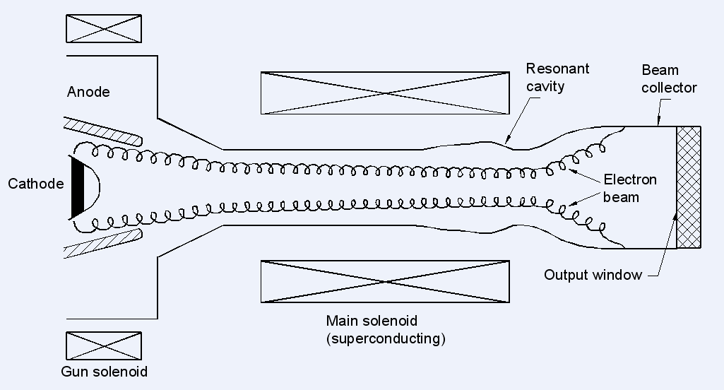

Fig.1.1: Schematic diagram of a conventional gyrotron [2]

A strong externally applied DC magnetic field support the cyclotron motion of the electron beam. The magnetic field in the interaction region is so chosen such that the cyclotron frequency is close to the frequency of the RF field in the beam frame of reference. The interaction region consists of an open-ended waveguide cavity usually with a circular transverse cross section. The transverse component of the RF field in this region interacts with the gyrating annular electron beams and converts large part of the orbital kinetic energy into RF power output. The electrons in the beam must therefore have substantial transverse velocity as well as the usual longitudinal velocity v_{z}, required for the axial transport of the electron beam. Most of these transverse velocities come as a result of the adiabatic compression resulting from the increasing magnetic field leading to the interaction region. The electrons follow a helical path around the lines of force of the external field. In order for the net flow of energy from the transverse electron motion to the electromagnetic wave to take place, the electrons must become bunched in phase within their cyclotron orbits. Such bunching occurs due to the fact that the electron cyclotron frequency is a function of electron energy.
In an electron cyclotron resonance maser (ECRM), electromagnetic energy is radiated by relativistic electrons gyrating in an external longitudinal magnetic field. In this case, the effective frequency Ω corresponds to the relativistic electron cyclotron frequency is given as follows:
(1.2)

Where e is the electron charge, m₀ is the rest mass of electron, γ₀ is the relativistic factor, B₀ is the DC magnetic flux density (which is usually referred as magnetic field in the gyrotron and gyro-device literature) and V₀ is the accelerating beam voltage.
A group of relativistic electrons gyrating in a strong magnetic field will radiate coherently due to bunching caused by the relativistic mass dependence of their gyration frequency. Bunching is achieved because, as an electron loses energy, its relativistic mass decreases and it thus gyrates faster. The consequence is that a small amplitude wave’s electric field, while extracting energy from the particles, causes them to become bunched in gyration phase and reinforces the existing wave electric field. The strength of the magnetic field determines the radiation frequency.
From (1.1)-(1.2), it is very clear that the cyclotron frequency is proportional to the magnetic field B₀; cyclotron frequency does not depend on size of resonators or RF structure. Because of this RF circuits are replaced in gyro devices by a simpler structure or by the smooth waveguide. Their dimensions are not limited and thus, the power handling ability increase many fold as compared to the conventional slow wave microwave tubes. The size of the RF structure depends on the operating mode. Higher the mode, larger the size of the waveguide and higher is the power handling capability. The helical beam produced by the magnetron injection gun, interacts with the electromagnetic field (in TE_{nm} mode), of the same frequency as of the cyclotron frequency, when it pass through the interaction region. The beam wave interaction produces angular velocity modulation, which in turn produces the modulation of electron energy. This causes bunching of the electron beam. This aspect could be understood through dispersion diagram also. Dispersion diagram or Brillouin diagram show the region of cyclotron interaction between the electromagnetic mode and a fast electron cyclotron mode (fundamental or harmonic) (Figs. 1.2 and 1.3), as an intersection of the waveguide mode dispersion curve (hyperbola):

(1.3)
while, the beam wave resonance line (straight line) is given by equation (1.1). Here, is the transverse wave number. In the case of a device with cylindrical resonator, the transverse wave-number:
(1.4)
where is the the m^{th} root of corresponding Bessel function (TM_{mn}) or derivative (TE_{mn}) and R_{o} is the waveguide radius. Phase velocity synchronism of the two waves is given in the intersection region. The interaction can result in a device that could either an oscillator or an amplifier [10].
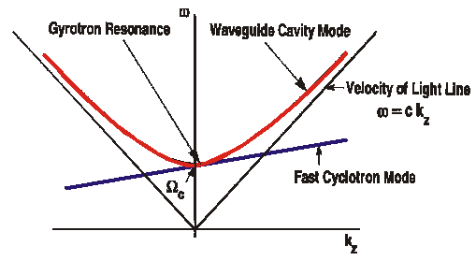
Fig. 1.2: Dispersion diagram of gyrotron oscillator (fundamental resonance).

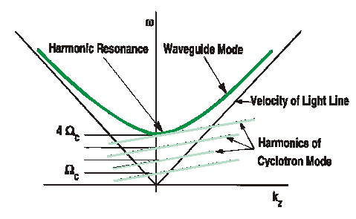
Fig. 1.3: Dispersion diagram of gyrotron oscillator (harmonic resonance).

The beam is initially un-bunched at the entrance to the interaction space (smooth wall circular waveguide which supports TE_{mn} mode and its eigen frequency matches the cyclotron frequency of the electron beam) and electrons are distributed randomly in the phase of their oscillations; Fig. 1.4 shows an electron in the presence of an RF magnetic field, E and DC magnetic field, H at position A (Fig. 1.4), the electron is accelerated from left to right by the instantaneous electric field (Fig. 1.4). As the result of magnetic field presence, the motion of the electron follows curved path and the electron arrives at position B. Provided the timing is correct, the direction of the electric field is reversed and the electron will again be accelerated. The electron therefore spins in a circle whose plane is a right angle to the direction of magnetic field.
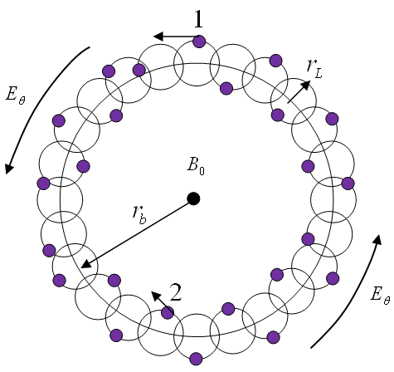
Fig. 1.4: Unbunched electron distributed randomly in phase of their oscillation

The electrons drift and rotate in the presence of RF field. The electrons in Fig. 1.5, are accelerated by the electric field, transverse velocity component is opposite in direction to that of electric field, and governed by equations (1.3) and (1.4) rotate at a lower cyclotron frequency and electrons falling behind the phase of the oscillating electric field lose phase as they drift.

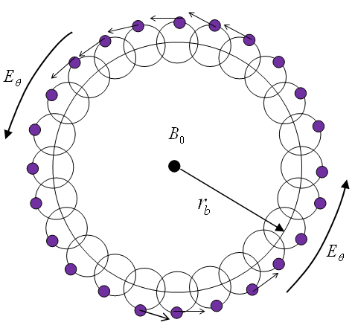
Fig. 1.5: Electron accelerated and decelerated in phase of their oscillation

Whereas electron is decelerated, transverse velocity component is in the same direction as electric field, lose energy, rotate at greater cyclotron frequency, and begin to overtake the phase of the electric field (gain phase as they drift).

After completion of many orbital cycles, the electrons that were initially distributed uniformly with respect to the phase of electric field become tightly bunched in phase. There is net bunching of electrons around the electrons and a rarefaction near electrons. The RF frequency is tuned to somewhat greater than the cyclotron frequency, so that the electron bunches are situated in the decelerating phase of the electric field to give up substantial fraction of its energy to the RF field. Similar interaction can be sustained at harmonics of the cyclotron frequency.
The major subassemblies of gyrotron are (i) electron gun (MIG), (ii) RF interaction structure (resonator cavity), (iii) collector, and (iv) output window. Fig. 1.1 shows the schematic view of a conventional gyrotron where the RF window is put along the axis of the gyrotron for the axial RF output. The other type of gyrotron built today is quasi-optical type, where RF window is perpendicular to the gyrotron axis for RF output.
Electron gun is the heart of any electron beam device and used to provide electron beam suitable for the beam wave interaction. In the electron gun used in microwave tubes, electrons are emitted from the cathode, forms an electron beam of suitable parameter (beam diameter, beam perveance, beam density, etc.) and pass through the region (microwave circuit) for interaction with the RF wave. For designing an electron gun, the parameters such as (i) beam diameter, (ii) beam density, (iii) beam velocity, etc. are taken into account. Typically, a high power gyrotron uses magnetron injection gun (MIG), so-named as it resembles a magnetron, which produces large annular gyrating electron beams with the electrons executing small cyclotron orbits as required for the cyclotron resonance interaction.
In MIG, the electron beam is emitted from the conical shaped cathode working on the principle of thermionic emission, which is based on the heating of an emitting surface to allow electrons to overcome the work function and escape up to the surface. No expanding surface plasma is required, and long pulse as well as continuous electron beam can be produced. The most common thermionic emitter types are pure material, such as tungsten and LaB₆ cathodes, oxide cathodes, dispenser cathodes, scandate cathodes and thorium-based cathodes. Tungsten and thorium-based cathodes operate at too high temperatures to make them less attractive. Present days, dispenser type of cathode is usually preferred due its emission density, life, and reliability.
The other important subassembly of the gyrotron is the RF interaction structure, also known as resonator cavity, which is usually a three-section smooth walled open ended cylindrical cavity structure. Here, the input section is a down taper section, which is a cut-off section, this prevents the back propagation of RF power to the gun region. The beam wave interaction takes place mainly in the uniform middle section where the RF field reaches peak values. Third section is a up taper section, which connects the cavity with the output waveguide. The parabolic smoothing is also done at the junction of two sections to minimize the mode conversion. This circuit can support electromagnetic mode depending upon the size of the uniform middle section, where the design is made in such way that the desired operating mode is excited properly, and then this RF mode interacts with the orbital kinetic energy to generate RF output. The electrons in the beam, therefore, must have a strong transverse velocity as well as the longitudinal beam velocity v_{z}. For the gyrotron most of this transverse velocity comes from the magnetic effect, produced by the increasing magnetic field leading up to the interaction region. The ratio of the transverse to the longitudinal velocity, α = / v_{z} in the interaction region is typically selected between 1 and 2, for the gyrotron. For the relativistic beam gyrotron with thermionic emission cathodes, this ratio is usually not less than unity. In this device relativistic operation has brought increased power through the use of stronger beam fields coupling within the interaction region.
The collector assembly of gyrotron acts primarily as a dump for the spent electrons. In the conventional gyrotron, it also functions as a waveguide for RF output. The collector is usually insulated from the gyrotron main body. This makes it possible to measure the collector current and body current separately. A reduction in the power density at the collector surface is possible by adding coils around the collector. This either decreases the derivative of the magnetic induction or makes the induction along the length of the collector more uniform.
Usually, oxygen free high conductivity (OFHC) copper is chosen for the gyrotron collector because of its good thermal conductivity. Until now, gyrotron at 120GHz have interaction efficiency of less than 35% in long pulse operation. A large fraction of the energy (60%-70 %) remains in the electron beam. The addition of an energy recovery system can significantly increase the overall efficiencies. The separation between beam and RF wave in high power gyrotron allows the installation of a depressed collector for the recovery of the residual electron energy. The depressed collector scheme consists of one or more electrodes.
The last gyrotron subassembly is RF window, which acts as an outlet for the RF output power, it is also used as a vacuum seal for the tube. It must be fabricated from a low-loss material, which is also suitable for ultra high vacuum application. The conditions for oscillations in the interaction cavity, especially the mode competition problems are dependent on the reflections from the window. Because of the high power, the thermal management of the output window becomes an important aspect. The design as well as the choice of the working temperature of the window has to be carefully chosen. Edge cooling does not seem to be sufficient even for medium power gyrotron at room temperature. Face cooling is much more efficient, but it requires a double disc window. For high power gyrotron a temperature of 77˚K or lower is necessary to minimize the reflections.
Besides, the gyrotron subassemblies discussed above, some additional subassemblies, like, beam tunnel, output taper and focusing system are also used. The beam tunnel is a component placed between the electron gun and the interaction cavity. It serves as a region where the electron beam gets stabilized. Most importantly, the beam tunnel region also serves as the absorber for the back propagating RF wave, if any. This is to protect the gyrotron electron gun heating due to reflected RF power from the interaction structure. However, there is chance of parasite oscillations in the beam tunnel itself. The design of the beam tunnel should be such that it should have some lossy material to absorb RF power and no continuous waveguide section to avoid the parasite oscillations.
An output taper is also placed between interaction structure and collector of the gyrotron. In a conventional gyrotron, having axial collection of RF wave, the output taper is a non-linear tapered waveguide, i.e., a continuously varying special radial contour designed to provide the mode purity in transfer of RF mode from the interaction structure to the window as well as no RF interaction in the non-linear tapered section itself as both RF and electron beam are passing along the same path. In the quasi optical gyrotron, it basically consists of a number of parabolic mirrors, so that RF is collected through gyrotron window at right angle to the beam propagation. Lastly, an important subassembly in the gyrotron is the focusing system, it provides the right magnetic field on the electron beam, so that electron beam gyrates properly and is effective for interaction with RF wave. The focusing is a superconducting magnetic system and placed around the interaction cavity.
Gyrotron is based upon cyclotron resonance phenomenon recognized around fifty years back and activities were started in different countries to understand the theoretical concepts, where RF generation takes place due to interaction between the electron beam and fast wave, and also practical demonstration of this phenomenon at low frequency and low power. Since then, the progress in gyrotron is tremendous with almost reaching 1-2MW power at 140GHz and 170GHz for plasma research and up to THz with moderate power for nuclear spectroscopy applications.

References
- O. Dumbrajs, “Kinetic theory of electron cyclotron resonance masers with asymmetry of the electron beam in a cavity”, IEEE Tr. Plasma Science, vol. 20, pp. 126, 1992.
- G. S. Nusinovich, Introduction to the physics of Gyrotron, Maryland, JHU, USA, 2004.
- M. Thumm, “Progress on gyrotrons for ITER and future thermonuclear fusion reactors”, IEEE Trans. Plasma Science, vol. 39, pp. 971, 2011.
- M. A. Henderson, S. Alberti, P. Benin, T. Bonicelli, R. Chavan, et al., “EU developments of the ITER ECRH system”, Fusion Eng. & Design, vol. 82, pp 454–462, 2007.
- T. Omoria, M. A. Hendersona, F. Albajarb, S. Albertic, U. Baruahd, et al., “Overview of the ITER EC H&CD system and its capabilities”, Fusion Eng. and Design, vol. 86, pp. 951-954, 2011.
- A. A. Andronov, V. A. Flyagin, A. V. Gaponov, A. L. Goldenberg, M. I. Petelin, V. G. Usov and V. K. Yulpatov, “The Gyrotron: high power sources of millimeter and sub millimeter waves,” Infrared Physics, vol. 18, pp. 385-393, 1978.
- M. Thumm, “MW gyrotron development for fusion plasma applications,” Plasma Phys. Control. Fusion, vol. 45, pp. A143–A161, 2003.
- A. V. Gaponov- Grekhov and V. L. Granatstein, Application of High Power Microwaves, Norwood: Artech House, 1994.
- G. Dammertz, “High-power Gyrotron development at forschungszentrum Karlsruhe for fusion applications”, International Conference on Plasma Science, 2005, Monterey, CA
- R. Chatterjee, Microwave, Millimetre-Wave and Submillimetre-Wave: Vacuum Electron Devices, New Delhi: Affiliated East-West Press, 1999.

