Empowerment of Women in Cottage Industry
Ms. A. Anusuya. Full-Time PhD Research Scholar. PG & Research Department of Commerce. Rani Anna Government College for Women. Gandhi Nagar. Tirunelveli-627008.

Ms. M. Ramalakshmi. Full-Time PhD Research Scholar. PG & Research Department of Commerce. Rani Anna Government College for Women. Gandhi Nagar. Tirunelveli-627008.

Mrs.R. Shunmugaselvi. Full-Time PhD Research Scholar. PG & Research Department of Commerce. Rani Anna Government College for Women. Gandhi Nagar. Tirunelveli-627008.

Dr. V. Darling Selvi. Head and Assistant Professor of Commerce. PG & Research Department of Commerce. Rani Anna Government College for Women. Tirunelveli-627008. prof.darlingselvi@gmail.com. Contact Number: 94423 64293.

Abstract
The main objective of the study is to inspect an empowerment of women in cottage industries. Primary data will be collected from the respondents with the help of structured interview schedule. Secondary data will be collected from various sources like journals, magazines etc. In this study used a sample of 200 respondents from Tirunelveli district with the use of SPSS 20 and AMOS 20 software, the researcher used a reliability test, exploratory factor analysis (EFA) and confirmatory factor analysis (CFA). It was concluded that to develop entrepreneurship skills in the society in educational empowerment followed by fight against superstitions in social empowerment then to understand the activities of women’s commission in political empowerment and finally, to market the goods and services in economic empowerment is the highest factors. Initially, the confirmatory factor analysis model did not fit. As per the modification indices one double arrow mark was connected with error to error. After that, the model fit perfectly.
(Keywords: Cottage Industry, Educational Empowerment, Economic Empowerment, Political Empowerment and Social Empowerment)
Introduction
Women empowerment refers to increasing economic, social, political and educational strength of an entity or entities. Empowerment covers many aspects such as women’s control over material and intellectual resources. Women Entrepreneurs in rural areas are dependent on cottage industries for many of their needs and it has generated employment opportunities for them and save their society from decay. Cottage Industry is a form of unorganized industry, predominantly rural and are mainly engaged in craftsmanship works such as handicraft, pottery, knitting, handloom, etc. In rural areas, it has been found that the cottage industries have given economic independence to the women. Through the cottage industries women are having decision making power and are also contributing to the growth process and changes that are never ending thus cottage industries have become a channelized route for the empowerment of women entrepreneur.
Review of Literature
Samitowska (2011) examined the contributions, development, and importance of cottage industries to the Polish economy. The survey concluded that considerable financial barriers, such as restricted access to capital and insufficient starting finance, were impeding the growth of entrepreneurship. Because of this, the biggest obstacles facing cottage industries in Poland are a lack of adequate state funding, a lack of assistance from corporate institutions, poor financial resource management, fierce competition between Polish and foreign businesses, Polish law, and administrative bodies.
Subrahmanya Bala (2011) examined the impact of globalisation on the export potential of small-scale firms and came to the conclusion that while the impact was significant during the security period, it also grew during the liberalisation phase, even though the development appeared to be gradual. In order to increase the productivity of these SSIs, the government might thus continue to make investments in infrastructure, financing, and marketing.
Shihabudheen (2012) in their study states that Micro businesses are crucial to the global empowerment of women and the development of rural areas, particularly in industrialised nations like India. Micro businesses attempt to create inclusive and equitable urban development with relatively low capital outlays, and they play a significant role in reducing poverty and the socioeconomic growth of the poor. By concentrating on micro firms that are a part of Kerala's government's flagship project to combat poverty, "Kudumbashree," this essay investigates the role of micro enterprises in women's empowerment.
Merlin Thanga Joy et al. (2013) in their paper, the authors discuss the economic benefits of cottage industries, which provide jobs for a sizable number of rural residents. The report makes the case that creating cottage industries is the most effective strategy to fight unemployment since our nation is overpopulated. The paper asserts that little is beautiful and that the government must devise even more initiatives to promote the expansion of cottage industries.
Srinivas, K., T. (2013) in their study concluded that Cottage Industries are the country's growth engine, and their role in inclusive development is that of micro, small, and medium-sized businesses. To consolidate this market, there have been numerous reforms at the federal and state levels in recent years. The lack of infrastructure and marketing linkages is the main cause of the cottage industry's slow growth in India. The state and federal governments' support is insufficient for the development of India's cottage industries. As a result, both the government and Indian businesspeople should take action to promote the development of these cottage industries in India.
Vijay Jariwala (2016) in their study learn about the challenges and opportunities faced by women entrepreneurs in Dang district who are running successful small businesses. It also looked at motivational causes, as well as woman entrepreneurs' key strengths and weaknesses. The study's results indicate that the challenge is finance marketing products and inadequate resources, as well as the fact that women's education plays a significant role in becoming a woman entrepreneur.
Research Methodology
The main objective of the study is to inspect an empowerment of women in cottage industries. Primary data will be collected from the respondents with the help of structured interview schedule. Secondary data will be collected from various sources like journals, magazines, websites, books, newspapers, and online sources, published and unpublished sources. In this study used a sample of 200 respondents from Tirunelveli district with the use of SPSS 20 and AMOS 20 software, the researcher used a reliability test, exploratory factor analysis (EFA) and confirmatory factor analysis (CFA).
Data Analysis and Interpretation
Table 1 Reliability Test
Factors | No. of variables | Cronbach's Alpha
Educational Empowerment | 4 | 0.890
Social Empowerment | 4 | 0.905
Political Empowerment | 4 | 0.863
Economic Empowerment | 4 | 0.824
Source: Primary data
The data reliability has been tested by using the statistic Cronbach alpha. The Cronbach’s Alpha for Educational Empowerment is 0.890, Social Empowerment is 0.905, Political Empowerment is 0.863 and Economic Empowerment is 0.824. As per the standards, the value needs to be greater than 0.5. Hence it can be concluded that the data is adequate.

Table 2 KMO and Bartlett's Test

Kaiser-Meyer-Olkin Measure of Sampling Adequacy. |  | .897
Bartlett's Test of Sphericity | Approx. Chi-Square | 1899.062
 | df | 120
 | Sig. | .000
Source: Primary Data

Kaiser-Meyer-Olkin Measure is an index which define of Sampling Adequacy. The KMO test value is 0.897 which is more than 0.5, can be considered great and valid to conduct data reduction technique. The Bartlett’s test of Sphericity helps to decide, whether the results of factor analysis are worth considering and whether should continue analysing the research work. Bartlett’s Test of Sphericity significant to a level of significance is <0.001 which shows that there is a high level of correlation between variables, which make it adequate to apply factor analysis.
Table 3 Empowerment of Women in Cottage Industry

Statements | Components
 | Educational Empowerment | Social Empowerment | Political Empowerment | Economic Empowerment
To develop entrepreneurship skills in the society | .861
To develop leadership skills in the society | .835
To adopt technological developments | .822
To connect with each other and share experiences in life | .806
To fight against superstitions |  | .884
To work for social equality |  | .817
To actively get involved in social service |  | .798
To achieve the goal of Social freedom |  | .794
To understand the activities of women’s commission |  |  | .790
To participate actively in political activities |  |  | .777
Understand the importance of adult ownership. |  |  | .753
To participate actively in elections |  |  | .745
To market the goods and services |  |  |  | .811
To gain self-employment opportunities |  |  |  | .782
To achieve the goal of agricultural and cottage industrial development |  |  |  | .730
To improve saving ability |  |  |  | .708
Eigen value | 6.548 | 2.710 | 1.491 | 1.015
Percentage of Variation | 40.926 | 16.938 | 9.319 | 6.346
Source: Primary Data
Factor 1 is the combination of four factors and it can be termed as Educational Empowerment. The Eigen value of Educational Empowerment is 6.548 with 40.926 %of variance. Factor 1 has very high significant loading on the variable To develop entrepreneurship skills in the society (0.861) and moderately high loading on the variables of To develop leadership skills in the society (0.835), To adopt technological developments (0.822) and To connect with each other and share experiences in life (0.806).
Factor 2 is the combination of four factors and it can be termed as Social Empowerment. The Eigen value of Social Empowerment is 2.710with 16.938 %of variance. Factor 2 has very high significant loading on the variable To fight against superstitions (0.884) and moderately high loading on the variables of To work for social equality (0.817), To actively get involved in social service (0.798) and To achieve the goal of Social freedom (0.794).
Factor 3 is the combination of seven factors and it can be termed as Political Empowerment. The Eigen value of Political Empowerment is 1.491 with 9.319 % of variance. Factor 3 has very high significant loading on the variable To understand the activities of women’s commission (0.790) and moderately high loading on the variables of To participate actively in political activities (0.777), Understand the importance of adult ownership (0. 753) and To participate actively in elections (0.745).
Factor 4 is the combination of four factors and it can be termed as Economic Empowerment. The Eigen value of Economic Empowerment is 1.015 with 6.346 %of variance. The Economic Empowerment has very high significant loading on the variable To market the goods and services (0.811) and moderately high loading on the variables of To gain self-employment opportunities (0.782), To achieve the goal of agricultural and cottage industrial development (0.730) and To improve saving ability (0.708).
Table 4 Goodness of fit test for CFA Model
Measure | Estimate | Suggested Value | Interpretation
CMIN/DF | 1.279 | < 5.00 ( Hair et al., 1998) | Excellent
GFI | 0.930 | > 0.90 (Hu and Bentler, 1999) | Excellent
AGFI | 0.901 | > 0.90 ( Hair et al. 2006) | Excellent
NFI | 0.937 | > 0.90 (Hu and Bentler, 1999) | Excellent
CFI | 0.985 | > 0.90 (Daire et al., 2008) | Excellent
RMSEA | 0.037 | <0.08 (Hu and Bentler, 1999) | Excellent
Source: Primary data

From the above table it is found that the value of CMIN/DF is 1.279 which is less than 5.00 which indicates perfectly fit. Here Goodness of Fit Index (GFI) value (0.930) and Adjusted Goodness of Fit Index (AGFI) value (0.901) is greater than 0.9 which represent it is a good fit. The calculated Normed Fit Index (NFI) value (0.937) and Comparative Fit Index (CFI) value (0.985) indicates that it is a perfectly fit and also it is found that Root Mean Square Error of Approximation (RMSEA) value is 0.037 which is less than 0.08 which indicated it is perfectly fit.

CFA Model with Standardized Factor Loading
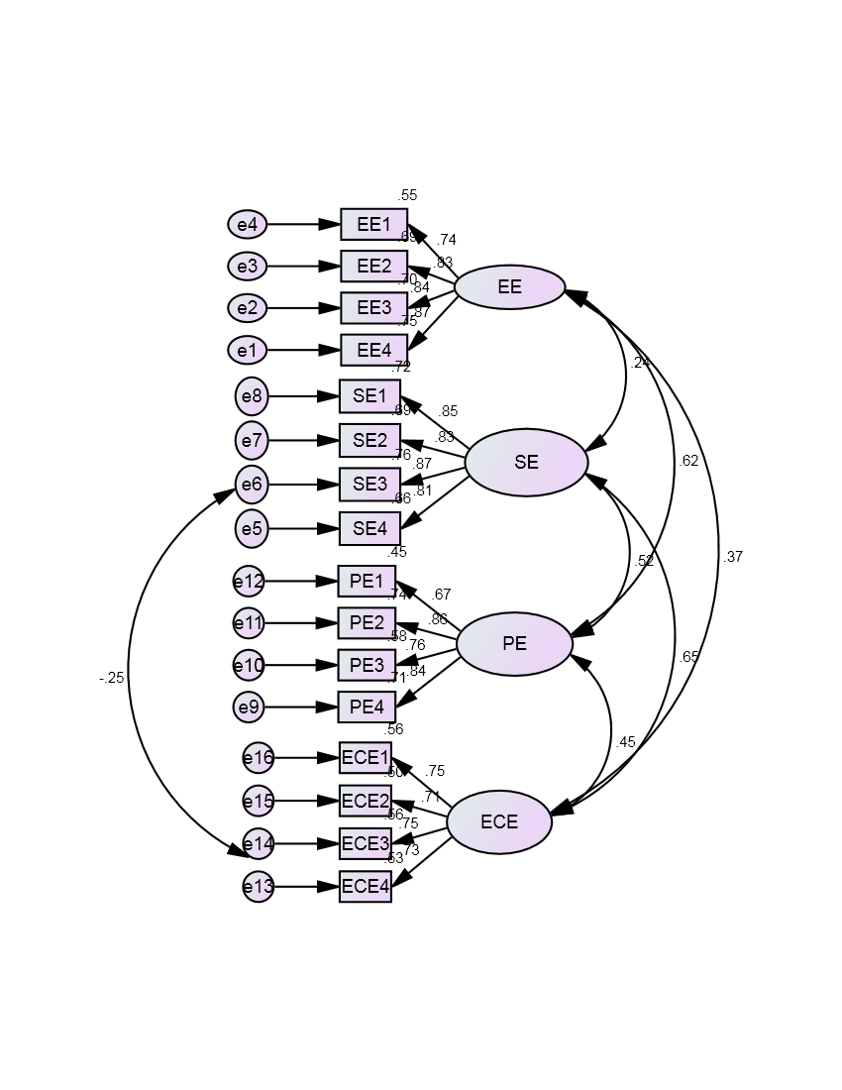

Based on the structural model, it is possible to conclude that Educational Empowerment, Social Empowerment, Political Empowerment and Economic Empowerment are statistically significant. Each factor has significant influence with other factors.

Table 5 Calculation of Average Variance Extracted (AVE) and Construct Reliability (CR)
 |  |  | Factor Loading | Item Reliability | Delta | AVE | Sum of FL | Sum of Delta | CR
EE4 | <--- | EE | 0.868 | 0.753 | 0.247 | 0.673 | 3.277 | 1.307 | 0.892
EE3 | <--- | EE | 0.838 | 0.702 | 0.298
EE2 | <--- | EE | 0.829 | 0.687 | 0.313
EE1 | <--- | EE | 0.742 | 0.551 | 0.449
SE4 | <--- | SE | 0.811 | 0.658 | 0.342 | 0.708 | 3.365 | 1.167 | 0.907
SE3 | <--- | SE | 0.872 | 0.760 | 0.240
SE2 | <--- | SE | 0.834 | 0.696 | 0.304
SE1 | <--- | SE | 0.848 | 0.719 | 0.281
PE4 | <--- | PE | 0.842 | 0.709 | 0.291 | 0.620 | 3.136 | 1.519 | 0.866
PE3 | <--- | PE | 0.761 | 0.579 | 0.421
PE2 | <--- | PE | 0.862 | 0.743 | 0.257
PE1 | <--- | PE | 0.671 | 0.450 | 0.550
ECE4 | <--- | ECE | 0.727 | 0.529 | 0.471 | 0.539 | 2.937 | 1.842 | 0.824
ECE3 | <--- | ECE | 0.751 | 0.564 | 0.436
ECE2 | <--- | ECE | 0.71 | 0.504 | 0.496
ECE1 | <--- | ECE | 0.749 | 0.561 | 0.439
Source: Calculated
The Construct Reliability is the method for assessing the contribution or significance of an item by examining the factors loading. The Construct Reliability (CR) of the four latent factors is greater than 0.70 which indicate good reliability and the value for Average Variance Extracted (AVE) is also greater than 0.50 which indicates adequate Convergent Validity. A high construct reliability indicates that internal consistency exists. The data has good Construct Reliability and Convergent Validity.
Table 6 Discriminant Validity of Women Empowerment
Factors | AVE | Squared Inter Correlation (SIC)
 |  | EE | SE | PE | ECE
EE | 0.673 |  | 0.056 | 0.387 | 0.135
SE | 0.708 | 0.056 |  | 0.275 | 0.428
PE | 0.62 | 0.387 | 0.275 |  | 0.198
ECE | 0.539 | 0.135 | 0.428 | 0.198
Source: Calculated
All Average Variance Extracted (AVE) estimates in the above table are larger than the corresponding Squared Inter construct Correlation (SIC) estimates. This means the indicators have more in common with the factor they are associated with than they do with other factors. Therefore CFA model demonstrates Discriminant Validity.
Conclusion
It was concluded that to develop entrepreneurship skills in the society is the highest loading factor 0.861 in educational empowerment followed by fight against superstitions is the highest loading factor with the value of 0.884 in social empowerment then to understand the activities of women’s commission in political empowerment and to market the goods and services in economic empowerment is the highest factor with the value 0.790 and 0.811 respectively. Initially, the confirmatory factor analysis model did not fit. As per the modification indices one double arrow mark was connected with error to error. After that, the model fit perfectly.
References
- Bala Subrahmanya, M H and S V Kasturi (2011): “Role of SSI Internationalization in the Promotion of SSI Production and Total Exports in India”, International Economics and Finance Journal, 6(2), 167-185.
- Merlin Thanga Joy, R. Melba kan,(2013), “Emerging Opportunities and Challenges for Cottage Industries in India”, International Journal of Scientific and Research Publications, 3(3), 2013.
- Samitowska, W. (2011).”Barriers to the development of entrepreneurship demonstrated by micro, small and medium enterprises in Poland. Economics & Sociology”, 4(2), pp.42-49.
- Shihabudheen (2012), “Role of Micro Enterprises in Women Empowerment: Evidence from a Field Study of „Kudumbashree‟ Units in Ernakulam District in Kerala”, IOSR Journal Of Humanities And Social Science (JHSS) ISSN: 2279-0837, ISBN: 2279-0845. Volume 3, Issue 6 (Nov. - Dec. 2012), PP 06-12 Www.Iosrjournals.Org
- Srinivas, K. T. (2013) “Role of micro, small and medium enterprises in inclusive growth”, International Journal of Engineering and Management Research (IJEMR), 3(4), 57-61.
- Vijay Jariwala, V. (2016). Rural Women Entrepreneurs: A Case Study for Cottage Industries of Dang District. Jariwala, VS (2016), Rural Women Entrepreneurs: A Case study for Cottage Industries of Dang District, Indian Journal of Technical Education, 1(1), 1-8.

